PROGRAM:1

AIM:
Write a program that prompts the user to enter his first name and last name.

Source Code:
fname = input("enter your first name")
lname = input("enter your last name")
print("Greetings!!!",fname,lname)

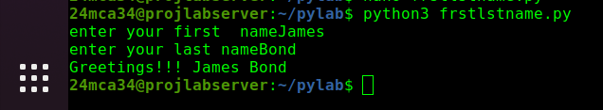
Output:

----------------------------------------------------------------------------------------------------

PROGRAM:2

AIM:
Write a program to demonstrate different number data types in python.

Source Code:
x,y,z = 2,2.5,4+4j
print("type of x",type(x))
print("type of y",type(y))
print("type of z",type(z))

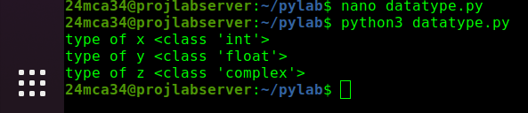
Output:

-----------------------------------------------------------------------------------------------------
PROGRAM:3

AIM:
Write a program to calculate the area of a circle by reading inputs from the user.

Source Code:
r=float(input("enter the radius"))
area = 3.14*r*r
print("area of circle is",area)

Output:
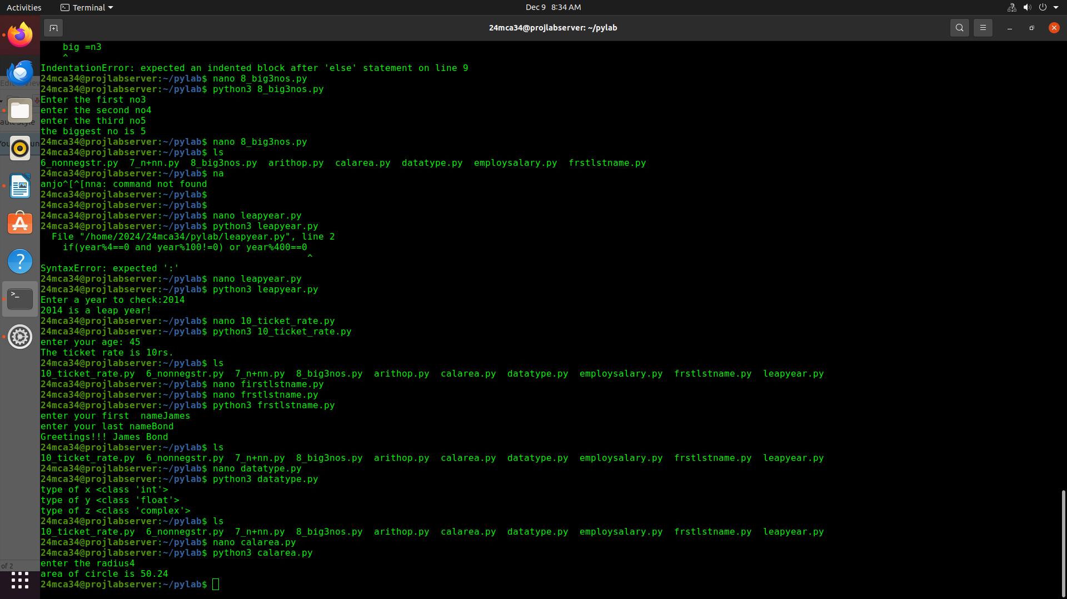

----------------------------------------------------------------------------------------------------------------

PROGRAM:4

AIM:
Write a program to calculate the salary of a employee given his basic pay(t o be entered by the user) HRA = 10percemt of the basic pay, TA =5 percent of the basic salary .

Source Code:
BP = float(input("enter the basic pay of the employee"))
HRA = 0.5*BP
TA = 0.005*BP
salary = BP+HRA+TA
print("salary of that employee is",salary)

Output:

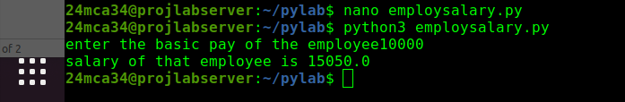

-----------------------------------------------------------------------------------------------------------------
PROGRAM:5

AIM:
Write a python program to perform arithmetic operations on two integer numbers .

Source Code:
x = int(input("enter the first no"))
y = int(input("enter your second no"))
print("sum:",x,"+",y,"=",x+y)
print("difference:",x,"-",y,"=",x-y)
print("multiply:",x,"*",y,"=",x*y)
print("division:",x,"/",y,"=",x/y)

Output:

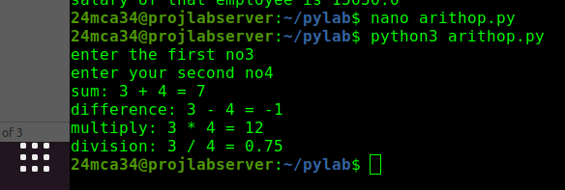

-----------------------------------------------------------------------------------------------------------------
PROGRAM:6

AIM:
Write a python program to get a string which is n() non-negative integer) copies of a given string

Source Code:
str = input("enter a string")
n = int(input("Enter the number(positive) of copies:"))
copy = str*n
print(copy)

Output:

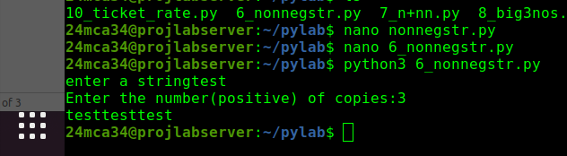

-----------------------------------------------------------------------------------------------------------------

PROGRAM:7

AIM:
Program to accept an integer n and computer n+nn+nnn.
[Hint:n=5, then computer 5+55+555]

Source Code:
n = input("Enter a positive integer")
print(n,'+',n*2,'+',n*3)
sum = int(n) + int(n*2)+int(n*3)
print("the sum is ",sum)

Output:

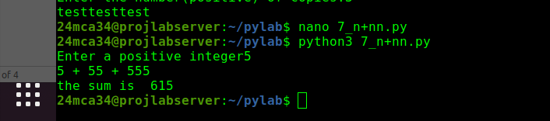

-----------------------------------------------------------------------------------------------------------------

PROGRAM:8

AIM:
Find the biggest of 3 numbers entered.

Source Code:

n1 = int(input("Enter the first no"))
n2 = int(input("enter the second no"))
n3 = int(input("enter the third no"))
if (n1>n2) & (n1>n3):
print(n1," is largest")
elif n2>n3:
print(n2," is largest")
else:
print(n3," is largest")

Output:

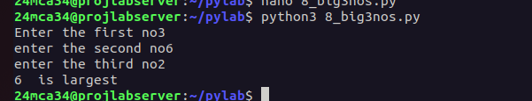

-----------------------------------------------------------------------------------------------------------------
PROGRAM:9

AIM:
Program to determine whether a year is leap year or not.

Source Code:

year=int(input("Enter year:"))
if year%100==0:
if year%400==0:
print(f"{year} is a leap year")
else:
print(f"{year} is not a leap year")
elif year%4==0:
print(f"{year} is a leap year")
else:
print(f"{year} is not a leap year")

Output:

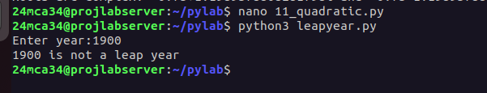

-----------------------------------------------------------------------------------------------------------------

PROGRAM:10

AIM:
Write a Python program to determine the rate of entry-ticket in a trade fair based on age as
follows:
Age Rate
<10 7
>=10 and <60 10
>= 60 5.

Source Code:

age = int(input("enter your age: "))

rate = 0

if(age<10):
rate=7
elif age>=10 and age<60:
rate=10
elif age>=60:
rate=5
else:
print("enter a valid age!")
print(f"The ticket rate is {rate}rs.")

Output:
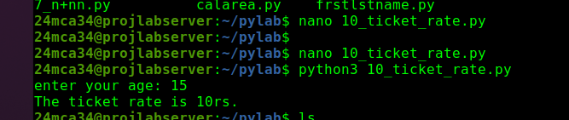

-----------------------------------------------------------------------------------------------------------------

PROGRAM:11

AIM:
Write a Python program to solve a quadratic equation.

Source Code:

import math
a=float(input("Enter a:"))
b=float(input("Enter b:"))
c=float(input("Enter c:"))
dis=b**2-4*a*c
if dis>0:
root1=(-b+math.sqrt(dis))/(2*a)
root2=(-b-math.sqrt(dis))/(2*a)
print(f"Roots are real and distinct: {root1} and {root2}")

elif dis==0:
root=-b/(2*a)
print(f"Root is real and equal: {root}")
else:
real_part=-b/(2*a)
imag_part=math.sqrt(-dis)/(2*a)
print(f"Roots are complex: {real_part}+{imag_part}i and {real_part}-{imag_part}i")

Output:





