PROGRAM:1

AIM:
Write a program that prompts the user to enter his first name and last name.

Source Code:
fname=input("enter first name:")
lname=input("enter last name:")
print(f"Greetings!!!{fname} {lname}")

Output:

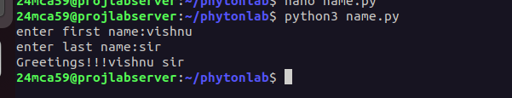

----------------------------------------------------------------------------------------------------

PROGRAM:2

AIM:
Write a program to demonstrate different number data types in python.

Source Code:
a=10
b=12.3
c=1+2j
print("a:",a)
print("b:",b)
print("c:",c)
print(a,"is a number with datatype",type(a))
print(b,"is a number with datatype",type(b))
print(c,"is a number with datatype",type(c))

Output:
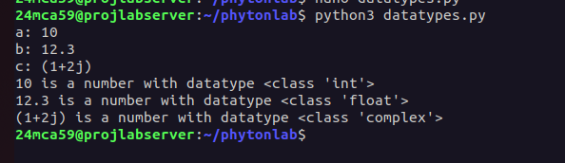

-----------------------------------------------------------------------------------------------------
PROGRAM:3

AIM:
Write a program to calculate the area of a circle by reading inputs from the user.

Source Code:
import math
radius=float(input("enter the radius of the circle:"))
area=math.pi*(radius**2)
print(f"The area of the circle with radius {radius}is:{area}")

Output:

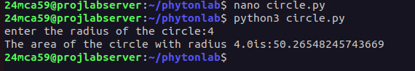

----------------------------------------------------------------------------------------------------------------

PROGRAM:4

AIM:
Write a program to calculate the salary of a employee given his basic pay(t o be entered by the user) HRA = 10percemt of the basic pay, TA =5 percent of the basic salary .

Source Code:
bp=float(input("Enter the basic pay:"))
hra=bp*0.1
ta=bp*0.05
salary=bp+hra+ta
print("Basic pay:",bp)
print("HRA:",hra)
print("TA:",ta)
print("TOTAL SALARY:",salary)

Output:

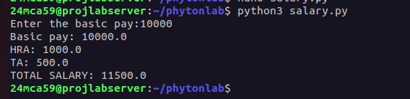

-----------------------------------------------------------------------------------------------------------------
PROGRAM:5

AIM:
Write a python program to perform arithmetic operations on two integer numbers .

Source Code:
num1=int(input("enter first integer:"))
num2=int(input("enter second integer:"))
add=num1+num2
sub=num1-num2
div=num1/num2
mul=num1*num2
mod=num1%num2
print(f"{num1}+{num2}={add}")
print(f"{num1}-{num2}={sub}")
print(f"{num1}/{num2}={div}")
print(f"{num1}*{num2}={mul}")
print(f"{num1}%{num2}={mod}")

Output:
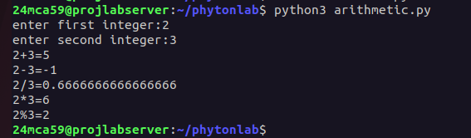

-----------------------------------------------------------------------------------------------------------------
PROGRAM:6

AIM:
Write a python program to get a string which is n() non-negative integer) copies of a given string

Source Code:
str=input("enter a string:")
n=int(input("enter the number of copies:"))
copy=str*n
print (copy)

Output:

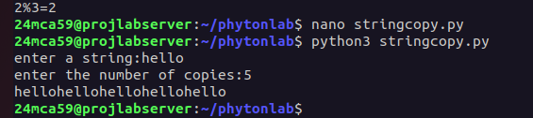

-----------------------------------------------------------------------------------------------------------------
PROGRAM:7

AIM:
Program to accept an integer n and computer n+nn+nnn.
[Hint:n=5, then computer 5+55+555]

Source Code:
n = input("Enter a positive integer")
print(n,'+',n*2,'+',n*3)
sum = int(n) + int(n*2)+int(n*3)
print("the sum is ",sum)

Output:

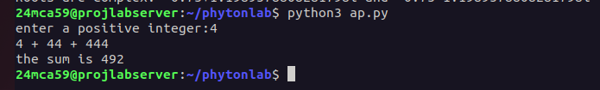

-----------------------------------------------------------------------------------------------------------------

PROGRAM:8

AIM:
Find the biggest of 3 numbers entered.

Source Code:

num1 = int(input("enter a number:"))
num2 = int(input("enter a number:"))
num3 = int(input("entera number:"))
if num1>num2&num1>num3:
print (num1,"is largest")
elif num2>num3:
print (num2,"is largest")
else:
print (num3,"is largest")

Output:

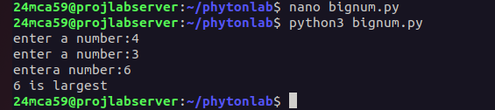

-----------------------------------------------------------------------------------------------------------------
PROGRAM:9

AIM:
Program to determine whether a year is leap year or not.

Source Code:

year=int(input("Enter year:"))
if year%100==0:
if year%400==0:
print(f"{year} is a leap year")
else:
print(f"{year} is not a leap year")
elif year%4==0:
print(f"{year} is a leap year")
else:
print(f"{year} is not a leap year")

Output:

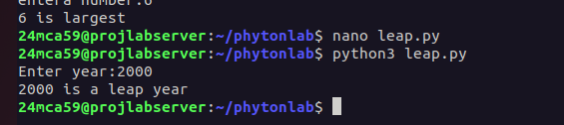

-----------------------------------------------------------------------------------------------------------------

PROGRAM:10

AIM:
Write a Python program to determine the rate of entry-ticket in a trade fair based on age as
follows:
Age Rate
<10 7
>=10 and <60 10
>= 60 5.

Source Code:

age=int(input("Enter age:"))
if age<10:
rate=7
elif age>=10 and age<60:
rate=10
else:
rate=5
print("Ticket rate:",rate)

Output:
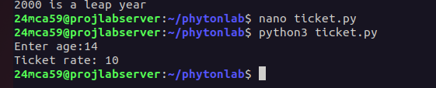

-----------------------------------------------------------------------------------------------------------------

PROGRAM:11

AIM:
Write a Python program to solve a quadratic equation.

Source Code:

import math
a=float(input("Enter a:"))
b=float(input("Enter b:"))
c=float(input("Enter c:"))
dis=b**2-4*a*c
if dis>0:
root1=(-b+math.sqrt(dis))/(2*a)
root2=(-b-math.sqrt(dis))/(2*a)
print(f"Roots are real and distinct: {root1} and {root2}")

elif dis==0:
root=-b/(2*a)
print(f"Root is real and equal: {root}")
else:
real_part=-b/(2*a)
imag_part=math.sqrt(-dis)/(2*a)
print(f"Roots are complex: {real_part}+{imag_part}i and {real_part}-{imag_part}i")

Output:





