Supply Chain X — System Overview & Architecture
AI-Powered Supply Chain Intelligence Platform
This document summarizes the end-to-end system architecture, machine learning workflows, and data integration pipelines for Supply Chain X. The platform leverages modern web technology (React, FastAPI), specialized machine learning models, and CP-SAT optimization algorithms to deliver actionable supply chain intelligence, predictive insights, and automated operational planning.
1. High-Level System Architecture
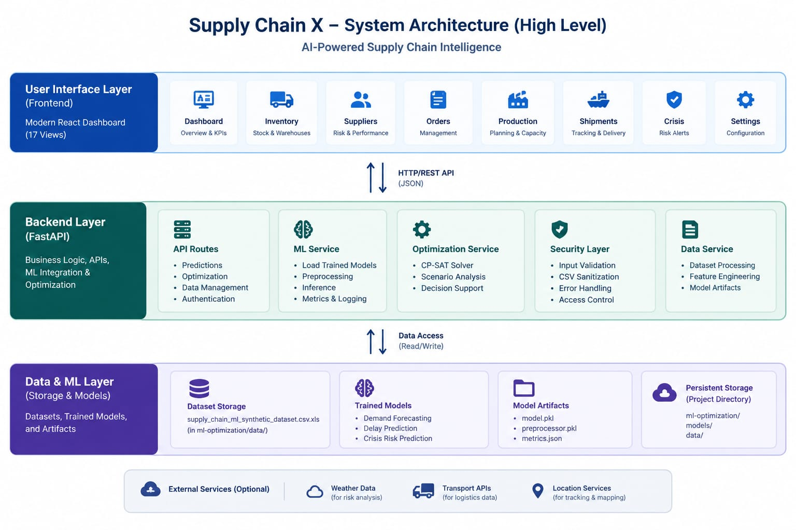
Figure 1: Supply Chain X — System Architecture (High Level)
Architecture Breakdown
- User Interface Layer (Frontend): Built with a Modern React Dashboard featuring 17 views, including Dashboard (Overview & KPIs), Inventory (Stock & Warehouses), Suppliers (Risk & Performance), Orders Management, Production (Planning & Capacity), Shipments (Tracking & Delivery), Crisis (Risk Alerts), and Settings.
- API Communication: Employs HTTP/REST API with JSON payloads connecting frontend components with backend services.
- Backend Layer (FastAPI): Houses business logic, API routing, ML integration, and optimization solvers. Comprises API Routes (Predictions, Optimization, Data Management, Authentication), ML Service (Load Trained Models, Preprocessing, Inference, Metrics & Logging), Optimization Service (CP-SAT Solver, Scenario Analysis, Decision Support), Security Layer (Input Validation, CSV Sanitization, Error Handling, Access Control), and Data Service (Dataset Processing, Feature Engineering, Model Artifacts).
- Data & ML Layer (Storage & Models): Manages Dataset Storage (CSV/Excel files), Trained Models (Demand Forecasting, Delay Prediction, Crisis Risk Prediction), Model Artifacts (model.pkl, preprocessor.pkl, metrics.json), and Persistent Storage in project directories.
- External Services (Optional): Integrates optional APIs for Weather Data (risk analysis), Transport APIs (logistics data), and Location Services (tracking & mapping).
2. AI/ML Prediction Workflow
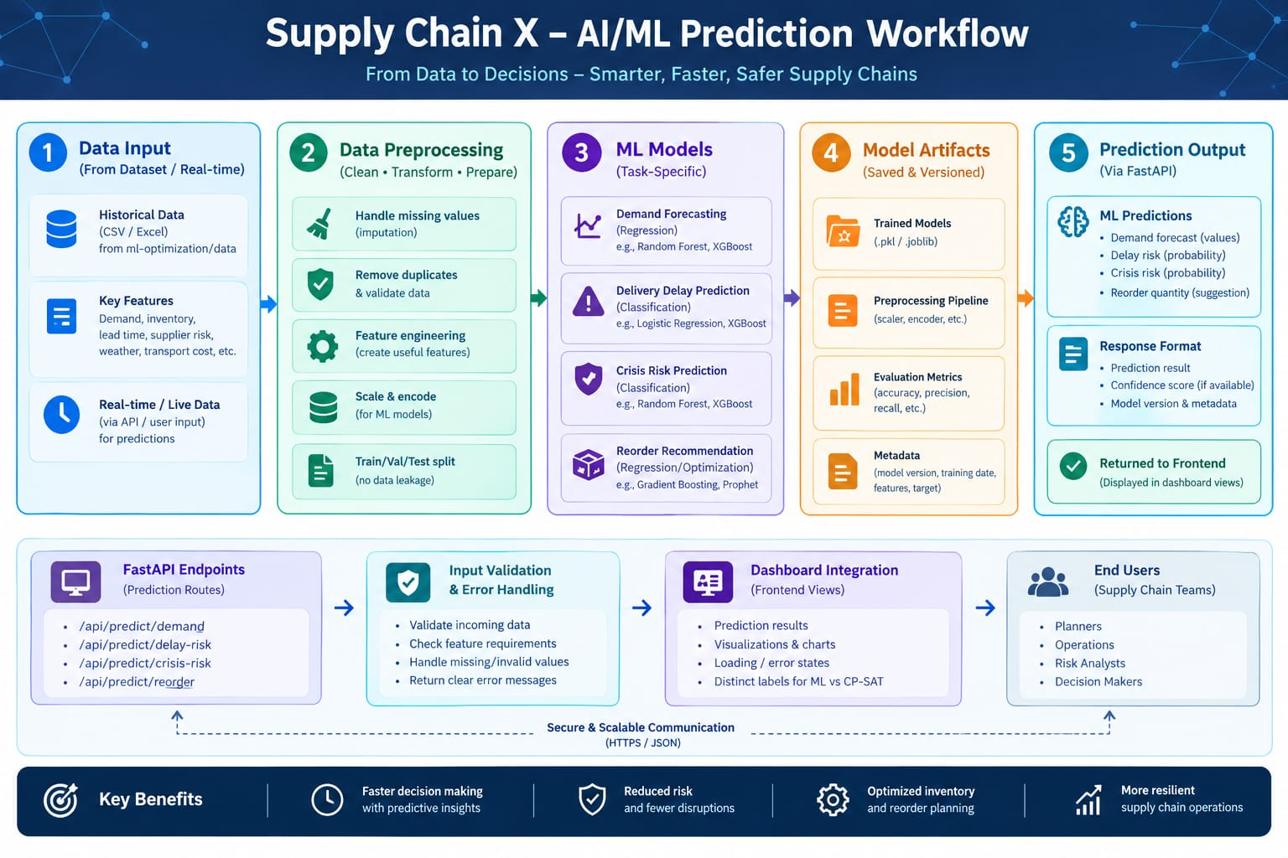
Figure 2: Supply Chain X — AI/ML Prediction Workflow (From Data to Decisions)
Workflow Stages
- Step 1: Data Input: Accepts historical data (CSV/Excel datasets) and real-time operational inputs (API or manual UI entry) containing demand, inventory levels, lead times, supplier risk, weather data, and transport costs.
- Step 2: Data Preprocessing: Cleans, transforms, and prepares data via missing value imputation, duplicate removal, feature engineering, scaling & encoding, and strict train/val/test splitting to prevent data leakage.
- Step 3: ML Models (Task-Specific): Deploys targeted algorithms — Demand Forecasting (Random Forest, XGBoost), Delivery Delay Prediction (Logistic Regression, XGBoost), Crisis Risk Prediction (Random Forest, XGBoost), and Reorder Recommendation (Gradient Boosting, Prophet).
- Step 4: Model Artifacts: Maintains versioned model binaries (.pkl, .joblib), preprocessing pipelines (scalers, encoders), evaluation metrics (accuracy, precision, recall), and feature metadata.
- Step 5: Prediction Output & FastAPI Endpoints: Exposes dedicated endpoints (/api/predict/demand, /api/predict/delay-risk, /api/predict/crisis-risk, /api/predict/reorder) with input validation, error handling, and JSON formatted predictions delivered directly to the frontend views.
Key Business Benefits
- Faster Decision Making: Accelerated decision-making powered by predictive AI insights.
- Reduced Risk: Proactive crisis detection and fewer operational supply chain disruptions.
- Optimized Inventory: Precision safety stock allocation and automated reorder planning.
- Resilient Supply Chain: Increased adaptability and resilience across logistics operations.
3. Data Flow & System Integration
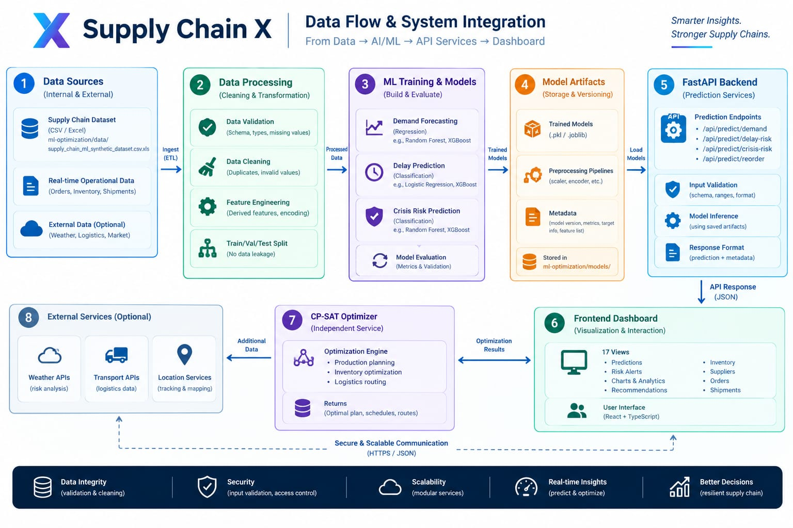
Figure 3: Supply Chain X — End-to-End Data Flow & System Integration
Integrated Lifecycle Steps
- 1. Data Sources: Combines internal datasets, real-time operational feeds, and optional external API inputs.
- 2. Data Processing: Executes ETL processes, schema validation, data cleaning, feature engineering, and dataset splitting.
- 3. ML Training & Models: Builds, trains, and evaluates regression and classification models for demand, delay, and crisis risk assessment.
- 4. Model Artifacts: Stores versioned model files, pipelines, and evaluation metadata in designated directory paths.
- 5. FastAPI Backend: Serves real-time inference endpoints, performs input validation, and formats JSON outputs.
- 6. Frontend Dashboard: Interactive React + TypeScript interface providing 17 views, visualizations, risk alerts, and recommendations.
- 7. CP-SAT Optimizer: Independent optimization service executing production planning, inventory optimization, and logistics routing.
- 8. External Services: Enhances system intelligence with live weather, transport logistics, and geographic tracking data.

