Name:-Aayush Patle
A5-B4_54
Practical 6

CODE:-
def optimal_bst(keys, p, q):
n = len(keys)

E = []
for i in range(n + 1):
row = []
for j in range(n + 1):
row.append(0.0)
E.append(row)

W = []
for i in range(n + 1):
row = []
for j in range(n + 1):
row.append(0.0)
W.append(row)

R = []
for i in range(n + 1):
row = []
for j in range(n + 1):
row.append(0)
R.append(row)

for i in range(n + 1):
E[i][i] = q[i]
W[i][i] = q[i]

for d in range(1, n + 1):
for i in range(n - d + 1):
j = i + d
E[i][j] = float('inf')
W[i][j] = W[i][j - 1] + p[j - 1] + q[j]

for k in range(i + 1, j + 1):
cost = E[i][k - 1] + E[k][j] + W[i][j]
if cost < E[i][j]:
E[i][j] = cost
R[i][j] = k

return E[0][n]

print("How many keys do you want to enter?")
num = int(input())

print("Type all the keys separated by spaces:")
input_keys = input().split()
keys = []
for val in input_keys:
keys.append(int(val))

print("Now enter the probabilities for each key (p), separated by spaces:")
p_input = input().split()
p = []
for val in p_input:
p.append(float(val))

print("Finally, enter the probabilities for dummy keys (q), separated by spaces:")
q_input = input().split()
q = []
for val in q_input:
q.append(float(val))

res = optimal_bst(keys, p, q)
print("\nThe minimum expected search cost is:", format(res, ".4f"))

OUTPUT:-
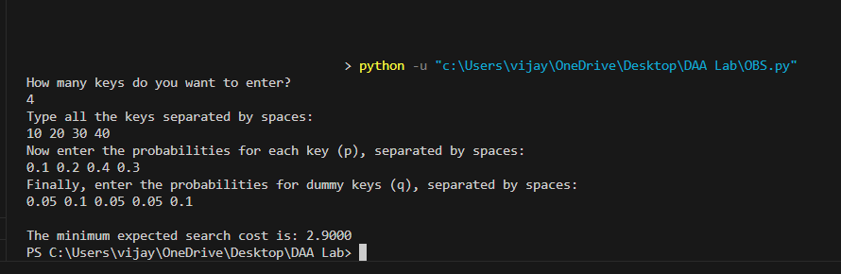

GEEKS FOR GEEKS:-

