Name :- Aayush Patle
A5_B4_54
Practical 7

CODE:-
V = 5
def isSafe(v, graph, path, pos):
if graph[path[pos - 1]][v] == 0:
return False
if v in path:
return False

return True
def hamCycleUtil(graph, path, pos):
if pos == V:
return graph[path[pos - 1]][path[0]] == 1
for v in range(1, V):
if isSafe(v, graph, path, pos):
path[pos] = v
if hamCycleUtil(graph, path, pos + 1):
return True
path[pos] = -1

return False
def hamCycle(graph):
path = [-1] * V
path[0] = 0

if not hamCycleUtil(graph, path, 1):
print("\nNo Hamiltonian Cycle exists for the given city map.")
return False

print("\nHamiltonian Cycle (Night Patrol Route):")
areas = ['T', 'M', 'S', 'H', 'C']
route = [areas[v] for v in path]
route.append(areas[path[0]])
print(" -> ".join(route))
return True

if __name__ == "__main__":

graph = [
[0, 1, 1, 0, 1],
[1, 0, 1, 1, 0],
[1, 1, 0, 1, 1],
[0, 1, 1, 0, 1],
[1, 0, 1, 1, 0]
]

hamCycle(graph)

OUTPUT:-
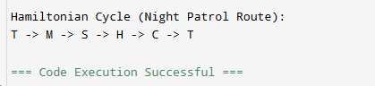

GFG Hamiltonian:-
