Name:- Aayush Patle
A5_B4_54
Practical 8

CODE:-
from typing import List, Set

n = 6
s: Set[List[int]] = set()

def helper(graph: List[List[int]], color: List[int], vertex: int, colours: List[int]):
paint = 1
found = 0
available = colours.copy()
for i in range(n):
if graph[vertex][i] == 1:
if color[i] in available:
available.remove(color[i])

if len(available) > 0:
for j in range(len(available)):
color[vertex] = available[j]
for i in range(n):
if color[i] == -1:
found = 1
helper(graph, color, i, colours)

if found == 0:
s.add(tuple(color))

else:
return

def main():
colours = [1, 2, 3]
graph = [
[0, 1, 1, 0, 1, 1],
[1, 0, 1, 0, 0, 0],
[1, 1, 0, 1, 0, 0],
[0, 0, 1, 0, 1, 0],
[1, 0, 0, 1, 0, 1],
[1, 0, 0, 0, 1, 0]
]

color = [-1] * n
helper(graph, color, 0, colours)

for i in range(n):
print(f"V{i+1}", end=" ")
print()

for v in s:
for x in v:
print(f"C{x}", end=" ")
print()

if len(s) == 0:
print("Not Possible")
else:
print(f"Total Combinations: {len(s)}")

if __name__ == "__main__":
main()

OUTPUT:-
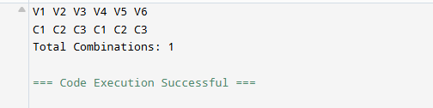

GFG Graph Colouring:-
