Name:- Aayush Patle
Roll no.:- A5_B4-54
Practical 5 DAA
TASK 1:-
X = input("Enter first DNA sequence: ")
Y = input("Enter second DNA sequence: ")

m = len(X)
n = len(Y)

C = [[{'val': 0, 'dir': ''} for j in range(n+1)] for i in range(m+1)]

for i in range(1, m+1):
for j in range(1, n+1):
if X[i-1] == Y[j-1]:
C[i][j]['val'] = C[i-1][j-1]['val'] + 1
C[i][j]['dir'] = 'd'
else:
if C[i-1][j]['val'] >= C[i][j-1]['val']:
C[i][j]['val'] = C[i-1][j]['val']
C[i][j]['dir'] = 'u'
else:
C[i][j]['val'] = C[i][j-1]['val']
C[i][j]['dir'] = 's'

def backtrack(C, X, i, j):
if i == 0 or j == 0:
return ""
if C[i][j]['dir'] == 'd':
return backtrack(C, X, i-1, j-1) + X[i-1]
elif C[i][j]['dir'] == 'u':
return backtrack(C, X, i-1, j)
else:
return backtrack(C, X, i, j-1)

lcs = backtrack(C, X, m, n)

print("\nCost Matrix (values):")
for i in range(m+1):
for j in range(n+1):
print(C[i][j]['val'], end=" ")
print()

print("\nDirection Matrix:")
for i in range(m+1):
for j in range(n+1):
print(C[i][j]['dir'] if C[i][j]['dir'] != '' else '-', end=" ")
print()

print("\nLength of LCS:", C[m][n]['val'])
print("LCS:", lcs)

OUTPUT:-
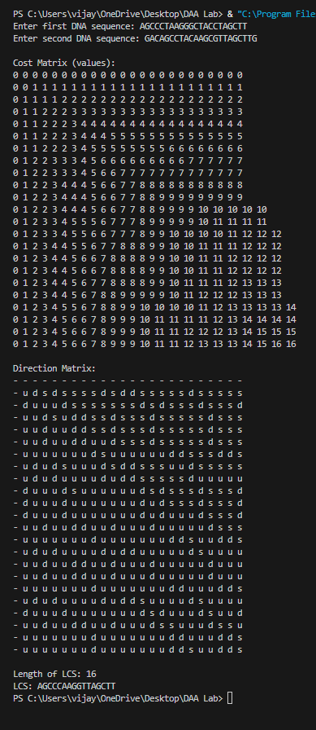
LEETCODE:-
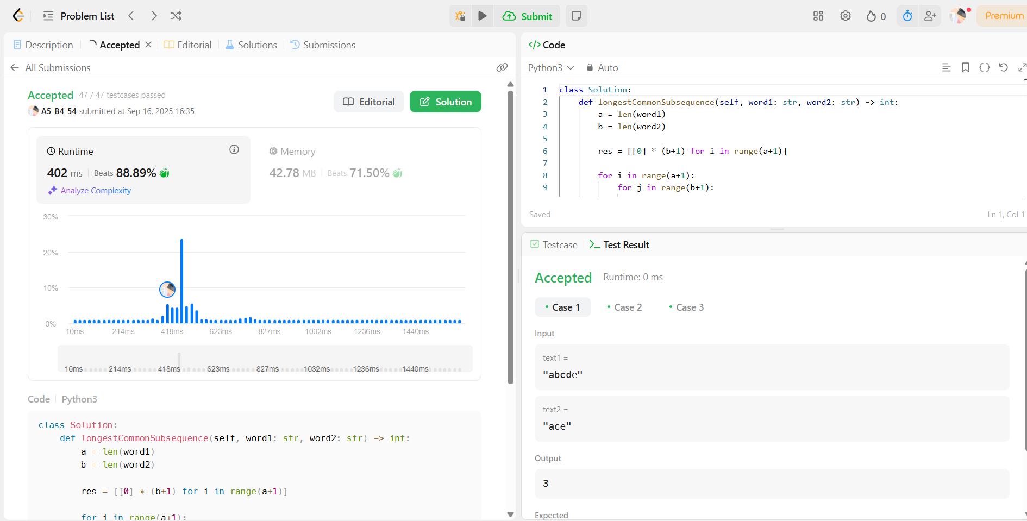

TASK 2:-
Code:-
X = input("Enter first string: ")
Y = input("Enter second string: ")

m = len(X)
n = len(Y)

C = [[{'val': 0, 'dir': ''} for j in range(n+1)] for i in range(m+1)]

for i in range(1, m+1):
for j in range(1, n+1):
# For LRS: extra condition (i != j) if strings are the same
if X[i-1] == Y[j-1] and (X != Y or i != j):
C[i][j]['val'] = C[i-1][j-1]['val'] + 1
C[i][j]['dir'] = 'd'
else:
if C[i-1][j]['val'] >= C[i][j-1]['val']:
C[i][j]['val'] = C[i-1][j]['val']
C[i][j]['dir'] = 'u'
else:
C[i][j]['val'] = C[i][j-1]['val']
C[i][j]['dir'] = 's'

def backtrack(C, X, i, j):
if i == 0 or j == 0:
return ""
if C[i][j]['dir'] == 'd':
return backtrack(C, X, i-1, j-1) + X[i-1]
elif C[i][j]['dir'] == 'u':
return backtrack(C, X, i-1, j)
else:
return backtrack(C, X, i, j-1)

subseq = backtrack(C, X, m, n)

print("\nCost Matrix (values):")
for i in range(m+1):
for j in range(n+1):
print(C[i][j]['val'], end=" ")
print()

print("\nDirection Matrix:")
for i in range(m+1):
for j in range(n+1):
print(C[i][j]['dir'] if C[i][j]['dir'] != '' else '-', end=" ")
print()

if X == Y:
print("\nLength of LRS:", C[m][n]['val'])
print("LRS:", subseq)
else:
print("\nLength of LCS:", C[m][n]['val'])
print("LCS:", subseq)

OUTPUT:-
