FINE TUNING
1.- AUMENTACION:
Para la imagen(archivo adjunto) usa Gemini para generar 50 variantes sintéticas:
-cambios de iluminación
-fondos distintos
-ángulos diferentes
-estadios de crecimiento distintos.
El prompt base sería algo como:
Prompt base (usar en todos):
"Realistic top-down field photograph of Echinochloa colona (junglerice) weed growing in a Peruvian potato field with drip irrigation, natural daylight, high resolution, photorealistic"
Cambios de iluminación (10 variantes):
...early morning soft light, long shadows, golden hour
...harsh midday sunlight, high contrast, strong shadows
...overcast sky, diffuse flat lighting, no shadows
...late afternoon warm light, orange tint
...cloudy day, cool blue-grey tones
...bright sunny day, bleached colors
...dusk lighting, low angle warm light
...after rain, wet soil, glistening leaves
...partial shade from nearby plants
...high altitude Andean sunlight, intense UV, vivid colors
Fondos distintos (15 variantes):
...dry straw mulch background, golden yellow
...moist dark brown soil, recently irrigated
...mixed dry straw and dark soil
...fine sandy soil, light beige
...clay soil, cracked dry surface
...dense dry straw, thick mulch layer
...sparse straw, mostly bare soil visible
...rocky soil with small stones
...soil with other small seedlings emerging
...red clay Andean soil
...black volcanic soil, coastal Peru
...soil with plastic drip irrigation tape visible
...surrounded by dry corn stubble
...mixed crop residue background
...freshly tilled soil, loose texture
Ángulos diferentes (10 variantes)
...viewed from directly above, 90 degrees nadir, drone perspective at 2 meters
...slight angle 75 degrees, partial side view
...45 degree angle side view
...low angle 30 degrees, ground level perspective
...drone view at 5 meters height, plant smaller in frame
...drone view at 10 meters height, multiple plants visible
...slight tilt 80 degrees, asymmetric composition
...viewed from north side, slight angle
...fisheye lens effect, wide angle distortion
...telephoto compression, flat perspective
Estadios de crecimiento (15 variantes)
...very early seedling stage, 2-3 small leaves, 3cm tall
...young plant 4-leaf stage, 8cm tall, no tillering
...juvenile plant beginning to tiller, 15cm
...mid-growth active tillering, 20cm, dense rosette
...mature vegetative stage, 30cm, full rosette
...early reproductive stage, first spikes emerging
...full flowering, multiple mature spikes like the reference image
...post-flowering, spikes turning brown and dry
...stressed plant, yellowing leaves, drought conditions
...healthy lush green plant after irrigation
...plant with insect damage, irregular leaf edges
...multiple plants growing together, dense patch
...single isolated plant, clear background
...plant partially covered by dry straw
...plant growing alongside other weed species

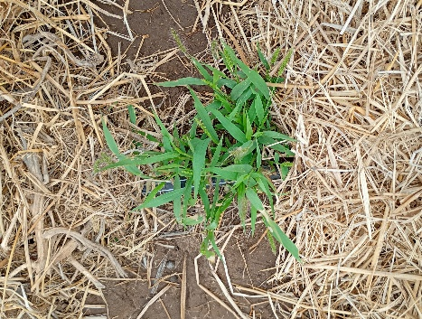

2.-ANOTACION
Usa Roboflow, es la misma herramienta que usó el paper. Crea un proyecto con la clase weed(1=weed), sube las imágenes y anota polígonos. Exporta en formato YOLOv8 segmentation (TXT). El proceso toma aproximadamente 2 horas para 50 imágenes. Se verá aproximadamente(color naranja es maleza).

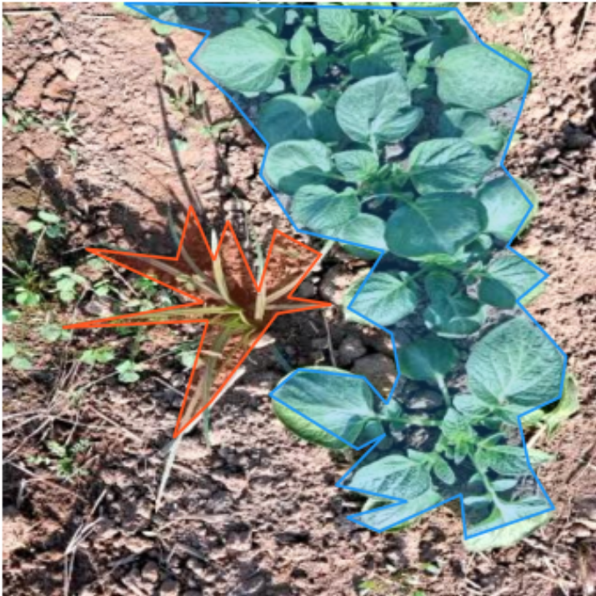

Cada punto del polígono sería de la forma general:
clase x1 y1 x2 y2 x3 y3 ......... xn yn

Para un polígono de 4 vertices:
1 0.512 0.341 0.498 0.367 0.521 0.389 0.543 0.371

