Introduction to Deep Learning
Week 15
Lecture 1
Engr. Hasib Shamshad
What is Deep Learning?
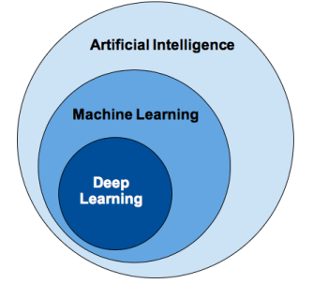
• Deep learning is a subfield of machine learning where concerned algorithms are inspired by the structure and function of the brain called artificial neural networks
• Most of the value today of deep learning is through supervised learning or learning from labelled data and algorithms.
• It uses multiple layers to progressively extract higher-level features from the raw input data
Steps
• Identifies relevant data sets and prepare them for analysis • Chooses the type of algorithm to use
• Train the model on test data sets, revising it as needed. • Runs the model to generate test scores
Difference between Machine Learning and Deep learning
• Amount of data
• Hardware Dependencies
• Feature Engineering
• Execution Time
Applications of Machine Learning and Deep Learning
• Computer vision: facial recognition and attendance mark, Object Detection, Object Tracking
• Medical diagnosis of cancer tumors or anomaly identification of any chronic disease.
Mathematical Foundations
Vector
• An array of numbers, which is either continuous or discrete, is defined as a vector.
• Machine learning algorithms deal with fixed length vectors for better output generation.
Scalar
• Scalar can be defined as one-dimensional vector.
• Scalars are those, which include only magnitude and no direction.
Matrix
• Matrix can be defined as multi-dimensional arrays, which are arranged in the format of rows and columns.
• The size of matrix is defined by row length and column length.
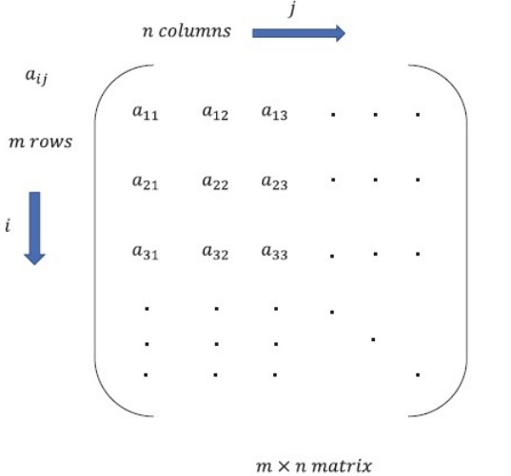
Mathematical Computations
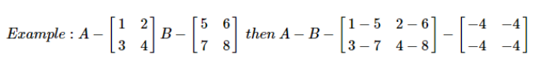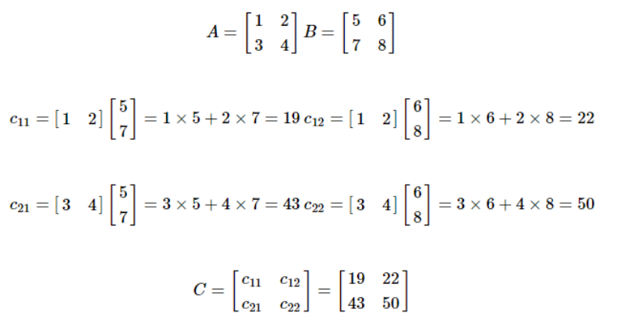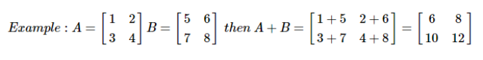
Tensor Data Structure
• Tensors are used as the basic data structures in TensorFlow language.
• Tensors represent the connecting edges in any flow diagram called the Data Flow Graph. Tensors are defined as multidimensional array or list.
• Tensors are identified by the following three parameters: • Rank
• Shape
• Type
Rank
• It identifies the number of dimensions of the tensor.
• A rank of a tensor can be described as the order or n dimensions of a tensor defined.
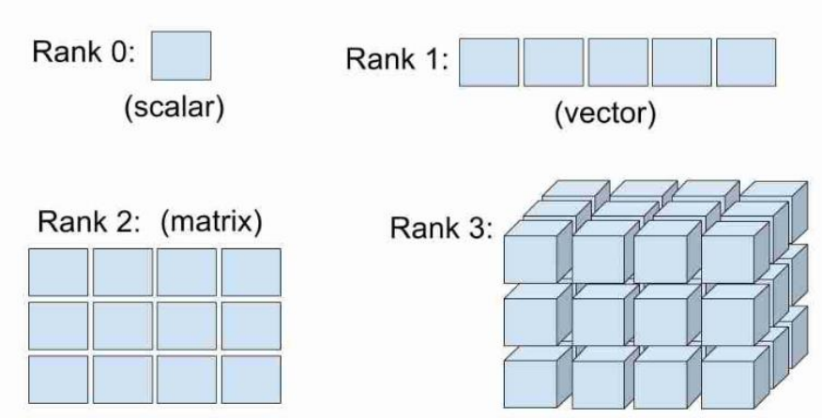
Tensors
• When we have more than two indices to refer to a specific element in a data structures (or mathematical, structure) we stop treating them with special names like scalars, vectors, matrices etc.
• Instead we address them with a more generalized language. • We call them Tensors.
Reshaping the Tensors
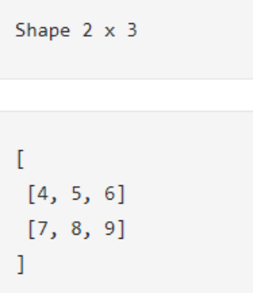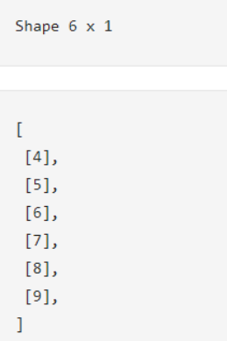
Epochs
• In Deep Learning, an epoch is a hyperparameter which is defined before training a model.
• One epoch is when an entire dataset is passed through the neural network only once.
• Batch Size = Number of training samples in 1 pass. (With increase in Batch size, required memory space increases.)
• Example : If we have 1000 training samples and Batch size is set to 500, it will take 2 iterations to complete 1 Epoch.
Neural Networks
• AnArtificialNeuralNetwork (ANN) is an information processing paradigm that isinspired by biological nervoussystems.
• It is composed of a large number of highly interconnected processing elements called neurons.
• AnANNis configured for aspecific application,such aspattern recognition or data classification
Why use neuralnetworks
• ability to derive meaning from complicated or imprecise data
• extract patterns and detect trends that are too complex to be noticed by either humans or other computer techniques
• Adaptive learning
• Real TimeOperation
Neural Networks v/sConventional Computers
• Conventional computers use an algorithmic approach, but neural networks workssimilarto human brain and learns byexample
Inspiration fromNeurobiology
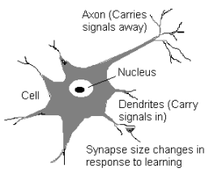
• A neuron: many-inputs /one- output unit
• output canbe excitedor not excited
• incoming signals fromother neurons
determine if the neuron shall excite("fire")
• Output subject toattenuation in the synapses,
which are junction parts of the neuron
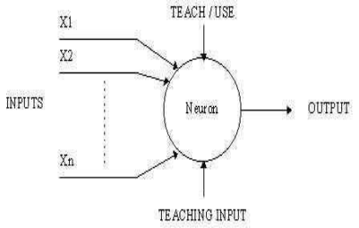
A simpleneuron • Takes the Inputs .
• Calculate the
summation of the
Inputs .
• Compare it with the
threshold being set
during the learning
stage.
Artificial Neural Network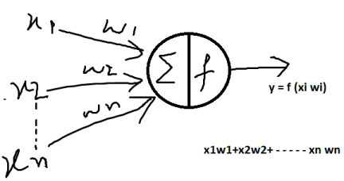
Artificial Neural Network


