UNIVERSITY OF ENGINEERING AND TECHNOLOGY, PESHAWAR
LAB REPORT
Application of Mask R-CNN for
Car Damage Detection and Instance Segmentation

Artificial Neural Networks & Deep Learning Lab
Fall 2026 | 5th Semester
Submitted by
Muhammad Arsalan
Registration No: 24PWAI0015 | Section: AI
Submitted to
Lecturer Hasib Shamshad
“On my honor, as a student of the University of Engineering and Technology, I have neither given nor received unauthorized assistance on this academic work.”
Student Signature: ____________________
Bachelor of Science in Artificial Intelligence

1. Introduction
Automated damage assessment supports insurance claims, used-vehicle inspection and repair estimation. Image classification labels a whole photo and bounding-box detectors (Faster R-CNN, YOLO) only localise damage coarsely, yet repair cost depends on the exact shape and area of the damage. Instance segmentation provides that pixel-accurate boundary.
This lab applies Mask R-CNN with a ResNet-101 + FPN backbone, fine-tuned from MS COCO weights on 68 annotated car-damage photographs, to segment scratches and quantify their area from the predicted polygons.
2. Mask R-CNN Architecture
Mask R-CNN (He et al., ICCV 2017) extends the two-stage Faster R-CNN detector with a third, parallel branch that predicts a segmentation mask for every detected region.
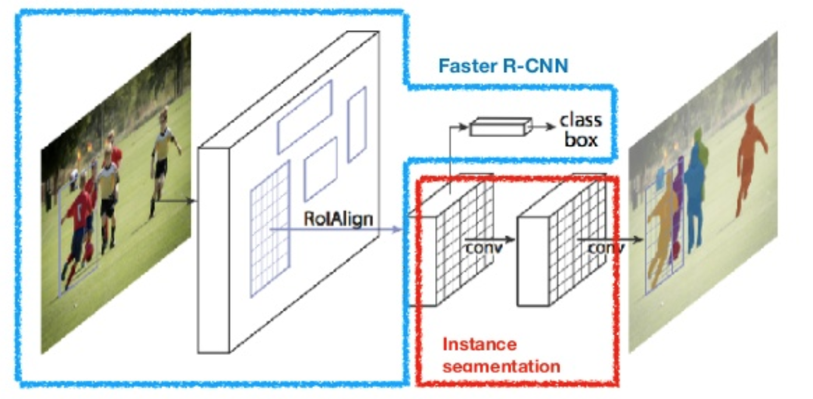
Figure 1. Mask R-CNN pipeline: Faster R-CNN with a parallel fully convolutional mask branch.
3. Dataset and Annotation
The photographs cover different car models, colours, lighting conditions, viewpoints and damage severity. Each damaged area was outlined as a polygon with the VGG Image Annotator and exported to via_region_data.json.
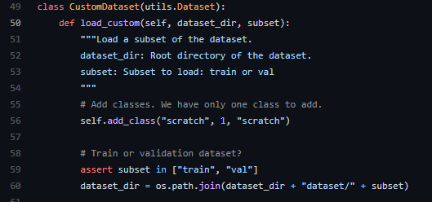
Figure 3. Dataset loader (load_custom in custom.py).
4. Transfer Learning and Training
Training a 101-layer network from scratch on 68 images would overfit, so the model is initialised from MS COCO weights (mask_rcnn_coco.h5). The class-specific output layers are re-initialised for two classes (background and scratch), and training uses layers='heads' for 15 epochs with SGD while the ResNet-101 backbone stays frozen.
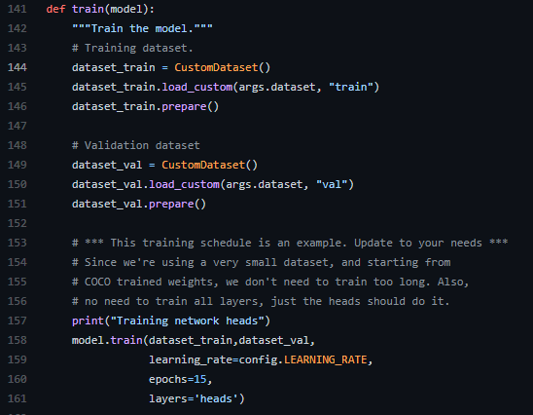
Figure 4. Training routine (train in custom.py).
5. Weight Diagnostics
Weights and biases of the trainable Conv2D, Dense and Conv2DTranspose layers were inspected to check numerical stability. Kernels follow a smooth distribution centred near zero (conv1 kernel: mean ≈ 0.00, std ≈ 0.13, range −0.86 to +0.84) and biases start at zero, so there is no sign of exploding or vanishing weights.
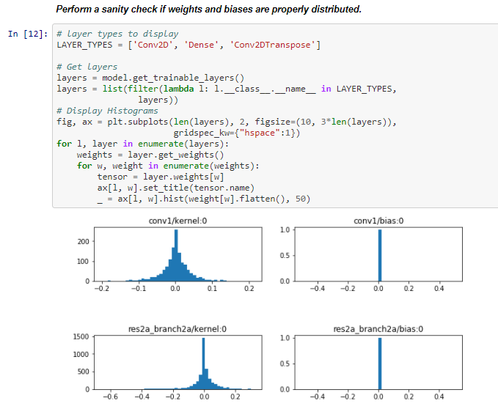
Figure 5. Histograms of weight and bias values for selected layers.
6. Results
Inference ran with batch size 1 and a detection threshold of 0.90. On validation image image79.jpg the scratch was localised with confidence above 92%. On the unseen image test2.jpg the model contoured the bumper scrape without false positives on the road, headlight or grille.
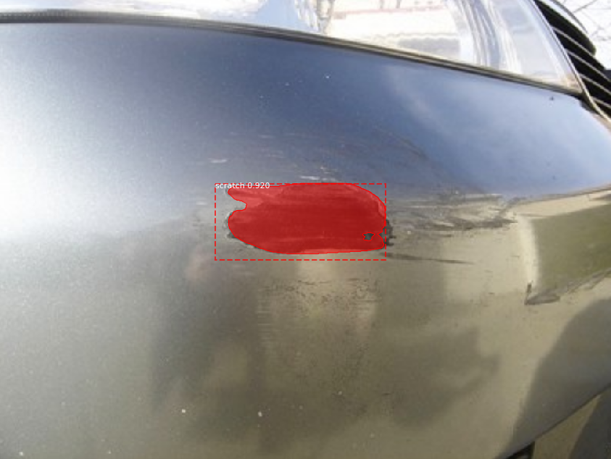
Figure 6. Predicted scratch masks and bounding boxes on test vehicle.
7. Discussion
Glare and reflections on metallic paint can mimic scratches at low thresholds, and dirt or water droplets resemble paint scrapes. Future directions include multi-class damage taxonomy (scratch, dent, panel tear) and monocular depth estimation.
8. Conclusion
A Mask R-CNN model with a ResNet-101 + FPN backbone, fine-tuned from MS COCO weights on 68 annotated images, produced pixel-level damage masks on both validation and unseen test images. Weight diagnostics showed stable parameters, and polygon areas can be computed with the Shoelace formula to quantify damage.

