WEEK 2 INTERNSHIP REPORT
Exploratory Data Analysis and Visualization of Logistics Data
Virtual Logistics Data Analysis Intern
Prepared by | Ramidi Bhaavani
College | Geetanjali College of Engineering and Technology

1. Introduction
Exploratory Data Analysis (EDA) is the process of examining a dataset using summaries and visualizations to understand its structure, patterns, relationships and possible quality issues before making decisions. In logistics, EDA can help teams understand delivery time, route performance, shipping cost, shipment volume and operational delays. This report uses a simulated dataset of 300 shipments because no real dataset was supplied. All numeric results and charts in this report describe the simulated data only and must not be treated as actual company performance.

2. Objectives
- Generate a plausible sample logistics dataset with route, distance, weather, volume, transit time and shipping cost fields.
- Clean missing values and prepare consistent numerical and categorical variables.
- Calculate summary statistics and compare performance across routes and weather conditions.
- Create and interpret multiple visualizations to identify patterns, relationships and potential outliers.
- Derive practical recommendations for logistics planning and further data collection.

3. Dataset Simulation and Description
A reproducible synthetic dataset of 300 shipments was generated using NumPy's random number generator with a fixed seed. Each row represents one shipment. The fields include shipment ID, route, distance in kilometres, weather condition, weekend dispatch indicator, shipment volume, transit time in days and shipping cost in Indian rupees. Route distances were set to representative values of 180, 420, 760 and 1,050 km. Transit time and cost were simulated using route distance, weather, weekend dispatch, volume and random variation. A small number of missing values and unusually long transit times were intentionally introduced to demonstrate cleaning and outlier checks.
Field | Type | Description
shipment_id | Text | Unique simulated shipment identifier
route | Category | Route A, B, C or D
distance_km | Numeric | Approximate route distance in kilometres
weather_condition | Category | Normal, Rain, Severe or missing
weekend_dispatch | Category | Whether dispatch occurred on a weekend
shipment_volume | Integer | Simulated volume units for a shipment
transit_days | Numeric | Elapsed transit time in days
shipping_cost_inr | Numeric | Simulated shipping cost in Indian rupees

4. Tools and Libraries
- pandas: creates and manipulates tabular data, handles missing values, groups records and calculates statistics.
- NumPy: generates reproducible simulated values and supports numerical operations.
- Matplotlib: creates histograms, box plots, scatter plots, bar charts and a correlation heatmap.
- Seaborn or Plotly could also be used for statistical or interactive visuals, but Matplotlib is sufficient for this report.

5. Data Cleaning and Preparation
The raw simulated dataset was saved separately before cleaning. The cleaning process converted numerical columns to numeric types, replaced missing weather labels with 'Unknown', and filled missing transit times and shipping costs using the median within the corresponding route. Route-level median imputation helps retain records while reducing sensitivity to extreme values; however, imputed values can affect distributions and should be marked in a production workflow. Interquartile-range (IQR) checks were used to flag potential outliers. Outliers were flagged rather than automatically deleted because extreme delays can be operationally important. A cost-per-kilometre feature and a flag for transit times above three days were also created.

6. Python Code: Dataset Simulation
import numpy as np
import pandas as pd
rng = np.random.default_rng(42)
n = 300
routes = rng.choice(
["Route A", "Route B", "Route C", "Route D"],
size=n, p=[0.30, 0.25, 0.25, 0.20]
)
distance_map = {"Route A": 180, "Route B": 420,
"Route C": 760, "Route D": 1050}
base_days = {"Route A": 1.3, "Route B": 2.4,
"Route C": 3.8, "Route D": 5.0}
distance = np.array([distance_map[r] for r in routes])
transit = np.array([base_days[r] for r in routes]) + distance/900
weather = rng.choice(["Normal", "Rain", "Severe"], n,
p=[0.72, 0.23, 0.05])
weekend = rng.choice(["No", "Yes"], n, p=[0.72, 0.28])
volume = rng.integers(1, 31, n)
transit += np.where(weather == "Rain", 0.7,
np.where(weather == "Severe", 1.8, 0))
transit += np.where(weekend == "Yes", 0.35, 0)
transit += rng.normal(0, 0.55, n)
transit = np.maximum(transit, 0.25)
df = pd.DataFrame({
"shipment_id": [f"SHP{i:04d}" for i in range(1, n+1)],
"route": routes,
"distance_km": distance,
"weather_condition": weather,
"weekend_dispatch": weekend,
"shipment_volume": volume,
"transit_days": np.round(transit, 2)
})

7. Python Code: Cleaning and Summary Statistics
# Keep a separate copy for cleaning
clean = df.copy()
clean["weather_condition"] = clean["weather_condition"].fillna("Unknown")
clean["transit_days"] = pd.to_numeric(
clean["transit_days"], errors="coerce"
)
clean["transit_days"] = clean.groupby("route")["transit_days"].transform(
lambda s: s.fillna(s.median())
)
# IQR-based potential outlier flag
q1 = clean["transit_days"].quantile(0.25)
q3 = clean["transit_days"].quantile(0.75)
iqr = q3 - q1
clean["transit_outlier"] = (
(clean["transit_days"] < q1 - 1.5 * iqr) |
(clean["transit_days"] > q3 + 1.5 * iqr)
)
print(clean[["distance_km", "shipment_volume",
"transit_days"]].describe())
print(clean.groupby("route")["transit_days"].agg(
["count", "mean", "median", "min", "max"]
))

8. Exploratory Data Analysis and Summary Statistics
The describe() method summarizes numeric fields through count, mean, standard deviation, minimum, quartiles and maximum. GroupBy summaries compare typical transit time and shipping cost between routes. The simulated dataset is intentionally designed so that longer routes tend to have longer transit times and higher total costs. The figures below illustrate how these patterns can be examined. Exact values should be interpreted as outputs of the simulation rather than evidence about real-world routes.
Route | Shipments | Mean transit (days) | Median transit (days) | Mean cost (₹) | Mean volume
Route A | 97 | 1.67 | 1.60 | 754.64 | 14.16
Route B | 67 | 3.50 | 3.22 | 1130.38 | 14.88
Route C | 79 | 5.54 | 4.98 | 1641.62 | 15.37
Route D | 57 | 6.49 | 6.43 | 2084.90 | 16.91

9. Visualizations and Interpretation

9.1 Histogram: Distribution of Transit Times
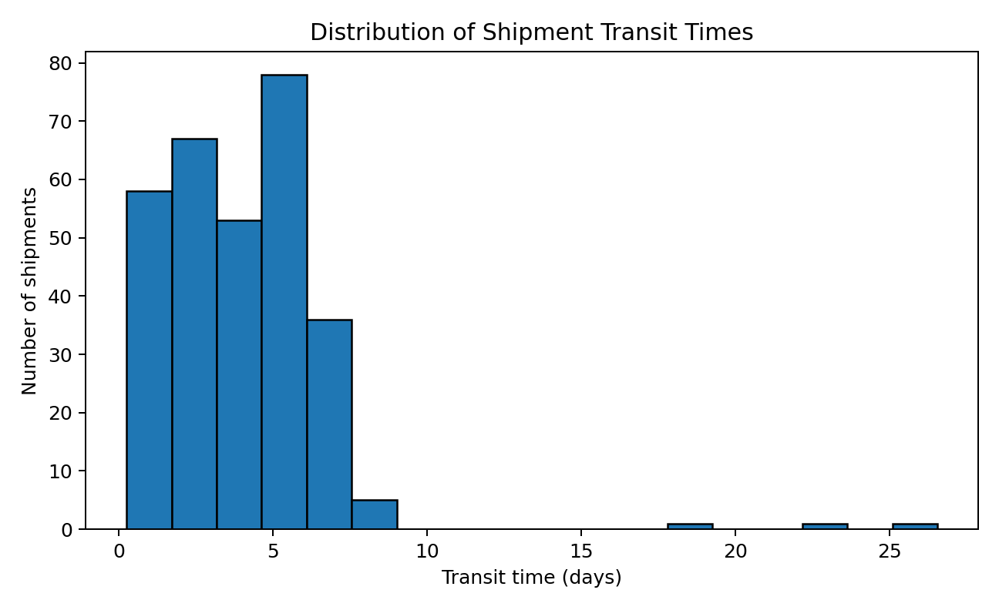
Interpretation: The histogram shows how frequently different transit-time ranges occur. Multiple peaks may appear because the simulated routes have different distances and typical travel durations. The right tail can reveal shipments with unusually long transit times. Operational use: establish expected delivery windows by route rather than applying one universal target.

9.2 Box Plot: Transit Time by Route
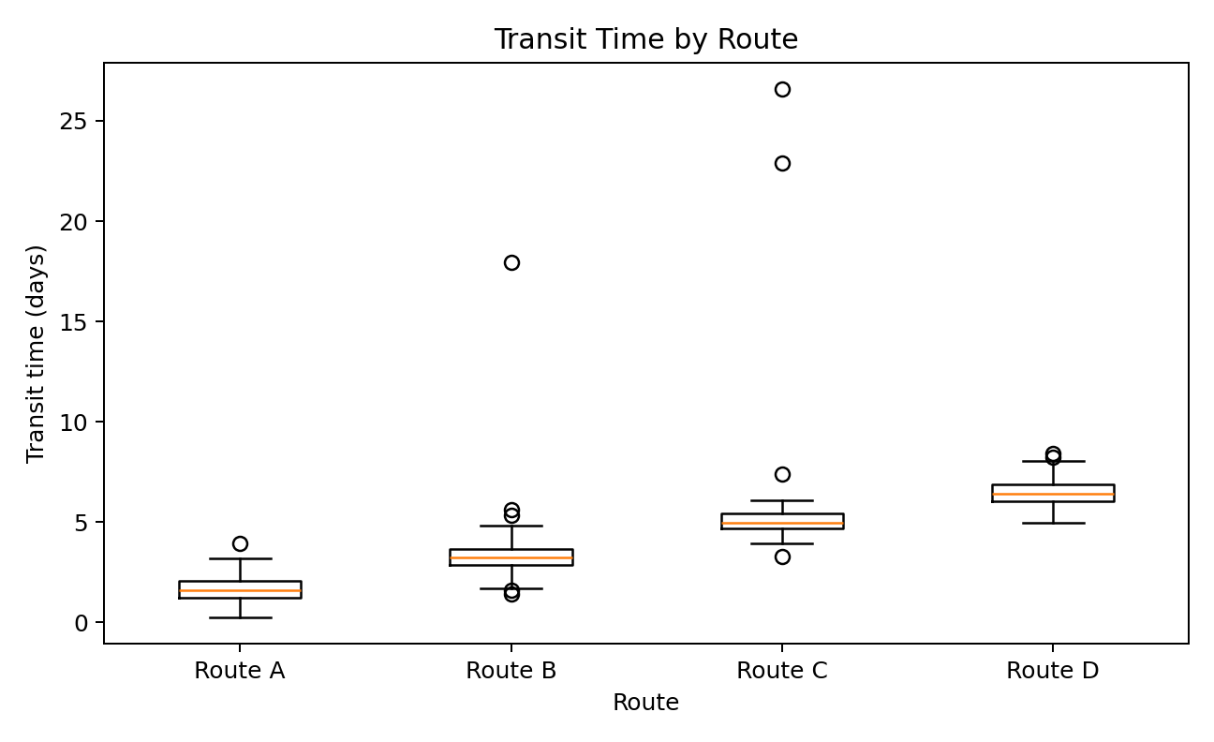
Interpretation: The box plot compares route medians, the middle 50% of observations and potential outliers. Longer routes are expected to have higher median transit times in this simulation. Points beyond whiskers indicate observations worth investigating, not necessarily erroneous data. Operational use: set route-specific service-level targets and investigate routes with unusually wide variation.

9.3 Scatter Plot: Distance vs Transit Time by Weather
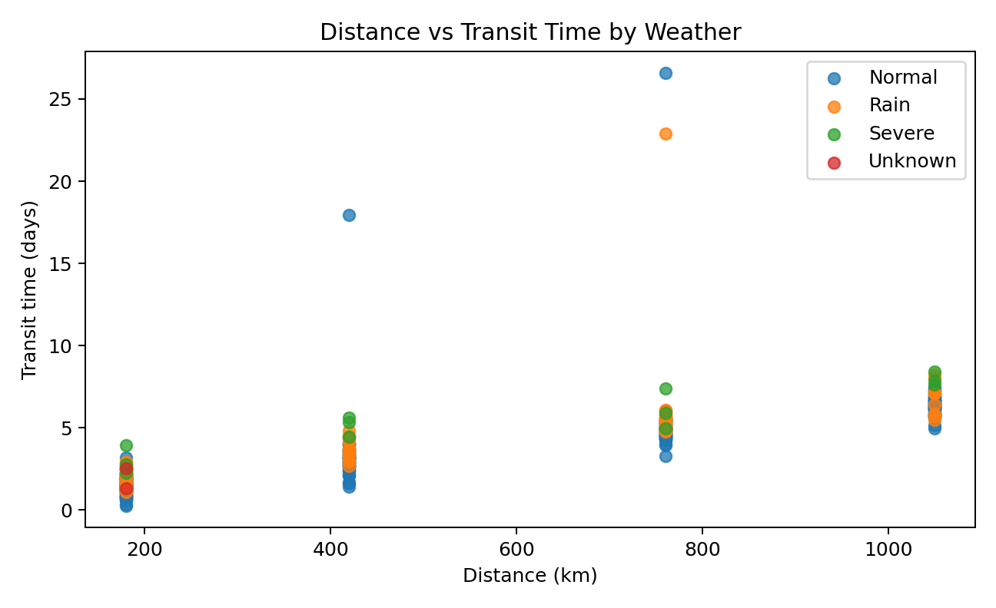
Interpretation: Each point represents a shipment. The overall pattern should generally rise with distance, while weather categories may show additional spread or longer transit times. A small number of severe-weather records means conclusions about severe weather are uncertain. Operational use: use distance as a planning baseline and incorporate weather alerts as a possible risk factor.

9.4 Bar Chart: Average Shipping Cost by Route
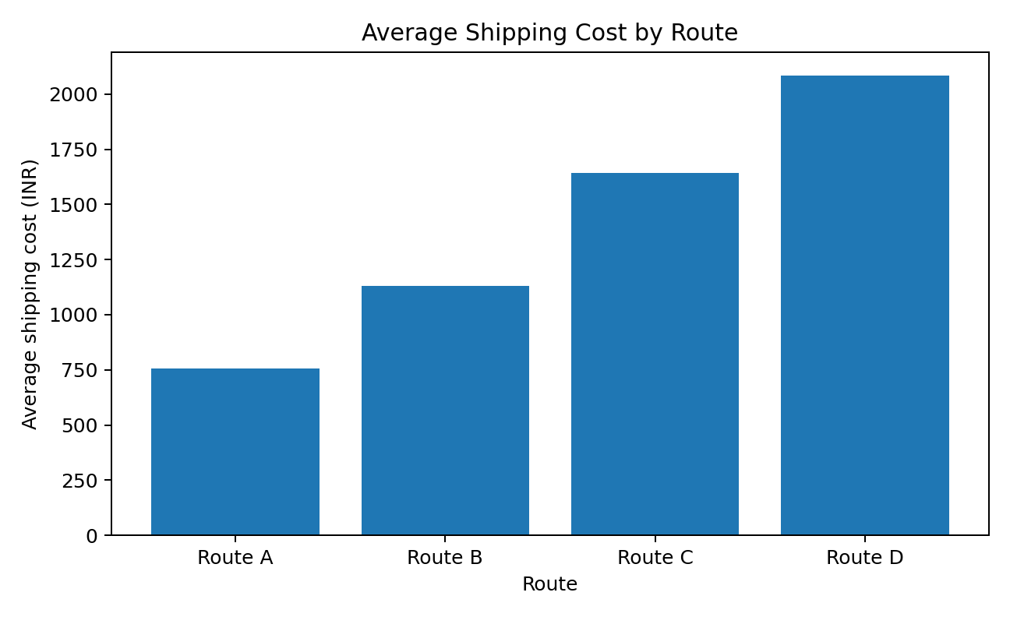
Interpretation: The bar chart compares average total shipping cost across routes. In the simulated data, longer distances generally have higher costs. Total cost alone does not establish which route is most efficient because route lengths differ; compare cost per kilometre and shipment characteristics as well.

9.5 Correlation Heatmap
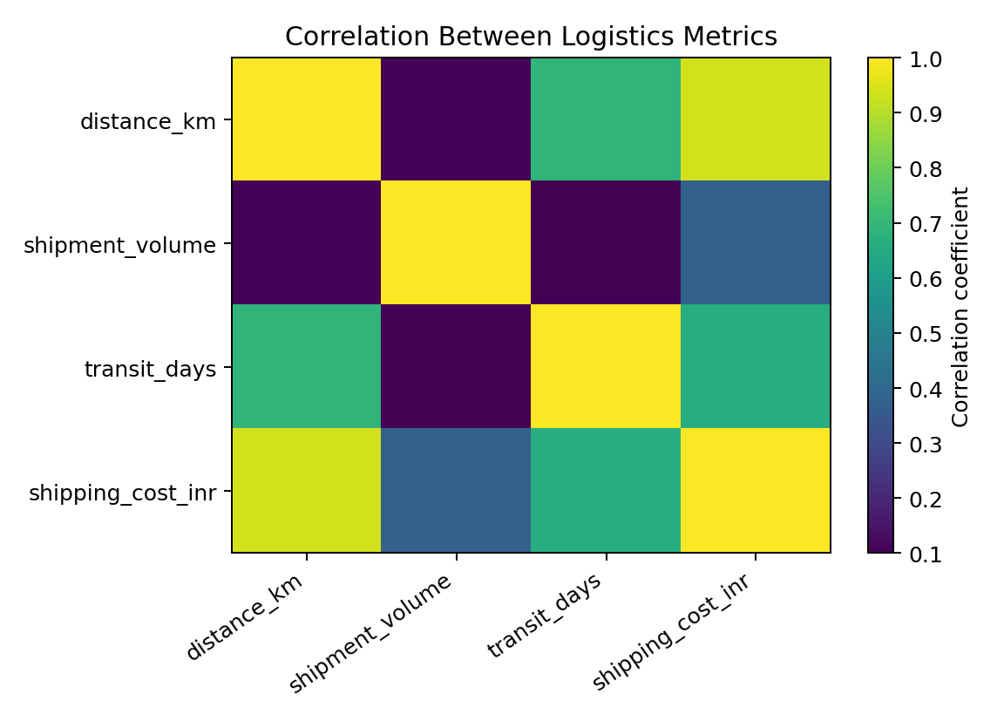
Interpretation: The heatmap displays pairwise linear correlations between numerical variables. A positive relationship between distance and transit time or total cost is expected because those effects are built into the simulation. Correlation does not prove causation, and route, weather and volume can influence relationships. Use this chart as an initial screening tool, not as proof of a causal effect.

10. Outliers and Anomaly Review
The IQR rule marks observations below Q1 − 1.5 × IQR or above Q3 + 1.5 × IQR. It is a general screening technique, not a definitive error detector. An unusual transit time may reflect a genuine disruption, data-entry error or an unmodeled factor. The appropriate next step is to inspect the record, compare it with source evidence and document the decision. For real operations, useful checks include impossible negative durations, missing identifiers, duplicate shipment IDs, and delivery dates earlier than dispatch dates.

11. Key Insights from the Simulated EDA
- Route length is an important planning variable: the simulation assigns longer typical transit times to longer routes.
- Longer routes also tend to incur higher total shipping costs; total cost should be evaluated alongside cost per kilometre and shipment volume.
- Weather and weekend dispatch were designed to add variation to transit time, illustrating why contextual fields can improve analysis.
- The histogram and box plot help reveal the typical range and possible delays, while the scatter plot helps inspect the distance-time relationship.
- Outliers and missing values should be reviewed transparently because automatically deleting them could hide meaningful operational problems.

12. Actionable Recommendations
- Create route-specific delivery-time baselines and service-level targets.
- Monitor late deliveries and transit-time variability by route, weather condition and dispatch day.
- Track both total shipping cost and cost per kilometre; compare like-for-like shipments before changing routes or carriers.
- Create a recurring dashboard with shipment counts, median transit time, on-time delivery rate, average cost and outlier count.
- Collect real data over a sufficient period before making operational policy changes; validate findings against actual dispatch and delivery records.
- Record imputation decisions and preserve an exceptions table so analysts can audit unusual or incomplete records.

13. Limitations
This report uses synthetic data generated for learning. It does not represent an actual logistics company, carrier or transport network. Relationships between distance, weather, weekend dispatch and cost were partly built into the simulation, so the observed patterns are not independent discoveries about real operations. The report does not establish causal effects, and no route change should be made based on these synthetic results alone. Real analysis should use verified source data, clear field definitions and validation with operations teams.

14. Conclusion
This task demonstrates a complete introductory EDA workflow: simulate a plausible dataset, preserve the raw data, clean missing and inconsistent values, calculate descriptive statistics, visualize distributions and relationships, investigate outliers, and convert observations into practical recommendations. Pandas, NumPy and Matplotlib provide a flexible foundation for these steps. The most important outcome is not a chart by itself, but a transparent process that allows analysts to explain what the data shows, what remains uncertain and what further evidence is needed before acting.

15. References
- Pandas documentation: https://pandas.pydata.org/docs/
- NumPy documentation: https://numpy.org/doc/
- Matplotlib documentation: https://matplotlib.org/stable/
- Seaborn documentation: https://seaborn.pydata.org/
- Plotly Python documentation: https://plotly.com/python/
All charts and statistics in this report are based on the simulated dataset generated for this assignment.

