Globalization of Robotic Surgery Clinical Trials: A 25-Year Bibliometric Analysis
Rahul Gorijavolu BS¹; Kaushik Madapati¹; Ife Shoyombo MD MS MPH¹; Leo A. Celi MD MS MPH; Joseph V. Sakran MD MPH MPA¹
Corresponding Author: [Contact information to be added]
Word Count: [To be calculated]
Number of Figures: 6
Number of Tables: 1
Keywords: Robotic surgery, clinical trials, global health equity, bibliometric analysis, health disparities, international collaboration

ABSTRACT
Background: Robotic surgery has evolved substantially since the widespread adoption of the da Vinci surgical system around 2000. While technological innovations continue to emerge globally, including new platforms such as Hugo and Versius and applications such as telesurgery, the geographic distribution of robotic surgery clinical research remains poorly characterized.
Objective: To examine the globalization of robotic surgery clinical trials over 25 years and identify geographic disparities in trial participation across countries of different income levels.
Methods: We conducted a bibliometric analysis of 2,244 robotic surgery clinical trials indexed in PubMed from January 2001 to August 2025. Studies were identified using robotic surgery search terms, filtering for publications explicitly mentioning clinical trials. Countries were extracted from author affiliations and mapped to World Bank income classifications. We analyzed temporal trends in trial growth, geographic concentration using the Herfindahl-Hirschman Index, international collaboration patterns, and regional distribution.
Results: The number of robotic surgery clinical trials increased substantially over the study period, with geographic concentration decreasing over time. However, significant disparities persisted: 84.5% of trials were conducted in high-income countries (HICs), 13.5% in upper-middle-income countries, 2.0% in lower-middle-income countries, and 0% in low-income countries. This distribution differed markedly from world population distribution (χ² = 9825, p < 0.001). Of 363 collaborative trials, only 21% involved HIC-LMIC partnerships, with no LMIC-LMIC collaborations observed. China emerged as the leading contributor among LMICs in recent years, accounting for over half of all LMIC collaboration partners. Geographic analysis revealed high trial activity in North America, Europe, and Eastern Asia, but minimal participation from Latin America and Africa.
Conclusions: Despite increased globalization of robotic surgery trials over 25 years, substantial barriers persist for trial conduct in Latin America and Africa. The concentration of trials in HICs limits generalizability of findings to global populations and may exclude diseases and patient outcomes most relevant to LMICs. Future efforts should prioritize equitable capacity building for both research infrastructure and clinical care delivery.

INTRODUCTION
The landscape of surgical innovation has been fundamentally transformed by robotic-assisted surgical systems. Following the FDA clearance and widespread deployment of the da Vinci surgical system in 2000, robotic surgery has become established across multiple surgical specialties, offering potential benefits including enhanced precision, improved visualization, and minimally invasive approaches.¹⁻³
The robotic surgery market has evolved considerably beyond the initial da Vinci monopoly. New competitors have emerged, including the Hugo system from Medtronic (CE marked in Europe in 2021, FDA cleared in the US in 2024) and the Versius system from CMR Surgical (CE marked in 2019, FDA cleared in 2024), potentially expanding institutional options and democratizing access.^{4,5} Concurrently, innovative applications are developing in Eastern Asia and India, where platforms such as SSI Mantra demonstrate potential for telesurgery and remote surgical interventions, with regulatory approval from India's Central Drugs Standard Control Organization for telesurgery capabilities.^{6,7}
Despite these technological advances, fundamental questions remain regarding the global distribution of research and innovation in robotic surgery. Clinical trials represent the primary mechanism through which new surgical techniques and technologies are validated and translated into practice. The geographic distribution of these trials has profound implications for health equity, as trial participation influences both access to cutting-edge treatments and the generalizability of research findings to diverse patient populations.^{8,9}
Historically, clinical research has been concentrated in high-income countries (HICs), raising concerns about the applicability of findings to low- and middle-income countries (LMICs) where disease burdens, patient characteristics, healthcare infrastructure, and resource constraints may differ substantially.¹⁰⁻¹² In oncology, for example, approximately 90% of clinical trials and more than 80% of participants are from HICs, despite LMICs bearing almost 80% of the global cancer burden.¹³ Similar disparities have been documented across multiple medical fields, but the specific patterns within robotic surgery remain poorly characterized.
Understanding the globalization of robotic surgery clinical trials is essential for several reasons. First, it provides insight into whether research findings can be generalized to populations worldwide or remain applicable primarily to HICs. Second, it reveals whether the global surgical community has equitable opportunities to contribute to and benefit from technological innovation. Third, it identifies geographic regions that may benefit from targeted capacity building initiatives. Finally, it highlights potential disparities in access to emerging surgical technologies.
This study examines the globalization of robotic surgery clinical trials over a 25-year period from 2001 to 2025, analyzing trends in geographic distribution, international collaboration, and equity in research participation across countries of different income levels.

METHODS

Data Source and Search Strategy
We conducted a comprehensive bibliometric analysis of robotic surgery clinical trials indexed in PubMed from January 2001 to August 8, 2025. The starting date corresponded to the period following initial widespread deployment of robotic surgical systems. We used search terms focused on robotic surgical procedures to identify relevant publications. To ensure inclusion of genuine clinical trials, we retained only publications where the Publication Type field explicitly included "Randomized Controlled Trial" or "Clinical Trial."

Data Extraction and Geographic Classification
Country attribution was determined from author affiliations when available in the PubMed records. We acknowledge this approach has limitations, as authorship may not perfectly reflect where research was conducted, but it represents the best available proxy in bibliometric data. Each country identified from author affiliations was mapped to World Bank income classifications (high-income, upper-middle-income, lower-middle-income, and low-income) using World Bank historical data corresponding to the publication year. For trials with authors from multiple countries, we recorded all participating countries to enable analysis of international collaboration patterns.

Outcome Measures
We analyzed several key outcomes:
1. Temporal trends in trial volume: We calculated the annual number of published robotic surgery clinical trials to assess growth patterns over the 25-year period.
2. Geographic concentration: We computed the Herfindahl-Hirschman Index (HHI) annually to quantify geographic concentration of trials. The HHI, traditionally used to measure market concentration in economics, was adapted to assess the distribution of clinical trials across countries. It is calculated as the sum of squared market shares (or in this case, trial shares) for each country, with values ranging from 0 (perfect distribution across infinite countries) to 10,000 (complete concentration in one country). HHI values below 1,500 indicate low concentration, 1,500 to 2,500 indicate moderate concentration, and above 2,500 indicate high concentration.
3. International collaboration: We identified trials with authors from multiple countries and calculated the proportion of trials involving international collaboration over time.
4. Income group distribution: We categorized trials by the income classification of participating countries and analyzed shifts in this distribution over time.
5. Collaborative partnerships: For trials involving international collaboration, we characterized partnership types (HIC-HIC, HIC-LMIC, LMIC-LMIC) and identified leading collaborative partners.
6. Regional participation: We created geographic visualizations to illustrate the global distribution of trial participation.

Statistical Analysis
Chi-square tests were performed to compare the observed distribution of trials across income groups with the expected distribution based on world population proportions. A p-value < 0.05 was considered statistically significant. Descriptive statistics were used to summarize temporal trends and collaborative patterns. All analyses were conducted using Python 3.x with standard data science libraries.

Data and Code Availability
All code used for data extraction, analysis, and visualization will be made publicly available upon publication to ensure reproducibility and enable future research.

Ethical Considerations
As this study involved analysis of publicly available bibliometric data without human subjects participation, institutional review board approval was not required.

RESULTS

Overall Growth in Robotic Surgery Clinical Trials
We identified 2,244 robotic surgery clinical trials published between January 2001 and August 2025. The number of trials increased substantially over this period, demonstrating growing global engagement with robotic surgery research (Figure 1). Early years showed modest activity, with rapid acceleration beginning in the mid-2010s.
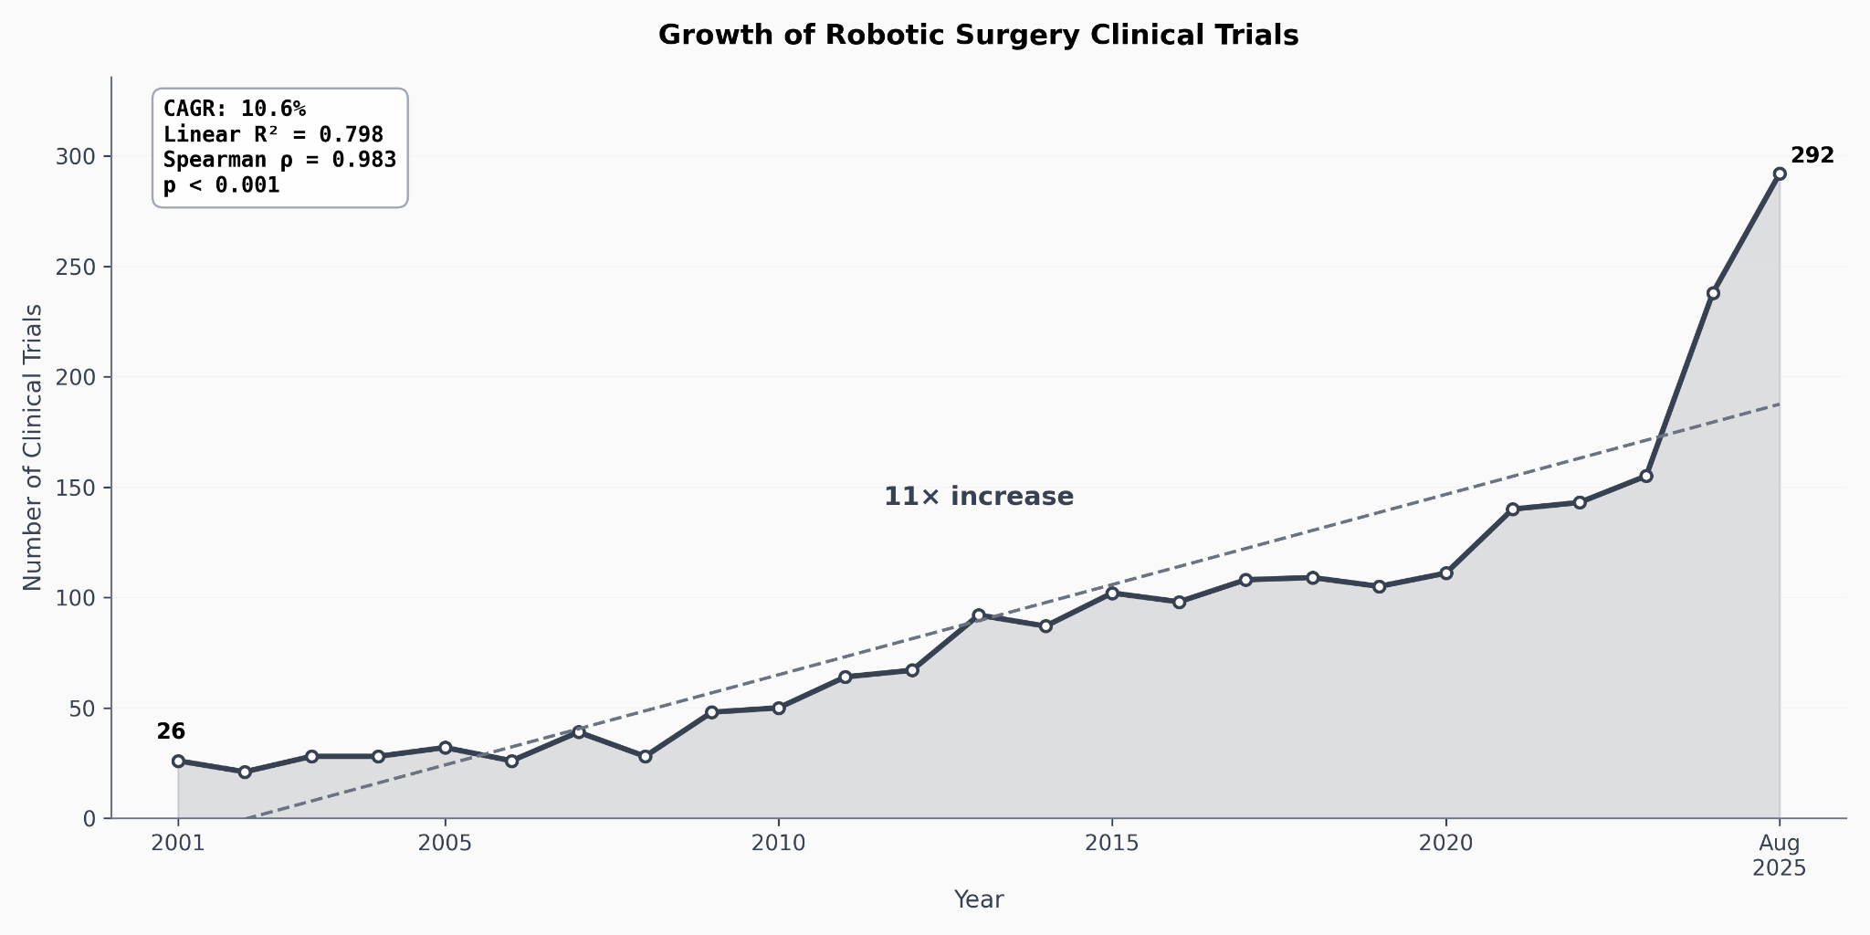

Geographic Concentration Trends
Analysis using the Herfindahl-Hirschman Index revealed a declining trend in geographic concentration over the 25-year period (Figure 2). While early years showed high concentration of trials in a small number of countries, the HHI decreased progressively, indicating broader geographic participation over time. However, concentration remained above levels that would indicate truly equitable global distribution.

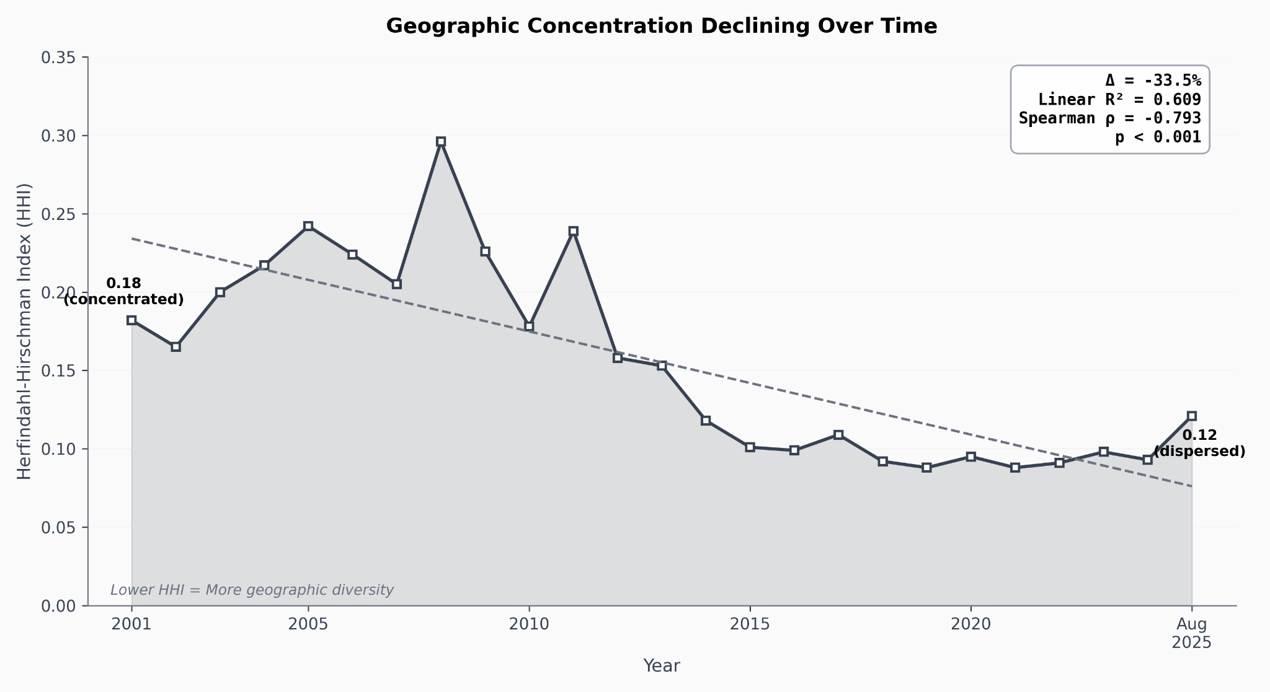

International Collaboration
International collaboration in robotic surgery trials increased progressively over the study period (Figure 3). The proportion of trials involving authors from multiple countries rose from minimal levels in the early 2000s to substantial international engagement in recent years, reflecting growing cross-border research partnerships.
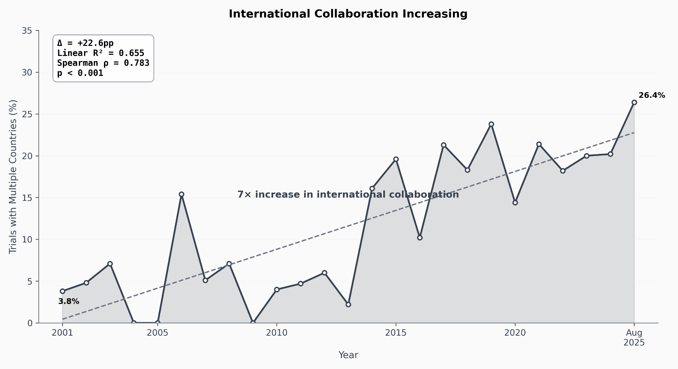

Global Distribution of Trials
Geographic mapping of all 2,244 trials over the 25-year period revealed marked regional disparities (Figure 4). North America and Europe demonstrated the highest levels of participation, with substantial activity also evident in Eastern Asia. In contrast, Latin America showed minimal engagement, and Africa had virtually no participation in robotic surgery clinical trials. The visualization distinguishes between HICs and LMICs, with marker size corresponding to the number of trials per country, illustrating the concentration of research activity in specific high-income nations.
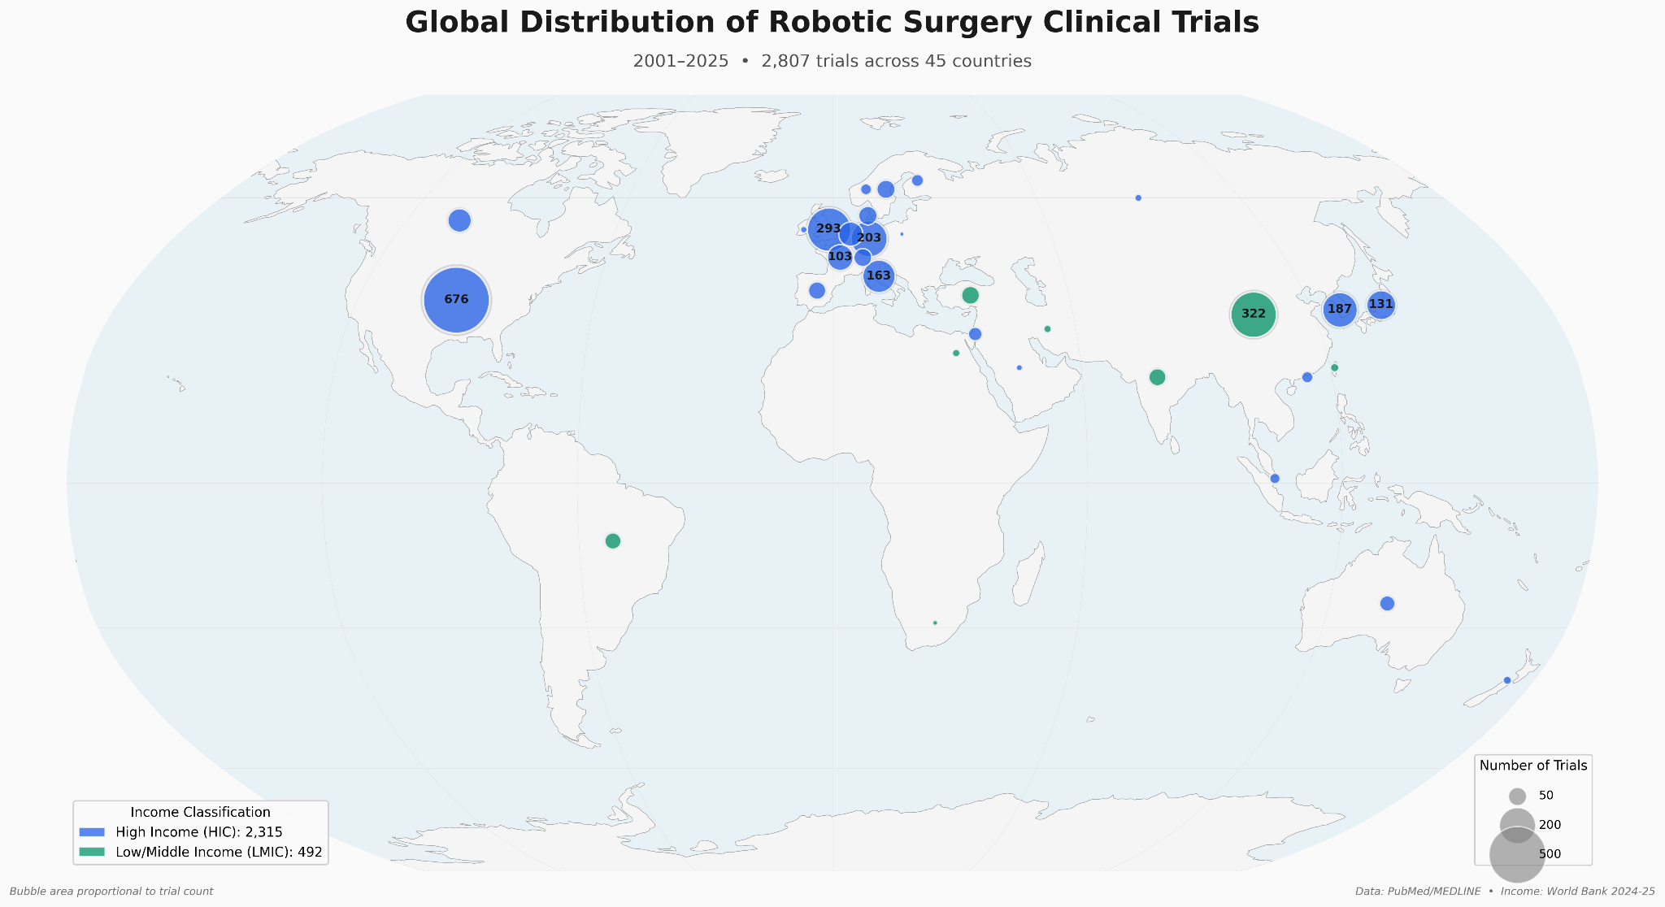

Distribution by Income Classification
Analysis by World Bank income classification revealed substantial inequities in trial distribution (Figure 5). High-income countries accounted for 84.5% of all trials, upper-middle-income countries for 13.5%, lower-middle-income countries for 2.0%, and low-income countries for 0%. When compared with world population distribution, where HICs represent approximately 16% of the global population, this concentration was highly significant (χ² = 9825, p < 0.001). The observed distribution deviated markedly from what would be expected if trials were distributed proportionally to population.
Temporal analysis showed some shift in this distribution over time, with increasing representation from upper-middle-income countries in recent years, particularly driven by growth in Eastern Asian countries. However, lower-middle-income and low-income countries remained severely underrepresented throughout the entire study period.
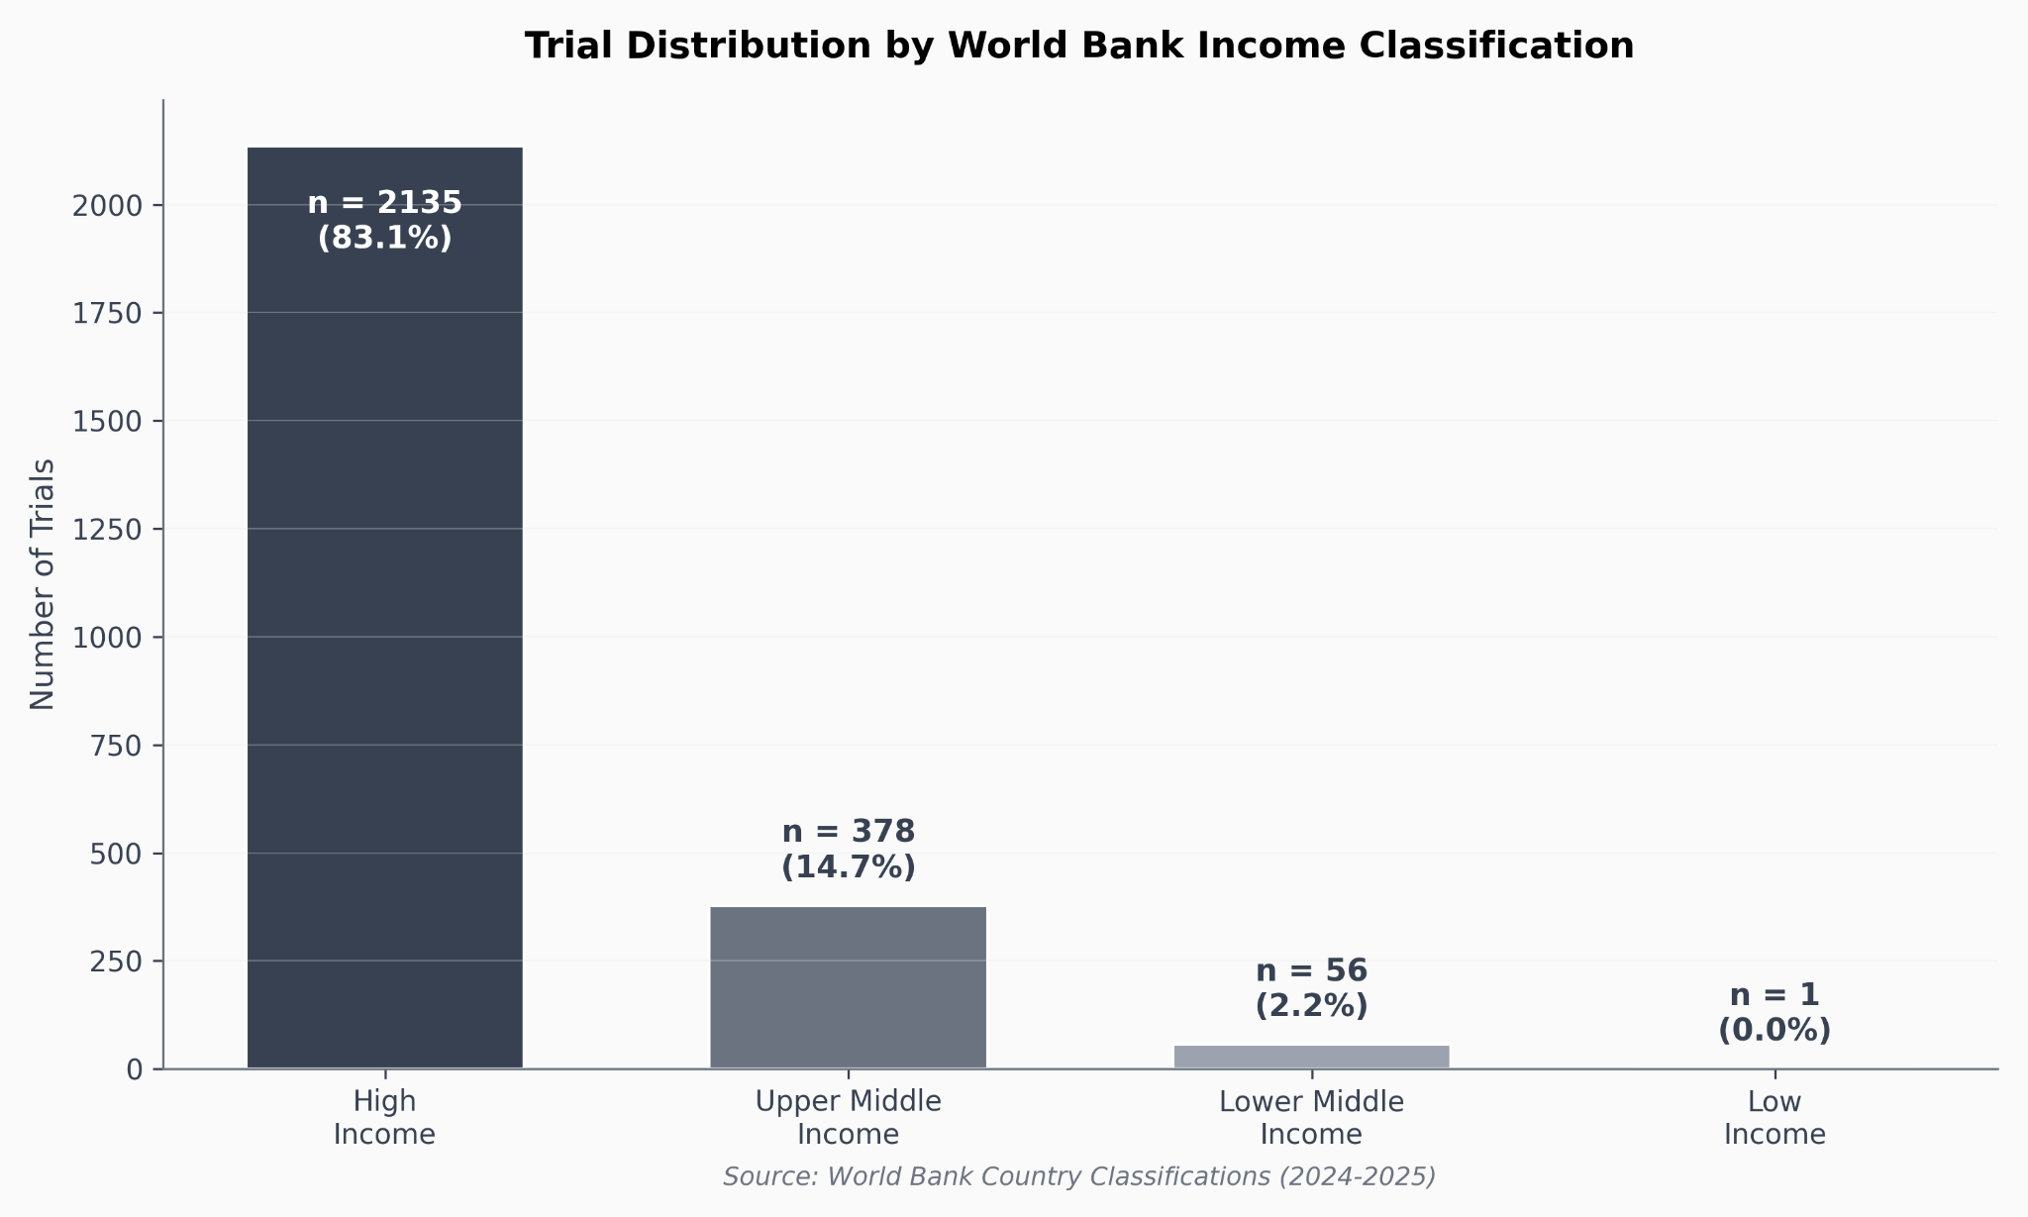

Leading Contributors
Analysis of the top contributing countries over the most recent five years revealed that China emerged as a leading force in robotic surgery clinical trials (Figure 6). China was the only LMIC among the top contributors and is classified as an upper-middle-income country approaching potential reclassification as a HIC. This finding indicates substantial investment in robotic surgery research and innovation within China. Other top contributors were predominantly established HICs with mature research infrastructure.
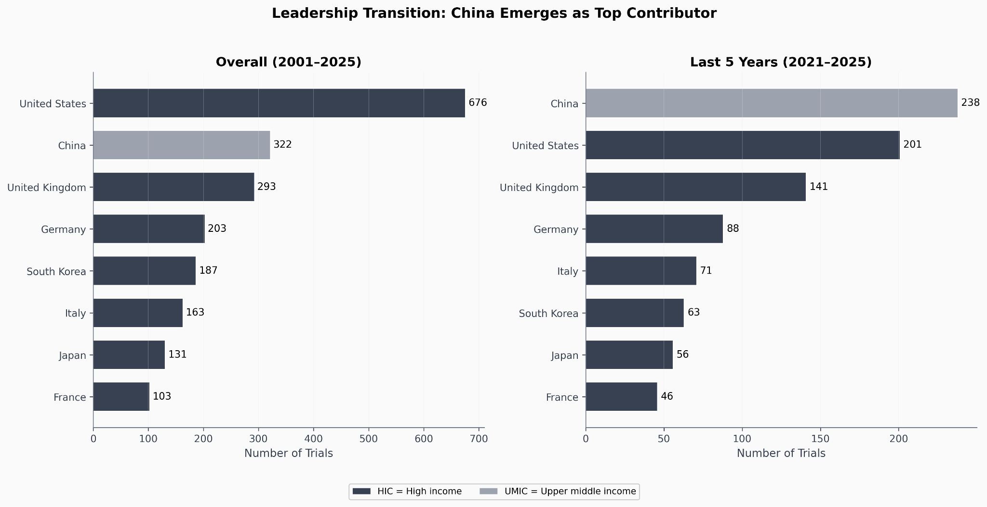

Patterns of Collaborative Research
Of the 2,244 total trials, 363 involved international collaboration between authors from different countries. Analysis of these collaborative trials revealed that the vast majority (79%) involved partnerships exclusively between HICs. Only 21% of collaborative trials included HIC-LMIC partnerships, and no LMIC-LMIC collaborations were identified.
Among LMIC partners in collaborative trials, China accounted for over 50% of all LMIC participation, further highlighting its dominant role as the primary LMIC contributor to robotic surgery research. Other LMICs had minimal representation in international collaborative research. Table 1 summarizes the key findings across all dimensions analyzed.
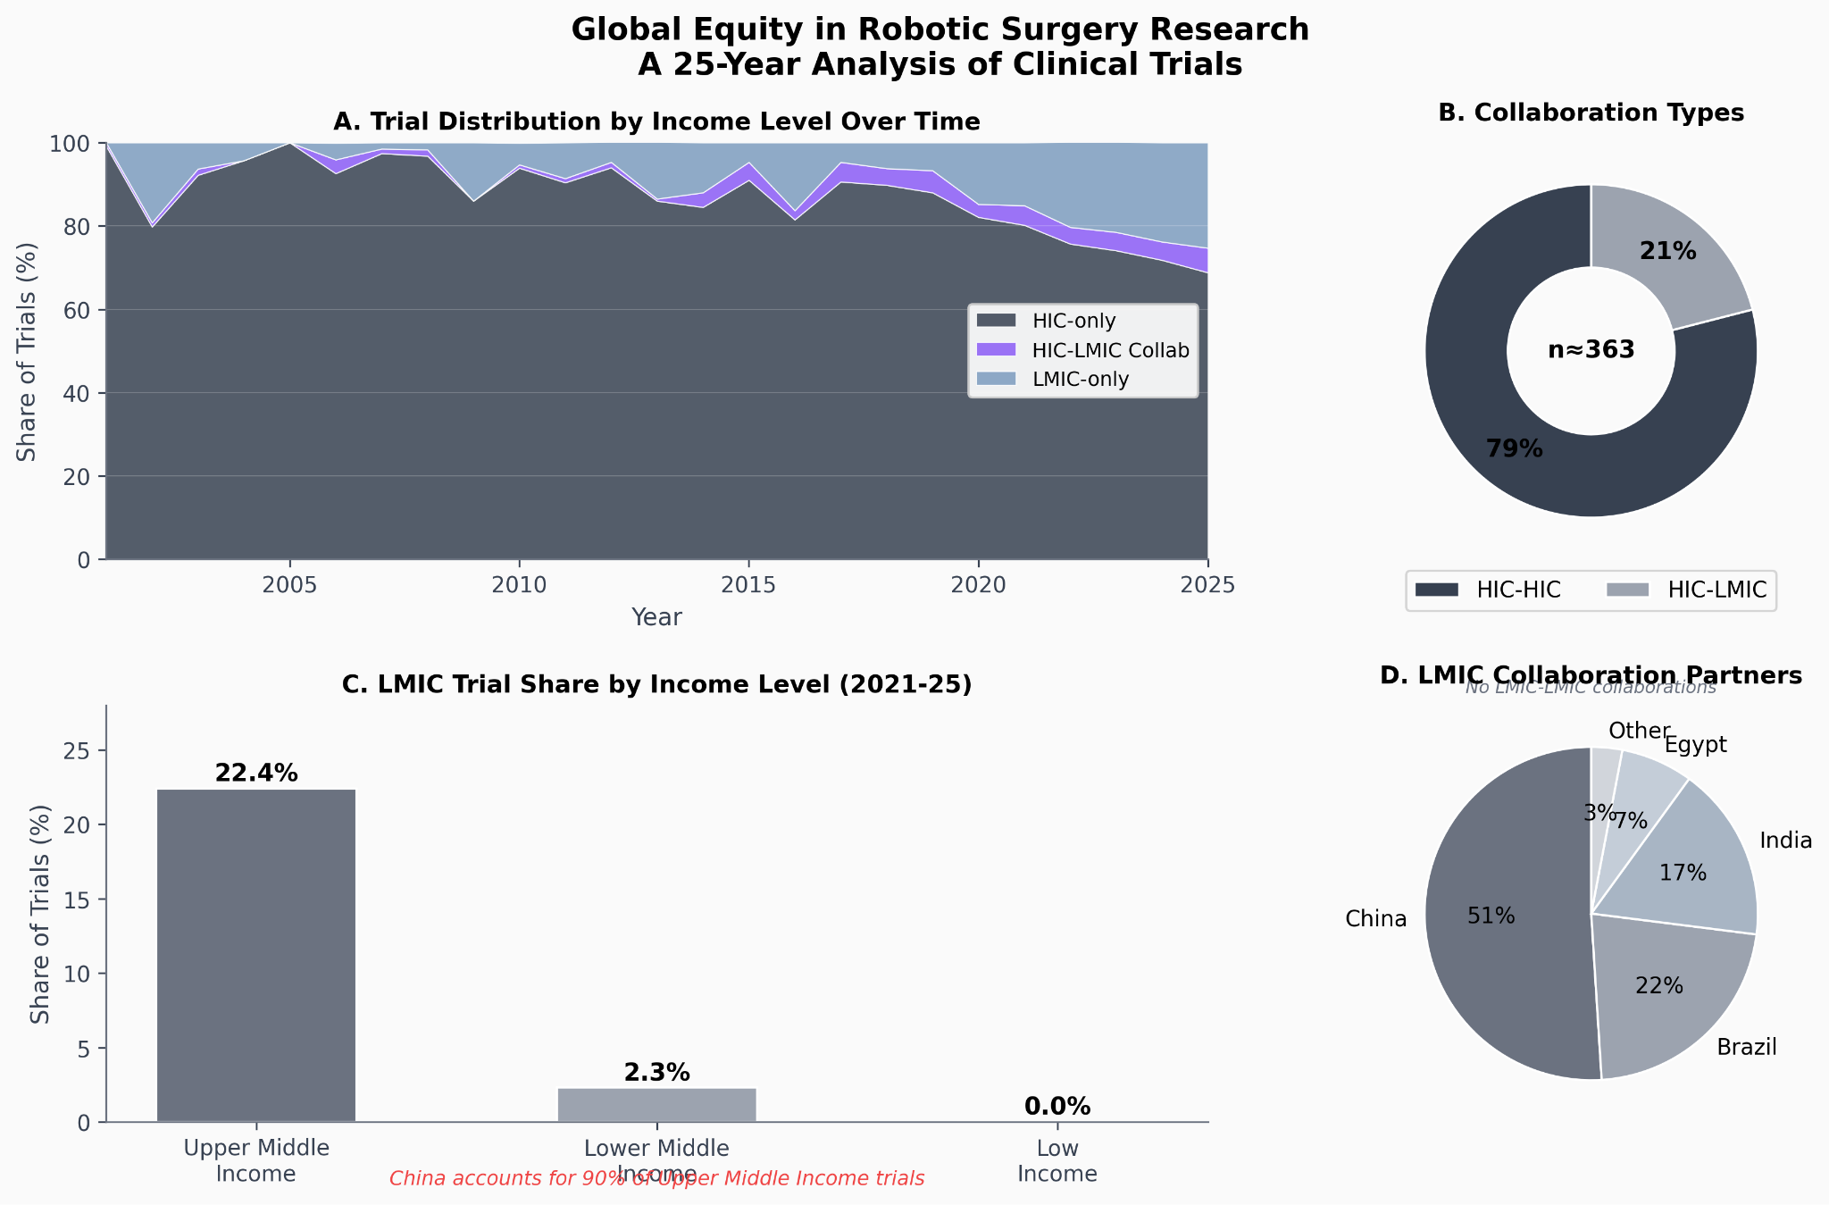

DISCUSSION
This bibliometric analysis of 2,244 robotic surgery clinical trials over 25 years reveals a complex picture of globalization marked by both progress and persistent inequities. While the absolute number of trials has increased substantially and geographic concentration has declined, the distribution of research activity remains heavily skewed toward high-income countries. The near-total absence of trial participation from low-income countries and minimal engagement from Latin America and Africa represents a critical gap in global surgical research.
Several findings merit particular attention. First, the massive concentration of trials in HICs (84.5%) far exceeds what would be expected based on population distribution (16%), indicating fundamental structural barriers to LMIC participation in robotic surgery research. This disparity is statistically striking (χ² = 9825, p < 0.001) and has important implications for the generalizability of research findings.
Second, China's emergence as a dominant force among LMIC contributors reflects substantial national investment in surgical innovation and research infrastructure. As an upper-middle-income country with rapid economic development, China's trajectory may offer insights for other LMICs seeking to build research capacity. However, the lack of similar progress in other major population centers, particularly in Africa and Latin America, suggests that economic development alone may be insufficient without targeted investments in surgical research infrastructure.
Third, international collaboration patterns reveal that when collaboration occurs, it predominantly involves partnerships between HICs rather than meaningful HIC-LMIC engagement. Only 21% of collaborative trials bridged the income divide, and no LMIC-LMIC collaborations were identified. This pattern suggests that international collaboration, while increasing, has not yet served as an effective mechanism for democratizing access to robotic surgery research.
The implications of these findings are substantial. When clinical trials are conducted predominantly in HICs, the resulting evidence base may not apply to populations in LMICs who face different disease burdens, comorbidity patterns, healthcare delivery systems, and resource constraints.^{14,15} Diseases and surgical conditions that disproportionately affect LMICs may be systematically underrepresented in the research agenda. Patient outcomes that are particularly relevant in resource-limited settings may not be adequately studied.
Furthermore, the geographic concentration of trials raises questions about equitable access to emerging surgical technologies. Participation in clinical trials often provides early access to innovative treatments.¹⁶ When trials are conducted exclusively in HICs, patients in LMICs may face delays of years or decades before benefiting from technological advances, if they gain access at all.
Several barriers likely contribute to the observed disparities. Infrastructure limitations, including lack of robotic surgical platforms in many LMICs, create fundamental obstacles to conducting trials.¹⁷ Regulatory frameworks for clinical research may be less developed in some settings.¹⁸ Funding for surgical research in LMICs is limited, and international funding mechanisms may preferentially support HIC institutions.¹⁹ Research capacity, including trained investigators, biostatisticians, and regulatory expertise, may be insufficient in many settings.²⁰
However, addressing these inequities requires recognizing an important tension: the priority in many LMICs must be establishing basic surgical capacity rather than participating in cutting-edge technology trials. As we innovate and develop increasingly sophisticated (and expensive) surgical technologies, we must acknowledge that access to fundamental surgical care remains lacking in much of the world.^{21,22} Investment in robotic surgery research should not come at the expense of building essential surgical infrastructure and workforce capacity.
The path forward likely requires multi-pronged approaches. International partnerships must move beyond token LMIC participation toward genuine capacity building and knowledge transfer. Funding mechanisms should be designed to support LMIC-led research addressing locally relevant questions. Regulatory harmonization could reduce barriers to conducting trials across multiple countries. Technology companies and academic institutions in HICs have ethical obligations to consider global equity in their research portfolios.
Importantly, capacity building for research must be integrated with broader efforts to strengthen surgical systems. As new robotic platforms become more affordable and accessible, different barriers may emerge. Future efforts must remain adaptable and attentive to emerging needs while maintaining focus on the fundamental goal of improving surgical care for all populations.

LIMITATIONS
This study has several limitations that warrant consideration. First, our reliance on author affiliations as a proxy for trial location may not perfectly capture where research was actually conducted. Some trials may involve data collection in one country with analysis and publication led by institutions in another country. However, author affiliations represent the best available indicator in bibliometric data and likely reflect meaningful participation in the research enterprise.
Second, our search strategy using PubMed and specific search terms may not capture all robotic surgery clinical trials, particularly those published in regional journals not indexed in PubMed or those not appropriately tagged. This could lead to underrepresentation of some regions, particularly those with robust regional publication venues.
Third, our analysis does not distinguish between different types of clinical trials (feasibility studies, pilot trials, definitive randomized controlled trials) or different surgical specialties. These factors may influence geographic distribution patterns and warrant future investigation.
Fourth, World Bank income classifications change over time as countries develop economically. While we used historical classifications corresponding to publication years, some classification changes may not be fully captured, particularly for countries near income thresholds.
Finally, bibliometric analysis cannot capture qualitative dimensions of research participation, such as the nature of LMIC involvement in collaborative trials or whether trial questions address locally relevant priorities. Future work incorporating qualitative methods could provide deeper insights into the quality and meaningfulness of global participation.

CONCLUSION
The globalization of robotic surgery clinical trials over the past 25 years shows both encouraging progress and concerning inequities. While trial volume has increased and geographic concentration has declined, with expanding participation from European and Asian countries, fundamental barriers persist for trial conduct in Latin America and Africa. The massive concentration of research in high-income countries limits the generalizability of findings to global populations and risks perpetuating disparities in access to surgical innovation.
Future efforts must prioritize building equitable research capacity alongside strengthening essential surgical care delivery systems. The surgical community has an obligation to ensure that technological advances benefit all populations, not just those in high-income settings. This requires intentional investment in LMIC research infrastructure, meaningful international partnerships, and continued attention to the balance between innovation and fundamental care access.
As robotic surgery continues to evolve, monitoring these trends and actively working to promote equitable global participation in research will be essential for ensuring that surgical innovation serves humanity broadly rather than deepening existing health disparities.

ACKNOWLEDGMENTS
None.

FUNDING
This research received no specific grant from any funding agency in the public, commercial, or not-for-profit sectors.

CONFLICTS OF INTEREST
The authors declare no conflicts of interest.

REFERENCES
1. Intuitive Surgical. Meta-analysis published in Annals of Surgery shows benefits of da Vinci surgery across seven oncologic procedures compared to laparoscopic and open. Available at: https://isrg.intuitive.com/news-releases/news-release-details/meta-analysis-published-annals-surgery-shows-benefits-da-vinci. Accessed December 5, 2024.
2. Shugaba A, Lambert JE, Bampouras TM, Nuttall HE, Gaffney CJ, Subar DA. Should the surgical robot be taken seriously? A review of the role of robotics in surgery. Mo Med. 2023;120(5):389-396.
3. Zakaria HM, Telemi E, Navarro-Ramirez R, et al. Robotic surgery: a comprehensive review of the literature and current trends. Cureus. 2023;15(8):e43371.
4. Kalil M. Medtronic's Hugo RAS vs. Da Vinci surgical robot. Available at: https://mikekalil.com/blog/medtronic-hugo-ras/. Published November 2, 2025.
5. Kelly S. Medtronic's Hugo surgical robot secures US clearance. FierceBiotech. December 3, 2025.
6. Srivastava S, Malik L, et al. India's first robotic system performs telesurgeries over a distance of 286 km. DD News. Available at: https://ddnews.gov.in/en/indias-first-robotic-system-performs-telesurgeries-over-a-distance-of-286-km/.
7. Agrawal A, Sharma D, Chaudhary SK, et al. Evaluating the efficacy of telesurgery with dual console SSI Mantra Surgical Robotic System: experiment on animal model and clinical trials. J Robot Surg. 2024;18(1):382.
8. Rubagumya F, Hopman WM, Gyawali B, et al. Participation of lower and upper middle-income countries in oncology clinical trials led by high-income countries. JAMA Netw Open. 2022;5(8):e2226694.
9. Access to Medicine Foundation. Patients in low- and middle-income countries largely left out of clinical trials, limiting access to new treatments. Available at: https://accesstomedicinefoundation.org/resource/patients-in-low-and-middle-income-countries-largely-left-out-of-clinical-trails-limiting-access-to-new-treatments.
10. Moyer CA, Dako-Gyeke P, Adanu RM. Ethical implications of clinical trials in low- and middle-income countries. American Bar Association. Available at: https://www.americanbar.org/groups/crsj/resources/human-rights/archive/ethical-implications-clinical-trials-low-middle-income-countries/.
11. Ahmed Z, Grover S, Bae S, et al. Clinical trials in low and middle-income countries: Successes and challenges. Gynecol Oncol Rep. 2016;18:58-62.
12. Ferrara D. Global trial equity: How LMIC data is reshaping US ophthalmology research. Ophthalmology Times. December 30, 2025.
13. Gyawali B, Prasad V. Drug development in low- and middle-income countries: opportunity or exploitation? ASCO Educ Book. 2022;42:1-7.
14. Suneja G, Ramondetta LM, Gaffney DK, et al. Addressing disparities in cancer care through the National Cancer Institute's patient navigation research program. Oncologist. 2015;20(11):e35.
15. Carlson RW, Scavone JL, Koh WJ, et al. NCCN framework for resource stratification: a framework for providing and improving cancer care across the range of settings in which oncology is practiced throughout the world. J Natl Compr Canc Netw. 2016;14(8):961-969.
16. Emanuel EJ, Wendler D, Killen J, Grady C. What makes clinical research in developing countries ethical? The benchmarks of ethical research. J Infect Dis. 2004;189(5):930-937.
17. Meara JG, Leather AJ, Hagander L, et al. Global Surgery 2030: evidence and solutions for achieving health, welfare, and economic development. Lancet. 2015;386(9993):569-624.
18. Nyamai LA, Mccall SJ, Oduor C, et al. Regulatory frameworks for clinical trials in Africa: a review of guidelines, practices and challenges. BMJ Global Health. 2021;6(12):e006813.
19. Viergever RF, Hendriks TCC. The 10 largest public and philanthropic funders of health research in the world: what they fund and how they distribute their funds. Health Res Policy Syst. 2016;14:12.
20. Chu KM, Jayaraman S, Kyamanywa P, Ntakiyiruta G. Building research capacity in Africa: equity and global health collaborations. PLoS Med. 2014;11(3):e1001612.
21. Alkire BC, Raykar NP, Shrime MG, et al. Global access to surgical care: a modelling study. Lancet Glob Health. 2015;3(6):e316-323.
22. Shrime MG, Bickler SW, Alkire BC, Mock C. Global burden of surgical disease: an estimation from the provider perspective. Lancet Glob Health. 2015;3 Suppl 2:S8-9.

