Supplementary Figures — Shifting Geography of Robotic Surgery Clinical Trials, 2001–2025

Supplementary Figure S1
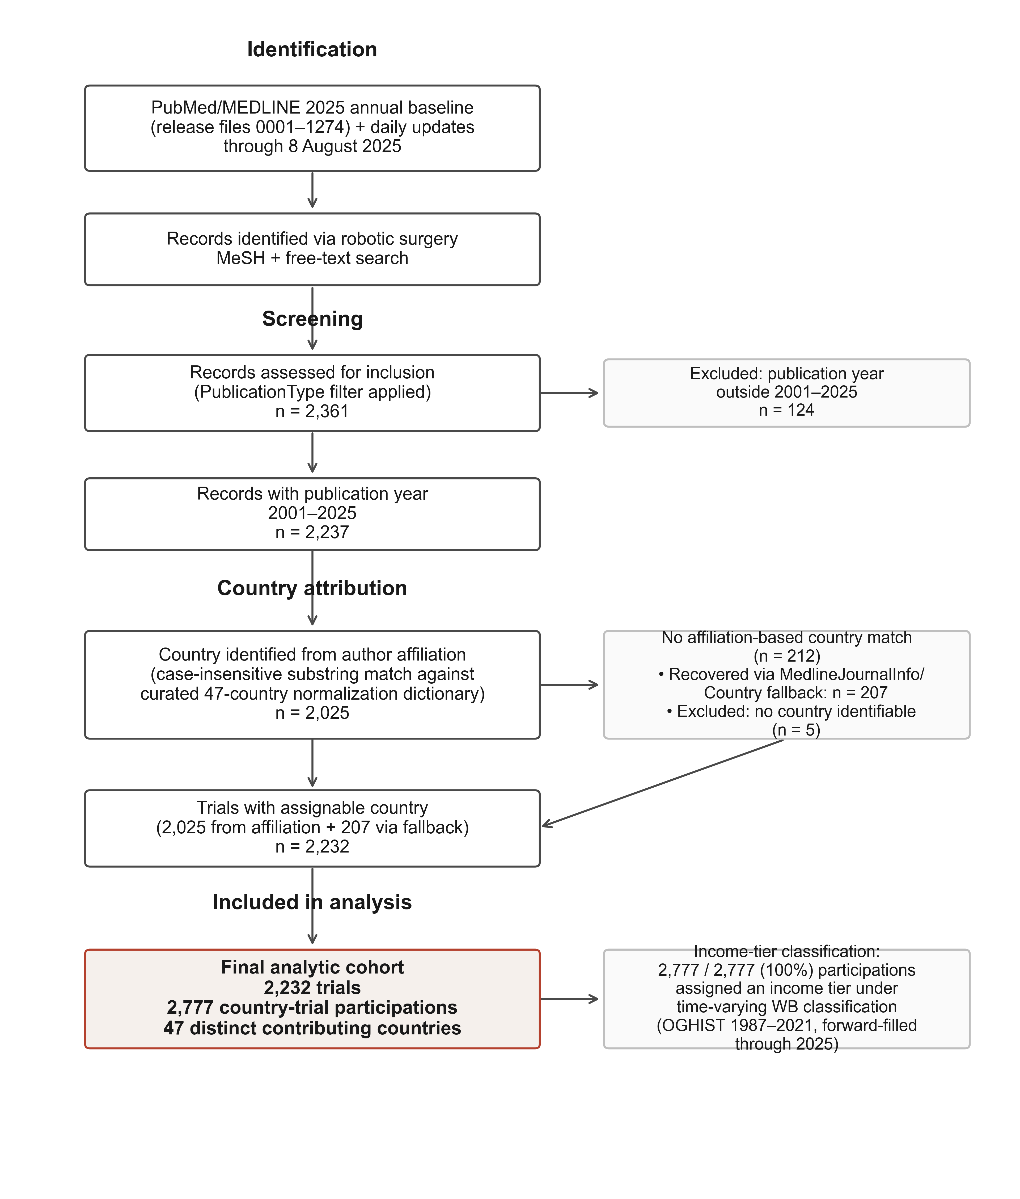
Supplementary Figure S1. Record-flow diagram: MEDLINE records screened, robotic surgery filter applied, clinical-trial-type filter applied, final analytic cohort, and attrition at each step including records without identifiable country attribution.

Supplementary Figure S2
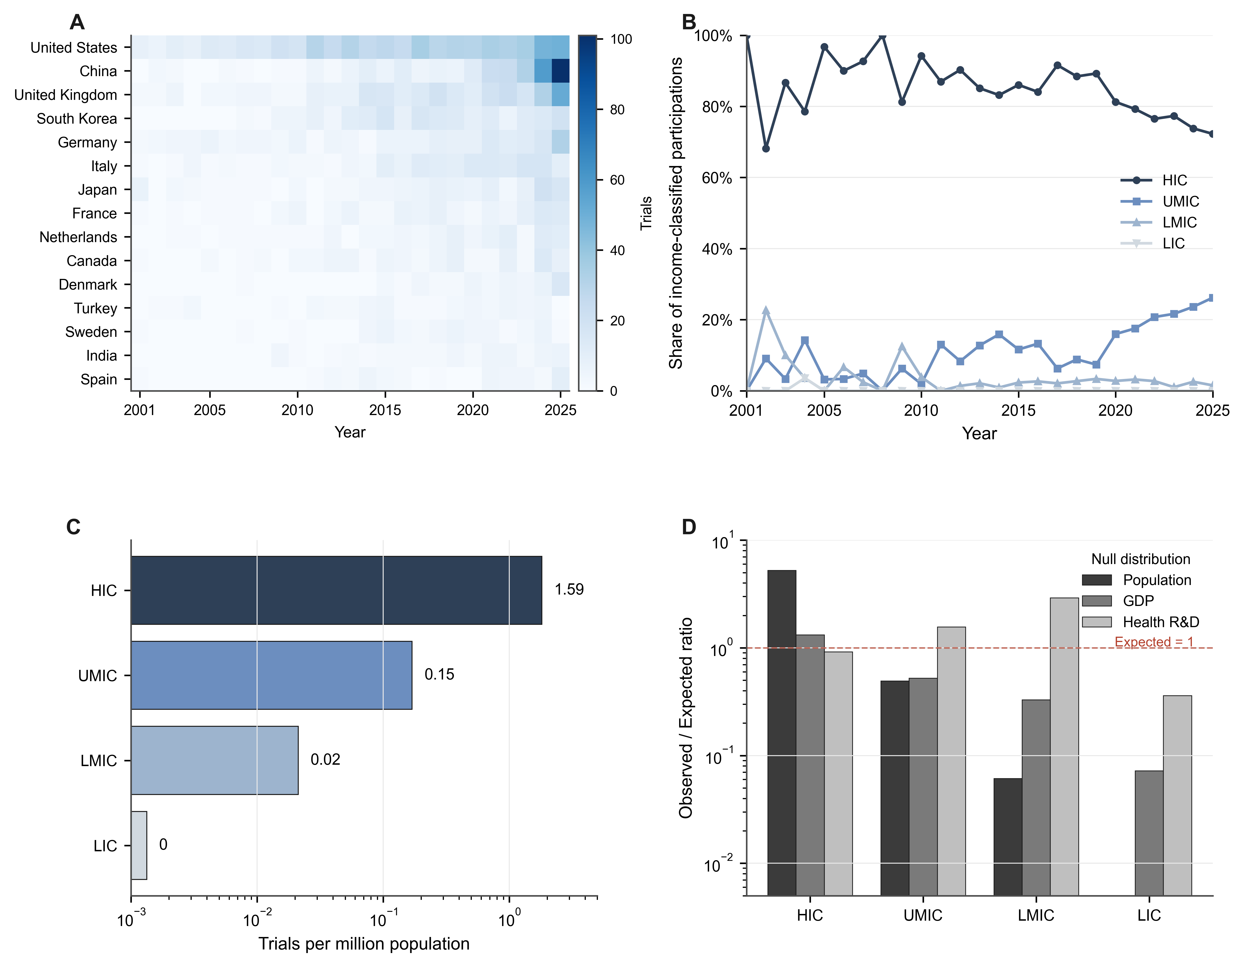
Supplementary Figure S2. Equity dashboard (multi-panel): per-country trial counts for the top 15 contributors over time; time-varying income-tier distribution; per-million-population production rate by income tier; observed-to-expected ratios under each of the three null distributions.

Supplementary Figure S3
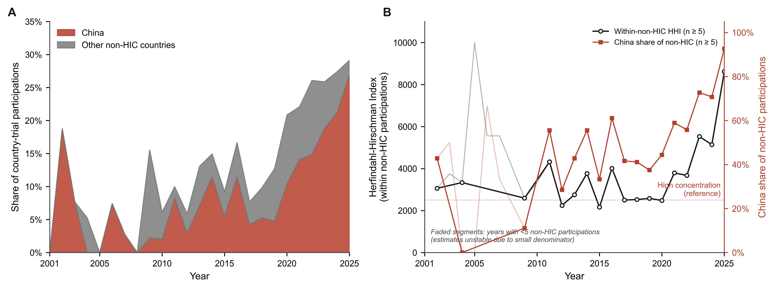
Supplementary Figure S3. Decomposition of non-HIC country-trial participations, 2001–2025. Panel A: Annual non-HIC share of participations, stratified into contribution from the single largest non-HIC contributor (China) versus all other non-HIC countries combined. The aggregate non-HIC share rose from 13.0% during 2001–2005 to 24.9% during 2021–2025, driven entirely by China's rise from 3.6% to 18.7%; the non-HIC share excluding China declined over the same interval from 9.4% to 6.2%. Panel B: Year-by-year Herfindahl-Hirschman Index computed across non-HIC countries alone, indicating that concentration within the non-HIC producer subset remained high throughout the study period; early-year values with small denominators (n < 5 non-HIC participations) are faded to reflect estimation instability.
---

