This project is based for a website that allows people to communicate with other people that live in their neighborhood. The users can sign up for the service and specify where they live; they can then send and receive messages to other users living close by, and participate in discussions with those users. We present the following ER diagram to represent our database.

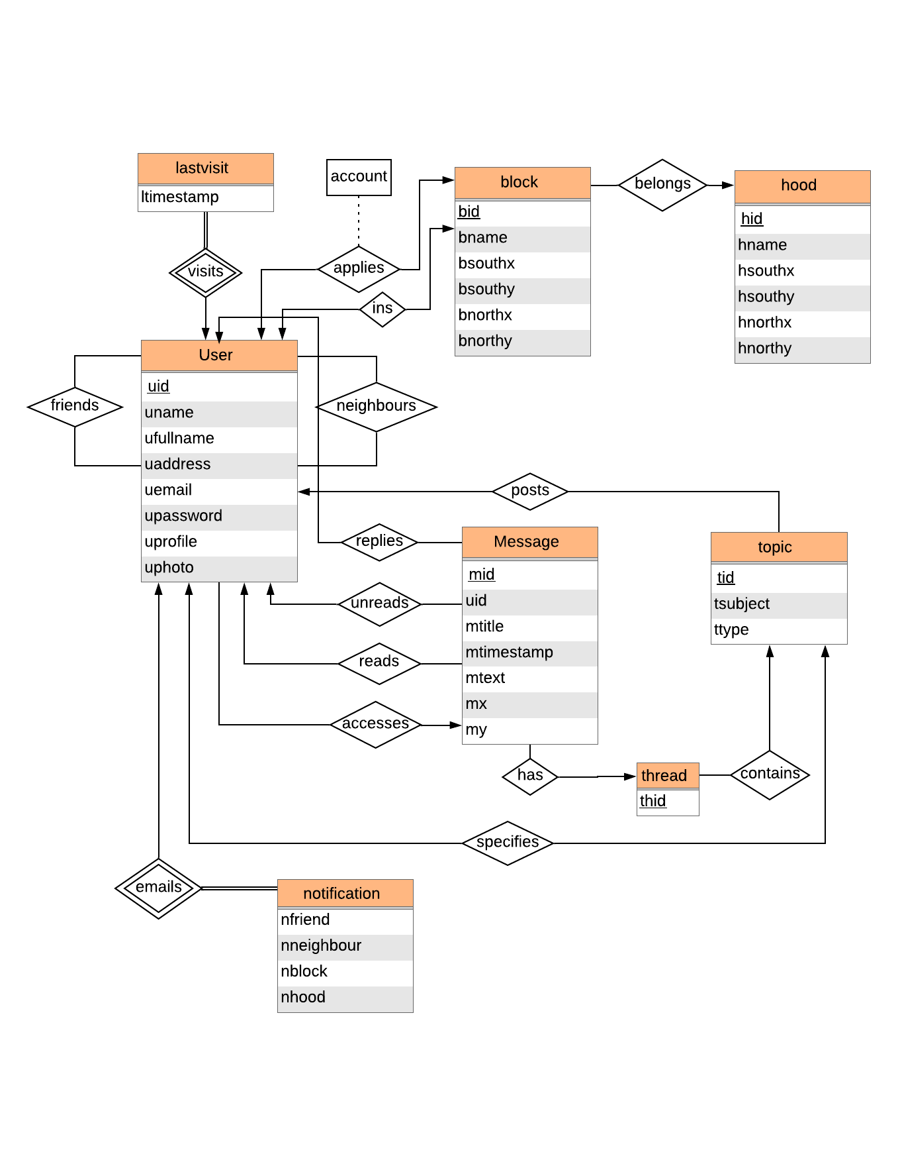

We include the following Entities in our Entity – Relational diagram that models the project.

1. User – It stores the details about all the user. Each user is identified using a unique username, user’s full name, user’s address, user’s email address, user’s account password, a short profile where user can describe himself and a profile photo.
2. Block – It stores the details about all the blocks that are identified using a block id and axis-aligned rectangles that can be defined by location coordinates of Southwest and Northeast corner of the rectangle. We also store the name associated with that block.
3. Hood – It stores the details about all the hoods. The data organisation in this relation is similar to the data organisation of the block relation.
4. Message – It stores the details about all the messages that exchanged amongst the users. Each message is identified using a unique message id. We store the sender of the message, the message title, the message text, the timestamp when the message is sent and coordinates of location from where the message was sent.
5. Topic – It stores the details about various topics and each topic is identified using a unique topic id. We store the subject and type of the topic. The type specifies the accessibility of that topic indicating the type of people who can read and reply to that topic.
6. Thread – It stores all the threads which are present in the system and each thread is uniquely identified by a thread id.
7. LastVisit – lastvisit stores the timestamps of all users which specifies the last time when a user accessed the system.
8. Notification – It stores the notification preference of all users. It indicates whether a user prefers a notification when a content is posted by a friend, neighbour, block member and/or a hood member.

We include the following relations in our Entity – Relational diagram that models the project.

1. Neighbours, one user can be neighbour of many other users.
2. Friends, one user can be friends with many other users.
3. Applies, each user submits an application for a particular block and acount maintains the number of people who have accepted the application.
4. Ins,
5. Belongs, many blocks belong to a single hood.
6. Visits, each user has a timestamp which specifies the last time when that user used the system.
7. Posts, one user can create a number of topics.
8. Replies, one user can reply to many messages.
9. Unreads, each user has different unread messages.
10. Reads, each user has different read messages. Since, a message can be read and unread by many users depending on the message’s accessibility, we maintain 2 different relations to store the read and unread messages.
11. Accesses, each message can be accessible to many users and is used to specify the users to whom a particular message is accessible.
12. Has, specifies the thread that a particular message belongs to.
13. Contains, each topic contains many threads.
14. Specifies, each user defines the type of the topic. The user specifies if the topic is visible to his friends, neighbours, block members and/or hood members.
15. Emails, each user has its own preference for receiving an email notification when a new content is posted.

Following is the equivalent relational schema of the above ER diagram.

1. user (uid, uname, ufullname, uaddress, uemail, upassword, uprofile, uphoto)

uid,uname is the primary key.

1. hood (hid, hname, hsouthx, hsouthy, hnorthx, hnorthy)

hid is the primary key.

1. block (bid, bname, bsouthx, bsouthy, bnorthx, bnorthy)

bid is the primary key.

1. message (mid, uid, mtitle, mtimestamp, mtext, mx, my)

mid is the primary key.

uid references uid in user.

1. topic (tid, tsubject, ttype)

tid is the primary key.

1. thread (thid)

thid is the primary key.

1. notification (uid, nfriend, nneighbor, nblock, nhood)

uid reference uid in user.

1. lastvisit (uid, ltimestamp)

uid reference uid in user.

1. applies (uid, bid, acount)

uid, bid is the primary key.

uid reference uid in user.

bid references bid in block.

1. ins (uid, bid)

uid, bid is the primary key.

uid reference uid in user.

bid references bid in block.

1. belongs (hid, bid)

hid, bid is the primary key.

hid references hid in hood.

bid references bid in block.

1. friends (uid, fid)

uid, fid is the primary key.

uid reference uid in user.

fid references uid in user.

1. neighbours (uid, nid)

uid, nid is the primary key.

uid reference uid in user.

fid references uid in user.

1. posts (uid, tid)

uid, tid is the primary key.

uid references uid in user.

tid references tid in topic.

1. contains (tid, thid)

tid, thid is the primary key.

tid references tid in topic.

thid references thid in thread.

1. has (thid, mid)

thid, mid is the primary key.

thid references thid in thread.

mid references mid in message.

1. replies (uid, mid)

uid, mid is the primary key.

uid references uid in user.

mid references mid in message.

1. unreads (uid, mid)

uid, mid is the primary key.

uid references uid in user.

mid references mid in message.

1. reads (uid, mid)

uid, mid is the primary key.

uid references uid in user.

mid references mid in message.

1. accesses (uid, mid)

uid, mid is the primary key.

uid references uid in user.

mid references mid in message.

1. specifies (tid,uid)

tid, uid is the primary key.

tid references topic id in topic.

uid references uid in user.

**Sample Queries**

**Joining**

**Sign-up:**

insert into `user` (`uid`, `uname`, `ufullname`, `uaddress`, `uemail`, `upassword`, `uprofile`, `uphoto`)

values (1, 'Ares', 'Zuoyiwei Zhang', '', 'aczzyw@gmail.com', 'pwd1', 'A handsome boy', 'None');

**Check if email has signed up or not:**

select * from user where uemail = 'aczzyw@gmail.com';

**Apply to be a member:**

insert into `applies` (`uid`, `bid`, `acount`)

values (1, 1, 0);

**Accept new block members:**

update `applies`

set acount=(select `acount` from `applies` where `uid` =1) + 1 where uid = 1;

**Update a profile:**

update `user` set uprofile = 'add something', uphoto = 'url' where uid = 1;

**Content Posting**

**Starting a new topic:**

insert into `topic` (`tid`, `tsubject`, `ttype`)

values (1, 'dog', 'friend'), (2, 'cat', 'neighbor'), (3, 'car', 'block'), (4, 'food', 'hood');

insert into `posts` (`uid`, `tid`) values (2, 1), (2, 2), (2, 3), (2, 4);

**Specify who can chat under this topic:**

insert into `specifies` (`tid`, `uid`)

values (2, 2), (3, 2), (4, 2);

**Starting a new thread with an initial message and specifying who can access it:**

insert into `thread` (`thid`) values (1);

insert into `contains` (`tid`, `thid`) values (1, 1);

insert into `message` (`mid`, `uid`, `mtitle`, `mtimestamp`, `mtext`, `mx`, `my`) values (1, 1, 'How to feed a dog', '2019-11-25 00:00:00', 'Do you have a dog?', 0, 0);

insert into `has` (`thid`, `mid`) values (1, 1);

insert into `accesses` (`mid`, `uid`) values (1, 1);

**Replying to a message:**

insert into `message` (`mid`, `uid`, `mtitle`, `mtimestamp`, `mtext`, `mx`, `my`)

values (2, 2, 'A reply', '2019-11-25 01:00:00', 'Dogs like meat.', 0, 0);

insert into `has` (`thid`, `mid`) values (1, 2);

insert into `accesses` (`mid`, `uid`) values (2, 1);

**Friendship**

**add someone as a friend or neighbour:**

insert into `friends` (`uid`, `fid`) values (1, 2), (2, 1);

insert into `neighbors` (`uid`, `nid`) values (1, 2);

**List current friends:**

select f1.fid

from friends as f1, friends as f2

where f1.uid = f2.fid and f1.fid = f2.uid and f1.uid = 1;

**List current neighbors:**

select nid from neighbors where uid = 1;

**Browse and search messages**

**list all threads in a user’s block feed that have new messages since the last time the user accessed the system last time the user accessed the system**:

create view block_topic as

select tid

from topic natural join specifies

where ttype = 'block' and uid = 2;

create view block_thread as

select thid

from `contains` join block_topic

on `contains`.tid = block_topic.tid;

create view accessable_message as

select has.thid as thid, has.mid as mid

from (block_thread join has on block_thread.thid = has.thid) join accesses on has.mid = accesses.mid

where uid = 2;

select thid

from accessable_message natural join message, lastvisit

where lastvisit.uid = 2 and ltimestamp < mtimestamp;

drop view block_topic;

drop view block_thread;

drop view accessable_message;

A**ll threads in friend feed that have unread message:**

create view friend_topic as

select tid

from topic natural join specifies

where ttype = 'friend' and uid = 2;

create view friend_thread as

select thid

from `contains` join friend_topic

on `contains`.tid = friend_topic.tid;

create view accessable_message as

select has.thid as thid, has.mid as mid

from (friend_thread join has on friend_thread.thid = has.thid) join accesses on has.mid = accesses.mid

where uid = 2;

insert into `unreads`(`uid`, `mid`)

select lastvisit.uid, message.mid

from accessable_message natural join message, lastvisit

where lastvisit.uid = 2 and ltimestamp < mtimestamp;

drop view friend_topic;

drop view friend_thread;

drop view accessable_message;

**All messages containing the words “bicycle accident” across all feeds that the user can access:**

select message.mid

from accesses join message on accesses.mid = message.mid

where accesses.uid = 2 and mtext like '%bicycle accident%'