Hack2Skill GenAI Hackathon · Challenge 4
Copa Companion — LinkedIn Post

Challenge 4 of the Hack2Skill GenAI Hackathon asked us to pick one vertical for the FIFA World Cup 2026.
I picked the fan experience.
Then it hit me: the same live crowd feed that rescues a lost fan is exactly what the people running the stadium are flying without. So I built both — from one engine.
Meet Copa Companion. 👇
The fan — Diego, 34, first World Cup, speaks only Spanish
His ticket says “Section 428, Entry K.” His gate has a 45-minute line. Another gate is nearly empty. Every sign is in English. He’s one of 80,000.
Copa Companion, in his language:
- Paste your ticket → it maps to your exact gate and seating level
- Live gate queues → it reroutes you when your gate is jammed (every gate accepts every ticket)
- “Where you are” → live map, driving route + ETA, and the nearest gate on arrival
- Ask anything, by text or voice → gates, food, bag policy, first aid, transport — grounded on a stadium knowledge pack, so it advises instead of hallucinating
Privacy by design: your GPS never leaves your phone — only the distance number reaches the assistant.
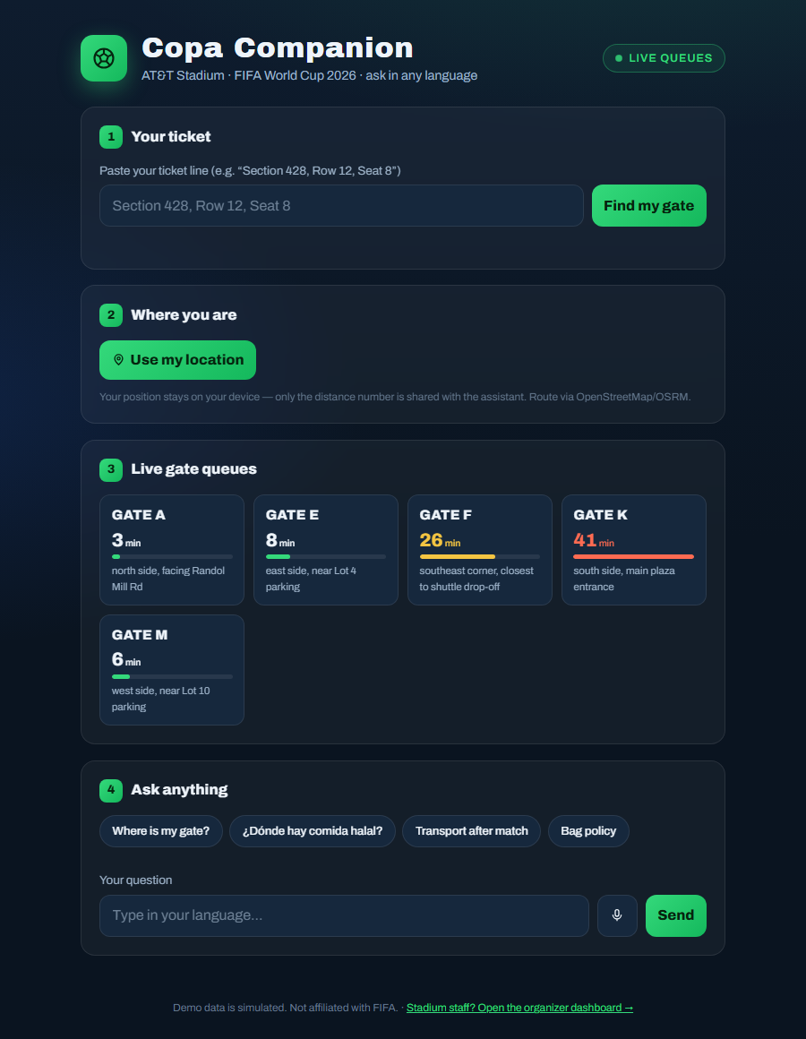
The fan app — ticket, live gate queues, location and multilingual chat
The organizer — the same live feed, staff lens
- Gate grid with 2-minute trend and load vs normal inflow
- An AI ops briefing: the situation in two lines, then the three actions to take now
- Threshold alerts the moment a gate goes critical
- A staggered post-match exit plan by seating level — the biggest crowd-safety lever of the day
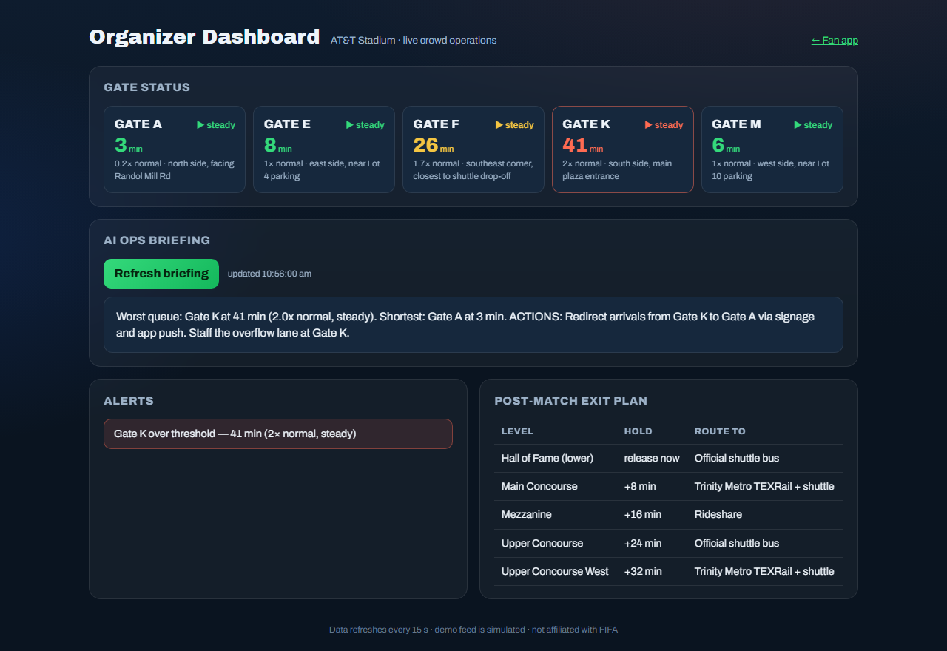
The organizer dashboard — gate status, AI ops briefing, alerts and exit plan
Two personas. One engine.
Built lean, built for real
- Google Gemini, server-side only — the API key never touches the browser
- FastAPI + vanilla JS, no build step
- A rule-based fallback that runs with no API key at all
- Validated inputs, 13 automated tests, accessible UI

🚀 Live demo: ch4.rukesh.in
💻 Code: github.com/24rukesh/copa-companion
Hack2Skill GenAI Hackathon · Challenge 4 · not affiliated with FIFA
#GenAI #FIFAWorldCup2026 #Hackathon #AI #FastAPI #Gemini #ProductEngineering #Accessibility

