MONGODB Compass –LAB Exercises
Ex 1. Collection creation using Insert Document
Aim: To create the collection for student details with five fields using insert document method.
Algorithm:
Step 1: Open MongoDB Compass on the system.
Step 2: After Successfully Opening, Click on “Connect” Button.
Step 3: After Click on “Connect” Button, Click on plus (+) Sign.
Step 4: After Clicking on Plus (+) icon, a popup will appear in which you have to give Database Name and Collection Name.
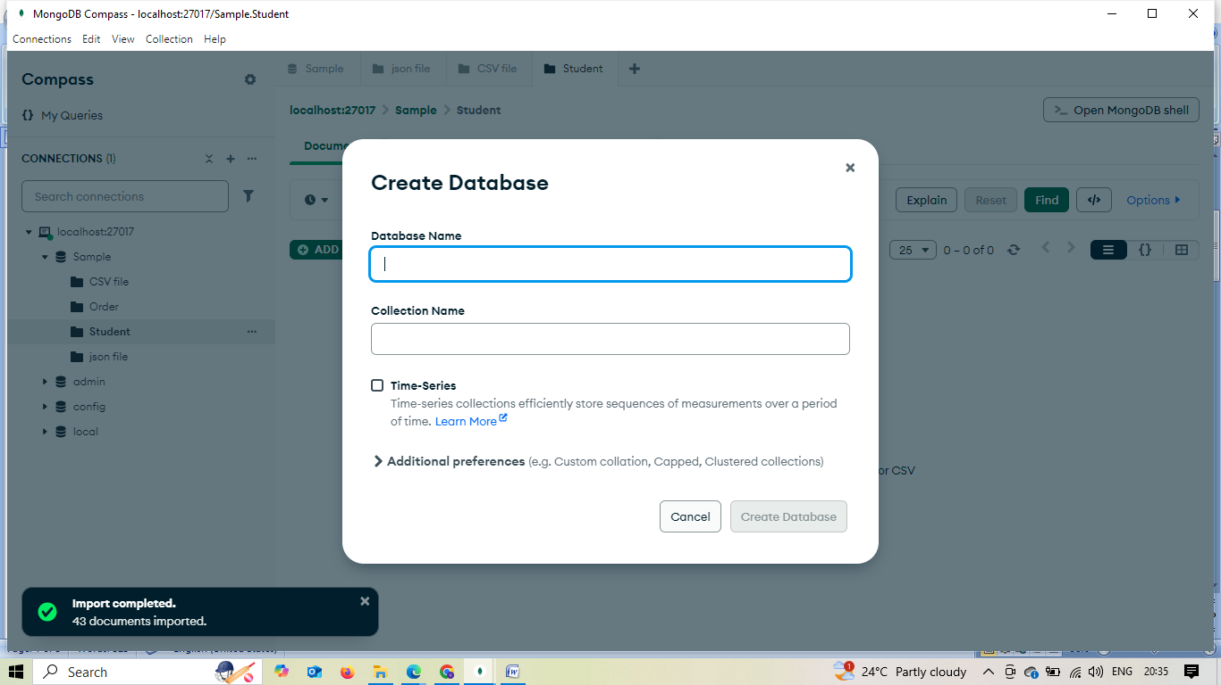
Step 5: Enter the Database Name ex:XXX(Student name) and Collection Name “Student”.
Step 6: After that Click on the “Create Database” Button. From the above Steps Database will be created.
Step 7: After that, click on “ADD DATA” and select the “Insert document” option.
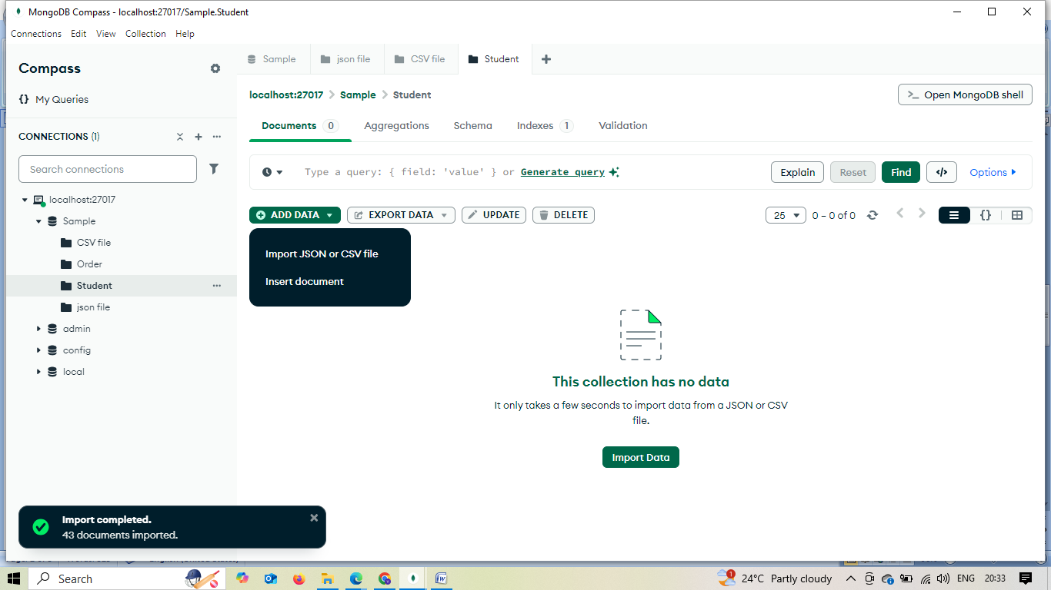
Step 8: After Clicking on “Insert document” a new popup appear.
Step 9: Here write the field and value for the record.
Ex:
“Rollno”:101,
“Name”:XXX,
“Class”:”III IT”,
“Semester”:6,
“Mail id”:xxx@gmail.com.
After that click the “Insert” Button to insert the document.
Step 10: Continue the same procedure for next 4 records.
Result:
Database & Collection have been successfully created using MongoDB compass.

Ex 2. Collection creation using Import JSON or CSV
Aim: To create the collection using import JSON or CSV file format method.
Algorithm:
Step 1: Open MongoDB Compass on the system.
Step 2: After Successfully Opening, Click on “Connect” Button.
Step 3: After Click on “Connect” Button, Click on plus (+) Sign.
Step 4: Open the existing database and create new Collection.
Step 5: Once the Collection created, click on “ADD DATA” and select the “Import JSON or CSV “option.
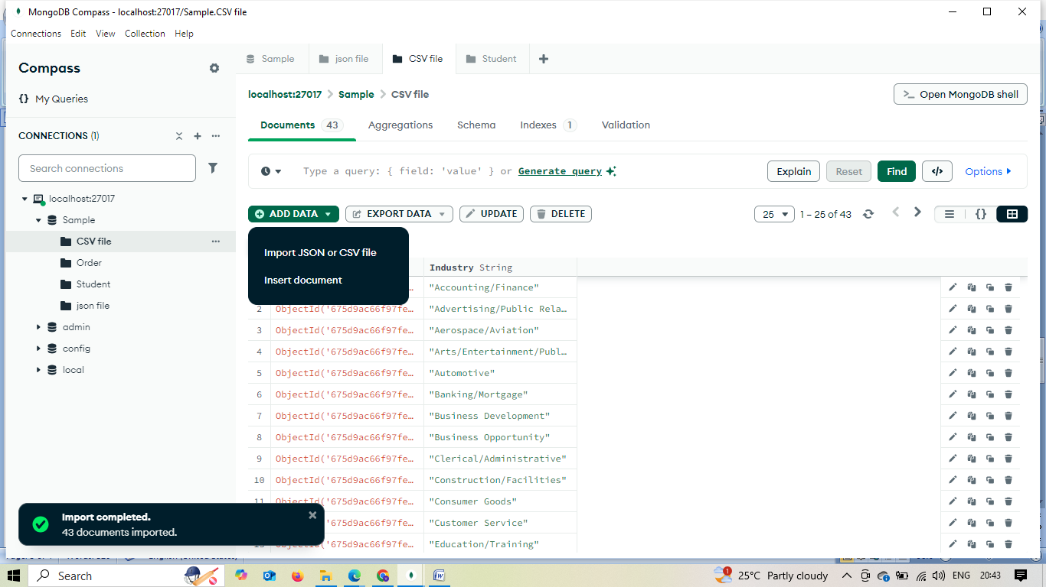

Comment line/* Dataset for JSON file: https://support.oneskyapp.com/hc/en-us/articles/208047697-JS’ON-sample-files
Dataset for CSV file: https://wsform.com/knowledgebase/sample-csv-files/ */
Step 8: After that click the “Insert” Button to insert the document.
Step 9: Continue the same procedure for next 4 records.
Result:
Database & Collection have been successfully created using MongoDB compass.

Ex 3: Update the record
Aim: To update the record for the existing collection on MongoDB Compass.
Algorithm:
Step 1: Open MongoDB Compass on the system.
Step 2: After Successfully Opening, Click on “Connect” Button.
Step 3: After Click on “Connect” Button, Click on plus (+) Sign.
Step 4: Open the existing database and click the any existing table
Step 5:
i) Updating documents in List View
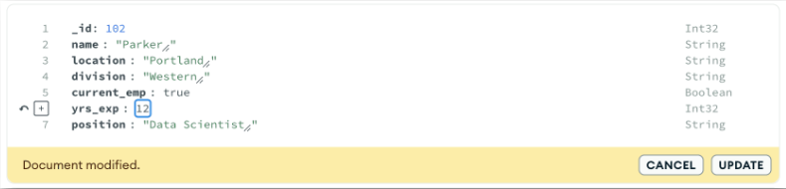
ii) Updating documents in JSON View
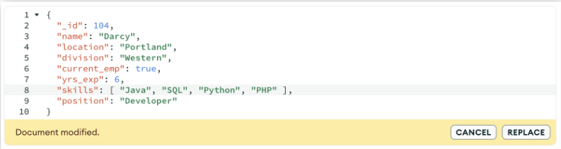
iii) Updating documents in Table View
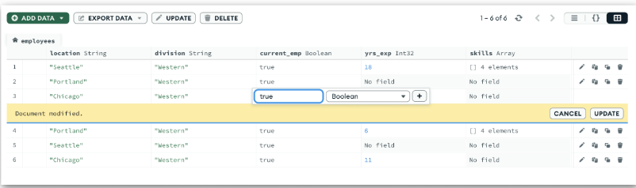
Result: Updated function has been successfully done in MongoDB Compass
Ex.4.Delete the record
Aim: To delete the record for the existing collection on MongoDB Compass.
Algorithm:
Step 1: Open MongoDB Compass on the system.
Step 2: After Successfully Opening, Click on “Connect” Button.
Step 3: After Click on “Connect” Button, Click on plus (+) Sign.
Step 4: Open the existing database and click the any existing table
Step 5:
i) Deleting single document in List View
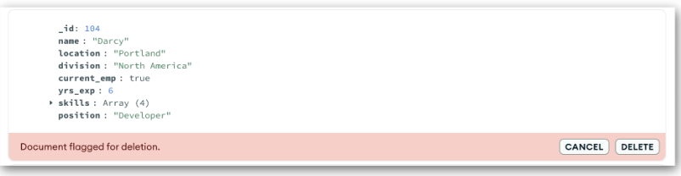
ii) Deleting bulk document in List View
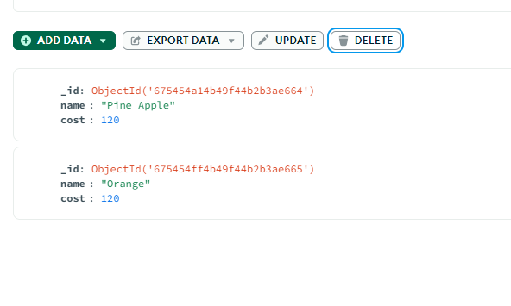
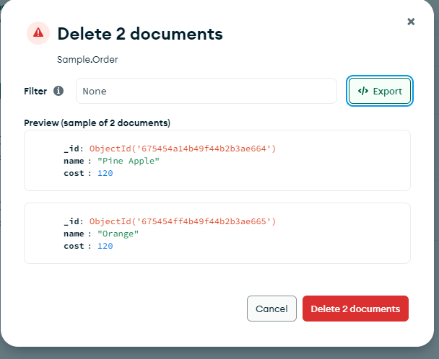

Result: Delete function has been successfully done in MongoDB Compass.

Ex.5.Drop the collection
Aim: To drop the collection on MongoDB Compass.
Algorithm:
Step 1: Open MongoDB Compass on the system.
Step 2: After Successfully Opening, Click on “Connect” Button.
Step 3: After Click on “Connect” Button, Click on plus (+) Sign.
Step 4: Open the existing database and click the any existing table
Step 5: In the collection window, click on the bin icon for the collection to delete. When you click on the trash icon, a dialog appears to ask your confirmation.
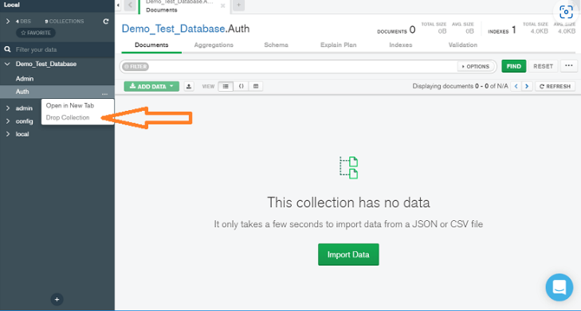
Step 6: In the appeared pop-up dialogue, enter the name of the collection you want to delete from the database.
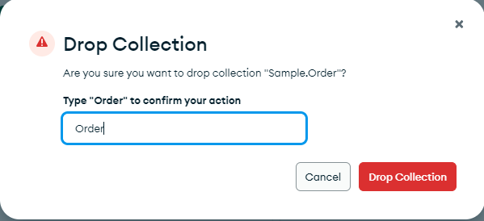
Step 7: Finally, click on Drop Collection button to delete the collection.
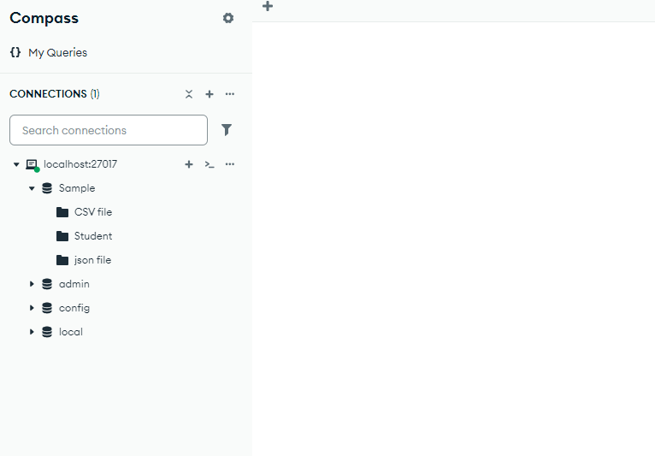
Result: Drop function has been successfully done in MongoDB Compass.

Practice Questions
- Create Collection for Movie with the following attributes for the 5 documents.

The Movies collection stores detailed information about each movie available for booking. This includes essential attributes such as the title, genre, release year, duration, ratings, and a list of actors. This data allows users to browse and select movies based on their preferences.
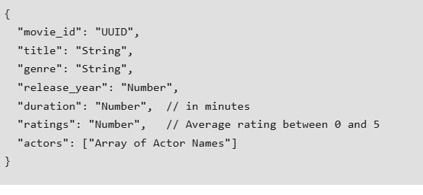

i) Insert a new movie into the Movies collection.

ii) Update the title of a movie with ID "1".

iii) Delete the document of a movie with ID “3”

2. Theaters Collection
The Theaters collection contains information about the different theaters where movies are screened. Key attributes include the theaters name, location (city, state, and country) and its seating capacity. This information is crucial for users to choose a convenient location for their movie experience.
Insert 5 document for the above collection
{
"theater_id": "UUID",
"name": "String",
"location": {
"city": "String",
"state": "String",
"country": "String"
},
"seating_capacity": "Number"
}

