ServiceNow Project Documentation: Implement Client Script & UI Policy (Incident)
This comprehensive project document provides end-to-end technical documentation for implementing client-side logic, data validation, and UI behavior policies on the Incident table in ServiceNow. The configurations documented herein ensure data integrity, streamline user experience, and enforce business rules both on Incident forms and list views.

Project Overview & Scope
The objective of this project is to implement dynamic client-side controls on the Incident (incident) table in ServiceNow. By leveraging UI Policies, UI Policy Actions, and Client Scripts (onChange, onSubmit, and onCellEdit), the platform enforces automated field behavior, field dependencies, form validations, and list editing security.
Milestone | Artifact Type | Artifact Name | Execution Context / Trigger
Milestone 1 | UI Policy | High Impact Control | Triggers when Impact = 1 - High on Incident form
Milestone 2 | UI Policy Action | Urgency Field Policy | Sets Urgency to Read-only when High Impact Control is active
Milestone 3 | onChange Client Script | Auto set urgency for high impact | Fires when Impact field value changes on Incident form
Milestone 4 | onSubmit Client Script | Prevent save if Assigned To missing | Fires on form submission to validate mandatory field 'Assigned To'
Milestone 5 | onCellEdit Client Script | Prevent state change via list edit | Fires when user attempts to inline-edit the State column in Incident list
Milestone 6 | Functional Testing | End-to-End Test Suite | Validation of 5 operational scenarios across UI Policies and Scripts

System Prerequisites & Environment Setup
- ServiceNow Platform: Personal Developer Instance (PDI) running Vancouver / Washington DC release.
- User Roles Required: admin or personal_dev_instance admin privileges to configure System UI elements.
- Target Module: Incident Management (incident table).
- Navigation Paths:
  - UI Policies: System UI > UI Policies
  - Client Scripts: System UI > Client Scripts
  - Incident List/Form: Incident > Create New / Incident > All

Milestone 1: Create UI Policy on Incident
UI Policies allow dynamically changing the behavior of information on a form based on conditions without scripting. In this step, a UI Policy named High Impact Control is created to govern field attributes when an incident is marked as High Impact.

Configuration Steps:
- Navigate to System UI > UI Policies.
- Click New to initiate a UI Policy record.
- Configure the policy parameters:
  - Name: High Impact Control
  - Table: Incident [incident]
  - Active: true (Checked)
  - Reverse if false: true (Checked)
- Set Condition: Impact is 1 - High.
- Save the UI Policy record.
- In the UI Policy Actions related list, click New to add an action for Assignment group:
  - Field name: Assignment group
  - Mandatory: True
- Click Submit.

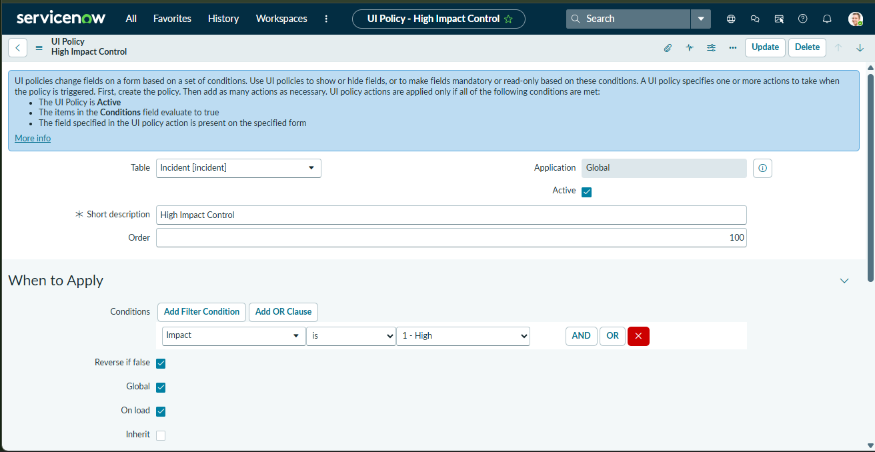

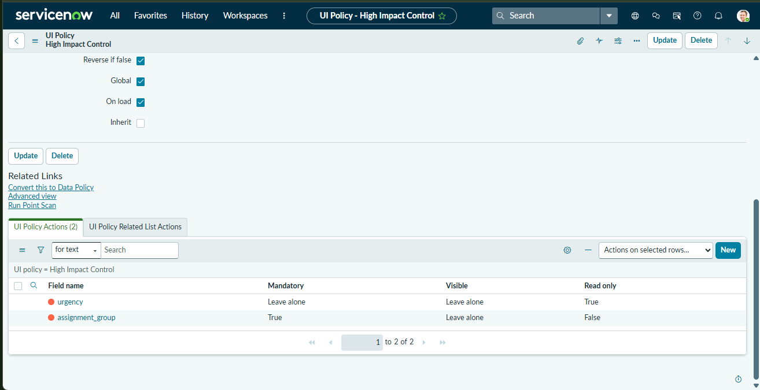

Milestone 2: Create UI Policy Action - Urgency Field
To prevent users from manually altering the Urgency field once High Impact is selected, a second UI Policy Action is linked to the High Impact Control UI Policy to enforce Read-only status on the Urgency field.

Configuration Steps:
- Open the High Impact Control UI Policy created in Milestone 1.
- Scroll down to the UI Policy Actions related list and click New.
- Fill in the Action details:
  - Field name: Urgency
  - Read-only: True
  - Visible: Leave as is
  - Mandatory: Leave as is
- Click Submit to save the action.

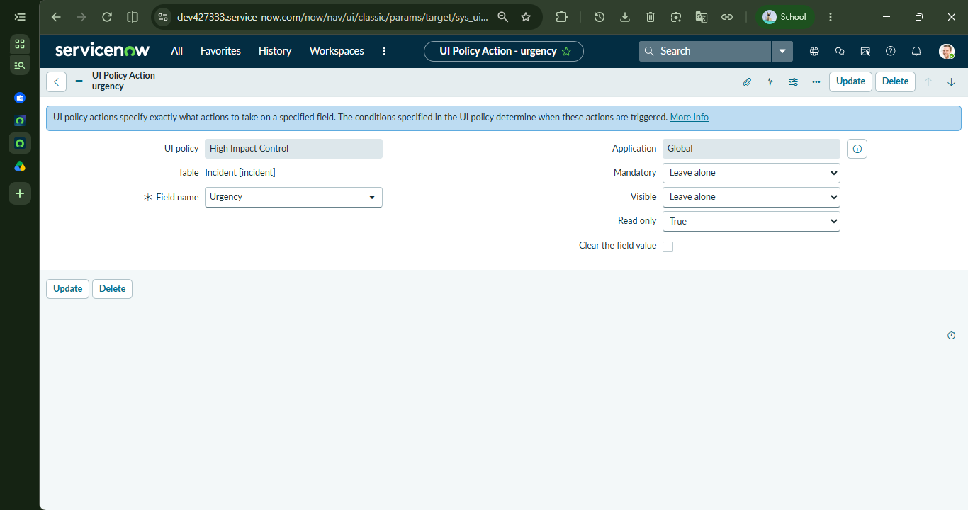

Milestone 3: Create onChange Client Script
The onChange Client Script automatically updates the urgency field to 1 - High whenever the user updates the impact field to 1 - High on the Incident form, and displays an informational message to the user.
Setting | Configured Value
Name | Auto set urgency for high impact
Table | Incident [incident]
UI Type | All / Desktop
Type | onChange
Field name | Impact
Active | true

Script Implementation:
function onChange(control, oldValue, newValue, isLoading) {
// Exit if the form is loading or the new value is empty
if (isLoading || newValue == '') {
return;
}
// Check if Impact is changed to '1' (High)
if (newValue == '1') {
g_form.setValue('urgency', '1');
g_form.addInfoMessage('Urgency set to High for High impact incident.');
}
}

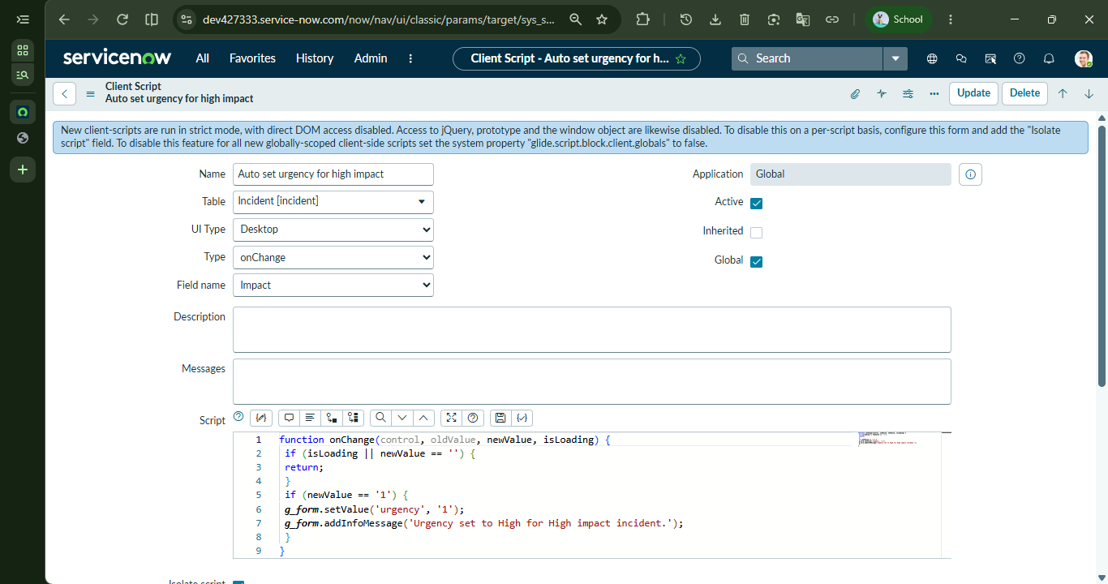

Milestone 4: Create onSubmit Client Script (Save Validation)
An onSubmit Client Script validates that high-impact incidents cannot be submitted without an assigned owner. If impact is set to 1 - High and assigned_to is empty, form submission is aborted and an error box is rendered under the field.
Setting | Configured Value
Name | Prevent save if Assigned To missing
Table | Incident [incident]
Type | onSubmit
Active | true

Script Implementation:
function onSubmit() {
// Check if Impact is High ('1') and Assigned To is empty
if (g_form.getValue('impact') == '1' && g_form.getValue('assigned_to') == '') {
g_form.showErrorBox('assigned_to', 'Assigned To is mandatory for High impact incidents.');
return false; // Prevent form save
}
return true; // Allow form save
}

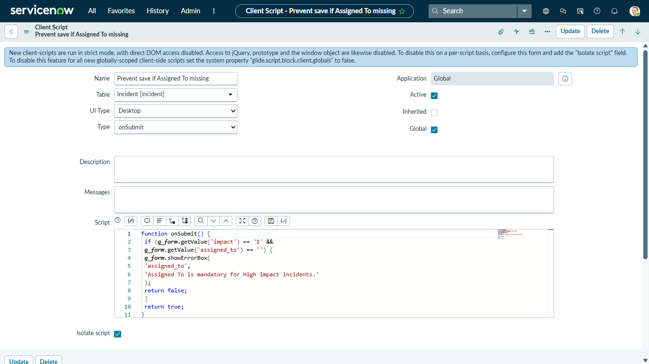

Milestone 5: Create onCellEdit Client Script
To prevent operational process bypasses, an onCellEdit Client Script is created to block users from modifying the State field directly from the Incident list view, forcing them to open the Incident record form.
Setting | Configured Value
Name | Prevent state change via list edit
Table | Incident [incident]
Type | onCellEdit
Field name | State
Active | true

Script Implementation:
function onCellEdit(sysIDs, table, oldValues, newValue, callback) {
// Show alert informing user that list editing State is disabled
alert('State cannot be updated using list editing. Please open the Incident.');
// Pass false to callback to cancel the cell edit operation
callback(false);
}

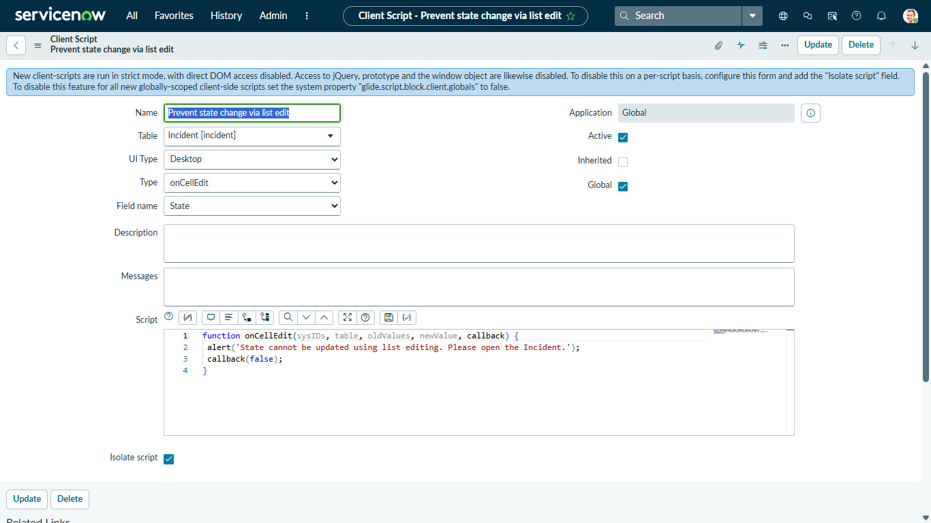

Milestone 6: Testing & Validation Results

Activity 1: Test Mandatory Enforcement (onSubmit Error Box)
Procedure: Create a new Incident record, set Impact to 1 - High, leave Assigned To blank, and click Submit.
Expected Result: Record save is blocked. An inline red error box appears under 'Assigned To' stating: "Assigned To is mandatory for High impact incidents."

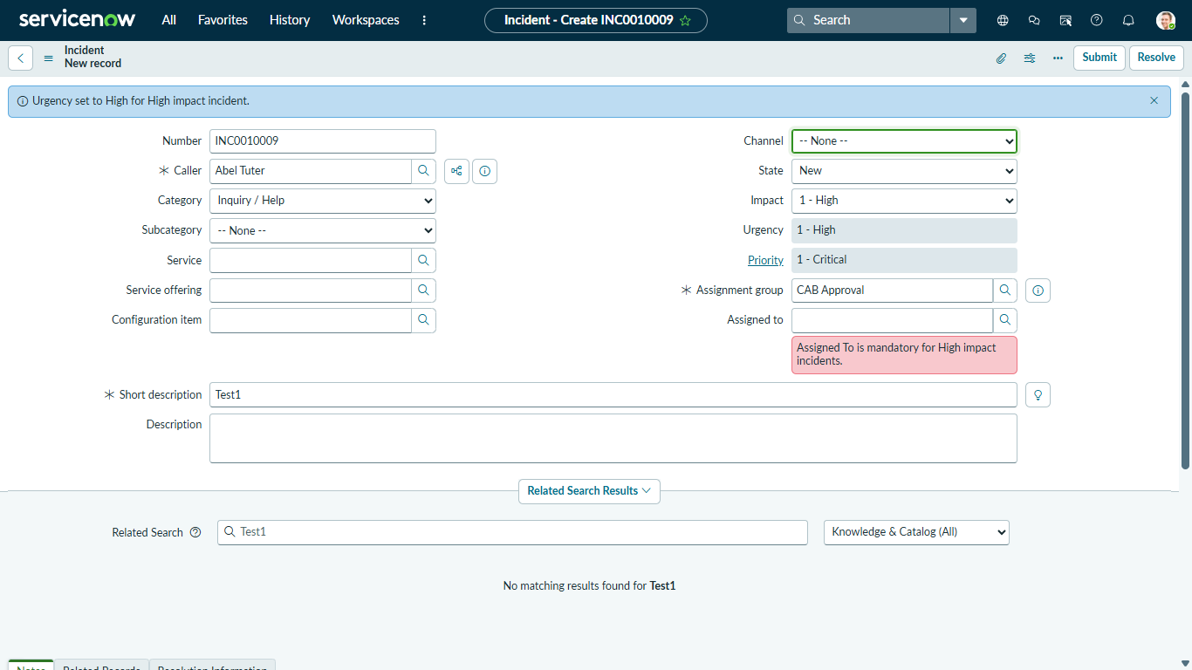

Activity 2: Test Successful Save
Procedure: Populate Assigned To with a user (e.g., Beth Anglin) while Impact is 1 - High, and click Submit.
Expected Result: Record saves successfully. Urgency is set to 1 - High and becomes Read-only. Information banner states: "Urgency set to High for High impact incident."

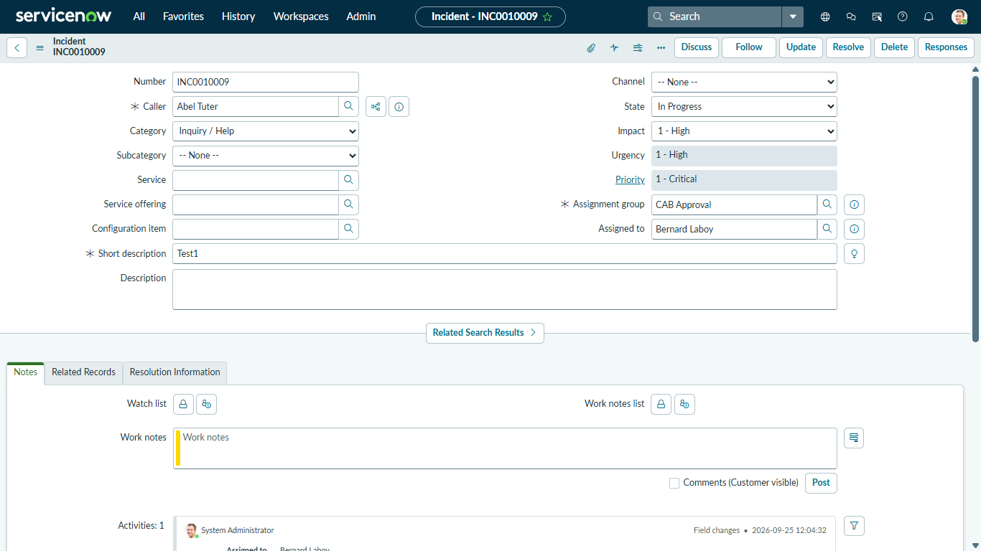

Activity 3: Reverse Condition Test
Procedure: Open an existing High Impact incident and change Impact from 1 - High to 2 - Medium.
Expected Result: The UI Policy conditions invert: Assignment Group is no longer mandatory, and Urgency becomes editable again. Record saves without error.

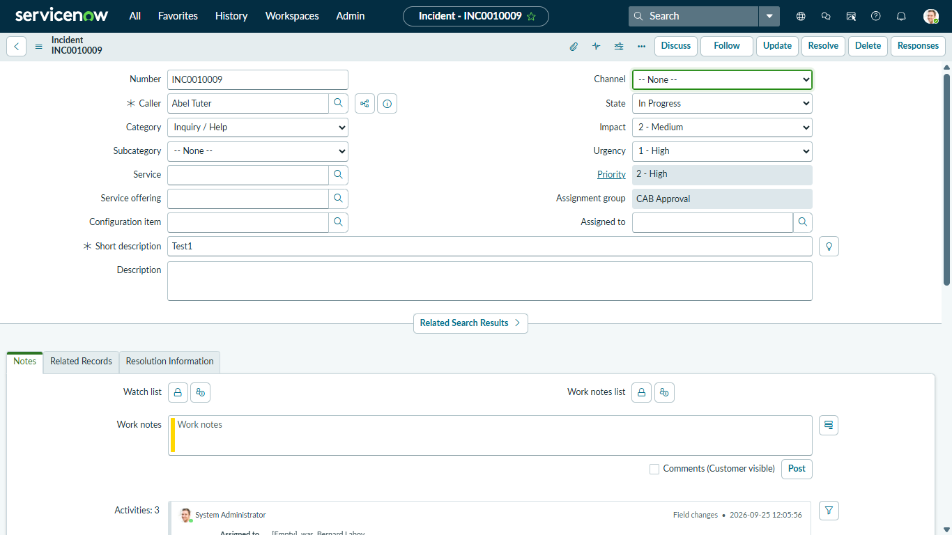

Activity 4: Test List Edit Blocking
Procedure: Navigate to Incident > All list view and double-click the State column cell for any record.
Expected Result: Browser alert pops up: "State cannot be updated using list editing. Please open the Incident." Cell modification is rejected.

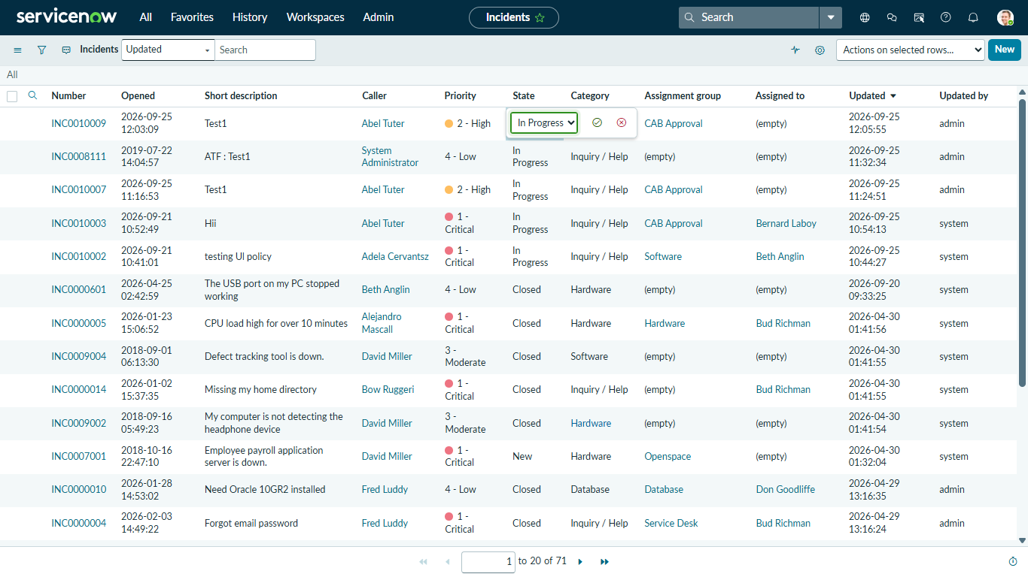

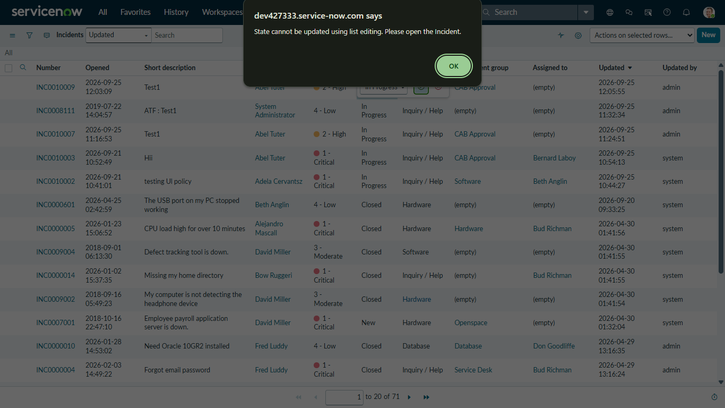

Activity 5: Test Form-Based Update
Procedure: Open the Incident record form directly, change the State field to In Progress, and click Update.
Expected Result: Form submission is successful, and the State updates properly in the database.

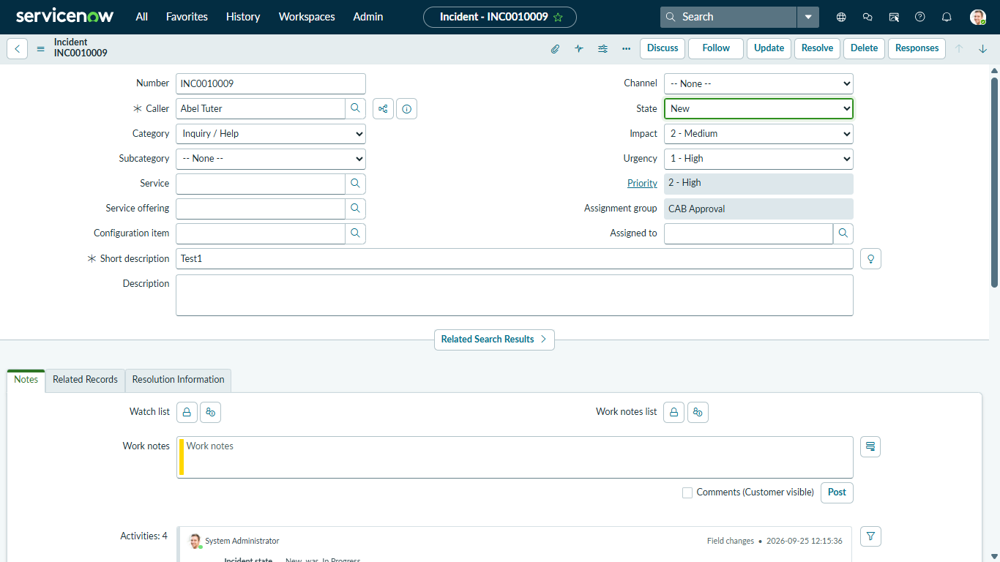

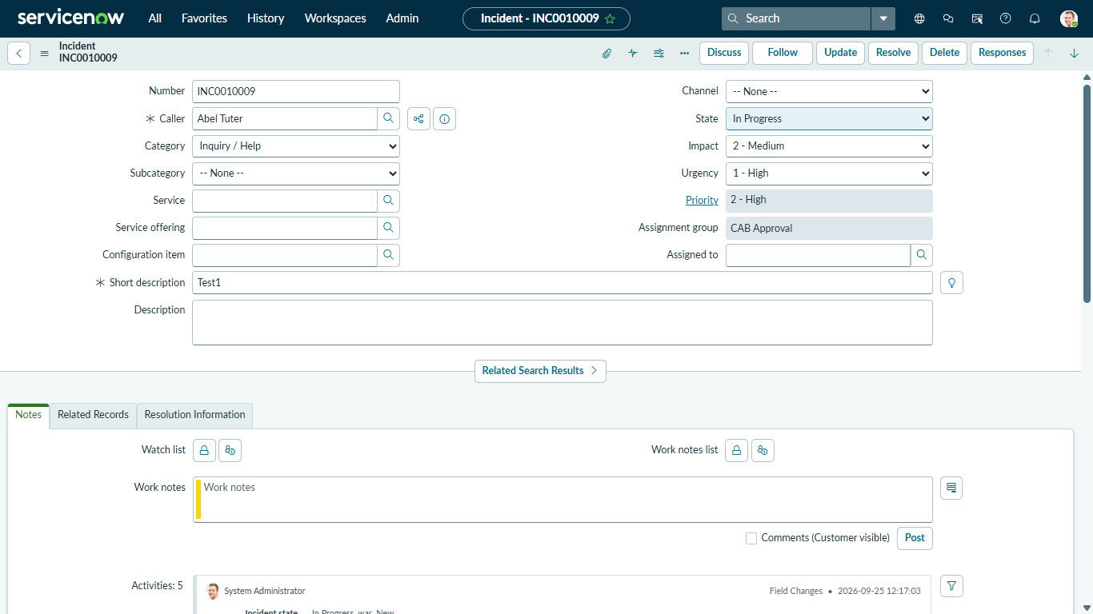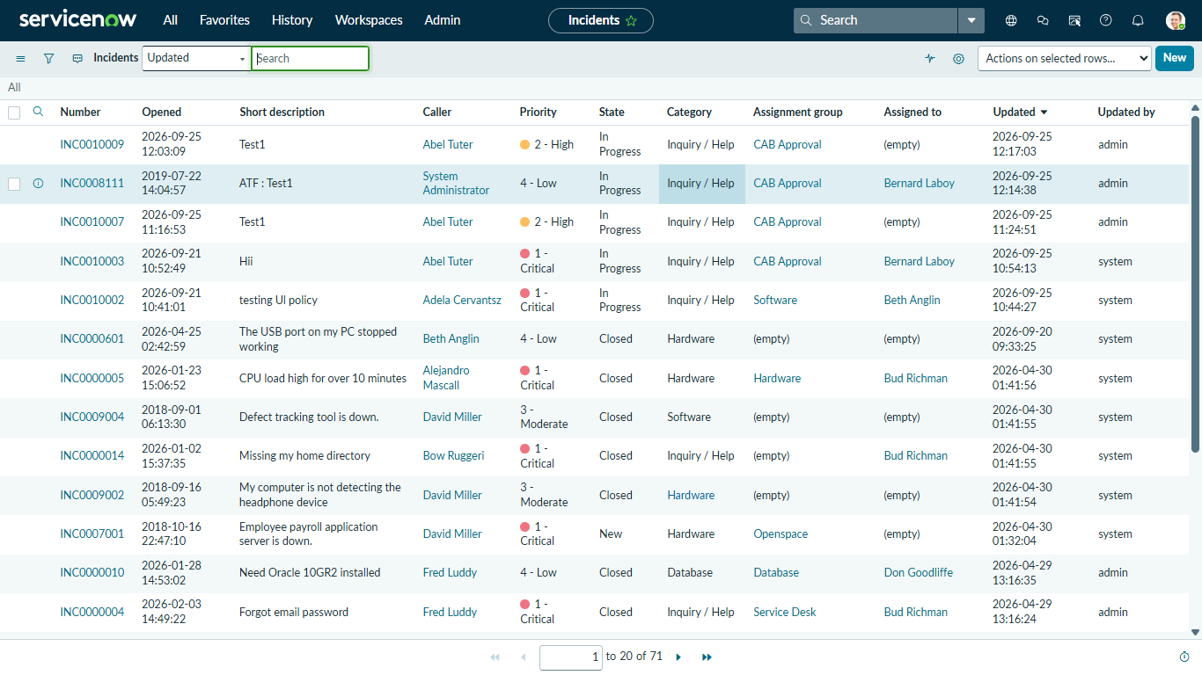

Conclusion
All 6 milestones for the Implement Client Script & UI Policy (Incident) project have been configured, tested, and validated. The combination of UI Policies and Client Scripts ensures robust client-side validation, improves user workflow accuracy, and prevents erroneous data modifications across Incident form and list contexts.

