SERVICENOW PROJECT DOCUMENTATION
Auto Ticket Classification using Flow Designer
Automated Incident Categorization and Email Notification

Project Information | Details
Project Type | ServiceNow IT Service Management / Automation
Primary Artifact | Flow Designer — Auto Classify School IT Tickets
Target Table | Incident Workflow
Primary Trigger | Record Created
Classification Input | Short Description
Categories | Network, Hardware, Access, Performance
Subcategories | Wi-Fi, Projector, Forgot Password, Slow Computer
Automation | Category + Subcategory + Email Notification
Reference Structure | ServiceNow implementation documentation format

Prepared as a project implementation, demonstration and presentation document

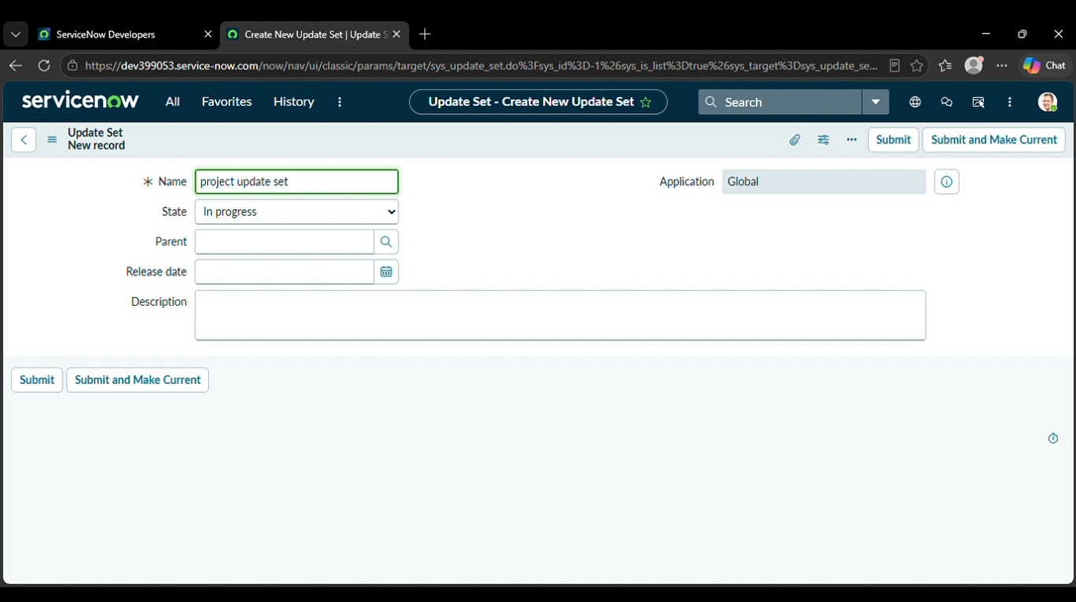
072544
1. Executive Summary
This project implements an automated IT ticket classification solution in ServiceNow using Flow Designer. The school IT helpdesk receives requests such as Wi-Fi problems, projector failures, password issues and slow computers. Instead of manually selecting a category and subcategory, the flow evaluates keywords in the Short Description and updates the ticket automatically.
The project uses a no-code Flow Designer approach. When an Incident Workflow record is created and Category is empty, the flow evaluates the Short Description and assigns the corresponding Category and Subcategory. After classification, an email notification is sent to the caller.
Project Outcome
- Create a structured Incident Workflow table for school IT tickets.
- Capture Caller, Category, Subcategory, Short Description, Description, State and assignment information.
- Implement dependent Category/Subcategory choices.
- Automatically classify Wi-Fi, Projector, Password/Login and Slow/Hanging issues.
- Send a ticket confirmation email to the caller.
- Validate the automation using representative test scenarios.
- Package the configuration in an Update Set for reuse or deployment.
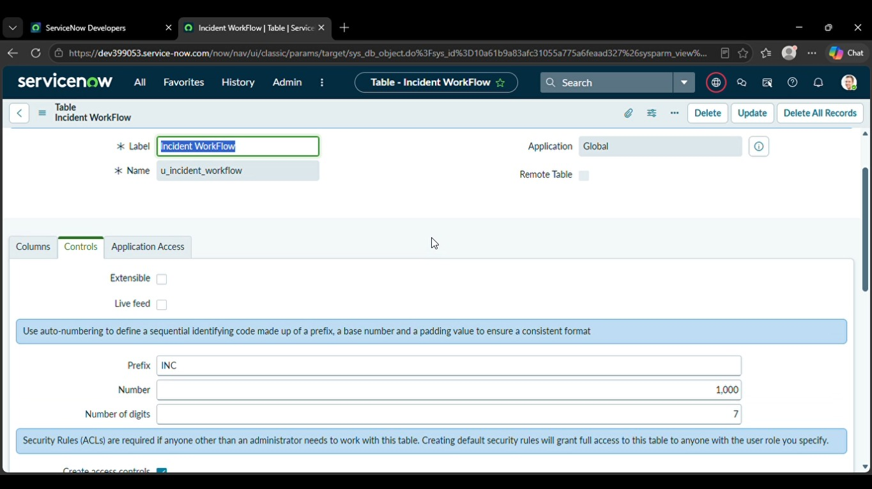
2. Project Overview & Scope
The implementation covers the complete path from ticket creation to automatic classification and notification. The main control is the Flow Designer flow named “Auto Classify School IT Tickets.”
Milestone | Artifact / Activity | Purpose
1 | Requirement Analysis | Define the helpdesk problem and automation requirements
2 | Update Set | Track project configuration changes
3 | Custom Table | Store structured IT ticket records
4 | Field Configuration | Create fields, choices and reference fields
5 | Dependency | Link Subcategory choices to Category
6 | Flow Trigger | Start automation when a record is created
7 | Classification Logic | Assign Category and Subcategory from keywords
8 | Email Action | Notify the caller after classification
9 | Testing | Validate multiple ticket scenarios
10 | Deployment | Complete and export the Update Set

Scope
- ServiceNow development / Personal Developer Instance or equivalent environment.
- School IT helpdesk ticket classification.
- No-code Flow Designer implementation.
- Keyword-based classification using Short Description.
- Automated email confirmation to the caller.
Out of Scope
- External identity-provider integration.
- Advanced machine-learning classification.
- Production change-management approval.
- Complex routing rules not described in the supplied project.
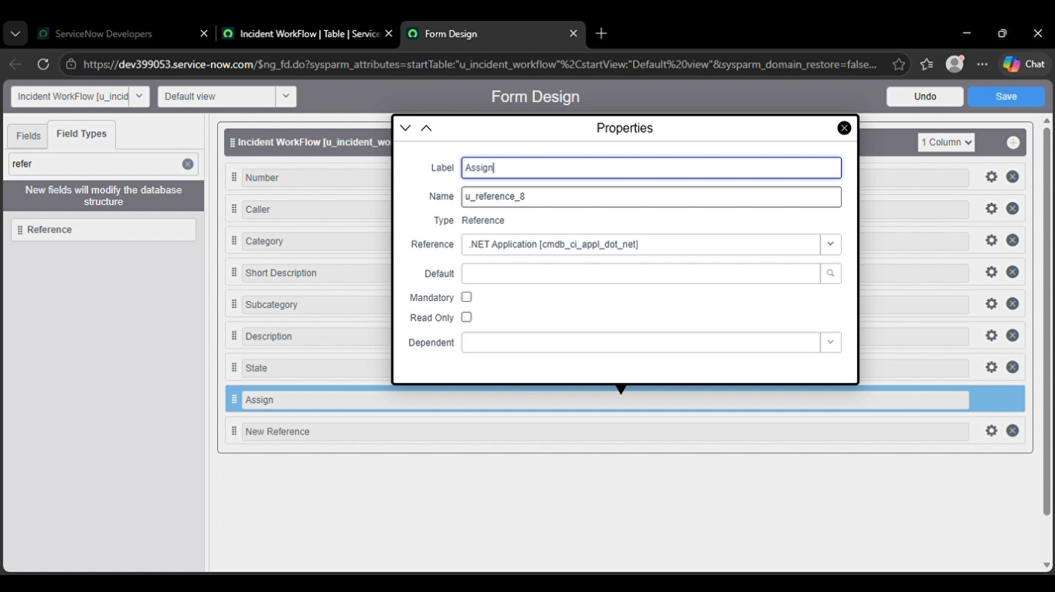

3. Automation Architecture
The project separates ticket data capture from automation logic. The Incident Workflow table stores the ticket, while Flow Designer evaluates the Short Description and updates classification fields.
Layer | Component | Responsibility
Input | Caller + Short Description | Provides the basic information required to create the ticket
Data | Incident Workflow table | Stores ticket number, caller, classification, state and assignment information
Choice Model | Category / Subcategory | Provides standardized classification values
Dependency | Category → Subcategory | Restricts subcategory choices according to category
Automation | Flow Designer | Evaluates keywords and updates the record
Notification | Send Email action | Sends ticket confirmation to the caller
Deployment | Project Update Set | Packages configuration changes for reuse

High-Level Flow
- User creates a new Incident Workflow ticket.
- Flow triggers when the record is created and Category is empty.
- Flow checks the Short Description for supported keywords.
- The matching branch updates Category and Subcategory.
- The flow sends an email notification to the caller.
- The ticket is stored with standardized classification values.

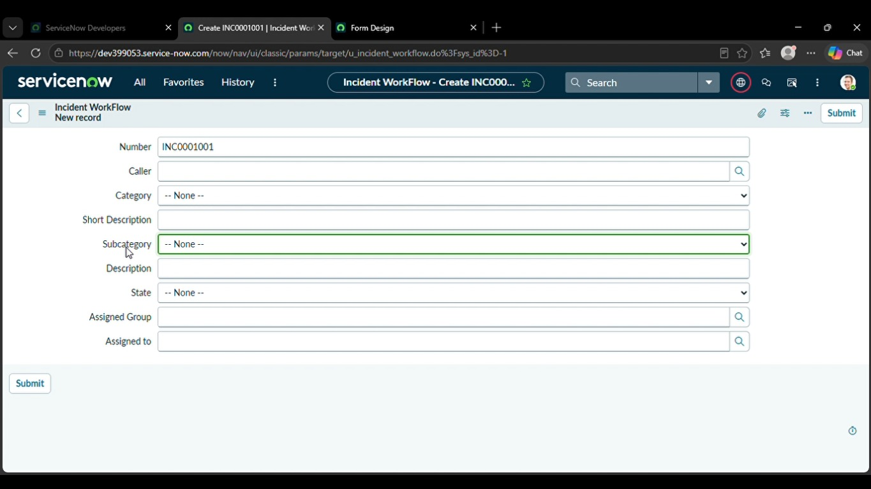

4. System Prerequisites & Environment Setup
Before building the automation, the ServiceNow instance should provide access to tables, Form Designer, Flow Designer and Local Update Sets.
Requirement | Configuration
Platform | ServiceNow development / Personal Developer Instance
Application | Global
Main navigation | All → System Definition → Tables; Process Automation → Flow Designer
Update Set | Project Update Set
Target table | Incident Workflow
Trigger | Record Created
Flow name | Auto Classify School IT Tickets
Classification input | Short Description

Important Navigation Paths
- All → System Update Sets → Local Update Sets
- All → System Definition → Tables
- Open the Incident Workflow form → Form Designer
- Process Automation → Flow Designer
- System Logs → Emails for notification verification

5. Phase 1 — Requirement Analysis & Update Set
The project begins by defining the helpdesk use case and then creating a Local Update Set named Project Update Set. The Update Set is made current so subsequent configuration changes are tracked.
Business Requirements
- Automatically classify IT tickets based on the issue description.
- Assign both Category and Subcategory without manual intervention.
- Support dependent choice logic between Category and Subcategory.
- Send an automated email notification to the caller upon ticket creation.
- Store ticket information in a structured and standardized format.
- Keep the solution easy to maintain and scalable.
Update Set Configuration
Setting | Value
Name | Project Update Set
State | In progress
Application | Global
Final action | Make This My Current Set

6. Phase 2 — Create the Incident Workflow Table
A custom table is created to store the school IT ticket records. The project labels the table Incident Workflow, disables the Create module during setup, enables Auto Number through Controls, and then uses Form Designer to create the required fields.
Configuration Steps
- Open All menus → System Definition → Tables.
- Click New and set Label to Incident Workflow.
- Uncheck Create module and save the form.
- Open Controls and enable Auto Number.
- Save and use the related links / Form Designer to create the fields.

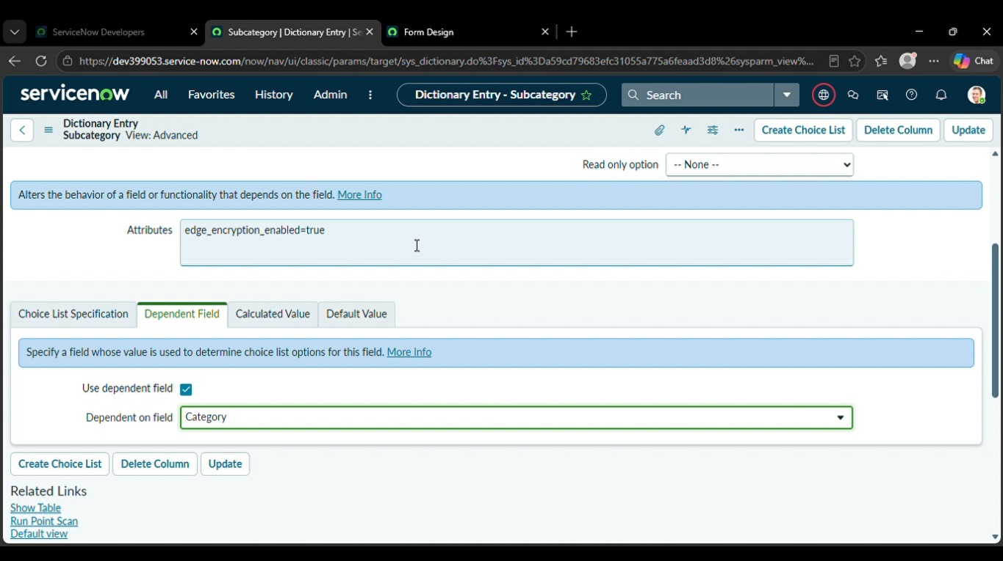
7. Activity — Field Creation & Data Type Configuration
The project creates structured fields so tickets can be classified consistently. Category, Subcategory and State are choice fields; Caller, Assigned Group and Assigned to use reference fields.
Field Label | Type | Reference / Choice
Number | Auto Number | —
Caller | Reference | sys_user
Category | Choice | Network, Hardware, Access, Performance
Subcategory | Choice | Wi-Fi, Projector, Forgot Password, Slow Computer
Short Description | String | —
Description | String | —
State | Choice | New, In progress, On hold, Resolved, Closed
Assigned Group | Reference | sys_user_group
Assigned to | Reference | sys_user

After creating the fields, add the choices through Form Designer and save/reload the form.

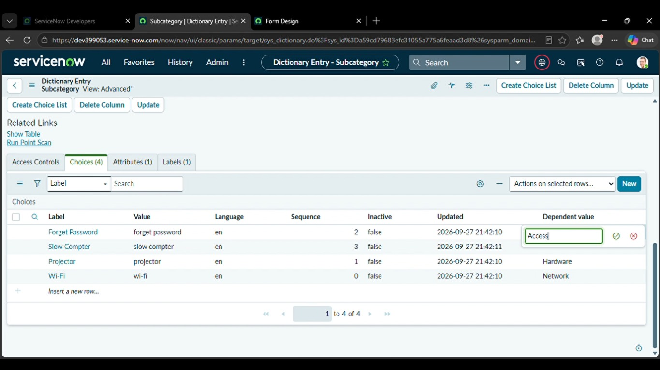
8. Activity — Category / Subcategory Dependency
The project implements a dependency between Category and Subcategory so that the available Subcategory options change according to the selected Category.
Navigation Steps
- Open the Incident Workflow form and right-click the Subcategory field.
- Select Configure Dictionary.
- Open the Advanced view from Related links.
- Enable Use dependent field.
- Select Category in the Dependent on field.
- Add the dependent choices and save.
Subcategory | Depends on Category
Wi-Fi | Network
Projector | Hardware
Forgot Password | Access
Slow Computer | Performance

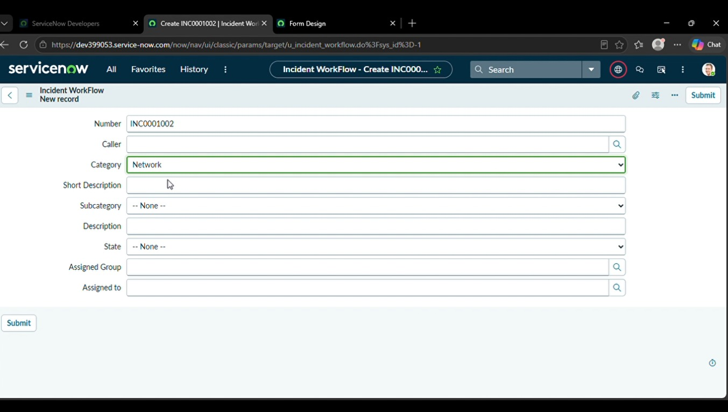
9. Phase 3 — Flow Designer & Trigger Configuration
The core automation is a Flow Designer flow named Auto Classify School IT Tickets. The flow starts when a ticket record is created and the Category field is empty.
Flow Configuration
Setting | Value
Flow Name | Auto Classify School IT Tickets
Application | Global
Trigger | Record Created
Table | Incident Workflow
Condition | Category is Empty
Logic | If / Else If classification branches
Final Action | Send Email to Caller

Build Steps
- Go to Process Automation → Flow Designer.
- Click New and select Flow.
- Enter the flow name and application.
- Click Build Flow.
- Configure the Record Created trigger for Incident Workflow.
- Set Category is Empty and click Done.

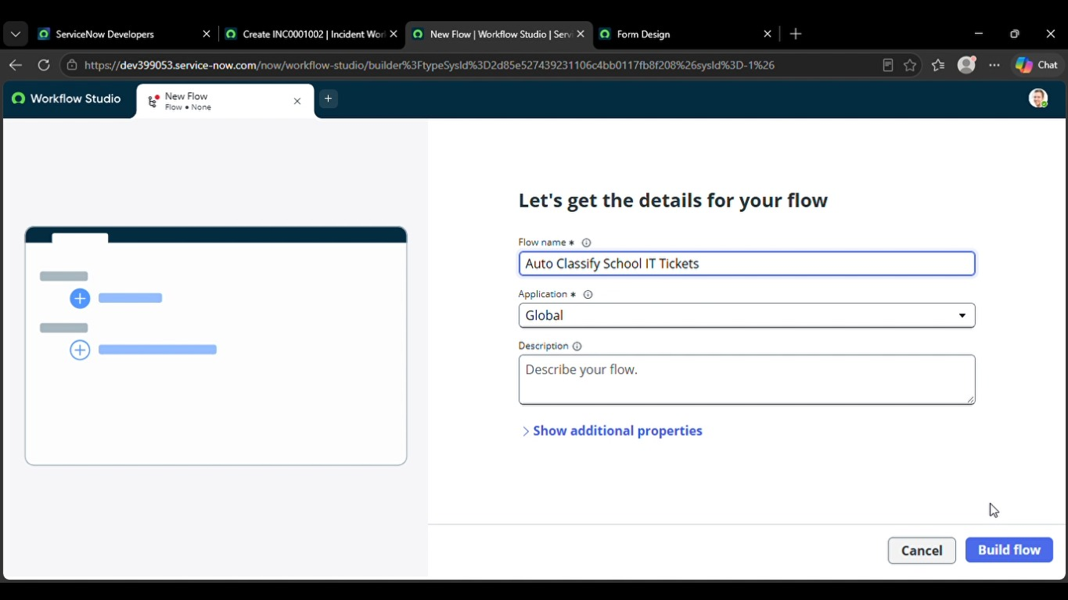

10. Activity — Automated Ticket Classification Logic
After the trigger, the flow uses Flow Logic to evaluate the Short Description. Each branch updates the record with the matching Category and Subcategory.
Classification Rules
Keyword / Condition | Category | Subcategory
Wi-Fi / Network | Network | Wi-Fi
Projector | Hardware | Projector
Password / Login | Access | Forgot Password
Slow / Hanging | Performance | Slow Computer

Wi-Fi Branch
- Select If condition.
- Check whether Short Description contains Wi-Fi or Network.
- Use Update Record.
- Set Category = Network and Subcategory = Wi-Fi.

11. Activity — Remaining Classification Branches
The remaining branches follow the same pattern: evaluate a keyword in Short Description and update the ticket fields with standardized values.
Projector Branch
- Else If condition checks for Projector.
- Update Record: Category = Hardware.
- Update Record: Subcategory = Projector.
Password Branch
- Else If condition checks for Forgot Password / Password / Login.
- Update Record: Category = Access.
- Update Record: Subcategory = Forgot Password.
Slow Computer Branch
- Else If condition checks for Slow / Hanging / Slow Computer.
- Update Record: Category = Performance.
- Update Record: Subcategory = Slow Computer.

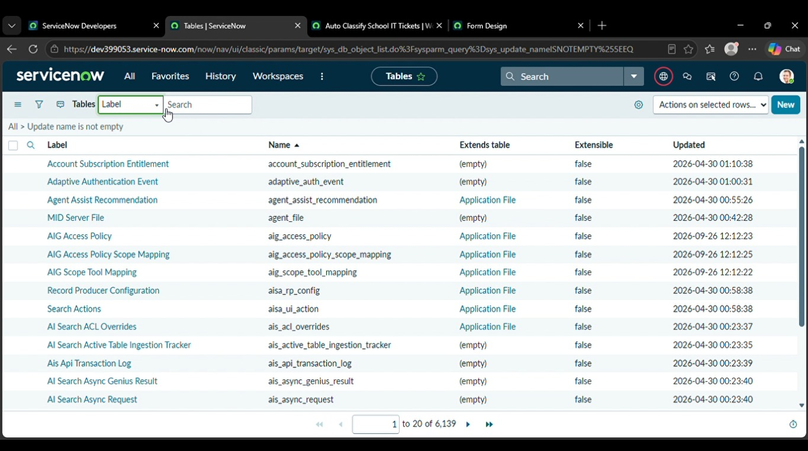

12. Activity — Email Notification Setup
After classification, the flow sends an email notification to the caller. This gives the requester a confirmation that the ticket has been submitted.
Email Action Configuration
Setting | Configured Value
Action | Send Email
To | Caller → Email
Subject | Your Request for the issue has been submitted.
Body | Ticket confirmation message

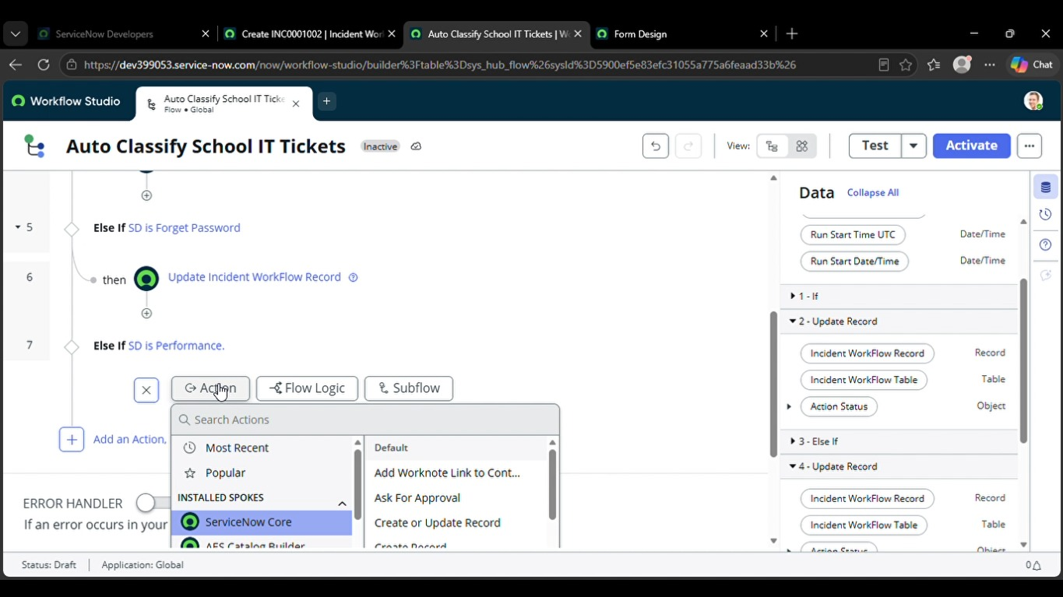
13. Phase 4 — Testing, Validation & Security
Testing validates the complete automation: required data is captured, classification values are populated correctly, and the email notification is generated.
Test Scenario 1 — Wi-Fi
- Enter a Caller.
- Short Description: WiFi not working in library.
- Save and reload the form.
- Expected Category → Network.
- Expected Subcategory → WiFi.
- Verify that an email is sent to the caller.
Test Scenario 2 — Projector
- Enter a Caller.
- Short Description: Projector not turning on.
- Save and reload the form.
- Expected Category → Hardware.
- Expected Subcategory → Projector.
- Verify that an email is sent to the caller.
Test | Input | Expected Classification
T01 | WiFi not working in library | Network / Wi-Fi
T02 | Projector not turning on | Hardware / Projector
T03 | Forgot password | Access / Forgot Password
T04 | Computer is slow / hanging | Performance / Slow Computer

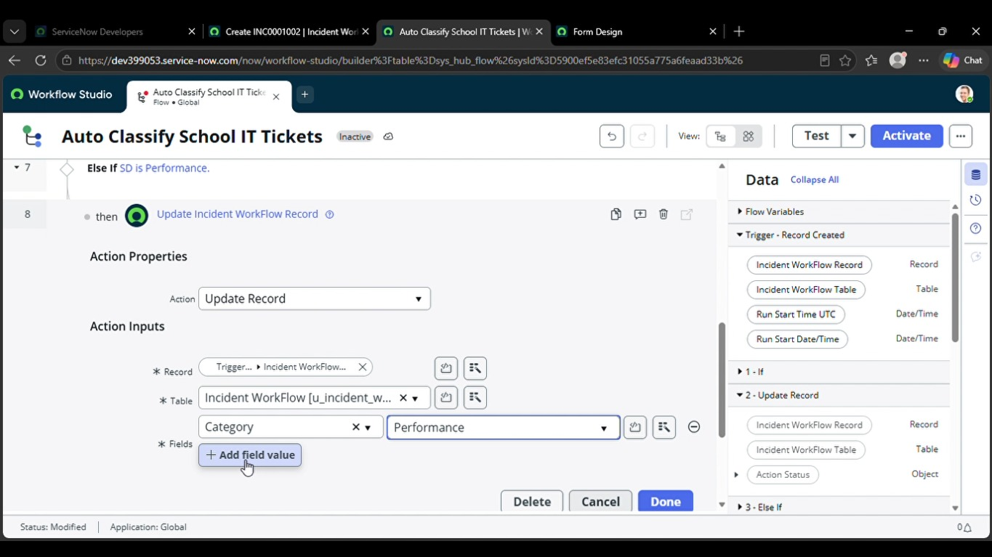
14. Testing Evidence & Email Verification
For a project demonstration, capture evidence showing the ticket before/after automation and the generated email. The project includes an email-log verification procedure.
Email Verification Procedure
- Open All menus → Search Emails.
- Under System Logs → select Emails.
- Search using the configured subject.
- Open the email record and use Preview mail from Related Links.
- Confirm that the recipient and confirmation content are correct.

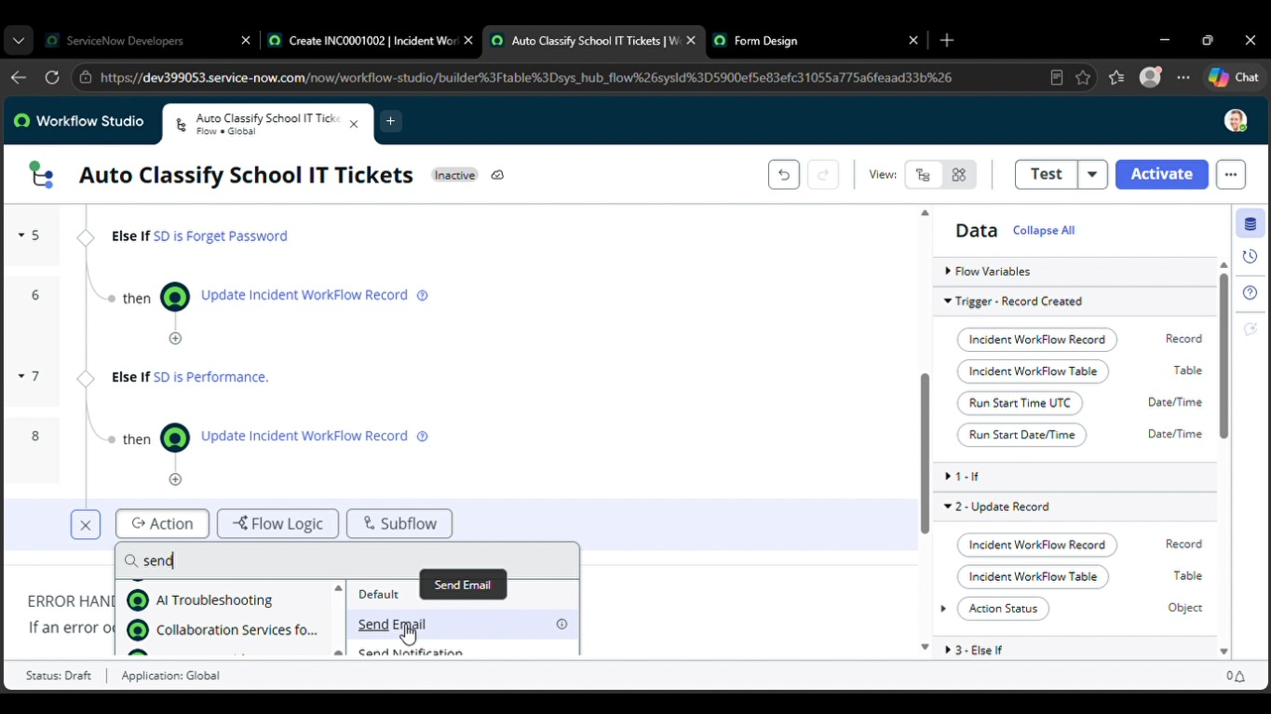
15. Phase 5 — Deployment & Final Documentation
The final stage prepares the project for reuse or demonstration by completing the Local Update Set and exporting its configuration as XML.
Deployment Steps
- Go to All menus → System Update Sets → Local Update Sets.
- Open Project Update Set.
- Change State from In progress to Complete.
- Save the form.
- Use Related Links → Export to XML.
- The downloaded XML can be shared or imported into another suitable instance.

16. Conclusion
The Auto Ticket Classification using Flow Designer project provides an end-to-end no-code automation for a school IT helpdesk. It standardizes ticket classification by mapping issue keywords to Category and Subcategory, reduces manual classification work, and provides an automated confirmation email to the caller. The project also includes structured testing and Update Set deployment steps.

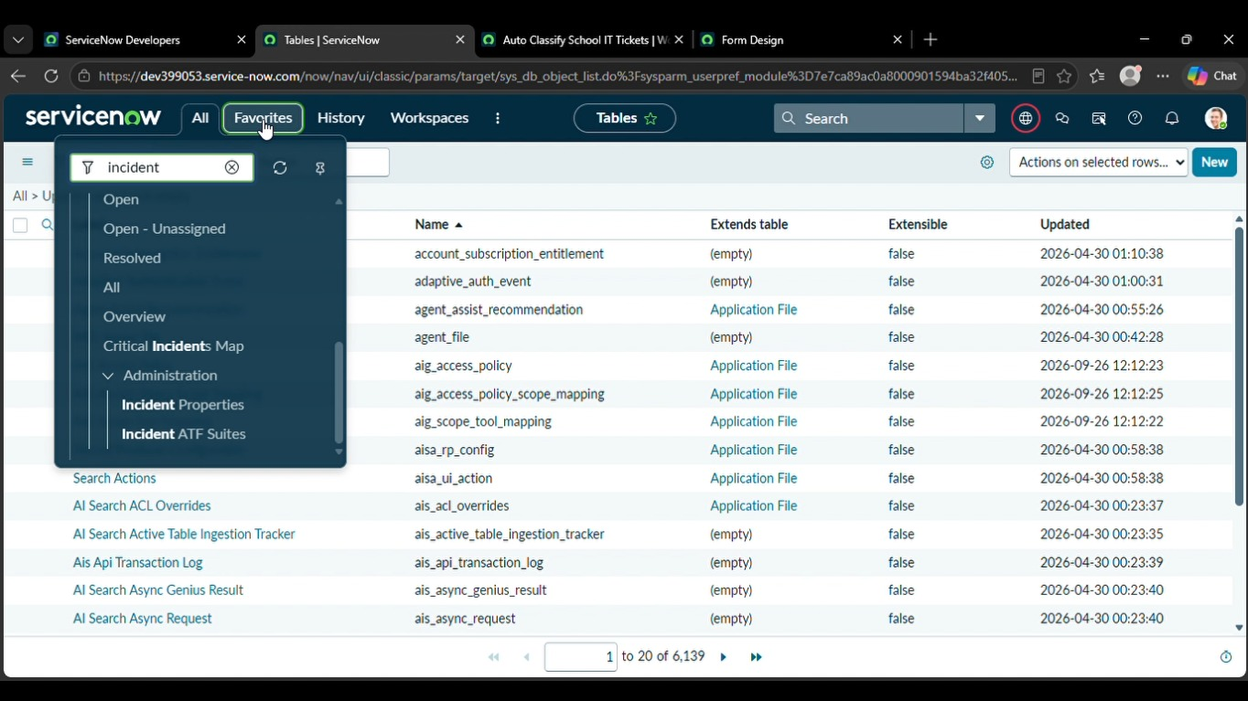
17. Troubleshooting & Validation Checklist
Problem | What to Check
Flow does not trigger | Confirm the flow is Active and the trigger table is Incident Workflow.
Category stays empty | Check that the Short Description contains a supported keyword and Category was empty at creation.
Wrong Subcategory | Verify the If / Else If condition and Update Record values.
Subcategory choices are not filtered | Verify the dependent field configuration and Category mapping.
Email is not generated | Check Send Email action, Caller email reference and System Logs → Emails.
Changes are not in Update Set | Confirm Project Update Set is the current set before configuration.
Cannot deploy configuration | Complete and export the Project Update Set as XML after final validation.

10 Screenshot Checklist
- 1 — Requirement / Update Set
- 2 — Incident Workflow table
- 3 — Fields and choices
- 4 — Category/Subcategory dependency
- 5 — Flow trigger
- 6 — Wi-Fi classification branch
- 7 — Remaining classification branches
- 8 — Email action
- 9 — Testing / email verification
- 10 — Completed Update Set / XML export

