Lab Experiment -1
NAME:Surapaneni Vathsalya
Course: MTECH VLSI & ES
Roll No:MUMT2512963
I-V Characteristics of Semiconductors
AIM : To study the I-V characteristics of intrinsic and extrinsic semiconductors.

OBJECTIVES:

1. Study the characteristics of undoped silicon.
2. Study the characteristics of doped silicon.
3. Study the characteristics of undoped germanium.
4. Study the characteristics of doped germanium.
SOFTWARE TOOL: Synopsys TCAD Sentaurus.

Semiconductors have unique electrical properties that place them between conductors, which allow electricity
to flow freely, and insulators, which do not conduct electricity. In both semiconductors and insulators, the
valence band (where electrons are normally found) and the conduction band (where electrons move to
conduct electricity) are separated by a forbidden energy gap (E₉) of significant width. The Fermi energy (Eₓ) lies
between the valence and conduction bands. For an electron to move into the conduction band, it must acquire
sufficient energy to cross this band gap. Once the electron makes this leap, it can contribute to electrical
conductivity.
The semiconductor crystals used in integrated circuits (ICs) and other applications are typically made from
high-purity single-crystal silicon with a purity of 99.999999999%. However, to create a functional circuit,
impurities are deliberately introduced to modify the electrical properties. Depending on the type of impurity
added, the semiconductor becomes either n-type or p-type.
For n-type semiconductors, pentavalent impurities like phosphorus (P) are added to high-purity silicon. These
impurities, known as donors, have an energy level close to the conduction band, meaning the energy gap is
small. As a result, electrons at this energy level can easily be excited into the conduction band, where they
enhance the material's conductivity.
In contrast, for p-type semiconductors, trivalent impurities such as boron (B) are introduced. These impurities,
known as acceptors, have an energy level close to the valence band. Since there are no electrons at this energy
level, electrons from the valence band are easily excited to the acceptor level, leaving behind "holes" in the
valence band. These holes act as positive charge carriers, contributing to the semiconductor's conductivity.
PROCEDURE:
1.Create a new folder. In the folder, Open in Terminal and enter the command ‘sde’ in the terminal.
2.Go to View, GUI Mode and select 2D Mode
3.Go to Draw and unselect ‘Auto Region Naming’. Select ‘Exact Coordinates’ on the Right Toolbar.
4.Change the grid width and height to desired value (~0.01).
5.Now select silicon as material and place a rectangle on the canvas
.6.Select the coordinates and enter the name of the region.
7.Create the p and n contacts and set them to either side of the silicon.
8.Then draw the mesh and set the min and max size in the refinement placement.
9.Now build the mesh and the device structure will open in svisual.
10. Edit the command file for the required plots and run in the terminal.
11. Next enter svisual in the terminal to plot the graphs using the plt file generated by running the command file.
12. Plot the I-V characteristics by using p contact Outer Voltage on x-axis and p contact Total current on y-axis.
RESULTS
Fig(1):Silicon undoped
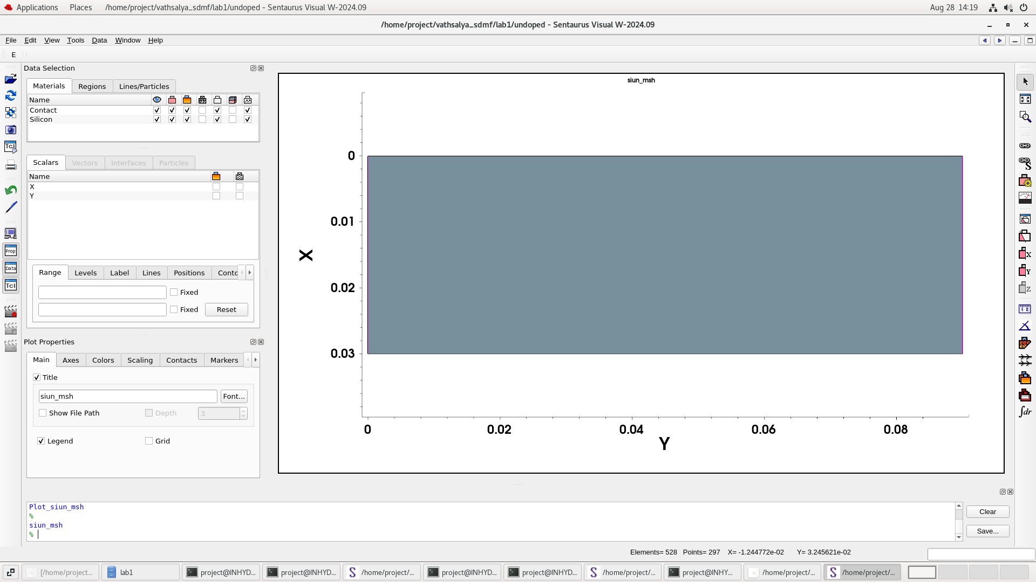

Fig(2):Silicon doped
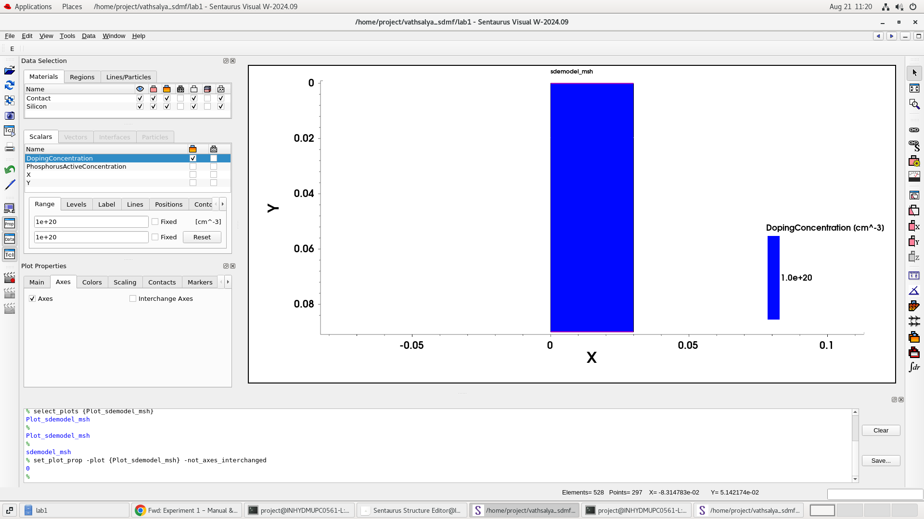
Fig(3):I-V characteristics of undoped Silicon

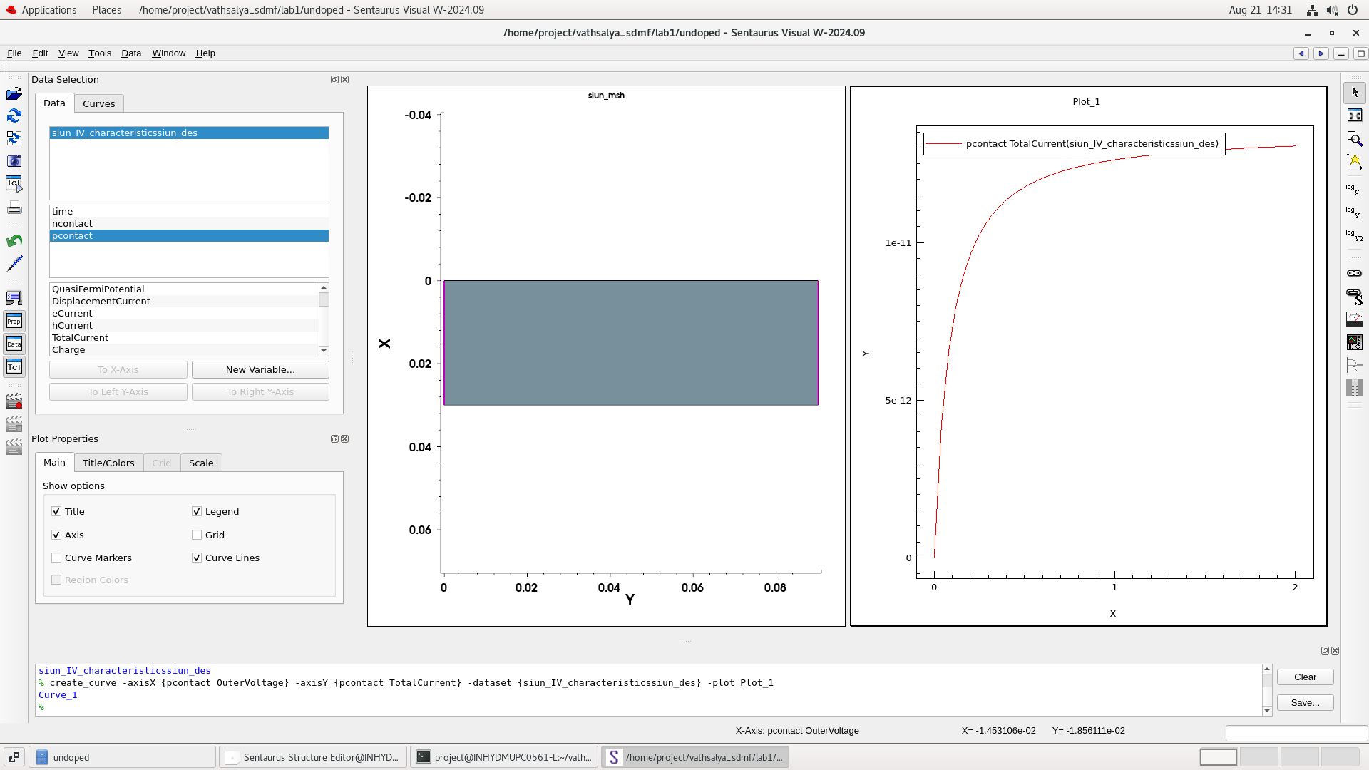

Fig(4):I-V characteristics of doped Silicon
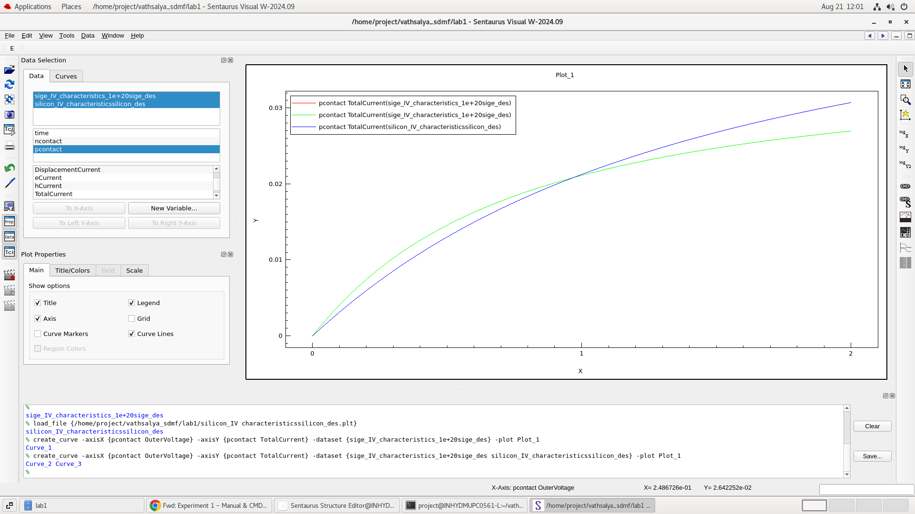
We observe the doping concentration of Si in Fig (1) and (2). Fig (1) shows the undoped Si. Fig (2) is
doped n type Si with 1e19 doping concentration.
We also observe the I-V Characteristics of undoped & doped Si in Fig (3) and Fig (4) respectively.
The maximum current of Undoped Si is 4e-11 A at 2V, while the maximum current of Doped Si is
4.6e-4 A at 2V.
Fig(5):Germanium doped
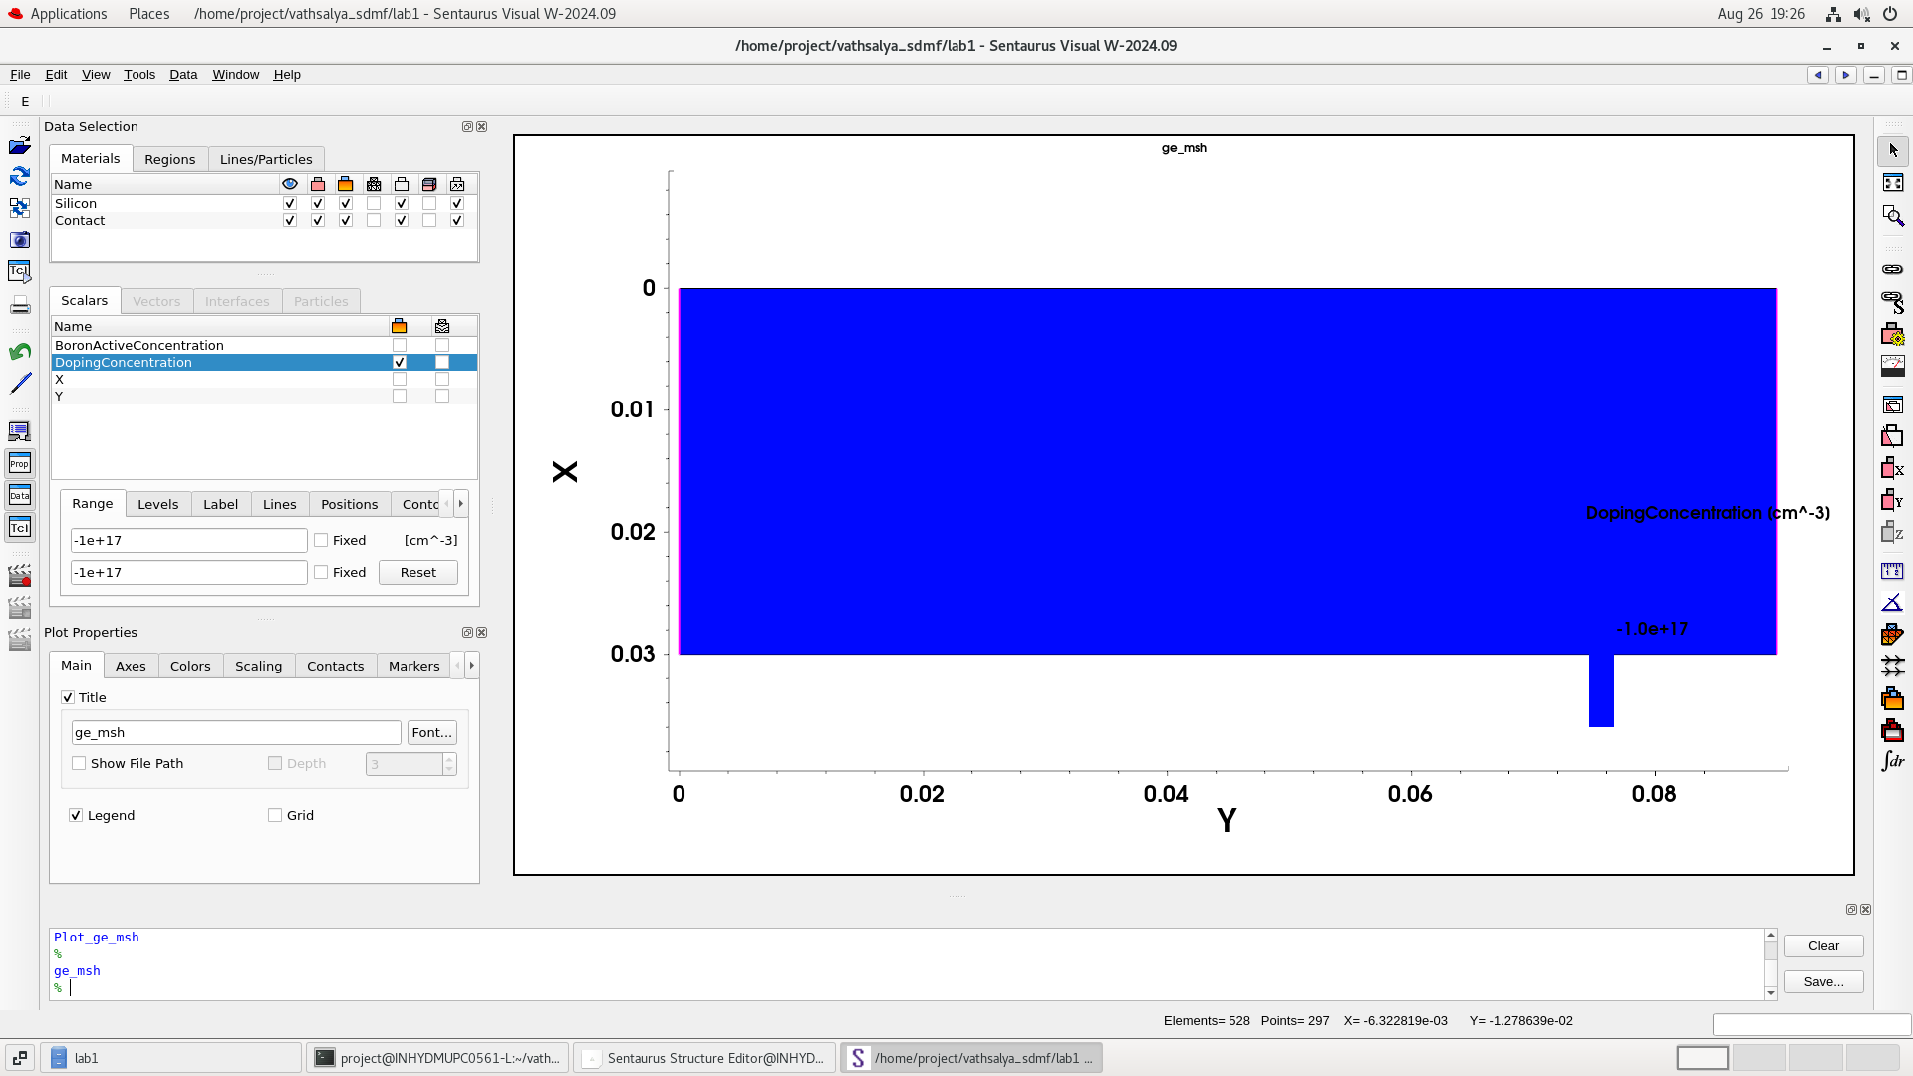

Fig(6):I-V characteristics of doped Germanium
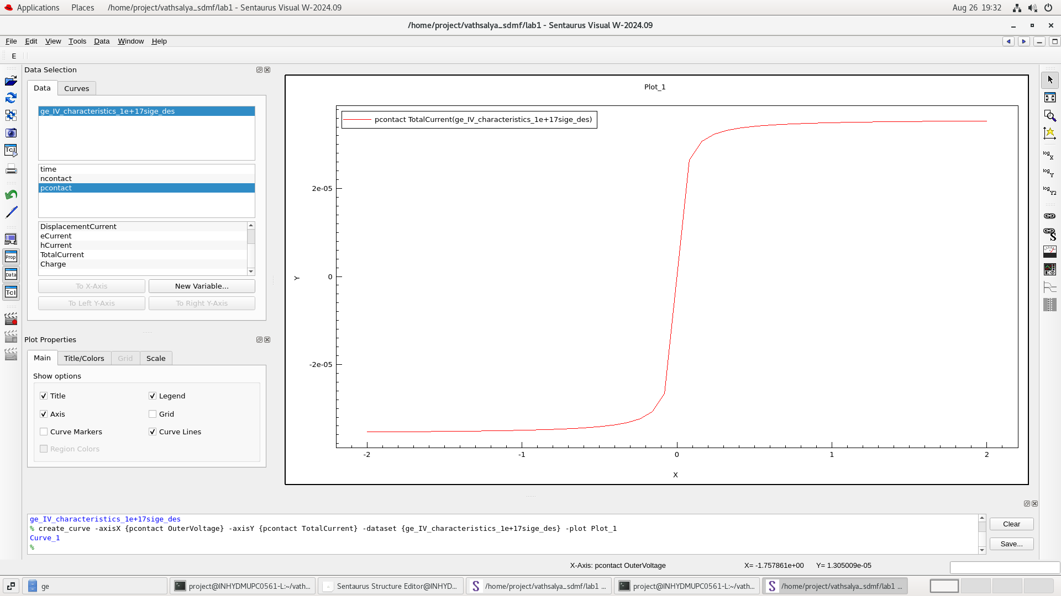
Fig(7): I-V characteristics of silicon Undoped(vs)silicon doped
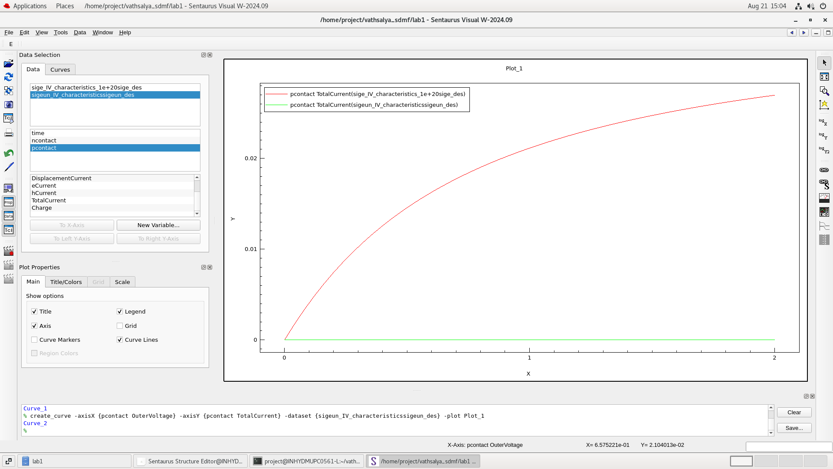

characteristics of Germanium Undoped(vs)Germanium doped
Fig(8):I-V
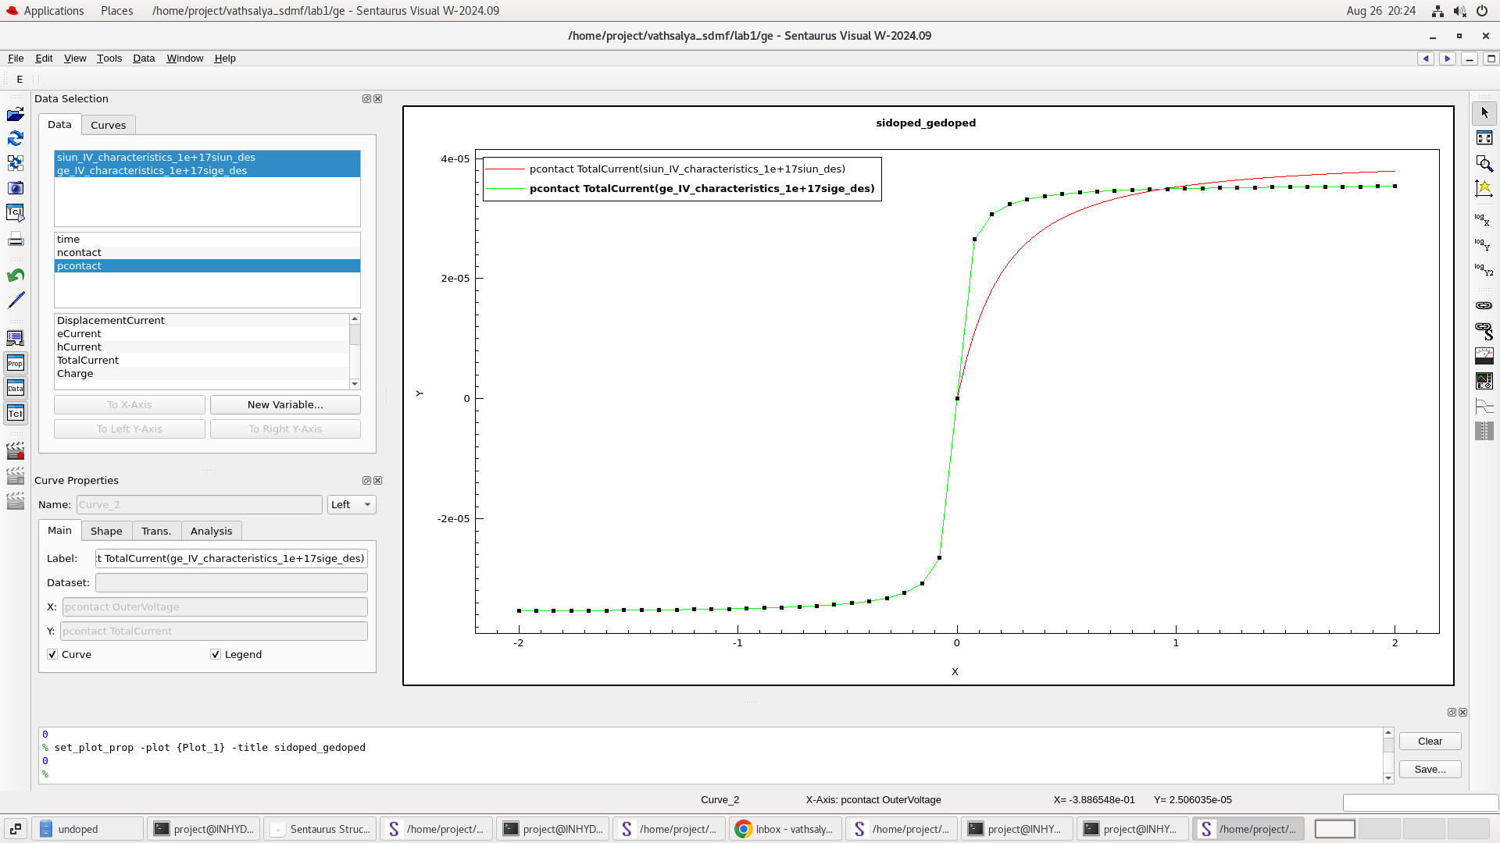
We observe the doping concentration of Germanium in Fig (5) and (6). Fig (5) shows the undoped Ge. Fig
(6) is doped Germanium with 1e+18 doping concentration.
We also observe the I-V Characteristics of undoped & doped Germanium in Fig (7) and Fig (8)
respectively.
And also we observed the I-V Characteristics of Germanium doped(vs)silicon doped.
The maximum current of Undoped Ge is 1.45e-8 A at 2V, while the maximum current of Doped
Germanium is 3.5e-4 A at 2V.
OBSERVATION:
We have observed that the doped silicon and germanium have higher current than the undoped silicon
and germanium.
The I-V Characteristics of both the undoped and doped devices have been studied

