Experiment-2
I-V Characteristics of PN Diode
NAME:S.Vathsalya
Roll No:se25mvls020
Course: MTECH VLSI & ES
Aim: Design silicon and germanium PN diode and study the I–V characteristics using Synopsys TCAD Sentaurus.
Objectives:
(1) Study the I-V characteristics of Si PN diode.
(2) Study the I-V characteristics of Ge PN diode.
(3) Study the effect of doping concentrations.
(4) Compare the Si & Ge diode characteristics.

Software Tool:
Synopsys TCAD Sentaurus.

Theory:
Donor impurities (pentavalent) are introduced into one-side and acceptor impurities into the other side of a single crystal of an intrinsic semiconductor to form a p-n diode with a Junction called depletion region (this region is depleted off the charge carriers). This Region gives rise to a potential barrier called Cut- in Voltage. This is the voltage across the diode at which it starts conducting. It can conduct beyond this Potential.
The P-N junction supports uni-directional current flow. If +ve terminal of the input supply is connected to anode (P-side) and –ve terminal of the input supply is connected to cathode (N- side) then diode is said to be forward biased. In this condition the height of the potential barrier at the junction is lowered by an amount equal to given forward biasing voltage. Both the holes from p-side and electrons from n-side cross the junction simultaneously and constitute a forward current (injected minority current – due to holes crossing the junction and entering N- side of the diode, due to electrons crossing the junction and entering P-side of the diode). Assuming current flowing through the diode to be very large, the diode can be approximated as short-circuited switch.

Procedure:
1. Create a new folder. Open in Terminal in new folder then enter “sde &“command in the terminal.
2. Go to View à GUI Mode à 2D Mode.
3. Go to Draw then deselect the “Auto Region Naming “and select the “Exact Coordinates”.
4. Now go to materials and select “silicon” (silicon is the default material) then click on “Create rectangular Sheet Region” on toolbar.
5. Place the rectangle on Canvas with below mentioned coordinates and press ok.
6. Now enter Region Name as “nregion”.
7. Go to View à Grid and change Grid Width and Grid Height values to 0.003.
8. Now create the p region inside the n region for that select Snap to Grid from Tool Bar.
9. Select the Rectangle, draw the p region from the top left corner of n region with coordinate values.
10. For doping the nregion, Go to Device à Constant Profile Placement. Select the region as nregion and change the parameters.
11. For doping the pregion, Go to Device Constant Profile Placement. Select the region as pregion and change the parameters.
12.For creating Contact, Go to Contacts à Contact Sets. Enter the contact name for pregion and nregion with different edge colour.
13. To Set Contact for pregion and nregion first change the Select Body to Select Edge on Tool Bar.
14. Now click on Arrow () placed at left panel and go to Contacts à Set Contact then place the electrical contact on the edge of pregion and nregion.
15. Go to Mesh à Define Rel/Eval Window and select rectangle à draw rectangle on canvas covering the entire design.
16. Got Mesh à Refinement Placement enter the minimum & maximum element size. Click on create Refinement.
17. Go to Mesh à click on Build Mesh. Then the device structure will be open in the svisual.
18. To study the device characteristics, edit the diode “ cmd file” (.cmd file). msh.tdr file name should be included in cmd file Grid section.
19. Enter the “sdevice cmdfilename” (Ex: sdevice diode.cmd) in working directory terminal.
20. To visualize the device characteristics, enter svisual command in terminal.
21. Go to file in svisual and open plot file(diode_des.plt).
22. For plotting I-V characteristics select pcontact Outer Voltage on x-axis and pcontact Total Current on Y-axis.
RESULTS:
Fig 1:I-V characteristics of si PN diode
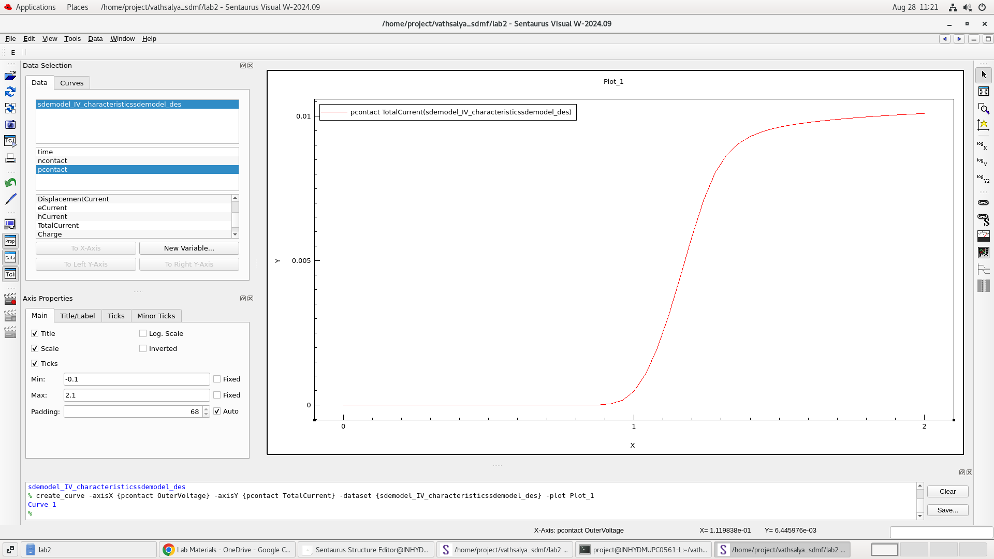
Fig 2:I-V characteristics of Ge PN diode
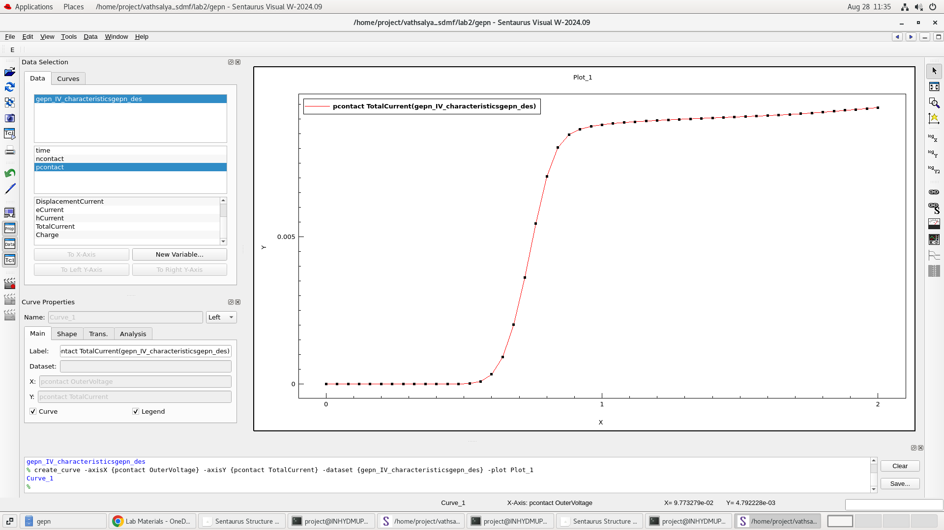

Fig 3:I-V characteristics of Si highly doped and lightly doped
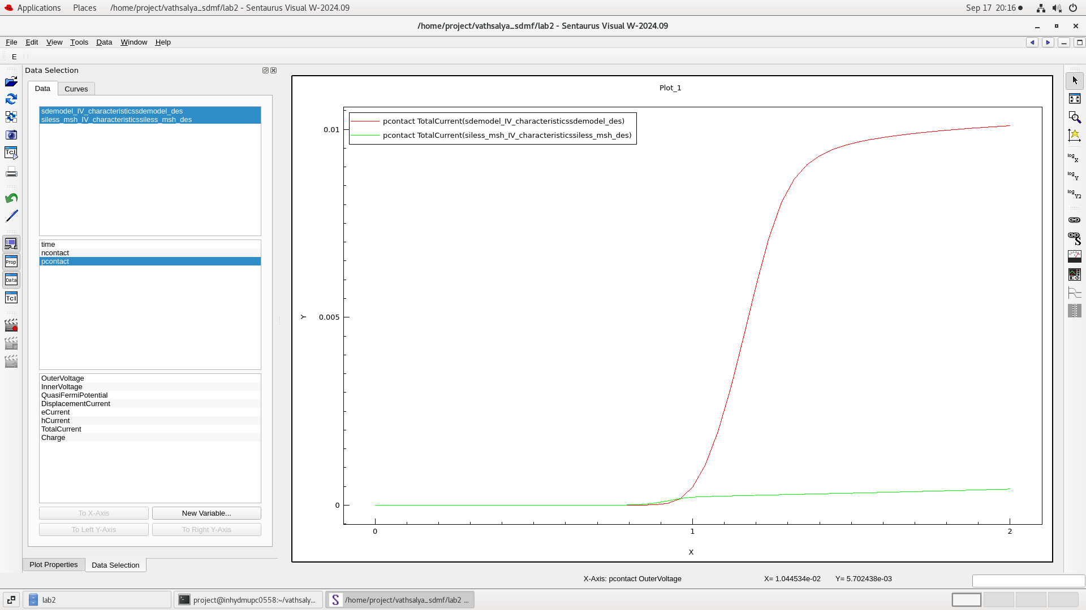
Fig 4:I-V characteristics of Ge highly doped and lightly doped
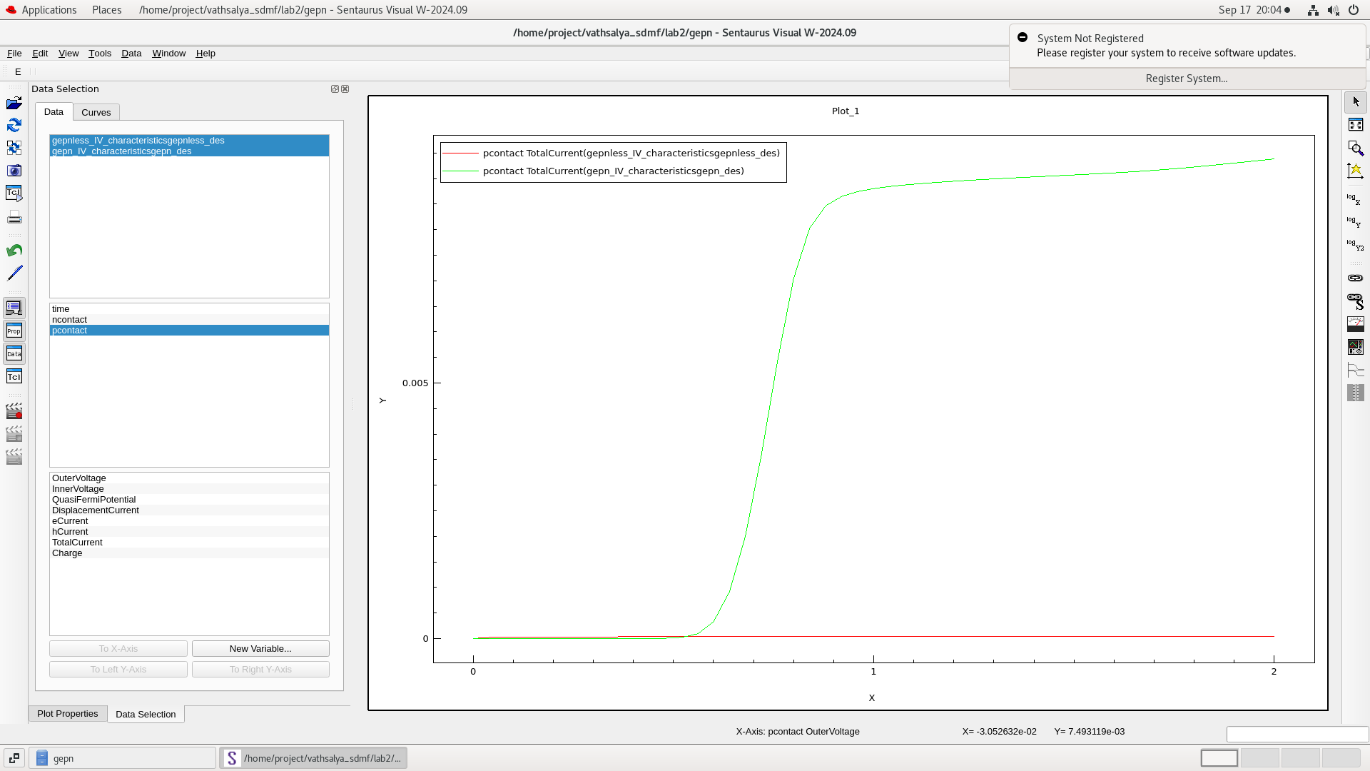

Fig 5:I-V characteristics of Si highly doped
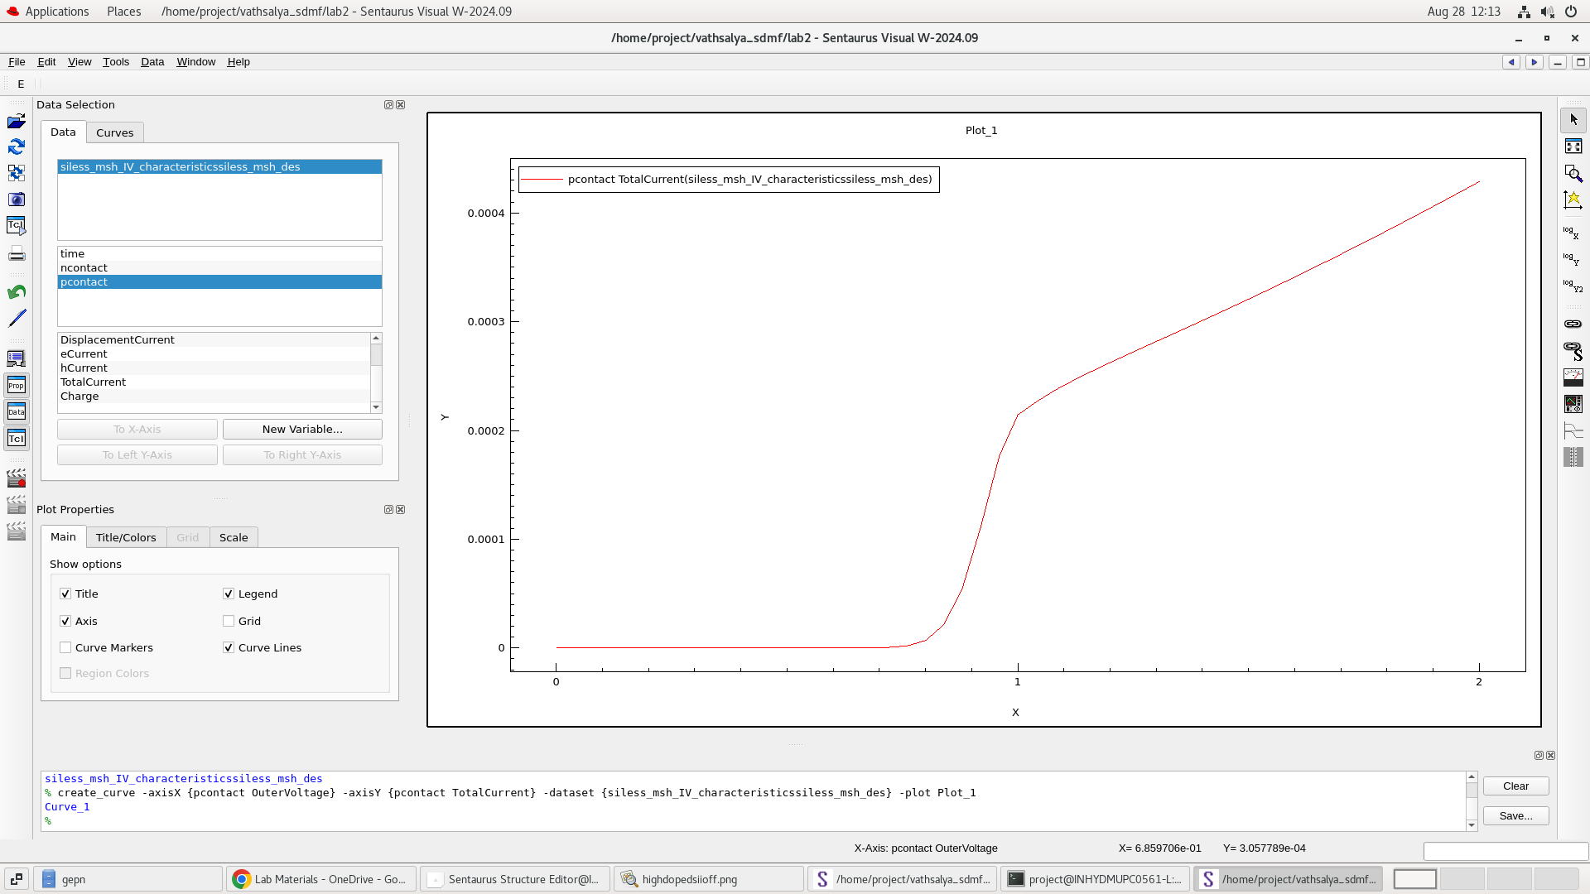
Fig 6: I-V characteristics of Si lightly doped
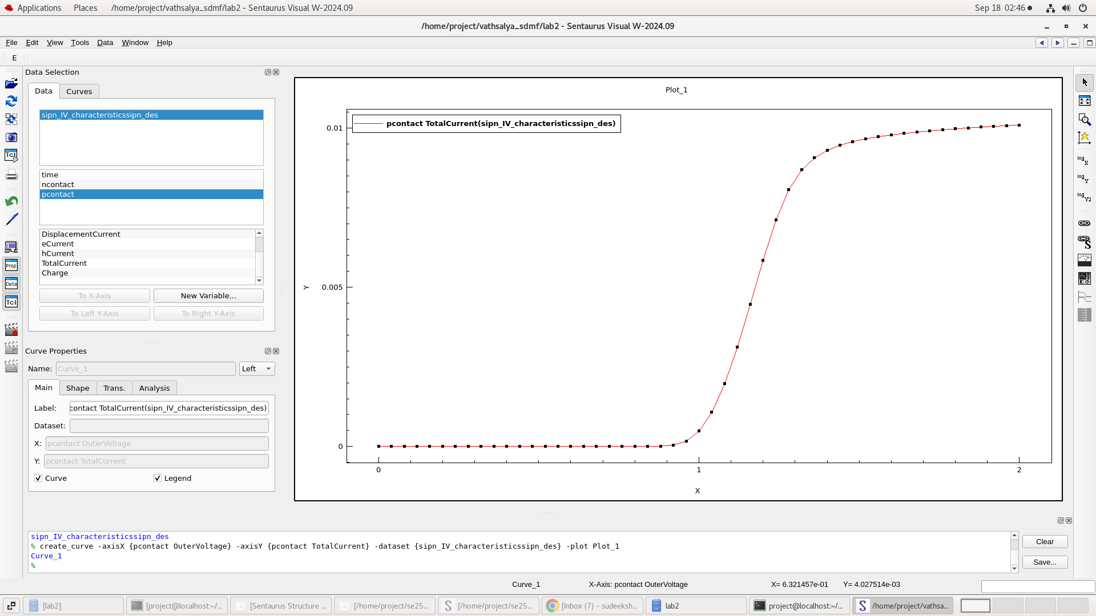

Fig 7:I-V characteristics of Ge lightly doped
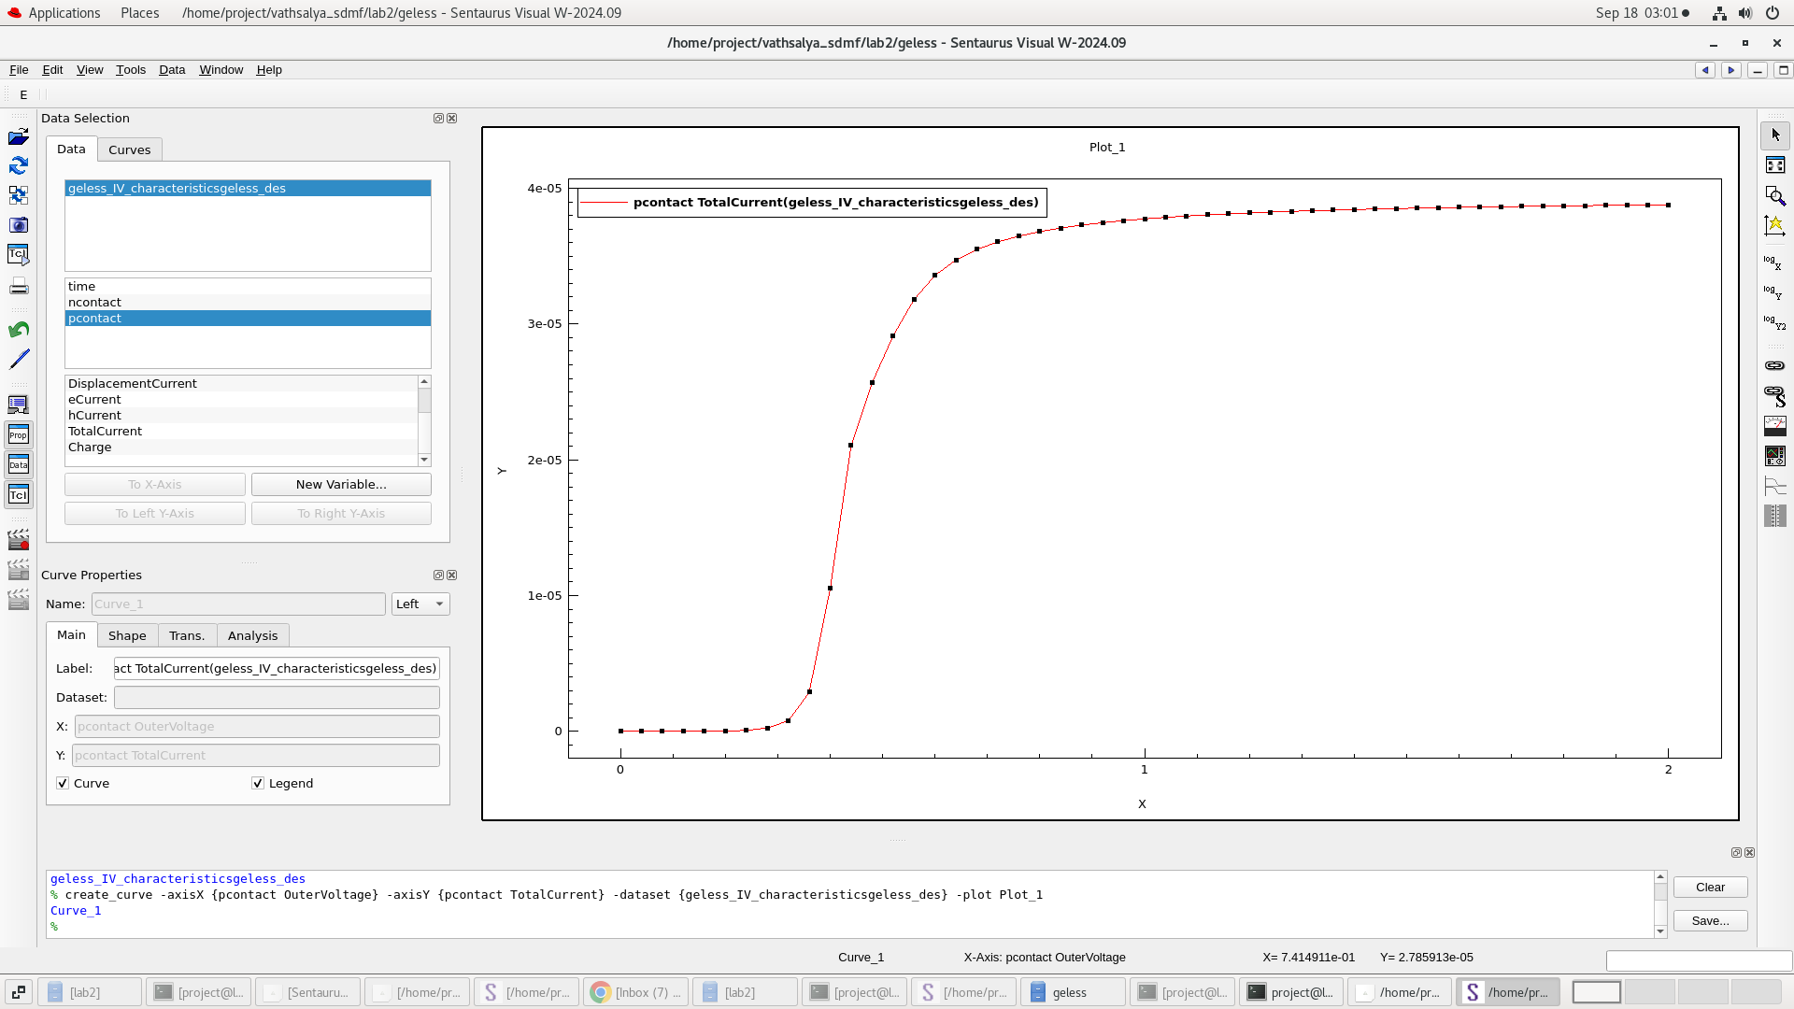
Fig 8: I-V characteristics of Ge highly doped
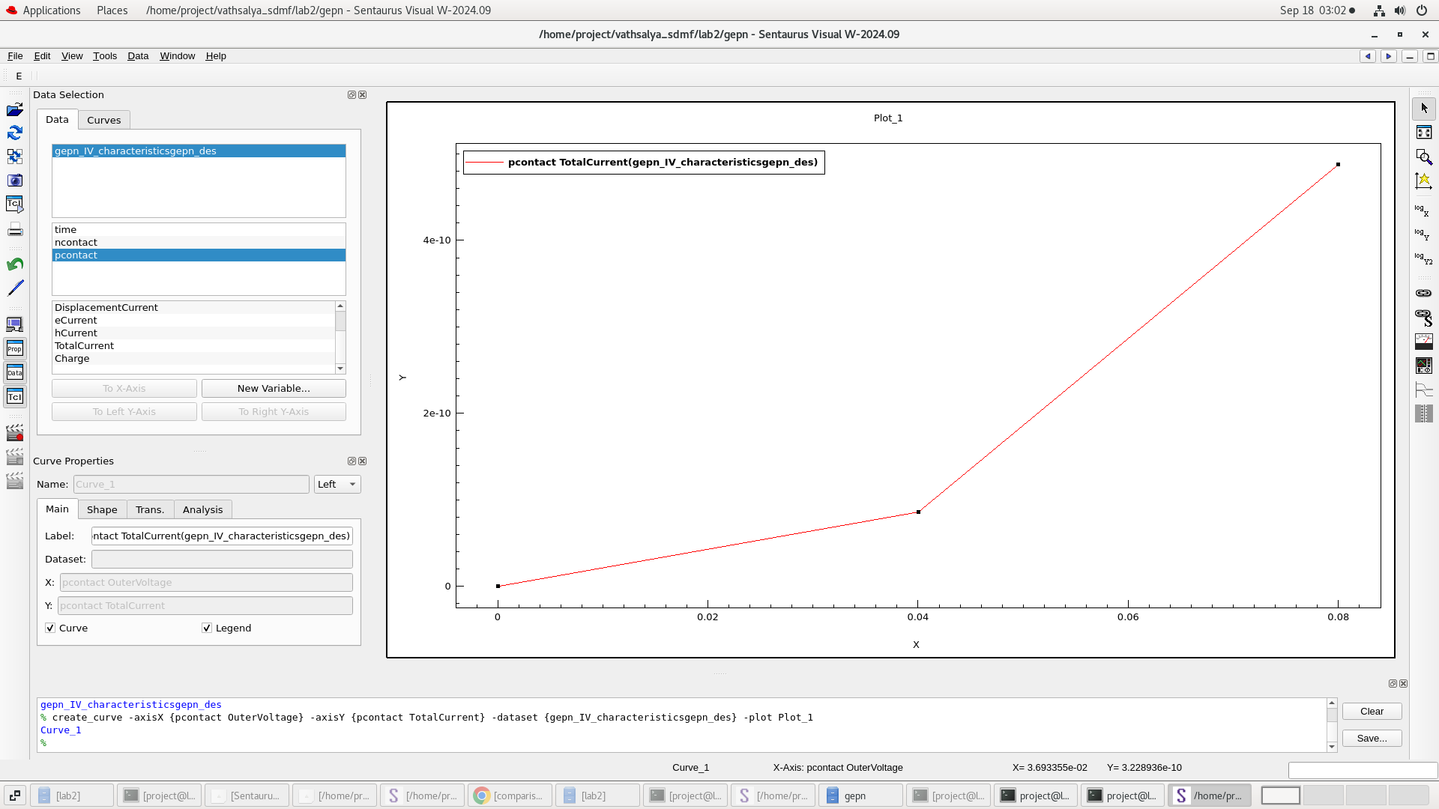

Fig 9:I-V characteristics of Si and Ge lightly doped
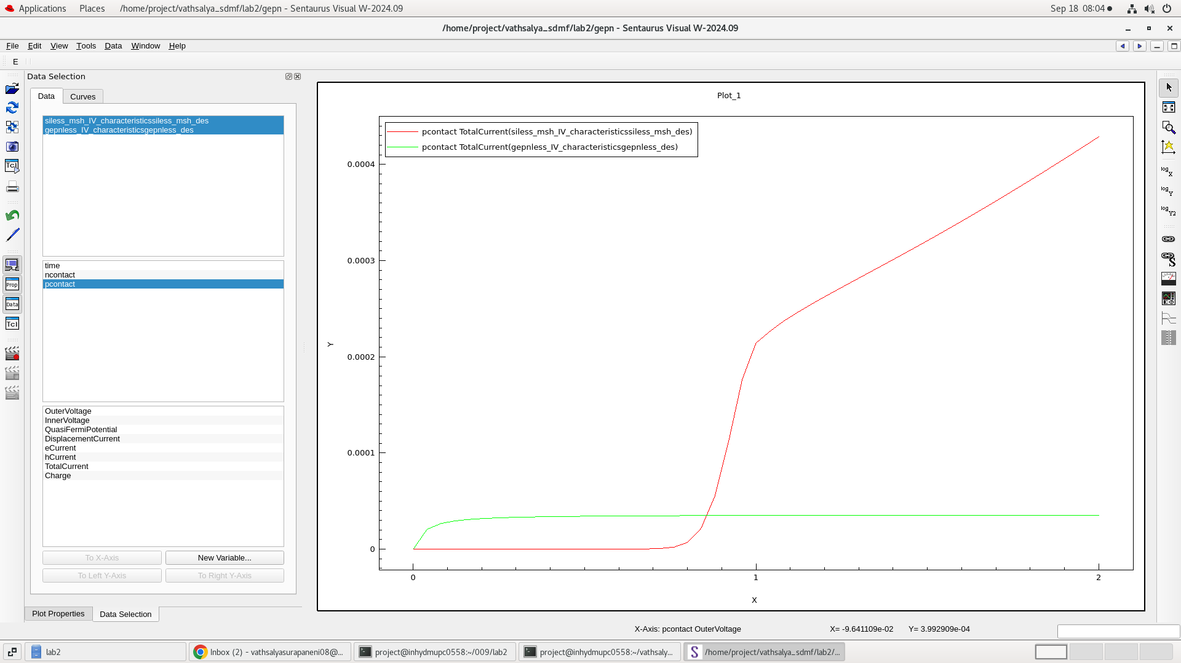

OBSERVATION:
The cut off of highly doped germanium is at 0.04v and the cutoff of lightly doped germanium is 0.3v so,current is more for highly doped germanium.
The cut off of highly doped si is at 0.7v and the cutoff of lightly doped silicon is 1.1 v.so the current in highly doped silicon is more .
Conclusion: The I-V characteristics of Silicon and Germanium PN diode are studied using Synopsys TCAD Sentaurus software.

