BVRIT HYDERABAD COLLEGE OF ENGINEERING FOR WOMEN
College Knowledge Base — RAG Grounding Document
Compiled from official sources (bvrithyderabad.edu.in) — July 2026

1. About BVRIT Hyderabad

History
BVRIT HYDERABAD College of Engineering for Women is an autonomous engineering college established in 2012 under the Sri Vishnu Educational Society (SVES), founded by Chairman Sri K. V. Vishnu Raju. It is the youngest institution under the SVES umbrella, created specifically to educate and empower women in engineering. The college began with an intake of 240 students across four branches (EEE, ECE, CSE, IT) and has since grown to an undergraduate intake of 660 across five B.Tech branches, plus postgraduate programmes.

Vision
To emerge as one of the best institutes of technology and research in the country, dedicated to promoting quality technical education.

Mission
- Achieve academic excellence through innovative learning practices.
- Enhance intellectual ability and technical competency for a successful career.
- Encourage research and innovation.
- Nurture students towards holistic development, with emphasis on leadership skills, life skills, and human values.

Accreditations & Approvals
- NAAC: Accredited with Grade 'A' (2020).
- NBA: Accredited for EEE, ECE, and CSE undergraduate programmes.
- UGC Autonomous status granted from Academic Year 2023-24, for a period of 10 years.
- Approved by AICTE (All India Council for Technical Education) and the Government of Telangana.
- Affiliated to Jawaharlal Nehru Technological University, Hyderabad (JNTUH).
The college is one of the educational institutions of the Sri Vishnu Educational Society (SVES), which also runs several other engineering, pharmacy, dental, and school institutions across Andhra Pradesh and Telangana (the 'Green Meadows', 'Orchard Park', 'Valley Vista', and 'Lake View' campuses).

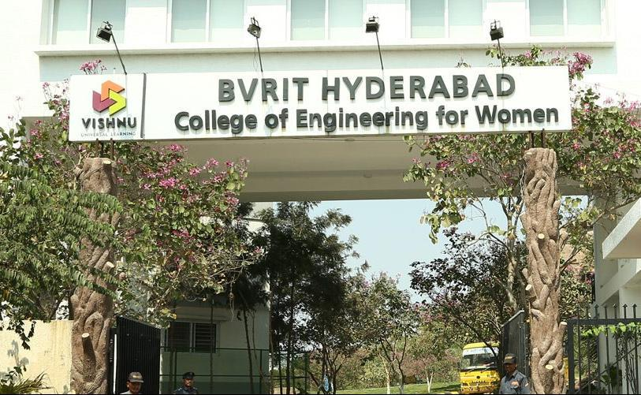

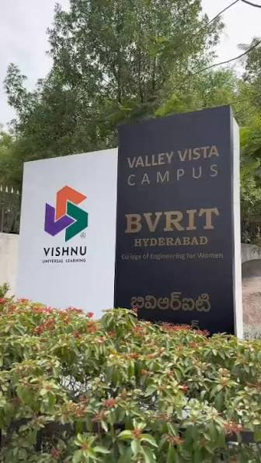

2. Departments
BVRIT Hyderabad offers undergraduate (B.Tech), postgraduate (M.Tech), and Ph.D research programmes through the following departments:

B.Tech (Undergraduate) Branches
- Computer Science & Engineering (CSE)
- Computer Science & Engineering — Artificial Intelligence and Machine Learning (CSE-AI&ML / CSM)
- Electronics and Communication Engineering (ECE)
- Electrical and Electronics Engineering (EEE)
- Information Technology (IT)
Total UG intake across these five branches: 660 seats (as per the official 'About BVRITH' page). Note: some third-party listings quote a lower overall UG intake figure (540); the college's own site states 660 including the CSE-AI&ML programme.

M.Tech (Postgraduate) Programmes
- M.Tech — Data Sciences (intake: 18)
- M.Tech — Computer Science and Engineering (intake: 12)
- M.Tech — VLSI Design (intake: 12)

Ph.D / Research Centres
- ECE (VLSI–Communications)
- CSE
- A dedicated 'Faculty as Ph.D Supervisors' programme for research guidance

Other Academic Units
- Basic Sciences and Humanities (BS&H) — supports first-year foundational courses across all branches.
- Honor Degree Programme — additional credentials for high-performing students.
Exact department-wise faculty headcounts are not published as a single consolidated figure on the college website; the site instead lists faculty individually under each department's page. This knowledge base does not fabricate a total faculty count.

3. Admissions

Eligibility
Candidates must have passed the 10+2 (Intermediate) examination with Mathematics, Physics, and Chemistry (MPC) as major subjects, with a minimum aggregate as prescribed by the Telangana State admissions authority (commonly cited as 60% aggregate, subject to category-wise relaxation).

Entrance Exams
- TS EAMCET / TG EAPCET — primary entrance exam for B.Tech admissions (Convener quota / Category-A seats).
- JEE Main — accepted by some listings as an alternate route for B.Tech admission.
- TS PGECET / GATE — for M.Tech admissions.

Admission Categories
- Category A: Seats filled through the Convener of TS EAMCET/TG EAPCET counselling (centralised counselling process).
- Category B: Management-quota seats filled directly by the college as per TSCHE (Telangana State Council of Higher Education) guidelines.

Admission Process (typical flow)
- Appear for TS EAMCET/TG EAPCET (or JEE Main, where applicable).
- Participate in state counselling and exercise web options for Category-A seats, or apply directly to the college for Category-B (management quota) seats.
- Complete document verification and fee payment as per the seat allotment.

College Codes
- EAMCET / ECET code: BVRW
- PGECET code: BVRW1

Key Contacts for Admissions
Professor In-Charge, Admissions: Dr. J. Manoj Kumar — Phone: 92471 64714 (as listed on the official site's admissions announcement).
Exact admission opening/closing dates change every academic year and are published on the TS EAMCET/TG EAPCET counselling portal and the college's own Admission Process page; this document does not fix a specific date so it does not go stale.

4. Fee Structure

B.Tech Tuition Fee — Official College Table (as published on bvrithyderabad.edu.in/admission/fee-details)
Batch | Branch(es) | Tuition Fee (₹/yr) | NBA Fee (₹/yr) | JNTUH/Misc. Fee (₹/yr)
2025 | CSE, ECE, EEE, CSM | 1,20,000 | 3,000 (CSM: –) | 5,500
2024 | CSE, ECE, EEE, CSM | 1,20,000 | 3,000 (CSM: –) | 5,500
2023 | CSE, ECE, IT, EEE, CSM | 1,20,000 | 3,000 (CSM: –) | 5,500
2022 | CSE, ECE, IT, EEE, CSM | 1,20,000 | 3,000 (CSM: –) | 2,500
2021 | CSE, ECE, IT, EEE, CSM | 90,000 | 3,000 (CSM: –) | 5,500

For the current (2025) batch, the CSE, ECE, and EEE tuition fee is ₹1,20,000/year plus a ₹3,000/year NBA fee and ₹5,500/year JNTUH/miscellaneous fee, totaling roughly ₹1,28,500/year under the Convenor (Category-A) quota. The CSM (CSE-AI&ML) branch does not carry the NBA fee line since it is not yet NBA-accredited.

Other Fees (third-party aggregator estimates — verify with the college before relying on these)
- Management-quota (Category-B) tuition: reported in the range of ₹1,20,000–₹1,50,000/year, depending on branch and source.
- Hostel fees: reported in the range of roughly ₹70,000–₹1,20,000/year depending on room type and source.
- Optional transport fee: reported around ₹18,000–₹40,000/year depending on route and source.
- M.Tech PGECET application/registration fee: ₹1,100 (₹600 for SC/ST/PH candidates) per test, as per TS PGECET norms.

Scholarships
- Telangana State Fee Reimbursement Scheme (government scholarship, income- and rank-linked).
- Merit-based scholarships/fee waivers for top TS EAMCET/TG EAPCET rankers.
- AICTE-administered scholarships such as the Pragati Scholarship for Girl Students (Technical Degree), the Saksham Scholarship for Specially Abled Students, and the AICTE Swanath Scholarship Scheme — all applied for via the National Scholarship Portal.
- SC/ST fee concessions for students whose family income is below the prescribed threshold (commonly cited as ₹2 lakh/year).
- PM Vidyalaxmi Scheme — education loan support, publicised on the official site.
The exact fee figures above beyond the official college table are sourced from third-party education portals (Collegedunia, Careers360, Shiksha, Propelld) and can vary by year and source; where the college's own published table and an aggregator disagree, the official college table (bvrithyderabad.edu.in) should be treated as authoritative.

5. Placements

Placement Cell
BVRIT Hyderabad's Training & Placement Cell is led by Sri. S. Jagapathi Reddy (Manager, Placements) and Sri. K. Mahesh Babu (Asst. Manager, Placements). There is also a central placement cell under the Sri Vishnu Educational Society that supports students across all SVES colleges with guidance and job-seeking support.

2021–2025 Batch Placement Summary
- Total students placed: 614 (across EEE, ECE, CSE, IT, and CSE-AI&ML).
- Highest package: ₹54.00 LPA (Microsoft).
- Notable high-package recruiters: Visa (₹32.88 LPA / ₹31.64 LPA), Optum (₹20.78 LPA), Synopsys (₹20.26 LPA), Swiss Re (₹14 LPA).
- High-volume recruiters: Capgemini SE (175 offers), Infosys SE (70), Tech Mahindra (71), Cognizant GenC (57), UST (33).

Placement Trend by Batch (total students placed)
Batch | Total Placed | Highest Package (LPA)
2021–2025 | 614 | 54.00 (Microsoft)
2020–2024 | 508 | 52.00 (Microsoft)
2019–2023 | 694 offers | 54.75 (Palo Alto Networks)
2018–2022 | 988 offers | 49.00 (Microsoft SDE)
2017–2021 | 533 offers | 26.58 (Flipkart)

Top Recruiters (across recent years)
Microsoft, Amazon, Adobe, Visa, Optum, Synopsys, IBM, Flipkart, Wells Fargo, Qualcomm, DE Shaw, JP Morgan Chase, Goldman Sachs, Wipro, Infosys, TCS, Capgemini, Cognizant, Accenture, Tech Mahindra, State Street, PwC, Deloitte, Bank of America, and Athena Health, among others.

Other Metrics
- As per the NIRF 2026 report, 400 B.Tech and 9 M.Tech students were offered placements in 2025.
- Average package for the 2025 batch is reported around ₹9.26 LPA by third-party sources; the average package for the top 25% of students was reported at ₹13.06 LPA.
Batch-wise placement PDFs (2017-21 through 2021-25) are published on the official Placement Details page and contain the full company-and-package breakdown by branch; the figures above are a summary. Package and headcount figures for batches before 2021 are sourced from the same official page's scanned/tabulated placement reports.

6. Campus & Facilities

Library
Housed in a four-storey building called the Ruby Block, the library serves as the college's intellectual hub. It holds textbooks, reference books, journals, and competitive-exam resources, and is a member of DELNET and the National Digital Library of India (NDLI). Materials are organised using the Dewey Decimal Classification (DDC) system.
- Library hours: 9:00 AM – 6:00 PM; Issue & Return: 10:00 AM – 5:00 PM.
- Digital library: 10 internet-enabled computers with access to NPTEL lectures and online mock tests.
- E-resources: IEEE Xplore, J-Gate, DELNET, accessible remotely via the Knimbus e-library platform and mLibrary mobile app.
- Plagiarism-check service using iThenticate (Turnitin) for staff and student publications.
- Rare book collection dating from 1919 onwards; a dedicated Book Bank for SC/ST students.

Laboratories
Each engineering department maintains dedicated laboratories aligned with its curriculum; the college also runs several specialised labs and centres as 'differentiators', including an IoT Maker Space, a Drone Technology Laboratory, and an Assistive Technology Lab (ATL).

Hostel
On-campus hostel accommodation is available across 4 blocks with 150+ rooms and capacity for 500+ students. Facilities include 24/7 water supply, geysers, round-the-clock security with lady wardens, a common room, gym area, TV/entertainment area, and an anti-ragging squad. A full-time lady physical director organises outdoor sports such as volleyball, badminton, and throw-ball.

Sports
The college has a dedicated Sports Club and physical-education staff supporting outdoor games (volleyball, badminton, throw-ball, etc.) and fitness activities, both for hostel residents and day scholars.

Wi-Fi & IT Infrastructure
Campus-wide Wi-Fi and computer labs are available; student reviews consistently describe classrooms as equipped with boards/projectors and functioning Wi-Fi.

Transportation
The college (via the broader BVRIT/SVES network) operates a private bus fleet — approximately 14 routes — covering various parts of Hyderabad, with buses equipped with GPS/GPRS tracking for student safety. Transport is optional and charged separately from tuition.

Other Campus Facilities
- Food & Cafeteria — on-campus dining options.
- Gym — fitness facility for students.
- Temple — on-campus place of worship.
- Security — round-the-clock campus security.
- Medical/health support — reported by students as part of standard campus facilities.
- PCS (Placement & Career Success) facilities.
- 600-seat-class auditorium and seminar halls for events (shared infrastructure noted across the SVES network).

7. Faculty

Leadership
- Chairman: Sri K. V. Vishnu Raju

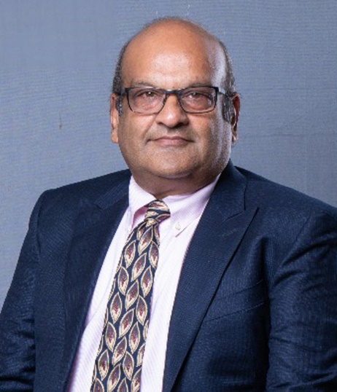

- Vice Chairman: Sri Ravichandran Rajagopal

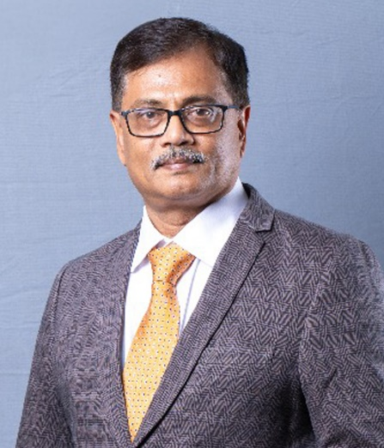

- Secretary: Sri Aditya Vissam

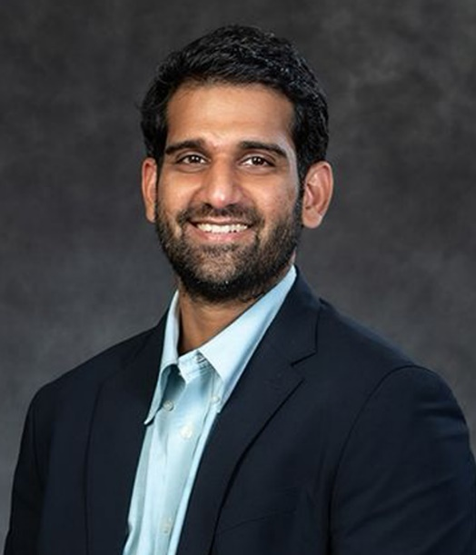

- Principal: Dr. K. V. N. Sunitha

Principal — Profile (Dr. K. V. N. Sunitha)
Dr. K. V. N. Sunitha holds a B.Tech in ECE from ANU, an M.Tech in CS from REC Warangal (1993), and a Ph.D in CSE from JNTU Hyderabad (2006). She has over 30 years of teaching experience and over 15 years of research experience, and has served as Founder Principal of BVRIT Hyderabad since August 2012. She has guided 20 Ph.D scholars, authored 5 text books, and published more than 185 papers and 7 patents; her research areas include Natural Language Processing, Speech Processing, and Network & Web Security. Her awards include the ISTE Best Computer Science Engineering Teacher Award (2008), the CSI Mumbai Distinguished Principal Award (2017), the Deewang Mehtha Women in Education Award (2017), the IEI Engineer of the Year Award (2019), and the ISTE Best Engineering College Principal in Telangana State Award (2019). She is a Fellow of the Institution of Engineers (India) and a Senior Member of IEEE.
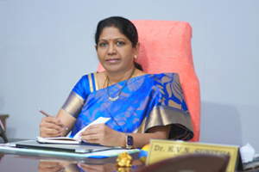

Placement Team
- Manager, Placements: Sri. S. Jagapathi Reddy
- Asst. Manager, Placements: Sri. K. Mahesh Babu

Library Staff
- Librarian: Dr. S. Satya Jaya (M.Com, M.L.I.Sc, PhD)
- Library Assistants: Y. Renuka (M.Com, M.L.I.Sc), G. Krishnaveni (B.A, M.A), G. Urmilasree (B.Sc, M.L.I.Sc)

Department-wise Faculty Strength & Heads of Department
Faculty strength and department leadership, as published on each department's 'About the Department' page (bvrithyderabad.edu.in):
- Computer Science & Engineering (CSE): 49 faculty members — 7 Professors, 6 Associate Professors, and 36 Assistant Professors — supplemented by adjunct faculty from industry and academia. Faculty specialisations span Machine Learning, Computer Networks, Data Mining, Image Processing, Parallel Computing, Software Engineering, Cloud Computing, Soft Computing, Blockchain, Deep Learning, and Artificial Intelligence.
- Electronics & Communication Engineering (ECE): Faculty are diversified across Communications, Signal Processing, and VLSI & Embedded Systems. Dr Vasu Babu, Professor, ECE, was listed among the world's top 2% of scientists (2024 ranking) in Information & Communication Technologies, released by Elsevier and Stanford University.
- Electrical & Electronics Engineering (EEE): Headed by Dr. B. Srinivasa Rao, M.Tech., Ph.D, a Senior Member of IEEE, a Fellow of IE (FIE), and a Life Member of ISTE (LMISTE). He has completed two funded research projects worth Rs. 13.8 lakh, with research interests in power system optimization, renewable energy systems, multi-objective optimization, deregulated power systems, and optimal operation with FACTS devices.
- Information Technology (IT): Faculty are described as highly motivated with a strong research orientation; the department holds Centre of Excellence status in Data Science. Exact headcount is not published as a single figure on the department page.
- CSE – Artificial Intelligence & Machine Learning (AI&ML) and Basic Sciences & Humanities (BS&H): Each maintains its own faculty listing under its department's 'About the Department' and 'Faculty' pages; individual faculty rosters, qualifications and specialisations are not consolidated into a single site-wide directory.
Every department page also names an individual 'About HOD' page (e.g. bvrithyderabad.edu.in/[department]/about-hod/) and a dedicated 'Faculty' listing page; the full name and designation of every faculty member from these pages is reproduced in the ‘Complete Faculty Roster’ section below. Faculty across departments are encouraged to pursue certifications via NPTEL-SWAYAM, Coursera, edX, NASSCOM, and similar platforms, and several have received recognitions such as the AIMERS Best Faculty Award and inclusion in Stanford/Elsevier's world top 2% scientists list.

Complete Faculty Roster (Name, Designation, and Department)
The following is the full faculty roster for every department, compiled from each department's individual 'Faculty' listing page on bvrithyderabad.edu.in (as of July 2026). Names and designations are listed exactly as published on the college website. Detailed years-of-experience figures are not published on these listing pages (only on some individual faculty profile sub-pages), so they are not included here to avoid inaccuracy.

Computer Science & Engineering (CSE) — 49 faculty
- Dr. Aruna Rao S L — Professor & Head, Dept. of CSE
- Dr. K.V.N. Sunitha — Professor & Principal
- Dr. Ganti Naga Satish — Professor & Professor I/C CNS
- Dr. R. Suneetha Rani — Professor
- Prof. Murali Nath R S — Professor I/C Accreditations
- Dr. Sanivarapu Prasanth Vaidya — Associate Professor
- Dr. B. Venkatesh — Associate Professor
- Dr. M. Shanmuga Sundari — Associate Professor
- Ms. S. Rama Devi — Associate Professor
- Ms. Swapna D — Associate Professor
- Mr. M. Dyva Sugnana Rao — Associate Professor
- Dr. K. Kanaka Vardhini — Assistant Professor
- Dr. Akangsha Tyagi — Assistant Professor
- Dr. C. Nagaraju — Assistant Professor
- Dr. Atluri Lakshmi — Assistant Professor
- Ms. Vidhyullatha Sukhavasi — Assistant Professor
- Dr. C. Rajeev — Assistant Professor
- Dr. G. Monika Rani — Assistant Professor
- Mr. Chintala Anil Kumar — Assistant Professor
- Mr. N. Raghava Rao — Assistant Professor
- Ms. K. B. K. S. Durga — Assistant Professor
- Ms. Budati Nagaveni — Assistant Professor
- Mr. Rajesh Kandakatla — Assistant Professor
- Mr. Naresh Koenni — Assistant Professor
- Ms. Rama Devi Gunnam — Assistant Professor
- Mr. K. Bhargav Ram — Assistant Professor
- Mr. Naga Sriharsha Mulugu — Assistant Professor
- Ms. Dharmapuri Sangeetha — Assistant Professor
- Ms. Padmavati E Gundgurti — Assistant Professor
- Ms. T. Durga Devi — Assistant Professor
- Ms. M. Sandhya Vani — Assistant Professor
- Ms. Suparna Das — Assistant Professor
- Ms. V. Manya — Assistant Professor
- Ms. Yeluri Divya — Assistant Professor
- Ms. K. Neha — Assistant Professor
- Ms. Vineela K — Assistant Professor
- Ms. Vemuri Aneesha — Assistant Professor
- Ms. Mugala Srisevitha — Assistant Professor
- Ms. Mynapati Lakshmi Prasudha — Assistant Professor
- Ms. P. Surya Bharati — Assistant Professor
- Ms. B. Pushpa — Assistant Professor
- Ms. Goguri Rashmitha — Assistant Professor
- Ms. G. Chandana Priya — Assistant Professor
- Ms J. Jhansi Goud — Assistant Professor
- Ms. T. Jhansi Renuka — Assistant Professor
- Ms. Mukku Sahaja — Assistant Professor
- Ms. Manjula Pilaka — Professor of Practice
- Dr. Jayanthi A — Assistant Professor
- Dr. R Sarath Babu — Assistant Professor

Electronics & Communication Engineering (ECE) — 27 faculty
- Dr. B. Nagesh Deevi — Associate Professor & HoD
- Dr. J. Naga Vishnu Vardhan — Professor & Dean Academics
- Dr. Anwar Bhasha Pattan — Professor & Professor I/C EDC
- Dr. M. Parvathi — Professor
- Dr. T. Thammi Reddy — Professor
- Dr. K. Vasu Babu — Professor
- Ms. M. Praveena — Associate Professor & Accreditations Manager
- Mr. R. Priyakanth — Associate Professor
- Mr. K. Mahesh Babu — Associate Professor & Assistant Training & Placement Officer
- Dr. V. Hindumathi — Associate Professor
- Dr. Santhosh Kumar Veeramalla — Associate Professor
- Dr. R. Viswanadham — Associate Professor, ATL & IIC Coordinator
- Mr. P. Rajesh Kumar — Assistant Professor
- Ms. G. RamaLakshmi — Assistant Professor
- Dr. M. Venkatesham — Assistant Professor, Controller of Examinations
- Mr. N. M. Sai Krishna — Assistant Professor
- Mrs. Rajidi Sahithi — Assistant Professor
- Mr. N. Srinivasa Rao — Assistant Professor
- Mr. Saikumar Tara — Assistant Professor
- Dr. Ranjeeth Mamidi — Assistant Professor
- Ms. T. Amy Prasanna — Assistant Professor
- Dr. L. Bhargava Kumar — Assistant Professor
- Dr. D Venkata Siva Prasad — Assistant Professor
- Dr. Y. Alekhya — Assistant Professor
- Dr. G. Purnachandrarao — Assistant Professor
- Dr. M. Kalpana Chowdary — Assistant Professor
- Dr. V S Santhosh N Varma B — Assistant Professor

Electrical & Electronics Engineering (EEE) — 16 faculty
- Dr. Balusu Srinivasa Rao — Professor & HoD
- Dr. Chava Sunil Kumar — Vice Principal & Dean Student Affairs
- Dr. K. Amritha — Associate Professor
- Dr. M. Rupesh — Associate Professor
- Mr. R. Guruswamy — Associate Professor
- Ms. Sujatha Banka — Associate Professor
- Mr. Sandeep Gogula — Associate Professor
- Dr. Bhavya Kanchanapalli — Assistant Professor
- Dr. Rampelli Manojkumar — Assistant Professor
- Dr. Chamakura Krishna Reddy — Assistant Professor
- Dr. Prasanta Kumar Jena — Assistant Professor
- Dr. C. Venkata Subba Reddy — Assistant Professor
- Ms. Babita Gupta — Assistant Professor
- Mr. M. Prashanth — Assistant Professor
- Dr. Koduru Sriranga Suprabhath — Assistant Professor
- Mr. Cherala Vikram — Assistant Professor

Information Technology (IT) — 9 faculty
- Dr. K. Srikar Goud — Assistant Professor & I/C HoD
- Dr. K. Bharathi — Associate Professor
- Mr. A. Rajashekar Reddy — Assistant Professor
- Ms. K. Kavitha — Assistant Professor
- Ms. A. Aruna Jyothi — Assistant Professor
- Ms. N. Sandhya — Assistant Professor
- Ms. Danthuluri Mani Sri Madhuri — Assistant Professor
- Ms. A. S. S. M. Pravallika — Assistant Professor
- Ms. T. Sukanya — Assistant Professor

CSE — Artificial Intelligence & Machine Learning (AI&ML) — 15 faculty
- Dr. Lakshmi Praveena Bellamkonda — HoD & Professor (CSE-AI & ML)
- Dr. M. Indrasena Reddy — Professor
- Mrs. Naga Kalyani Ayyadevara — Assistant Professor
- Ms. P Anusha — Assistant Professor
- Ms. Veeramachaneni Indu — Assistant Professor
- Mr. B. Kishore Kumar — Assistant Professor
- Ms S Annapoorna — Assistant Professor
- Ms Asha Vuyyuru — Assistant Professor
- Ms. R. Priyanka — Assistant Professor
- Ms. Bandaru Shanmukha Priya — Assistant Professor
- Ms. T. Bhargavi — Assistant Professor
- Mr. M. N. S. Gangadhar — Assistant Professor
- Ms. Kolli Lalitha Kumari — Assistant Professor
- Ms. Spurthi Kalevar — Assistant Professor
- Ms. Jyothi B — Assistant Professor
- Ms. Pallavi Malavath — Assistant Professor
- Ms. Patlolla Sruthi — Assistant Professor

Basic Sciences & Humanities (BS&H) — 33 faculty
- Dr. M. Anita — Professor & HoD
- Dr. J. Manoj Kumar — Professor i/c Admissions
- Dr. V. Madhavi — Associate Professor
- Dr. C. Nageswaranath — Associate Professor
- Mr. M. Gopi Krishna — Associate Professor
- Dr. K. Kavita — Associate Professor
- Dr. S. Faith Manjusha Vijayalatha — Assistant Professor
- Dr. B. Anna Tanuja Safala — Associate Professor
- Dr. T. Roja Rani — Assistant Professor
- Dr. M. Venkanna — Associate Professor
- Dr. T. Ramesh — Associate Professor
- Dr. S. Kalyan — Assistant Professor
- Dr. Devidutta Das — Assistant Professor
- Dr. Anji Reddy Polu — Associate Professor
- Dr. S. Ammani — Assistant Professor
- Dr. Chennuri Bharath Kumar — Assistant Professor
- Dr. Chitturi Sai Krishna — Assistant Professor
- Dr. B. Uma Rani — Assistant Professor
- Dr. V. Malathi — Assistant Professor
- Dr. Prathyusha G — Assistant Professor
- Dr. Torsa Saha — Assistant Professor
- Dr. B. Sreekala — Assistant Professor
- Mr. Kasturi Sydaiah — Assistant Professor
- Dr. A. Ramya — Assistant Professor
- Ms. V. Saileela — Assistant Professor
- Ms. T. Mounika — Assistant Professor
- Ms. P. Chaitanya — Assistant Professor
- Mr. S. Raghavendra — Assistant Professor
- Ms. Vellanki Saritha — Assistant Professor
- Ms. G. L. Sirisha — Assistant Professor
- Ms. M. Rajani — Assistant Professor
- Dr. Kanakamedala Sowmya — Assistant Professor
- Mr. Teja Venkata Satish J — Assistant Professor

Research Areas / Faculty Domains
Faculty publish across department-aligned research areas including VLSI & Communications (ECE) and Computer Science & Engineering; individual faculty thrust areas, publications, and Ph.D supervision details are listed department-by-department on the college's Research pages rather than in one consolidated directory.
The college website does not publish a single combined 'faculty list' page with qualifications for every staff member; instead, each department (CSE, ECE, EEE, IT, CSE-AI&ML, BS&H) maintains its own faculty listing under '[Department] > Faculty' and '[Department] > About HOD'. This document adds the department-wise faculty strength, named HODs and notable faculty achievements found on the 'About the Department' pages, plus the Principal's full profile, in addition to the leadership, placement, and library staff named on general/administrative pages — without inventing details not present on the source pages.

8. Contact

Address
BVRIT HYDERABAD College of Engineering for Women Plot No. 8-5/4, Rajiv Gandhi Nagar Colony, Nizampet Road, Bachupally, Hyderabad – 500090, Telangana, India

Phone
+91 40 4241 7773

Email
info@bvrithyderabad.edu.in | principal@bvrithyderabad.edu.in

Website
https://bvrithyderabad.edu.in

Social Media
- LinkedIn: linkedin.com/school/bvrit-hyderabad
- Instagram: instagram.com/bvrit_hyderabad_
- YouTube: youtube.com/@BvritHyderabadWomen
- Facebook: facebook.com/BvritHyderabad
- X (Twitter): x.com/bvrithyderabad

College / Exam Codes
- EAMCET / ECET Code: BVRW
- PGECET Code: BVRW1

Important Dates — Admissions & Academic Calendar 2026
The following dates are approximate and based on the standard Telangana State engineering admissions calendar (TS EAMCET / TG EAPCET 2026). Exact dates are published on the official TS EAMCET portal (tseamcet.nic.in) and the college's Admission Process page (bvrithyderabad.edu.in). Students should verify with the college or the counselling authority before acting on these dates.

TS EAMCET / TG EAPCET 2026 — Exam & Results
• TS EAMCET 2026 Engineering Exam: 7 May 2026 (PAST — exam already conducted)
• TS EAMCET 2026 Results Announced: 12 June 2026 (PAST — results published on tseamcet.nic.in)
• Rank Card Download Opens: 15 June 2026 (PAST)

Web Counselling Schedule — 2026
• Certificate Verification & Registration Opens: 5 July 2026 (Upcoming)
• Web Counselling Phase 1 — Option Entry Opens: 10 July 2026 (Upcoming)
• Web Counselling Phase 1 — Option Entry Closes: 18 July 2026 (Upcoming)
• Phase 1 Seat Allotment Result: 22 July 2026 (Upcoming)
• Phase 1 — Last date to Report & Pay Fees: 28 July 2026 (Upcoming)
• Web Counselling Phase 2 — Option Entry Opens: 1 August 2026 (Upcoming)
• Web Counselling Phase 2 — Option Entry Closes: 10 August 2026 (Upcoming)
• Phase 2 Seat Allotment Result: 14 August 2026 (Upcoming)
• Phase 2 — Last date to Report & Pay Fees: 20 August 2026 (Upcoming)
• Spot Admissions / Mop-up Round (if any): 25 August 2026 (Upcoming — subject to availability)

BVRIT Hyderabad — Admission Deadlines 2026
• Last date for Category-A (Convener) seat admission: 31 August 2026 (Upcoming)
• Last date for Category-B (Management quota) admission: 15 September 2026 (Upcoming)
• Fee payment deadline (Category-A): 31 August 2026 (Upcoming)
• Fee payment deadline (Category-B): 15 September 2026 (Upcoming)
• Document verification deadline: 20 September 2026 (Upcoming)

Academic Calendar 2026-27
• Orientation / Induction Programme: 1 October 2026 (Upcoming — for new B.Tech 2026 batch)
• Commencement of Classes (I Year B.Tech): 6 October 2026 (Upcoming)
• First Internal Examinations (I Year): November 2026 (Upcoming — exact dates notified by the college)
• Semester End Examinations (I Year): January 2027 (Upcoming — subject to JNTUH schedule)
• M.Tech Admissions Last Date (TS PGECET): 30 September 2026 (Upcoming)

Scholarship Application Deadlines 2026
• Telangana Fee Reimbursement Scheme — Application Opens: 1 October 2026 (Upcoming)
• Telangana Fee Reimbursement Scheme — Last date to apply: 30 November 2026 (Upcoming)
• AICTE Pragati Scholarship — Application deadline: 31 October 2026 (Upcoming — via National Scholarship Portal)
• PM Vidyalaxmi Scheme — Application deadline: 31 October 2026 (Upcoming — via pmvidyalaxmi.co.in)
Note: All dates above are approximate. Always confirm with the official TS EAMCET portal (tseamcet.nic.in), TSCHE (tsche.ac.in), or BVRIT Hyderabad admissions office (Phone: 92471 64714) before making any decisions.

Head of Department (HOD) — Profiles & Qualifications
The following profiles are sourced from each department's 'About HOD' page on bvrithyderabad.edu.in. They include the HOD's name, qualification, and research specialisation.

Computer Science & Engineering (CSE)
HOD: Dr. Aruna Rao S L
Profile: Ph.D. (CSE, JNTUH); specialises in computer networks, network security, IoT; ~49 faculty (7 Professors, 6 Associate Professors, 36 Assistant Professors).

CSE — Artificial Intelligence & Machine Learning (AI&ML)
HOD: Dr. B. Lakshmi Praveena
Profile: Ph.D. (SPMVV, Tirupati); HOD since April 2023; specialises in Machine Learning, Deep Learning and Data Analytics; ~28 faculty (5 Professors, 5 Associate Professors, 18 Assistant Professors).

Electronics & Communication Engineering (ECE)
HOD: Dr. B. Nagesh Deevi
Profile: Ph.D. (RF-VLSI, NIT Warangal); IEEE member; ~28 research publications and 5 published patents.

Electrical & Electronics Engineering (EEE)
HOD: Dr. B. Srinivasa Rao
Profile: M.Tech, Ph.D.; ~26 years of teaching experience; Senior Member IEEE/FIE/LMISTE; research areas include power system optimisation and renewable energy systems.

Information Technology (IT)
HOD: Dr. P. Kayal (Kayal Padmanandam)
Profile: Associate Professor & HOD; research areas include emotion recognition, healthcare AI/ML, NLP and social learning platforms.

