REPORT
ON
PYTHON CHAT APPLICATION – TWO-WAY GUI
Submitted in partial fulfilment of the requirements for the award of

BACHELOR OF TECHNOLOGY
in
COMPUTER SCIENCE & ENGINEERING
by
Ms. V. Jahnavi – 24WH1A0544
Ms. V. Aashritha – 24WH1A0551
Ms. D. Tulasi Priya – 24WH1A0536
Ms. P. Sowjanya – 24WH1A0560
Under the esteemed guidance of
Ms. G. Rashmitha
Assistant Professor, BS&H


BVRIT HYDERABAD College of Engineering for Women
(UGC Autonomous Institution — Approved by AICTE — Affiliated to JNTUH)
(NAAC Accredited – A Grade — NBA Accredited B.Tech.(EEE,ECE,CSE and IT))
Bachupally, Hyderabad – 500090
2026-27

TECHNICAL REPORT
PYTHON CHAT APPLICATION – TWO-WAY GUI

ABSTRACT
This project presents a two-way graphical chat application developed using Python. It enables users on two or more computers connected to the same local area network (LAN) to exchange text messages through a server-client architecture. The server program provides a graphical interface to start and stop the service, view chat activity, monitor connected clients, and send messages. The client program provides a graphical interface to connect to the server using its Wi-Fi IPv4 address, choose a display name, and send or receive messages. TCP sockets provide reliable stream-based communication, while JSON packets encoded as UTF-8 and separated by newline characters provide a simple message format. Threads allow the server to accept and handle client connections while the graphical interfaces remain responsive.

1. INTRODUCTION
Communication between computers over a network is a fundamental application of computer networking. This project demonstrates a basic real-time text communication system using Python socket programming. One computer runs the server application and listens for incoming connections. Another computer runs the client application and connects to the server over the same Wi-Fi network. After connection, messages can be exchanged in both directions.
The application uses Tkinter for its graphical user interface (GUI), Python socket programming for network communication, JSON for packet representation, and threading for concurrent connection handling.

2. OBJECTIVES
- To develop a graphical chat application using Python.
- To establish communication between computers connected to the same Wi-Fi/LAN.
- To implement a server-client model using TCP sockets.
- To support sending and receiving text messages in both directions.
- To handle client connections and message reception using threads.
- To display connection status and connected-client information through the GUI.

3. SOFTWARE AND HARDWARE REQUIREMENTS

3.1 Software Requirements
- Programming language: Python 3.
- GUI library: Tkinter.
- Networking library: socket.
- Concurrency library: threading.
- Data format and encoding: JSON and UTF-8.
- Operating system: Windows (as demonstrated in the supplied screenshots).
- Execution: Command Prompt or a Python-compatible IDE.

3.2 Hardware and Network Requirements
- Two computers/laptops for the demonstrated server-client setup.
- Both computers connected to the same Wi-Fi network.
- A network interface with an IPv4 address on the server computer.
- Windows Firewall configured to allow Python communication on the Private network.

4. SYSTEM ARCHITECTURE
The application follows a server-client architecture. The server binds to 0.0.0.0 on port 5000, making it listen on the computer's available network interfaces. It waits for incoming TCP connections and creates a separate thread to handle each accepted client. The client connects to the server using the server computer's IPv4 address and port 5000.
After connecting, the client sends a join packet containing its display name. Chat messages are sent as JSON packets. The server displays messages received from clients and broadcasts them to the other connected clients. Messages sent from the server GUI are broadcast to connected clients. System packets communicate join and disconnect events.
CLIENT COMPUTER | NETWORK | SERVER COMPUTER
Tkinter client GUI  Display name  Send / receive | TCP socket  IPv4 address  Port 5000 | Tkinter server GUI  Accept clients  Broadcast messages

5. IMPLEMENTATION DETAILS

5.1 Server Module (server.py)
The server module creates the server GUI and initializes the listening socket when the START SERVER button is selected. It binds to HOST = 0.0.0.0 and PORT = 5000, starts listening for incoming connections, and launches an accept loop in a background thread. Each accepted client is handled in an independent thread.
- The server maintains a collection of connected client sockets and their display names.
- A lock protects shared client information, and an individual send lock helps prevent simultaneous writes to the same client socket.
- Incoming data is buffered and split at newline boundaries before JSON decoding.
- A join packet registers the client's display name and updates the connected-client count.
- A chat packet is displayed in the server window and broadcast to the other clients.
- The server GUI can send messages to all connected clients and can stop the service, closing connected sockets.

5.2 Client Module (client.py)
The client module creates the client GUI. When the application starts, it asks for the server computer's Wi-Fi IPv4 address and a display name. It then creates a TCP socket and attempts to connect to port 5000. On successful connection, it sends a join packet and starts a background receive thread.
- The client displays the connection status and enables the SEND button after connection.
- Messages can be submitted using the SEND button or the Enter key.
- The client sends chat packets to the server and displays its own sent messages locally.
- The receive thread processes incoming chat and system packets and schedules GUI updates through Tkinter's after() method.
- If the connection closes or sending fails, the client disables sending and updates its status.

5.3 Communication Protocol
The application uses TCP sockets for transport. Each packet is converted to JSON, encoded using UTF-8, and terminated with a newline character. The newline delimiter allows the receiver to identify complete packets even when socket data arrives in multiple chunks.
- Join packet: identifies a new client and carries its username.
- Chat packet: carries the text of a chat message.
- System packet: carries status information such as a user joining or leaving.

6. WORKING PROCEDURE
- Connect both computers to the same Wi-Fi network.
- On Laptop 1, open Command Prompt in the project folder and run: python server.py.
- Click START SERVER in the server window. The server begins listening on port 5000.
- Find Laptop 1's Wi-Fi IPv4 address using the ipconfig command.
- On Laptop 2, run: python client.py.
- Enter Laptop 1's Wi-Fi IPv4 address in the client connection prompt. Do not use 127.0.0.1 on a different computer.
- Enter a display name. After a successful connection, the client status changes to connected.
- Type a message and press Enter or click SEND. Messages can be exchanged between the connected client and the server interface.
- When finished, stop the server or close the application windows.

7. OUTPUT AND RESULTS
The supplied output screenshots demonstrate that the server and client applications were launched successfully and established a connection over the local network. The server window shows a RUNNING status, one connected client, and the server-side chat history. The client window shows a connected status with the server's LAN IPv4 address. The displayed conversation confirms that a client message and a server reply were exchanged.

7.1 Server Application Output
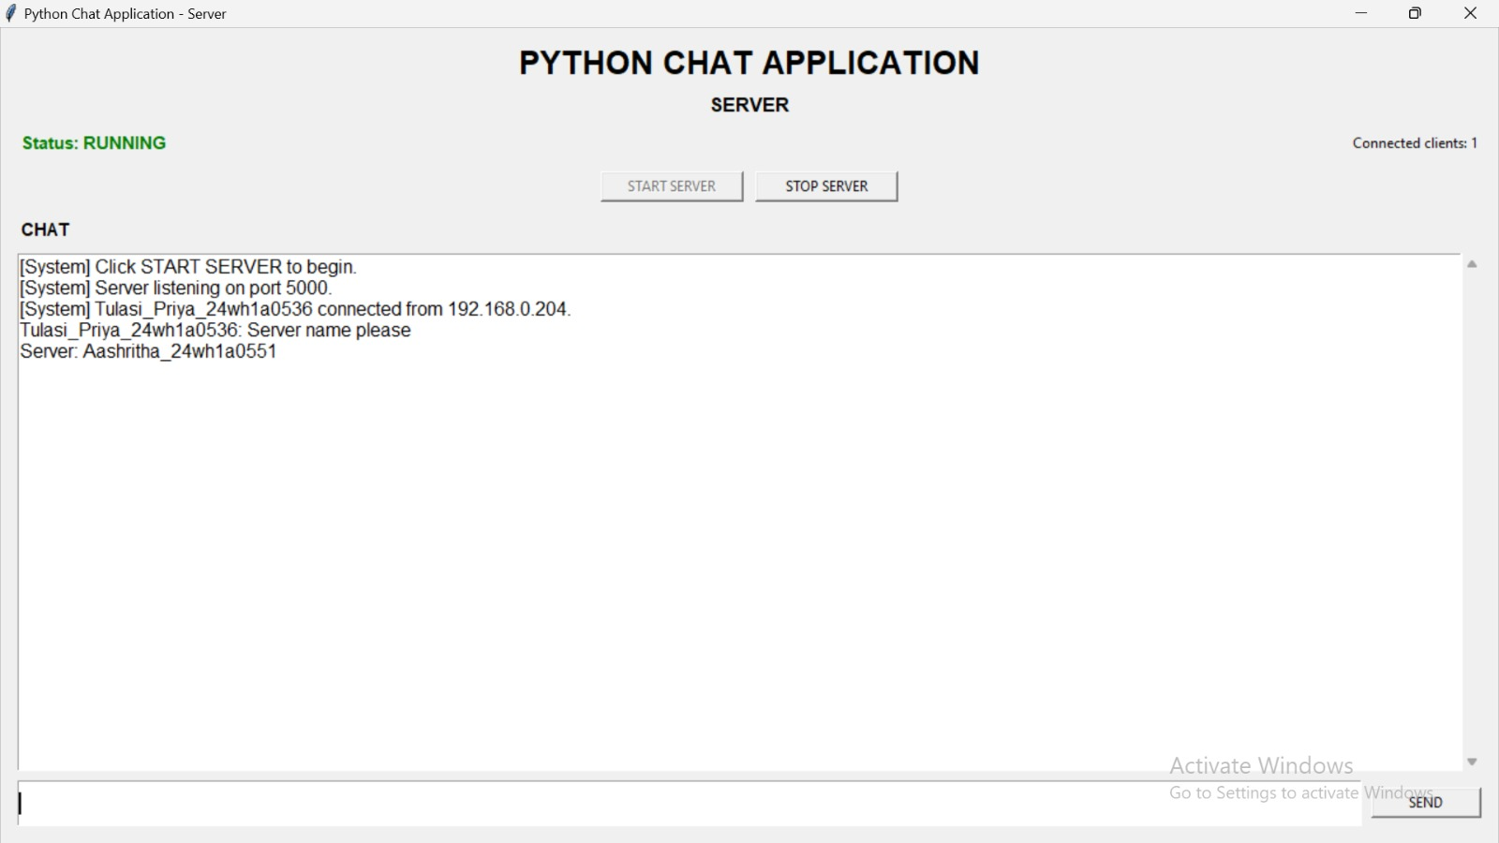
Figure 1: Server GUI showing running status, one connected client, and chat messages.

7.2 Client Application Output
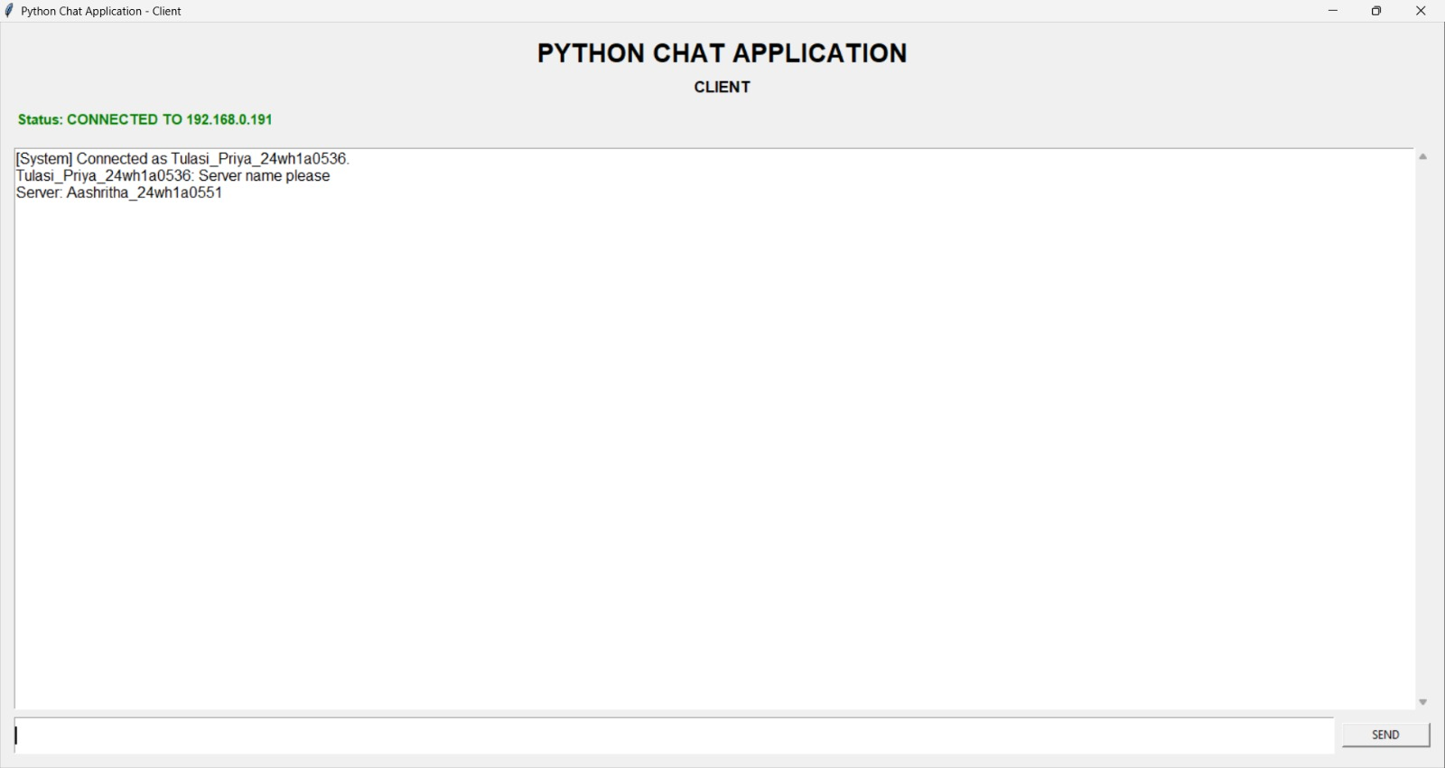
Figure 2: Client GUI showing successful connection and exchanged messages.

8. TESTING AND OBSERVATIONS
The screenshots provide evidence of the following observed test conditions:
- The server started and displayed the RUNNING status.
- The server reported one connected client.
- The client displayed a successful connection to the server's LAN IPv4 address.
- The client sent a text message that appeared in the server chat display.
- The server sent a reply that appeared in the client chat display.
These observations demonstrate basic two-way message exchange for the shown server and client session. They do not constitute a formal load, security, or multi-client stress test.

9. LIMITATIONS AND SECURITY CONSIDERATIONS
- The supplied README identifies this application as an educational LAN demonstration.
- Communication is not encrypted; messages are transmitted without transport-layer encryption.
- The application does not implement user authentication, so display names should not be treated as verified identities.
- The application does not provide message storage or chat-history persistence.
- Communication depends on LAN connectivity and may be blocked by firewall rules or router client/AP isolation.
- The client and server use a simple newline-delimited JSON protocol and do not describe advanced delivery guarantees at the application level.
The application should therefore be used for learning and controlled demonstrations, not for transmitting confidential information over untrusted networks.

10. CONCLUSION
The Python Chat Application – Two-Way GUI successfully demonstrates a basic real-time messaging system using Python socket programming. The server-client design, TCP connection, JSON-based packet exchange, Tkinter graphical interfaces, and multithreaded handling combine to provide two-way communication over a local network. The supplied screenshots show a running server, a connected client, and messages exchanged in both directions. The project serves as a practical introduction to network programming and GUI-based application development in Python.

11. FUTURE ENHANCEMENTS
- Add secure communication using TLS encryption.
- Introduce user authentication and stronger input validation.
- Add timestamps and improved message formatting.
- Support file sharing and private messaging.
- Store chat history in a database.
- Add reconnection handling and clearer network diagnostics.
- Test the application with several simultaneous clients and larger message volumes.

REFERENCES
- Python source files supplied for the project: server.py and client.py.
- Project execution and troubleshooting instructions supplied in README.txt.
- Python standard library modules used in the implementation: socket, threading, json, and tkinter.

