**GAME LOGO AND TITLE**

**GAME DESIGN DOCUMENT**

**Index**

Game Overview

What is the game about 3

ART

**Game Overview**

**What is the Game About?**

Discuss what the game is about, including the game play style, game mechanics and the summary of the game content.

**Game Theme**

What is the game theme? (Sci FI, Horror, Medieval, Modern)

**Game Genre**

What is the game genre? (Action FPS, Action Hack and Slash, RPG, RTS, Platformer)

**Game Platform**

What is the intended game platform? (PC, Console (PS4, XBOX, NINTENDO, Mobile)

**Game Story**

Discuss about the game story, what is the motivation of the characters of the game, what is the end goal/objective, who are the villains in the game etc.

**Target Audience**

Who is the game intended for? (Teenagers, Kids, Adults, Everyone)

**ART**

**Characters**

**Hero Characters**

**Villain Characters**

**NPC (Non Playable Characters)**

|  |  |  |  |  |
| --- | --- | --- | --- | --- |
| **N.O** | **Name of Character** | **Type** | **About the Character** | **Abilities** |
| **1** | Name of Character | Hero/Villain/NPC | More about the character that in relation to the game play and game story | What are the character’s abilities |

**Environments**

**REGIONS:**

**R1: Dark Forest**

**R2: Sandy Desert**

**R3: Ice and Snow**

Discuss the overview what is Region 1 about. (Ice and Snow lands, Difficult to see, Full of Ice Giants etc)

|  |  |  |  |  |
| --- | --- | --- | --- | --- |
| **N.O** | **Name of Region** | **Levels** | **About the Region** | **Enemies** |
| **1** | Name of Region | How many Levels in the Region | More about the region in relation to the game play and game story | What are the enemies found in this region |

**UI DESIGN**

Discuss the types of UI design and the art style of the UI design that will be used. (Dark Theme, Purple and Black Background, Have the sense of horror that is related to the horror game) Insert 3 different example images from other games for the inspiration for your UI design.

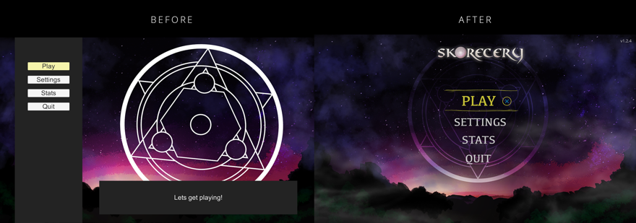

**DESIGN**

**LEVEL DESIGN**

|  |  |  |  |  |
| --- | --- | --- | --- | --- |
| **N.O** | **Region** | **About the Level** | **Objectives of the Level** | **Challenges of the Level** |
| **1** | Which Region is this Level in | What is the Level About? | 1. End Goal 2. Collect the Key | 1. Enemy 2. Time |

**SOUND DESIGN**

**Background Sound**

Discuss how many background sound will be in the game (3-5) and how it will be used in the game

BG Sound 1: To be played when player is fighting enemies (Intense)

BG Sound 2: To be played when player is exploring the lands

**Sound Effects**

Discuss the main sound effects to be used for the game

Sound FX 1: Attack Sound

Sound FX 2: Jumping Sound

**PROGRAMMING**

**GAME SYSTEMS**

Discuss the game systems and rules that the game will have. This includes the points systems, health system, rules of the game, skill tress etc

**GAME MECHANICS**

Discuss the game mechanics to be used for the game. This includes the attack moves, defend moves, combo moves etc of the hero and enemy characters. Also include the triggers such as pick up items (speed pick up, health pick up, weapon pick up) etc. Map out the game controls to the key board and mouse image seen below

Left Click: Fire 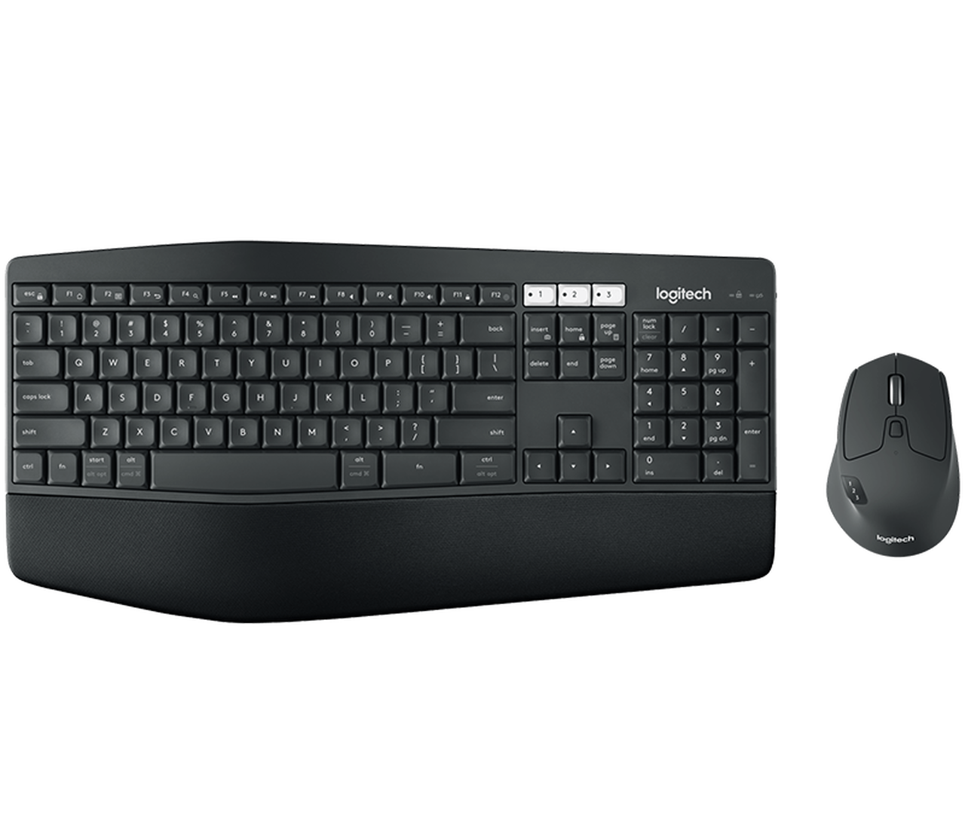: Fire

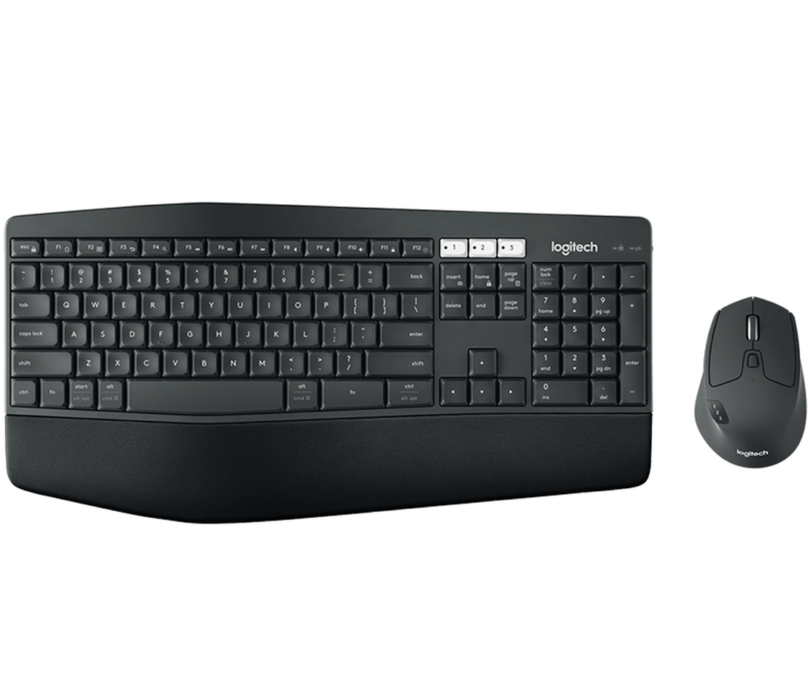

Space Bar: Jump

**MARKETING**

**SOCIAL MEDIA:**

Discuss the different social media pages that the game will have and the type of content that will be put there

**Facebook:** Images, Videos, Game Play Trailer

**Instagram**

**YouTube:** Development Vlogs, Game Play Trailers

**WEBSITES/FORUMS**

Discuss the different websites or forum pages where you will write in for your game to be displayed. Identify 5 different websites or Forums where you can display your game.

<https://www.pcgamer.com>

<https://www.game.co.uk/>

**MANAGEMENT**

**SCHEDULE OF GAME PRODUCTION (8 WEEKS)**

|  |  |  |
| --- | --- | --- |
| WEEK | Things to be Start On | Things to be Completed |
| Week 1 | Concept Art of Characters, 3D Models of Characters, | NA |
| Week 2 | 3D Animation of Characters, Basic Level Design | Concept Art of Characters, 3D Models of Characters, |
| Week 3 |  |  |
| Week 4 |  |  |
| Week 5 |  |  |

**REFRENCES**

Add the references (with accompanying images and website link) of the game assets used for your game.