Systems-level drivers of microplastic biodegradation: Mechanistic insights from bacterial–fungal consortia

Abstract
Microplastics (<5 mm) are ubiquitous pollutants of water, land and air, resulting from plastic manufacture of over 400 million tonnes per year and continuous waste accumulation. Most established removal techniques such as filtering, settling or chemical treatments are largely ineffective for operationalized microplastics in suspension and cause secondary pollution, thus encouraging environmentally friendly options. Biodegradation by microorganisms is promising, although single strains are mostly ineffective against highly crystalline polymers like polyethylene terephthalate (PET). Degradation by mangrove soil microbial communities over 90 days resulted in 18 % PET microplastic weight reduction, indicating bioavailability as a part of the overall biodiversity potential of the soil. Engineered artificial microbial communities with PET-hydrolyzing bacteria resulted in 13.6% loss of PET film mass over a period of 7 days, while complex three- and four- species communities achieved 31.2% in 3 days, and 23.2% under ambient conditions respectively, hence, demonstrating the kinetic benefit of synergistic multi-species systems. It was found that a sequential bacterial-fungal consortium removed 28 ± 2% of PET during a 60-day incubation; The structural breakdown of the PET was verified by spectroscopic methods. This review synthesizes the mechanistic understandings of microbial consortium-mediated PET biodegradation and proposes pathways to up-scalable and sustainable PET microplastic remediation.

Graphical abstract
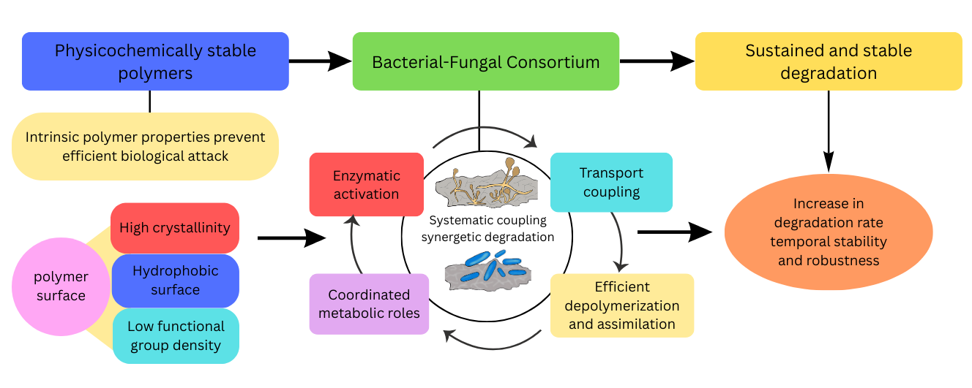

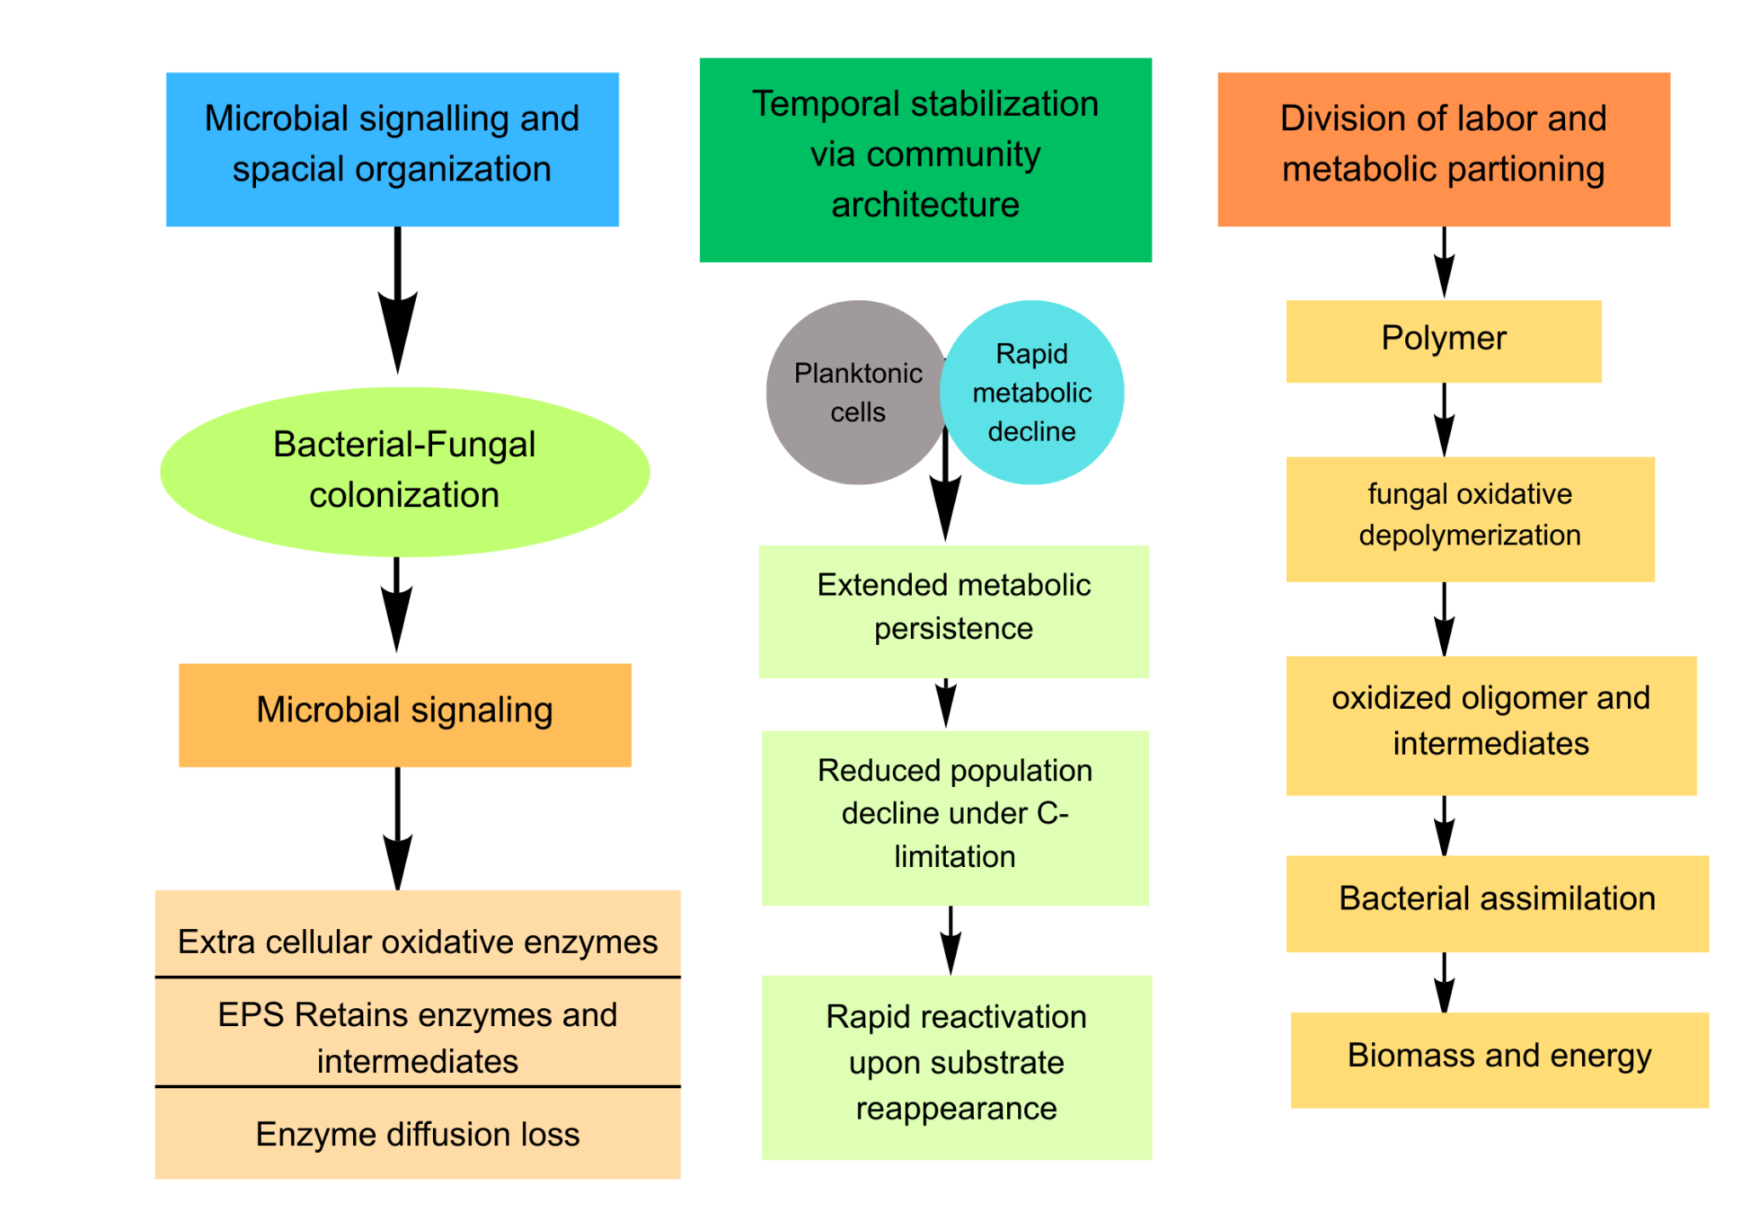
Fig. 1. Schematic representation of how microbe signaling, spatial organization, and functional division of labor contribute to accelerated microplastic degradation in fungal-bacterial consortia. The production of extracellular enzymes and (Extracellular Polymeric Substances) EPS-based biofilms results from quorum sensing and interkingdom communication, keeping these substances in close proximity to the polymer surface. Community structural organization helps to promote stability in microbial activity and community growth rate over longer timescales, thereby minimizing losses and lag phases in community development when growth substrates are in limiting supply. Functional division of labor based on fungal oxidative and bacterial assimilation capabilities results in an unceasing loss of intermediate compounds, thereby promoting microplastic degradation.

2. Bacterial Roles in Microplastic Degradation

2.1 Polymer-Specific Oxidation Kinetics
The bacterial contribution to microplastic biodegradation is specified by the polymer-specific oxidation kinetics that control the rate at which chemically resistant carbon–carbon backbones are converted into biologically available structures [12]. Gravimetric measurements give an apparent daily rate of weight loss of untreated polyethylene and polypropylene between 0.02% and 0.15%, these figures being due to the fundamental resistance of saturated polymers to microbial attack [13]. Such low reaction rates account for the slow early degradation even in optimized lab tests and for the fact that oxidation efficiency and not net biomass growth defines the system’s overall performance.
At the enzymatic level, bacterial monooxygenases and alkane hydroxylases show low specific activities on polymer-like alkane substrates in comparison to vastly higher turnovers on low-molecular-weight hydrocarbons [14]. The significant decrease in catalytic activity is due to steric hindrance and poor substrate access, causing partial oxidation of the substrate and the formation of new functional groups without full chain scission [15]. Therefore, polymer oxidation continues to be kinetically limited, and, unless downstream metabolic removal of oxidized products is also coupled to the increase in enzyme concentration, the rate enhancement will be limited.
Cross-polymer comparisons show that the bacterial oxidation rate of different polymers drops with increasing crystallinity and molecular weight [16]. For example, low-density polyethylene consistently exhibits higher mineralization rates than high-density polyethylene under identical microbial conditions, highlighting the importance of polymer physicochemical structure in controlling reaction kinetics [17].Consequently, intracellular carbon supply is uncoupled from extracellular oxidation, producing a secondary kinetic bottleneck in the degradation process. These quantitative relationships establish bacterial oxidation as a rate-limiting step in microplastic degradation, providing a mechanistic explanation for why bacterial activity alone is inadequate for sustained polymer conversion in environmental systems [18].

Table 1 Representative Polymers, Associated Degraders, and Principal Enzyme Systems
Polymer | Barriers | Key Bacterial Degraders | Key Fungal Degraders | Primary Enzymes | Typical Outcomes | References
LDPE | High hydrophobicity, low surface oxidation | Stenotrophomonas, Achromobacter, Bacillus velezensis | Aspergillus niger, Pestalotizia microspora | Laccase, Cytochrome P450, Alkane hydroxylase | Co-culture: 26.3% loss (60 d)​; Monoculture: 6.8%​; Surface pitting | [19]
HDPE | Very high crystallinity | Bacillus, Rhodococcus, Pseudomonas | Aspergillus, Pestalotizia | Laccase, Peroxidase, Monooxygenase | Weight loss 1–5% in monocultures (60+ d) | [19], [20]
PP | High crystallinity, linear backbone | Bacillus, Rhodococcus, Stenotrophomonas panacihumi | Aspergillus niger, Coniochaeta, Lasiodiplodia theobromae | Laccase, Manganese peroxidase | Pre-treatment required; Fungal loss 8–18.8% (12 months) | [21]
PET | Aromatic rings, ester bonds, high crystallinity | Ideonella sakaiensis, Thermobifida fusca, Pseudomonas | Thermomyces lanuginosus, Humicola insolens | PETase, MHETase, Cutinase | Monocultures: 5–9% degradation (7 d); Room temperature active | [22]
PU (Ester) | Ester/urethane bonds (hydrolyzable) | Pseudomonas chlororaphis, Bacillus subtilis, Corynebacterium | Aspergillus versicolor, Fusarium solani, Pestalotiopsis | Polyurethanase (~21 kDa)​, Esterase, Lipase | A. versicolor: ~58% degradation (soil burial)​; FTIR-confirmed ester cleavage | [23]
PCL | Low crystallinity, aliphatic polyester | Rhodococcus, Bacillus, Pseudomonas, Streptomyces | Aspergillus, Fusarium, Thermomyces lanuginosus | Cutinase, Serine lipase (α/β hydrolase) | Complete degradation in compost (50°C, 91 d); Fastest among polyesters | [24]
PHA/PHB | Aliphatic polyester, low Tg | Pseudomonas aeruginosa, Pseudomonas putida, Bacillus | Aspergillus (limited data) | PHA depolymerase (extracellular/intracellular)​, Lipase | Complete biodegradation (5–6 weeks, compost)​; Weight loss up to 89.94% (30 d) | [25]
PBS | Aliphatic polyester, hydrolyzable | Pseudomonas mendocina, Bacillus | Cryptococcus sp.  (Limited data) | Extracellular esterase (α/β hydrolase)​, Lipase | Co-culture >60% loss (60 h)​; Higher degradation in compost vs. soil​ | [26], [27]

2.2 Transport-Limited Uptake and Intracellular Flux Control
Following extracellular oxidation, bacterial degradation efficiency is limited by transport and uptake kinetics of polymer degradation intermediates rather than enzyme availability [28]. Quantitative and comparative studies shows that oxidized oligomers and long-chain fatty acids are derived from polyethylene degradation shows significantly lower membrane permeability coefficients than comparable short-chain hydrocarbons, due to limited permeability and heavy reliance on inducible transport systems [29]. As a result, intracellular carbon availability becomes decoupled from extracellular oxidation, imposing a secondary kinetic bottleneck on the degradation process.
Degradation throughput is further limited by flux partitioning through central metabolism once internalized [30]. Metabolic flux analysis further indicates that, especially under carbon-poor conditions, a substantial portion of the imported polymer-derived carbon flux is channeled into energy generation, cellular maintenance, and stress mitigation, which decreases net conversion efficiency in monocultures of bacteria [31].
The estimation of bacterial degradation performance, combining transport limitation and intracellular flux imbalance, sets an upper bound [32]. As a result of the inherent limitations of membrane transport and metabolic regulation, experimental approaches manipulating substrate uptake or co-substrate availability only marginally enhance degradation kinetics and rapidly saturate[33].These findings show that bacterial microplastic degradation is fundamentally controlled by intracellular flux economics rather than enzyme abundance, reinforcing the necessity of metabolic coupling with complementary organisms in consortium-based systems [34].
2.3 Redox Balance and Cofactor Constraints
Microplastic substrate breakdown by bacteria is predominantly limited by the cell’s redox state and the amounts of and flux through reduced cofactors NADH and FADH2 [35]. Quantitative redox measurements indicate that the oxidation of long-chain, polymer-derived hydrocarbons produces the reducing equivalents at a rate that temporarily surpasses the capacity of respiratory chain reoxidation, resulting in redox disequilibrium under aerobic conditions [36]. This deficiency inhibits additional oxidative steps by restricting cofactor regeneration, thereby halting degradation even with the presence of the substrate.
Cofactor limitation gets more pronounced under low oxygen or nutrient-limited conditions, where electron acceptor availability limits oxidative phosphorylation [37]. Measurements of the intracellular redox state during alkane and plastic-analog degradation indicate the elevated reductive pressure and impaired electron turnover under oxidative stress conditions, consistent with redox imbalance during polymer-derived carbon metabolism [38]. This redox limitation causes cells to shift carbon to overflow pathways or to storage compounds, decreasing the part of substrate carbon that can be completely oxidized and mineralized.
Within mixed microbial consortia, interspecific electron transfer and synergistic redox metabolisms may relieve redox stress to some extent [39]. Intracellular redox state measurements in alkane and plastic-analog degradation show increased reductive stress and a block in electron flow under oxidative stress, supporting redox imbalance in the process of polymer derived carbon metabolism [40]. Such redox balancing mechanisms introduce an additional layer of metabolic cooperation, indicating that efficient microplastic degradation requires not only enzymatic and transport coordination, but also system-level management of intracellular electron flow [41].

3. Fungal Roles in Microplastic Degradation

3.1 Extracellular Enzyme Deployment and Physical Penetration Capacity
Quantitative separation of fungal involvement in microplastic breakdown is achieved through the fungi’s capacity to produce extensive extracellular oxidative enzymes that traverse the cell wall and the plasma membrane [42]. Fungal enzymes secreted into the environment, for example laccases, manganese peroxidases and versatile peroxidases, are usually 55–80 kDa in molecular weight, and can catalyse reactions within a confined, diffusion-controlled oxidative zone emanating from the hyphal surface, broadening considerably the spatial range of the enzymes relative to membrane-bound bacterial enzymes [43]. The spatially restricted catalytic radius enables fungi to start polymer alteration without physical cell contact, increasing the area of degradation.
Beyond enzymatic expansion, fungal hyphae generate significant mechanical pressures that enable the physical entry into the polymer matrix [44]. Experiments and imaging studies show that hyphal extension is able to distort and penetrate oxidatively damaged areas of polymers, exposing micro-fissures and lower regions normally impenetrable to bacteria [45][46]. The mechanical feature adds a volume-based degradation term that is essentially different from surface mode microbial degradation, and thereby enhances the effective reactive surface area accessible to the community.
Fungal extracellular enzymes are also characterized by wide operational stability, retaining catalytic activity over a broad pH and temperature range which are ecologically, and increasingly of biotechnological relevance [47]. Enzyme half-life assessments suggest a continued activity for a long time in extracellular matrices, mirroring consistent polymer modification during changing environmental conditions [48].
3.2 Enzyme Selectivity, Catalytic Breadth, and Reaction Stoichiometry
The general substrate specificity of extracellular oxidative enzymes is the main factor determining the efficiency of fungal degradation and permits the concurrent alteration of chemically varied polymer segments. Comparative enzyme assays show that fungal laccases and peroxidases are capable of oxidizing a broad range of structurally diverse aromatic and aliphatic intermediates, indicating a flexible active-site conformation that can process the chemically complex mixture of oxidation products produced during microplastic weathering [49]. The catalytic diversity decreases the requirement for uniformity of substrate and facilitates the ongoing oxidation at the presence of the chain length and the functional group distribution variations of the polymer. This versatility is in contrast to the somewhat limited substrate specificity of many bacterial enzymes, which usually necessitate more precise molecular architectures for functioning [50].
Mechanistically and in terms of stoichiometry, fungal oxidative systems function by high electron-abstraction capacity via SET rather than by stepwise depolymerization [51]. This mode of reaction facilitates the partial oxidation of the polymer chains without full scission into monomeric units, leading to a diversified mix of oxidized intermediates accessible for subsequent microbial catabolism [52]. Crucially, materials and environmental studies show that fungal oxidative systems are still active in the presence of polymer additives and stabilizers, showing the resilience to the chemical heterogeneity of plastic matrices.
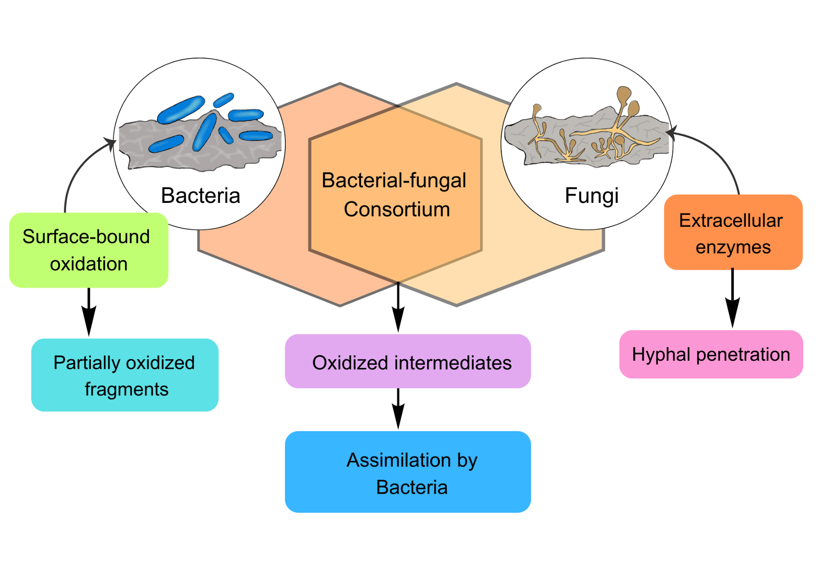
Fig. 2. Schematic concept presenting the role of bacteria, fungi, and a consortium in the degradation process of microplastics; Bacteria play a role in the oxidation of the crystalline polymer substrates through surface interactions, thereby producing partly oxidized fragments. Fungi play a role independently through the alteration of the polymer matrix through external enzymatic activities and hyphal penetration, thereby producing oxidation fragments. In the bacterial and fungal interactions, oxidation fragments produced in the consortium interactions are transported to the bacteria for assimilation through their internal cellular activities.

4. Microbial Interactions in Degradation

4.1 Signaling and Communication Mechanisms

Bacterial–fungal consortia are initiated and maintained at the population level, enzyme level, and biofilm maturity on polymer surfaces through microbial signaling [53]. N-acyl-L-homoserine lactone (AHL), autoinducing peptides and autoinducer-2 mediated bacterial quorum sensing have been demonstrated to cause large and stepwise increases in extracellular enzyme production in response to reaching threshold cell densities, thereby affecting the rate of polymer surface oxidation [54]. Signaling-dependent adaptations facilitate the coordination of bacterial groups’ metabolic activity and prevent the early dilution of enzymes during initial degradation phases.

Cross-kingdom fungal-bacterial signaling also increases the rate of degradation by regulating oxidative metabolism and stress resistance [55]. Co-culture experiments have shown that bacterial signaling compounds can induce the expression and activity of fungal oxidative enzymes and that fungal secondary metabolites can improve bacterial growth and substrate assimilation in limiting media [56]. This two-way communication synchronizes the metabolic clocks of the partners so that the oxidative depolymerization and intermediate assimilation take place in a concerted rather than independent fashion.

Locally, quorum sensing-controlled synthesis of extracellular polymeric substances (EPS) creates a common physico-chemical matrix trapping enzymes and degradation by-products close to the microplastic surface [57]. Transport studies of macromolecules show markedly diminished enzyme diffusion rate within mature biofilms relative to planktonic systems, resulting in continuous enzymatic function and diminished escape of reactive intermediates [58]. The signaling-elicited spatial arrangement converts the separate microbial activities into a synergistic metabolic network, offering a mechanistic understanding of the improved degradation rates routinely reported in bacterial–fungal consortia [59].

4.2 Temporal Stabilization of Degradation Through Community Architecture
Temporal degradation studies show that microplastic surface colonizing bacteria persist in metabolically active forms to a much greater extent than freely suspended cells, despite similar fast reaction rates [60]. Quantitative research shows extended periods of active colonization in tightly organized microbial systems, while free-floating systems tend to undergo early metabolic ceasing, even if initial enzyme levels are the same [61]. Extending the functional lifetime thus enhances total polymer mass loss by extending the period of efficient catalysis, rather than by speeding up the initial reactions.

Extended monitoring indicates also that community-associated systems exhibit a decreased rate of population decline in C-deprived environments [62]. Although free-living bacterial communities involved in microplastic degradation usually decrease after the consumption of the substrate, structured communities persist in basal metabolic activity and can quickly reactivate when substrate becomes available again [63]. This endurance curtails restart pauses and avoids re-occurring lag periods, which would decrease the net degradation rate in the long term.
In bacterial–fungal systems, temporal stabilization is strengthened by independent metabolic activity between partners [64]. Fungal oxidative processes often remain active after the bacterial growth slows, while bacterial metabolism revives upon release of secondary intermediates, producing staggered but overlapping activity phases that extend overall system functionality [65]. Comparative degradation studies show that such temporally offset activity enhances cumulative polymer conversion over long-term incubations relative to synchronized monocultures, highlighting temporal stability as an independent driver of synergistic microplastic degradation [66].
4.3 Functional Division of Labor and Metabolic Partitioning
Within bacterial–fungal consortia, performance of degradation is controlled by functional division of labour, with metabolic processes broken up according to enzyme specificity, redox potential and energetic yield (Fig. 1) [67]. Quantitative carbon cycle analyses suggest that the efficiency of metabolism is at its peak in the scenario where fungal components of the microbiota are responsible for the initial degradation of complex polymers and bacterial partners are specialists in the fast assimilation of the derived molecules [68]. Breaking it up lightens the metabolic load of each species and enhances the net energy output of the community by avoiding the local build-up of inhibitory intermediates. Through the communal investment in the synthesis of extracellular enzymes, consortia show 1.5 to 2.2-fold increases in biomass yield per unit of polymer substrate relative to monocultures, diverting the conserved energy to persistent enzymatic activity over individual survival [69].
Thermodynamically, the division of labor enhances the possibility by separating energetically unfavorable oxidation reactions from subsequent exergonic assimilation reactions, and the constant removal of intermediates drives the reaction equilibria toward more polymer breakdown [69][70]. Stoichiometric and network-level studies suggest that functional complementarity decreases within-cell expenditure of redundant metabolic pathways and offloads energy from stress response and maintenance to persistent catalytic activity [71]. Collectively, these changes show that consortium functioning is the result of refined metabolic economics and synchronized energy distribution rather than linear enhancement of enzymes [72].
5. Synergistic Bacterial–Fungal Consortia

5.1 Coupled Depolymerization–Assimilation Efficiency

A key benefit of bacterial–fungal consortia is the mechanistic link between the extracellular polymer depolymerization and the intracellular bacterial assimilation, controlling the efficiency of polymer-derived carbon migration over trophic interfaces [73]. Stable-isotope and pathway-resolved experiments demonstrate that fungal oxidative or hydrolytic activity liberates low-molecular-weight intermediates that are quickly scavenged by metabolically compatible bacterial associates while uncoupled systems contain a higher proportion of transformation products outside the biological uptake pathway [74]. Intermediate capture by proximity confines diffusive escape, reduces abiotic side reactions, and preserves the advantageous chemical gradients that drive ongoing depolymerization.

On a system level, the coupling efficiency results from a kinetic matching of intermediate release and uptake, and limits residence time and clamps downstream metabolic fluxes [75]. Functional studies of consortia demonstrate that synchronized enzyme deployment and transport regulation decrease the buildup of intermediate transformation products and promote biomass production from polymeric substrates (Fig. 2) [76]. The integration stems from coordinated reaction and transport steps, creating a degradation–assimilation cascade with the greatest utilization efficiency (Fig. 3)[77].

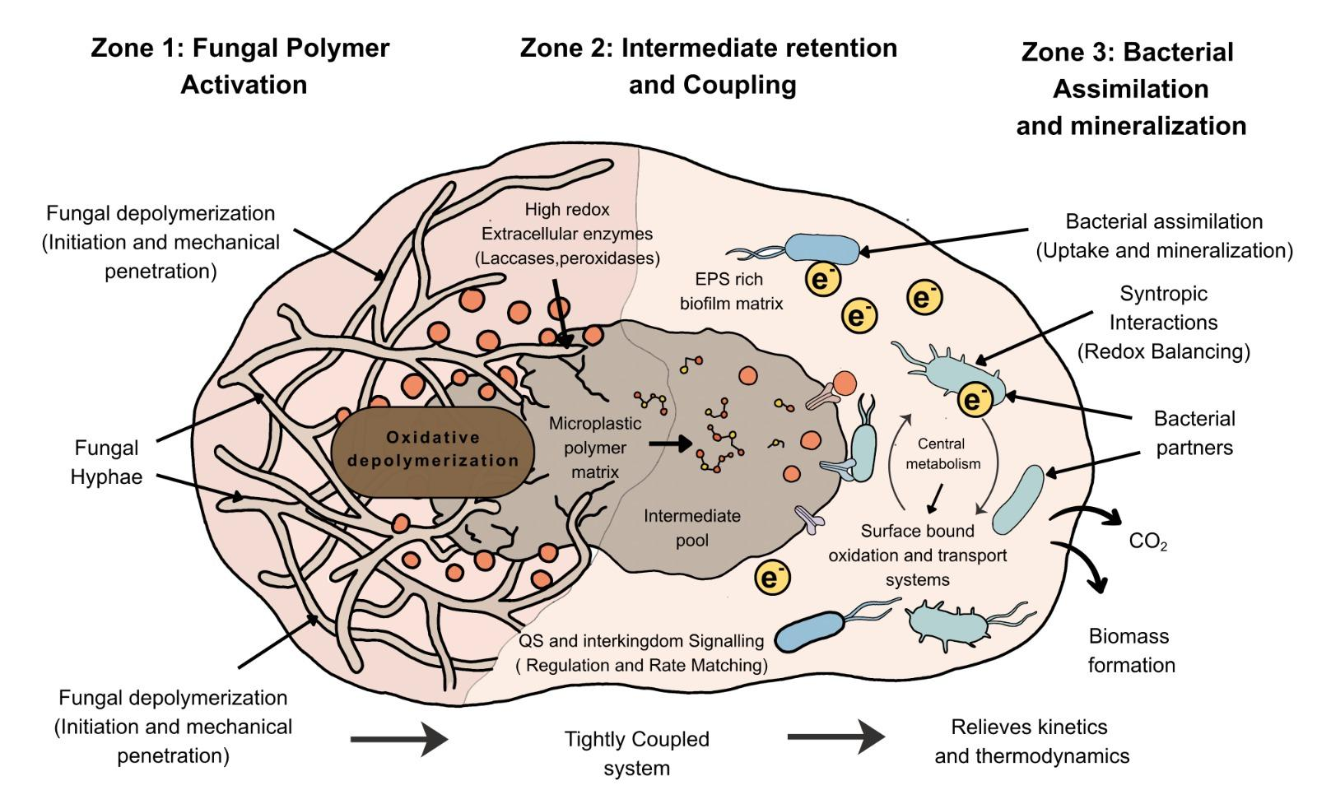
Fig. 3. Three-zone, tightly coupled bacterial–fungal consortium driving microplastic degradation.
The system is structured into three functionally integrated zones. Zone 1 illustrates penetration of fungal hyphae into the microplastic polymer matrix and secretion of high-redox extracellular oxidative enzymes like laccases and peroxidases, thereby initiating oxidative depolymerization. Zone 2 depicts an EPS-rich biofilm matrix that retains partially oxidized oligomers and mediates metabolic coupling via quorum sensing and interkingdom signaling, thereby enabling rate matching between fungal depolymerization and bacterial uptake. Zone 3 shows bacterial partners performing surface-bound oxidation, transport, and central metabolism of oxidized intermediates, resulting in formation of biomass and CO₂ release. Directional electron transfer highlights syntrophic redox balancing that stabilizes metabolic flux and alleviates kinetic and thermodynamic constraints.

5.2 Rate Matching and Kinetic Imbalance in Synergistic Consortia
The functional efficiency of bacterial–fungal associations depends on the kinetic harmony of the upward depolymerization reactions and downward assimilation routes, maintaining a constantly interactive synthesis and utilization of intermediates [78]. Mechanistic investigations of cross-feeding systems show that equalization of transformation rates results in a stable transfer of degradation intermediates into metabolic networks and that kinetic mismatch results in temporary accumulation or premature depletion of intermediates destabilizing the function of the system [79]. It therefore sets rate matching, rather than maximum enzymatic rate, as the fundamental factor for continued cooperative degradation.
Experimental studies of uneven consortia indicate that too much upstream conversion can fill transport and metabolic routes, leading to feedback inhibition, changed redox status, and dampened cellular functions [80]. On the other hand, excessive downstream metabolic capacity in relation to intermediate supply leads to starvation-related stress responses and reroutes carbon flux to basal instead of growth metabolism, disrupting cooperative exchange [81][82]. The competing failure modes stem from reaction–transport decoupling, not from the disappearance of the catalytic capability.
Mathematical and systems-level modeling also shows that kinetic mismatch shortens the effective operational lifetime of consortia by collapsing metabolite gradients and regulatory feedback loops [83]. Stability studies indicate that the tuned velocities of the reactions enable extended operational stability, while mismatched systems quickly derailed through an intermediate imbalance [84].Together, these findings demonstrate that synergistic degradation comes from the quantitative alignment of reaction velocities across trophic partners, defining a constrained operational regime for efficient polymer turnover [85][86].

Table 2 Kinetic and Thermodynamic Bottlenecks and Consortium-Level Mitigation
Scale | Main Bottleneck | Mechanistic Consequence | Consortium-Level Mitigation | References
Bacterial cell | Slow polymer surface oxidation | Partial oxidation and kinetic stasis; low overall weight loss (e.g. LDPE 1.3–4.3% in 60 d) | Fungal partners provide high-redox-potential enzymes and hyphal access, accelerating initial activation | [87]
Bacterial cell | Transport-limited uptake of oxidized oligomers | Decoupled extracellular oxidation from intracellular assimilation; intermediate loss and low carbon flux | EPS-rich biofilms and close bacterial–fungal proximity retain intermediates near cells, improving capture | [88]
Bacterial cell | Redox imbalance (excess NADH/FADH₂) | Inhibited further oxidation; overflow/storage metabolism; reduced mineralization yield | Syntrophic electron sharing and complementary redox metabolisms partially relieve redox stress in consortia | [89]
Fungal hypha | Limited access in highly crystalline polymers | Low enzyme turnover on intact surfaces; strong dependence on pre-weathering | Hyphal penetration opens micro-fissures and increases effective reactive surface for both partners | [90]
Consortium | Intermediate accumulation & feedback inhibition | Kinetic mismatch between depolymerization and assimilation; inhibition of upstream enzymes and pathway slowdown | Rate matching of release/uptake, syntrophic consumption, and spatial coupling stabilize intermediate pools | [91]
Consortium | Kinetic mismatch (too slow assimilation) | Starvation-related stress; rerouting of carbon to basal metabolism instead of growth | Tuned metabolic reaction rates across partners; temporal offsetting of activity phases (bacteria → fungi → bacteria)​ extends operational lifetime | [24]
System | Temporal stasis and stress sensitivity | Early loss of activity in monocultures; sharp decline under nutrient/O₂ or temperature shifts | Structured, diverse consortia show extended active lifetimes, buffering and faster post-stress recovery | [15]

5.3 Buffering Capacity, Resilience, and Failure Recovery
Synergistic bacterial-fungal consortia show measurable buffering capacity that enables sustained degradation activity even under fluctuating environmental conditions by redistributing functional load across interacting metabolic partners [92]. Perturbation experiments involving nutrient limitation, temperature variation, and short toxic exposure shows that consortium-based systems maintain a substantially larger fraction of baseline functional activity when compared to monocultures, which often experience rapid performance decline under equivalent stress [93]. Functional redundancy and asynchronous metabolic engagement results in this buffering behavior, which allows stress to be dissipated across multiple enzymatic and regulatory pathways rather than concentrated within a single organism.
Another aspect of resilience is shown in post-disruption relaxation dynamics, where cooperative communities demonstrate faster restoration of degradation function relative to single-species systems [94]. Time-resolved analyses indicate that recovery efficiency is governed primarily by the availability of alternative metabolic routes, reserve enzymatic capacity, and regulatory flexibility, rather than total biomass alone [95]. These attributes rapid reactivation of dormant pathways and redistribution of metabolic flux once favorable conditions are restored.
The result of the threshold-based analysis shows that consortium failure arises only after perturbations exceed the compensatory capacity of cooperative interactions [96]. When disturbances remain below this threshold, functional losses are reversible through community reorganization, however, exceeding it leads to irreversible collapse due to breakdown of metabolic coordination [97]. Within this resilience framework, buffering capacity is measured as a quantifiable and design-relevant property for engineered microplastic degradation systems [98].

6. Engineering Bacterial-Fungal Consortia

6.1 Design Parameters and Quantitative Optimization Rules
Engineering functional bacterial–fungal consortia necessitates defined control of population ratios, spatial arrangement and distribution of metabolic burdens instead of co-inoculation [99]. Consistent experimental results indicate that consortium performance is related to the proportionate sharing of the complementary metabolisms between the partners, as disproportionate dominance of either organism can lead to the intermediate product accumulation, competitive exclusion or the inefficient resource use [100]. These results suggest that the best cooperative dynamics are the result of metabolic costs and interaction configurations rather than static species ratios.
Apart from the population composition, inoculation timing and sequencing profoundly impact the consortium performance by directing initial metabolic pathways and accessibility of substrates [101]. Systems which set up upstream polymer-modifying activity before downstream assimilation exhibit enhanced coordination of transformation and assimilation, which reduces early competition and more efficient division of the labor [102]. This time-based coordination of functions obviates the need for augmented enzyme expression or external intervention.
At larger process scales, designed microbial communities react in a predictable manner to external variables like oxygen level, nutrient restriction and spatial confinement, all of which affect the stability of interactions and the division of carbon flux [103]. Theoretical and experimental studies suggest that keeping the environmental parameters within the ranges of the cooperative metabolism is necessary to avoid competitive overgrowth and functional imbalance [104]. Collectively, these findings demonstrate that consortium engineering is governed by tunable but system-specific parameters, supporting rational design strategies over empirical trial-and-error approaches [105][106].

Table 3 Design Parameters for Engineered Bacterial-Fungal Consortia for Microplastic Remediation
Design Parameter | Tunable Range/Options | Primary Effects on Performance | Key Trade-offs | References
Population Ratio | Bacteria-dominated, balanced, fungi-dominant | Coupling efficiency; intermediate-product accumulation | High bacterial ratio: faster assimilation but reduced oxidative capacity; fungi-dominant: better polymer activation but slower intermediate uptake | [102]
Inoculation Sequencing | Fungi-first → bacteria; co-inoculation; bacteria-first | Early polymer oxidation; reduced lag phase; competitive dynamics | Fungi-first optimizes coordination but adds timing complexity​; simultaneous simplifies but risks slower initial activation | [66]
Substrate Presentation | Powder vs. film; size (smaller = more surface area) | Biofilm colonization; accessible reactive surface | Fine powder: high surface area but transport limitations; films: stable but slower initial attachment | [66]
Environmental Window | Temperature (20–30°C)​; Oxygen (aerobic)​; Glucose inhibition​ | Enzyme activity, metabolic rate, gene expression; stress tolerance | Tight constraints maximize performance but reduce robustness; excessive constraints cause system collapse | [107]
Spatial Architecture | Extracellular biofilm; tightly integrated; endosymbiotic internalization | Intermediate retention, coupling efficiency, long-term stability | Loose biofilms: >20% intermediate loss but flexible; endosymbiotic: max efficiency but low modularity | [108]
Consortium Complexity | 2–4 species (optimized DOL); >4 species (redundancy) | Substrate specificity, product detoxification, stress buffering | 3-species: best efficiency (30% PET loss, 7 d)​; 4-species: complete product detoxification but slower degradation | [109]
Functional Partitioning | Polymer-degrader; intermediate-assimilator; detoxifier specialist​ | Rate matching, prevention of inhibition, sustained carbon flow​ | Precise metabolic burden distribution improves yield but requires optimized population ratios | [102]

6.2 Endosymbiotic and Intracellular Consortium Architectures
High-resolution microscopy and cell-quantification studies show that experimentally induced fungal endosymbiosis can sustain dense intracellular bacterial populations, establishing direct cytoplasmic proximity between partners and substantially reducing spatial separation with respect to extracellular consortia [110]. This intracellular localization enables continuous exposure of bacterial metabolism to host-generated oxidation products, and in turn shifts system control from diffusion-limited interspecies exchange to intracellular metabolic coordination and substrate channeling.

At the metabolic level, endosymbiotic integration produces measurable changes in carbon routing, energy utilization, and stress tolerance relative to free-living associations [111]. The genome-scale reconstructions of fungal holobionts have shown that the intracellular bacteria are able to access a dominant fraction of host-derived intermediates through tightly coupled metabolic networks, whereas extracellular consortia experience greater intermediate loss and competition prior to uptake [108].

Experimental perturbation studies show that endosymbiotic systems maintain functional metabolic activity under oxygen and nutrient limitation, reflecting host-mediated buffering and regulated intracellular environments that stabilize partner metabolism (Fig. 4) [112]. Genomic analyses show that these performance gains are accompanied by progressive genome reduction, loss of autonomous metabolic functions, and increased host dependence, defining endosymbiosis as a high efficiency but low flexibility design regime suited to applications prioritizing maximal coupling efficiency and long-term stability over modularity [113].
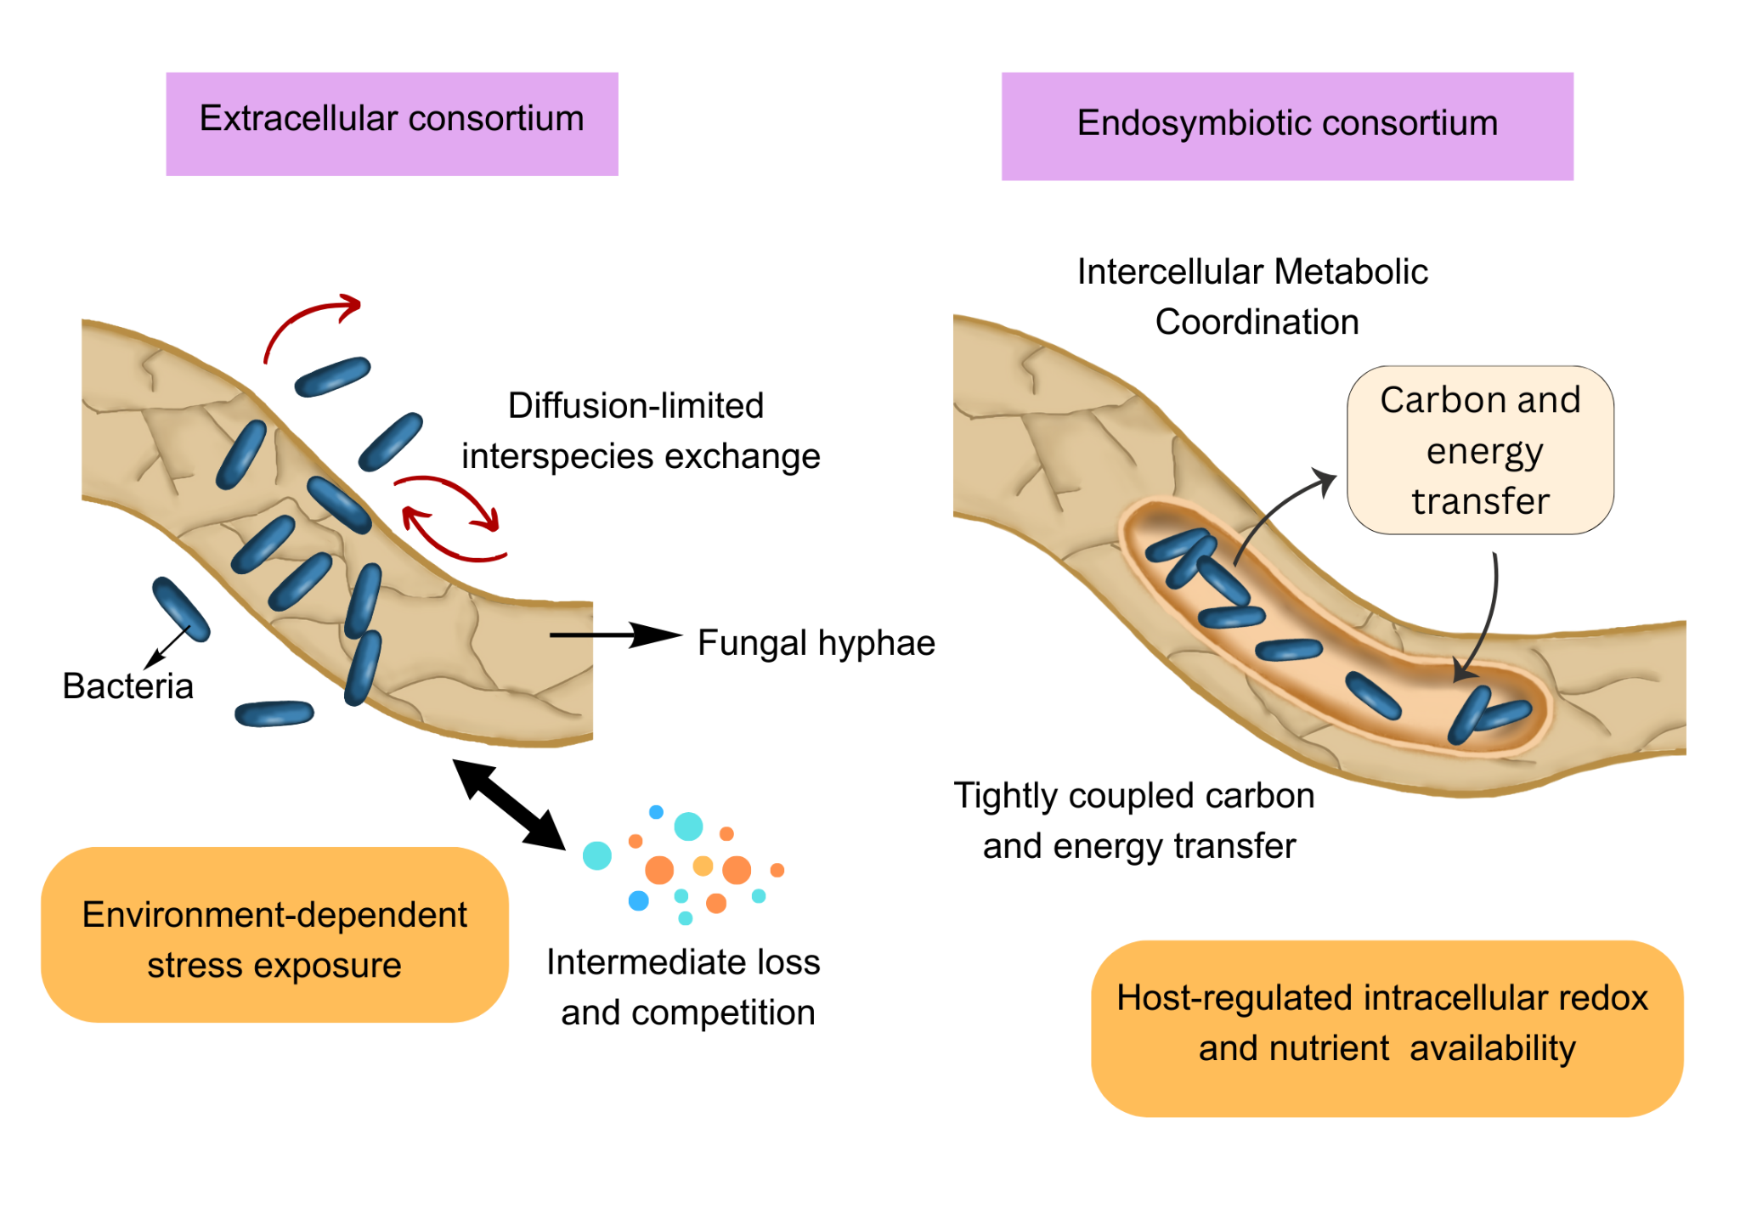
Fig. 4. Schematic illustration of structure of extracellular and endosymbiotic fungal-bacterial consortia In extracellular consortia, bacterial cells are external to fungal hyphae with metabolite exchange occurring via diffusion-driven processes, which result in low capture efficiency and a loss of intermediates to the surrounding environment. In endosymbiotic consortia, bacterial cells are confined to the fungal cytoplasm with physical containment allowing control over intracellular environments and reduced metabolite transport efficiency.

7. Challenges and Future Directions
Bacterial-fungal consortia, despite evident improvements in terms of the efficiency of biodegradation, are still limited by scale dependent and system level limitations that hinder translation beyond controlled experimental settings [114]. Substantial reductions in degradation performance are consistently reported in scale-up analyses when laboratory microcosms are scaled to pilot-scale systems, primarily due to diminished spatial control, heterogeneous substrate distribution, and increased stochasticity in community composition [115]. These constraints are exacerbated in environmental matrices in which fluctuations in temperature, oxygen availability, and nutrient flux frequently exceed the narrow operational windows defined for optimized consortia.
A further persistent limitation in the field is the absence of standardized kinetic and mechanistic benchmarks for evaluating consortium performance across studies [116]. Reported metrics-including polymer weight loss, carbonyl index shifts, and biomass yield-are frequently collected across disparate timescales and experimental conditions, thereby complicating quantitative comparison and predictive modeling. In the absence of harmonized reporting of rate constants, carbon flux partitioning, and stability thresholds,the rational design and cross-validation of next-generation consortia remain limited [117].
Future progress will depend on integrating systems-level modeling, real-time monitoring, and adaptive control strategies into consortium design frameworks [118]. Advances in multi-omics–informed modeling and feedback-controlled bioprocessing now permit estimation of collapse thresholds and long-term stability under dynamic conditions. However, translating these tools to environmentally relevant microplastic degradation will require expanded datasets capturing long-term dynamics, evolutionary drift, and failure modes, enabling robust deployment of bacterial–fungal consortia as scalable remediation systems [118].

Conclusion
Through this review we understand that effective microplastic biodegradation arises from quantitatively coordinated bacterial-fungal interactions operating across enzymatic, metabolic, and architectural scales rather than being understood or optimized through single-organism perspectives. From the combining of numerical data on oxidation kinetics, transport constraints, redox constraints, metabolic partitioning, and coupling efficiency, it is clear that systems-level alignment of reaction rates, energy flows, and spatial organization, rather than just maximal enzymatic activity, determines degradation performance. Bacterial-fungal consortia perform better than monocultures due to the synergistic integration that reduces basic kinetic, thermodynamic, and regulatory bottlenecks associated with polymer degradation rather than additive capabilities.
A key result of this synthesis is that various operational regimes with characteristic efficiency, stability, and flexibility trade-offs are prescribed by consortium architecture, from the loosely coupled extracellular systems to the highly integrated endosymbiotic associations. Endosymbiotic structures are a maximum coupling efficiency and metabolic stability design approach eliminating interspecies transfer losses, while extracellular consortia are modular and adaptable. Rather than considering microbial decomposition to be a solely biological event resulting from organism choice, the results cast it as an engineering challenge governed by adjustable variables such as rate matching, coupling efficiency and stability thresholds.
The collective mechanistic picture present here provides the foundation for the rational design of future microbial systems for microplastic remediation. The progression of this research will require transition from qualitative degradation descriptions to quantitative kinetic parameters, to the implementation of long-term system investigations and to the development of integrative models that unify polymer chemistry with community ecology. Bacterial–fungal consortia can be transitioned from innovative laboratory observations to robust, scalable tools for addressing the persistent issue of microplastic contamination through system-oriented experimental design.

REFERENCE
[1] Jenna R. Jambeck et al. ,Plastic waste inputs from land into the ocean.Science347,768-771(2015). https://doi.org/10.1126/science.1260352
[2] Liu, J., & Li, C. (2025). Impact of Microplastics on Aquatic Ecosystems. Water, 17(14), 2124. https://doi.org/10.3390/w17142124
[3] Talvitie, J., Mikola, A., Setälä, O., Heinonen, M., & Koistinen, A. (2017). Solutions to microplastic pollution — Removal of microplastics from wastewater effluent with advanced wastewater treatment technologies. Water Research, 123, 401–407. https://doi.org/10.1016/j.watres.2017.07.005
[4] Auta, H. S., Emenike, C. U., Jayanthi, B., & Fauziah, S. H. (2018). Growth kinetics and biodeterioration of polypropylene microplastics by Bacillus sp. and Rhodococcus sp. isolated from mangrove sediment. Marine Pollution Bulletin, 127, 15–21. https://doi.org/10.1016/j.marpolbul.2017.11.036
[5] Muangchinda, C., & Pinyakong, O. (2024). Enrichment of LDPE-degrading bacterial consortia: Community succession and enhanced degradation efficiency through various pretreatment methods. Scientific Reports, 14, Article 28795. https://doi.org/10.1038/s41598-024-80306-4
[6] Roberts, C., Edwards, S., Vague, M., León-Zayas, R., Scheffer, H., Chan, G., Swartz, N. A., & Mellies, J. L. (2020). Environmental consortium containing Pseudomonas and Bacillus species synergistically degrades polyethylene terephthalate plastic. mSphere, 5(6), e01151-20 https://doi.org/10.1128/msphere.01151-20
[7] Giyahchi, M., & Moghimi, H. (2025). Sustainable solution for microplastic removal: Sequential biodegradation and detoxification of polyethylene terephthalate microplastics by two natural microbial consortia. Ecotoxicology and Environmental Safety, 302, 118738. https://doi.org/10.1016/j.ecoenv.2025.118738
[8] Yoshida, S., Hiraga, K., Takehana, T., Taniguchi, I., Yamaji, H., Toyohara, K., Miyamoto, K., Kimura, Y., & Oda, K. (2016). A bacterium that degrades and assimilates poly(ethylene terephthalate). Science, 351(6278), 1196–1199. https://doi.org/10.1126/science.aad6359
[9] Shokunbi, A. O., Ezeh, O. M., Fadipe, D. P., Olanrewaju, A. S., Badru, O. O., Eze, C. N., & Iwuala, L. C. (2025). Microbial Consortia: Synergistic Effects on Plastic Degradation and Enzyme Production. Journal of Medical Science, Biology, and Chemistry, 2(1), 149-156. https://doi.org/10.69739/jmsbc.v2i1.681
[10] Xiang, P., Zhang, T., Wu, Q., & Li, Q. (2023). Systematic review of degradation processes for microplastics: Progress and prospects. Sustainability, 15(17), 12698. https://doi.org/10.3390/su151712698
[11]Wei, R., & Zimmermann, W. (2017). Microbial enzymes for the recycling of recalcitrant petroleum-based plastics: How far are we? Microbial Biotechnology, 10(6), 1308–1322. https://doi.org/10.1111/1751-7915.12710
[12] Pérez-García, P., de la Fuente, G., & de Lorenzo, V. (2025). Microbial plastic degradation: enzymes, pathways and challenges. Microbiology and Molecular Biology Reviews, 89(1), e00087-24. https://doi.org/10.1128/mmbr.00087-24
[13] Choi, J., Kim, H., Ahn, Y. R., Kim, M., Yu, S., Kim, N., Lim, S. Y., Park, J. A., Ha, S.-J., & Lim, K. S. (2024). Recent advances in microbial and enzymatic engineering for the biodegradation of micro- and nanoplastics. RSC Advances, 14, 9943–9966. https://doi.org/10.1039/D4RA00844H
[14] Rojo F. Degradation of alkanes by bacteria. Environmental Microbiology (2009). https://doi.org/10.1111/j.1462-2920.2009.01948.x
[15] Cai, Z., Li, M., Zhu, Z., Wang, X., Huang, Y., Li, T., Gong, H., & Yan, M. (2023). Biological Degradation of Plastics and Microplastics: A Recent Perspective on Associated Mechanisms and Influencing Factors. Microorganisms, 11(7), 1661. https://doi.org/10.3390/microorganisms11071661
[16] Pfohl, P., Oelschlägel, K., & Simon, F. (2022). Effect of polymer properties on the biodegradation of thermoplastic polyurethanes and related materials. Environmental Science & Technology, 56(4), 2345–2357. https://doi.org/10.1021/acs.est.2c05602
[17] Akram, M. A., Savitha, R., Kinsella, G. K., Nolan, K., Ryan, B. J., & Henehan, G. T. (2024).\ Microbial and enzymatic biodegradation of plastic waste for a circular economy. Applied Sciences, 14(24), 11942. https://doi.org/10.3390/app14241194
[18] Thakur, B., Singh, J., Singh, J., Angmo, D., & Vig, A. P. (2023). Biodegradation of different types of microplastics: Molecular mechanisms and degradation efficiency. Science of the Total Environment, 862, 162912. https://doi.org/10.1016/j.scitotenv.2023.162912
[19] Ojha, N., Pradhan, N., Singh, S. et al. Evaluation of HDPE and LDPE degradation by fungus, implemented by statistical optimization. Sci Rep 7, 39515 (2017). https://doi.org/10.1038/srep39515
[20] Álvarez-Barragán J, Domínguez-Malfavón L, Vargas-Suárez M, González-Hernández R, Aguilar-Osorio G, Loza-Tavera H.2016.Biodegradative Activities of Selected Environmental Fungi on a Polyester Polyurethane Varnish and Polyether Polyurethane Foams. Appl Environ Microbiol82:. https://doi.org/10.1128/AEM.01344-16
[21] Rauthan, D.S. and Rauthan, A.(2025). Biodegradation of Polyethylene Microplastics by Bacteria, Fungi, and Algae: Mechanisms, Enzymes, and Microbial Diversity. Chemical and Environmental Science Archives, Vol. 5 (1),1-8. https://doi.org/10.47587/CESA.2025.5101
[22] Mathew, Jiby & Vazhacharickal, Prem & N K, Sajeshkumar & Mathews, Alex. (2022). Microbial degradation of Polyethylene Terphthalate (PET): an outlook study.
[23] Alidoosti, F., Giyahchi, M., & Moghimi, H. (2025). Synergistic bioremediation: Fungal-bacterial partnership degrades LDPE microplastics twice as fast. Current research in microbial sciences, 9, 100450. https://doi.org/10.1016/j.crmicr.2025.100450
[24] Khairul Anuar, N. F. S., Huyop, F., Ur-Rehman, G., Abdullah, F., Normi, Y. M., Sabullah, M. K., & Abdul Wahab, R. (2022). An Overview into Polyethylene Terephthalate (PET) Hydrolases and Efforts in Tailoring Enzymes for Improved Plastic Degradation. International journal of molecular sciences, 23(20), 12644. https://doi.org/10.3390/ijms232012644
[25] Sutkar, P. R., & Dhulap, V. P. (2025). Advancements in polypropylene biodegradation: A comprehensive microbial and analytical review. Sustainable Chemistry for the Environment, 9, 100213. https://doi.org/10.1016/j.scenv.2025.100213
[26] Maestri, C., Plancher, L., Duthoit, A., Hébert, R. L., & Di Martino, P. (2023). Fungal Biodegradation of Polyurethanes. Journal of fungi (Basel, Switzerland), 9(7), 760. https://doi.org/10.3390/jof9070760
[27] Okal, E. J., Heng, G., Magige, E. A., Khan, S., Wu, S., Ge, Z., Zhang, T., Mortimer, P. E., & Xu, J. (2023). Insights into the mechanisms involved in the fungal degradation of plastics. Ecotoxicology and Environmental Safety, 262, 115202. https://doi.org/10.1016/j.ecoenv.2023.115202
[28] Özkan, M., Yılmaz, H., Ergenekon, P., Çelik, E., & Çalık, P. (2024). Microbial membrane transport proteins and their biotechnological applications. World Journal of Microbiology and Biotechnology, 40, 71. https://doi.org/10.1007/s11274-024-03891-6
[29] Eyheraguibel, B., Traikia, M., Fontanella, S., Sancelme, M., Bonhomme, S., Fromageot, D., Lemaire, J., Lauranson, G., Lacoste, J., & Delort, A. M. (2017). Characterization of oxidized oligomers from polyethylene films by mass spectrometry and NMR spectroscopy before and after biodegradation by a Rhodococcus rhodochrous strain. Chemosphere, 184, 366–374. https://doi.org/10.1016/j.chemosphere.2017.05.137
[30] Sauer U. (2006). Metabolic networks in motion: 13C-based flux analysis. Molecular systems biology, 2, 62. https://doi.org/10.1038/msb4100109
[31] Ali, S. S., Elsamahy, T., Koutra, E., Kornaros, M., El-Sheekh, M., Abdelkarim, E. A., Zhu, D., & Sun, J. (2021). Degradation of conventional plastic wastes in the environment: A review on current status of knowledge and future perspectives of disposal. Science of the Total Environment, 771, 144719. https://doi.org/10.1016/j.scitotenv.2020.144719
[32] Skariyachan, S., Taskeen, N., Kishore, A. P., & Krishna, B. V. (2022). Recent advances in plastic degradation—From microbial consortia-based methods to data sciences and computational biology driven approaches. Journal of Hazardous Materials, 426, 128086. https://doi.org/10.1016/j.jhazmat.2021.128086
[33] García-Depraect, O., Lebrero, R., Rodríguez-Vega, S., Bordel, S., Santos-Beneit, F., Martínez-Mendoza, L. J., Börner, R. A., Börner, T., & Muñoz, R. (2022). Biodegradation of bioplastics under aerobic and anaerobic aqueous conditions: Kinetics, carbon fate and particle size effects. Bioresource Technology, 344, 126265. https://doi.org/10.1016/j.biortech.2021.126265
[34] Salinas, J., Martínez-Gallardo, M. R., Jurado, M. M., Suárez-Estrella, F., López-González, J. A., Estrella-González, M. J., Toribio, A. J., Carpena-Istán, V., Barbani, N., Cappello, M., & López, M. J. (2024). Microbial consortia for multi-plastic waste biodegradation: Selection and validation. Environmental Technology & Innovation, 36, 103887. https://doi.org/10.1016/j.eti.2024.103887
[35] Amobonye, A., Bhagwat, P., Singh, S., & Pillai, S. (2021). Plastic biodegradation: Frontline microbes and their enzymes. Science of the Total Environment, 759, 143536. https://doi.org/10.1016/j.scitotenv.2020.143536
[36] Lv, S., Li, Y., Zhao, S., & Shao, Z. (2024). Biodegradation of Typical Plastics: From Microbial Diversity to Metabolic Mechanisms. International Journal of Molecular Sciences, 25(1), 593. https://doi.org/10.3390/ijms25010593
[37] Taghavi, N., Singhal, N., Zhuang, W.-Q., & Baroutian, S. (2021). Degradation of plastic waste using stimulated and naturally occurring microbial strains. Chemosphere, 263, 127975. https://doi.org/10.1016/j.chemosphere.2020.127975
[38] Nelson, T.F., Baumgartner, R., Jaggi, M. et al. Biodegradation of poly(butylene succinate) in soil laboratory incubations assessed by stable carbon isotope labelling. Nat Commun 13, 5691 (2022). https://doi.org/10.1038/s41467-022-33064-8
[39] Du, Y., Liu, X., Dong, X., & Yin, Z. (2022). A review on marine plastisphere: biodiversity, formation, and role in degradation. Computational and structural biotechnology journal, 20, 975–988. https://doi.org/10.1016/j.csbj.2022.02.008
[40] Embree, M., Liu, J. K., Al-Bassam, M. M., & Zengler, K. (2015). Networks of energetic and metabolic interactions define dynamics in microbial communities. Proceedings of the National Academy of Sciences of the United States of America, 112(50), 15450–15455. https://doi.org/10.1073/pnas.1506034112
[41] Shengbo Wu, Yongsheng Zhou, Lei Dai, Aidong Yang, Jianjun Qiao, Assembly of functional microbial ecosystems: from molecular circuits to communities, FEMS Microbiology Reviews, Volume 48, Issue 6, November 2024, fuae026. https://doi.org/10.1093/femsre/fuae026
[42] Ibrahim, S. S., Ionescu, D., & Grossart, H.-P. (2024). Tapping into fungal potential: Biodegradation of plastic and rubber by potent fungi. Science of the Total Environment, 934, 173188. https://doi.org/10.1016/j.scitotenv.2024.173188
[43] Magalhães, R. P., Cunha, J. M., & Sousa, S. F. (2021). Perspectives on the Role of Enzymatic Biocatalysis for the Degradation of Plastic PET. International Journal of Molecular Sciences, 22(20), 11257. https://doi.org/10.3390/ijms222011257
[44] Money, N. P., & Howard, R. J. (2020). Biomechanics of invasive hyphal growth. Current Opinion in Microbiology, 58, 19–25. https://doi.org/10.1007/978-3-540-70618-2_10
[45] He, L., Yang, S.-S., Ding, J., et al. (2023). Responses of gut microbiomes to commercial polyester polymer biodegradation in Tenebrio molitor larvae. Journal of Hazardous Materials, 457, 131759. https://doi.org/10.1016/j.jhazmat.2023.131759
[46] Rodrigo, O.-A., Daynet, S. D. C., Jaime, N.-M., Nora, F., José, Á.-B., Alejandro, A., Jhonny, S. V., & Milton, B.-A. (2021). Analysis of the degradation of polyethylene, polystyrene and polyurethane mediated by three filamentous fungi isolated from Antarctica. African Journal of Biotechnology, 20(2), 66–76. https://doi.org/10.5897/AJB2020.17200
[47] Samir, A., Ashour, F.H., Hakim, A.A.A. et al. Recent advances in biodegradable polymers for sustainable applications. npj Mater Degrad 6, 68 (2022). https://doi.org/10.1038/s41529-022-00277-7
[48] Retnadhas, S., Ducat, D. C., & Hegg, E. L. (2024). Nature-inspired strategies for sustainable degradation of synthetic plastics. JACS Au, 4, 3323–3339. https://doi.org/10.1021/jacsau.4c00388
[49] Temporiti, M. E. E., Nicola, L., Nielsen, E., & Tosi, S. (2022). Fungal Enzymes Involved in Plastics Biodegradation. Microorganisms, 10(6), 1180. https://doi.org/10.3390/microorganisms10061180
[50] Magnin, A., Hoornaert, L., Pollet, E., Laurichesse, S., Phalip, V., & Avérous, L. (2019). Isolation and characterization of different promising fungi for biological waste management of polyurethanes. Microbial biotechnology, 12(3), 544–555. https://doi.org/10.1111/1751-7915.13346
[51] Jeon, J.-M., Park, S.-J., Choi, T.-R., Park, J.-H., Yang, Y.-H., & Yoon, J.-J. (2021). Biodegradation of polyethylene and polypropylene by Lysinibacillus species JJY0216. Polymer Degradation and Stability, 191, 109662. https://doi.org/10.1016/j.polymdegradstab.2021.109662
[52] Linde, D., Ruiz-Dueñas, F. J., Fernández-Fueyo, E., Guallar, V., Hammel, K. E., Pogni, R., & Martínez, A. T. (2015). Basidiomycete DyPs: Genomic diversity, structural–functional aspects, reaction mechanism and environmental significance. Archives of Biochemistry and Biophysics, 574, 66–74. https://doi.org/10.1016/j.abb.2015.01.018
[53] Deveau, A., Bonito, G., Uehling, J., Paoletti, M., Becker, M., Bindschedler, S., Hacquard, S., Hervé, V., Labbé, J., Lastovetsky, O. A., Mieszkin, S., Millet, L. J., Vajna, B., Junier, P., Bonfante, P., Krom, B. P., Olsson, S., van Elsas, J. D., & Wick, L. Y. (2018). Bacterial-fungal interactions: ecology, mechanisms and challenges. FEMS microbiology reviews, 42(3), 335–352. https://doi.org/10.1093/femsre/fuy008
[54] Whiteley, M., Diggle, S. P., & Greenberg, E. P. (2017). Progress in and promise of bacterial quorum sensing research. Nature, 551(7680), 313–320. https://doi.org/10.1038/nature24624
[55] Zhang, M., Zhang, Y., Zhao, Z., Deng, F., Jiang, H., Liu, C., Li, Y., & Chai, J. (2025). Bacterial–Fungal Interactions: Mutualism, Antagonism, and Competition. Life, 15(8), 1242. https://doi.org/10.3390/life15081242
[56] Netzker, T., Flak, M., Krespach, M. K., Stroe, M. C., Weber, J., Schroeckh, V., & Brakhage, A. A. (2018). Microbial interactions trigger the production of antibiotics. Current opinion in microbiology, 45, 117–123. https://doi.org/10.1016/j.mib.2018.04.002
[57] Flemming HC, Wingender J. The biofilm matrix. Nature Reviews Microbiology (2010). https://doi.org/10.1038/nrmicro2415
[58] Rumbaugh, K. P., & Sauer, K. (2020). Biofilm dispersion. Nature Reviews Microbiology, 18, 571–586. https://doi.org/10.1038/s41579-020-0385-0
[59]Urbanek, A.K., Rymowicz, W. and Mirończuk, A.M. (2018) Degradation of Plastics and Plastic-Degrading Bacteria in Cold Marine Habitats. Applied Microbiology and Biotechnology, 102, 7669-7678. https://doi.org/10.1007/s00253-018-9195-y
[60] Zettler ER, Mincer TJ, Amaral-Zettler LA. Life in the plastisphere: microbial communities on plastic marine debris. Environmental Science & Technology (2013). https://doi.org/10.1021/es401288x
[61] Miao, L., Li, W., Adyel, T. M., Yao, Y., Deng, Y., Wu, J., Zhou, Y., Yu, Y., & Hou, J. (2022). Spatio-temporal succession of microbial communities in plastisphere and their potentials for plastic degradation in freshwater ecosystems. Water Research, 229, 119406. https://doi.org/10.1016/j.watres.2022.119406
[62] Ventura, E., Marín, A., Gámez-Pérez, J., & Cabedo, L. (2024). Recent advances in the relationships between biofilms and microplastics in natural environments. World journal of microbiology & biotechnology, 40(7), 220. https://doi.org/10.1007/s11274-024-04021-y
[63] Sonja Oberbeckmann, Matthias Labrenz. 2020. Marine Microbial Assemblages on Microplastics: Diversity, Adaptation, and Role in Degradation. Annual Review Marine Science. 12:209-232. https://doi.org/10.1146/annurev-marine-010419-010633
[64] Zeghal, E., Gallard, M., Le Goff, M., & Meistertzheim, A.-L. (2021). The potential role of marine fungi in plastic degradation: Colonization, mechanisms, and interactions. Frontiers in Marine Science, 8, 738877. https://doi.org/10.3389/fmars.2021.738877
[65] Perdigão, R., Tavares, A.S., Carvalho, M.F. et al. Microbial communities associated with plastic fishing nets: diversity, potentially pathogenic and hydrocarbon degrading bacteria. Sci Rep 15, 22877 (2025). https://doi.org/10.1038/s41598-025-06033-6
[66] Salinas, J., de Oliveira, T. F., Gonçalves, R. C., Oliveira, L., & dos Santos, L. F. (2023). Development of plastic-degrading microbial consortia by sequential enrichment of enriched microcosms under plastic selective pressure. Frontiers in Microbiology, 14, 1143769. https://doi.org/10.3389/fmicb.2023.1143769
[67] Westerholm, M., Calusinska, M., & Dolfing, J. (2022). Syntrophic propionate-oxidizing bacteria in methanogenic systems. FEMS Microbiology Reviews, 46(2), fuab057. https://doi.org/10.1093/femsre/fuab057
[68] Antonella Succurro, Oliver Ebenhöh; Review and perspective on mathematical modeling of microbial ecosystems. Biochem Soc Trans 17 April 2018; 46 (2): 403–412. doi: https://doi.org/10.1042/BST20170265
[69] Boza, G., Segovia, L., & Oña, L. (2023). Eco-evolutionary modeling of microbial syntrophy: Emergent principles of cooperative energy sharing. Scientific Reports, 13, 27421. https://doi.org/10.1038/s41598-023-27421-w
[70] McGlynn, S. E., Chadwick, G. L., Kempes, C. P., & Orphan, V. J. (2015). Single cell activity reveals direct electron transfer in methanotrophic consortia. Nature, 526(7574), 531–535. https://doi.org/10.1038/nature15512
[71] Puente-Sánchez, F., Pascual-García, A., Bastolla, U. et al. Cross-biome microbial networks reveal functional redundancy and suggest genome reduction through functional complementarity. Commun Biol 7, 1046 (2024). https://doi.org/10.1038/s42003-024-06616-5
[72] Lindemann, S. R., Bernstein, H. C., Song, H. S., Fredrickson, J. K., Fields, M. W., Shou, W., Johnson, D. R., & Beliaev, A. S. (2016). Engineering microbial consortia for controllable outputs. The ISME journal, 10(9), 2077–2084. https://doi.org/10.1038/ismej.2016.26
[73] Weinstein, J. E., Dekle, J. L., Leads, R. R., & Hunter, R. A. (2020). Degradation of bio-based and biodegradable plastics in a salt marsh habitat: Another potential source of microplastics in coastal waters. Marine Pollution Bulletin, 160, 111518. https://doi.org/10.1016/j.marpolbul.2020.111518
[74] Großkopf, T., & Soyer, O. S. (2014). Synthetic microbial communities. Current Opinion in Microbiology, 18, 72–77. https://doi.org/10.1016/j.mib.2014.02.002
[75] Zuñiga, C., Li, T., Guarnieri, M. T., Jenkins, J. P., Li, C. T., Bingol, K., Kim, Y. M., Betenbaugh, M. J., & Zengler, K. (2020). Synthetic microbial communities of heterotrophs and phototrophs facilitate sustainable growth. Nature communications, 11(1), 3803. https://doi.org/10.1038/s41467-020-17612-8
[76] Smith NW, Shorten PR, Altermann E, Roy NC and McNabb WC (2019) The Classification and Evolution of Bacterial Cross-Feeding. Front. Ecol. Evol. 7:153. https://doi.org/10.3389/fevo.2019.00153
[77] Bernstein, H. C., & Carlson, R. P. (2012). Microbial Consortia Engineering for Cellular Factories: in vitro to in silico systems. Computational and structural biotechnology journal, 3, e201210017. https://doi.org/10.5936/csbj.201210017
[78] Nielsen, J., & Keasling, J. D. (2016). Engineering cellular metabolism. Cell, 164, 1185–1197. https://doi.org/10.1016/j.cell.2016.02.004
[79] Großkopf, T., & Soyer, O. S. (2016). Microbial diversity arising from thermodynamic constraints. The ISME journal, 10(11), 2725–2733. https://doi.org/10.1038/ismej.2016.49
[80] Zengler, K., Zaramela, L.S. (2018). The social network of microorganisms — how auxotrophies shape complex communities. Nat Rev Microbiol 16, 383–390. https://doi.org/10.1038/s41579-018-0004-5
[81] Mori, M., Hwa, T., Martin, O. C., De Martino, D., & Marinari, E. (2016). Metabolic modeling of consortia reveals feedback inhibition and saturation effects in interacting pathways. Frontiers in Microbiology, 7, 1553. https://doi.org/10.3389/fmicb.2016.01553
[82] Tanniche, I., & Behkam, B. (2024). New and Notable: Metabolic modeling of microbial communities: Past, present, and future. Biophysical journal, 123(18), 2966–2968. https://doi.org/10.1016/j.bpj.2024.08.021
[83] William Harcombe, NOVEL COOPERATION EXPERIMENTALLY EVOLVED BETWEEN SPECIES, Evolution, Volume 64, Issue 7, 1 July 2010, Pages 2166–2172, https://doi.org/10.1111/j.1558-5646.2010.00959.x
[84] Harcombe, W. R., Riehl, W. J., Dukovski, I., Granger, B. R., Betts, A., Lang, A. H., Bonilla, G., Kar, A., Leiby, N., Mehta, P., Marx, C. J., & Segrè, D. (2014). Metabolic resource allocation in individual microbes determines ecosystem interactions and spatial dynamics. Cell reports, 7(4), 1104–1115. https://doi.org/10.1016/j.celrep.2014.03.070
[85] Butler, S., O’Dwyer, J.P. (2018). Stability criteria for complex microbial communities. Nat Commun 9, 2970. https://doi.org/10.1038/s41467-018-05308-z
[86] Goldford, J. E., Lu, N., Bajić, D., Estrela, S., Tikhonov, M., Sanchez-Gorostiaga, A., Segrè, D., Mehta, P., & Sanchez, A. (2018). Emergent simplicity in microbial community assembly. Science, 361(6401), 469–474. https://doi.org/10.1126/science.aat1168
[87] Estrela S, Brown SP (2018) Community interactions and spatial structure shape selection on antibiotic resistant lineages. PLOS Computational Biology 14(6): e1006179. https://doi.org/10.1371/journal.pcbi.1006179
[88] Cai Z, Li M, Zhu Z, Wang X, Huang Y, Li T, Gong H, Yan M. Biological Degradation of Plastics and Microplastics: A Recent Perspective on Associated Mechanisms and Influencing Factors. Microorganisms. 2023 Jun 26;11(7):1661. doi: 10.3390/microorganisms11071661. PMID: 37512834; PMCID: PMC10386651.
[89] Mohanan, N., Montazer, Z., Sharma, P.K. and Levin, D.B. (2020). Microbial and Enzymatic Degradation of Synthetic Plastics. Frontiers in Microbiology, 11:580709. https://doi.org/10.3389/fmicb.2020.580709
[90] Gates, E. G., & Crook, N. (2024). The biochemical mechanisms of plastic biodegradation. FEMS microbiology reviews, 48(6), fuae027. https://doi.org/10.1093/femsre/fuae027
[91] Lee, G. H., Kim, D. W., Jin, Y. H., Kim, S. M., Lim, E. S., Cha, M. J., Ko, J. K., Gong, G., Lee, S. M., Um, Y., Han, S. O., & Ahn, J. H. (2023). Biotechnological Plastic Degradation and Valorization Using Systems Metabolic Engineering. International journal of molecular sciences, 24(20), 15181. https://doi.org/10.3390/ijms242015181
[92] Louca, S., Polz, M.F., Mazel, F. (2018). et al. Function and functional redundancy in microbial systems. Nat Ecol Evol 2, 936–943. https://doi.org/10.1038/s41559-018-0519-1
[93] Shade A, Peter H, Allison SD, Baho DL, Berga M, Bürgmann H, Huber DH, Langenheder S, Lennon JT, Martiny JBH, Matulich KL, Schmidt TM and Handelsman J (2012) Fundamentals of microbial community resistance and resilience. Front. Microbio. 3:417. https://doi.org/10.3389/fmicb.2012.00417
[94] Song, H.-S., Cannon, W. R., Beliaev, A. S., & Konopka, A. (2014). Mathematical modeling of microbial community dynamics: A methodological review. Processes, 2, 711–752. https://doi.org/10.3390/pr2040711
[95] Ho, A., Di Lonardo, D. P., & Bodelier, P. L. E. (2017). Revisiting life-strategy concepts in environmental microbial ecology. FEMS Microbiology Ecology, 93, fix006. https://doi.org/10.1093/femsec/fix006
[96] Dai, L., Korolev, K. S., & Gore, J. (2013). Slower recovery in space before collapse of connected populations. Nature, 496, 355–358. https://doi.org/10.1038/nature12071
[97] Coyte, K. Z., Schluter, J., & Foster, K. R. (2015). The ecology of the microbiome: Networks, competition, and stability. Science, 350, 663–666. https://doi.org/10.1126/science.aad2602
[98] Renganathan, P., Gaysina, L. A., García Gutiérrez, C., Rueda Puente, E. O., & Sainz-Hernández, J. C. (2025). Harnessing engineered microbial consortia for xenobiotic bioremediation: Integrating multi-omics and AI for next-generation wastewater treatment. Journal of Xenobiotics, 15(4), 133. https://doi.org/10.3390/jox15040133
[99] Song, H., Ding, M. Z., Jia, X. Q., Ma, Q., & Yuan, Y. J. (2014). Synthetic microbial consortia: From systematic analysis to construction and applications. Chemical Society Reviews, 43, 6954–6981. https://doi.org/10.1039/C4CS00114A
[100] Alidoosti, F., Giyahchi, M., & Moghimi, H. (2025). Synergistic bioremediation: Fungal-bacterial partnership degrades LDPE microplastics twice as fast. Current Research in Microbial Sciences, 9, 100450. https://doi.org/10.1016/j.crmicr.2025.100450
[101] Cao, Z., Zhang, Y., Li, Y., Wang, J., & Li, H. (2022). Construction of microbial consortia for biodegradation of complex compounds. Frontiers in Bioengineering and Biotechnology, 10, 1051233. https://doi.org/10.3389/fbioe.2022.1051233
[102] Bao, T., Qian, Y., Xin, Y. et al. Engineering microbial division of labor for plastic upcycling. Nat Commun 14, 5712 (2023). https://doi.org/10.1038/s41467-023-40777-x
[103] Robert L. Shahab et al. (2020) A heterogeneous microbial consortium producing short-chain fatty acids from lignocellulose.Science369,eabb1214. https://doi.org/10.1126/science.abb1214
[104] Widder, S., Allen, R. J., Pfeiffer, T., Curtis, T. P., Wiuf, C., Sloan, W. T., Cordero, O. X., Brown, S. P., Momeni, B., Shou, W., Kettle, H., Flint, H. J., Haas, A. F., Laroche, B., Kreft, J.-U., Rainey, P. B., Freilich, S., Schuster, S., Milferstedt, K., … Soyer, O. S. (2016). Challenges in microbial ecology: Building predictive understanding of community function and dynamics. The ISME Journal, 10(11), 2557–2568. https://doi.org/10.1038/ismej.2016.45
[105] Wang, L., Zhang, X., Tang, C. et al. Engineering consortia by polymeric microbial swarmbots. Nat Commun 13, 3879 (2022). https://doi.org/10.1038/s41467-022-31467-1
[106] Brenner, K., You, L., & Arnold, F. H. (2008). Engineering microbial consortia: A new frontier in synthetic biology. Trends in Biotechnology, 26(9), 483–489. https://doi.org/10.1016/j.tibtech.2008.05.004
[107] Gambarini, V., Pavlov, N., Young, P., Dawes, S., Auffret, A., Kingsbury, J. M., Donaldson, L. A., Smith, D. A., Weaver, L., Pantos, O., Handley, K. M., & Lear, G. (2025). Molecular mechanisms of plastic biodegradation by the fungus Clonostachys rosea. mBio, 16(8), e0033525. https://doi.org/10.1128/mbio.00335-25
[108] Valadez-Cano, C., Olivares-Hernández, R., Espino-Vázquez, A. N., & Partida-Martínez, L. P. (2024). Genome-scale model of Rhizopus microsporus: Metabolic integration of a fungal holobiont with its bacterial and viral endosymbionts. Environmental Microbiology, 26(1), e16551. https://doi.org/10.1111/1462-2920.16551
[109] Qi, X., Ma, Y., Chang, H., Li, B., Ding, M., & Yuan, Y. (2021). Evaluation of PET Degradation Using Artificial Microbial Consortia. Frontiers in microbiology, 12, 778828. https://doi.org/10.3389/fmicb.2021.778828
[110] Giger, D., et al. (2024). Inducing novel endosymbioses by implanting bacteria in fungi. Nature, 634(8023), 124–132. https://doi.org/10.1038/s41586-024-08010-x
[111] Lupini, A., Prigigallo, M. I., Carlucci, A., & Frisullo, S. (2022). Effect of endosymbiotic bacteria on fungal resistance to chemical stress. Frontiers in Microbiology, 13, 822541. https://doi.org/10.3389/fmicb.2022.822541
[112] Gassler, T., Giger, G. H., Sintsova, A., Bossert, O. X., Holderbusch, A., Bortfeld-Miller, M., Dehapiot, B., Sunagawa, S., & Vorholt, J. A. (2025). Induced endosymbiosis between a fungus and bacterium reveals a shift from antagonism to commensalism. Nature Communications, 16, 10717. https://doi.org/10.1038/s41467-025-65741-9
[113] McCutcheon, J., Moran, N. Extreme genome reduction in symbiotic bacteria. Nat Rev Microbiol 10, 13–26 (2012). https://doi.org/10.1038/nrmicro2670
[114] Ben Said, S., Tecon, R., Borer, B., & Or, D. (2020). The engineering of spatially linked microbial consortia: Potential and perspectives. Current Opinion in Biotechnology, 62, 137–145. https://doi.org/10.1016/j.copbio.2019.09.015
[115] Gewert, B., Plassmann, M. M., & MacLeod, M. (2015). Pathways for degradation of plastic polymers floating in the marine environment. Environmental Science: Processes & Impacts, 17(9), 1513–1521. https://doi.org/10.1039/C5EM00207A
[116] Oberbeckmann, S., Löder, M. G. J., & Labrenz, M. (2015). Marine microplastic-associated biofilms – a review. Environmental Chemistry, 12(5), 551–562. https://doi.org/10.1071/EN15069
[117] Danso, D., Chow, J., & Streit, W. R. (2019). Plastics: Environmental and biotechnological perspectives on microbial degradation. Applied and Environmental Microbiology, 85(19), e01095-19. https://doi.org/10.1128/AEM.01095-19
[118] Su, Z., Liu, T., Guo, J., & Zheng, M. (2023). Nitrite oxidation in wastewater treatment: Microbial adaptation and suppression challenges. Environmental Science & Technology, 57(34), 12557–12570. https://doi.org/10.1021/acs.est.3c00636
[119] Syranidou, E., Karkanorachaki, K., Amorotti, F., Franchini, M., Repouskou, E., Kaliva, M., … Kalogerakis, N. (2017). Biodegradation of weathered polystyrene films in seawater microcosms. Scientific Reports, 7, 17991. https://doi.org/10.1038/s41598-017-18366-y

