MINOR PROJECT 2 REPORT
AUTOMATED WEB APPLICATION DEPLOYMENT USING AWS, TERRAFORM, DOCKER, AND JENKINS
Submitted by
Yashasvi
Roll Number: 1
Branch: CSE
Minor Project 2

Abstract
This project demonstrates an automated workflow for packaging and deploying a web application using Docker, Jenkins, Terraform, and Amazon Web Services (AWS). The application is packaged as a Docker image and published to Docker Hub. A Jenkins pipeline coordinates the workflow, including source checkout, Docker image handling, and deployment to an existing AWS EC2 instance using AWS Systems Manager (SSM). Terraform configuration is validated to check its syntax and structure. Trivy is used to scan the Docker image for HIGH and CRITICAL vulnerabilities. The reported scan for the project image found zero HIGH/CRITICAL vulnerabilities. The deployed website was verified in a browser.

1. Introduction
Manual application deployment can involve repetitive steps and can make updates harder to reproduce. A deployment pipeline helps standardize these steps by connecting source control, container packaging, security scanning, and deployment. This project uses a simple Nginx-based web application as the deployment target and demonstrates how common DevOps tools can work together.

2. Objectives
- Package the web application in a Docker container.
- Store and version application source code in GitHub.
- Publish the Docker image to Docker Hub.
- Use Jenkins to coordinate the deployment pipeline.
- Deploy the containerized application to an existing AWS EC2 instance.
- Validate Terraform configuration without modifying AWS infrastructure.
- Scan the Docker image with Trivy for HIGH and CRITICAL vulnerabilities.

3. Tools and Technologies
Technology | Purpose
GitHub | Source-code repository and version control.
Docker | Builds the application container image.
Docker Hub | Stores the published image yashasvi17/clouddeploy-app:latest.
Jenkins | Runs the CloudDeploy-Pipeline job and coordinates deployment stages.
AWS EC2 | Hosts the deployed web application.
AWS Systems Manager (SSM) | Supports remote deployment commands to the EC2 instance.
Terraform | Infrastructure-as-code tool; terraform validate was run successfully.
Trivy | Scans the container image for vulnerabilities.
Nginx Alpine | Base web-server image used by the Dockerfile.

4. System Architecture and Workflow
The project workflow is: developer source code → GitHub → Jenkins pipeline → Docker image build/pull and deployment steps → AWS EC2 web server → browser verification. Docker Hub stores the published container image. Trivy scans the image for HIGH and CRITICAL vulnerabilities. Terraform validation is performed separately to check the configuration files.
[Architecture diagram placeholder]
GitHub → Jenkins → Docker/Docker Hub → AWS EC2 (via SSM) → Browser

5. Implementation

5.1 Web Application Container
The Dockerfile uses nginx:alpine as the base image, upgrades available Alpine packages, copies index.html into Nginx's default web directory, exposes port 80, and runs Nginx in the foreground.
FROM nginx:alpine
# Update Alpine packages to include available security fixes
RUN apk update && apk upgrade --no-cache
COPY index.html /usr/share/nginx/html/index.html
EXPOSE 80
CMD ["nginx", "-g", "daemon off;"]

5.2 Source Control and Container Registry
The source repository is hosted at https://github.com/2500030189/CloudDeploy-Minor-Project-2. The Dockerfile security-update change was committed as e4caa00 and pushed to the master branch. The container image is published as yashasvi17/clouddeploy-app:latest on Docker Hub.

5.3 Jenkins Pipeline
The Jenkins job is named CloudDeploy-Pipeline and is available locally at http://localhost:8081. The confirmed pipeline stages include AWS credential setup, SSM-related steps, Git checkout, Docker image handling, and deployment to the existing EC2 instance through SSM. The latest successful pipeline page is documented with a screenshot in the results section.

5.4 AWS Deployment
The web application was verified in a browser at http://15.135.194.151. The project reused the existing EC2 instance; no new instance was required for this workflow.

5.5 Terraform Validation
Terraform was invoked using its executable path because it was not available through the Windows PATH. The command terraform validate completed successfully, indicating that the Terraform configuration syntax and internal structure are valid. Validation alone does not confirm that every cloud resource is deployed or that a future apply operation would be safe.

5.6 Container Security Scan
Trivy was run against yashasvi17/clouddeploy-app:latest with the severity filter HIGH,CRITICAL. The scan reported zero HIGH/CRITICAL vulnerabilities for the image. This result is limited to the scanner version, image contents, and scan time; it does not mean the image is free from every possible security issue.

6. Results and Screenshots
Insert the screenshots captured during implementation into the matching placeholders below. Keep the terminal or browser text readable and ensure that no credentials, access keys, or secret values are visible.

Figure 1. Terraform validation
PowerShell output showing successful terraform validate.

Figure 2. Docker image
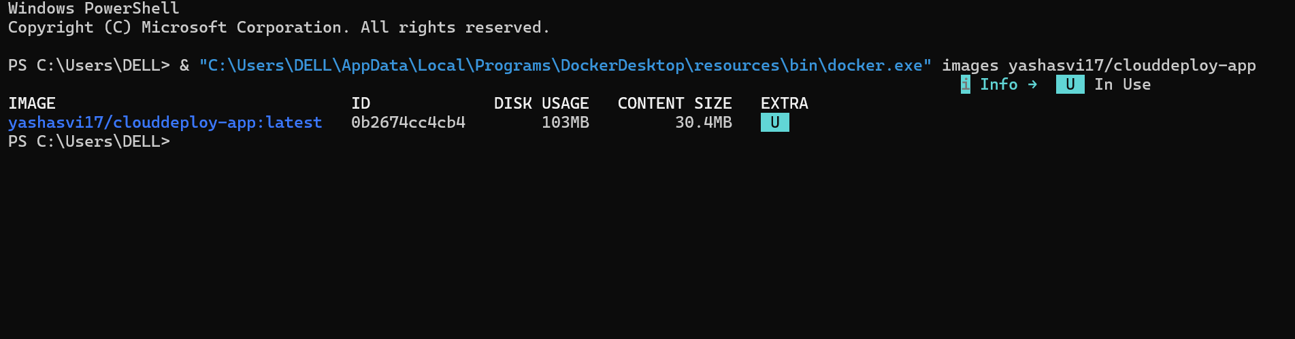
Docker CLI output showing yashasvi17/clouddeploy-app:latest.

Figure 3. Trivy security scan
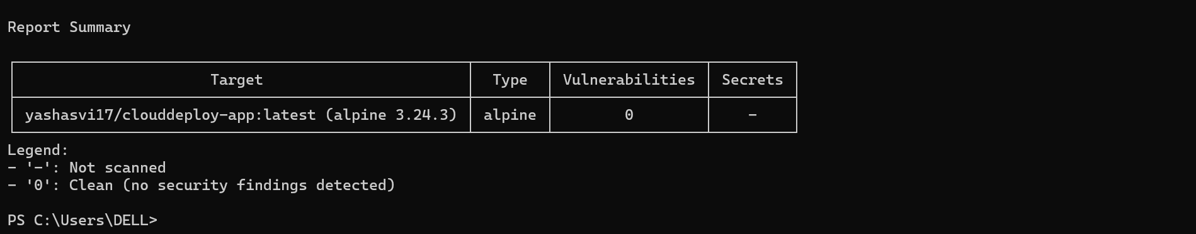Trivy scan summary showing zero HIGH/CRITICAL vulnerabilities.

Figure 4. Docker Hub image
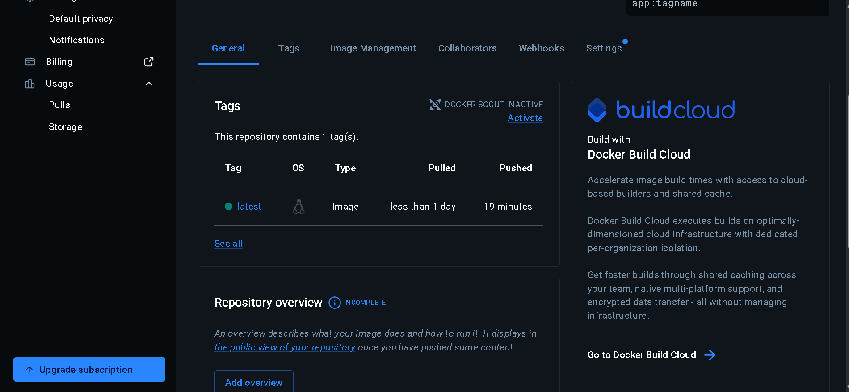Docker Hub repository and latest image tag.

Figure 5. GitHub Dockerfile
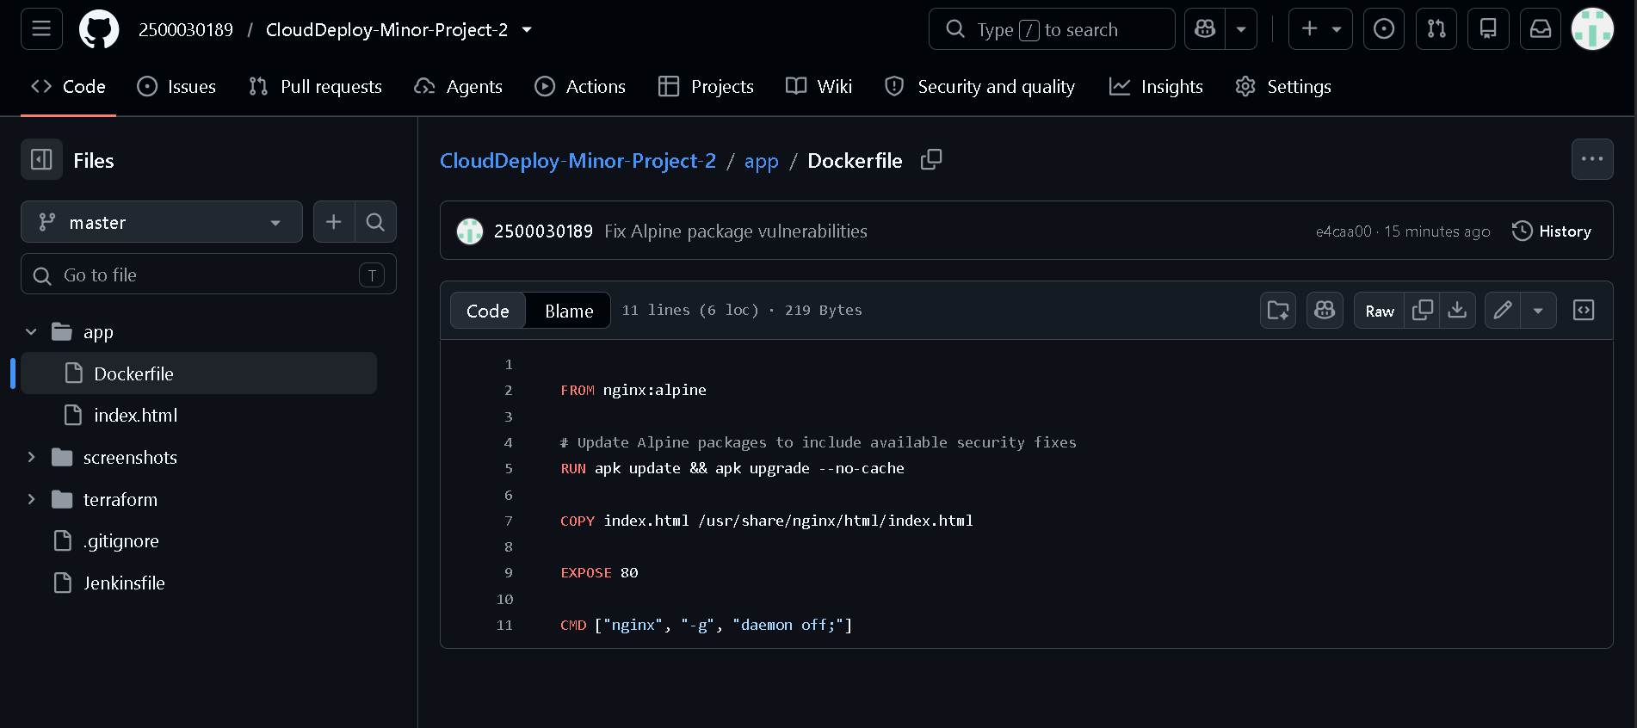GitHub Dockerfile showing the Alpine package upgrade command.

Figure 6. Jenkins pipeline
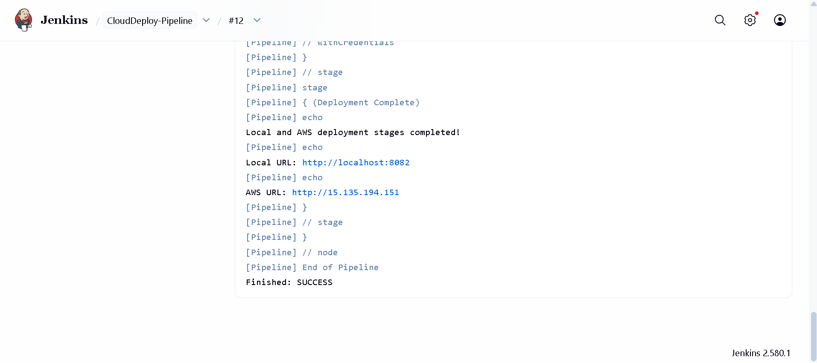CloudDeploy-Pipeline latest successful build and stages.

Figure 7. AWS website
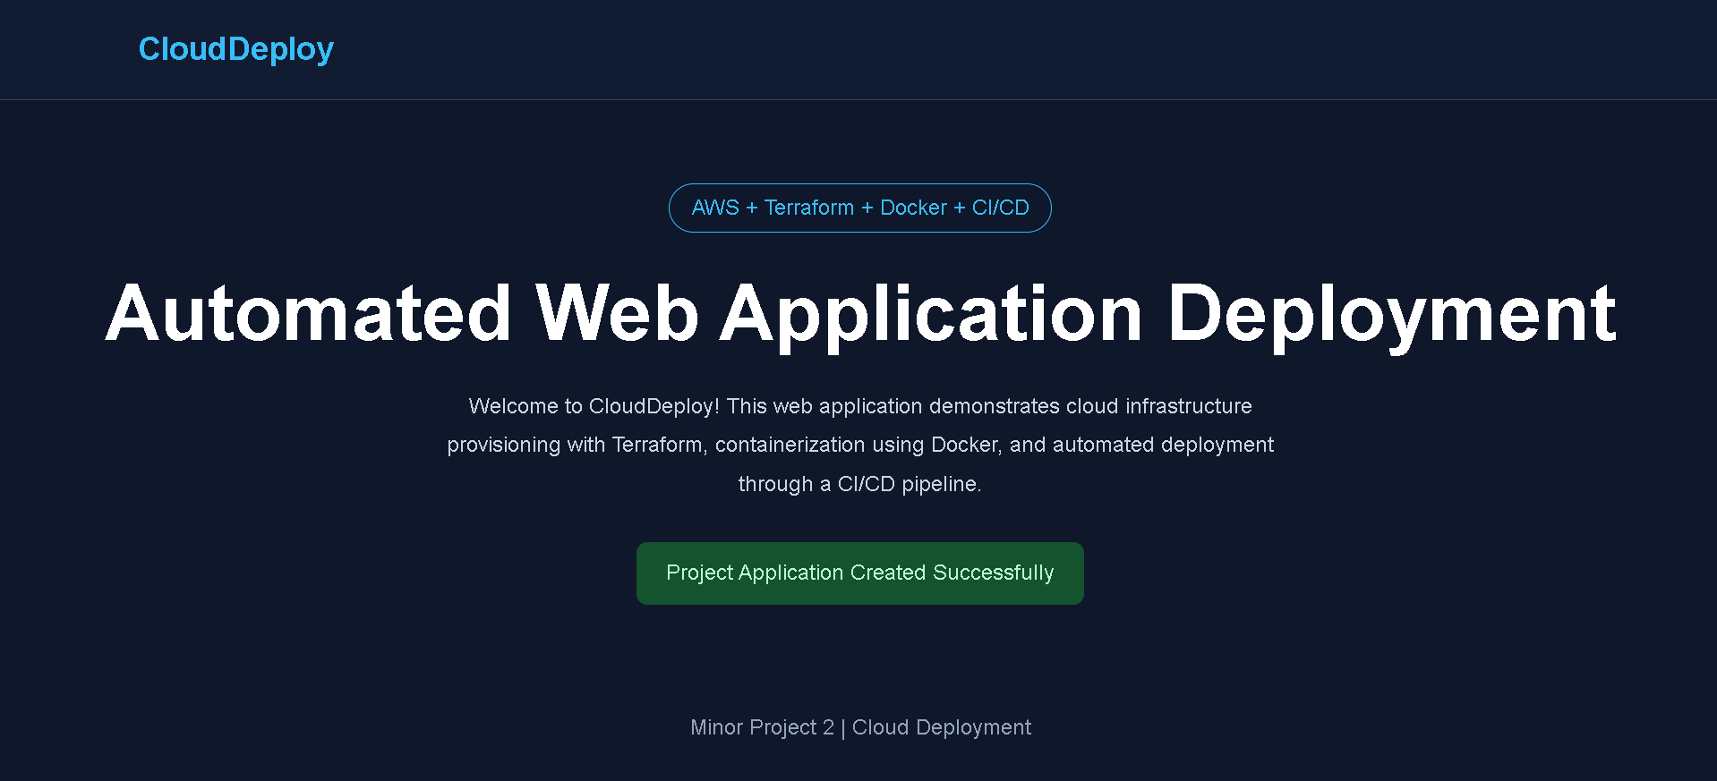Browser showing the deployed application at http://15.135.194.151.

7. Conclusion
The project demonstrates a practical DevOps deployment workflow combining source control, Docker container packaging, Docker Hub image publishing, Jenkins automation, AWS EC2 deployment using SSM, Terraform configuration validation, and Trivy image scanning. The website was verified in a browser, Terraform validation succeeded, and the recorded Trivy scan found zero HIGH/CRITICAL vulnerabilities. These results show that the core workflow was implemented and tested.

8. Future Scope
- Add automated tests and quality gates before deployment.
- Add image scanning as an enforced stage in the Jenkins pipeline.
- Use immutable image tags and deployment approvals for release traceability.
- Add HTTPS, domain-name configuration, and monitoring/alerting.
- Store credentials only in a secure secret-management system and rotate them periodically.
- Add infrastructure plan review and controlled change management before any Terraform apply.

9. References
- Terraform documentation: https://developer.hashicorp.com/terraform/docs
- Docker documentation: https://docs.docker.com/
- Jenkins documentation: https://www.jenkins.io/doc/
- Amazon EC2 documentation: https://docs.aws.amazon.com/ec2/
- AWS Systems Manager documentation: https://docs.aws.amazon.com/systems-manager/
- Trivy documentation: https://trivy.dev/
- Project GitHub repository: https://github.com/2500030189/CloudDeploy-Minor-Project-2
- Docker Hub image: https://hub.docker.com/r/yashasvi17/clouddeploy-app

