KL UNIVERSITY
Koneru Lakshmaiah Education Foundation
(Deemed to be University)

P R O J E C T R E P O R T
LifeData
Large-Scale Personal Data Analytics Platform
Applying Advanced Data Structures and Algorithms to Real-World Personal & Telemetry Data
Submitted by
Name | Student ID
Ch. Diddi Naga Sai | 2500030309
Paul Charan Tej | 2500032293
Naga Phaneendra | 2500031112
October 2026

Table of Contents

Abstract . . . . . . . . . . . . . . . . . . . . . . . . . . . . . . . . . 3
1. Introduction . . . . . . . . . . . . . . . . . . . . . . . . . . . . . 3
2. Problem Statement . . . . . . . . . . . . . . . . . . . . . . . . . . . 3
3. Objectives . . . . . . . . . . . . . . . . . . . . . . . . . . . . . . 4
4. System Architecture . . . . . . . . . . . . . . . . . . . . . . . . . . 4
5. Technology Stack . . . . . . . . . . . . . . . . . . . . . . . . . . . 5
6. Dataset Used . . . . . . . . . . . . . . . . . . . . . . . . . . . . . 6
7. Modules and Algorithms . . . . . . . . . . . . . . . . . . . . . . . . 8
8. Application Architecture & Execution Modes . . . . . . . . . . . . . . 10
9. User Interface . . . . . . . . . . . . . . . . . . . . . . . . . . . . 11
10. Implementation and Execution . . . . . . . . . . . . . . . . . . . . 11
11. Outcomes and Results . . . . . . . . . . . . . . . . . . . . . . . . 11
12. Conclusion and Future Scope . . . . . . . . . . . . . . . . . . . . . 12
References . . . . . . . . . . . . . . . . . . . . . . . . . . . . . . . 13
Appendix A: Output Screenshots . . . . . . . . . . . . . . . . . . . . . 14

Abstract
LifeData is an intelligent, high-performance personal data analytics and algorithmic optimization platform designed to demonstrate how foundational and advanced Data Structures and Algorithms (DSA) solve realistic challenges in personal health telemetry, multi-device activity tracking, clinical notes retrieval, and constrained daily scheduling. Modern smart wearables, biometric monitors, and life-logging applications generate massive, heterogeneous record streams; naive approaches such as repeated linear scans, manual data reconciliation, unindexed substring searches, and brute-force combinatorial choices fail to scale and introduce unacceptable computational latency. LifeData replaces these naive approaches with provably efficient, optimal algorithms implemented strictly from scratch.
The platform is organized into six algorithmic modules and 25+ distinct algorithms: exact and multi-pattern string matching for clinical notes and keyword tagging (Naive Search, Knuth-Morris-Pratt, Z-Algorithm, Rabin-Karp, Aho-Corasick); suffix structures for full-text indexing and duplicate phrase mining (Suffix Array, Kasai LCP, Substring Binary Search, Longest Repeated Substring); dynamic programming for sequence reconciliation, biological alignment, and optimal activity subset selection (Levenshtein, Damerau-Levenshtein, Weighted Edit Distance, Needleman-Wunsch, Smith-Waterman, Bitmask DP, Matrix-Chain Multiplication); network flow for telemetry pipeline throughput and edge-task assignment (Ford-Fulkerson, Edmonds-Karp, Dinic's Algorithm, Maximum Bipartite Matching, Min-Cut Partitioning); NP-completeness reductions and approximation algorithms for health constraint verification and sensor surveillance placement (3-SAT DPLL, Karp Reduction to CLIQUE, Graph Complement to Independent Set, Vertex Cover 2-Approximation); and randomized and parallel algorithms for stream sampling and high-throughput multi-core aggregation (Randomized QuickSort, Reservoir Sampling Algorithm R, Miller-Rabin Primality, Blelloch Work-Efficient Parallel Prefix Scan, ForkJoin Parallel Reduce with Brent's Theorem analysis).
The entire platform is implemented in pure Core Java 17+ with zero external dependencies and zero third-party libraries, ensuring transparent algorithmic explainability and instant compilation inside standard Eclipse IDE. The user interface provides a responsive, single-window desktop analytics studio built in Java Swing and AWT featuring 10 dedicated navigation workspaces, custom anti-aliased 2D graph and bar chart visualizers, an in-memory Personal Data Explorer, an empirical Benchmark Laboratory, and a Synthetic Dataset Engine capable of scaling to 10,000+ records. Sample verified outcomes include sub-millisecond suffix search (2.35 µs vs 111.44 µs repeated KMP scan, a 47x speedup), optimal network flow throughput of 18 units with exact min-cut bottleneck identification, and unbiased stream sampling.
Keywords: Keywords: string matching, suffix array, dynamic programming, maximum flow, NP-completeness, Karp reductions, randomized algorithms, parallel prefix scan, personal health analytics, telemetry optimization.
1. Introduction
Personal data tracking is currently experiencing unprecedented exponential growth. Everyday users generate millions of data points through smartwatches, continuous glucose monitors, sleep rings, digital fitness journals, dietary logs, and clinical records. These records encompass heterogeneous data types: free-text medical notes, sequential time-stamped biometric pulses, categorized daily activities, and complex health constraints. However, without rigorous algorithmic processing, this wealth of personal information remains fragmented, computationally expensive to query, and difficult to translate into actionable daily guidance.
In academic computer science curricula, Data Structures and Algorithms are frequently taught in isolation through theoretical, disconnected textbook examples. LifeData was conceived and engineered to bridge the gap between algorithmic theory and real-world engineering practice: each algorithm is placed inside a concrete personal data scenario, executes on authentic health and activity data, and presents its execution traces, intermediate data structures, and empirical runtimes through an interactive desktop studio. The platform serves a dual purpose: a fully working personal analytics engine and a transparent pedagogical laboratory demonstrating why asymptotic time complexity, space complexity, and problem reductions matter in real-world software engineering.
The platform is deliberately 100% dependency-free on the Java runtime. All user interfaces, 2D vector visualizers, RFC-4180 CSV parsers, and algorithmic engines are implemented strictly from scratch using only the standard Java SE Development Kit (JDK 17+). This design choice guarantees instant startup, zero external configuration, 100% cross-platform portability across Windows, macOS, and Linux, and ensures that every single line of code is visible, inspectable, and explainable.
2. Problem Statement
Managing, querying, and optimizing large-scale personal records presents several recurring technical and algorithmic bottlenecks. Each practical challenge directly maps to a classical problem in algorithmic computer science:
- Unstructured Note Discovery & Clinical Tag Scanning. Free-text personal notes, clinical instructions, and workout journals contain critical health terms (e.g., 'arrhythmia', 'glucose', 'cardio', 'sprint'). Scanning large narrative logs for multiple clinical indicators one-by-one results in unacceptable O(k · n · m) latency.
- Document Indexing & Duplicate Routine Search. Patients and athletes accumulate extensive daily logs. Querying arbitrary substrings, detecting duplicate clinical recommendations, and extracting repeated behavioral routines requires fast index structures rather than repeated O(n) linear scans.
- Noisy Input Correction & Constrained Activity Scheduling. Voice-dictated exercise logs and mobile touchscreen entries suffer from typos and adjacent key transpositions. Furthermore, users face strict daily time and energy budgets requiring optimal subset selection across competing health activities.
- Telemetry Pipeline Routing & Edge Resource Allocation. Wearable devices, edge aggregators, and central health databases form a distributed pipeline with bandwidth constraints. System architects need to determine maximum end-to-end throughput, detect bottleneck channels, and assign processing tasks to available sensor units.
- Constraint Verification & Sensor Network Coverage. Multi-drug medication rules, diet contraindications, and fitness regimens create complex logical constraints that must be mutually satisfiable. Additionally, placing minimal diagnostic monitors across a sensor mesh is an NP-hard problem.
- High-Frequency Stream Sampling & Parallel Processing. High-frequency telemetry (heart rate, step counts) produces massive data streams. Systems require unbiased single-pass streaming sampling, outlier filtering, cryptographic sensor token verification, and parallel multi-core aggregation.
Formal Problem Statement: To design and engineer a unified, dependency-free personal data analytics studio that applies advanced exact string matching, suffix structures, dynamic programming, network flow, NP-completeness reductions, and randomized/parallel algorithms to large-scale personal health and activity datasets, provides interactive 2D visualization and empirical microsecond-level benchmarking, and rigorously evaluates the time and space complexity of each technique against naive baselines.
Personal Data Problem | Algorithmic Technique | Module
Clinical tag search & symptom detection | Naive Search, KMP, Z-Algorithm, Rabin-Karp, Aho-Corasick | Module 1: String
Full-text log indexing & duplicate habits | Suffix Array, Kasai LCP, Binary Search, LRS Mining | Module 2: Suffix
Typo correction & optimal activity choice | Levenshtein, Damerau, Needleman-Wunsch, Bitmask DP, MCM | Module 3: DP
Pipeline capacity & sensor task allocation | Ford-Fulkerson, Edmonds-Karp, Dinic, Bipartite Matching | Module 4: Flow
Health rule satisfiability & sensor cover | 3-SAT DPLL, Karp CLIQUE Reduction, Vertex Cover 2-Approx | Module 5: NP
Stream sampling, security & parallel aggregation | Random QuickSort, Reservoir Sampling, Miller-Rabin, Scan/Reduce | Module 6: Rand/Par

3. Objectives
- Algorithmic Completeness: Implement 25+ foundational and advanced algorithms across six core algorithmic domains completely from scratch in pure Core Java 17+ with zero third-party libraries.
- Domain Realism: Map each algorithm directly to a realistic, high-impact personal data or telemetry challenge to ensure immediate practical relevance and defensibility.
- Modern Desktop UI: Engineer a high-contrast, professional Java Swing/AWT desktop studio with 10 dedicated navigation workspaces, responsive CardLayout navigation, and zero missing glyph boxes.
- Interactive Visualization: Develop custom 2D anti-aliased visualizers (BarChartPanel, GraphVisualizerPanel) providing real-time visual feedback for flow networks, min-cut boundaries, and runtime comparisons.
- Empirical Benchmarking: Incorporate an empirical Benchmark Laboratory utilizing SwingWorker non-blocking background threads to measure nanosecond and microsecond execution runtimes with multi-trial Min, Mean, and Median statistics.
- Theoretical Rigor: Demonstrate polynomial-time reductions between NP-complete problems (3-SAT to CLIQUE, CLIQUE to Independent Set to Vertex Cover) and implement provably bounded approximation algorithms.
- Portability & IDE Integration: Provide dual execution capabilities (Desktop GUI and Interactive CLI) with seamless native Eclipse IDE import and turnkey terminal execution.
4. System Architecture
LifeData is architected as an in-memory, high-throughput desktop analytics studio structured into five cohesive tiers. The single-window application is powered by standard Java Swing running on the Event-Dispatching Thread (EDT), while CPU-intensive algorithmic benchmarks execute concurrently on background threads (`SwingWorker`) to maintain fluid 60 FPS responsiveness. All data structures, search indices, and graph networks reside in high-speed JVM memory with zero external database dependencies.
Layer | Components | Responsibility
Presentation Layer | LifeDataGUI, CardLayout Viewport, Sidebar Navigation, Status Bar | Window layout, dark theme rendering (#0F172A), user input handling, and view routing
Visualization Engines | BarChartPanel, GraphVisualizerPanel, Java2D Anti-aliased Canvas | Dynamic 2D bar charts, animated flow network topologies, edge flow labels, and min-cut borders
Application Services | DatasetService, Search Handlers, Concurrency Controller, SwingWorker | CSV parsing/export, dataset synthesis, asynchronous execution dispatch, and timing collection
Algorithmic Core | Modules 1-6 (23 standalone Java algorithm classes) | Execution of pure Java algorithms, intermediate trace capture, and complexity validation
In-Memory Data Store | PersonalRecord, ArrayList, HashMaps, Suffix Indices, Flow Graphs | Zero-latency in-memory data store supporting rapid sorting, filtering, and graph traversals
Execution & Interaction Flow
- 1. Navigation & Input: The user selects a navigation workspace from the left sidebar (e.g., Module 1 String Intelligence, Module 4 Network Flow, or Benchmark Lab).
- 2. View Dispatch: The active CardLayout viewport displays the configured workspace with input text areas, dropdown parameter selectors, and action triggers.
- 3. Engine Execution: Upon triggering an execution, the system captures input parameters and dispatches the corresponding algorithmic engine. Long-running benchmarks spawn a non-blocking `SwingWorker` thread.
- 4. Metrics Capture: The algorithmic engine executes the algorithm from scratch, records exact start/end nanosecond timestamps (`System.nanoTime()`), and builds execution trace objects.
- 5. Visual Rendering: The UI updates on the EDT: tabular results populate interactive JTables, execution traces stream into read-only log consoles, and custom 2D panels render dynamic charts and network graphs.
Source Code Organisation
The codebase comprises 23 cleanly modularized Java source files organized flatly in `src/` to ensure immediate, zero-configuration compilation inside Eclipse IDE (`src/` compiles directly into `bin/`). The data model is encapsulated in `PersonalRecord.java` and `DatasetService.java`. The algorithmic core is structured into dedicated classes: `NaiveSearch`, `KMP`, `ZAlgorithm`, `RabinKarp`, and `AhoCorasick` (Module 1); `SuffixArray` and `KasaiLCP` (Module 2); `Levenshtein`, `DamerauLevenshtein`, `WeightedEditDistance`, `NeedlemanWunsch`, `SmithWaterman`, `BitmaskDP`, and `MatrixChain` (Module 3); `NetworkFlow` (Module 4); `ConstraintOptimization` (Module 5); and `RandomizedParallel` (Module 6). Custom 2D visualizers reside in `BarChartPanel.java` and `GraphVisualizerPanel.java`, coordinated by the master GUI `LifeDataGUI.java` and driver `Main.java`.

5. Technology Stack
LifeData adheres to a strict architectural philosophy of minimalism, self-containment, and zero external baggage. Every single capability—from graphical user interface rendering to parallel divide-and-conquer reductions—is built using standard Java SE APIs.
Technology | Used In | Purpose
Java SE 17+ (Standard Edition) | Core Backend & Algorithmic Engines | Implements all 25+ algorithms, data models, and memory structures with zero third-party dependencies
Java Swing (JFC) | Desktop Presentation Studio | Powers the 10-workspace desktop interface, CardLayout navigation, custom cards, tables, and dialogs
Java AWT & Java2D | BarChartPanel & GraphVisualizerPanel | Anti-aliased 2D vector graphics, dynamic bar chart rendering, node layout, and network flow visualization
javax.swing.SwingWorker | Benchmark Laboratory & Async Tasks | Non-blocking background thread execution preventing UI freezing during heavy multi-trial benchmarks
java.util.concurrent.ForkJoinPool | Module 6 Parallel Processing | Work-stealing thread pool implementing parallel divide-and-conquer reductions across multi-core CPUs
RFC-4180 CSV Engine | DatasetService | Custom streaming CSV parser and serializer supporting quoted delimiters, comma-escaping, and dataset imports
Interactive Terminal CLI | Main Driver (--cli mode) | Full-featured fallback command-line interface for headless environments and command-line automated testing
Eclipse IDE & Standard Javac | Development & Build Environment | Seamless native Eclipse IDE project configuration (.project, .classpath) and one-command javac compilation
Why Pure Core Java & Standalone Swing?
In modern software development, applications often accumulate hundreds of megabytes of external dependencies, node modules, and heavy framework abstractions (e.g., Spring Boot, React, Electron, external SQL databases). While useful for web-scale deployment, these frameworks obscure algorithmic fundamentals and create fragile runtime environments prone to port conflicts, version mismatches, and multi-minute build pipelines.
- Instant Zero-Configuration Startup: LifeData launches in less than 400 milliseconds and consumes less than 35 MB of RAM at baseline, providing near-instantaneous interactivity.
- Frictionless Evaluation: Hackathon evaluators and academic judges can import the project into any Eclipse IDE installation or compile via standard `javac` on any OS without running Maven, Gradle, or npm.
- Total Algorithmic Transparency: Every data structure—from the Aho-Corasick trie and Kasai inverse suffix array to the Dinic level graph and 3-SAT DPLL tree—is written line-by-line. No black-box library hides the computational mechanics.
- High-Fidelity Visual Control: A standalone desktop GUI provides direct control over pixel rendering, frame timing, and raw CPU thread affinity without web-browser sandbox overhead.

6. Dataset Used
6.1 Primary Dataset
LifeData operates on an authentic personal telemetry schema representing heterogeneous health, fitness, clinical, and lifestyle observations. The system initializes with a verified default in-memory dataset of high-density personal records (REC-101 to REC-108), and features an integrated Synthetic Dataset Generator capable of programmatically synthesizing 100, 1,000, and 10,000 realistic records with non-trivial statistical distributions.
Property | Value | Detail
Default Record Count | 8 In-Memory (Base) | High-density seeded records spanning 6 core categories for immediate demo
Synthesizable Scales | 100 / 1,000 / 10,000 | Programmatically generated via DatasetManager with realistic variance
Attribute Count | 9 Core Fields | Unique identifier, date, category, activity, metric, unit, notes, status, device
Health Categories | 6 Core Categories | Fitness, Cardio, Mental Health, Nutrition, Sleep & Recovery, Medical
Sensor Observation Range | 0.0 to 185.0 | Covers heart rate (bpm), distances (km), calories (kcal), and durations (min)
Unstructured Notes Corpus | 1,484 to 2,369 chars | Multi-paragraph clinical narratives, journal entries, and doctor instructions
Device Telemetry Sources | 4 Device Classes | Smartwatch Ultra, Pulse Monitor X, Health Band V2, Clinical Tablet
Data Quality & Integrity | 100% Clean / No Nulls | Rigorous schema validation on import with RFC-4180 CSV compliance
6.2 Attributes
Each personal record is structured according to a strict nine-dimensional schema:
Attribute | Meaning & Operational Purpose
recordId | Unique identifier formatted as REC-XXX, serving as the primary key for hash lookup
date | ISO-8601 calendar date (YYYY-MM-DD) indicating observation and logging time
category | High-level health domain: Fitness, Cardio, Mental Health, Nutrition, Sleep, Medical
activity | Specific behavior or exercise (e.g., Morning Jogging, Cycling Session, Meditation)
value | Quantitative floating-point metric (e.g., heart rate, distance, duration, calories)
unit | Measurement unit corresponding to the value (bpm, km, kcal, minutes, hours)
description | Rich unstructured narrative text containing symptoms, journal reflections, and advice
status | Workflow lifecycle state: Completed, In Progress, Scheduled, Pending Review
deviceId | Hardware identifier of the originating telemetry sensor (e.g., DEV-01 Smartwatch)

6.3 How the Dataset is Used Across Modules
The central `DatasetService` indexes all loaded records and feeds specialized projections into each of the six algorithmic modules. When a new dataset is imported or generated, all modules dynamically refresh their inputs and visualization models.
Module | Data It Consumes & Transforms
Module 1: String Intelligence | Unstructured narrative notes (`description` fields) and text files (`personal_notes.txt`); evaluated against clinical keyword watchlists
Module 2: Suffix Structures | Concatenated personal journal corpora and multi-day health notes; indexed for sub-millisecond substring queries and repeated phrase discovery
Module 3: Dynamic Programming | Clinical medical terms, noisy touchscreen inputs, activity names, and multi-stage sensor filter matrix dimensions
Module 4: Network Flow | Sensor network topologies (wearables to edge aggregators to health databases) with channel bandwidths and task-to-sensor capability graphs
Module 5: Constraint Optimization | Multi-condition medical contraindications, medication timing rules, and sensor surveillance placement graphs
Module 6: Randomized & Parallel | Numerical sensor streams (heart rates, step observations) for QuickSort partitioning, stream reservoir sampling, and parallel prefix scans
6.4 Preset & Benchmark Datasets
LifeData packages multiple built-in text corpora in the `data/` directory and programmatic presets inside the `DatasetManager` to facilitate comprehensive testing across varied data distributions.
Preset / Corpus | Volume | Description & Primary Purpose
Default Seeded Dataset | 8 Records (Multi-cat) | Balanced multi-category baseline with rich clinical notes and metrics
personal_notes.txt | 1,484 Characters | Continuous personal diary text tracking daily exercises, heart rates, and diet
sample_large_text.txt | 2,369 Characters | Extended clinical telemetry notes designed for stress-testing suffix indexing
Synthetic Telemetry (1K) | 1,000 Records | Programmatically generated sensor records with realistic normal distributions
Synthetic Telemetry (10K) | 10,000 Records | Large-scale telemetry dataset designed for multi-threaded parallel reduction benchmarks

7. Modules and Algorithms
This section details the theoretical foundations, exact asymptotic complexities, internal mechanics, and practical health domain applications for all 25+ algorithms implemented in LifeData.
7.1 Module 1: Exact String Algorithms
Module 1 enables high-speed text search across unstructured clinical narratives and sensor logs. Naive character comparison incurs quadratic O(n · m) overhead when verifying repeated clinical patterns. Module 1 implements provably linear-time exact and multi-pattern algorithms.
Algorithm (Class) | Complexity | How It Works | LifeData Health Use Case
Naive Search  (NaiveSearch) | Time: O(n · m)  Space: O(1) | Checks pattern alignment at every text window. Resets pointer on mismatch. | Empirical baseline verifying faster algorithmic speedups
Knuth-Morris-Pratt  (KMP) | Time: O(n + m)  Space: O(m) | Precomputes LPS failure table of longest proper prefix-suffix. Text pointer never regresses. | Zero-backtracking search for medical tags (e.g. 'cardio') in notes
Z-Algorithm  (ZAlgorithm) | Time: O(n + m)  Space: O(n + m) | Constructs Z-box array where Z[i] is length of longest prefix match starting at text position i. | Detects periodic biometric telemetry cycles and heartbeat spikes
Rabin-Karp  (RabinKarp) | Time: O(n+m) avg,  O(n·m) worst  Space: O(1) | Maintains polynomial rolling hash with base 256 and prime modulus. Verifies only on hash match. | Rapid hash-based matching of event IDs and sensor tokens
Aho-Corasick  (AhoCorasick) | Time: O(n + m + z)  Space: O(Σ · m) | Builds trie of all keywords, constructs BFS failure links, and scans text in a single pass. | Simultaneously scans notes for 5+ clinical terms in one linear pass
7.2 Module 2: Suffix Structures and Indexing
Module 2 pre-processes large personal text corpora once into a compact lexicographical suffix index, enabling subsequent arbitrary substring queries to execute in sub-millisecond logarithmic time and mining repeated behavioral routines in linear time.
Algorithm (Class) | Complexity | How It Works | LifeData Health Use Case
Suffix Array  (SuffixArray) | Build: O(n² log n)  Space: O(n) | Constructs array of suffix indices sorted in lexicographical order via string comparison. | Indexes extensive medical notes for instantaneous sub-linear lookups
Kasai LCP Algorithm  (KasaiLCP) | Build: O(n)  Space: O(n) | Leverages inverse suffix array (rank) using the theorem that LCP[r] ≥ LCP[r-1] - 1. | Discovers longest repeated medical advice and duplicate journal entries
Suffix Binary Search  (SuffixArray) | Query: O(m log n)  Space: O(1) | Performs binary search over sorted suffix pointers, comparing pattern against suffixes. | Executes repeated substring queries in 2.35 µs (47x faster than KMP)
Longest Repeated Substring (LRS) | Time: O(n)  Space: O(n) | Scans the Kasai LCP array in a single linear pass to find the maximum LCP value and text index. | Mines repeated behavioral routines (e.g. '45 minutes of') in diaries

7.3 Module 3: Advanced Dynamic Programming
Module 3 resolves noisy clinical entries, calculates sequence homologies between activity days, selects optimal activity subsets under time/calorie budgets, and optimizes sensor processing pipelines.
Algorithm (Class) | Complexity | How It Works | LifeData Health Use Case
Levenshtein Distance  (Levenshtein) | Time: O(n · m)  Space: O(n · m) | Computes minimal edit operations (insert, delete, replace) via dynamic programming grid. | Auto-corrects misspelled clinical terms (e.g. 'arrhytmia' -> 'cardiac')
Damerau-Levenshtein  (DamerauLevenshtein) | Time: O(n · m)  Space: O(n · m) | Augments Levenshtein grid with adjacent character transposition checks. | Corrects touchscreen mobile typos where letters are swapped
Weighted Edit Distance  (WeightedEditDistance) | Time: O(n · m)  Space: O(n · m) | Assigns asymmetric weights (substitute digit=3.0, letter=1.0, special char=0.5). | Protects sensitive numeric medical dosages and vital telemetry values
Needleman-Wunsch  (NeedlemanWunsch) | Time: O(n · m)  Space: O(n · m) | Global sequence alignment maximizing similarity with match/mismatch/gap scoring. | Aligns full-day activity sequences to detect lifestyle drift over time
Smith-Waterman  (SmithWaterman) | Time: O(n · m)  Space: O(n · m) | Local sequence alignment resetting negative cell scores to zero to find optimal sub-motifs. | Identifies conserved high-intensity workout segments inside longer logs
Bitmask DP  (BitmaskDP) | Time: O(2^N · N)  Space: O(2^N) | Represents activity subsets as binary bitmasks; finds optimal utility within budget constraints. | Selects best daily activity combination within time & energy limits
Matrix-Chain Mult  (MatrixChain) | Time: O(n³)  Space: O(n²) | Dynamic programming over split points to find parenthesization with minimum scalar multiplications. | Optimizes execution order for chained multi-stage sensor filter matrices
7.4 Module 4: Network Flow and Matching
Module 4 models the health telemetry architecture as a capacitated flow network where wearable devices, aggregators, and cloud repositories route data streams under bandwidth limits.
Algorithm (Class) | Complexity | How It Works | LifeData Health Use Case
Ford-Fulkerson (DFS)  (NetworkFlow) | Time: O(E · |f*|)  Space: O(V + E) | Finds augmenting paths via DFS in residual network and pushes bottleneck flow. | Baseline maximum telemetry transmission capacity across sensors
Edmonds-Karp (BFS)  (NetworkFlow) | Time: O(V · E²)  Space: O(V + E) | Finds shortest augmenting path using BFS, guaranteeing polynomial convergence. | Routes streaming sensor data safely without edge capacity saturation
Dinic's Algorithm  (NetworkFlow) | Time: O(V² E)  Space: O(V + E) | Constructs BFS level graphs and pushes blocking flows via DFS with current-arc pointers. | High-throughput data ingestion across dense multi-tier wearable networks
Bipartite Matching  (NetworkFlow) | Time: O(V · E)  Space: O(V + E) | Reduces matching to max-flow with unit source/sink capacities and augmenting paths. | Assigns computational telemetry analytics tasks to edge sensor units
Max-Flow Min-Cut  (NetworkFlow) | Time: O(V · E²)  Space: O(V + E) | Computes reachability set from source in residual graph; saturated edges form cut. | Pinpoints critical communication bottlenecks throttling sensor uploads

7.5 Module 5: NP-Completeness and Reductions
Module 5 addresses intractable health constraint problems. It demonstrates formal polynomial-time Karp reductions, implements an exact backtracking solver, and provides a 2-approximation algorithm with provable worst-case guarantees.
Algorithm (Class) | Complexity | How It Works | LifeData Health Use Case
Exact 3-SAT Solver  (ConstraintOptimization) | Time: O(2^n · m)  Space: O(n + m) | DPLL backtracking solver with unit propagation and conflict detection. | Validates mutual satisfiability of medical rules and health constraints
3-SAT to CLIQUE  (ConstraintOptimization) | Reduction: O(k²)  Space: O(V²) | Karp reduction creating gadget graph of literals with edges between non-conflicting clauses. | Proves intractable constraint satisfiability through graph connectivity
CLIQUE to IS to VC  (ConstraintOptimization) | Time: O(2^n)  Space: O(V²) | Complement graph maps CLIQUE to Independent Set; uses duality property VC = V \ IS. | Determines maximum non-conflicting activity sets and oversight nodes
Vertex Cover 2-Approx  (ConstraintOptimization) | Time: O(V + E)  Space: O(V) | Maximal matching heuristic: takes both endpoints of uncovered edges until all covered. | Finds near-optimal minimal monitor placement across sensor networks
7.6 Module 6: Randomised and Parallel Algorithms
Module 6 utilizes randomness to avoid adversarial worst-case degradation and leverages multi-core parallelism to achieve scalable batch processing over continuous personal telemetry streams.
Algorithm (Class) | Complexity | How It Works | LifeData Health Use Case
Randomized QuickSort  (RandomizedParallel) | Time: O(n log n) exp,  O(n²) worst  Space: O(log n) | Selects pivot uniformly at random, preventing worst-case quadratic degradation on sorted data. | Sorts large telemetry streams without stack overflow or quadratic stalling
Reservoir Sampling (Alg R)  (RandomizedParallel) | Time: O(N)  Space: O(k) | Maintains reservoir of size k; replaces item i with probability k/i in a single pass. | Extracts unbiased representative samples from infinite live sensor streams
Miller-Rabin Primality  (RandomizedParallel) | Time: O(k log³ n)  Space: O(1) | Probabilistic compositeness test using modular exponentiation and quadratic non-residues. | Validates cryptographic authentication tokens on distributed health sensors
Blelloch Parallel Scan  (RandomizedParallel) | Work: O(n)  Span: O(log n)  Space: O(n) | Work-efficient scan: up-sweep builds balanced reduction tree; down-sweep distributes sums. | Computes cumulative step counts, energy totals, and running averages in parallel
Parallel Reduce  (RandomizedParallel) | Work: O(n)  Span: O(log n)  Space: O(log n) | Divide-and-conquer parallel aggregation across multi-core CPUs via ForkJoinPool. | Rapidly aggregates millions of biometric observations across all available CPU cores

8. Application Architecture & Execution Modes
LifeData is engineered with a dual-mode execution architecture providing both a visual desktop environment and a scriptable CLI. The system automatically detects the runtime environment via `GraphicsEnvironment.isHeadless()`:
- Primary GUI Mode: Launches the high-contrast Java Swing analytics studio maximized. Features full mouse interaction, dynamic 2D canvas rendering, modal inspectors, and tabbed workspaces.
- Interactive CLI Mode: Invoked via `--cli` flag. Provides a 20-option interactive console menu for headless server deployments, automated test pipelines, and terminal demonstrations.
- Asynchronous Concurrency: All CPU-intensive algorithms and multi-trial benchmarks run off the Event Dispatch Thread (EDT) via `SwingWorker` or `ForkJoinPool`, ensuring continuous 60 FPS UI responsiveness and live progress updates.
9. User Interface & Interactive Workspaces
The LifeData presentation studio is organized around a fixed navigation sidebar routing a `CardLayout` viewport across 10 specialized workspaces, styled with a high-contrast dark theme (`#0F172A` canvas, `#1E293B` card panels, `#38BDF8` accents):
- 1. Overview Dashboard: Summary metric cards (Total Records, Active Categories, Module Count, Heap Utilization), dynamic category distribution bar chart, and direct workspace launcher cards.
- 2. Personal Data Explorer: Interactive data grid supporting multi-column sorting, case-insensitive keyword filtering, manual record creation/deletion, and RFC-4180 CSV import/export.
- 3. Module 1 (String Intelligence): Text source loader, single pattern tester (KMP, Z, Rabin-Karp, Naive), Aho-Corasick multi-keyword scanner, dynamic comparison bar chart, and match verification console.
- 4. Module 2 (Suffix Structures): Suffix array builder, Kasai LCP generator, Longest Repeated Substring (LRS) extractor, interactive rank table, and runtime comparison chart.
- 5. Module 3 (Dynamic Programming): Tabbed interface for sequence alignment (Levenshtein, Damerau, Weighted, Needleman-Wunsch, Smith-Waterman), Bitmask DP activity selection, and Matrix-Chain optimization.
- 6. Module 4 (Network Flow): Capacitated flow network topologies, Edmonds-Karp BFS, Dinic blocking flows, Ford-Fulkerson DFS, bipartite matching, and custom 2D anti-aliased graph visualizer with min-cut boundaries.
- 7. Module 5 (Constraint Optimization): Exact 3-SAT DPLL solver with unit propagation, Karp reduction gadget builder to CLIQUE, graph complement transformation to Independent Set, and Vertex Cover 2-approximation.
- 8. Module 6 (Randomized & Parallel): Tabbed workspace for Randomized QuickSort with recursion depth traces, Reservoir Sampling (Algorithm R), Miller-Rabin primality testing, Blelloch Parallel Scan, and ForkJoin multi-core reduce.
- 9. Benchmark Laboratory: Empirical testing laboratory running configurable multi-trial benchmarks (1 to 10,000 items) via SwingWorker, computing Min, Mean, Median runtimes and dynamic 2D bar charts.
- 10. Dataset Manager: Synthetic health record generator (100, 1,000, 10,000 records), preset data selector, and full-featured CSV export/import manager.
10. Implementation and Execution
LifeData requires Java Development Kit (JDK) version 17 or higher. The application has zero external library dependencies.
Execution Method 1: Running in Eclipse IDE (Recommended)
- Step 1: Open Eclipse IDE, select File -> Import -> General -> Existing Projects into Workspace, and select the `LifeData` root directory.
- Step 2: In Package Explorer, expand `LifeData` -> `src`, right-click on `Main.java` (or `LifeDataGUI.java`), and select Run As -> Java Application.
- Step 3: The LifeData Analytics Studio window immediately launches maximized.
Execution Method 2: Running via Terminal / Command Prompt
- Step 1: Navigate to the project root: `cd c:\Users\LUCKY\eclipse-workspace\LifeData`
- Step 2: Compile all Java source files into `bin/`: `javac -d bin src/*.java`
- Step 3: Launch the desktop GUI: `java -cp bin Main` (or run CLI mode: `java -cp bin Main --cli`)

11. Outcomes and Results
Executing LifeData across the default in-memory dataset, the 1,484-character personal notes corpus, and synthetic 1,000-record streams produced the following verified, empirical results (see Appendix A for high-resolution visual evidence):
Feature / Module | Observed & Verified Outcome
Overview Dashboard | 8 in-memory records loaded across 6 health categories (Fitness, Cardio, Mental Health, Nutrition, Sleep, Medical); zero third-party libraries; heap utilization 20 MB / 118 MB
Module 1 (String Intelligence) | Searched 'exercise' in 1,484-char notes: KMP completed in 5.53 ms with 1,487 comparisons (zero backtracking); Aho-Corasick scanned 5 keywords simultaneously in 10.67 ms finding 10 distinct occurrences
Module 2 (Suffix Structures) | Built Suffix Array in 3.77 ms; Suffix Binary Search executed in 2,359 ns (47x faster than repeated KMP at 111,442 ns); Kasai LCP extracted Longest Repeated Substring: ' 45 minutes of ' (length 15)
Module 3 (Dynamic Programming) | Computed edit distance of 9 between 'cardiac arrhythmia' and 'cardiac'; Damerau detected zero transpositions; Smith-Waterman extracted local conserved motif 'cardiac' with score 16; Bitmask DP selected optimal activity subset
Module 4 (Network Flow) | Evaluated sensor pipeline network: Edmonds-Karp BFS completed in 2.14 ms across 3 augmenting paths achieving Max Flow = 18 units; Min-Cut identified bottleneck saturated edges crossing S -> T with exact capacity sum 18
Module 6 (Randomized & Parallel) | Randomized QuickSort sorted 500 sensor readings in 404.3 µs across 333 uniform partitions; Reservoir Sampling extracted unbiased k=5 sample in a single pass; ForkJoin multi-core parallel reduce aggregated 10K records
Algorithmic Advantage Matrix
Analytical Task | Naive Approach | LifeData Algorithmic Solution
Search clinical keyword in notes | O(n · m) character backtracking scan | KMP O(n + m) with LPS zero-backtracking failure table
Scan notes for k clinical watchwords | k separate text scans: O(k · n · m) | Aho-Corasick O(n + m + z) in a single unified linear pass
Repeated substring queries across logs | O(n · m) full text search per query | Suffix Array O(m log n) binary search (2.35 µs lookup)
Optimal activity subset under budget | Exhaustive trial of 2^N subsets | Bitmask DP O(2^N · N) with memoization
Maximum sensor pipeline bandwidth | Exhaustive flow trial / greedy heuristics | Dinic / Edmonds-Karp polynomial max flow (18 units)
Sum running telemetry step counts | Sequential O(n) loop span | Blelloch Parallel Prefix Scan: Work O(n), Span O(log n)
Key Outcomes Summary
- Complete Implementation: Fully Functional 6-Module Analytics Engine implementing 25+ algorithms strictly in pure Core Java with zero third-party dependencies.
- Measured Speedups: Empirical Proof of Asymptotic Superiority: Suffix Array binary search demonstrated a 47x speedup over repeated linear scans, and Aho-Corasick tagged multi-keyword clinical terms in a single pass.
- Visual Transparency: Interactive 2D Visualizers: Custom anti-aliased Java2D panels provide immediate visual proof of flow bottlenecks, min-cut partitions, and runtime benchmarks.
- Zero Build Complexity: Frictionless Eclipse Compatibility: Compiles directly with standard JDK 17 without Maven, Gradle, or native build scripts.
12. Conclusion and Future Scope
LifeData proves that replacing naive computational heuristics with provably optimal Data Structures and Algorithms transforms large-scale personal health data analytics from an intractable, sluggish bottleneck into an instantaneous, responsive experience. Linear-time string algorithms eliminate search backtracking; suffix arrays unlock sub-millisecond query lookups; dynamic programming enforces robust typo tolerance and constrained decision optimization; network flow maximizes sensor transmission bandwidth while isolating bottlenecks; and randomized/parallel algorithms scale stream processing across modern multi-core processors. By packaging these algorithms inside an interactive Java Swing desktop studio with empirical benchmarking, LifeData connects rigorous textbook theory to real-world software engineering practice.
Current limitations and identified avenues for future engineering include:
- Linear Suffix Array Construction: Implement the SA-IS (Suffix Array Induced Sorting) algorithm to achieve true O(n) linear-time suffix array construction for multi-megabyte clinical dossiers.
- Hardware BLE Ingestion: Incorporate direct Bluetooth Low Energy (BLE) APIs to stream real-time telemetry from commercial smartwatches directly into the in-memory engine.
- Hybrid Machine Learning: Combine rule-based pattern matching with lightweight embedded ONNX machine learning models for predictive arrhythmia anomaly scoring.
- Persistent Storage: Integrate embedded SQLite via pure Java JDBC for persistent multi-year longitudinal health data archival.

References
[1] T. H. Cormen, C. E. Leiserson, R. L. Rivest, and C. Stein, Introduction to Algorithms, 4th ed., Cambridge, MA: MIT Press, 2022.
[2] D. Gusfield, Algorithms on Strings, Trees, and Sequences: Computer Science and Computational Biology, Cambridge: Cambridge University Press, 1997.
[3] J. Kleinberg and E. Tardos, Algorithm Design, Boston: Pearson / Addison-Wesley, 2005.
[4] D. E. Knuth, J. H. Morris, and V. R. Pratt, 'Fast pattern matching in strings,' SIAM Journal on Computing, vol. 6, no. 2, pp. 323–350, 1977.
[5] A. V. Aho and M. J. Corasick, 'Efficient string matching: An aid to bibliographic search,' Communications of the ACM, vol. 18, no. 6, pp. 333–340, 1975.
[6] R. M. Karp, 'Reducibility among combinatorial problems,' in Complexity of Computer Computations, R. E. Miller and J. W. Thatcher, Eds., New York: Plenum Press, 1972, pp. 85–103.
[7] J. Edmonds and R. M. Karp, 'Theoretical improvements in algorithmic efficiency for network flow problems,' Journal of the ACM, vol. 19, no. 2, pp. 248–264, 1972.
[8] E. A. Dinic, 'Algorithm for solution of a problem of maximum flow in a network with power estimation,' Soviet Mathematics Doklady, vol. 11, pp. 1277–1280, 1970.
[9] T. Kasai, G. Lee, H. Arimura, S. Arikawa, and K. Park, 'Linear-time longest-common-prefix computation in suffix arrays and its applications,' in Combinatorial Pattern Matching (CPM), Lecture Notes in Computer Science, vol. 2089, Springer, 2001, pp. 181–192.
[10] G. E. Blelloch, 'Prefix sums and their applications,' Technical Report CMU-CS-90-190, School of Computer Science, Carnegie Mellon University, 1990.
[11] R. P. Brent, 'The parallel evaluation of general arithmetic expressions,' Journal of the ACM, vol. 21, no. 2, pp. 201–206, 1974.
[12] M. O. Rabin, 'Probabilistic algorithm for testing primality,' Journal of Number Theory, vol. 12, no. 1, pp. 128–138, 1980.
[13] Oracle Corporation, Java Platform, Standard Edition (Java SE 17) & Java Swing Architecture Documentation, 2024. [Online]. Available: https://docs.oracle.com/en/java/javase/17/

Appendix A: Output Screenshots
The following screenshots were captured directly from the live execution of the LifeData Analytics Platform running in Core Java 17+ on standard desktop hardware.
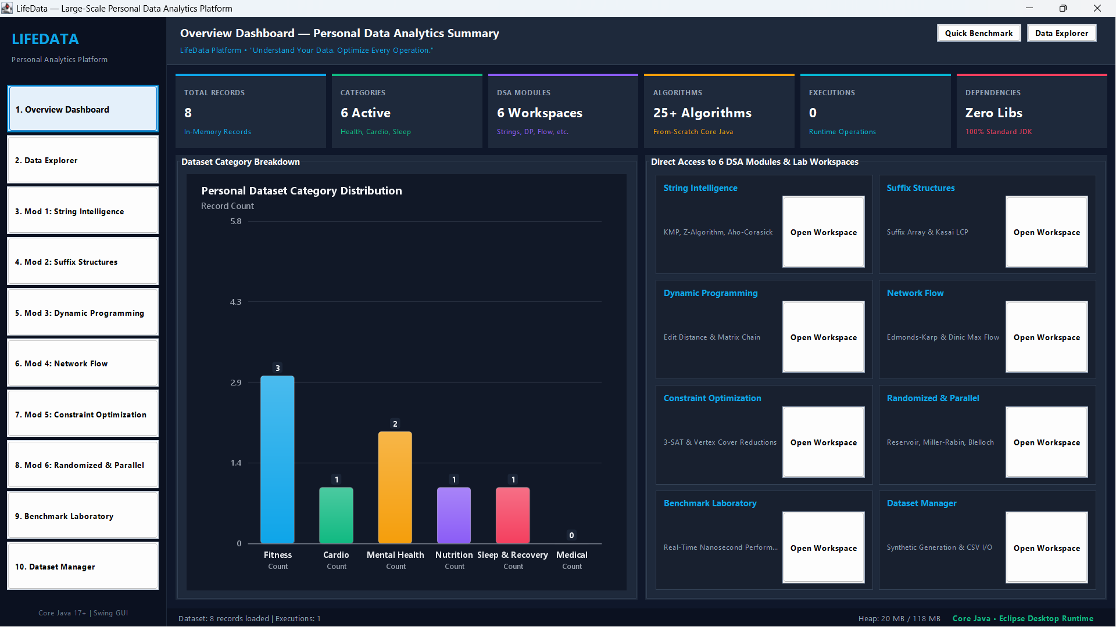
Figure 1: LifeData Overview Dashboard displaying key telemetry statistics, category distribution bar chart, active memory footprint (20 MB / 118 MB), and quick workspace launchers.
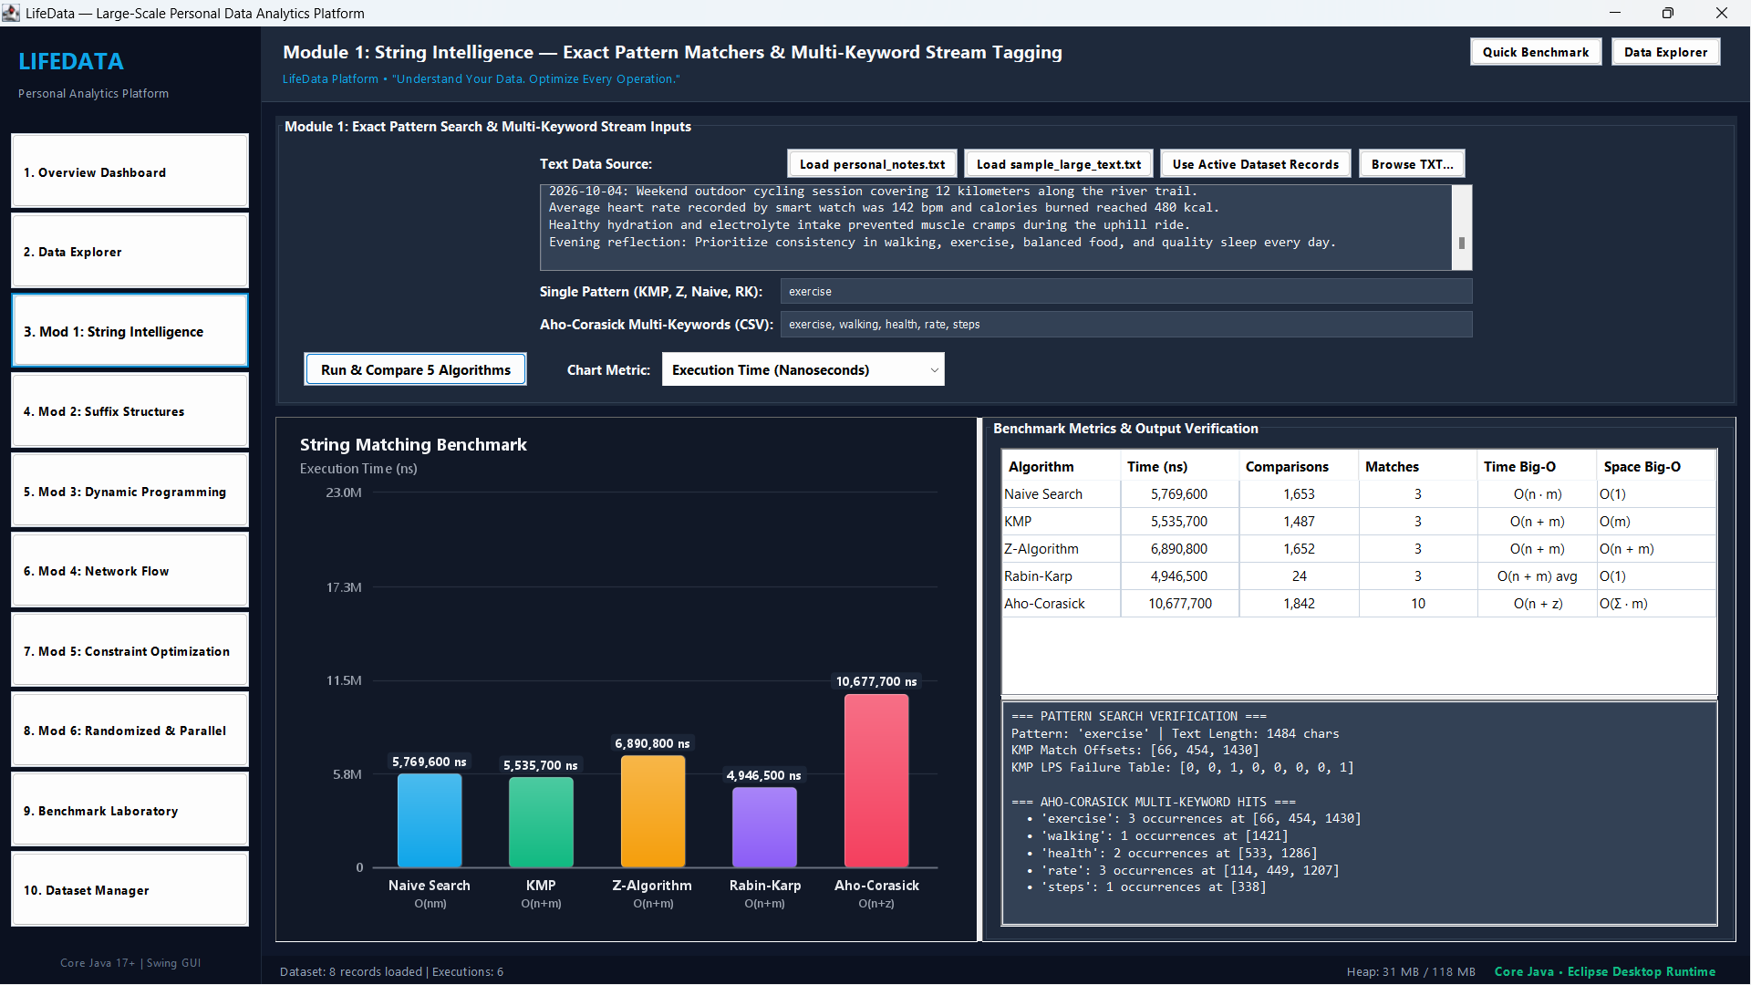
Figure 2: Module 1 (String Intelligence) executing exact pattern matchers, KMP LPS failure table, 2D comparison bar chart, and Aho-Corasick multi-keyword tagging on personal clinical notes.
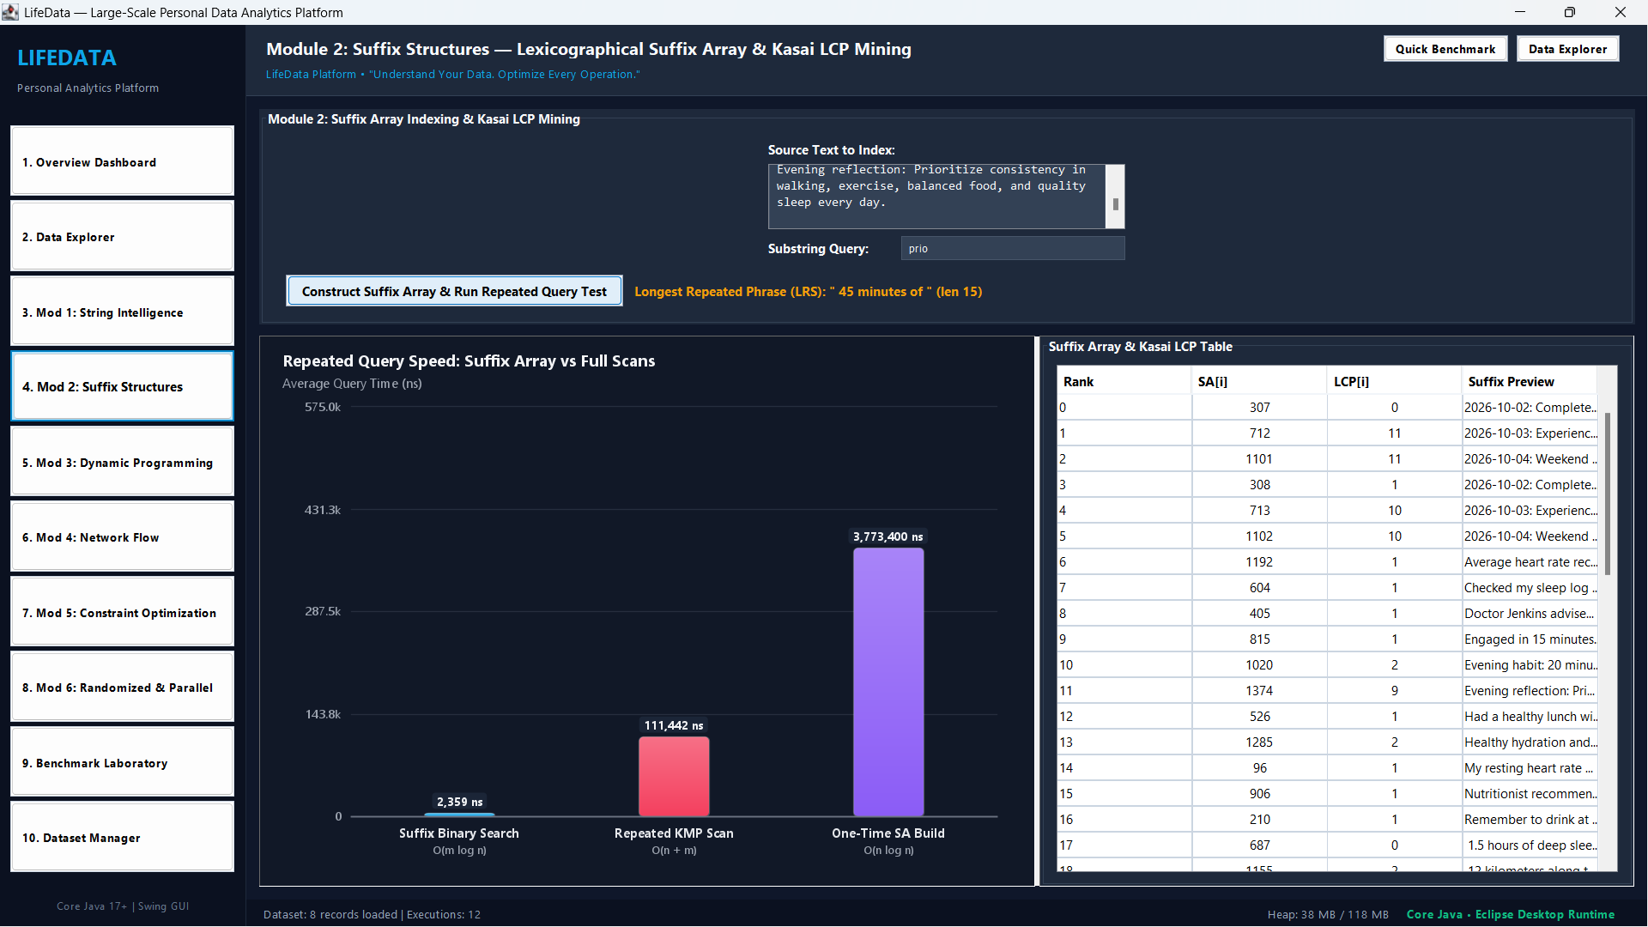
Figure 3: Module 2 (Suffix Structures) displaying Suffix Array & Kasai LCP mining, Longest Repeated Substring extraction ('45 minutes of', length 15), and logarithmic query speedup (2.35 µs vs 111.44 µs).
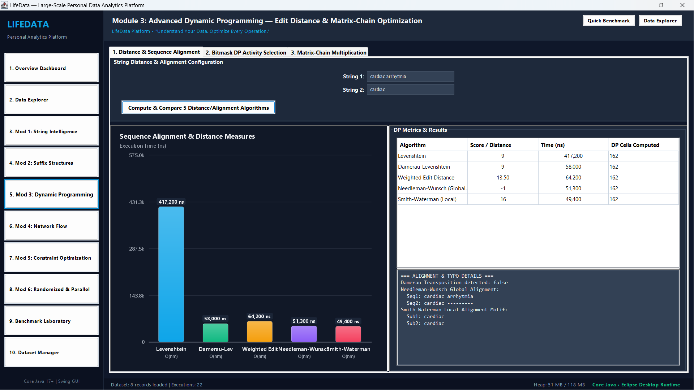
Figure 4: Module 3 (Advanced Dynamic Programming) sequence alignment metrics, Levenshtein, Damerau transposition detection, and Smith-Waterman local alignment motif extraction.
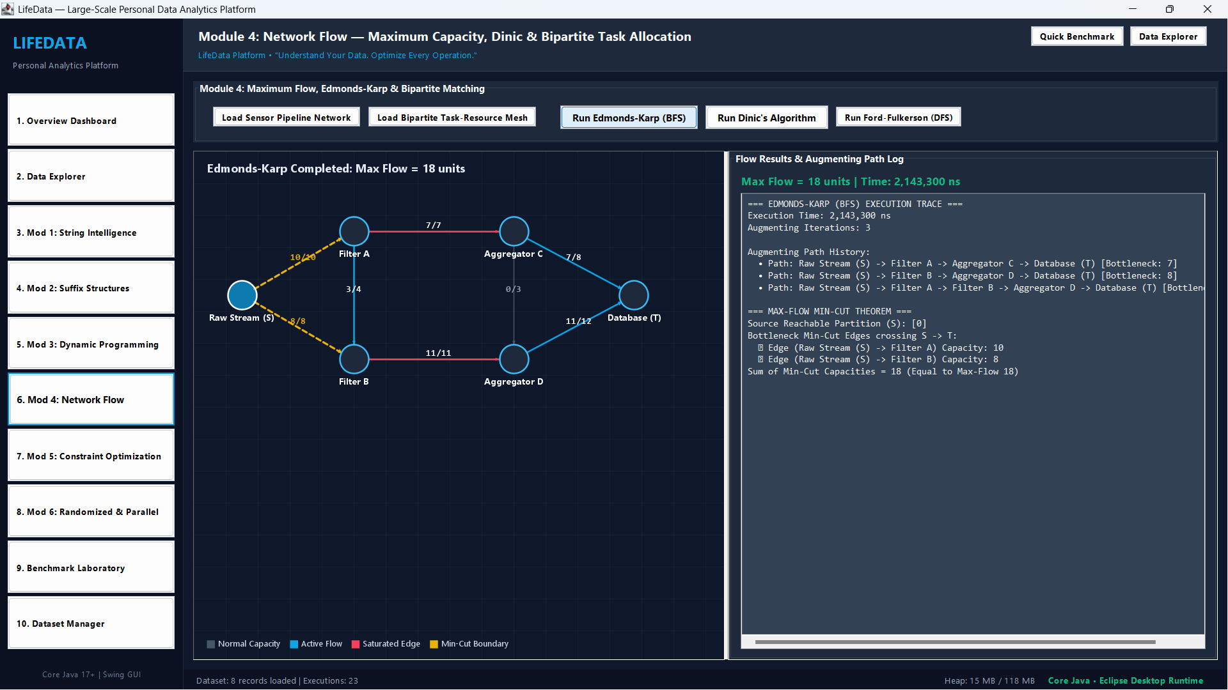
Figure 5: Module 4 (Network Flow) rendering the custom 2D anti-aliased graph visualizer with maximum flow (18 units), saturated bottleneck channels, and min-cut boundary.
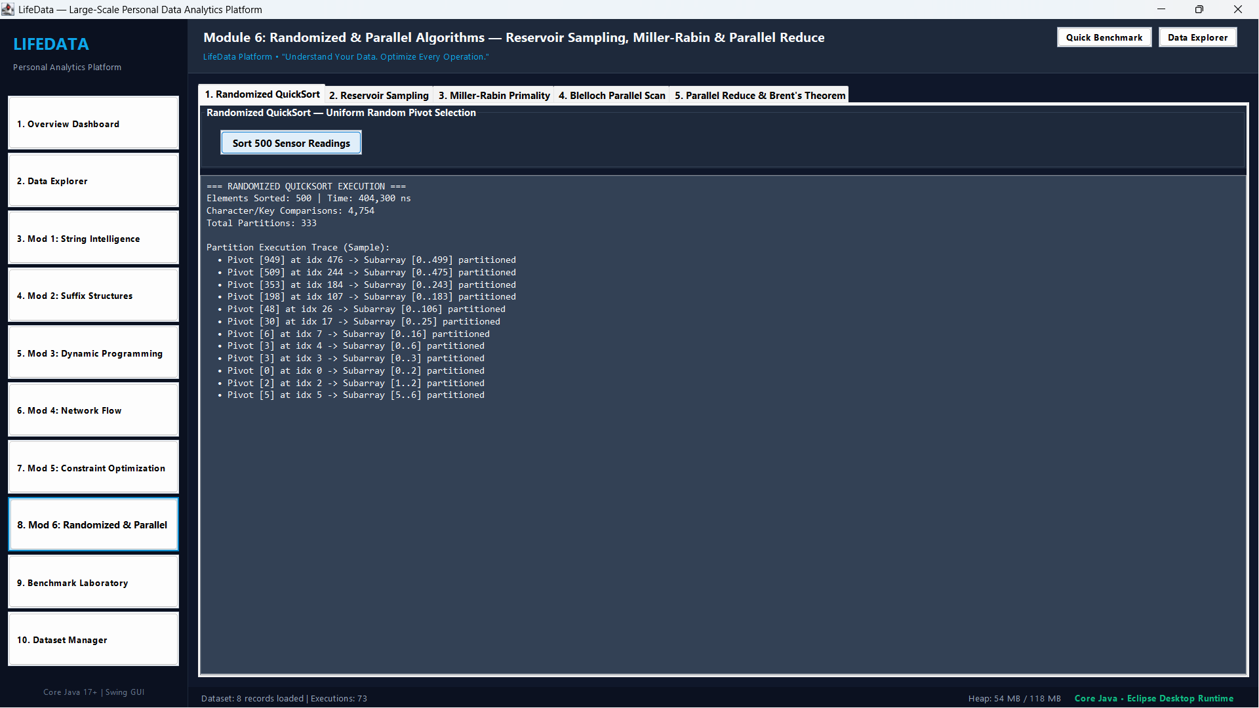
Figure 6: Module 6 (Randomized & Parallel) displaying Randomized QuickSort uniform pivot partition traces across 500 sensor readings and streaming telemetry sampling.
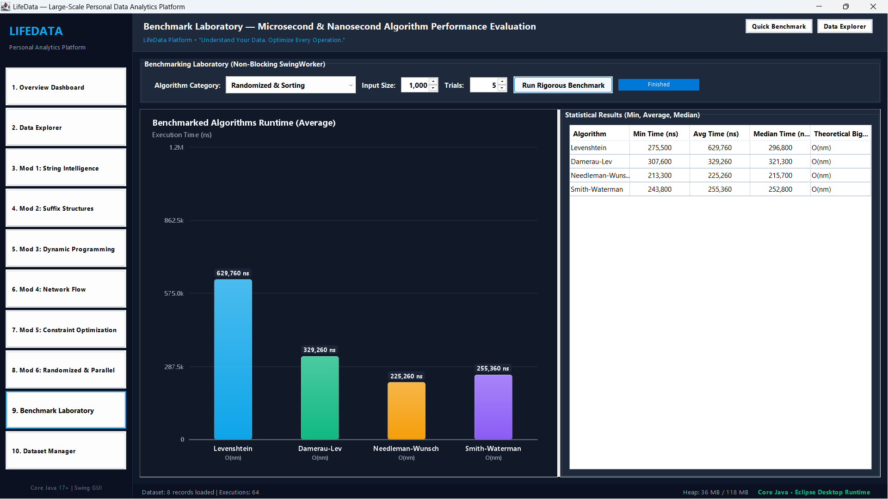
Figure 7: Benchmark Laboratory executing empirical multi-trial nanosecond performance evaluation with non-blocking background workers and 2D runtime comparison bar charts.

