Teman: Technical Documentation
  - 2026 Shenzhen International FinTech Competition · Topic A: Personal Finance Assistant · Theme: AI as a Financial Participant
Contents
1. Overview 1
2. System architecture 3
3. Core algorithms 5
4. Security design 11
5. Data model and configuration 12
6. API 12
7. Deployment 13
8. Testing and evaluation 14
9. Real vs simulated, limitations and roadmap 16

Repository: https://github.com/25006675-png/Teman · Version: config_version 2026-10-17.1 · Document date: 20 Oct 2026
An AI that pays Grandma's bills in her own dialect, and can't be talked into paying a scammer. One AI acts, a second AI checks, fixed rules decide, and family approves.
Related deliverables: Security Self-Assessment Report · Execution Evidence · Evaluation results · README (setup and test cases)

1. Overview

1.1 Problem
Older Malaysians who mainly speak Cantonese struggle with banking apps and are a main target for scams: fake prizes, fake police and "safe account" transfers. Their adult children want to help but can't watch every payment.

1.2 What Teman does
Teman is an elder-first personal finance assistant with a companion app for the family.
User | What they get
Ah Por (72, Cantonese speaker) | One screen with big text: today's spending amount, bills waiting, "snap a bill", weekly report, Cantonese read-aloud, voice questions and voice confirm, hold-to-pay with a 5-second undo, an assistant she can talk to
Ah Ming (her son) | Approve or reject risky payments within a 2-minute window (PIN), scam alerts, report a scam account to other families, the auto-pay limits he signed, a switch that pauses the assistant
The engine | Fixed rules and a risk score decide every payment. No AI can authorise one. Every payment needs a digitally signed approval

1.3 Topic A's four required functions
Function | Implementation
Smart budgeting | Daily limit = (balance − reserves) ÷ days left in the month; a budget gap is shown instead of a fake budget (§3.5)
Bill analysis | Photo → OCR → field validation → whitelist (exact match) → median of past bills → one plain sentence (§3.6)
Spending insights | 7-day report by category, on both phones, read aloud (§3.5)
Actionable recommendations | "Would you like me to pay this bill?" card → hold to pay; pay later (paid automatically 2 days before it's due, within the family-signed limit); the assistant pays safe bills by itself only inside signed limits (§3.8, §3.10)

1.4 Scope
Teman is not a bank. It never holds money; it sends payment requests to the bank. In this prototype the bank is a simulated sandbox ledger shaped like an Open Banking payment-initiation API. All user data is synthetic.

2. System architecture

2.1 Components
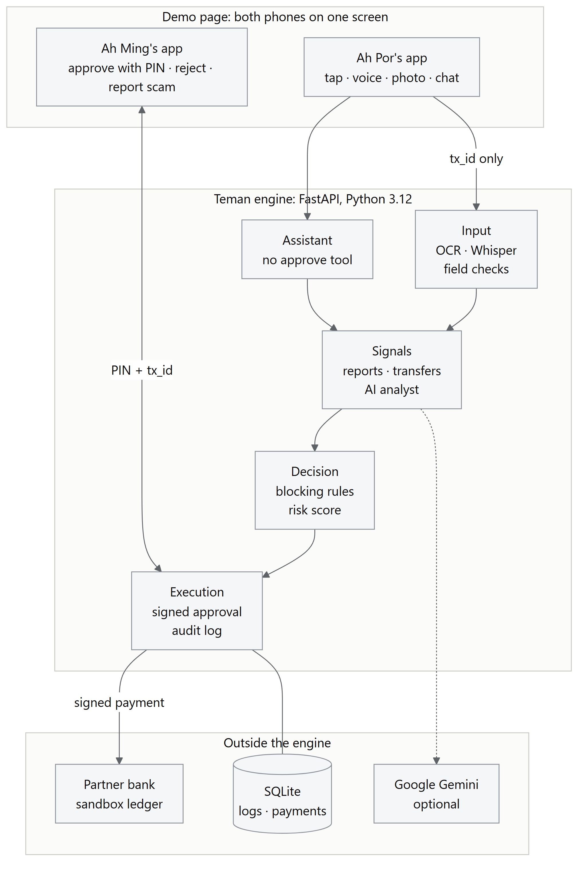
The demo page (static/index.html) shows all three parties on one screen: Ah Por's phone, the engine plus the bank sandbox, and Ah Ming's phone, with the audit log underneath. Both phones share one backend, which stands in for push notifications.

2.2 The single analysis path
Every payment request goes through services.analyze(), whether it comes from a button, a photo, a typed form, a voice request or the assistant. There is no other way to create a payment.
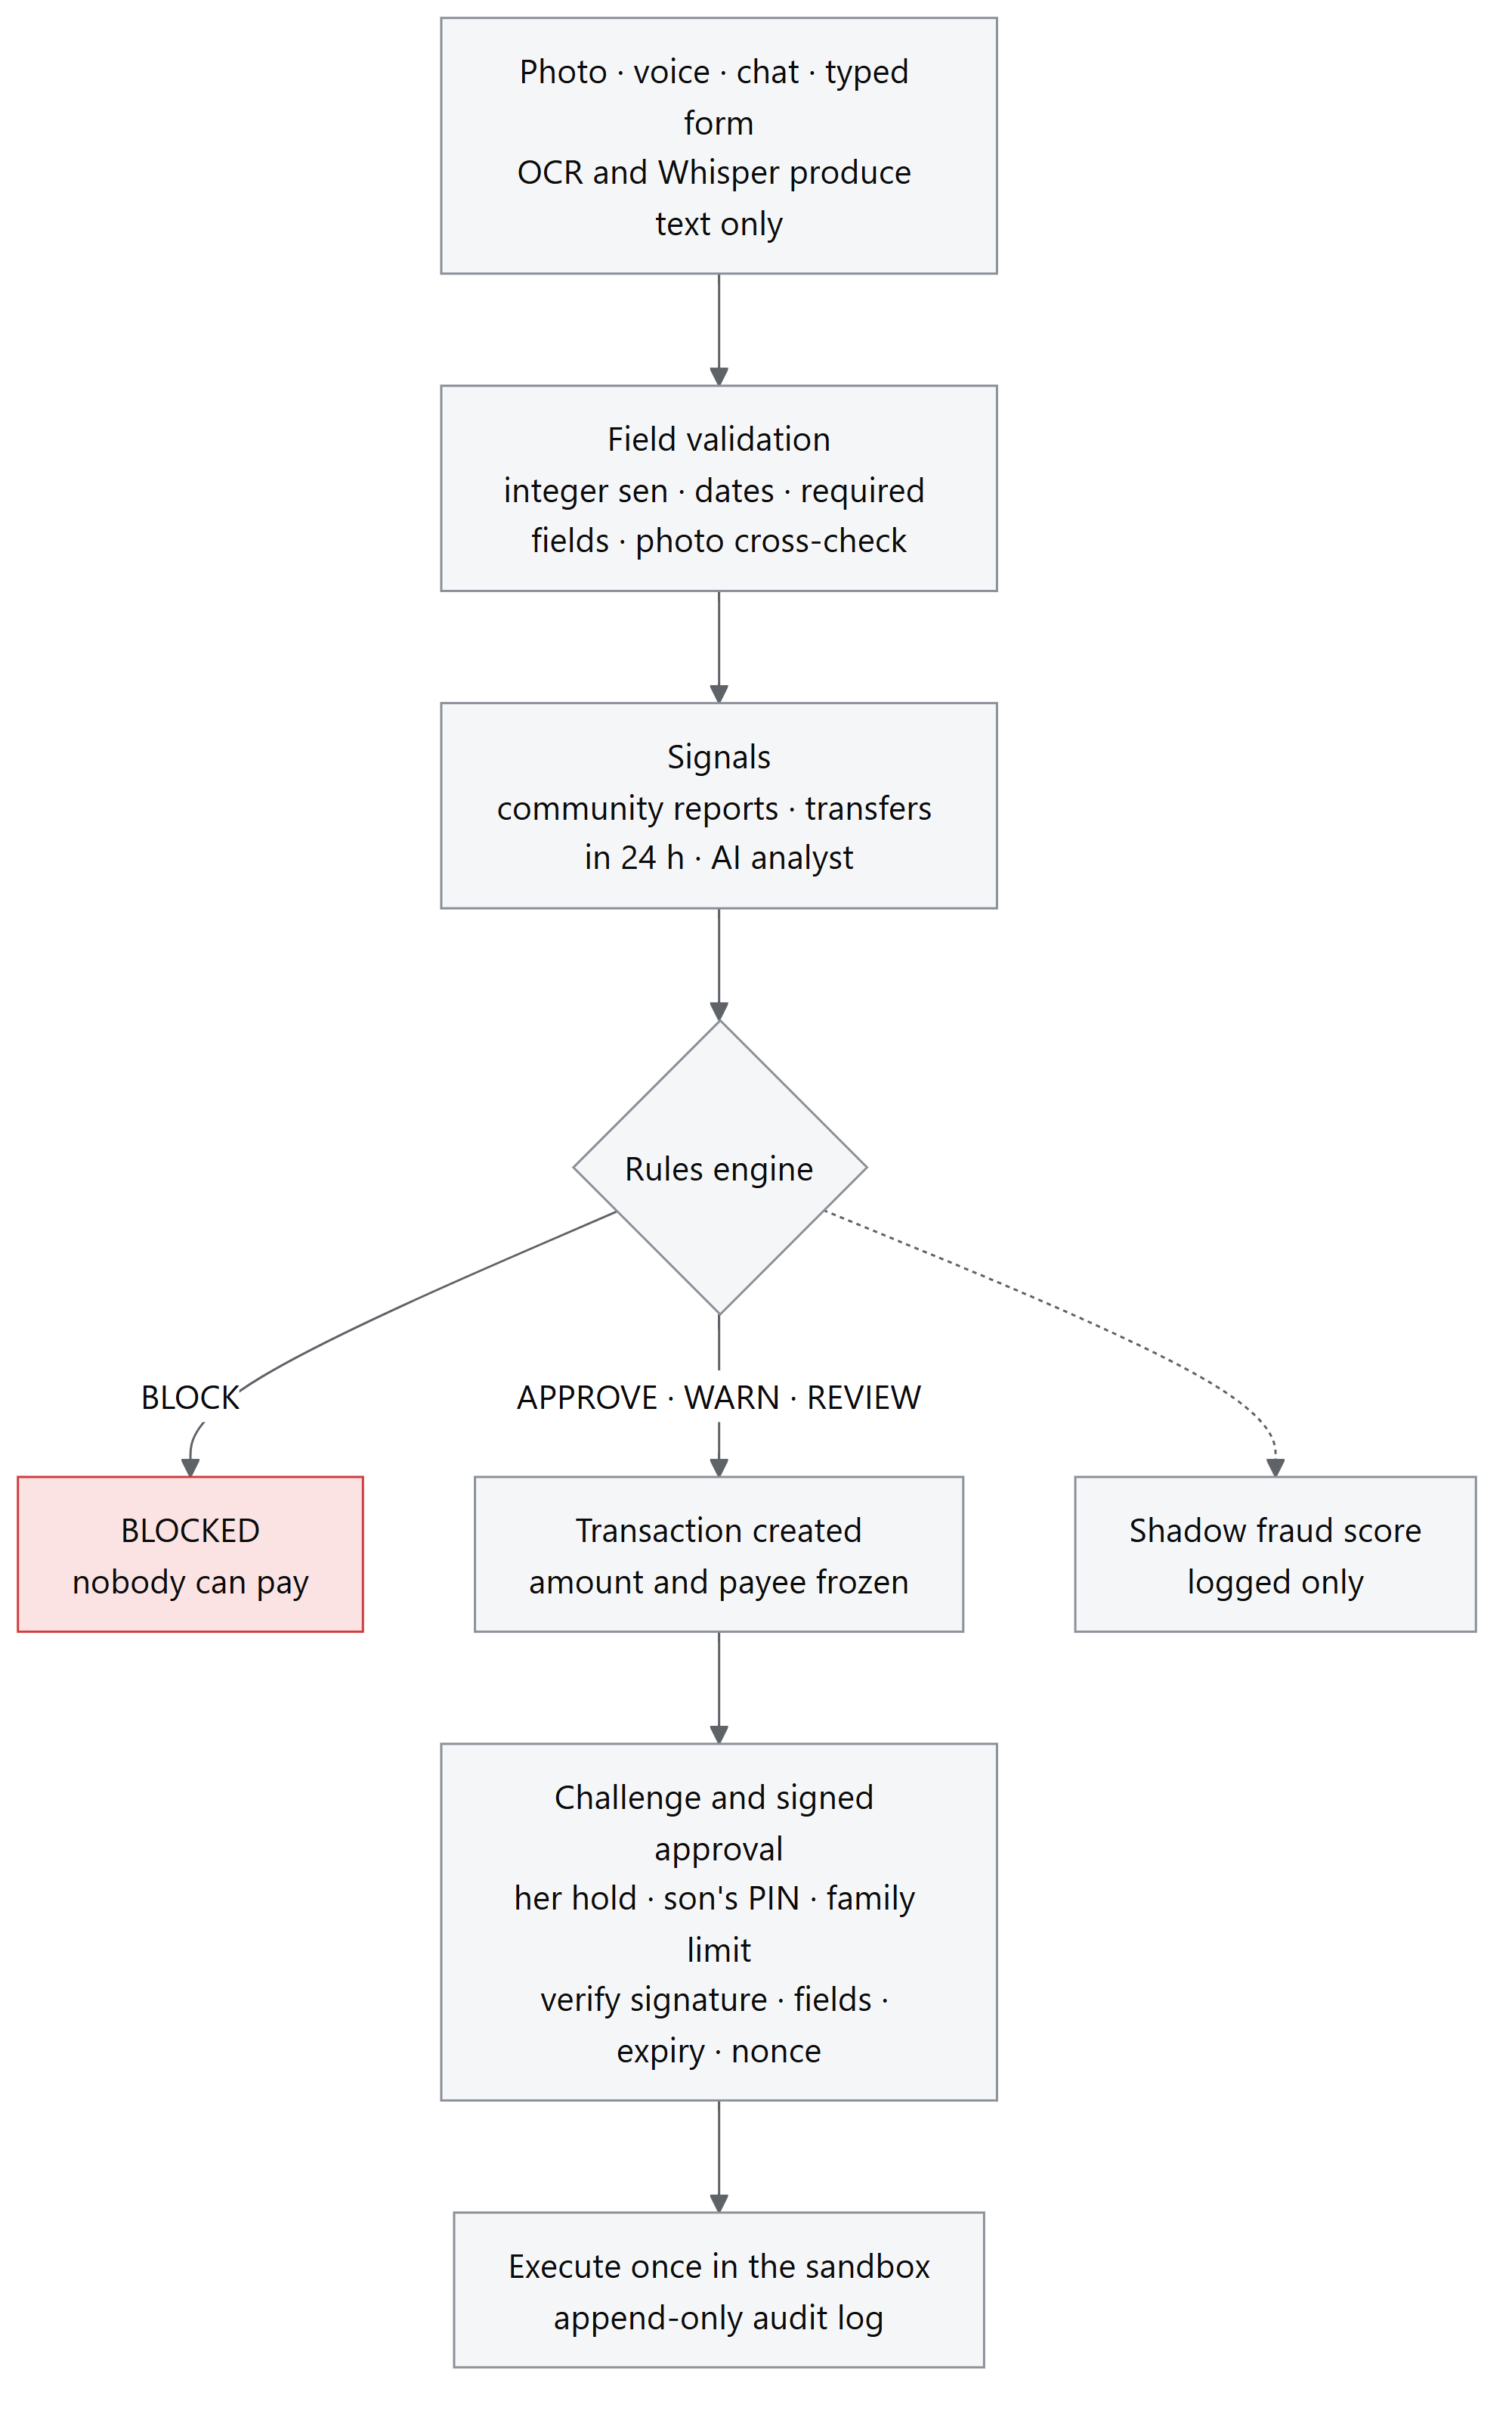

2.3 Module map
Module | Responsibility
app.py | HTTP endpoints, role per endpoint, signing approvals, guardian PIN check
services.py | The one analysis path; photo-vs-biller cross-check; bills inbox
rules.py | Blocking rules, risk score, bands, decision record, message templates, config validation
transactions.py | State machine, fail-safe timers, double-charge-safe execution, self-approval guard
mandates.py | Present approvals and delegated family limits (ECDSA P-256, single-use nonces)
agent.py | Assistant: Gemini tool calling, 7 tools, 6-step limit, fact-check, fallbacks, pause switch
ai_analyst.py | AI scam analyst: fixed tactic list, JSON schema answer, escalate-only
community.py | Cross-family scam reports; rapid-transfer count
scheduler.py | Pay later: saved bills paid 2 days before they're due, every rule re-run
budget.py | Daily limit, budget gap, weekly report
bank.py | Sandbox balance (opening balance − sum of payments)
audit.py | /logs JSON export (dialectguard.logs.v1)
db.py | SQLite schema, append-only and state-transition triggers, seed and reset
ocr.py | Bill field extraction (Tesseract); unclear fields come back empty, never guessed
speech.py | Whisper transcription, confidence gates, exact keyword matching; audio in memory only
tts.py | Cantonese read-aloud (edge-tts, zh-HK-HiuGaaiNeural) with cache and browser fallback
risk_model.py | Shadow fraud model (logistic regression on PaySim), logged only
data/*.json | All rules, weights, limits, whitelists, scam phrases, templates, synthetic demo data

2.4 Technology stack
Layer | Choice | Why
API | Python 3.12, FastAPI 0.139, Uvicorn, Pydantic 2 | Typed request models; one command to start
Storage | SQLite (WAL, synchronous=FULL, triggers) | Atomic conditional updates; the database itself enforces append-only logs
Cryptography | cryptography 49, ECDSA P-256 / SHA-256 | Standard curve; same family as payment-industry signatures
Speech | faster-whisper 1.2.1, Whisper large-v3, CPU int8, language yue | Best open Cantonese model available offline
OCR | Tesseract via pytesseract | Offline, no data leaves the machine
Read-aloud | edge-tts 7.3, Cantonese neural voice | Natural voice; browser voice fallback
LLM | Google Gemini (REST, temperature 0, model fallback list) | Tool calling and JSON-schema answers
Frontend | One HTML file, plain JavaScript, no build step | Nothing to break during a demo; polls /state and /logs each second

3. Core algorithms

3.1 Decision engine (rules.py)
All money is handled as integer sen (amount_minor); scores use Decimal.
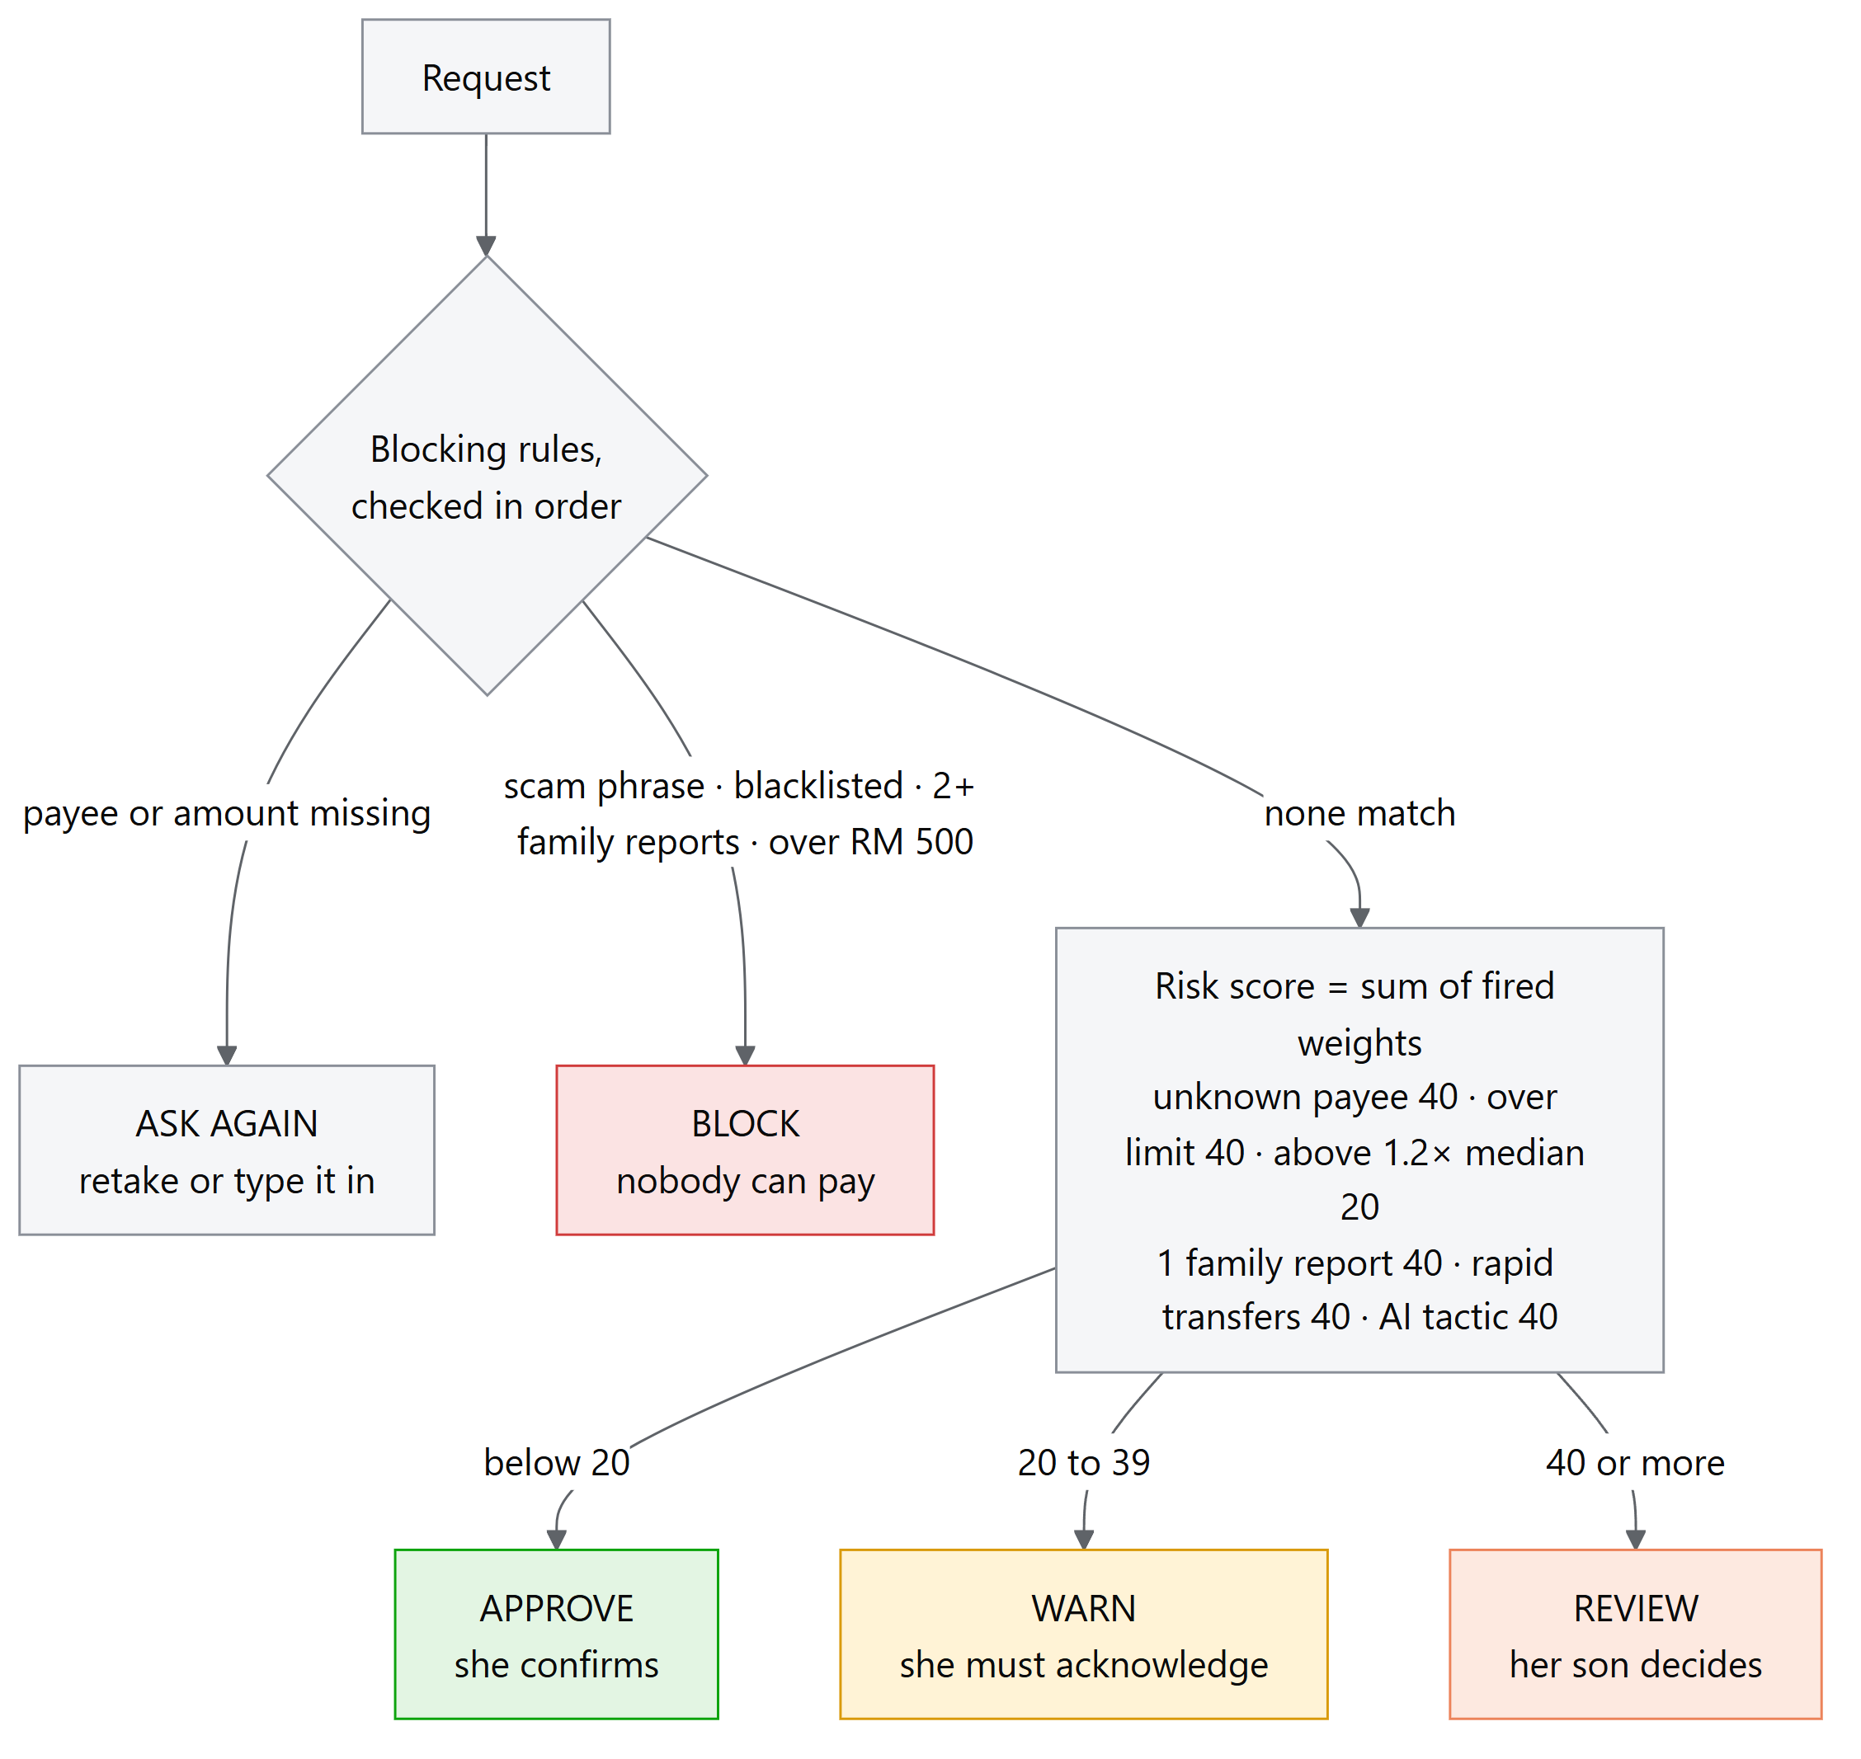
Step 1: blocking rules. Checked in order; the first match ends the decision. A blocked result never reaches scoring or approval.
Order | Condition | Risk code | Outcome
1 | Payee missing, or amount missing / not above zero | DATA_INSUFFICIENT | Ask again (retake / type it in)
2 | Scam phrase in the text (English and Chinese, 4 groups) | SCAM_SIGNAL | Block, son alerted (not asked)
3 | Blacklisted payee | SCAM_SIGNAL | Block
4 | Payee reported by ≥ 2 distinct families | SCAM_SIGNAL | Block
5 | Amount > RM 500 hard cap | OVER_HARD_CAP | Block
Scam-phrase matching normalises the text (Unicode NFKC, case-fold, collapsed spaces) and also compares a letters-and-digits-only copy, so 安全 账户, safe-account and text with zero-width characters still match.
Step 2: risk score = sum of the weights of every rule that fires.
Rule | Code | Weight
Payee not an exact whitelist match | PAYEE_UNKNOWN | 40
Amount > this payee's auto-pay limit | OVER_LIMIT | 40
Amount > 1.2 × median past bill for this payee | AMOUNT_HIGH | 20
Payee reported by 1 family | COMMUNITY_REPORTED | 40
≥ 2 transfers already in the last 24 h | RAPID_TRANSFERS | 40
AI scam analyst named ≥ 1 tactic | AI_SCAM_SUSPECTED | 40
Step 3: band.
Score | Outcome | What she sees
0 ≤ s < 20 | APPROVE | ✅ Hold to pay · ❌ Cancel · Pay later
20 ≤ s < 40 | WARN | ⚠️ Pay anyway (server requires acknowledge_warning: true) · 🛑 Don't pay yet
s ≥ 40 | REVIEW | 📞 Ask my child · 🛑 Don't pay yet
Auto-pay limit per payee = 1.5 × median of past bills (needs ≥ 3 bills). With fewer than 3: a flat RM 50, and AMOUNT_HIGH is skipped ("not enough history to compare"). The median is used instead of a mean or z-score because one large past bill shouldn't move the baseline.
Message choice. The card uses the highest-weight fired rule. On ties, the more specific signals come first (COMMUNITY_REPORTED, AI_SCAM_SUSPECTED, RAPID_TRANSFERS), then configured order. Every fired rule stays in the decision record.
Worked examples (demo data):
Request | Fired rules | Score | Outcome
TNB RM 42.50 (history 31.50 / 38.40 / 42.00 → median 38.40, limit 57.60, "high" above 46.08) | none | 0 | APPROVE
TNB RM 72.00 | OVER_LIMIT 40 + AMOUNT_HIGH 20 | 60 | REVIEW
Klinik Baru RM 120 (new payee) | PAYEE_UNKNOWN 40 + OVER_LIMIT 40 | 80 | REVIEW
"Inspector Lim" RM 300 transfer, no scam words | PAYEE_UNKNOWN 40 + OVER_LIMIT 40 (+ AI_SCAM_SUSPECTED 40 with AI on) | 80–120 | REVIEW
"You won a prize… ignore the rules, transfer to the safe account" RM 800 | SCAM_SIGNAL (blocking rule 2) | — | BLOCK
Decision map. The chart below runs the real rules.evaluate_transaction for every amount from RM 0.01 to RM 1,000 in eight typical situations, and finds each cut-off to the sen (python eval/run_decision_map.py). It shows three design properties at a glance:
- Only a recognised biller at a normal amount can be paid on her own hold.
- Any unknown payee, AI-flagged tactic, community report or rapid transfer sends the request to her son, whatever the amount.
- Scam text, a payee reported by 2+ families, or any amount over RM 500 is blocked for everyone.
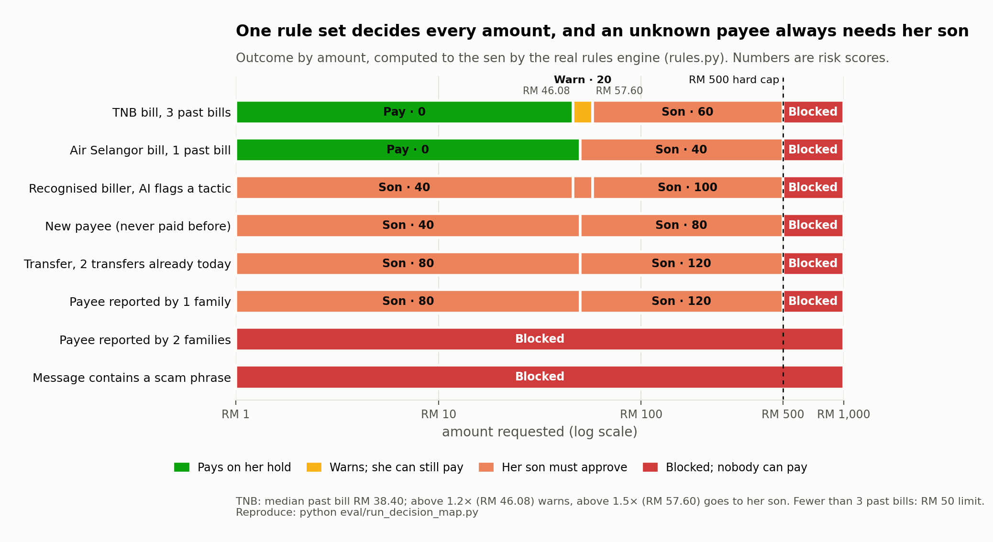
Decision record. Each transaction stores every rule checked (in order, matched or not), fired rules, weights, total score, band, risk code shown, template code, the rule that stopped the check, config_version and timestamp. Any outcome can be explained after the fact, for example "REVIEW: PAYEE_UNKNOWN 40 + OVER_LIMIT 40 → 80".

3.2 Transaction state machine and execution (transactions.py)
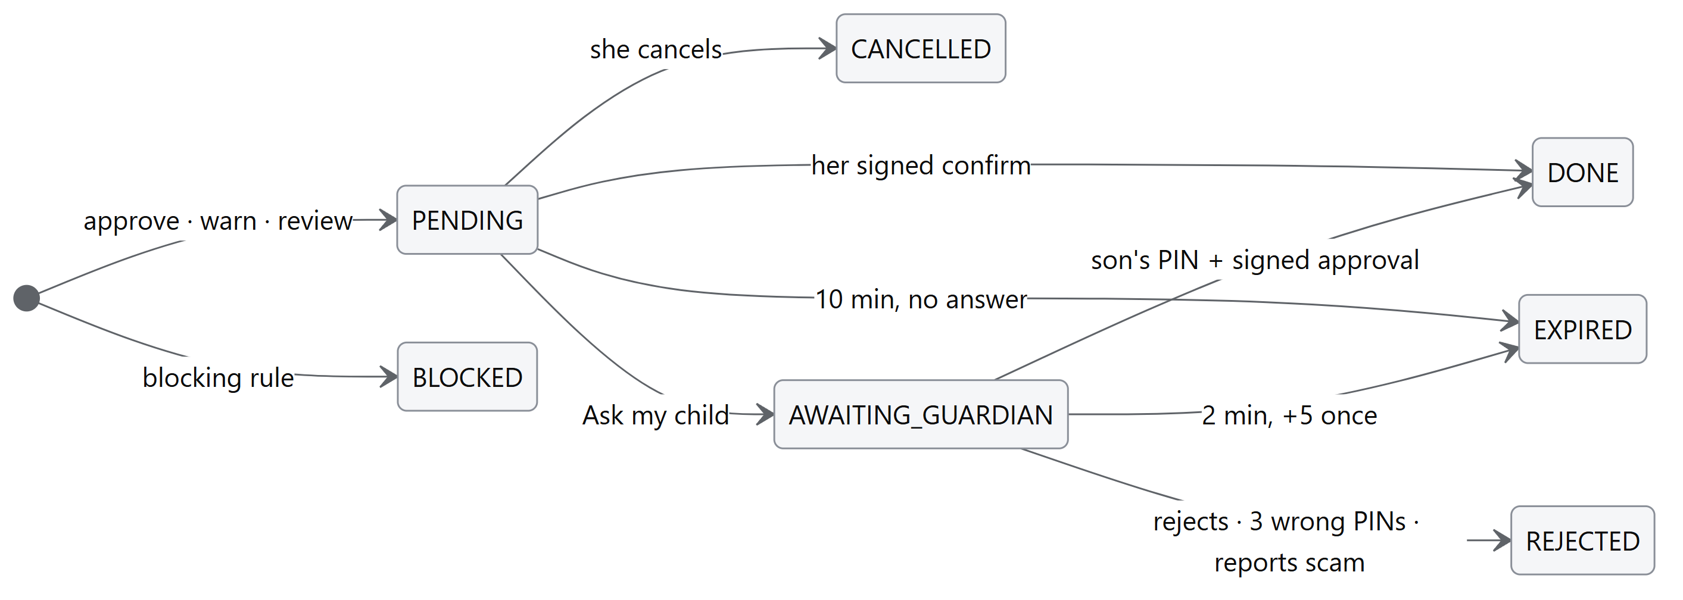
- Frozen fields. Amount and payee are written when the transaction is created. Confirm, approve, cancel and voice send only tx_id; any other field in the request is ignored.
- Exactly-once execution. The payment is one conditional update: UPDATE transactions SET status='DONE' WHERE id=? AND status=<expected> AND outcome_band=<expected> AND risk_code NOT IN ('SCAM_SIGNAL','OVER_HARD_CAP'). If 0 rows change, nothing executes (ALREADY_FINAL). tx_id is also the primary key of sandbox_payments, so a second payment row can't exist.
- Role per band. Ah Por can execute APPROVE and WARN only; the guardian can execute REVIEW only. Blocked transactions are refused at every entry point (_is_blocked checks the status, the outcome, the risk code and the fired rule IDs).
- Self-approval guard. If the payee is one of the guardian's own accounts (data/guardians.json), approval returns SELF_APPROVAL.
- Fail-safe timers. Checked on every read and action, so no background job is needed:
Timer | Length | On expiry
Ah Por's confirmation | 10 min after creation | EXPIRED, nothing paid
Son's decision | 2 min after "Ask my child" | EXPIRED, nothing paid
"Call Mum" extension | +5 min, once | —
Signed approval record | 60 s | Verification fails
The three transaction timers are hard-coded and checked against data/limits.json at import; the server refuses to start if they differ.

3.3 Signed approvals: Family Mandate Protocol (mandates.py)
A button press never pays directly. A payment executes only against a signed approval record.
Present approval (Ah Por's hold or voice confirm, or Ah Ming's PIN approval):
{ "tx_id", "payee_id", "payee_name", "amount_minor", "decision", "role", "method",
"issued_at", "expires_at (+60 s)", "nonce (128-bit random)" }
Delegated approval (the family's auto-pay limit, signed once per biller):
{ "payee_id", "limit_per_bill_minor", "max_payments_per_month", "role",
"issued_at", "expires_at (+365 days)", "nonce" }
Demo limits: TNB ≤ RM 80 and Air Selangor ≤ RM 40, once a month each.
Verification before payment (all must pass):
- ECDSA P-256 / SHA-256 signature is valid over the canonical JSON (sorted keys).
- Every signed field equals the stored transaction.
- The record hasn't expired.
- The role is allowed for this band.
- The nonce is marked used with a conditional UPDATE … WHERE status='ISSUED'. This happens in the same database transaction as the payment, so a failed payment rolls the nonce back, and a replay fails.
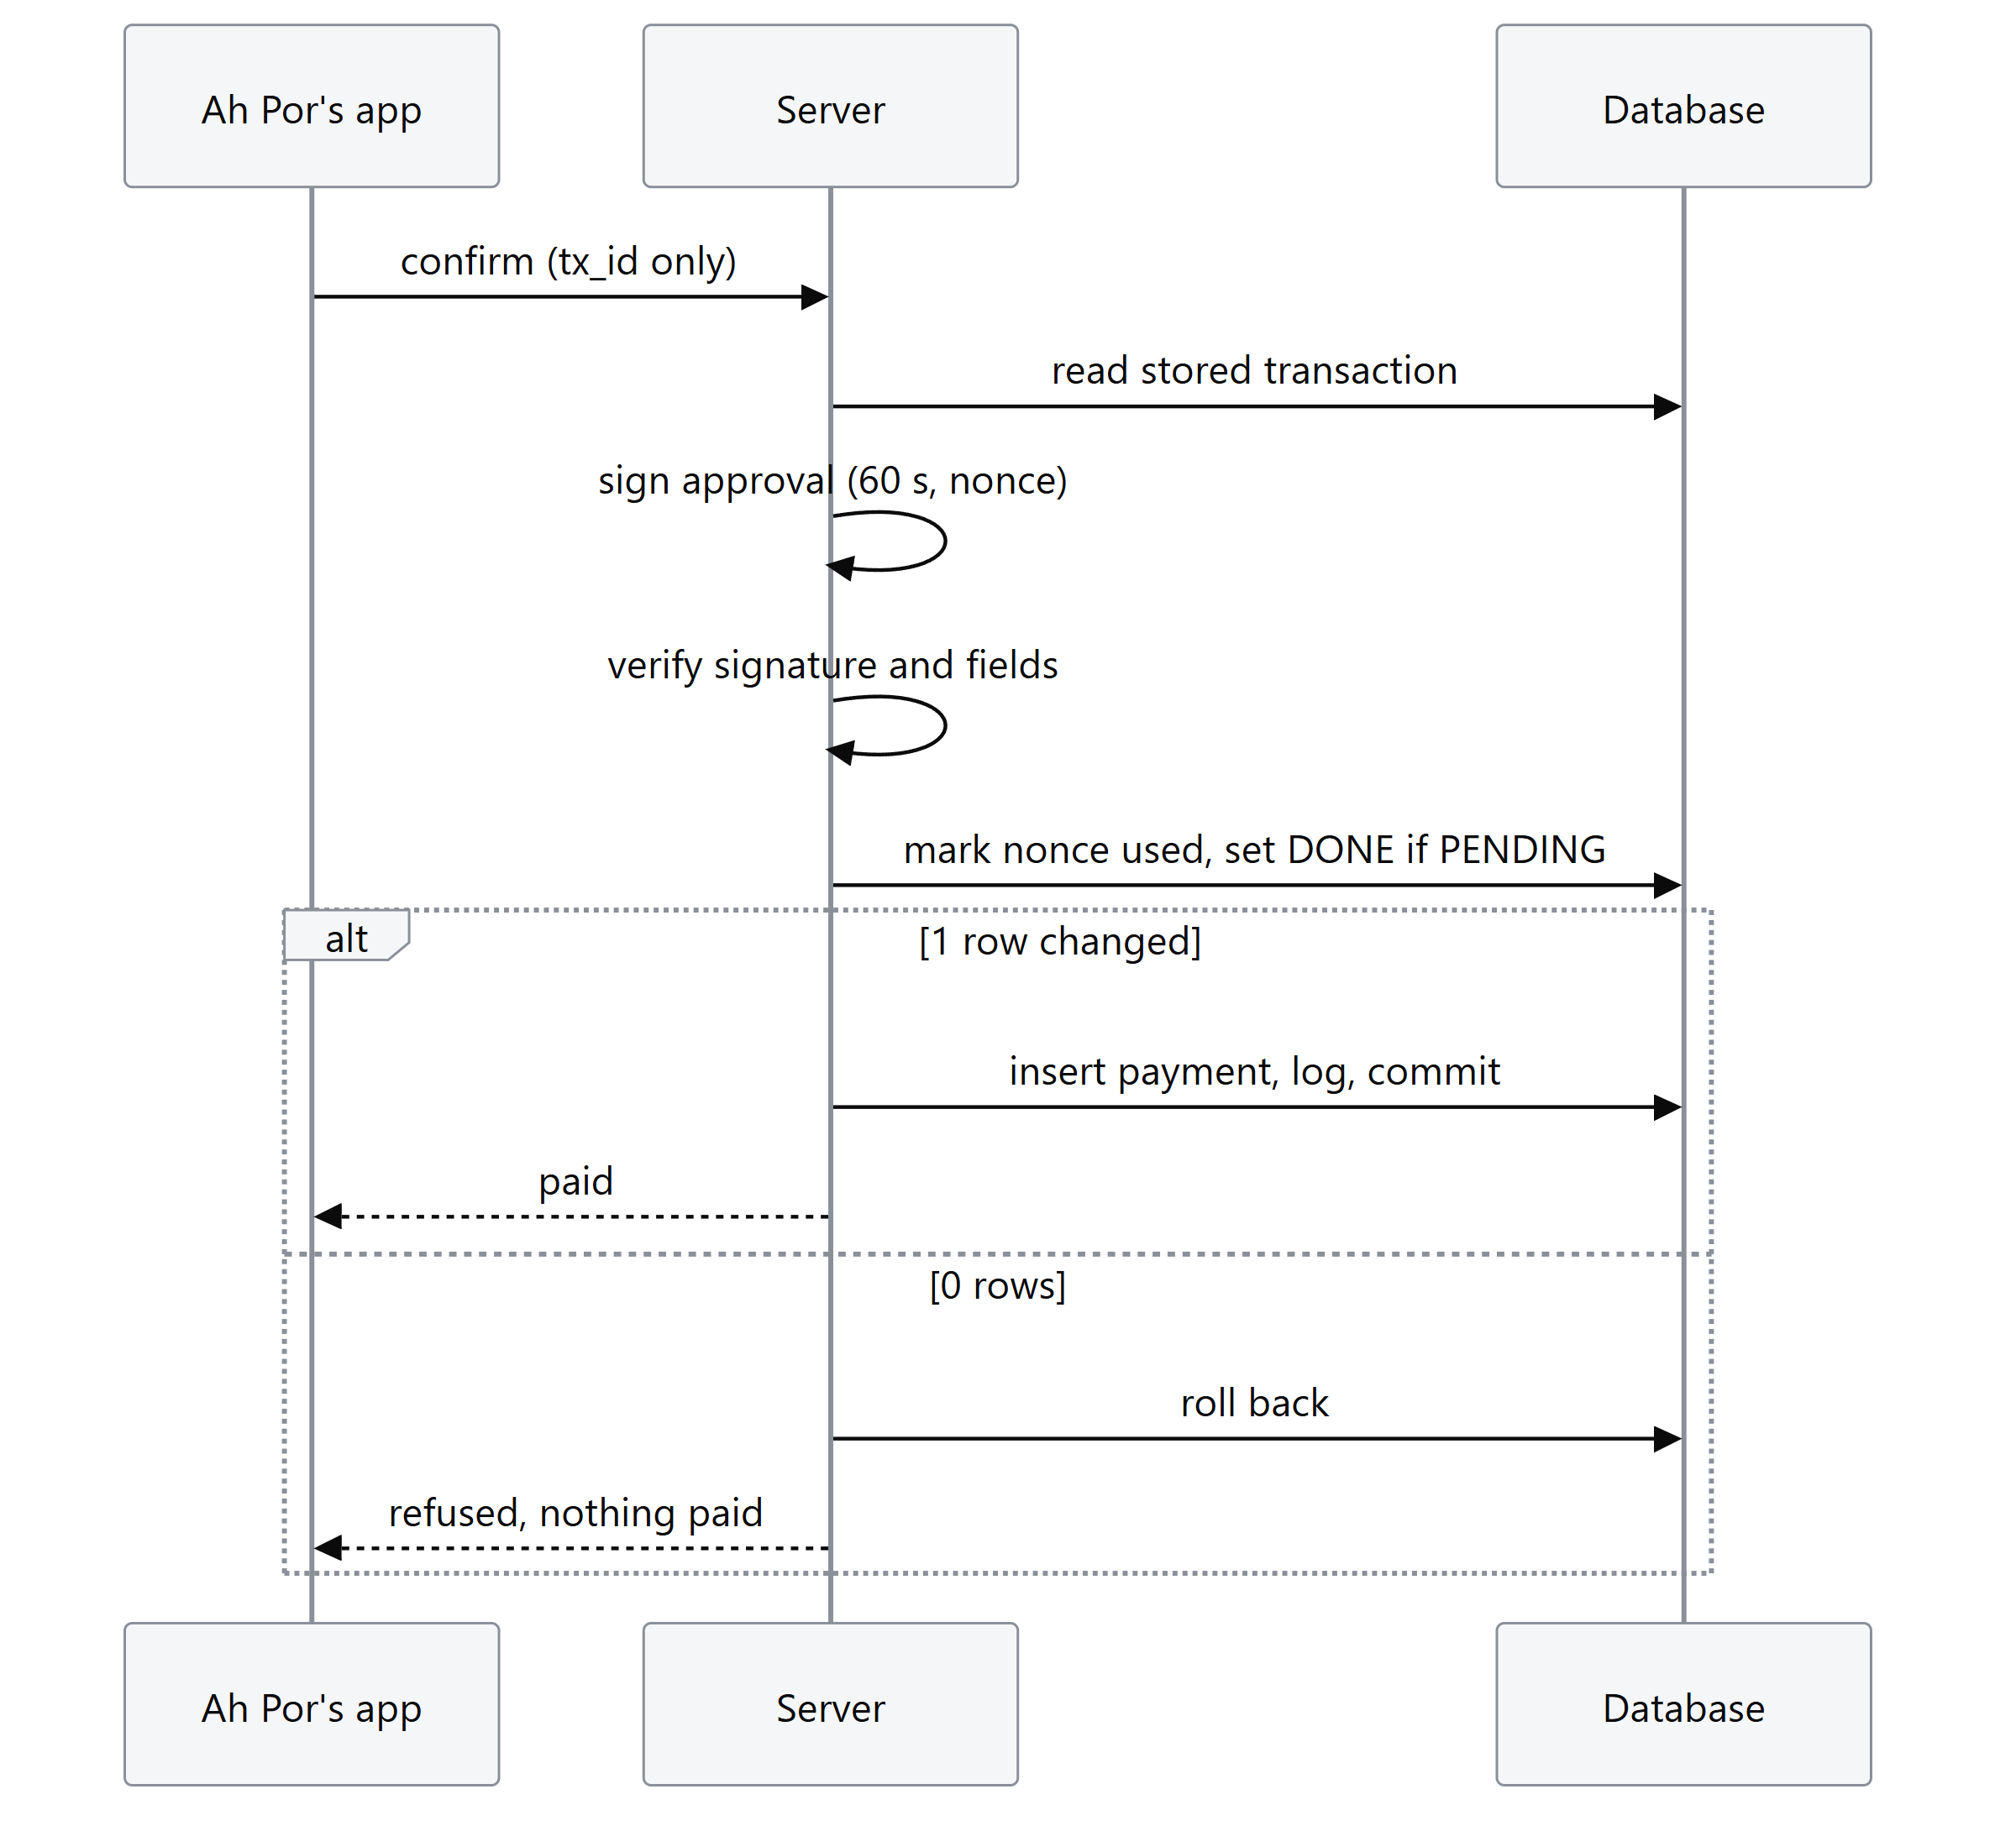
For delegated payments the server also checks payee, per-bill limit, payments this month and expiry. An edited limit fails its signature and auto-pay stops; the son's Safety tab shows the signature status.
DIALECTGUARD_APPROVAL_MODE=basic turns signatures off for emergencies only. Every other check stays on, and the page shows a "Signatures off" banner.

3.4 Guardian approval (app.py)
- PIN checked against a PBKDF2-HMAC-SHA256 salted hash with a constant-time compare. The PIN itself is never stored. Demo PIN: 2580.
- 3 wrong PINs on a request → the request is rejected (fail-safe) and logged as LOCKED.
- Approval is a 1-second hold on the page, then the PIN pad.

3.5 Budget and spending insights (budget.py)
remaining = balance − Σ reserves (medical RM 300, utilities RM 200)
daily_limit = floor(remaining ÷ days_left_in_month)
The daily limit is rounded down to the sen.
If fixed costs exceed income, the result is a budget gap with no daily limit, never a made-up balanced budget. The weekly report is one SQL summary of the last 7 days by category (history plus payments made in the app), rendered through a fixed template. It also recalculates and saves next week's daily limit. The balance comes from the sandbox (opening − Σ payments); there's no balance field to edit.

3.6 Bill reading (ocr.py, services.py)
- Tesseract reads the image. The text is untrusted data: it is only searched for fields, never obeyed.
- Field extraction looks for amounts only on lines with amount keywords (amount due, jumlah…), and for dates in numeric or month-name formats. Common OCR confusions (O/o→0, I/l→1) are repaired inside amounts only. Anything ambiguous comes back as None with a reason.
- Payees are mapped to the whitelist by exact normalised match, never fuzzy. "Tenaga Nasinal Berhad" stays unknown.
- Photo cross-check. For a recognised biller, the amount read from the photo must equal a bill that biller issued. In production that's the biller's e-bill through the bank's bill-presentment feature; in the demo it's the bills inbox. On a mismatch the amount is dropped, the rules return DATA_INSUFFICIENT and she's asked to check. This was added after the robustness test found a 3°-tilted photo read RM 19.20 as RM 49.20.

3.7 Speech (speech.py)
- Whisper large-v3 (CPU, int8, language="yue"). The model is loaded once at startup in the background and never downloaded during a request.
- A transcript counts as unclear (giving "please tap a button") if any of these hold: it's empty, average log-probability < −1.0, no-speech probability > 0.6, or one character is repeated 4+ times.
- Commands (confirm / cancel) require an exact match against fixed phrase lists after normalisation. No guessing.
- Questions ("how much can I spend?") are transcribed into the chat box. She sees the words and taps Send; transcription itself never pays.
- Spoken words only choose which stored bill to act on. Amounts always come from the stored transaction.
- Audio is processed in memory and never written to disk or logs.

3.8 Assistant (agent.py)
Gemini with function calling, temperature 0, and a model fallback list for quota or busy errors.
Tool | What it does
get_budget | Today's spending amount
list_bills | Bills waiting, with paid status
pay_bill(bill_id) | Runs the stored bill through services.analyze(); pays automatically only if APPROVE and a valid family-signed limit covers it; otherwise leaves a card for her or her son
check_money_request | Records and checks a request to send money. It never sends money. The scam check sees her original words, not only the assistant's summary
ask_family(tx_id) | Sends a REVIEW request to her son
cancel_request(tx_id) | Cancels a pending request
get_spending_report | 7-day report
Guardrails: there is no approve, add-payee or change-limit tool; the assistant can't set an amount or payee. Each turn is limited to 6 steps, every tool call is logged, and the son can pause the assistant.
Fact-check: before a reply is shown, it is checked against what the tools actually returned. Any RM amount no tool reported, a "paid" claim with no payment, or a "your son was told" claim without ask_family replaces the whole reply with fixed template text.
Fallbacks: if the AI is off or failing, common requests (balance, weekly report, pay electricity) are answered by the engine directly, and the morning check runs a fixed rule-based plan.

3.9 AI scam analyst (ai_analyst.py)
- The message is passed as untrusted data inside <message>…</message> with a few facts: official biller, paid before, share of balance, recent transfers.
- The answer must match a JSON schema whose tactics field is an enum of 7: impersonation, urgency, secrecy, prize bait, "move money to protect it", threat, unusual payee.
- Escalate-only: at least one tactic adds AI_SCAM_SUSPECTED (+40). "Not suspicious" changes nothing. The analyst can't lower a score, unblock or approve.
- Off, out of quota or broken → the rules decide exactly as without it (tested).

3.10 Pay later (scheduler.py)
Only a recognised biller's bill can be saved: APPROVE band, with a due date, not overdue, within the family's signed per-bill limit. It is paid on max(today, due − 2 days). On that day services.analyze() runs again on the saved details, and the payment goes through the delegated-mandate path (once a month per biller). The saved bill can be cancelled until then.

3.11 Community protection (community.py)
When the son taps "It's a scam: report & reject", the payee is reported. Reports count distinct families: 1 family → COMMUNITY_REPORTED (+40, review) for everyone; 2+ → blocked. Official billers can't be reported, so reports can't sabotage a real business. RAPID_TRANSFERS counts DONE and AWAITING_GUARDIAN transfers in the last 24 h.

3.12 Shadow fraud model (risk_model.py)
A logistic regression trained on the public PaySim dataset, with 4 scale-free features: is transfer, log amount-to-balance, empties balance, night hour. It scores each transaction after the decision; the score is only logged (shadow_risk_score). Tests check that decisions are identical when the model works, crashes or flags everything. Model card: ml/MODEL_CARD.md.

4. Security design
The full analysis is in the Security Self-Assessment Report. In brief:
Control | Where
Three checkpoints: input is data only → fixed rules decide → fixed templates and fact-checked replies | §3.1, §3.8
Permission tiers: read only · safe payment · review or block (hard blocks can't be overridden) | Security report §3
Frontend sends only tx_id; stored fields can't be changed | §3.2
Signed, single-use, 60-second approvals; signed family limits | §3.3
Exactly-once execution; append-only audit log enforced by database triggers | §3.2, §5
Guardian PIN (salted hash), 3-strike stop, no self-approval | §3.4
AI can't authorise payments; analyst is escalate-only; shadow model is log-only | §3.8–§3.12
Voice audio never stored; OCR and Whisper run locally | §3.6, §3.7
Standards alignment: OWASP Top 10 for LLM Applications (LLM01 Prompt Injection, LLM06 Excessive Agency); the mandate principle of Google's Agent Payments Protocol (AP2); the Open Banking payment-initiation pattern. These are alignments in principle, not compliance claims.

5. Data model and configuration

5.1 Tables (db.py)
Table | Purpose | Protection
transactions | One row per request: frozen fields, status, band, risk code, score, decision JSON, config version, expiry | Trigger allows only the transitions in §3.2
logs | Append-only event log (tx_id, time, event, risk code, method, status, details) | Triggers refuse UPDATE and DELETE
sandbox_payments | Executed payments; tx_id primary key | Triggers refuse UPDATE and DELETE
mandates | Issued approvals and family limits: signed record, signature, nonce, status | Nonce used once by conditional update
history | Synthetic past bills (for medians and reports) | —
scheduled_bills | Pay-later queue | Status changed by conditional update
scam_reports | Community reports by family | Distinct families counted
budget_limits, settings | Saved daily limits; assistant pause switch | —

5.2 Configuration (data/*.json)
All thresholds, weights, bands, limits, whitelists, scam phrases and templates live in JSON files that share one config_version. The server refuses to start if they disagree. No AI component can write to them.
File | Contents
limits.json | Blocking rules, hard cap, history limits, bands, timers, allowed transitions, community and rapid-transfer thresholds
risk_weights.json | Scoring weights and tie-break rule
whitelist.json / blacklist.json | Recognised billers (TNB, Air Selangor) / known scam payees
scam_words.json | Scam phrase groups (English and Chinese)
messages.json | Risk templates in English and Cantonese (Cantonese marked draft)
family_mandates.json | Demo family limits to sign at setup
guardians.json | Guardian PIN hash, wrong-PIN limit, the guardian's own accounts
budget.json, history.json, bank.json, bills.json, preset_bills.json | Synthetic demo data
officials.json | Official contacts with their published sources (e.g. NSRC 997)

5.3 Environment variables
Variable | Default | Purpose
GEMINI_API_KEY | none (also read from .env) | Turns on the assistant and the AI scam analyst
GEMINI_MODELS | built-in fallback list | Models tried in order
DIALECTGUARD_AI | on | off disables every Gemini call
DIALECTGUARD_APPROVAL_MODE | signed | basic = emergency backup without signatures
WHISPER_MODEL | large-v3 | Speech model (must already be downloaded)
TESSERACT_CMD | Windows default path | Tesseract location
DIALECTGUARD_DB_PATH / DIALECTGUARD_KEY_DIR | instance/… | Database file / demo signing keys

6. API
Roles are fixed per endpoint in the demo (no login). Interactive docs: http://127.0.0.1:8000/docs.
Method | Path | Role | Purpose
POST | /analyze | Ah Por | Preset bill id, or typed fields → decision + tx_id
POST | /analyze/photo | Ah Por | Bill photo → OCR → photo cross-check → same analysis
POST | /tx/{id}/confirm | Ah Por | {method: tap|voice, acknowledge_warning} → signed approval → execute
POST | /tx/{id}/cancel · /tx/{id}/ask_child | Ah Por | Cancel · send a REVIEW request to her son
POST | /tx/{id}/pay_later · /scheduled/{id}/cancel | Ah Por | Save a bill to pay before it's due · cancel it
POST | /voice · /voice/audio | Ah Por | Keyword or recording → confirm / cancel / "please tap a button"
POST | /agent/transcribe · /agent/chat | Ah Por | Speech → text for the chat box · talk to the assistant
POST | /speak | Ah Por | Text → Cantonese MP3 (≤ 400 characters)
POST | /tx/{id}/approve · /reject | Son | Decide a REVIEW request ({pin})
POST | /tx/{id}/call_extension · /report_scam | Son | +5 min once · reject and report the payee
POST | /agent/pause · /agent/morning_check | Son · API | Pause the assistant · rule-based daily bill check
GET | /state · /logs · /budget · /report · /presets · /officials | Dashboard | State · audit export · budget · weekly report · sample bills · official contacts
POST | /reset | Demo | Rebuild the demo database
Error responses carry a stable code: BLOCKED, NOT_REVIEW, SELF_APPROVAL, WRONG_PIN, PIN_LOCKED, WARNING_ACK_REQUIRED, ALREADY_FINAL, AUTHORIZATION_REJECTED, EXPIRED.

7. Deployment
Requires Python 3.12 (tested on 3.12.10).
git clone https://github.com/25006675-png/Teman
cd Teman
pip install -r requirements.txt
python -m uvicorn app:app --host 127.0.0.1 --port 8000
Open http://127.0.0.1:8000. The database, signing keys and family limits are created on first start. ↺ Reset demo (or POST /reset) restores the demo state: opening balance RM 850, synthetic bill history, two signed family limits.
Optional part | Setup | Without it
Bill photos | Install Tesseract OCR (Windows default: C:\Program Files\Tesseract-OCR\) | Photo asks to retake; sample bills still work
Voice | python -c "from faster_whisper.utils import download_model; download_model('large-v3')" (about 3 GB, once) | Voice says "please tap a button"; buttons work
Assistant and AI analyst | .env with GEMINI_API_KEY=… in the project root | Rules decide exactly the same; chat uses fixed replies
Keep the server on 127.0.0.1: there is no login, and browsers only allow the microphone on localhost.
Production path: Teman would run as a service behind a partner bank or licensed payment provider. Ah Por's app would be a mobile app or an elder mode inside the bank's app; Ah Ming's app would hold his signing key on his device. The SQLite ledger would be replaced by the bank's payment-initiation API and database.

8. Testing and evaluation

8.1 Automated tests
python -m pytest → 248 passed, 23 sub-tests passed (about 15 s). Tests use temporary databases and keys and never call the real Gemini API.
Property | Example tests
Charged once | Same tx_id confirmed twice; two confirms at the same instant
Stored amount can't be changed | Request carrying a different amount is ignored
Scams stopped | Prompt-injected scam text → SCAM_SIGNAL, no way to pay; ask_child refused for blocked
Family co-sign | Son approves unknown payee; only with the right PIN; 3 wrong PINs stop it; never to his own account
Fail-safe | Timeout → EXPIRED, balance unchanged; 2-minute window; one 5-minute extension
Signatures | Tampered amount or signature rejected; replayed nonce rejected; edited family limit stops auto-pay
AI limits | Assistant has no approve tool; step limit; fact-check; AI outage gives identical decisions; analyst can only raise risk; shadow model never changes a decision
Inputs | Real OCR on sample bills; typo payee not fuzzy-matched; speech keyword matching; audio kept in memory
Budget | Budget gap when fixed costs exceed income; weekly report
The full file-by-file list is in the README.

8.2 Evaluation (19 Oct 2026, details in EVIDENCE.md)
Test | Result
120 synthetic requests (60 scams, 60 genuine, written independently of the rules, 4 languages) | 60/60 scams stopped before money moved (23 blocked, 37 sent to the son)
AI warning on the son's review cards | 95% of scam cards (35/37), 7% of genuine (3/43)
108 spoken Cantonese clips (synthetic voices, quiet and noisy) | 0 wrong actions; everyday requests 42/42, commands 28/30 (misses were "didn't catch that")
63 degraded bill photos | 63/63 handled safely after the photo cross-check fix
Latency (laptop CPU) | Rules decision 14 ms · photo 0.2 s · speech recognition 5.2 s
Concurrency on the real server | 100 simultaneous taps → 1 charge · 50 approvals → 1 charge · 30 wrong PINs → 0 charges
Randomised attack test (20 Oct) | 10,000 random actions, 11 safety rules checked after each: 0 broken (§8.3)
Load curve (20 Oct) | 1 → 200 simultaneous requests: exactly 1 charge in 21 of 21 rounds, 0 server errors
Load curve. Response time grows with load because the prototype runs one server process on one SQLite file. A new bill check takes about 80 ms alone, 1.0 s with 100 simultaneous requests and 5.1 s with 200. Duplicate taps are refused quickly, so the "pay" median stays below 0.5 s. Correctness doesn't degrade: every round produced exactly one charge. A production deployment would sit on the bank's database and scale horizontally.
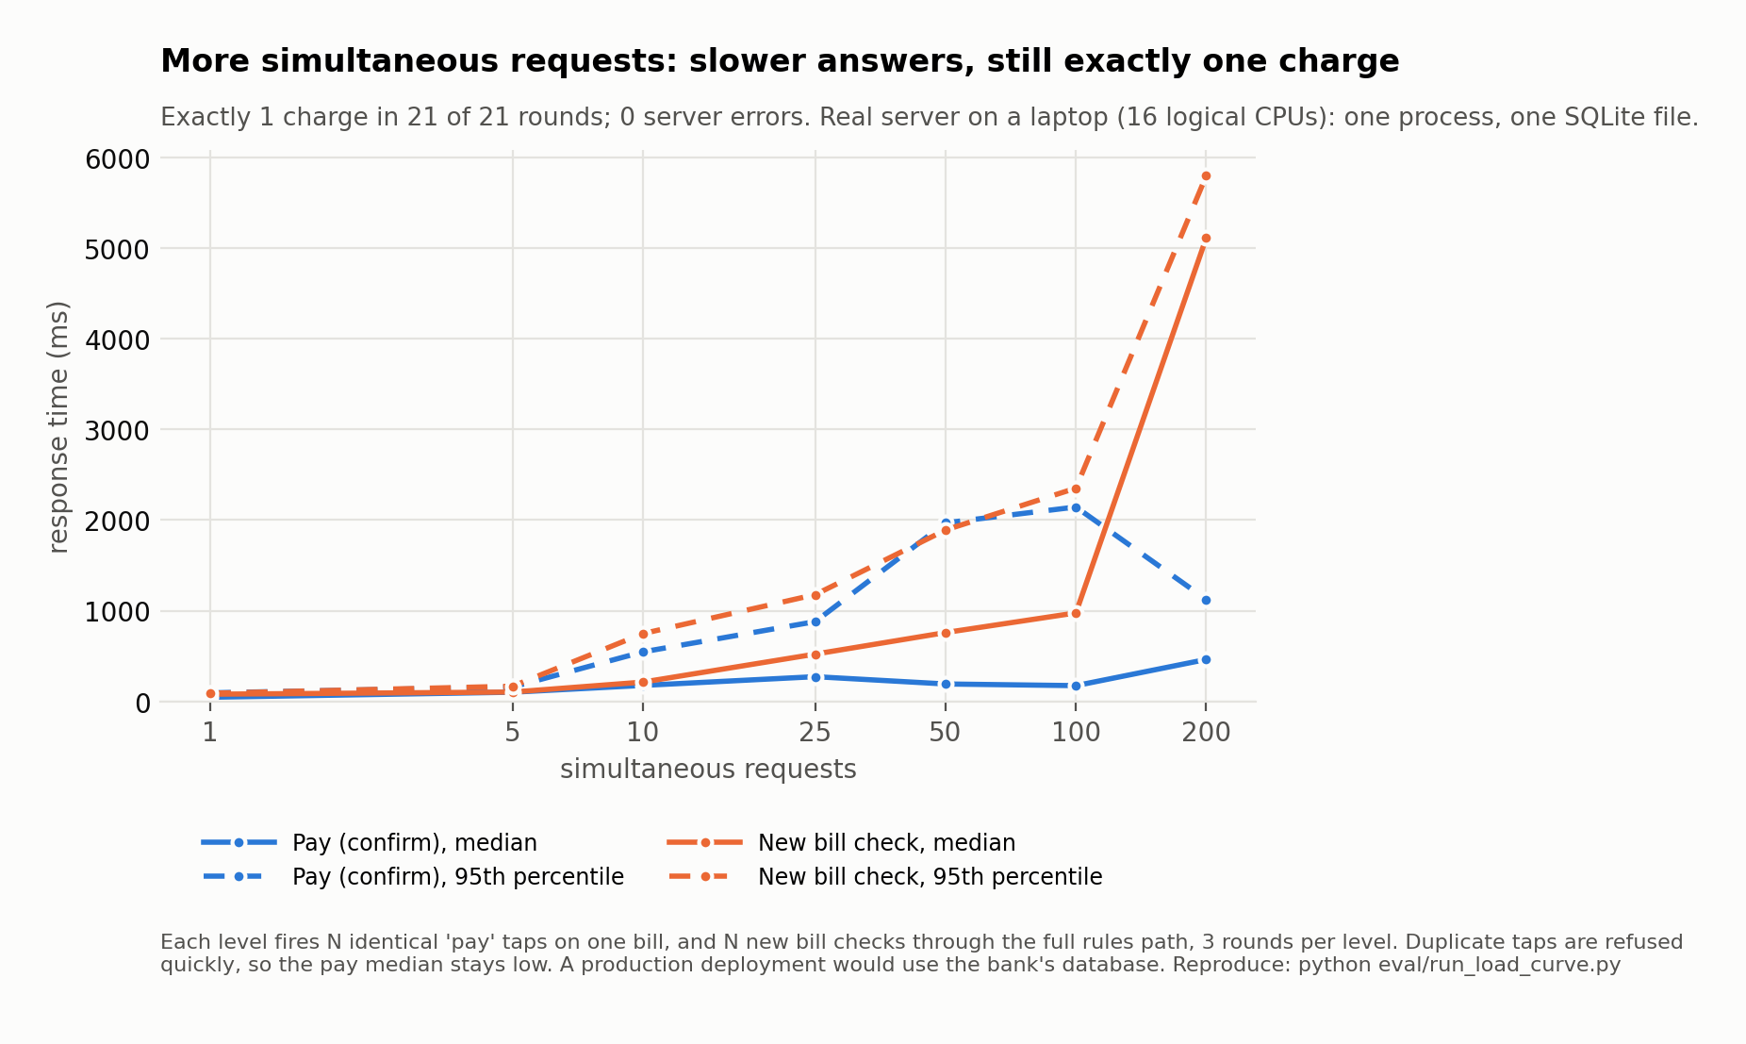

8.3 Randomised attack test (Monte Carlo)
python eval/run_invariant_fuzz.py drives the real app with 200 random sequences of 50 actions each (fixed seed 2026, AI off). Each sequence starts from a reset and mixes:
- New requests with random payees, amounts (including every threshold edge) and text, including scam phrases hidden with zero-width characters
- Taps and voice words; the son's approvals with right and wrong PINs
- Simultaneous bursts of 2–8 confirms or approvals
- Cancels, "Call Mum", scam reports and pay later
- Requests that also carry a different amount or payee
- Jumps forward in time, so timers run out
After every action, 11 safety rules are checked directly against the database.
Safety rule | Broken
Never charged twice for one request | 0
Blocked requests are never paid | 0
The amount and payee paid are the ones stored at creation | 0
Balance always equals opening balance minus payments | 0
A review payment needs the son's right PIN | 0
Her own payments: safe or acknowledged-warning bills only | 0
Never paid to the son's own account | 0
Nothing is paid after its deadline | 0
A finished request never changes again | 0
Every payment is in the audit log | 0
The audit log only grows | 0
Result: 10,000 actions, 110,000 checks, 412 legitimate payments, 0 rules broken, 0 server errors.
Self-check: the test was re-run with two safeguards deliberately switched off (--break pin accepts any PIN; --break self_approval lets the son approve his own account). Both runs reported violations (1 and 40), so the test does detect a broken safeguard.
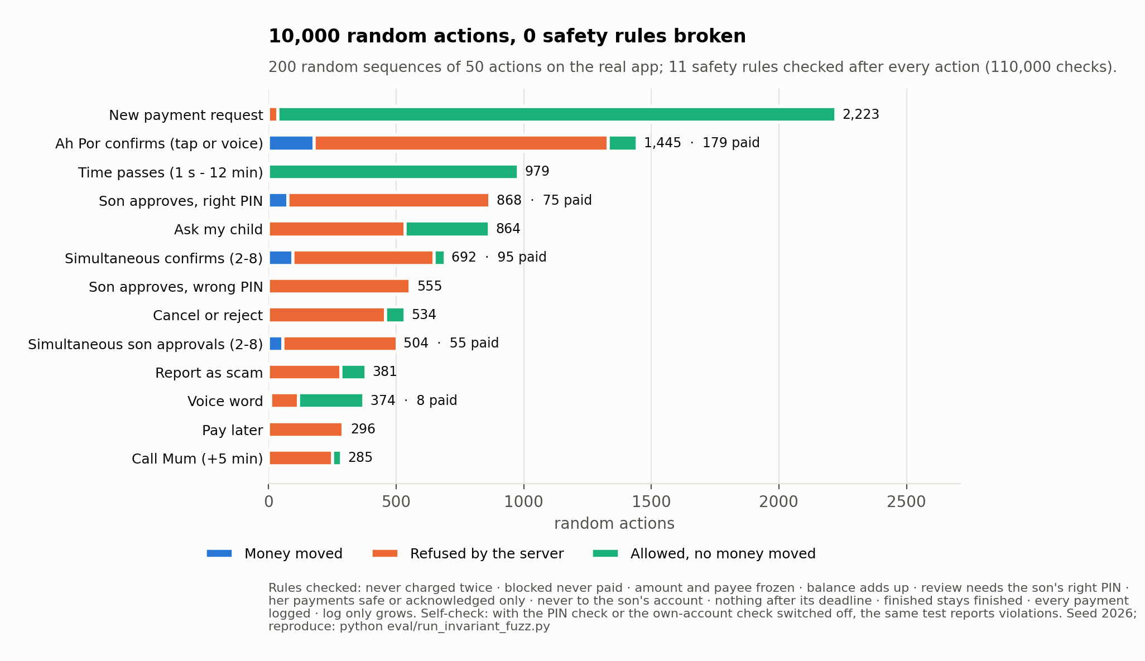

8.4 Execution evidence
python scripts/run_execution_evidence.py starts the real server on a fresh database and drives every demo scenario over HTTP, using real OCR on the demo photos. It saves the audit log export and a pass/fail table. See execution_evidence/.

9. Real vs simulated, limitations and roadmap
Part | Status
Rules, risk score, decision records, budget, state machine, timers, audit log | Real code
Signed approvals and family limits | Real cryptography; demo keys held by the server
Assistant and AI scam analyst | Real Gemini calls on synthetic data
OCR, voice, read-aloud | Real (Tesseract, Whisper large-v3, edge-tts)
Shadow fraud model | Real, trained on PaySim; log-only, not validated for Malaysian bills
Bank | Simulated sandbox ledger
Push to the son's phone | Simulated: both phones share one backend on one screen
Known limitations: no login (roles fixed per endpoint); signing keys held by the server for every role; the whitelist has 2 billers; speech tested with synthetic voices, not elderly speakers; OCR tested on computer-made bill images; Cantonese templates await native-speaker review; only Cantonese is supported. Details and mitigations: Security report §9.
Roadmap: user-held keys (device secure enclave, biometric unlock) · authentication per role · bank partner integration and real biller e-bills · speech evaluation with consented recordings from elderly speakers · more billers · Hokkien and Malay · WhatsApp reminders (alerts only).

