HTML Editors

[❮ Previous](https://www.w3schools.com/html/html_intro.asp)[Next ❯](https://www.w3schools.com/html/html_basic.asp)

A simple text editor is all you need to learn HTML.

Learn HTML Using Notepad or TextEdit

Web pages can be created and modified by using professional HTML editors.

However, for learning HTML we recommend a simple text editor like Notepad (PC) or TextEdit (Mac).

We believe that using a simple text editor is a good way to learn HTML.

Follow the steps below to create your first web page with Notepad or TextEdit.

Step 1: Open Notepad (PC)

**Windows 8 or later:**

Open the **Start Screen** (the window symbol at the bottom left on your screen). Type **Notepad**.

**Windows 7 or earlier:**

Open **Start** >**Programs >** **Accessories >** **Notepad**

Step 1: Open TextEdit (Mac)

Open **Finder > Applications > TextEdit**

Also change some preferences to get the application to save files correctly. In **Preferences > Format >**choose**"Plain Text"**

Then under "Open and Save", check the box that says "Display HTML files as HTML code instead of formatted text".

**Then open a new document to place the code.**

Step 2: Write Some HTML

Write or copy the following HTML code into Notepad:

<!DOCTYPE html>  
<html>  
<body>  
  
<h1>My First Heading</h1>  
  
<p>My first paragraph.</p>  
  
</body>  
</html>

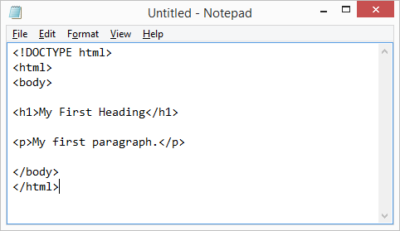

Step 3: Save the HTML Page

Save the file on your computer. Select **File > Save as** in the Notepad menu.

Name the file **"index.htm"** and set the encoding to **UTF-8** (which is the preferred encoding for HTML files).

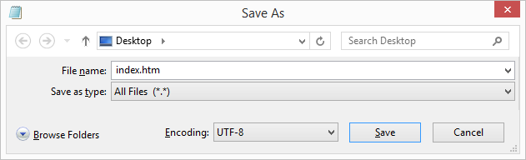

**Tip:** You can use either .htm or .html as file extension. There is no difference; it is up to you.

Step 4: View the HTML Page in Your Browser

Open the saved HTML file in your favorite browser (double click on the file, or right-click - and choose "Open with").

The result will look much like this:

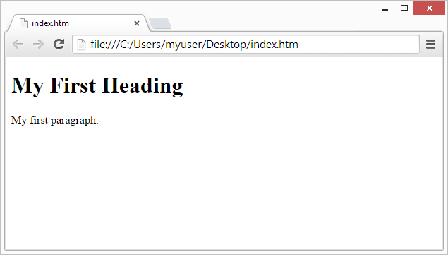

W3Schools Online Editor - "Try it Yourself"

With our free online editor, you can edit the HTML code and view the result in your browser.

It is the perfect tool when you want to **test** code fast. It also has color coding and the ability to save and share code with others:

Example

<!DOCTYPE html>  
<html>  
<head>  
<title>Page Title</title>  
</head>  
<body>  
  
<h1>This is a Heading</h1>  
<p>This is a paragraph.</p>  
  
</body>  
</html>

[Try it Yourself »](https://www.w3schools.com/html/tryit.asp?filename=tryhtml_editors)

**Click on the "Try it Yourself" button to see how it works.**

W3Schools Spaces

If you want to create your own website and save your code online, try our free **website builder**, called [**W3schools Spaces**](https://www.w3schools.com/spaces/):

**W3Schools Spaces**

Everything you need right in the browser.

[Get Started Now](https://www.w3schools.com/spaces/)  
  
