AI TEACHER
Project Documentation
AI Innovation Hackathon 2026 — Round 2 Technical Assessment
Bharat Academix
Challenge: AI Teacher — Build a Human-Like AI Educator That Teaches Through Video
Submission Links
- Working prototype: https://ai-mentor-acme-6640.vercel.app
- GitHub repository: https://github.com/2501640100693-code/AI-mentor
- Demo video:
1. Problem Statement
Most digital learning tools fall into one of two categories: pre-recorded video lectures, which cannot adapt to an individual learner, or text-based Q&A chatbots, which can answer questions but do not plan, pace, or check understanding the way a real teacher does. Neither format replicates the core behavior of human teaching — introducing a topic, explaining it progressively, checking comprehension, correcting misconceptions, and adjusting difficulty in response to how the learner is actually doing.
AI Teacher addresses this gap by combining a planning LLM, a mastery-tracking model, and video/voice generation into a single pipeline that behaves less like a chatbot and more like a personalized instructor: it plans a lesson, teaches it through a talking avatar, and produces a structured report at the end.
2. Solution Overview
A student either uploads learning material (a PDF, textbook chapter, or notes) or names a topic directly. The system extracts and processes that content, then uses Google Gemini to generate a structured, personalized lesson plan. The lesson is delivered as a video: a Tavus-rendered AI avatar speaks a Gemini-generated script, narrated with Sarvam TTS. During the lesson, the system questions the learner, checks that a concept has actually landed before moving on, and offers a different explanation when it hasn't. Each answer updates a Bayesian Knowledge Tracing (BKT) mastery estimate per concept, which drives whether the next segment is simplified, held steady, or advanced. At the end of the lesson, a report is generated from the accumulated mastery data, summarizing performance and recommending next steps.
This design is intended to avoid the two patterns the assessment brief explicitly rules out — a static video and a chatbot that only answers questions — by keeping the lesson plan, the pacing, and the difficulty of each segment driven by the learner's actual responses rather than a fixed script.
3. Key Features
- AI-generated lesson planning — lesson structure is produced by Gemini per learner/topic, not templated.
- Scored diagnostic pre-assessment — a short quiz built from the lesson's concept graph sets each concept's starting mastery estimate from the learner's actual answers, rather than a flat default.
- In-lesson adaptive questioning — wrong answers lower the BKT mastery estimate for that concept and adjust pacing; correct answers advance the learner.
- Misconception-aware re-explanation — getting the same concept wrong twice triggers a re-explanation built around a different analogy, followed by a new question, rather than repeating the same script.
- Confirm-understanding checkpoint — after a concept is taught, the learner confirms understanding before moving on, with the option to request a different explanation instead.
- Knowledge-grounded answers (RAG) — in-lesson explanations and questions are grounded in retrieved chunks of the uploaded material; the system says so explicitly rather than guessing when something falls outside that material.
- Human-like spoken delivery — every learner-facing spoken line — lesson explanations, re-explanations, grading feedback, and the report summary — is generated from prompts written for a warm, spoken-teacher voice, avoiding generic AI-assistant phrasing.
- Video-based teaching — Tavus-rendered avatar video with real script text (not a static recording) on a cache miss.
- Mastery and reporting — mastery and report calculations run against the session database, scoped per lesson, and the end-of-lesson report includes score, concepts understood, weak areas, incorrect concepts, a suggested next topic, and a plain-language summary.
- Flashcards — LLM-generated concept definitions for review.
- Concept maps — supporting visual reference material.
- Multilingual support — English and Hindi, including switching languages mid-lesson without restarting the lesson.
- Sentence-synced captions — on-screen captions advance sentence by sentence in time with the narration, rather than appearing as one static block.
- Mock/Live mode switching — a startup banner distinguishes MOCK MODE from LIVE TAVUS MODE, so development and demoing can be done safely, and the mode is never disguised as something it isn't.
4. System Architecture
Stack: FastAPI backend, Next.js frontend, SQLite for session and lesson data, Chroma as the vector store for retrieval.
Data flow
- Learner uploads material or provides a topic via the Next.js frontend.
- If a file is uploaded, the backend runs OCR (Tesseract) to extract text, which is chunked and embedded (SentenceTransformer, all-MiniLM-L6-v2) into a Chroma vector store.
- The extracted text or topic, along with retrieved chunks where relevant, is sent to Gemini, which generates a structured lesson plan.
- The lesson plan is stored in SQLite.
- The player renders the lesson: Tavus generates the avatar video from the Gemini-written script, grounded in the retrieved material, and Sarvam TTS provides narration.
- During playback, the learner answers in-lesson questions and confirms understanding at checkpoints; each answer is graded by Gemini and used to update a per-concept p_know value in the BKT model, written back to SQLite along with the last misconception and explanation used for that concept.
- The mastery state read from SQLite determines whether the next segment is simplified, repeated, or advanced.
- At the end of the lesson, the report screen reads the accumulated mastery data back out of SQLite and presents it to the learner.
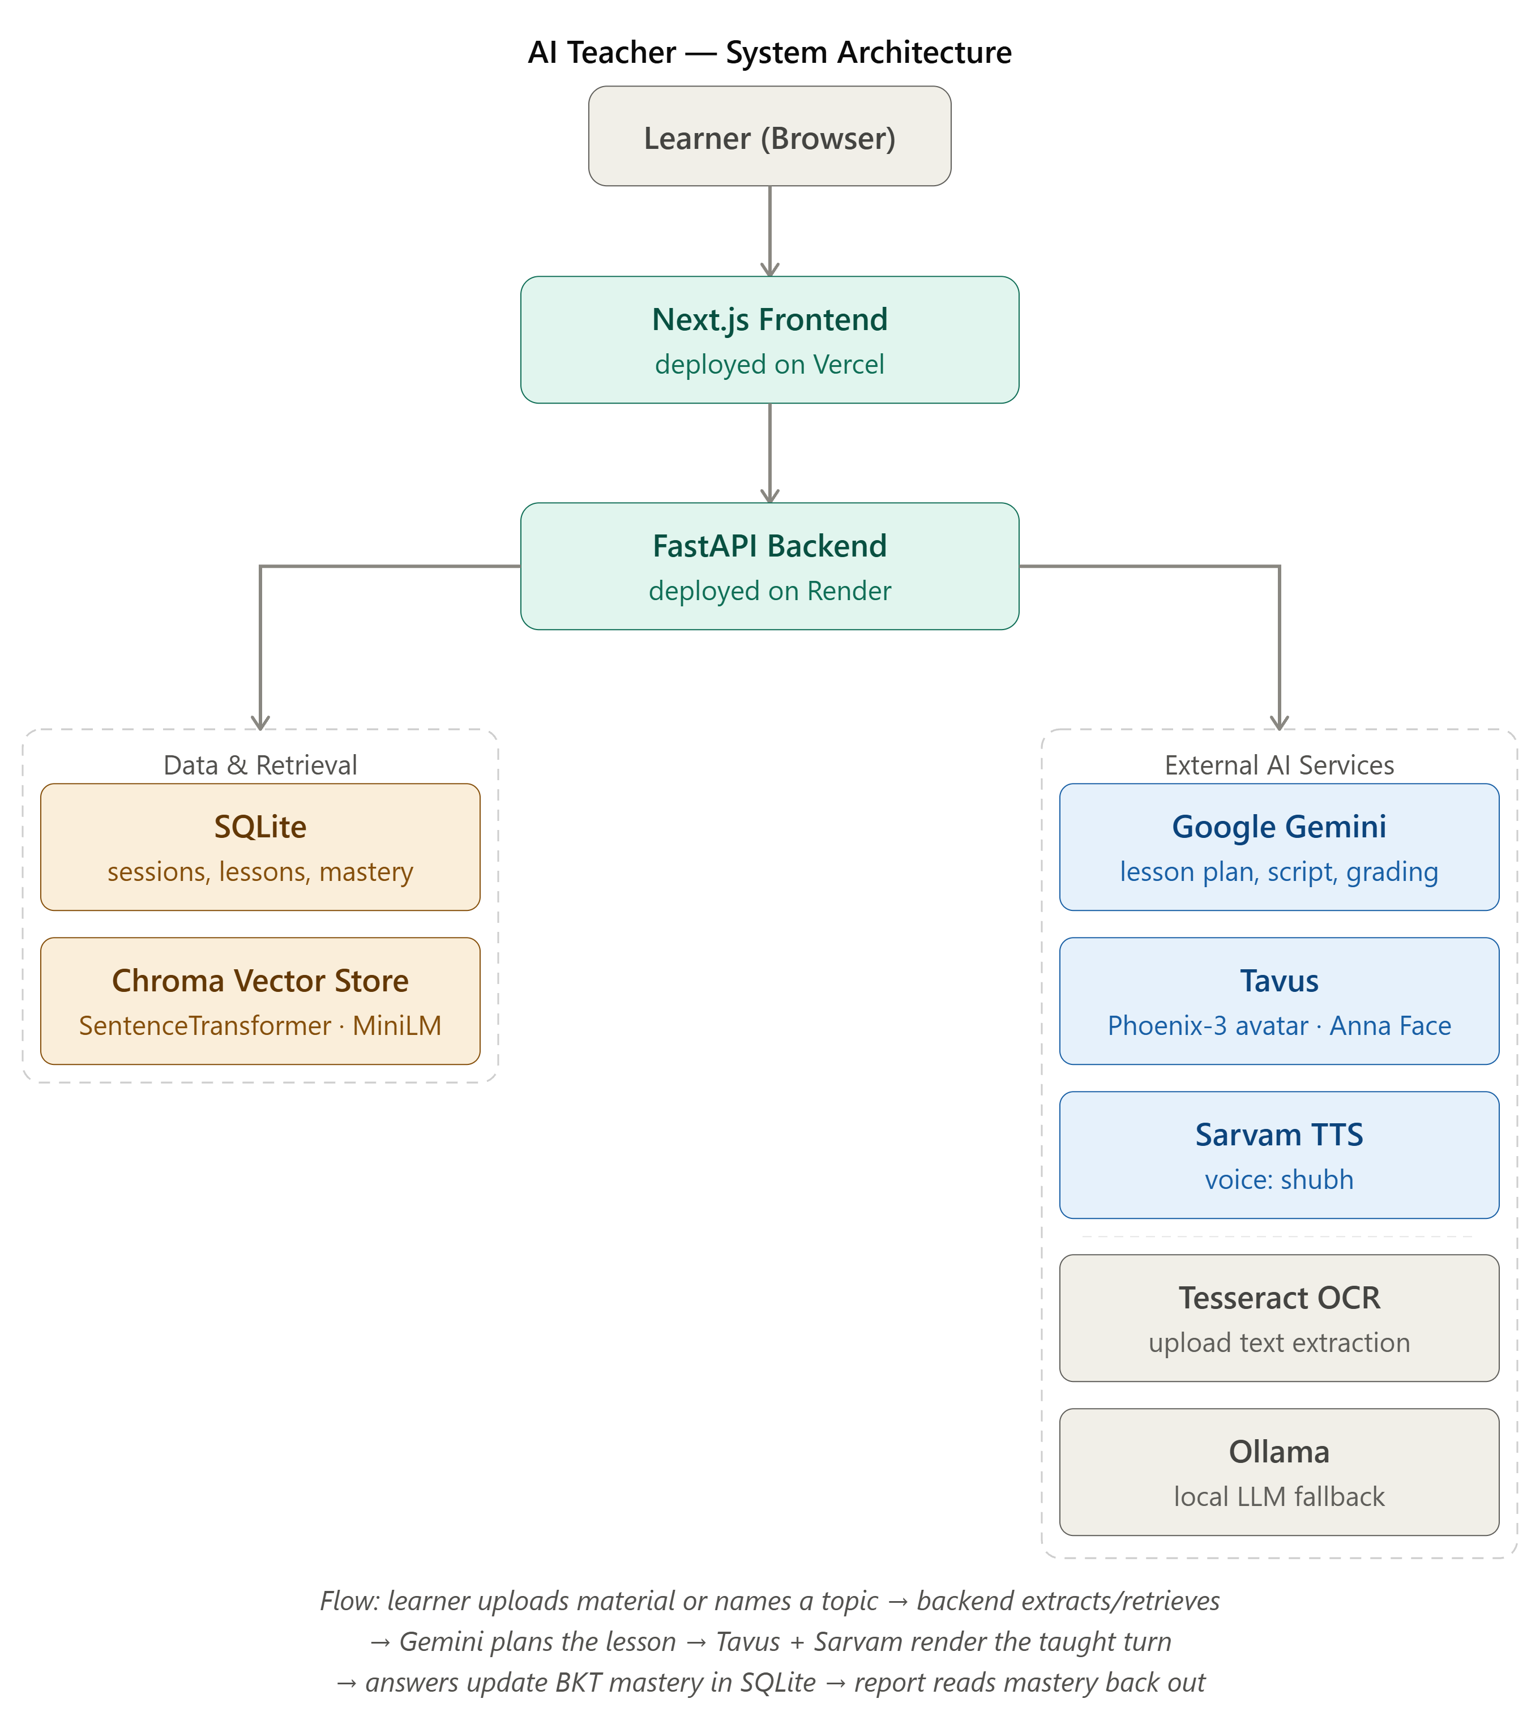
Figure 1 — AI Teacher system architecture and data flow.
5. AI/ML Models Used
- Google Gemini — primary LLM, used for lesson plan generation, per-turn script generation, and answer grading.
- SentenceTransformer (all-MiniLM-L6-v2) — embedding model used to vectorize uploaded material for retrieval; not used for text generation.
- Ollama — local fallback tier for LLM calls, used when the primary Gemini path is unavailable.
- Bayesian Knowledge Tracing (BKT) — not a generative model, but the core mastery-modeling algorithm: tracks a p_know probability per concept and updates it based on right/wrong answers, driving difficulty adaptation.
A Claude/Anthropic API key is present in the configuration but is optional and not currently used in the live pipeline.
6. RAG Implementation
Uploaded material is chunked and embedded using SentenceTransformer (all-MiniLM-L6-v2) into a Chroma vector store. At generation time, the system retrieves the chunks relevant to the current concept and grounds both the explanation and any in-lesson questions in that retrieved content, rather than inserting the full extracted text into the prompt.
A fail-closed guard ensures the system never presents an unverified answer as fact: if claim verification fails for any reason, or if retrieval returns no relevant chunks for a question, the system responds that the answer isn't in the uploaded material rather than generating one anyway.
7. Agent Architecture
Gemini is invoked as several separate, purpose-specific calls rather than one general-purpose prompt:
- Lesson plan generation — given the topic or extracted material plus learner preferences (level, time available, language), produces a structured lesson plan.
- Per-turn script generation — generates the spoken script for each lesson segment as the learner progresses.
- Answer grading — evaluates the learner's response to an in-lesson question and returns a correctness judgment that feeds the BKT update.
- Misconception-targeted re-explanation — when a concept is answered wrong twice, a separate adapt prompt is instructed to use a different analogy than the prior explanation and target the specific misconception, rather than repeating the same script.
Prompts behind learner-facing spoken content — lesson explanations, re-explanations, grading feedback, and the report summary — are written to sound like a teacher speaking in the room: warm and conversational, avoiding stiff AI-assistant phrasing. Prompts that produce structured data rather than spoken content — the concept graph, curriculum JSON, visual SVG/LaTeX, the hallucination check, and question-generation JSON — are intentionally left in a more formal style, since that instruction concerns what the avatar and report say to the learner, not internal structured output.
8. Personalization Approach
Personalization operates on two levels. A diagnostic pre-assessment presents real questions built from the concept graph before the lesson begins; each answer sets an initial p_know of 0.6 (correct) or 0.2 (incorrect) for that concept, so the lesson starts from an estimate of the learner's actual prior knowledge rather than a flat default. From there, in-lesson BKT updates continue to adjust each concept's p_know as the lesson proceeds, adjusting difficulty in response to real-time answers.
Profile seeding extends this across sessions: the diagnostic loads the learner's saved profile from a prior session, matches prior mastery onto the new lesson's concepts by name, and appends one review concept drawn from previously weak areas if it isn't already covered.
9. Assessment Methodology
In-lesson questions (conceptual and short-answer) are generated during the lesson and graded by Gemini; each grading result feeds the BKT mastery update for the relevant concept. At the end of the lesson, a report is generated from the accumulated mastery data.
Status: all six fields from the assessment brief's example report are implemented — score, concepts understood, weak areas, incorrect concepts, a recommended-revision/suggested-next-topic field, and a short plain-language summary — and rendered on the report page.
10. Multilingual Implementation
English and Hindi are currently supported.
Status: mid-lesson language switching is supported — selecting a new language from the in-lesson dropdown applies to the next turn's script and narration without restarting the lesson or losing progress. This is a per-turn override rather than a change to the stored lesson language.
Tavus's API has no native language parameter, so language reaches the avatar indirectly, through the generated script text and the render cache key.
11. Voice Implementation
Narration uses Sarvam TTS with a fixed speaker voice ("shubh"). On a Tavus cache miss or fallback scenario, the system falls back to a loop video with Sarvam audio played separately, rather than audio baked directly into an avatar render.
12. Avatar/Video Generation Approach
The avatar is built on Tavus, using a Phoenix-3 replica with the stock Tavus "Anna" Face (free tier, no custom training). It runs in prerendered/broadcast mode by default — not Tavus's live reactive/conversational mode.
Technical nuance: renders are cached by a key of {concept_id}:main:{language}:{level}. This means revisiting a concept reuses its first-rendered clip even if the underlying script text has since changed.
13. APIs and Third-Party Services Used
- Google Gemini — LLM for lesson planning, script generation, and grading.
- Tavus — AI avatar video generation (Phoenix-3 replica, "Anna" Face).
- Sarvam TTS — text-to-speech narration.
- Tesseract OCR — text extraction from uploaded material.
- Chroma — vector database storing embedded chunks of uploaded material, used for retrieval-grounded generation.
- Ollama — local LLM fallback tier.
An Anthropic/Claude API key is configured but currently unused in the live pipeline — included here for transparency.
14. Setup Instructions
Prerequisites (Windows 11, no WSL required):
- Python 3.11
- Node.js LTS
- Git
- Tesseract OCR with Hindi language data (UB Mannheim installer); set TESSERACT_CMD if not on PATH
- Ollama, with ollama pull qwen2.5:7b, for the local LLM fallback tier (optional)
- Note: the first pip install pulls PyTorch via sentence-transformers (a large download); embeddings run CPU-only
Backend setup (local):
- Create and activate a Python virtual environment
- Install backend dependencies
- Copy .env.example to .env and fill in API keys
- Run uvicorn app.main:app --reload for local development (Render runs the same entrypoint as uvicorn app.main:app --host 0.0.0.0 --port $PORT)
Frontend setup (local):
- cd frontend && npm install
- Copy .env.local.example to .env.local, or set NEXT_PUBLIC_API_URL to the backend URL directly
- npm run dev
Environment variables the running application actually reads:
Backend (Render):
- GEMINI_API_KEY — required for live LLM output
- GEMINI_MODEL — defaults to gemini-3.5-flash-lite
- ANTHROPIC_API_KEY — optional Claude tier; that tier is skipped if omitted
- LOCAL_LLM_MODEL — defaults to qwen2.5:7b (Ollama fallback; unused without Ollama available)
- TAVUS_API_KEY, TAVUS_AVATAR_ID, TAVUS_PERSONA_ID — persona ID is optional, created once
- SARVAM_API_KEY
- MOCK_LLM, MOCK_VIDEO, FORCE_FALLBACK — set to false for a live demo
- FRONTEND_URL — the deployed Vercel origin, required for CORS
- PIPER_VOICE_PATH — only needed if Piper voice files are present on the host
- TESSERACT_CMD — Windows local development only; left empty on Render
Frontend (Vercel):
- NEXT_PUBLIC_API_URL — the deployed Render backend URL, no trailing slash
- NEXT_PUBLIC_USE_MOCK — false for a real backend
A separate README.md in the repository root documents this same setup in a narrative, first-person format for a developer cloning the repository; this section summarizes the same information for the documentation package.
Database: SQLite requires no separate server. A migration (ALTER TABLE) adding the session_meta_json column was applied as part of round 2; this is required for any database file created before that change.
15. Deployment Instructions
The backend is deployed on Render (free-tier web service) and the frontend on Vercel.
- Backend — FastAPI service deployed as a Render web service, started with uvicorn app.main:app --host 0.0.0.0 --port $PORT. Environment variables are set directly in Render's dashboard, since .env is not committed to the repository.
- Frontend — Next.js app deployed on Vercel, with NEXT_PUBLIC_API_URL pointing at the Render backend URL.
Known limitation: Render's free tier spins down a web service after 15 minutes without traffic, and the next request takes roughly 30–60 seconds to wake it back up. The free tier also has an ephemeral filesystem, meaning locally stored data — including the SQLite database used for sessions — is not guaranteed to persist across restarts or redeploys.
16. Known Limitations
- Login is a UI gate only. Any email/password combination is accepted; there is no real account system behind it.
- The flashcards' "I know this" button is not spaced repetition. It performs a local index increment rather than scheduling review based on a spaced-repetition algorithm.
- The /quiz route is dead and redirects to /player.
- Multilingual coverage is limited to English and Hindi, and language reaches the Tavus avatar only indirectly (through script text and the render cache key), since Tavus has no native language parameter.
- Render's free-tier hosting spins down after 15 minutes of inactivity and has an ephemeral filesystem, so SQLite-backed session data is not guaranteed to persist indefinitely in production. See Section 15.
17. Conclusion
AI Teacher combines a planning LLM, a knowledge-grounded retrieval pipeline, a Bayesian mastery model, and video/voice generation into a single lesson experience that plans, teaches, checks understanding, and adapts to the learner in real time — going beyond both a static video lecture and a Q&A chatbot. The current build supports the full loop end to end: upload or topic entry, personalized lesson planning, video-based teaching with adaptive difficulty, misconception-aware re-explanation, bilingual delivery, and a structured end-of-lesson report. The limitations noted above are scoped, disclosed trade-offs rather than gaps in the core teaching loop the brief asks for.

