Expense Reimbursement System

# Executive Summary

The Expense Reimbursement System (ERS) will manage the process of reimbursing employees for expenses incurred while on company time. All employees in the company can login and submit requests for reimbursement and view their past tickets and pending requests. Finance managers can log in and view all reimbursement requests and past history for all employees in the company. Finance managers are authorized to approve and deny requests for expense reimbursement.

**State-chart Diagram (Reimbursement Statuses)**

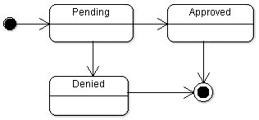

**Reimbursement Types**

Employees must select the type of reimbursement as: LODGING, TRAVEL, FOOD, or OTHER(you can get creative here).

**Logical Model**

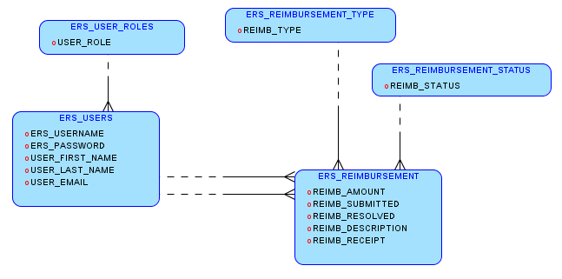

**Physical Model**

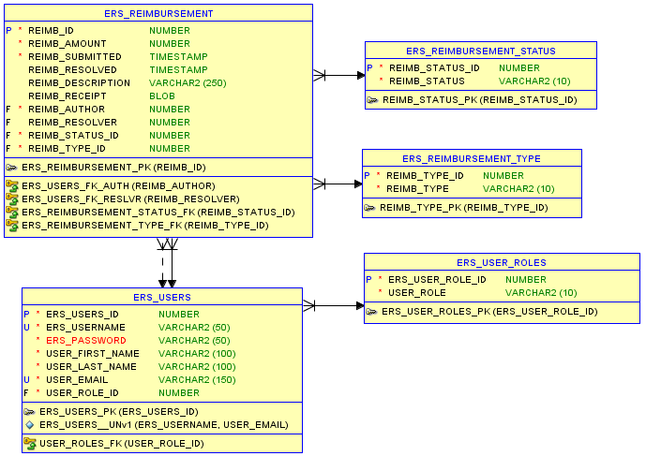

**Use Case Diagram**

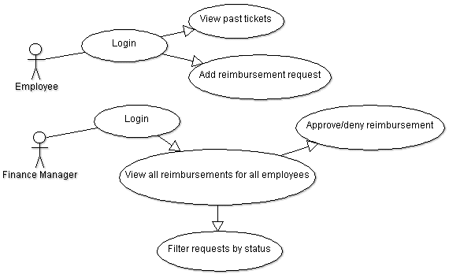

**Activity Diagram**

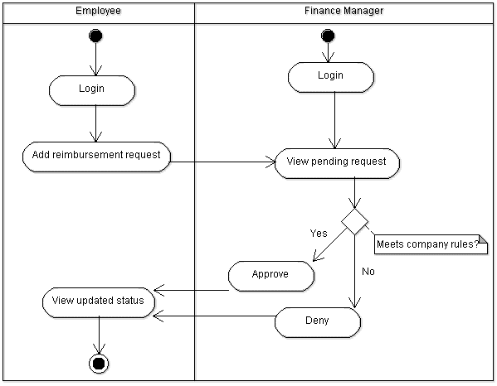

# Technical Requirements

* The application shall employ the DAO design pattern, and properly separate your code into the appropriate layers
* The back-end system shall use **JDBC** to connect to a database.
  + Use at least one of each of our three statements – Statement, PreparedStatement, and CallableStatement
* The application shall deploy onto Tomcat Server
* The middle tier shall use Servlet technology for dynamic Web application development
* The front-end view can use JavaScript/jQuery with AJAX to make a single page application that uses AJAX to call server-side components
* Use Log4J
* Passwords shall be encrypted(optional) in Java and securely stored in the database
* Users can upload a document or image of their receipt when submitting reimbursements(optional)
* The application will send an email to employees letting them know that they have been registered as a new user, giving them their temporary password(optional)

## Important/Related Dates

* 3/21: Project 1 Assignment
* 4/1: Tentative date for p1 presentations