GitHub Repository and Figma Prototype Assignment
Name: Parmar Darshak
Enrollment Number: 2502031030053
Subject: WT
Assignment: 1

Assignment 1 – Task 1: Create Git Repository
Step 1: Open the GitHub website and log in to your account.
Step 2: Click on the 'New Repository' button.
Step 3: Enter your Enrollment Number as the repository name.
Step 4: Click on 'Create Repository'.
Step 5: In the repository, click 'Add File' → 'Create new file'.
Step 6: Create a folder named 'Assignment_1' by typing: Assignment_1/readme.txt and commit the file.
Step 7: Similarly create another folder named 'Assignment_2' by typing: Assignment_2/readme.txt and commit the file.
Step 8: Check that both folders are created successfully in the repository.
Step 9: Copy the repository link for submission.

Assignment 1 – Task 2: Figma Website Prototype
Step 1: Open the Figma website and log in.
Step 2: Create a new design file.
Step 3: Design a website prototype with at least 8–10 screens.
Step 4: Example screens: Home Page, Login Page, Signup Page, Product Page, Cart Page, Contact Page, About Page, Checkout Page.
Step 5: Take screenshots of each screen after completing the design.
Step 6: Save the screenshots in image format.
Step 7: Upload all the screen images to the 'Assignment_1' folder in the GitHub repository.

Assignment 2 – Website Development
Step 1: Develop a website using HTML and CSS based on the Figma prototype screens.
Step 2: Create separate HTML files for different pages such as index.html, login.html, signup.html, cart.html etc.
Step 3: Create a CSS file (style.css) to design the website layout and style.
Step 4: Test the website in a browser to ensure all pages work correctly.
Step 5: Upload all website code files into the 'Assignment_2' folder in the GitHub repository.

Home page.

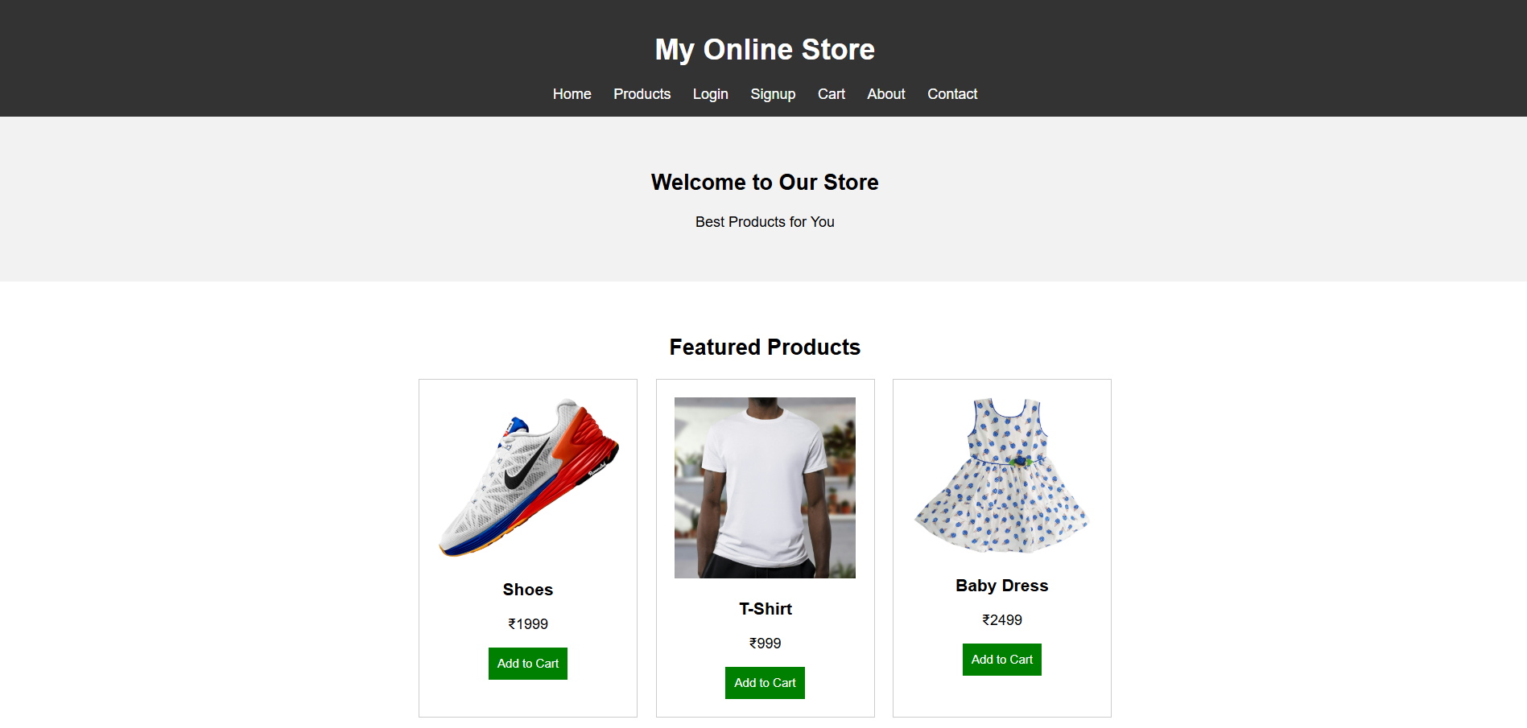

Product Page

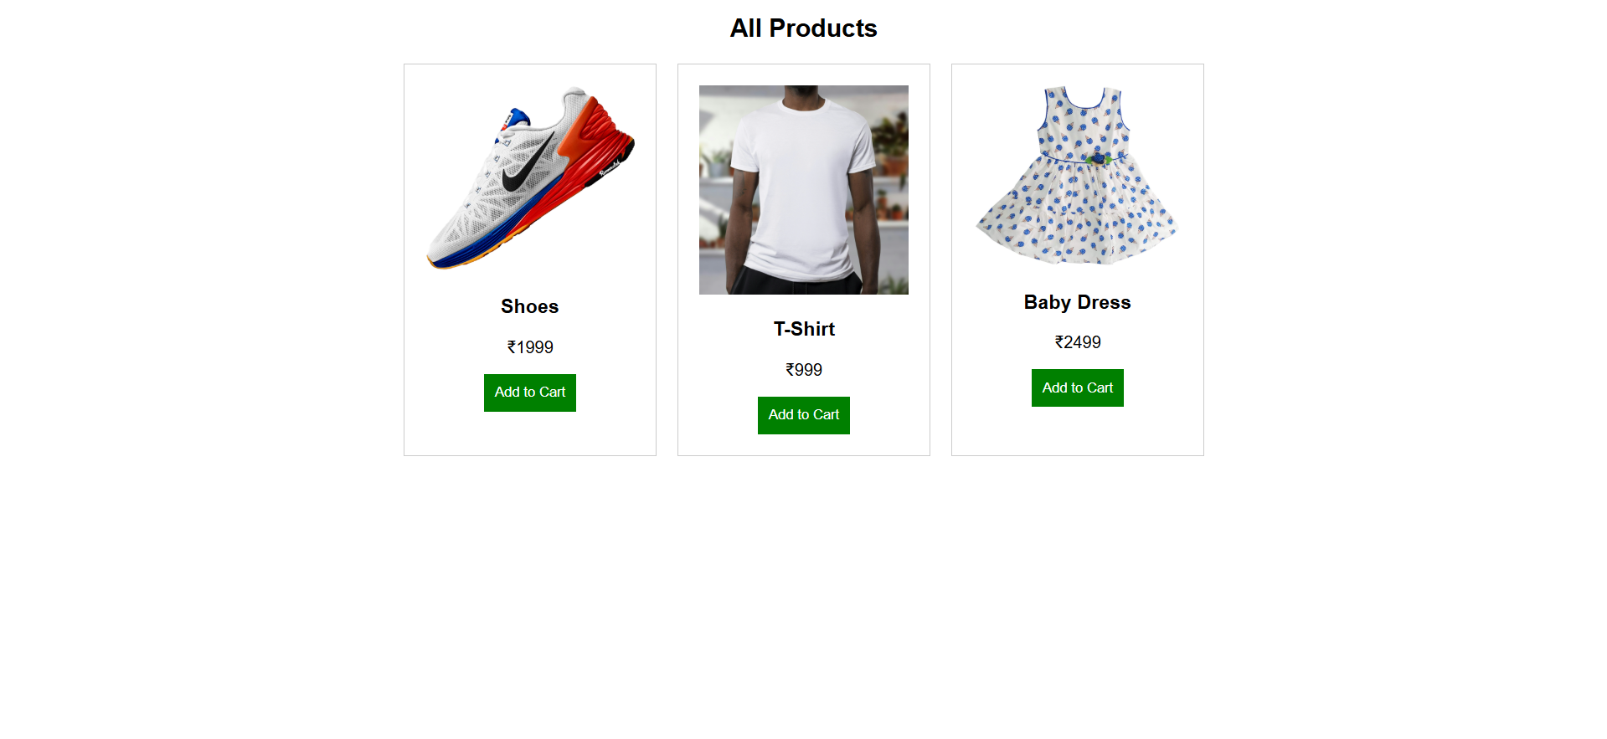

Login Page

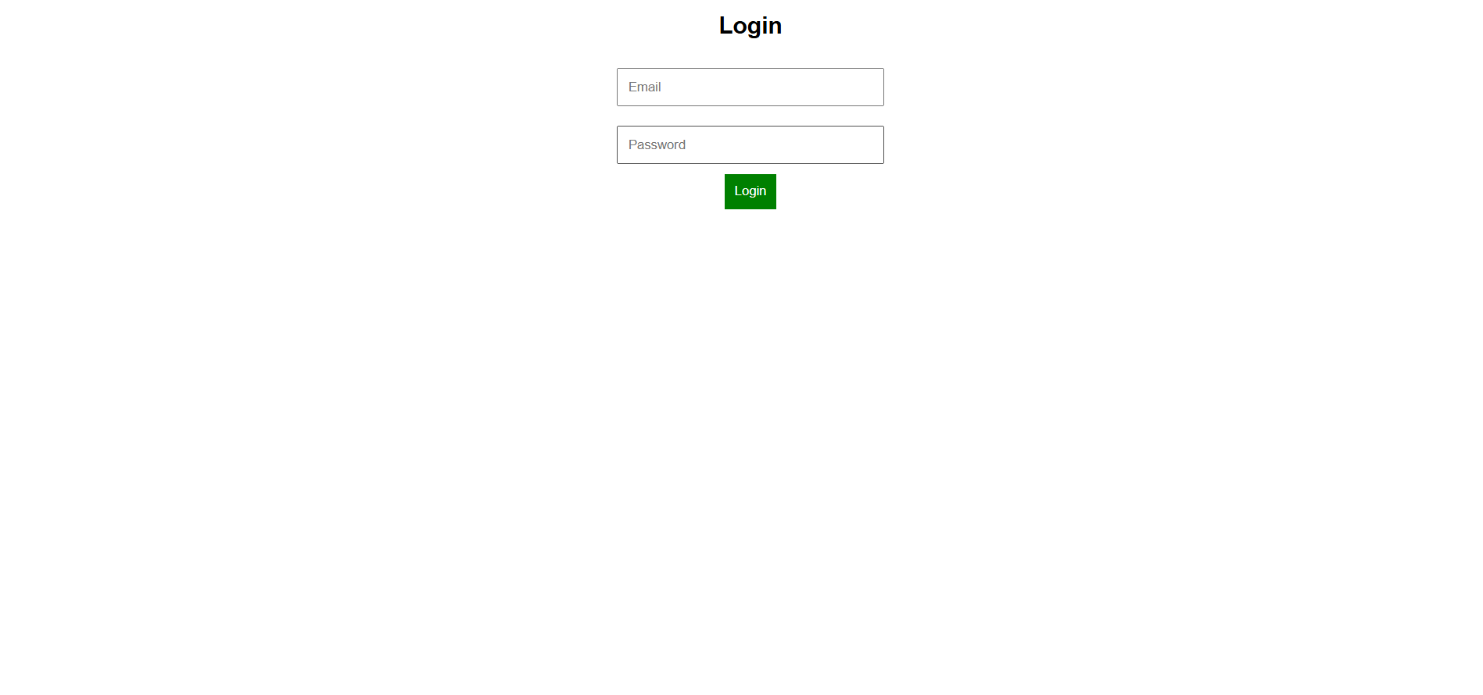

Signup Page

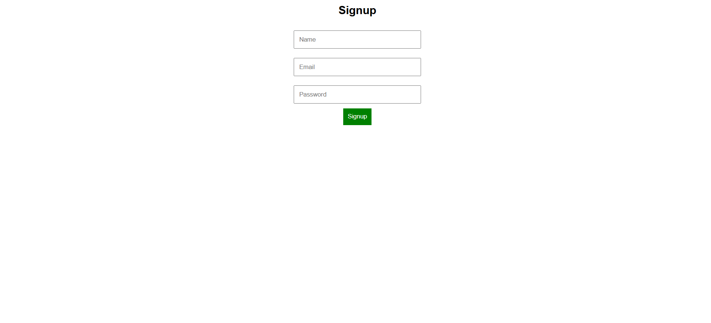

Cart Page

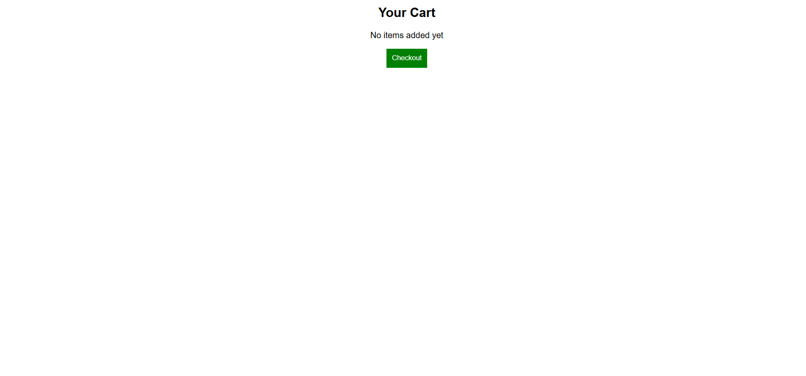

About Page

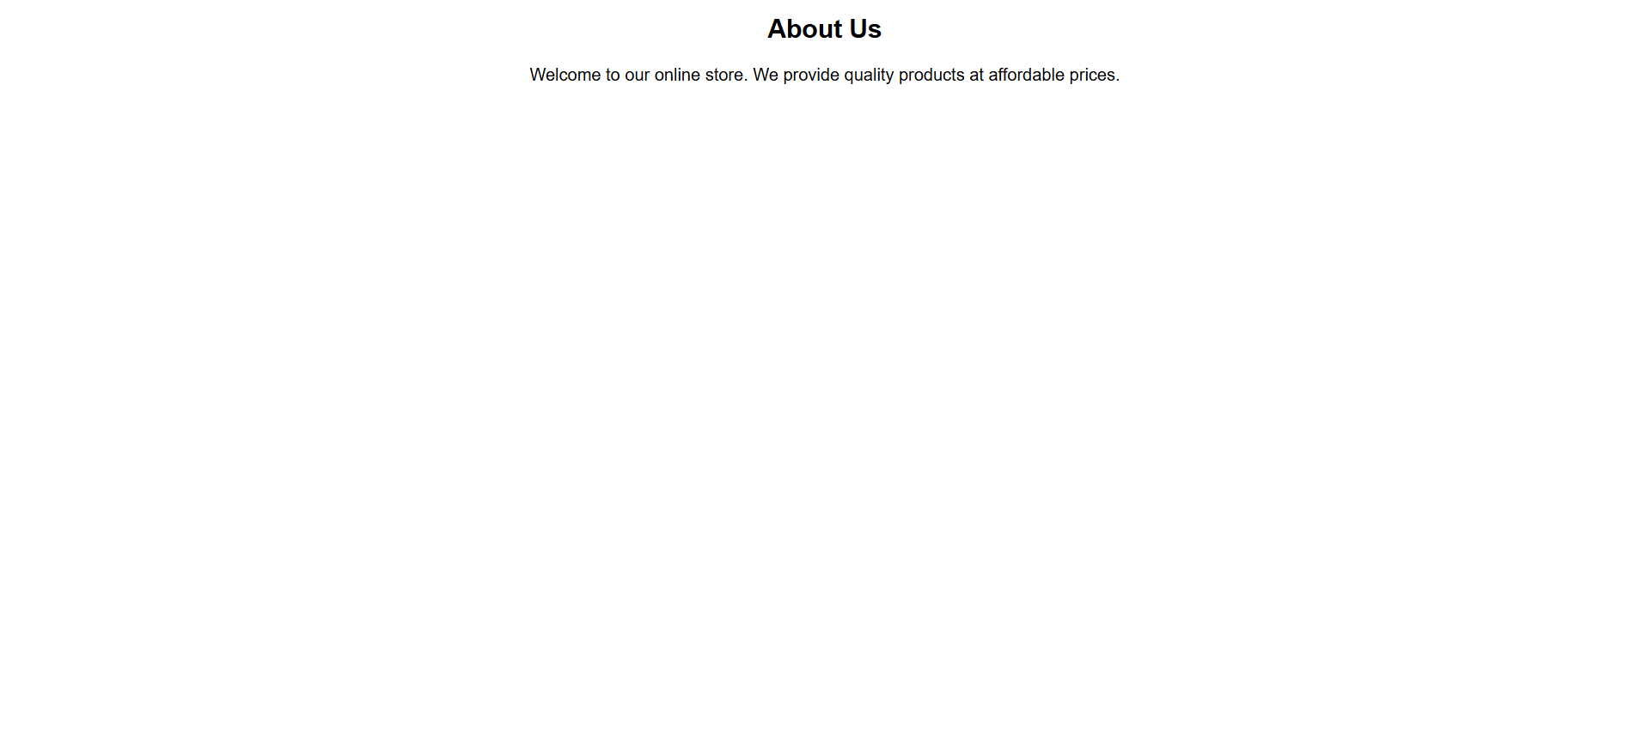

Contact Page

