Homework #3

Task#1

Create a multiplayer fighting JavaScript Canvas game.

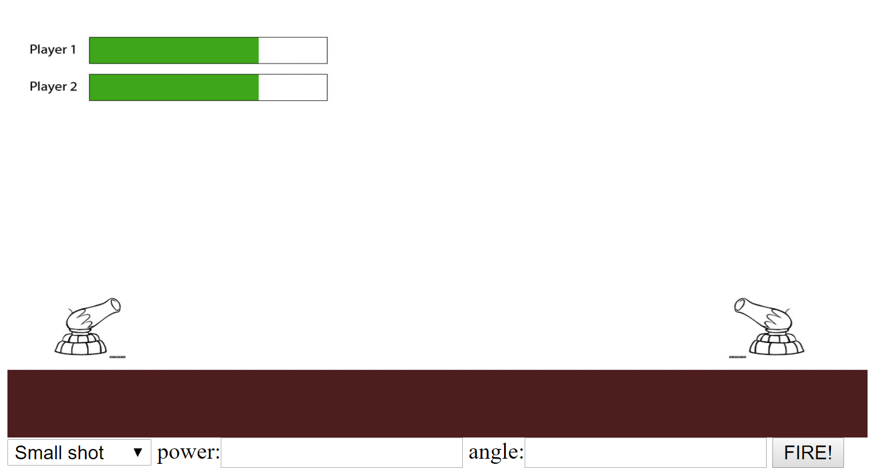

Requirements:

1. Each player has 5 Small, 3 medium and 1 big projectile.

2. Each players health equal to 1 big, 3 medium or 5 small shots. If the player gets hit by the projectile, depending on the projectile damage the health bar should lower.

3. Small, Big, Medium projectiles has different mass, speed and size.

4. Each player has his/her own turn.

5. Use JavaScript object programming.

Task#2

Create a JavaScript Canvas snake game.

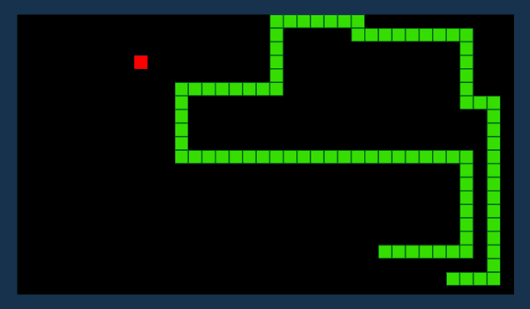

Requirements:

1. Do not use internet source. However, you can get the idea from it. (Leo knows every example from the internet so be careful).

2. Use java object programming.