Homework #1

Task#1

Create a HTML webpage with following view. 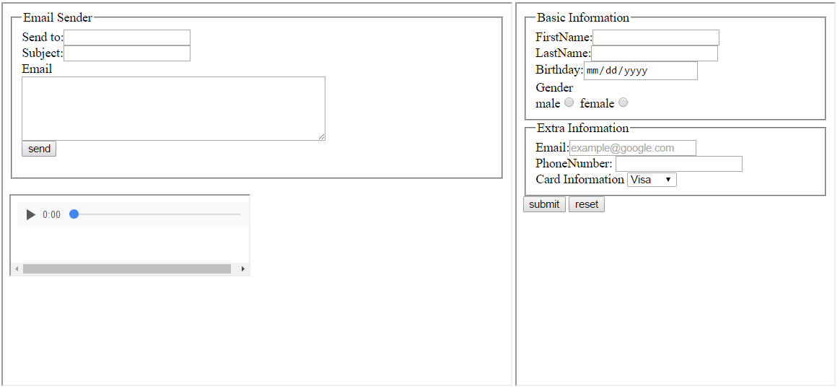

Requirement:

1. All the input fields are **required**.

2. Audio should play if you press play button.

3. Inside of this web page, there are 3 iframes.

4. PhoneNumber has pattern (###-####-####)

5. Send to and Email input field has email type.

Task#2

Create a HTML web page with following view

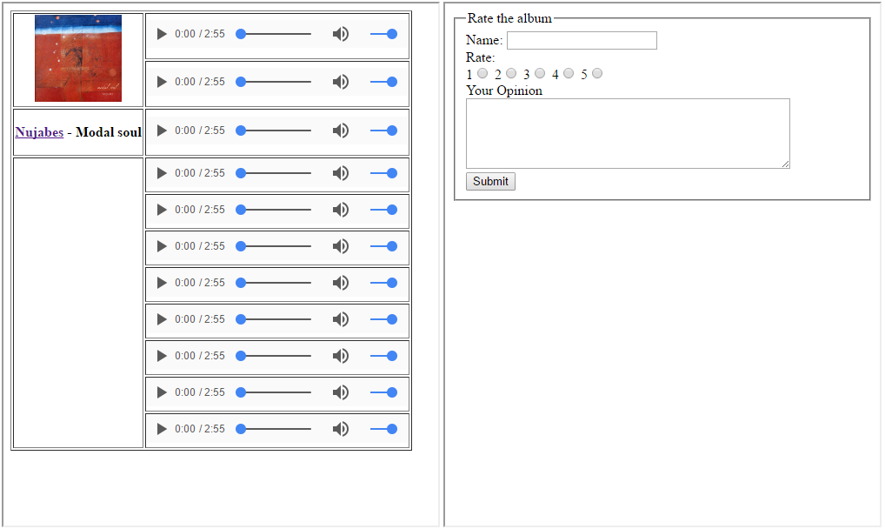

1. Audio does **not have** auto play

2. The name of the artist is a **link**. It leads to new tab on your browser.

3. All input fields are required.

The **link** leads to following web page.

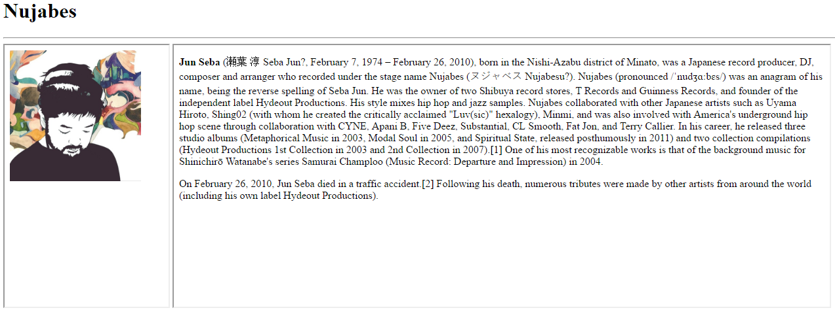

1. This view should include the picture of the artist on left and description on right.