
Assignment-04 | CLO-4
Project Implementation Report
for
Smart Inventory Sales Management System
A Web-Based Inventory and Sales Management Solution

Student Name 1: | Muhammad Anas
Registration No. (S1): | 2502886
Student Name 2: | Muhammad Kashif
Registration No. (S2): | 2501601
Degree Program: | Bachelor of Science in Software Engineering (BSSE)
Semester / Section: | 2nd semester | BSSE-2-A
Subject / Course Code: | Software Engineering Concepts | SE101
Assignment Number: | Assignment-04
Supervisor: | Dr. Zulfiqar Ali
University: | AIR University, Islamabad, Pakistan

Table of Contents
Section | Title | Page
1 | Introduction | 2
2 | Project Overview | 2
3 | Selected Modules for Implementation | 3
4 | Figma UI Design and Prototype | 3
5 | Frontend Implementation | 6
6 | Backend and Database Implementation | 6
7 | Major Module Implementation - Product Management | 7
8 | Minor Module Implementation - Low Stock Alert System | 8
9 | Implementation Screenshots and Evidence | 9
10 | GitHub Repository Links | 9
11 | YouTube Demonstration Video | 9
12 | Project Implementation Guidelines | 10
13 | Challenges Faced and Solutions | 10
14 | Future Improvements | 11
15 | Conclusion | 11
16 | References | 11

1. Introduction
The Smart Inventory Sales Management System (SISMS) is a web-based software application designed to help small and medium-sized businesses manage products, suppliers, stock levels, sales transactions, invoices, and business reports through one centralized platform. This Assignment-04 report presents the implementation phase of the project according to CLO-4 requirements.
The purpose of this document is to describe the user interface design, frontend development, backend development, database design, implemented modules, GitHub submission links, YouTube demonstration link, and implementation guidelines. The report focuses on two modules: one major module and one minor module, as required in the assignment instructions.

2. Project Overview
Item | Description
Project Name | Smart Inventory Sales Management System (SISMS)
Project Type | Web-Based Inventory and Sales Management System
Primary Users | Administrator, Inventory Manager, Sales Staff, and Business Owner
Development Methodology | Agile Development Model
Design Methodology | Object-Oriented Design (OOD)
Implementation Scope | Two modules: Product Management and Low Stock Alert System

2.1 Main Features of the System
- User login and role-based access control
- Product catalog management with add, update, delete, and view operations
- Inventory tracking with real-time stock quantity updates
- Supplier information management
- Sales processing and invoice generation
- Analytics dashboard for revenue and stock reports
- Low stock alerts based on minimum stock threshold

3. Selected Modules for Implementation

3.1 Major Module - Product Management
Product Management is selected as the major module because it is the core module of the inventory system. Without product records, the system cannot perform stock monitoring, sales processing, invoices, or low stock alerts.
- Add new product with category, price, quantity, and minimum stock threshold
- View all products in a searchable table
- Update product information
- Delete inactive or incorrect products
- Connect product records with inventory and alert modules

3.2 Minor Module - Low Stock Alert System
The Low Stock Alert System is selected as the minor module because it supports inventory control by notifying users when product quantity falls below the minimum stock threshold.
- Read product quantity from the database
- Compare available stock with minimum stock level
- Generate low stock warning message
- Display alert on dashboard and mobile responsive screen

3.3 Work Division
Student | Registration No. | Assigned Work
Muhammad Anas | 2502886 | Created the Figma AI prototype and designed all project screens.
Muhammad Kashif | 2501601 | Prepared the project report, documentation, and assignment formatting.

4. Figma UI Design and Prototype
The user interface design was prepared in Figma before implementation. The purpose of the UI design is to visualize the layout, navigation flow, buttons, forms, tables, dashboard cards, and mobile responsive screens before starting frontend development.

4.1 Designed Screens
Screen No. | Screen Name | Purpose
1 | Login Page | Allows authorized users to enter username and password.
2 | Dashboard | Displays total products, low stock items, sales summary, and quick navigation.
3 | Product List Page | Displays all products with search, update, and delete actions.
4 | Add Product Form | Allows admin or inventory manager to create a new product record.
5 | Edit Product Form | Allows product details to be updated.
6 | Low Stock Alert Page | Displays products whose quantity is below the minimum stock threshold.
7 | Mobile Low Stock Alert Screen | Shows alert cards in a mobile-friendly layout.

4.2 Prototype Link and PDF Export
Required Item | Link / File Name
Public Figma Prototype Link | https://market-funny-64963652.figma.site
Figma Design PDF | The user interface prototype was generated and refined using Figma AI. The generated screens were reviewed, customized, and connected through interactive navigation to demonstrate the workflow of the system.

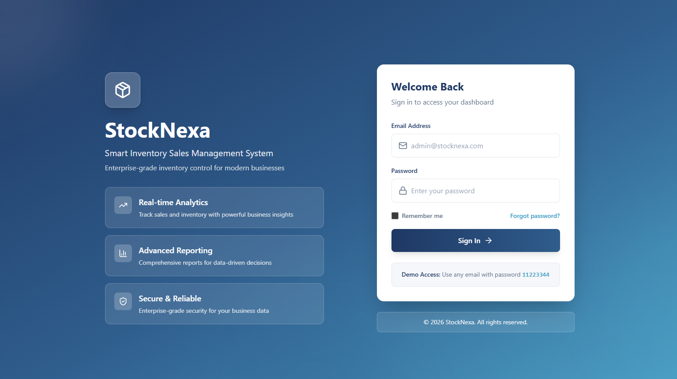

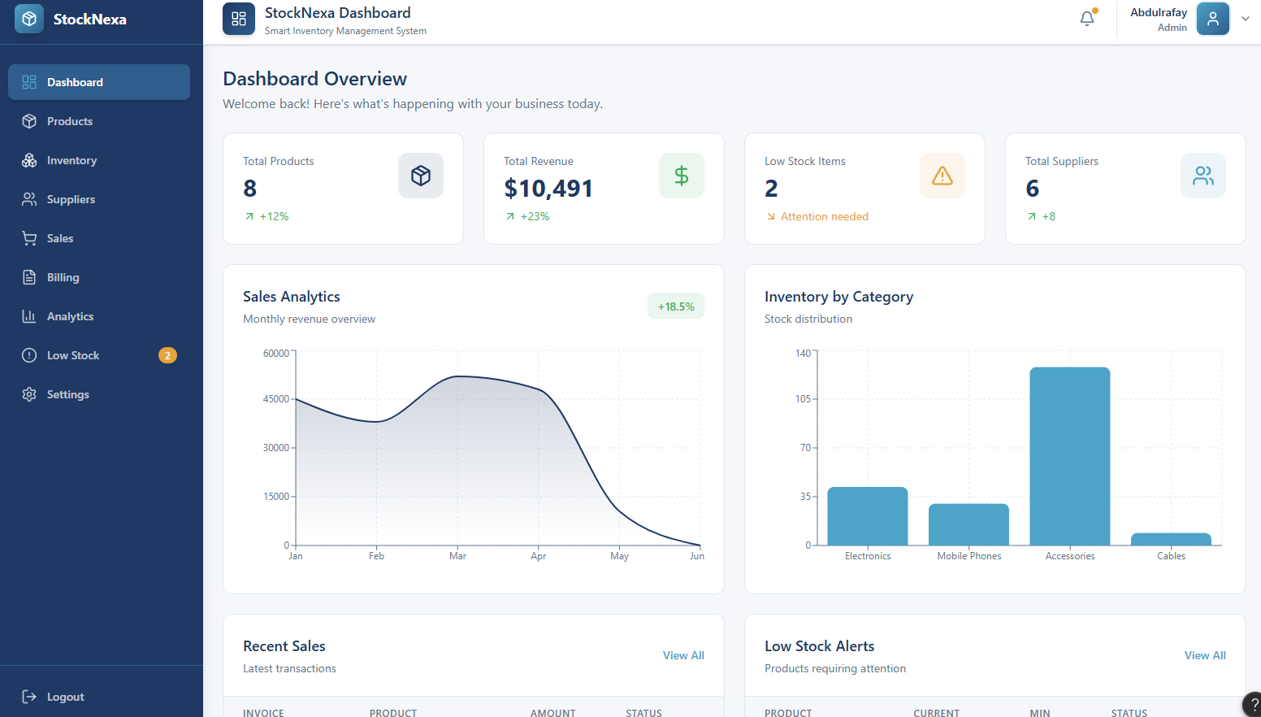

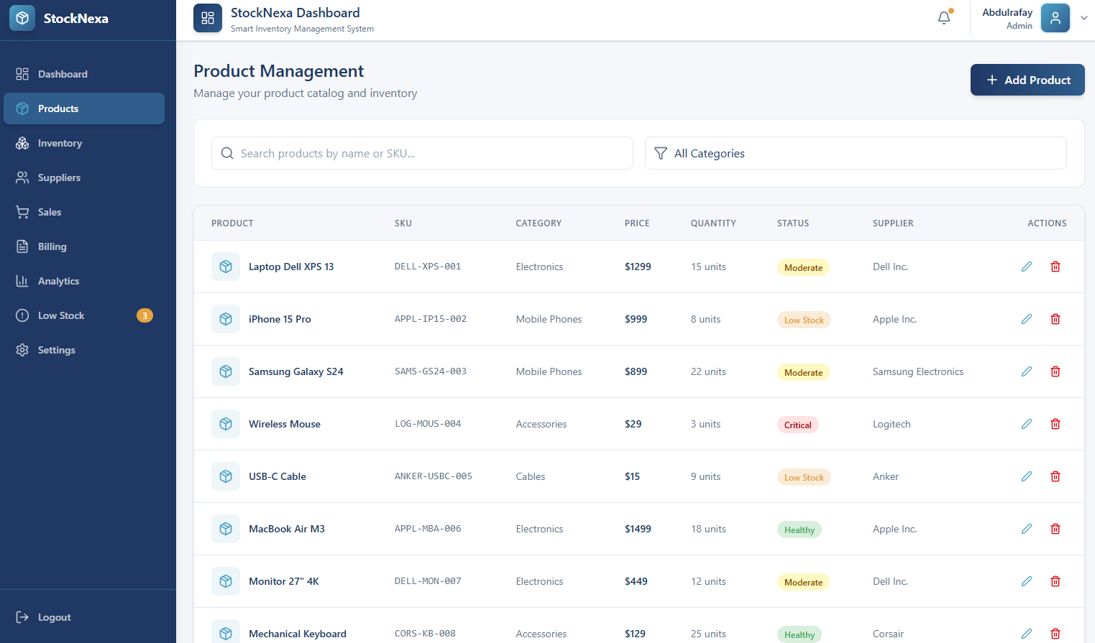

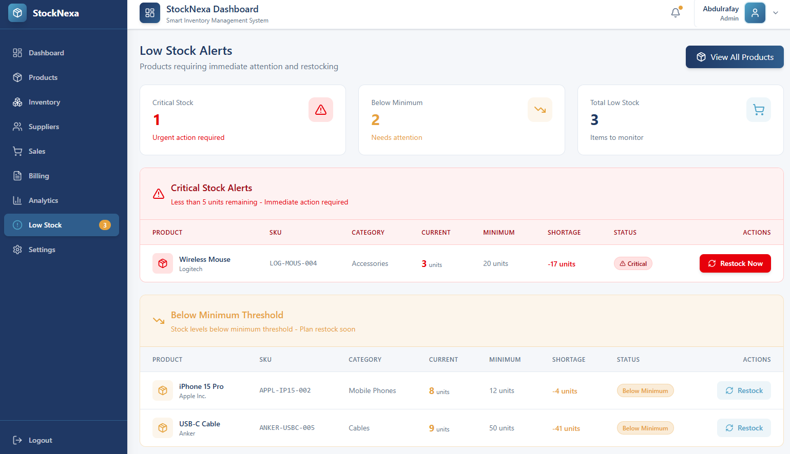

5. Frontend Implementation
The frontend prototype was designed using Figma AI. Interactive screens were connected through Figma prototyping features to demonstrate the workflow of the system. The interface is simple, responsive, and suitable for business users managing inventory, suppliers, and sales activities.

5.1 Frontend Pages Developed
Page | Main UI Components
Login Page | Username field, password field, login button, validation message
Dashboard | Sidebar, summary cards, alerts, product count, recent activity
Product Management | Product table, search bar, add button, edit button, delete button
Add Product | Input fields for product name, category, price, quantity, and minimum stock
Low Stock Alerts | Alert cards, product name, current quantity, minimum quantity, warning status
Mobile Alert View | Responsive card layout for low stock products

5.2 Frontend Design Principles
- Consistent color scheme based on professional blue and white interface
- Clear navigation sidebar for easy module access
- Readable tables for product records
- Responsive layout for desktop and mobile screens
- Simple form validation to guide the user
- Buttons and alerts designed with Bootstrap components

6. Backend and Database Implementation
The backend handles business logic, validation, database communication, and system responses. The database stores product records and generated alert data. The backend can be implemented using PHP or Python Flask depending on the selected technology stack.

6.1 Technology Stack
Layer | Technology Used | Purpose
Frontend | Figma AI | Design responsive user interface and interactive prototype
Backend | PHP / Python Flask | Handle requests, validations, and CRUD operations
Database | MySQL | Store products and alerts permanently
IDE | Visual Studio Code | Code editing and project management
Version Control | GitHub | Code backup and collaboration

6.2 Database Tables
The implementation mainly uses two database tables: products and low_stock_alerts. The products table stores product records, and the low_stock_alerts table stores generated alert messages.
Field Name | Data Type | Description
product_id | INT, Primary Key | Unique ID of each product
product_name | VARCHAR(100) | Name of the product
category | VARCHAR(50) | Product category
price | DECIMAL(10,2) | Selling price of the product
stock_quantity | INT | Available stock quantity
minimum_stock | INT | Minimum stock level for alert
created_at | DATETIME | Date and time of product creation
Table Name: low_stock_alerts
Field Name | Data Type | Description
alert_id | INT, Primary Key | Unique alert ID
product_id | INT, Foreign Key | Related product ID
alert_message | VARCHAR(255) | Low stock warning message
status | VARCHAR(20) | Alert status such as Active or Resolved
created_at | DATETIME | Date and time when alert was generated

7. Major Module Implementation - Product Management
The Product Management module is implemented as the major web module. It allows authorized users to manage product records and maintain inventory data. This module is important because all other inventory-related features depend on accurate product information.

7.1 Implemented Functionalities
Functionality | Description
Add Product | User enters product details and saves the product in the database.
View Product List | System displays all stored products in table format.
Search Product | User can search product by name or category.
Update Product | User can edit product name, price, category, quantity, and threshold.
Delete Product | User can remove incorrect or inactive product records.
Validation | System checks required fields and prevents invalid price or quantity values.

7.2 Product Management Workflow
- User logs in as Administrator or Inventory Manager.
- User opens the Product Management page from the sidebar.
- System loads all products from the database.
- User clicks Add Product to open the product form.
- User enters product details and clicks Save.
- Backend validates the input data.
- Product record is inserted into the MySQL database.
- System shows success message and refreshes the product list.

7.3 Product Management Business Rules
- Product name should not be empty.
- Product price must be greater than zero.
- Stock quantity cannot be negative.
- Minimum stock threshold cannot be negative.
- Only authorized users can add, update, or delete products.

8. Minor Module Implementation - Low Stock Alert System
The Low Stock Alert System is implemented as the minor module. It supports inventory monitoring by checking whether product quantity is lower than the defined minimum stock level. The module is also shown in a mobile responsive layout to satisfy the web and mobile domain requirement.

8.1 Implemented Functionalities
Functionality | Description
Stock Checking | System checks current quantity of each product.
Threshold Comparison | System compares stock quantity with minimum stock value.
Alert Generation | If stock is below threshold, system creates a warning alert.
Dashboard Display | Low stock alerts are displayed on dashboard cards.
Mobile Display | Alerts are shown in mobile-friendly card format.

8.2 Low Stock Alert Logic
The alert logic is simple and effective. If stock_quantity is less than or equal to minimum_stock, the system marks the product as a low stock item and generates an alert message.
Condition | System Result
stock_quantity > minimum_stock | Product is available. No alert is generated.
stock_quantity <= minimum_stock | Low stock alert is generated and displayed.
stock_quantity = 0 | Out of stock warning is displayed.

8.3 Example Scenario
Product | Current Quantity | Minimum Stock | Status
Keyboard | 15 | 5 | Available
Mouse | 3 | 5 | Low Stock
USB Cable | 0 | 10 | Out of Stock

9. Implementation Screenshots and Evidence
This section should contain screenshots from the implemented system. Screenshots provide visual proof that the UI, backend, database, and module workflows are completed.
Figure No. | Screenshot Title | Description
Figure 10.1 | Login Page | Shows user login interface.
Figure 10.2 | Dashboard | Shows dashboard summary cards and navigation sidebar.
Figure 10.3 | Product List | Shows product table with action buttons.
Figure 10.4 | Add Product Form | Shows product entry form.
Figure 10.5 | Edit Product Form | Shows update product screen.
Figure 10.6 | Low Stock Alert Page | Shows generated alert records.
Figure 10.7 | Mobile Alert View | Shows mobile responsive alert screen.
Figure 10.8 | Database Tables | Shows products and alerts tables in MySQL.

10. GitHub Repository Links
Each student must share the GitHub link of the implemented module. The repositories should include source code, database file, README file, and setup instructions.
Student | Module | GitHub Link
Muhammad Anas | Product Management Web Module | https://github.com/2502886-sys/StockNexa-Prototype
Muhammad Kashif | Low Stock Alert Mobile Responsive Module | https://github.com/2502886-sys/StockNexa-Prototype

11. YouTube Demonstration Video
After completing the implementation, the team will record a video demonstration of the project from the user interface. The video should include voice guidelines explaining the working of both implemented modules.
Link: https://youtu.be/FcvCzLc0pdU?si=DA753iMhtmterY8E

12. Project Implementation Guidelines
The following guidelines explain how the project was implemented from design to deployment preparation.

Step-by-Step Implementation Process

Analyze Assignment-01, Assignment-02, and Assignment-03 to understand the project scope, requirements, and system design.

Finalize the main screens and workflow of the StockNexa – Smart Inventory Sales Management System.

Design the complete user interface using Figma AI.

Create interactive navigation between screens to simulate the workflow of the system.

Design the Login Page, Dashboard, Product Management, Inventory Tracking, Supplier Management, Sales Processing, and Low Stock Alert screens.

Review and refine the generated screens to ensure consistency and usability.

Build an interactive prototype using Figma prototyping features.

Generate and share a public Figma prototype link.

Test all screen navigation and user interaction flows within the prototype.

Capture screenshots of all major screens for documentation purposes.

Upload the project files, screenshots, and documentation to GitHub.

Record a project demonstration video with voice explanation showing the prototype workflow.

Upload the demonstration video to YouTube and include the link in the report.

12.2 Testing Guidelines
Test Case | Expected Result
Add product with valid data | Product should be saved successfully.
Add product with empty name | System should show validation error.
Add product with negative price | System should reject the input.
Update product quantity | Updated quantity should be saved in database.
Set quantity below minimum stock | Low stock alert should be generated.
Open alert page on mobile screen | Responsive alert cards should display correctly.

13. Challenges Faced and Solutions
Challenge | Solution
Designing responsive UI | Bootstrap grid system and responsive cards were used.
Database connectivity issues | Database credentials and server connection settings were checked carefully.
CRUD operation errors | Backend validation and SQL queries were tested step by step.
Low stock alert logic | Simple comparison condition was used to generate accurate alerts.
GitHub collaboration | Separate module folders and clear README files were maintained.

14. Future Improvements
- Add barcode scanner support for faster product entry
- Add email or SMS notifications for low stock alerts
- Add role-based dashboards for different users
- Add sales forecasting and demand prediction
- Deploy the system on a cloud hosting platform
- Develop a complete Android mobile application in the future

15. Conclusion
Assignment-04 demonstrates the implementation phase of the Smart Inventory Sales Management System. The project includes user interface design in Figma, frontend implementation using HTML, CSS, JavaScript, and Bootstrap, backend and database connectivity, and implementation of two modules. Product Management is implemented as the major web module, while Low Stock Alert System is implemented as the minor mobile responsive module.
The implemented system supports basic inventory control by allowing users to manage products and receive alerts when stock levels become low. This work shows practical application of software engineering concepts including UI design, modular development, database design, implementation, testing, documentation, and project demonstration.

16. References
Sommerville, I. (2015). Software Engineering (10th ed.). Pearson Education.
Pressman, R. S. (2014). Software Engineering: A Practitioner's Approach. McGraw-Hill Education.
Bootstrap Documentation. (2026). Bootstrap 5 Documentation. Available at: https://getbootstrap.com/

