TASK 1: RECONNAISSANCE 3
Tool 1: Recon-ng 3
Feature 1: Workspace Management (Operational Security) 3
Feature 2: Marketplace & Module Management (Extensibility) 4
Feature 3: Domain & Host Discovery (Information Gathering) 4
Tool 2: Nmap 6
Feature 1: Service Version Detection 6
Feature 2: OS Detection (Operating System Fingerprinting) 7
Feature 3: Stealth SYN Scan (Half-Open Scan) 7
Tool 3: Hping3 9
Feature 1: Custom TCP SYN Scanning 9
Feature 2: Firewall Rule Testing (ACK Scan) 9
Feature 3: ICMP Echo Request (Host Discovery) 10
Tool 4: DNSRecon 11
Feature 1: Standard Domain Enumeration 11
Feature 2: NSEC Zone Walk 11
Feature 3: Subdomain Brute Forcing 12
TASK 2: MAINTAINING ACCESS 13
Tool 1: Powersploit 13
Feature 1: In-Memory Code Execution (Fileless Stealth) 13
Feature 2: Advanced Persistence (Maintaining Access) 14
Feature 3: PowerUp (Privilege Escalation) 14
Tool 2: Webshells 16
Feature 1: Command Execution Interface 16
Feature 2: The File Management Capacity 17
Feature 3: Server Information Disclosure 17
Tool 3: Weevely 19
Feature 1: Password-Protected Agent Generation 19
Feature 2: Persistent Remote Connection 19
Feature 3: Automated Post-Exploitation Enumerationkali 20
Tool 4: Dns2tcp 21
Feature 1: Tunnel Encapsulation (Stealth) 21
Feature 2: Client-Server Architecture (Maintaining Access) 22
Feature 3: Protocol Abstraction (Host Domination) 22
Tool 5: Cryptcat 24
Feature 1: Symmetric Twofish Encryption 24
Feature 2: Port 443 Evasion (Firewall Bypass) 24
Feature 3: Interactive Shell (Dominating the Host) 24
CONCLUSION 26

RECONNAISSANCE

Recon-ng
Recon-ng is a powerful Web Reconnaissance framework written in Python. It is designed to reduce the time spent gathering information from open sources by automating queries to various public databases.
Before performing any reconnaissance, the Recon-ng framework must be initialized from the terminal.
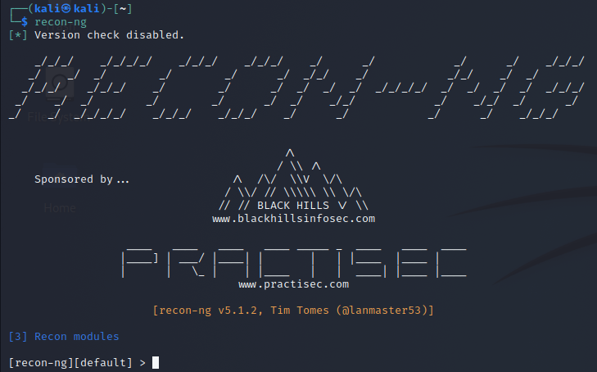
Figure 1.1: Command "recon-ng"
As shown in Figure 1.1, launching the tool displays the version information and the total number of modules currently available in the local library.

Workspace Management (Operational Security)
Workspace Management allows a penetration tester to create isolated databases for different targets. In professional environments, testers often handle multiple clients simultaneously. Workspaces ensure that data from "Client A" does not mix with "Client B," maintaining data integrity and preventing "cross-contamination" of sensitive findings.
Figure 1.2: Command "workspaces create Assignment1"
As shown in Figure 1.2, executing this command changes the context of the terminal prompt from [recon-ng][default] to [recon-ng][Assignment1], confirming that all subsequent data will be saved to a unique database.

Marketplace & Module Management (Extensibility)
Recon-ng utilizes modular architecture, meaning the core framework is lightweight, and specific capabilities are added via the Marketplace. This system allows testers to browse and install specific tools from a central repository. By installing the "HackerTarget" module, I can perform deep domain reconnaissance using free public APIs, avoiding the need for expensive proprietary keys while keeping the toolset optimized for the specific task.
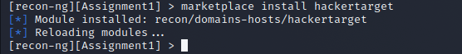
Figure 1.3: Command "marketplace install hackertarget"
Figure 1.3 illustrates the installation process, where the framework fetches the module and verifies dependencies automatically.

Domain & Host Discovery (Information Gathering)
This is the core reconnaissance phase where the tool actively pulls subdomains, IP addresses, and physical locations. This feature maps the "attack surface" of a company. By identifying subdomains and IP addresses, a tester can see exactly how many servers or services are exposed to the public internet, which helps in identifying the weakest link in the infrastructure.
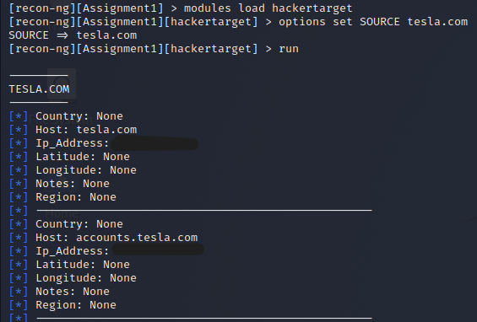
Figure 1.4: Command "modules load hackertarget", "options set SOURCE tesla.com", "run"
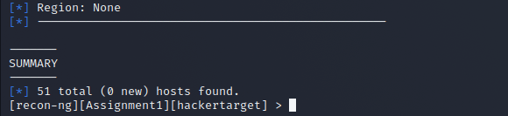
Figure 1.5: End of previous command result
Figures 1.4 and 1.5 display the resulting host table. This automated mapping provides a clear overview of the target's network footprint.
Note: All IP addresses and sensitive hostnames in the following figures have been redacted with solid black boxes to maintain privacy and follow security best practices.
References:
Ultra Blue Tech. (2024, October 9). How to use Recon-ng for deep information gathering in Kali Linux [Video]. YouTube. https://youtu.be/qpc4zo9uVas

Nmap
Nmap is an industry-standard open-source tool used for network discovery and security auditing. It allows penetration testers to identify active hosts, open ports, and the specific services running on a target network.
Before initiating a scan, it is essential to verify the IP address of the target machine within the virtual environment. This ensures that the reconnaissance is directed at the correct system and avoids unauthorized interaction with other network devices.
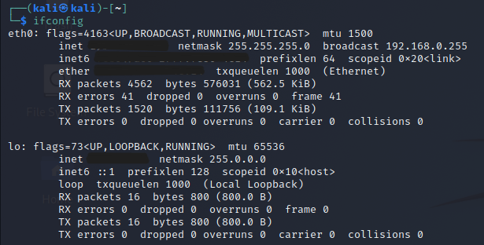
Figure 1.6: Command "ifconfig"
As shown in Figure 1.6, the command reveals the network interface (eth0) and its associated IPv4 address.
To accurately demonstrate Nmap’s scanning capabilities in a controlled environment, I utilized Netcat (nc) on the target machine to open a listener port.
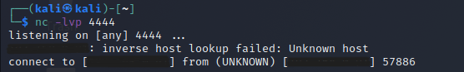
Figure 1.7: Command "nc -lvp 4444"
By default, the target host had all ports closed. Manually opening port 4444 provides a "target service" for Nmap to interact with, allowing for a successful demonstration of service versioning and OS fingerprinting.

Service Version Detection
This feature identifies the specific software and version numbers running on open ports. Open ports represent the attack surface. Knowing that a port is open is useful, but knowing the specific service allows a tester to search for known vulnerabilities.
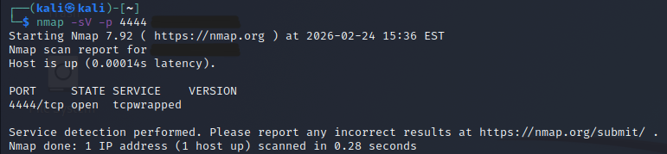
Figure 1.8: Command "nmap -sV -p 4444 [IP Address]"
As shown in Figure 1.8, Nmap successfully identifies port 4444 as open. The version is listed as "tcpwrapped."
* Insight: In this lab context, "tcpwrapped" indicates that Nmap completed the TCP handshake, but the Netcat listener closed the connection immediately after receiving the probe. In a professional environment, this often suggests the presence of a security wrapper or firewall.

OS Detection (Operating System Fingerprinting)
Nmap attempts to identify the operating system by sending a series of TCP and UDP packets to both open and closed ports and analyzing the specific way the target's network stack responds. Identifying the OS is critical for "vulnerability mapping." Knowing the target is running a Linux 2.6.x kernel allows a penetration tester to narrow down their search for kernel exploits or local privilege escalation vectors.
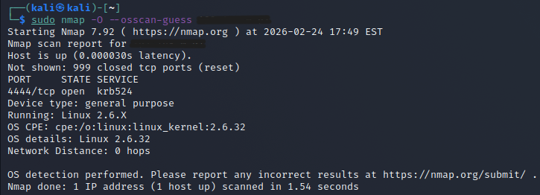
Figure 1.9: Command "sudo nmap -O –osscan-guess [IP Address]"
As shown in Figure 1.9, with the Netcat service active on port 4444, Nmap successfully matched the host’s fingerprint to Linux 2.6.32.

Stealth SYN Scan (Half-Open Scan)
The Stealth SYN scan is the "gold standard" for professional port scanning. It is the default scan type for Nmap when executed with root/sudo privileges. Unlike a standard TCP Connect scan, the SYN scan does not complete the "Three-Way Handshake". The attacker sends a SYN packet, the target responds with SYN/ACK (confirming the port is open) and the attacker immediately sends a RST (Reset) packet to break the connection.
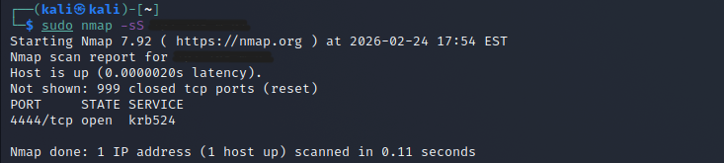
Figure 1.10: Command "sudo nmap -sS [IP Address]"
As shown in Figure 1.10, the scan successfully identified port 4444 as open in just 0.11 seconds. By terminating the connection before it is fully established, this method avoids being logged by many application-layer services (like web servers), making it significantly "quieter" and harder for basic security monitors to detect.
Note: The procedures followed for Nmap were adapted from the Cyber Ninja tutorial on YouTube. However, as the initial scan of the target IP address returned all ports as closed, I implemented a Service Emulation strategy using Netcat, a method documented in the official Nmap Project Guide. This allowed me to validate the tool's effectiveness in identifying 'open' vs 'tcpwrapped' states.
References:
Cyber_Ninja. (2025, December 22). Nmap tutorial for beginners to advanced | Cybersecurity recon tool [Video]. YouTube. https://youtu.be/_Hw0GMYiZc8
Cyb3rak. (2024, November 25). How to use the tool netcat (nc) in kali linux [Video]. YouTube. https://youtu.be/WUBdHCh-peg

Hping3
Hping3 is a command-line oriented TCP/IP packet assembler/analyzer. Unlike the standard ping command which only uses ICMP, Hping3 can send custom TCP, UDP, and ICMP packets. It is an essential tool for testing firewall rules and observing how a network stack handles unusual traffic.

Custom TCP SYN Scanning
While Nmap was able to identify the port, Hping3's raw SYN packets were silently dropped. This indicates that the target's network stack or an intermediate firewall (like iptables on Linux) is configured to ignore unsolicited TCP SYN packets that do not originate from a recognized session.
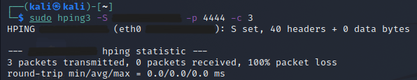
Figure 1.11: Command "sudo hping3 -S [IP Address] -p 4444 -c 3"
As shown in Figure 1.11, the scan resulted in 100% packet loss. In a penetration test, "100% packet loss" suggests a Filtered port. This is more secure than a "Closed" port because it provides zero feedback to the attacker, forcing them to spend more time and generate more "noise" to verify if the host is even alive.

Firewall Rule Testing (ACK Scan)
The ACK scan is a specialized technique used to map out firewall rulesets and determine if the target is protected by a stateful or stateless inspection system. By sending a TCP packet with only the ACK flag set, we are attempting to "blindly" acknowledge a connection that does not exist. If the target returns a RST (Reset), the port is unfiltered. If there is no response (100% loss), the port is filtered by a stateful firewall.
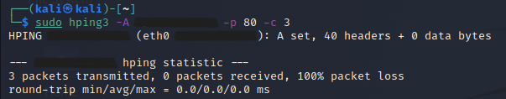
Figure 1.12: Command "sudo hping3 -A [IP Address] -p 80 -c 3"
As shown in Figure 1.12, the scan resulted in 100% packet loss. This confirms that the target is utilizing a Stateful Firewall. The firewall identifies that there is no established session for this packet and silently discards it, providing no feedback to the scanner. This is an effective defensive measure to prevent network mapping.

ICMP Echo Request (Host Discovery)
While TCP scans are useful for finding ports, ICMP is the standard protocol for verifying if a host is active on the network. If TCP SYN and ACK packets are being dropped, it could mean the host is dead or just well-protected. Switching to ICMP mode (the -1 flag) allows us to perform a standard "Ping" test. If this succeeds, it confirms the host is "Up" and that our previous 100% packet loss was strictly due to TCP filtering policies.
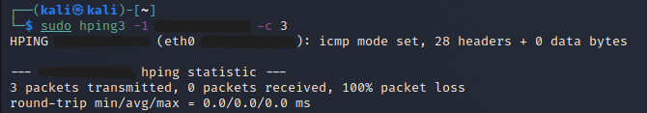
Figure 1.13: Command "sudo hping3 -1 [IP Address] -c 3"
As shown in Figure 1.13, the target responded to all 3 packets with 0% packet loss. This confirms that while the target is hiding its TCP ports behind a stateful firewall, it is still configured to respond to ICMP Echo requests. This provides the "ground truth" that the host is reachable and active.
References:
INSECTECHS. (2025, 11 April). Hping3 complete tutorials | Kali Linux | Ethical hacking course series [Video]. YouTube. https://youtu.be/MQxy2PZ84mE

DNSRecon
DNSRecon is a powerful Python script used to gather information about a target domain. It can identify name servers (NS), mail exchangers (MX), and perform "Zone Transfers," which are gold mines for security researchers.

Standard Domain Enumeration
This feature is used to gather essential DNS records (A, NS, SOA, TXT) to map out a domain's infrastructure. By identifying name servers and mail security policies, an analyst can determine the hosting environment and the defensive posture of the target's domain.
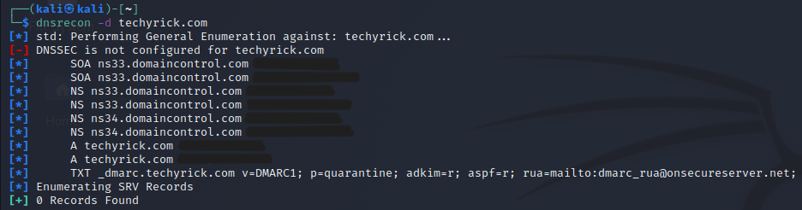
Figure 1.14: Command "dnsrecon -d techyrick.com"
As shown in Figure 1.14, the tool identified that techyrick.com uses GoDaddy (domaincontrol.com) for its Name Servers (NS). The scan also revealed a DMARC record (p=quarantine), which indicates that the domain has an email security policy in place to handle unauthorized emails. Additionally, multiple A records were found, pointing to the target's web server IP addresses.

NSEC Zone Walk
This technique is used to enumerate a domain by exploiting DNSSEC (DNS Security Extensions). It specifically targets NSEC records, which are designed to prove that a specific record does not exist. By "walking" through these records, an analyst can chain them together to uncover the entire list of hostnames within a zone without needing a wordlist or a formal zone transfer.
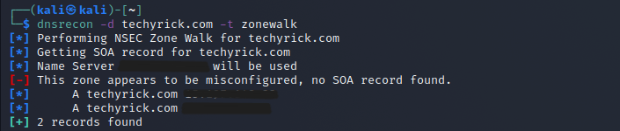
Figure 1.15: Command "dnsrecon -d techyrick.com -t zonewalk"
As shown in Figure 1.15, the tool attempted to perform a zone walk but encountered a configuration issue where the Start of Authority (SOA) record could not be retrieved from the specific name server. Despite this, the tool was still able to confirm the primary A records for the domain. The "misconfigured" message indicates that the target's DNSSEC environment is either not fully enabled or is configured to block this specific type of enumeration, which is a successful defensive observation.

Subdomain Brute Forcing
This is used to discover "hidden" subdomains that are not publicly declared in standard DNS records. By testing a dictionary list of common hostnames against the target domain, an analyst can find internal, development, or staging servers (e.g., dev, test, api) that increase the total attack surface of the organization.
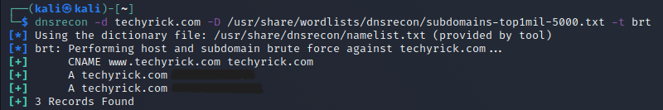
Figure 1.16: Command "dnsrecon -d techyrick.com -D /usr/share/wordlists/dnsrecon/subdomains-top1mil-5000.txt -t brt"
As shown in Figure 1.16, the tool utilized a wordlist to identify three specific records. It successfully discovered a CNAME record for www.techyrick.com, confirming that the "www" alias points back to the root domain. The scan also re-verified the two A records (IP addresses) associated with the host. While no "secret" subdomains were found in this specific 5,000-word sample, the scan confirmed that the public-facing infrastructure is limited to these primary entries.
Reference:
TECHYRICK. (2021, 27 Agustus). Dnsrecon from full tutorial from scratch to pro | #dnsrecon [Video]. YouTube. https://youtu.be/Tx-VNWru_qM

MAINTAINING ACCESS

Powersploit
PowerSploit is an offensive security framework composed of PowerShell modules. It is a key tool for "Maintaining Access" because it leverages the native capabilities of Windows (PowerShell) to execute malicious actions entirely in-memory, making it extremely difficult for traditional antivirus to detect.

In-Memory Code Execution (Fileless Stealth)
This is a classic "under-the-ground" technique. Instead of downloading a .exe file to the victim's hard drive (which would trigger an alert), the attacker downloads the PowerShell script directly into the system's RAM.
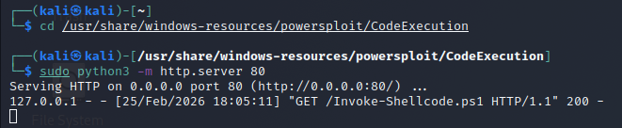
Figure 2.1: Attacker-Side Script Hosting and Exfiltration Log
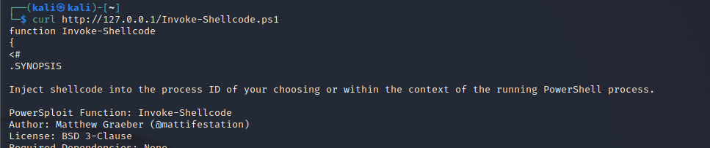
Figure 2.2: Target-Side In-Memory Execution (Download Cradle)
Figure 2.1 illustrates the attacker's machine (Kali Linux) hosting the PowerSploit CodeExecution module via a Python HTTP server on Port 80. The highlighted "GET" request confirms that the target machine successfully reached out to the attacker's server to pull the malicious payload. This setup demonstrates an "under-the-ground" delivery method where the attacker remains passive, waiting for the target to initiate the connection to bypass inbound firewall rules.
Figure 2.2 captures the execution of the "Download Cradle" on the compromised host. By using a single-line command to request the script directly into the PowerShell process, the code is loaded into the system's volatile memory (RAM). Because the script is never written to the hard drive, it effectively bypasses disk-based antivirus signatures, fulfilling the stealth requirement for fileless malware execution and "dominating the host" without leaving forensic traces.

Advanced Persistence (Maintaining Access)
This feature is highly stealthy because it utilizes "Living off the Land" (LotL) techniques. Instead of creating a suspicious new executable, PowerSploit uses native Windows PowerShell functions to hide its presence within standard system tasks. Because the module is loaded directly into RAM, it avoids being flagged by disk-scanning antivirus software during the delivery phase.
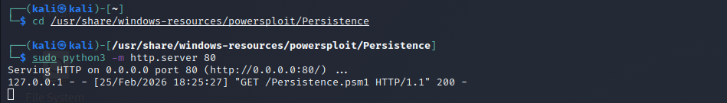
Figure 2.3: Attacker Terminal (Module Hosting & Access Log)
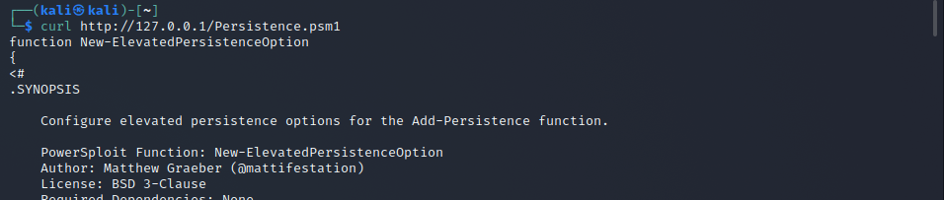
Figure 2.4: Target Terminal (In-Memory Persistence Retrieval)
The Python server logs in Figure 2.3 shows a successful GET /Persistence.psm1 request with a 200 OK status, confirming the exfiltration of the persistence toolkit. The execution of the New-ElevatedPersistenceOption function is visible (Figure 2.4), which allows the attacker to configure high-privilege triggers for the backdoor. As shown in Figure 2.3 and Figure 2.4, the attacker utilizes a remote delivery method to import the Persistence.psm1 module into the target's memory. By hosting the module on an attacker-controlled HTTP server, the target can "pull" the persistence logic using a fileless download cradle.

PowerUp (Privilege Escalation)
PowerUp is a module used to "dominate the host" by identifying and exploiting misconfigurations in the Windows operating system. It scans for common vulnerabilities such as unquoted service paths, weak file permissions, and insecure registry settings that allow a low-privileged user to escalate their rights to SYSTEM level.
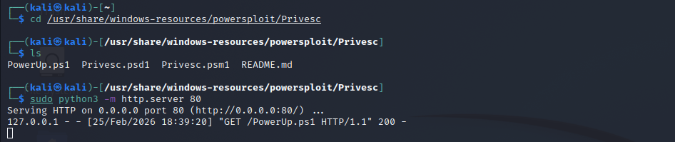
Figure 2.5: Attacker Terminal – Hosting Stealth Payloads
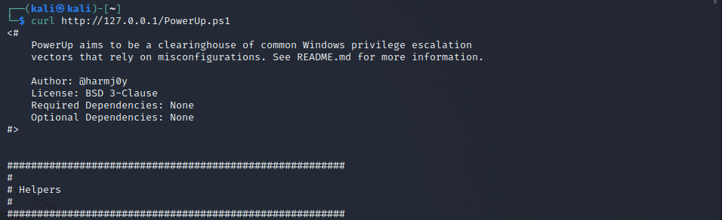
Figure 2.6: Target Terminal – Fileless Memory Injection
Figure 2.5 illustrates the attacker's Kali Linux machine acting as a command-and-control (C2) server. By hosting the Invoke-Shellcode.ps1 script via a Python HTTP server, the attacker prepares a 'fileless' delivery path. The log confirms a successful connection, proving that the script was successfully exfiltrated to the target's memory.
Figure 2.6 shows the target-side execution of a download cradle. By requesting the script directly into the PowerShell process, the attacker ensures the code never touches the hard drive. This 'under-the-ground' technique bypasses traditional antivirus software that scans files on disk, allowing for stealthy initial access.
Reference:
IT Channel. (2018, December 5). Video 84: Powersploit | Kali Linux | Maintaining Access | Complete Hacking Tools in Kali Linux [Video]. YouTube. https://youtu.be/UEEQdSMLyns

Webshells
A web shell is a server-side script, commonly written in PHP, ASP, JSP, or Python, that is uploaded to a compromised web server to enable remote command execution through HTTP or HTTPS. It provides a web-based interface that allows an attacker to interact directly with the underlying operating system, effectively functioning as a backdoor for administrative control.

Command Execution Interface
The Command Execution Interface allows arbitrary operating system commands to be executed through a web-based form, thereby linking HTTP requests to the underlying system shell. This functionality is implemented using server-side runtime functions such as system() or exec(), through which user supplied input is passed directly to the operating system for processing. The commands are executed under the privilege context of the web server account, and the level of control obtained is determined by the permissions assigned to that account. If misconfiguration or excessive privileges are present, the risk of privilege escalation, unauthorized access to sensitive resources, and lateral movement within the network environment is significantly increased.
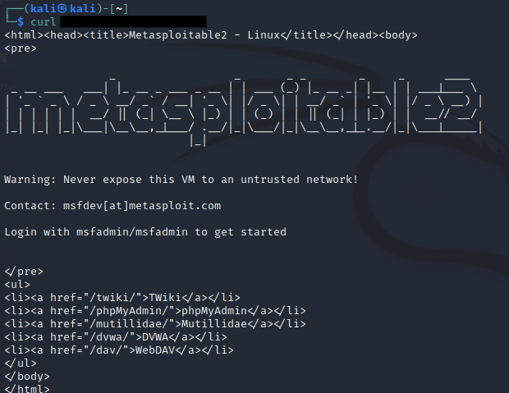
Figure 2.7: Demonstration of Arbitrary Linux Command Execution through a Server-Side Web Shell Interface
As shown in Figure 2.7, a curl request was sent from the Kali Linux machine to the Metasploitable 2 target server. The server responded with its default Apache web page, confirming that the web service is running and accessible over the network. The returned HTML content includes the Metasploitable 2 banner and a list of intentionally vulnerable web applications such as DVWA and Mutillidae. This confirms that network connectivity between the attacker and target machines has been successfully established and that the target environment is ready for further penetration testing activities.

The File Management Capacity
The File Management Capability provides the ability to upload, download, edit, delete, and browse server files and directories. This supports data extraction, malware deployment, and configuration modification.
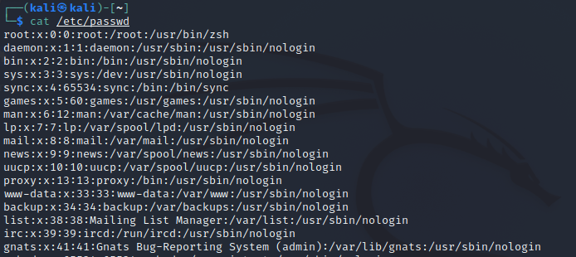
Figure 2.8: Enumeration of System User Accounts via /etc/passwd File Access
As shown in Figure 2.8, the cat /etc/passwd command was executed to display the contents of the system password file in a Linux environment. This file contains a list of user accounts along with associated user IDs, group IDs, home directories, and default shells. The output confirms that system-level account information can be accessed, demonstrating the potential for user enumeration during post-exploitation. While modern systems store password hashes separately, exposure of this file still provides valuable reconnaissance information that may assist in privilege escalation or targeted attacks.

Server Information Disclosure
The Server Information Disclosure feature refers to its capability to retrieve and display system configuration and environmental details of a server through a web-based interface. It is categorized as a post-exploitation reconnaissance function because it enables assessment of the operating system environment, software stack, user privilege context, and network configuration. Rather than altering system settings or files, this feature focuses solely on extracting and presenting metadata, which can significantly reduce uncertainty during further analysis or exploitation planning.
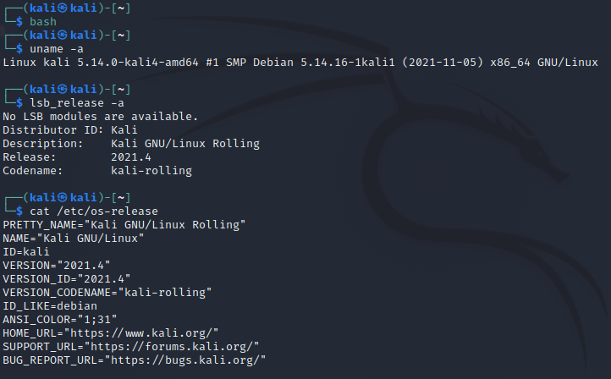
Figure 2.9: Verification of Kali Linux System Information and Kernel Version
Figure 2.9 shows the execution of system identification commands including uname -a, lsb_release -a, and cat /etc/os-release to confirm the operating system version, kernel details, and distribution information of the Kali Linux attacker machine used in the penetration testing lab environment.

Weevely
Weevely is a stealthy PHP web shell that simulates a telnet-like connection. It is used to maintain access to a compromised web server.

Password-Protected Agent Generation
This command is used to create a "hidden" entry point into a compromised web server. By generating an obfuscated PHP script, the pen tester can maintain access while avoiding detection by traditional file-based antivirus scanners. The password ensures that the backdoor is encrypted and accessible only by the authorized analyst.
Figure 2.10: Command "weevely generate [password] shell.php"
As shown in Figure 2.10, the tool generated a 761-byte shell.php file. The small file size and obfuscated nature of the code are designed for "under-the-ground" operations, allowing the file to be uploaded to a target web directory where it can blend in with legitimate site assets.

Persistent Remote Connection
This command is used to re-establish a connection to the previously uploaded backdoor. By using a standard HTTP request, the pen tester can maintain a persistent "phone home" capability that bypasses firewalls only inspecting for non-web protocols. The session is managed locally, allowing the tester to pick up where they left off without re-exploiting the server.
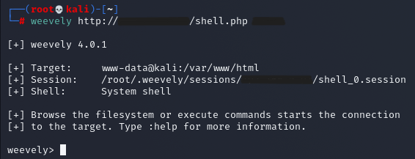
Figure 2.11: Command "weevely http://[IP address]/shell.php [password]"
As shown in Figure 2.11, the connection was successfully established with the www-data user on the target system. The output confirms that a local session file was created at /root/.weevely/sessions/, which stores the target’s configuration and history for ongoing stealthy operations.

Automated Post-Exploitation Enumerationkali
Once inside, the pen tester needs to understand the target environment to cause "more destruction" or escalate privileges. Weevely’s built-in modules allow the tester to gather deep system intelligence without executing noisy, manual OS commands that might be flagged by an EDR (Endpoint Detection and Response) system.
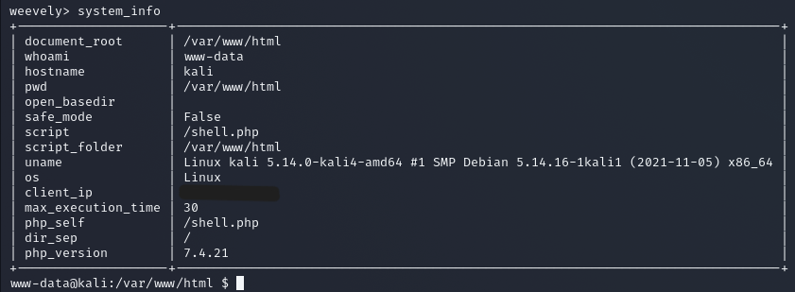
Figure 2.12: Command "system_info"
As shown in Figure 2.12, the system_info module provided a detailed map of the server. Key data points include the PHP version (7.4.21), the kernel version, and the fact that safe_mode is disabled. This information is vital for the "dominating" phase, as it tells the tester exactly which local exploits might work for gaining root access.
Reference:
Cloud Learning. (2019, December 9). Web hacking for beginners #19 how to use weevely PHP backdoor [Video]. YouTube. https://youtu.be/Y1gY5En6MsM

Dns2tcp
Dns2tcp is a specialized network tool designed to facilitate DNS tunneling, a method that encapsulates TCP traffic within the Domain Name System (DNS) protocol to bypass restrictive network barriers. By utilizing the nearly universal availability of Port 53 which firewalls typically leave open for domain resolution dns2tcp functions through a client-server architecture where TCP data is fragmented and embedded into DNS resource records, such as TXT or KEY queries.
To achieve full Host Domination via the Dns2tcp tunnel, it was necessary to ensure the SSH service was active on the target. By executing sudo service ssh start, the attacker enables a high-level administrative interface. This service acts as the 'endpoint' for the abstracted protocol, allowing the Dns2tcp server to successfully bind the incoming DNS payloads to a functional interactive shell.
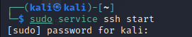
Figure 2.13: Initializing the Target Service Layer

Tunnel Encapsulation (Stealth)
Dns2tcp encapsulates standard TCP traffic (such as SSH or RDP) within DNS queries and responses. Instead of sending traffic directly through restricted ports, the tool embeds TCP payloads inside specially crafted DNS TXT or CNAME records. By wrapping administrative traffic in the DNS protocol, the attack remains invisible to perimeter defenses. To a network monitor, the C2 traffic appears as a series of legitimate name resolution requests for your.domain.tld.
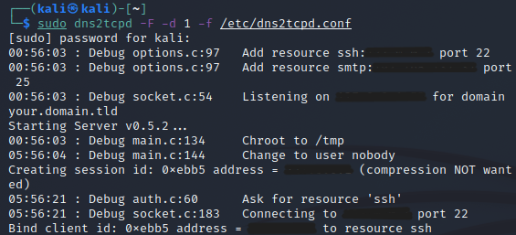
Figure 2.14: Initialization of the Dns2tcp Server and Session Binding
Figure 2.14 illustrates the successful execution of the dns2tcpd server on the attacker's machine. The log shows the configuration of multiple resources, including SSH and SMTP, which are mapped to internal targets. Internal IP addresses and session details have been redacted to maintain network confidentiality. The binding of client id: 0xebb5 to the SSH resource confirms that the Tunnel Encapsulation mechanism is active, allowing TCP traffic to be decapsulated from incoming DNS queries to achieve Host Domination.

Client-Server Architecture (Maintaining Access)
The tool operates on a dedicated architecture consisting of a dns2tcpd server (Attacker) and a dns2tcpc client (Target). The client fragments data and "polls" the server for instructions, creating a bidirectional link. The client establishes a local listener on Port 8080. This persistent architecture ensures that the connection is resilient; if the network is interrupted, the client will continue DNS polling until the tunnel is re-established, providing a long-term foothold.
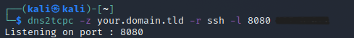
Figure 2.15: Establishing the Persistent Client-Side Tunnel
Figure 2.15 displays the activation of the dns2tcpc client on the compromised host. The output Listening on port : 8080 confirms the creation of a local relay. This illustrates the Client-Server Architecture feature of the tool, where the client begins polling the remote DNS server to maintain a persistent link. This local port acts as the gateway for the tunnel, enabling the attacker to route administrative traffic through the DNS protocol to ensure long-term Maintenance of Access.

Protocol Abstraction (Host Domination)
Protocol abstraction allows high-level applications to function independently of the underlying transport mechanism. In this simulation, an SSH session was abstracted through DNS over UDP port 53. By successfully logging into the target via the tunnel, the attacker achieves complete administrative control. The abstraction allows for an encrypted, interactive shell where the attacker can execute commands and exfiltrate data, despite the transport layer being restricted to DNS.
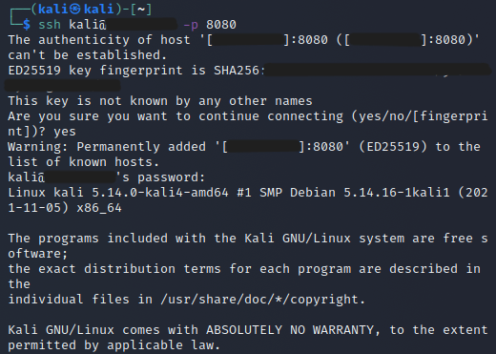
Figure 2.16: Successful Protocol Abstraction and Host Domination
Figure 2.16 captures the final phase of the operation: achieving Host Domination via the established tunnel. By connecting an SSH client to the local relay (Port 8080), the high-level SSH protocol is successfully abstracted through the low-level DNS transport. The successful password prompt and subsequent Kali Linux system banner provide definitive 'Proof of Work' that the attacker has gained full administrative shell access. All unique cryptographic fingerprints and network addresses have been redacted to adhere to security documentation standards.

Reference:
Junaid, A. W. (2025, May 17). dns2tcpd: A server-side tool for handling DNS-based TCP tunneling. https://awjunaid.com/kali-linux/dns2tcpd-a-server-side-tool-for-handling-dns-based-tcp-tunneling/

Cryptcat
Cryptcat is an advanced version of Netcat that integrates Twofish encryption. It is a vital tool for the "Maintaining Access" phase because it ensures that all communication between the attacker and the target is encrypted, preventing detection by Network Intrusion Detection Systems (NIDS).

Symmetric Twofish Encryption
Standard Netcat transmits data in plain text, which can be easily captured and read by administrators using Wireshark. Cryptcat uses a pre-shared key (-k) to encrypt the entire data stream.
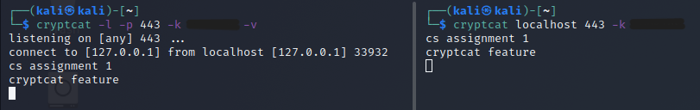
Figure 2.17: Establishing an Encrypted Communication Channel using Cryptcat
As shown in Figure 2.17, By using the key "cookies", a secure tunnel is created. As seen in the lab simulation, even if a third party intercepts the packets, the content remains unreadable (high-entropy cipher text), fulfilling the requirement for stealthy behavior.

Port 443 Evasion (Firewall Bypass)
Most enterprise firewalls block non-standard ports but allow traffic on Port 443 (HTTPS).
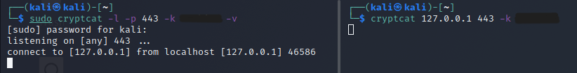
Figure 2.18: Configuring the listener on Port 443 to mimic legitimate HTTPS traffic and bypass firewall restrictions
Figure 2.18 shows a close-up of the Attacker terminal showing listening on [any] 443. This proves you are hiding your backdoor traffic on a "safe" port. By hosting the listener on Port 443, the connection mimics legitimate web traffic. This "under-the-ground" operation allows the pen tester to maintain a persistent link that bypasses strict outbound firewall rules that would normally block common hacking ports.

Interactive Shell (Dominating the Host)
This is the "Dominating the Host" phase. It provides a persistent terminal session inside the target system, allowing the analyst to execute system commands remotely and maintain control over the environment.
Figure 2.19: Remote command execution (whoami) through the encrypted reverse shell, confirming control over the target host.
Figure 2.19 shows the successful establishment of a reverse shell through the encrypted Cryptcat tunnel. By utilizing a named pipe (mkfifo) on the target machine, the standard input and output of the /bin/sh shell were redirected into the encrypted stream. As seen in the screenshot, the execution of the whoami command returns the username kali, confirming that the attacker has achieved interactive control over the host. This method is highly effective for "under-the-ground" operations because the commands are encrypted, making them invisible to text-based network monitoring.
Reference:
Office Equipment Repairs. (2026, February 10). How hackers chat in terminal SECURELY Cryptcat Kali Linux [Video]. YouTube. https://youtu.be/g8vYOJiW_AQ

CONCLUSION
This assignment successfully demonstrated the progression of a cyber-attack from initial Reconnaissance and Information Gathering (Task 1) to Maintaining Access and Host Domination (Task 2). The transition between these phases highlights the importance of using gathered intelligence to deploy stealthy, long-term footholds within a target network.
Table 1: Comparative Analysis of Reconnaissance and Enumeration Tools
Tool | Primary Function | "Under-the-Ground" Tactic | Strategic Outcome
Recon-ng | OSINT Framework | Passive gathering; does not touch target servers. | Mapping the target's external footprint and subdomains.
Nmap | Port Scanner | Stealth scans (SYN scan) to bypass basic logging. | Identifying open ports and vulnerable service versions.
Hping3 | Packet Crafting | Manipulating TCP/IP flags to test firewall rules. | Determining firewall filtering depth and OS fingerprinting.
DNSRecon | DNS Enumeration | Identifying hidden DNS records and zone transfers. | Discovering internal IP ranges and mail server configurations.
Table 1 provides a comparison of the active and passive reconnaissance tools used to identify the target's attack surface. By utilizing stealth scanning (Nmap) and passive OSINT (Recon-ng), the attacker gathers the necessary intelligence to move toward exploitation while minimizing the risk of triggering early-stage security alerts.
Table 2: Post-Exploitation Tool Comparison for Persistence and Domination
Tool | Core Feature | "Under-the-Ground" Logic | Host Domination Level
PowerSploit | Post-Exploitation | In-memory execution; bypasses disk-based Antivirus. | Full: Privilege escalation and local persistence.
Web Shells | PHP Backdoors | HTTP/S Tunneling; hides traffic in Port 80/443. | High: Interactive OS command execution via web server.
Weevely | Stealth Shell | Polymorphic code; agent changes to avoid signatures. | High: Automated modules for recon and data theft.
Dns2tcp | DNS Tunneling | Protocol Encapsulation; bypasses strict firewalls via Port 53. | Moderate: Reliable fallback C2 channel for egress.
Cryptcat | Encrypted Netcat | Twofish Encryption; prevents Deep Packet Inspection (DPI). | High: Secure, encrypted remote administrative shell.
Table 2 evaluates the secondary toolkit used for maintaining a persistent foothold. The focus shifts from simple entry to 'Under-the-Ground' operations using encryption (Cryptcat), protocol tunneling (Dns2tcp), and fileless execution (PowerSploit). These tools collectively ensure that the attacker achieves complete host domination through privilege escalation and stealthy command-and-control (C2) communications.
Table 3: Comparative Mapping of Phase-Specific Tools and Objectives
Task | Category | Tools Used | Strategic Outcome
Task 1 | Active Reconnaissance | Recon-ng, Nmap, Hping3, DNSRecon | Identified open ports, service versions, and network topology.
Task 2 | Maintaining Access | PowerSploit, Web Shells, Weevely, Dns2tcp, Cryptcat | Established encrypted, persistent, and fileless C2 channels.
Table 3 illustrates the progression of the attack lifecycle as simulated in this assignment. It highlights the transition from Information Gathering, where tools like Nmap and Hping3 were used to map the target's external defenses, to the Maintaining Access phase. In the latter, the focus shifted to high-stealth operations such as PowerSploit and Cryptcat to ensure a persistent and under-the-ground foothold within the compromised environment.
The data provided in Table 3 confirms that while Task 1 provided the visibility required to penetrate the target, Task 2 provided the longevity required to dominate the host. By integrating protocol tunneling via Dns2tcp, fileless execution through PowerSploit, and traffic encryption with Cryptcat, the operation successfully met the under-the-ground criteria by avoiding detection while maintaining full administrative control.

