Handwritten Digit Recognition Report
A two hidden layer neural network and a Flask drawing application
The application recognizes one handwritten digit from 0 to 9. The trained model achieved 97.15% accuracy on the official 10,000-image MNIST test set. This report describes the experiment, its errors and the drawing interface used for a classroom demonstration.

Purpose and sources
The task combines the MNIST recognition exercise illustrated by agnivahp [1] and Google Cloud [2] with the canvas-to-Flask workflow described by Philip Purwoko [3]. The accompanying examples [4–7] inspired the program structure. The model, preprocessing and evaluation were adapted for this project; no performance results are taken from the source authors.

Data and network
MNIST contains 28 × 28 grayscale images of digits. A NumPy default_rng(42) permutation divides the original 60,000 training examples into 50,000 training and 10,000 validation examples. The official 10,000 test examples remain separate and are not used to choose the stopping epoch. Pixels are converted to float32 and divided by 255, producing white digits on black in [0,1]. Labels remain integer classes 0–9.
The architecture is Input(28 × 28) → Flatten → Dense(128, ReLU) → Dense(64, ReLU) → Dense(10, softmax), with 109,386 parameters. The two moderate hidden layers provide nonlinear classification while keeping CPU training practical. No claim of architectural optimality is made.

Training and selection
Training uses Adam with learning rate 0.001, sparse categorical cross-entropy, batch size 128, training-data shuffling and a maximum of 20 epochs. Keras sets the random seed to 42; deterministic TensorFlow operations, two inter/intra-op threads and disabled oneDNN are retained. The recorded run used Python 3.13.14, TensorFlow 2.21.0 and Keras 3.15.1 on Windows CPU.
Early stopping monitors validation loss with patience 3 and min_delta 0.0001, restoring the best weights. Training completed 8 epochs and selected epoch 5. The later source cleanup changed result-export organization only; the saved model and the recorded experiment were not retrained or replaced.

Evaluation of the restored weights
Set | Images | Accuracy | Loss
Training | 50,000 | 98.51% | 0.048553
Validation | 10,000 | 96.88% | 0.100980
Test | 10,000 | 97.15% | 0.093391
The table reports evaluation after restoring the best weights, rather than training-batch averages from the final epoch. The test result is 9,715 correct predictions and 285 errors.

Test errors
The confusion matrix below contains all 10,000 test predictions. Rows are true classes and columns are predicted classes; diagonal entries are correct classifications. Values come from the recorded experiment and agree with the local CSV export.
True / pred. | 0 | 1 | 2 | 3 | 4 | 5 | 6 | 7 | 8 | 9
0 | 969 | 0 | 1 | 0 | 3 | 1 | 2 | 2 | 2 | 0
1 | 0 | 1127 | 2 | 1 | 0 | 0 | 2 | 0 | 3 | 0
2 | 5 | 7 | 990 | 9 | 3 | 0 | 1 | 10 | 7 | 0
3 | 0 | 0 | 3 | 987 | 1 | 6 | 0 | 9 | 3 | 1
4 | 1 | 0 | 5 | 0 | 961 | 1 | 1 | 3 | 0 | 10
5 | 2 | 0 | 0 | 8 | 1 | 868 | 4 | 4 | 3 | 2
6 | 5 | 3 | 2 | 1 | 9 | 11 | 925 | 0 | 2 | 0
7 | 1 | 7 | 7 | 2 | 2 | 0 | 0 | 1005 | 1 | 3
8 | 3 | 0 | 6 | 10 | 5 | 5 | 7 | 8 | 927 | 3
9 | 3 | 5 | 2 | 8 | 12 | 9 | 1 | 10 | 3 | 956
Table 2 Test confusion matrix with counts
Examples of repeated confusions include true 9 predicted as 4 (12 cases), true 6 predicted as 5 (11), and true 2 predicted as 7 (10). These counts describe this test set and do not establish how often the same errors occur on browser drawings.
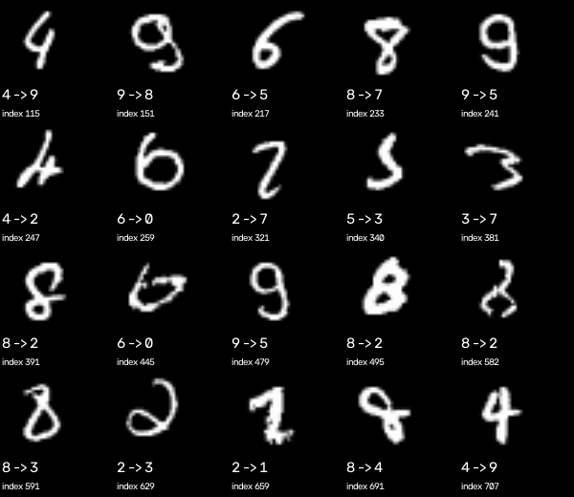
Figure 1 First twenty test errors in dataset order with true to predicted labels
A high score can still be wrong: test image 321 is a true 2 predicted as 7 with a 99.67% softmax score. The errors shown are the first twenty mismatches, not a curated selection.

Drawing application
The short wsgi.py entry point starts Flask. app/main.py loads the saved .keras model once, serves the drawing page on GET and processes its PNG/base64 form on POST. Training is a separate command and is not required during the demonstration.
The browser draws white ink on a black 280 × 280 canvas using Pointer Events for mouse or touch. The backend validates the image and rejects an empty or very small drawing. It removes the background below intensity 20, crops the digit, scales its longest side to 20 pixels while preserving proportions, and centres its mass on a black 28 × 28 image. Division by 255 produces float32 input of shape (1,28,28), matching the training input convention.
The model returns ten softmax scores. The English page shows fixed rows 0–9, linear 0–100% bars and percentages, highlighting the largest score, including class 0. Clear resets the canvas, all bars, the highlight and any error. Invalid input receives an English message without a Python traceback.

Verification and observations
After cleanup, 5 automated integration tests passed with no failures or errors. They cover model reloading, input shape and range, centring, GET and live HTTP POST, ten score rows, agreement with model outputs, sums near 100%, class 0 and invalid, empty or oversized input. The first test example of each class passed through preprocessing and POST with 10 correct predictions. This small integration check is not a new accuracy measurement.
Earlier informal mouse trials in Opera recognized drawings of 1, 7 and 4, preserved the canvas after POST, and checked clearing and empty-input rejection. These notes concern the earlier single-result interface and are qualitative, not a systematic test of handwriting accuracy. A later browser retest was blocked by the automation tool, so drawing and Clear in the final ten-bar interface still need a manual check on the presentation device. Physical touch input has not been tested.

Limitations and conclusion
Personal handwriting, rotation, multiple digits and scribbles may differ from MNIST. Cropping and centring reduce some differences but do not eliminate them. Softmax scores are not calibrated guarantees of correctness. No comparison with CNNs or alternative architectures was performed, and the Flask development server is intended for a local demonstration.
The project connects a simple ANN experiment to a working drawing application. The 97.15% MNIST result supports its use as a classroom example, while the recorded mistakes show why predictions require caution. Model, report and runtime code can be submitted without local experiment files.

References
[1] agnivahp Tensorflow Handwritten digit recognition demo
[2] Google Cloud Platform TensorFlow MNIST tutorial
[3] Philip Purwoko How To Deploy Digit Recognition Model Into Drawing App
[4] Philip Purwoko Training example
[5] Philip Purwoko Flask example
[6] Philip Purwoko Drawing interface example
[7] Philip Purwoko WSGI example

