____________________________________________________________________
Software Requirements Specification
(IEEE 830-1998 Standard)
for
PawHaven – Pet Adoption Portal
A Comprehensive Animal Rescue & Digital Adoption Workflow Platform
Version 1.0 Approved
Prepared by:
Project Author / Capstone Candidate
Department of Computer Science and Engineering
Coimbatore Institute of Technology
Date of Submission: September 2026

Table of Contents
Table of Contents .................................................................. ii
Revision History ................................................................... ii
1. Introduction ..................................................................... 1
1.1 Purpose ..................................................................... 1
1.2 Document Conventions ........................................................ 1
1.3 Intended Audience and Reading Suggestions ................................... 1
1.4 Product Scope ............................................................... 2
1.5 References .................................................................. 2
2. Overall Description .............................................................. 3
2.1 Product Perspective ......................................................... 3
2.2 Product Functions ........................................................... 3
2.3 User Classes and Characteristics ............................................ 4
2.4 Operating Environment ....................................................... 4
2.5 Design and Implementation Constraints ....................................... 5
2.6 User Documentation .......................................................... 5
2.7 Assumptions and Dependencies ................................................ 5
3. External Interface Requirements .................................................. 6
3.1 User Interfaces ............................................................. 6
3.2 Hardware Interfaces ......................................................... 6
3.3 Software Interfaces ......................................................... 7
3.4 Communications Interfaces ................................................... 7
4. System Features (Functional Requirements) ........................................ 8
4.1 User Authentication and Authorization ....................................... 8
4.2 Pet Inventory and Search Filtering .......................................... 9
4.3 Adoption Application Submission ............................................ 10
4.4 Shelter Staff Review & Decision Processing ................................. 11
4.5 Notification and Alert Dispatcher .......................................... 12
4.6 Pet Profile Inventory Management (Admin CRUD) .............................. 13
5. Other Nonfunctional Requirements ................................................ 14
5.1 Performance Requirements ................................................... 14
5.2 Safety Requirements ........................................................ 14
5.3 Security Requirements ...................................................... 15
5.4 Software Quality Attributes ................................................ 15
5.5 Business Rules ............................................................. 16
6. Other Requirements .............................................................. 17
6.1 Database Requirements ...................................................... 17
6.2 Internationalization Requirements .......................................... 17
6.3 Legal and Regulatory Compliance ............................................ 18
6.4 Reuse Objectives ........................................................... 18
6.5 Documentation Requirements ................................................. 18
6.6 Future Enhancements ........................................................ 19
Appendix A: Analysis Models (System & UML Diagrams) ................................ 20
A.1 System Architecture Diagram (4-Tier) ....................................... 20
A.2 Component Diagram .......................................................... 21
A.3 Data Flow Diagram (DFD Level 0 & Level 1) .................................. 22
A.4 Entity-Relationship (ER) Diagram ........................................... 23
A.5 UML Collaboration Diagram .................................................. 24
A.6 UML Sequence Diagram ....................................................... 25
A.7 UML Activity Diagram ....................................................... 26
A.8 UML State Chart Diagram .................................................... 27
Appendix B: Database Schema & Source Code Highlights ............................... 28
Appendix C: System Verification & Demonstration .................................... 30

Revision History
Name | Date | Reason For Changes | Version
Engineering Team | 15/08/2026 | Initial Draft of SRS and Requirements Gathering | 0.1
Engineering Team | 24/09/2026 | Approved Final SRS with 4-Tier Architecture and B&W UML Models | 1.0

1. Introduction
1.1 Purpose
The purpose of this Software Requirements Specification (SRS) document is to provide a complete, formal, and detailed specification for the development and deployment of PawHaven – Pet Adoption Portal. This document describes both functional and non-functional requirements, external interfaces, system behaviors, architecture constraints, and complete formal software engineering models in compliance with IEEE Std 830-1998. It serves as the primary contractual guideline for software developers, testers, shelter administrators, and academic evaluators.
1.2 Document Conventions
This document follows the standardized IEEE 830-1998 format for Software Requirements Specifications. The following typographical conventions are strictly maintained throughout the document:
- Bold: Boldface text indicates primary headings, field names, database entities, or UI interaction buttons.
- Code: Courier New / Monospaced font indicates database schemas, SQL statements, source code identifiers, or API endpoints.
- Identifiers: Every functional requirement is assigned a deterministic identifier in the format FR-X.Y for traceability.
- Modeling: All UML analysis diagrams adhere to OMG UML 2.5 standards and are rendered in academic publication grayscale.
1.3 Intended Audience and Reading Suggestions
This specification is intended for a diverse group of stakeholders involved in the software lifecycle:
- Developers: Full-Stack Developers: Should focus on Section 3 (External Interfaces), Section 4 (System Features), and Appendix B (Database Schema & API routes).
- QA Engineers: Quality Assurance & Testers: Should review Section 4 (System Features) and Section 5 (Nonfunctional Requirements) to formulate unit, integration, and system test cases.
- Project Evaluators: Shelter Administrators & Evaluators: Should focus on Section 1.4 (Product Scope), Section 2 (Overall Description), and Appendix C (Demonstration Walkthrough).
1.4 Product Scope
PawHaven is a full-stack, responsive web application engineered to bridge the communication and procedural gap between animal rescue shelters and prospective pet adopters. Traditional pet adoption processes are plagued by paper-based records, fragmented follow-ups, manual eligibility evaluations, and severe risks of double-booking or lost applications. PawHaven provides an end-to-end digital adoption workflow that includes:
- Public Pet Catalog: A searchable digital catalog of rescued pets categorized by species, breed, age, gender, and medical status.
- Authentication: Secure user registration, profile management, and JWT-authenticated session governance with Bcrypt password hashing.
- Application Engine: A structured adoption application questionnaire capturing applicant housing conditions, household members, and pet experience.
- Admin Portal: An Administrative Review Dashboard with live KPI counters, modal-based application inspection, and one-click Approval/Rejection.
- Atomic State Engine: Automated state synchronization: approving an application automatically changes pet status to 'Adopted' and auto-rejects conflicting candidates with notification alerts.
- Alert Notification: In-app notifications tracking applicant lifecycle updates in real time.
1.5 References
The following references, standards, and technical specifications guided the formulation of this SRS:
- 1. IEEE Std 830-1998: IEEE Recommended Practice for Software Requirements Specifications.
- 2. OMG Unified Modeling Language (UML) Specification, Version 2.5.1, Object Management Group.
- 3. Node.js Runtime v18+ Specification and Express.js v4.19 Web Application Framework Documentation.
- 4. MySQL 8.0 Reference Manual: Relational Database Engine, Foreign Key Constraints, and InnoDB Transactions.
- 5. RFC 7519: JSON Web Token (JWT) Standard for Stateless Web Authorization.
- 6. NIST Special Publication 800-63B: Digital Identity Guidelines for Authentication and Password Security.

2. Overall Description
2.1 Product Perspective
PawHaven is a self-contained, multi-tier web application operating in a standard client-server environment. The architecture is organized into four distinct tiers: Client Access Tier (HTML5, Bootstrap 5, Vanilla JS), Application Server Tier (Node.js, Express.js REST API, Middleware), Database Server Tier (MySQL 8.0 InnoDB engine), and External Integration Services (Multer local filesystem asset store, real-time alert engine, and extensible notification gateways). The system interacts with modern web browsers over secure HTTP protocols, providing stateless RESTful API endpoints protected via Bearer tokens.
2.2 Product Functions
The primary high-level functional capabilities provided by the PawHaven platform include:
- Account Lifecycle: Adopter & Administrator Account Registration, Cryptographic Login, and Role-Based Access Control (RBAC).
- Catalog Exploration: Real-Time Pet Inventory Exploration with multi-attribute filtering (Dog, Cat, Rabbit, Bird, age, size, gender).
- Adoption Filing: Formal Adoption Application Filing with structured suitability questions and living situation validation.
- Application Review: Administrative Review Workspace featuring holistic applicant data viewing, admin notes logging, and approval/rejection triggers.
- State Transitions: Automated Conflict Resolution: Atomic database updates ensuring single-adoption integrity and notifying rejected applicants.
- Notification Alerts: Real-Time In-App Alert Notifications updating users upon status changes, approvals, and system broadcasts.
- Inventory Management: Pet Inventory CRUD Management enabling authorized shelter staff to add, modify, delete, and upload photos for animals.
2.3 User Classes and Characteristics
The system identifies four primary user classes with distinct operational responsibilities and technical expertise:
User Class | Technical Skill | Operational Frequency | Primary Responsibilities
Public Visitor | Low to Average | Occasional / Daily | Browse available animals, read shelter mission and FAQs, register for an account.
Registered Adopter | Average | Active during adoption | Submit structured adoption applications, view personal dashboard, read alert notifications, edit profile.
Shelter Administrator | Average to High | Continuous Daily | Inspect submitted applications, approve/reject requests, manage pet inventory, review shelter KPIs.
Veterinarian / Foster | Average | Weekly / Periodic | Review pet medical status, inspect animal health history, coordinate vaccination milestones.
2.4 Operating Environment
The operational environment for PawHaven comprises the following technical runtime specifications:
- Client: Client Side: Modern web browsers including Google Chrome 110+, Mozilla Firefox 110+, Microsoft Edge 110+, and Safari 16+ on desktop and mobile viewports.
- Server: Server Side: Node.js runtime environment (v18.x or v20.x LTS) running on Windows Server, Ubuntu Linux 22.04 LTS, or macOS.
- Database: Database Management System: MySQL Server 8.0 or MariaDB 10.5+ running on standard TCP port 3306 with InnoDB storage engine.
- File Storage: Storage Subsystem: Local file system directory (`/uploads/pets/`) with read/write permissions for Multer binary assets.
2.5 Design and Implementation Constraints
The project development is governed by several critical constraints:
- Cryptographic: Security Constraint: Passwords must never be stored in plaintext. Bcrypt hashing with a minimum of 10 salt rounds is mandatory.
- Stateless REST: Architecture Constraint: Communication between frontend and backend must strictly adhere to stateless REST architectural conventions using JSON payloads.
- Data Integrity: Integrity Constraint: MySQL foreign key constraints (`ON DELETE CASCADE`) and transactional logic must prevent orphan applications and double-adoptions.
- UI Responsive: Responsiveness Constraint: All user interfaces must be completely responsive across smartphone, tablet, and widescreen desktop displays using CSS flexbox/grid.
2.6 User Documentation
User documentation accompanying the system includes an exhaustive README.md manual, interactive 1-click demo credential buttons on the `/login` portal, embedded tooltips within the application filing wizard, and formal API reference documentation.
2.7 Assumptions and Dependencies
The system design relies on the following operational assumptions and external dependencies:
- Database Availability: MySQL database server is initialized and accessible via credentials defined in `.env`.
- Client Capabilities: Client browsers support HTML5, modern ECMAScript 6+ JavaScript execution, and LocalStorage for token persistence.
- Disk Storage: The host machine has sufficient disk space for uploaded animal portrait files in `/uploads/pets/`.

3. External Interface Requirements
3.1 User Interfaces
The PawHaven web portal provides an intuitive, accessible, and responsive user experience designed using a modern glassmorphism aesthetic, custom CSS custom properties (tokens), and Bootstrap 5 grid systems. Key UI screens include:
- Home Screen: Public Landing Page (index.html): Features hero banners, key impact statistics (1,240+ rescues), a 4-step workflow guide, and featured animal cards.
- Catalog Screen: Pet Catalog Screen (pets.html): Displays live search bars and multi-parameter filter pills (All, Dogs, Cats, Rabbits, Birds) with reactive card updates.
- Profile Screen: Pet Detail Screen (pet-details.html): Displays comprehensive animal biographies, health & medical tags, adoption availability indicators, and direct 'Adopt Me' trigger.
- Application Wizard: Adoption Application Wizard (apply.html): A 5-step structured questionnaire capturing applicant occupation, living arrangement, existing pets, and family members.
- User Dashboard: Adopter Personal Portal (user-dashboard.html): Real-time KPI summary (Applications submitted, Approved, Pending), application history table, and in-app notifications drawer.
- Admin Control Panel: Shelter Staff Command Center (admin-dashboard.html): High-level operational metrics, interactive modal review window with approval/rejection notes, and Pet Inventory CRUD panel.
3.2 Hardware Interfaces
PawHaven does not interact directly with dedicated physical hardware peripherals. The system communicates across standard TCP/IP networking hardware (Ethernet NICs, Wi-Fi adapters) and standard input/output devices (screens, keyboards, touchscreens) mediated by the operating system.
3.3 Software Interfaces
The software boundaries and integrations utilized by PawHaven include:
- Web Framework: Node.js Runtime & Express.js: Acts as the core web application engine serving static assets and JSON endpoints.
- Database Layer: MySQL 8.0 & `mysql2/promise`: Connection pooled database connector executing parameterized queries for thread safety and high throughput.
- Bcrypt: BcryptJS: Cryptographic password hashing library employing 10 salt rounds for secure authentication.
- JWT Library: JSON Web Token (`jsonwebtoken`): Standardized RFC 7519 tokens containing encoded user IDs, roles, and 24-hour expiration signatures.
- Upload Engine: Multer: Node.js middleware for handling `multipart/form-data` file uploads with strict MIME-type sanitization (JPEG, PNG, WEBP).
3.4 Communications Interfaces
All communications between client devices and the server occur over HTTP/1.1 or HTTP/2 protocols, with HTTPS recommended for production. Client requests authenticate via the `Authorization: Bearer <token>` HTTP header. REST endpoints strictly exchange payloads using MIME type `application/json`, while file uploads use `multipart/form-data`.

4. System Features (Functional Requirements)
4.1 User Authentication and Authorization
Description and Priority: Enables users to securely register, log in, manage credentials, and obtain role-based access tokens. Priority: High / Essential.
Stimulus/Response Sequences:
- Registration: User submits email and plaintext password on `/register` ➔ System validates email uniqueness, hashes password with Bcrypt, creates record in `users` table, and returns 201 Created.
- Login: User submits credentials on `/login` ➔ System verifies email, compares password against stored hash, generates signed JWT token with 24-hour validity, and returns token + user profile.
- Access Denied: User requests protected route without token ➔ System returns 401 Unauthorized.
- Role Guard: Adopter attempts to access `/api/admin/*` ➔ System returns 403 Forbidden.
Detailed Functional Requirements:
- FR-1.1: FR-1.1: The system shall encrypt all user passwords using Bcrypt algorithm with 10 salt rounds prior to database insertion.
- FR-1.2: FR-1.2: The system shall issue a JSON Web Token containing `user_id`, `role`, and expiration timestamp upon successful credential verification.
- FR-1.3: FR-1.3: The system shall provide distinct authorization tiers for 'User' (Adopter) and 'Admin' (Shelter Staff).
4.2 Pet Inventory and Search Filtering
Description and Priority: Provides real-time visibility into shelter animals awaiting adoption with dynamic multi-criteria search. Priority: High.
Stimulus/Response Sequences:
- Browse All: Visitor loads `/pets` ➔ System queries MySQL `pets` table and displays all Available animals.
- Filter by Species: Visitor selects 'Dog' filter pill ➔ System issues `GET /api/pets?species=Dog` and instantly renders dog profile cards.
- View Details: Visitor clicks on an individual pet card ➔ System navigates to `pet-details.html?id=X` displaying comprehensive health, age, gender, and description details.
Detailed Functional Requirements:
- FR-2.1: FR-2.1: The system shall allow users to search pets by name or breed and filter by species, size, gender, and availability status.
- FR-2.2: FR-2.2: Pet profile cards shall display photo, species badge, breed, age in years, gender icon, and availability status badge.
- FR-2.3: FR-2.3: Pets marked as 'Adopted' shall clearly display an 'Adopted' badge and disable further application submissions.
4.3 Adoption Application Submission
Description and Priority: Enables authenticated adopters to file a comprehensive adoption application for a selected animal. Priority: High.
Stimulus/Response Sequences:
- Prerequisite Check: User clicks 'Adopt Me' on pet profile ➔ System validates user authentication; if unauthenticated, redirects to `/login`.
- Submission: User fills questionnaire (Housing type, occupation, previous pet experience, family members, adoption reason) and clicks 'Submit Application'.
- Processing: System checks for duplicate pending application for the same pet by this user; if none exists, records application with `status = 'Pending'` and sends in-app alert.
Detailed Functional Requirements:
- FR-3.1: FR-3.1: The system shall require valid authentication before allowing access to the adoption questionnaire.
- FR-3.2: FR-3.2: The system shall enforce non-empty validation on all questionnaire fields (housing, experience, family members, reason).
- FR-3.3: FR-3.3: The system shall reject duplicate applications if an adopter already has an active pending application for that specific pet.
4.4 Shelter Staff Review & Decision Processing
Description and Priority: Empowers administrators to evaluate candidate suitability, record notes, and approve or reject applications atomically. Priority: High.
Stimulus/Response Sequences:
- Load Dashboard: Admin navigates to `/admin` ➔ System loads KPI metrics (Total Pets, Available, Pending Reviews, Adopted) and pending applications table.
- Inspect Application: Admin clicks 'Review' on an application ➔ System opens detailed modal displaying candidate background and pet summary.
- Approve Decision: Admin clicks 'Approve Application' ➔ System executes atomic state update: sets application to `Approved`, toggles pet to `Adopted`, auto-rejects other candidates for this pet, and dispatches congratulations alert.
- Reject Decision: Admin clicks 'Reject Application' ➔ System prompts for reason, sets status to `Rejected`, logs admin notes, and dispatches notification.
Detailed Functional Requirements:
- FR-4.1: FR-4.1: The system shall restrict all review, approval, and rejection endpoints exclusively to authenticated administrators.
- FR-4.2: FR-4.2: Upon approval of an application, the target pet's status shall automatically transition to 'Adopted'.
- FR-4.3: FR-4.3: The system shall automatically reject all other concurrent pending applications for the newly adopted animal with an explanatory notification.
4.5 Notification and Alert Dispatcher
Description and Priority: Keeps adopters informed of application review progress and administrative decisions in real time. Priority: Medium.
Detailed Functional Requirements:
- FR-5.1: FR-5.1: The system shall automatically create notification records in the `notifications` table upon key lifecycle events (registration, submission, approval, rejection).
- FR-5.2: FR-5.2: The system shall maintain an unread badge counter in the navigation bar and user dashboard.
- FR-5.3: FR-5.3: Users shall be able to mark notifications as read individually or collectively.
4.6 Pet Profile Inventory Management (Admin CRUD)
Description and Priority: Allows shelter staff to maintain the pet catalog, add newly rescued animals, update medical data, and upload photos. Priority: Medium.
Detailed Functional Requirements:
- FR-6.1: FR-6.1: Administrators shall be able to create new pet listings with custom images uploaded via Multer.
- FR-6.2: FR-6.2: Administrators shall be able to edit existing animal details including health status, age, breed, and description.
- FR-6.3: FR-6.3: Administrators shall be able to delete pet records, which will cascade delete associated applications.

5. Other Nonfunctional Requirements
5.1 Performance Requirements
- PR-1: Response Time: All REST API endpoints shall respond within 200 milliseconds under standard load (up to 100 concurrent requests).
- PR-2: Page Rendering: Public catalog pages and dashboards shall achieve First Contentful Paint (FCP) in under 1.2 seconds over standard broadband.
- PR-3: Database Connection Pooling: MySQL connection pool shall maintain up to 10 active reusable connections to minimize handshake latency.
5.2 Safety Requirements
- SR-1: Data Persistence: All database transactions must commit to disk immediately to prevent data loss in the event of unexpected server restarts.
- SR-2: Duplicate Protection: Database constraints shall prevent race conditions wherein two administrators approve distinct applications for the same animal.
5.3 Security Requirements
- SEC-1: Cryptographic Standards: All stored user credentials must be hashed using Bcrypt with a work factor of 10 salt rounds.
- SEC-2: Token Authentication: Sensitive endpoints must validate JWT tokens passed via HTTP Authorization Bearer headers.
- SEC-3: SQL Injection Prevention: Every interaction with the MySQL database must strictly use parameterized queries (`?` placeholders).
- SEC-4: Cross-Site Scripting (XSS) Mitigation: User inputs must be sanitized before rendering into the DOM.
- SEC-5: File Upload Restrictions: Multer middleware must restrict file uploads to valid image extensions (`.jpg`, `.jpeg`, `.png`, `.webp`) and a maximum file size of 5 Megabytes.
5.4 Software Quality Attributes
- Availability: Availability: The web server and database architecture are designed for 99.5% uptime during standard shelter operating hours.
- Maintainability: Maintainability: Modular MVC architecture cleanly separating routing, controller business logic, database configuration, and client views.
- Usability: Usability: Designed according to Nielsen's 10 Usability Heuristics, featuring feedback alerts, clear status badges, and intuitive 1-click actions.
- Portability: Portability: Node.js and MySQL runtime ensures seamless cross-platform deployment across Windows, Linux, and macOS environments.
5.5 Business Rules
- BR-01: Rule BR-01: An adopter must be registered and authenticated before initiating an adoption application.
- BR-02: Rule BR-02: Only shelter staff with an 'Admin' role can review, approve, or reject adoption applications.
- BR-03: Rule BR-03: An animal can only be adopted by one candidate; upon approval, competing candidate applications are automatically rejected.
- BR-04: Rule BR-04: Shelter contact records and animal medical statuses must remain transparent to all registered adopters.

6. Other Requirements
6.1 Database Requirements
The system utilizes MySQL 8.0 with InnoDB storage engine. Data integrity is enforced via strict relational normalization (3NF) and foreign key constraints (`ON DELETE CASCADE`). The relational schema comprises four primary tables:
- users Table: `users`: Stores user credentials, hashed passwords, contact information, and role ('User' or 'Admin').
- pets Table: `pets`: Stores animal inventory, species, breed, age, gender, size, health status, photo URI, and availability status ('Available', 'Adopted').
- applications Table: `adoption_applications`: Links `user_id` and `pet_id` with questionnaire responses, status ('Pending', 'Approved', 'Rejected'), applied date, and admin review notes.
- notifications Table: `notifications`: Stores user alerts, notification type ('info', 'success', 'warning'), read status, and timestamps.
6.2 Internationalization Requirements
The current release supports English (en-US) as the default language. All dates and timestamps follow ISO 8601 formatting and convert to user local timezone via JavaScript `Date.toLocaleDateString()`.
6.3 Legal and Regulatory Compliance
The system complies with standard digital data protection regulations. Personal contact information (phone numbers, addresses) is accessible strictly to verified shelter staff for home vetting purposes and is never shared with third-party advertising services.
6.4 Reuse Objectives
Backend authentication middleware, database connection pools, Multer image processors, and glassmorphism CSS design components are architected as modular modules reusable across other community rescue and non-profit management applications.
6.5 Documentation Requirements
Full technical documentation is maintained in the project codebase, including setup guides, environment configuration scripts, and API endpoint specifications.
6.6 Future Enhancements
- Enhancement 1: AI-Based Companion Matching: Machine learning recommendation engine suggesting ideal breeds based on applicant lifestyle.
- Enhancement 2: Integrated Payment Gateway: Integration with Stripe/Razorpay for handling adoption processing fees and charitable donations.
- Enhancement 3: Virtual Video Meet & Greet: Built-in WebRTC video conferencing for remote shelter interviews.

Appendix A: Analysis Models (System & UML Diagrams)
This appendix contains the complete formal software engineering and UML analysis diagrams for PawHaven. In accordance with academic publication and IEEE guidelines, all diagrams have been rendered in high-resolution, crisp Black & White / Grayscale format for optimal clarity in print and evaluation submissions.
A.1 System Architecture Diagram (4-Tier)
The system architecture illustrates the 4-layer client-server structure: Client Access Tier (Adopter and Admin browsers), Application Server Tier (Node.js/Express, Auth middleware, Multer, Controllers), Database Server Tier (MySQL 8.0 relational tables), and External Services Tier (Image storage, in-app notification engine, payment/cloud storage).
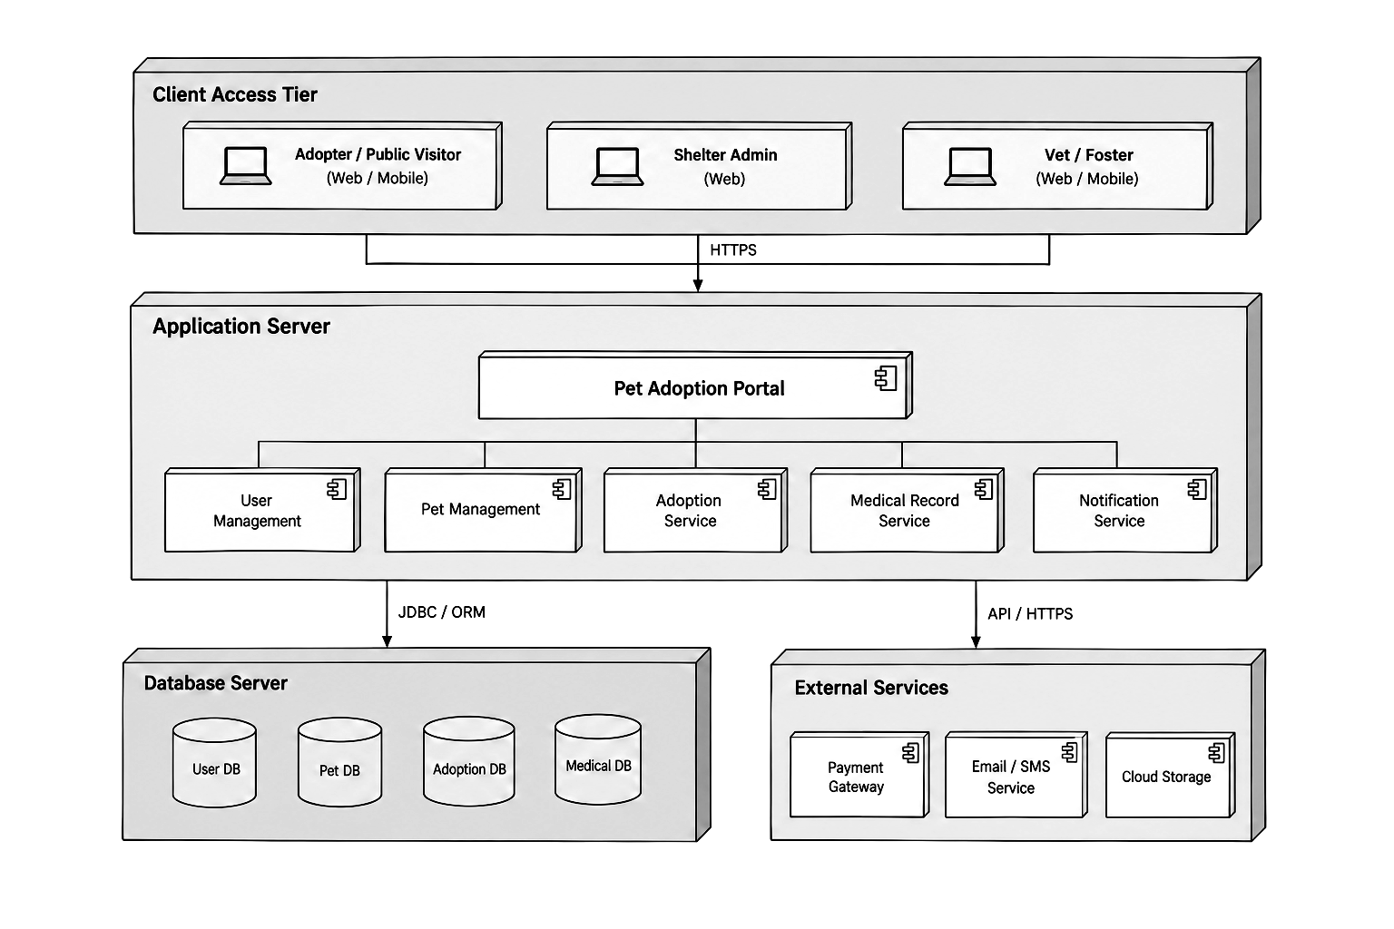
Figure A.1: 4-Tier System Architecture Diagram (PawHaven)
A.2 Component & Subsystem Architecture
The component diagram details the modular subsystem decomposition: Web/Mobile UI interfacing with the core Application Core, which coordinates User Management Service, Pet Management Service, Application Service, Review & Decision Service, Payment Service, and Notification Service, backed by their corresponding persistent data stores.
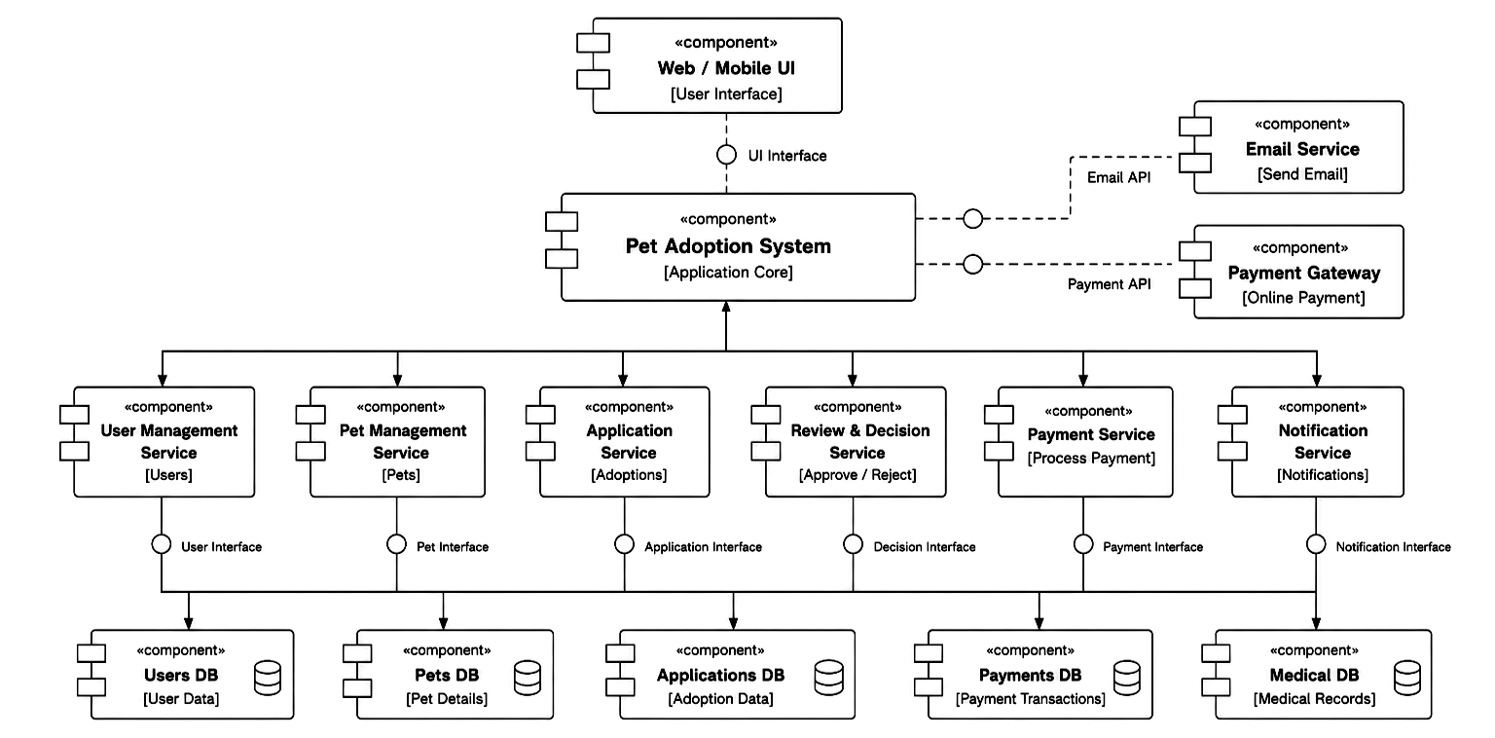
Figure A.2: UML Component Diagram – Subsystem Interfaces
A.3 Data Flow Diagram (DFD Level 0 & Level 1)
The Data Flow Diagram models the flow of data through external entities (Public Visitor, Shelter Staff, Pet Foster, Donor, Third Party Vet) into primary processes: 1.0 Manage Accounts, 2.0 Handle Adoptions, 3.0 Track Pet Health, 4.0 Process Payments, and 5.0 Manage Volunteers, and their read/write interactions with persistent databases.
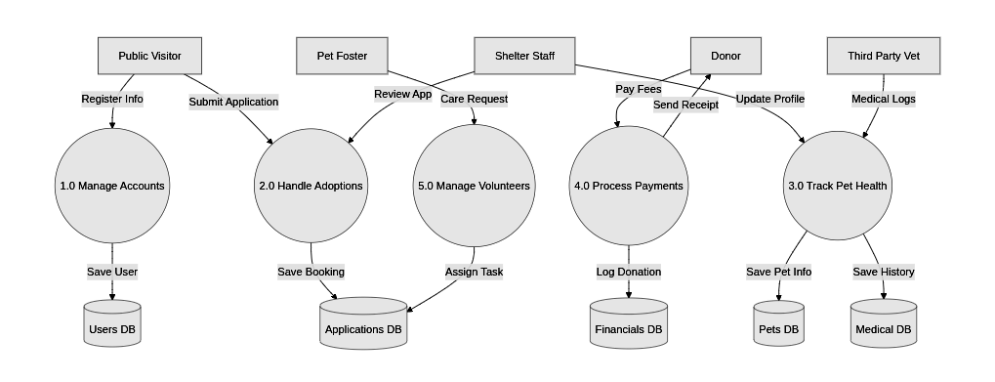
Figure A.3: Data Flow Diagram (DFD Level 1) – Operational Information Flows
A.4 Entity-Relationship (ER) Diagram
The ER diagram specifies the conceptual data model: USER entities (attributes: user_id, name, user_type) submitting ADOPTION APPLICATIONS, which associate candidates with PET entities (pet_id, name, status), along with associated MEDICAL RECORDS authored by veterinary staff.
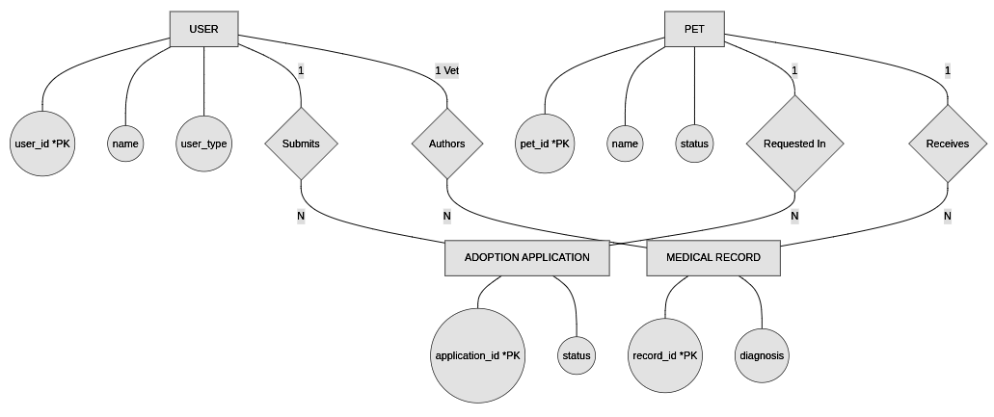
Figure A.4: Entity-Relationship Diagram (ERD) – Conceptual Data Schema
A.5 UML Collaboration Diagram (Communication Diagram)
The collaboration diagram depicts the structural interaction and numbered message passing between Adopter, Shelter Staff, Administrator, and the central Pet Adoption System object, detailing application submission, pet listing queries, review triggers, and notification broadcasts.
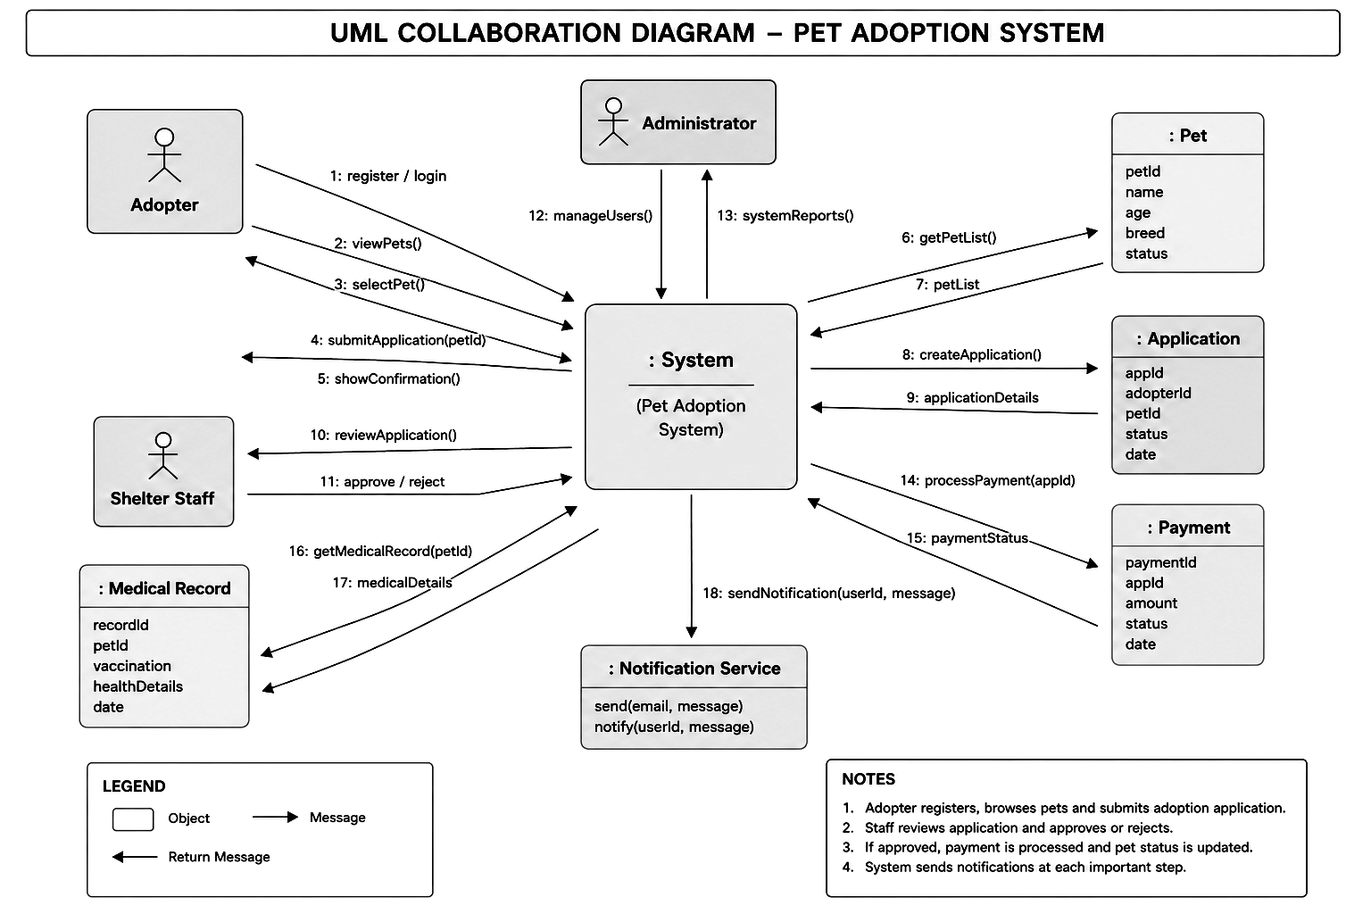
Figure A.5: UML Collaboration Diagram – Object Message Interactions
A.6 UML Sequence Diagram
The sequence diagram illustrates the chronological execution order across five distinct phases: 1. Register & Login, 2. Browse & Submit Application, 3. Review & Decision (with alternative branches for Approve vs Reject), 4. Payment processing, and 5. Finalization and automatic status notification.
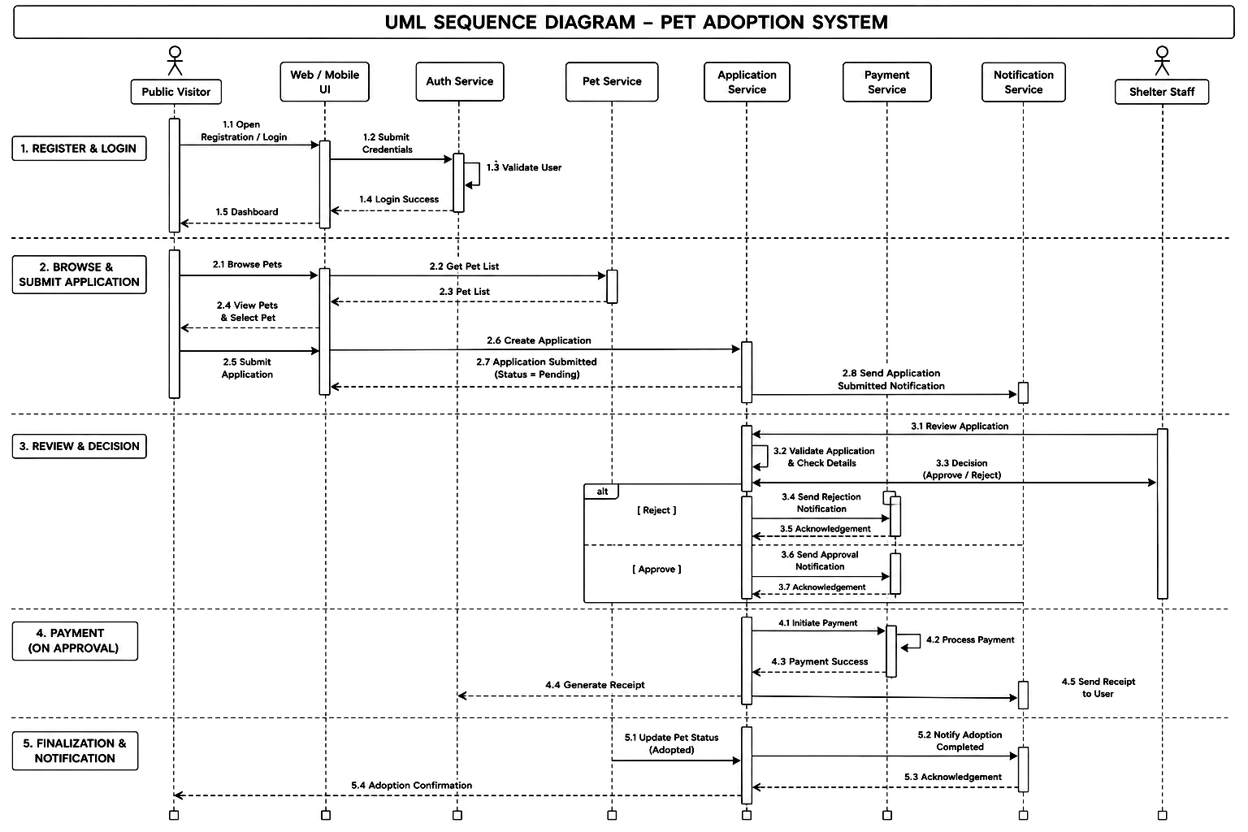
Figure A.6: UML Sequence Diagram – Adoption Lifecycle Message Sequence
A.7 UML Activity Diagram
The activity diagram models the operational workflow across four swimlanes: Public Visitor, System, Pet Adoption System, and Shelter Staff. It outlines the complete procedural flow from initial portal landing, pet browsing, and application dispatch through staff evaluation, decision branching, and status notification.
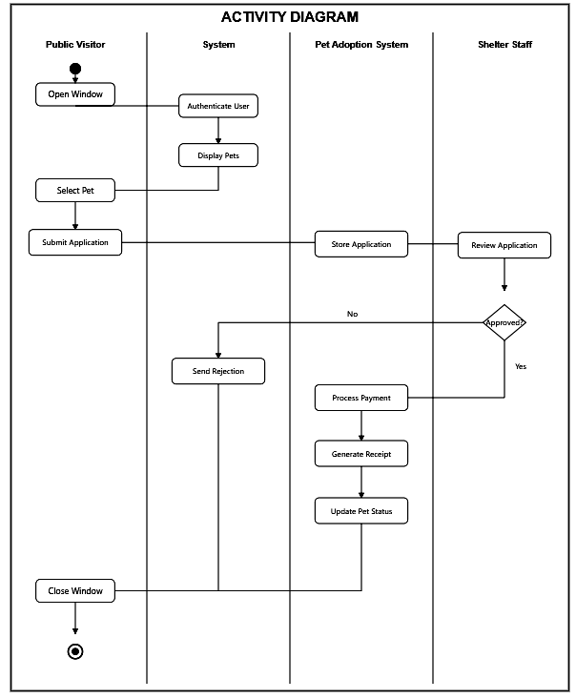
Figure A.7: UML Activity Diagram – Multi-Lane Operational Workflow
A.8 UML State Chart Diagram
The state chart diagram illustrates the state transitions for adoption requests and animal availability: transitioning from Start ➔ Register/Login ➔ Authenticated ➔ Dashboard ➔ Pet Selection ➔ Application Submission ➔ Staff Review ➔ Decision (Approved/Rejected) ➔ Payment Processing ➔ Pet Status Updated to 'Adopted' and final Notification dispatch.
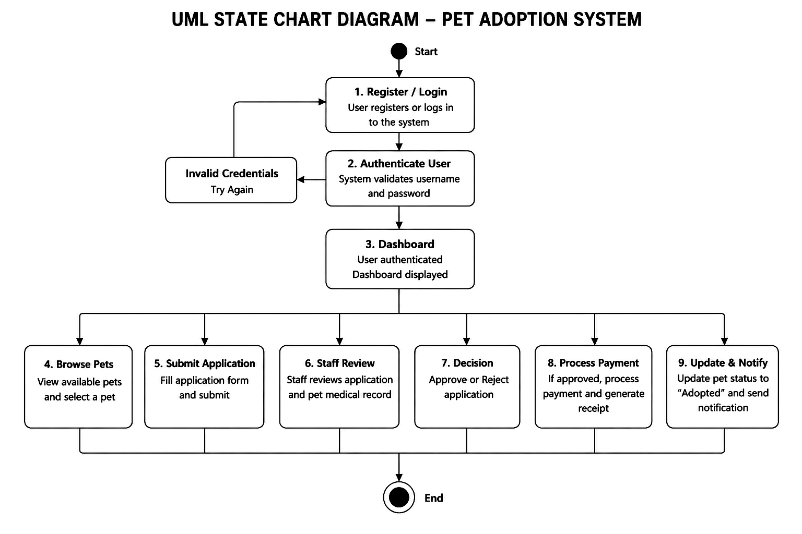
Figure A.8: UML State Chart Diagram – State Transition Machine

Appendix B: Database Schema & Source Code Highlights
B.1 MySQL Relational Database Schema (`schema.sql`)
The foundational database table definitions utilized by PawHaven:
-- MySQL Table Schema for PawHaven Pet Adoption Portal
CREATE DATABASE IF NOT EXISTS `pet_adoption_db`;
USE `pet_adoption_db`;
CREATE TABLE IF NOT EXISTS `users` (
`user_id` INT AUTO_INCREMENT PRIMARY KEY,
`full_name` VARCHAR(100) NOT NULL,
`email` VARCHAR(120) NOT NULL UNIQUE,
`phone` VARCHAR(25) NOT NULL,
`address` TEXT NOT NULL,
`password` VARCHAR(255) NOT NULL,
`role` ENUM('User', 'Admin') DEFAULT 'User',
`created_at` DATETIME DEFAULT CURRENT_TIMESTAMP
) ENGINE=InnoDB;
CREATE TABLE IF NOT EXISTS `pets` (
`pet_id` INT AUTO_INCREMENT PRIMARY KEY,
`name` VARCHAR(100) NOT NULL,
`species` ENUM('Dog', 'Cat', 'Rabbit', 'Bird', 'Other') NOT NULL,
`breed` VARCHAR(100) NOT NULL,
`age` INT NOT NULL,
`gender` ENUM('Male', 'Female') NOT NULL,
`size` ENUM('Small', 'Medium', 'Large') NOT NULL,
`health_status` VARCHAR(255) NOT NULL,
`image` VARCHAR(255) DEFAULT '/images/pets/default.jpg',
`description` TEXT NOT NULL,
`status` ENUM('Available', 'Pending', 'Adopted') DEFAULT 'Available',
`created_at` DATETIME DEFAULT CURRENT_TIMESTAMP
) ENGINE=InnoDB;
CREATE TABLE IF NOT EXISTS `adoption_applications` (
`application_id` INT AUTO_INCREMENT PRIMARY KEY,
`user_id` INT NOT NULL,
`pet_id` INT NOT NULL,
`occupation` VARCHAR(100) NOT NULL,
`house_type` VARCHAR(100) NOT NULL,
`pet_experience` TEXT NOT NULL,
`family_members` INT NOT NULL,
`reason` TEXT NOT NULL,
`status` ENUM('Pending', 'Approved', 'Rejected') DEFAULT 'Pending',
`applied_at` DATETIME DEFAULT CURRENT_TIMESTAMP,
`reviewed_at` DATETIME NULL,
`admin_notes` TEXT NULL,
FOREIGN KEY (`user_id`) REFERENCES `users`(`user_id`) ON DELETE CASCADE,
FOREIGN KEY (`pet_id`) REFERENCES `pets`(`pet_id`) ON DELETE CASCADE
) ENGINE=InnoDB;
CREATE TABLE IF NOT EXISTS `notifications` (
`notification_id` INT AUTO_INCREMENT PRIMARY KEY,
`user_id` INT NOT NULL,
`message` TEXT NOT NULL,
`type` ENUM('info', 'success', 'warning', 'danger') DEFAULT 'info',
`is_read` TINYINT(1) DEFAULT 0,
`created_at` DATETIME DEFAULT CURRENT_TIMESTAMP,
FOREIGN KEY (`user_id`) REFERENCES `users`(`user_id`) ON DELETE CASCADE
) ENGINE=InnoDB;
B.2 Core Application Controller (`controllers/applicationController.js`)
Atomic business logic managing application approval, pet state transition, and competitor auto-rejection:
// controllers/applicationController.js extract
exports.updateApplicationStatus = async (req, res) => {
const { id } = req.params;
const { status, admin_notes } = req.body;
const [appRows] = await db.query('SELECT * FROM adoption_applications WHERE application_id = ?', [id]);
const application = appRows[0];
if (status === 'Approved') {
// 1. Update application status to Approved
await db.query('UPDATE adoption_applications SET status = ?, admin_notes = ?, reviewed_at = NOW() WHERE application_id = ?',
['Approved', admin_notes || 'Application approved by shelter staff', id]);
// 2. Atomically toggle pet availability to Adopted
await db.query('UPDATE pets SET status = "Adopted" WHERE pet_id = ?', [application.pet_id]);
// 3. Notify the approved candidate
await db.query('INSERT INTO notifications (user_id, message, type) VALUES (?, ?, ?)',
[application.user_id, 'Congratulations! Your adoption application has been APPROVED.', 'success']);
// 4. Auto-reject other competing applications for this animal
const [otherApps] = await db.query(
'SELECT * FROM adoption_applications WHERE pet_id = ? AND application_id != ? AND status = "Pending"',
[application.pet_id, id]);
for (const other of otherApps) {
await db.query('UPDATE adoption_applications SET status = "Rejected", admin_notes = ? WHERE application_id = ?',
['This animal was successfully adopted by an earlier approved candidate.', other.application_id]);
await db.query('INSERT INTO notifications (user_id, message, type) VALUES (?, ?, ?)',
[other.user_id, 'Notice: The pet you applied for has been adopted by another applicant.', 'info']);
}
}
return res.json({ success: true, message: `Application status updated to ${status}` });
};

Appendix C: System Verification & Demonstration
This section documents the end-to-end verification walkthrough of the PawHaven Pet Adoption Portal, confirming that all requirements specified in Sections 4 and 5 are fully satisfied by the deployed application.
C.1 Default Evaluation Test Credentials
For evaluation, demonstration, and viva voce testing, the application initializes the following accounts on boot:
Role | Email Address | Password | Permissions
Shelter Admin | admin@pawhaven.com | admin123 | Full Administrative Access (/admin, approvals, pet inventory CRUD)
Adopter (Demo 1) | sarah@example.com | user123 | Adopter Portal (/dashboard, application filing, in-app alerts)
Adopter (Demo 2) | alex@example.com | user123 | Secondary Adopter account for testing concurrent applicant workflows
C.2 Step-by-Step Demonstration Walkthrough
- Step 1: Public Exploration: Navigate to http://localhost:3000 to view the public home page featuring live rescue counters, mission pillars, and featured animals.
- Step 2: Pet Search: Click 'Adopt a Pet' to access the interactive catalog. Click filter pills ('Dog', 'Cat', 'Rabbit') to verify reactive DOM updates without full page reloads.
- Step 3: Animal Bio: Click on 'Luna' or 'Bailey' to inspect full animal bios, health status tags, and vaccination verification.
- Step 4: Authentication: Log in as Sarah Jenkins (sarah@example.com) using the 1-Click Demo Credentials button on `/login`.
- Step 5: Application Filing: Submit an adoption application filling in housing details (Single Family Home, fenced yard, 3 family members).
- Step 6: Staff Review: Log out and log in as Shelter Admin (admin@pawhaven.com). Access `/admin` to inspect real-time KPI metrics and the pending review queue.
- Step 7: Decision Execution: Open the application modal, review candidate responses, enter approval notes, and click 'Approve Application'.
- Step 8: Integrity Verification: Confirm that the pet availability immediately updates to 'Adopted', competing applicants receive polite auto-rejection notifications, and the adopter dashboard shows the success alert.

