AI ASSISTED CODING LAB
ASSIGNMENT-10.2
Name: Guangsinlung Phaomei
Enroll no: 2503A51L20
Batch: 19

TASK DESCRIPTION 1:
- Write python program as shown below.

- Use an AI assistant to review and suggest corrections.

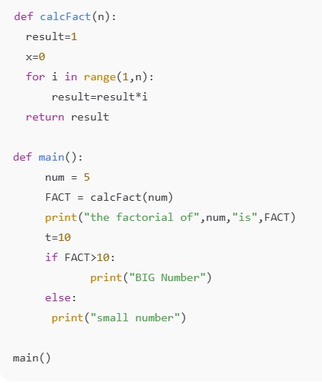

PROMPT 1:
Generate a Python program that calculates the factorial of a number using a function. Then, use a conditional statement to print whether the result is a "BIG Number" or a "small number" based on a threshold.
CODE GENERATED:

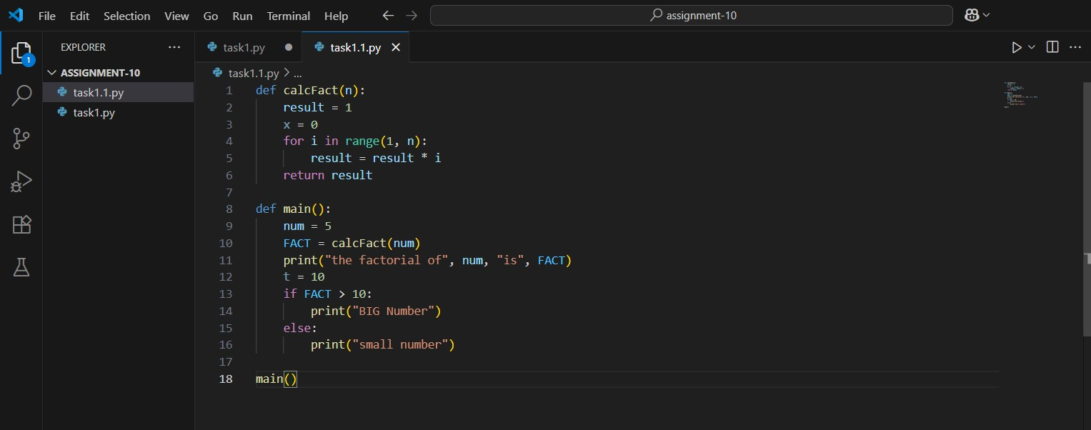
OUTPUT:

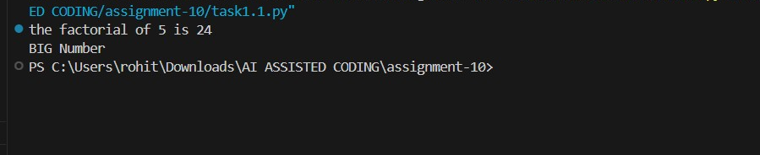

CORRECT CODE GENERATED:

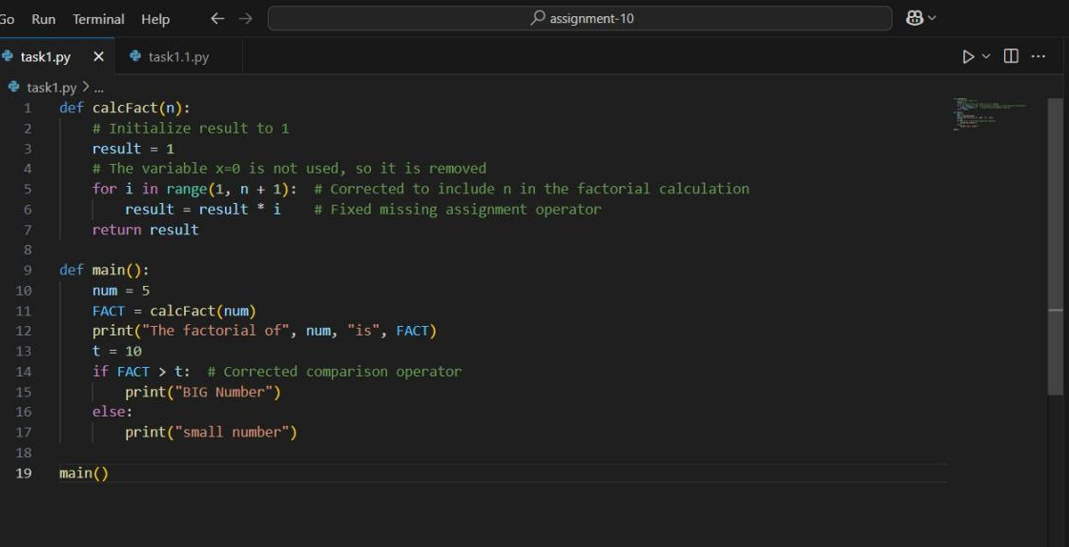
OUTPUT:
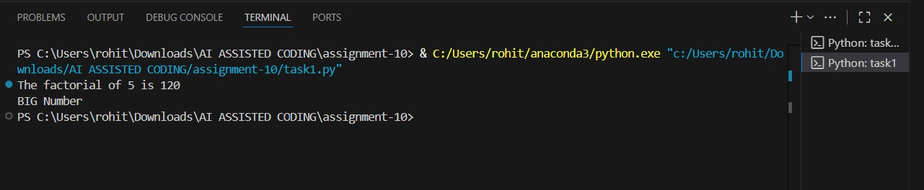

OBSERVATION:
I created a Python program using functions, loops, and conditionals to calculate factorials. With AI help, I improved logic and readability, showing a clear understanding of Python basics

TASK DESCRIPTION 2:
Write the Python code for Fibonacci as shown below and execute.
Ask AI to improve variable names, add comments, and apply PEP8 formatting (cleaned up).
Students evaluate which suggestions improve readability most. one.
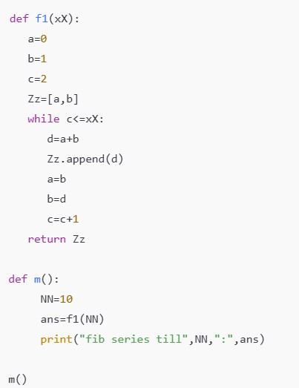

PROMPT 1:
Write a Python program using a function to generate the Fibonacci series up to a given number of terms, then review the code with an AI assistant.

CODE GENERATED: 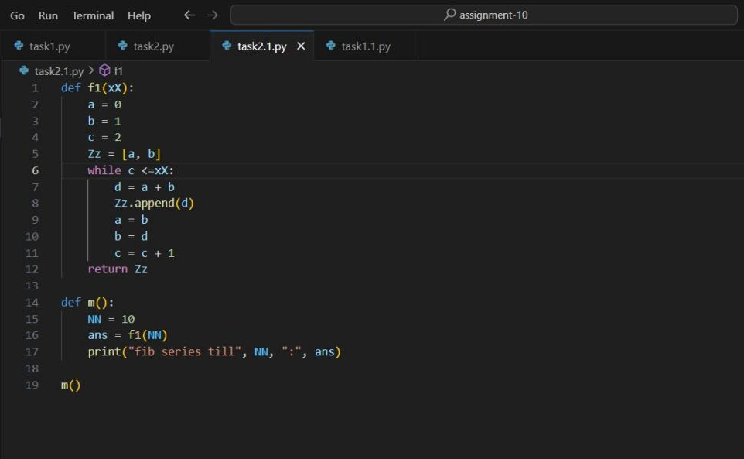
OUTPUT:
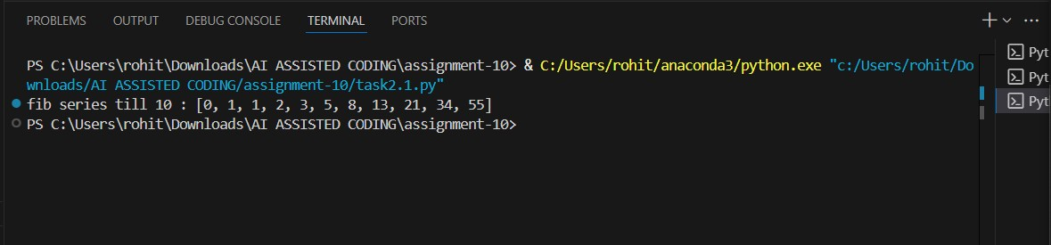
COREECT CODE GENERATED:

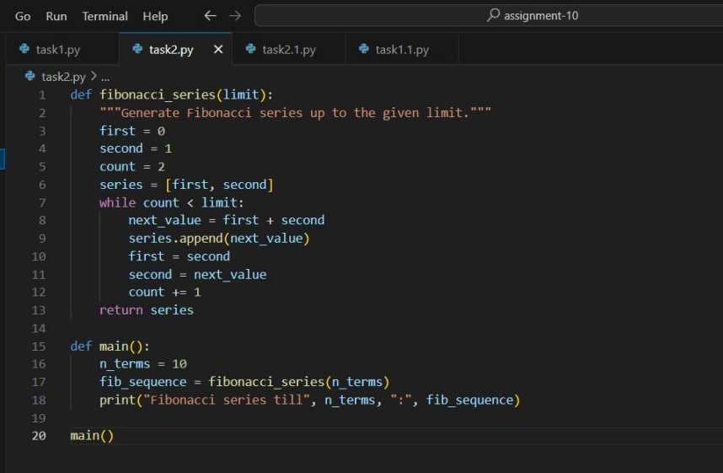

OUTPUT:

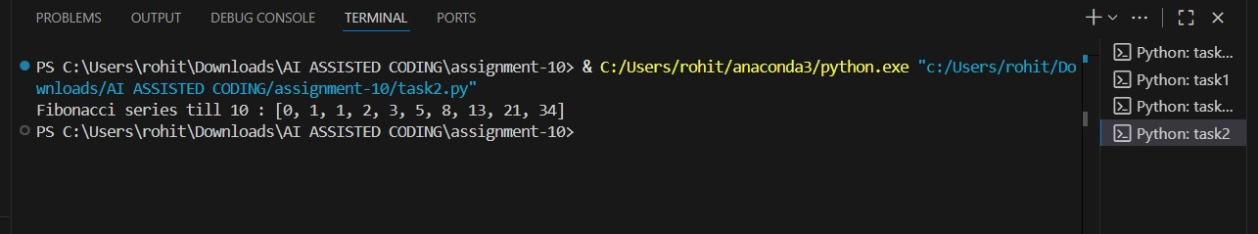
OBSERVATION:
I created a Python program to generate the Fibonacci series using a function and loop. With AI feedback, I improved variable naming, formatting, and code clarity, enhancing readability and showing strong understanding and improvement through feedback

TASK DESCRIPTION 3:
- Write a Python script with 3–4 functions (e.g., calculator: add, subtract, multiply, divide).
- Incorporate manual docstring in code with NumPy Style
- Use AI assistance to generate a module-level docstring + individual function docstrings.
- Compare the AI-generated docstring with your manually written one.

PROMPT 1:
Generate a Python program that does basic math (like adding, subtracting, multiplying, dividing) and practice writing clear documentation for your code.
CODE GENERATED:

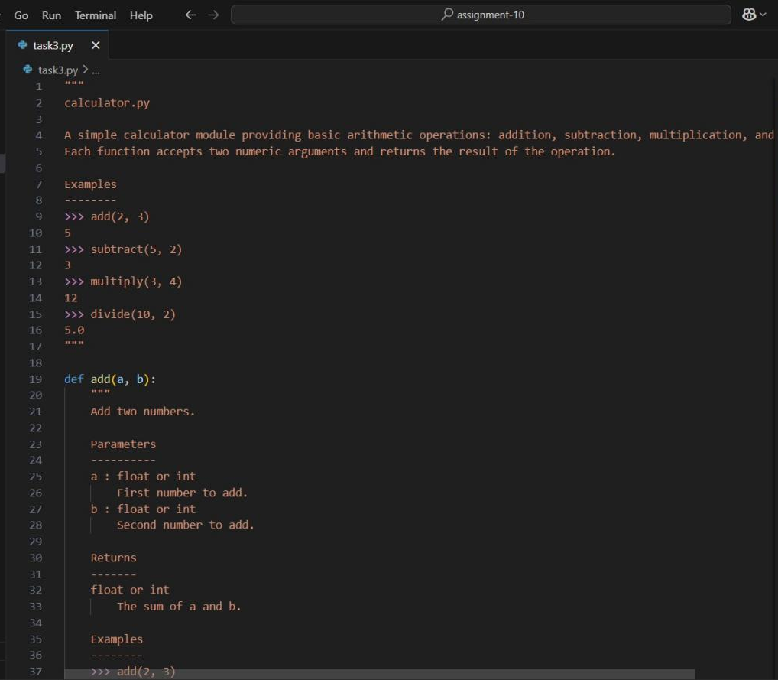

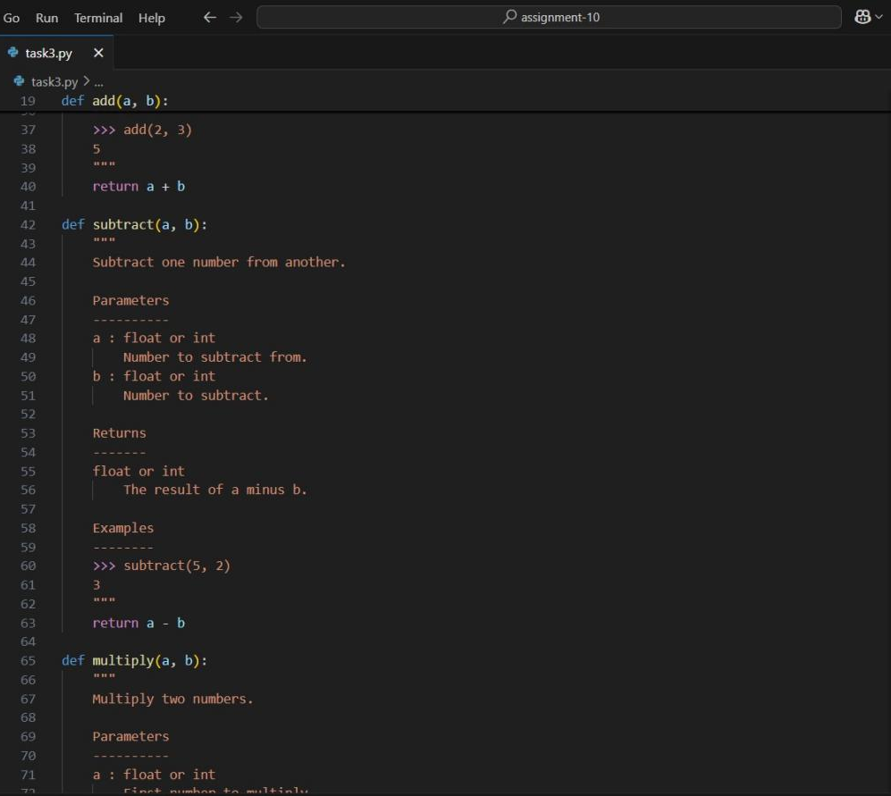

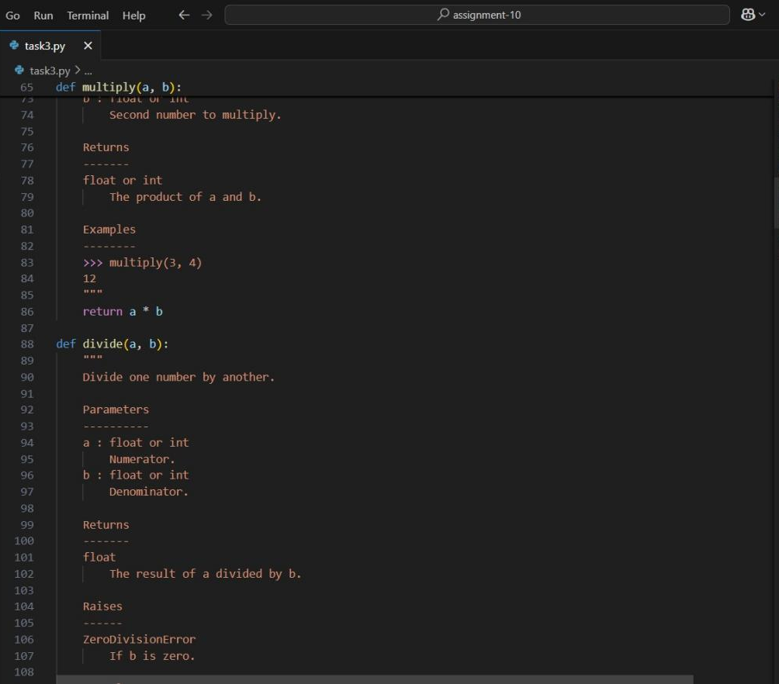

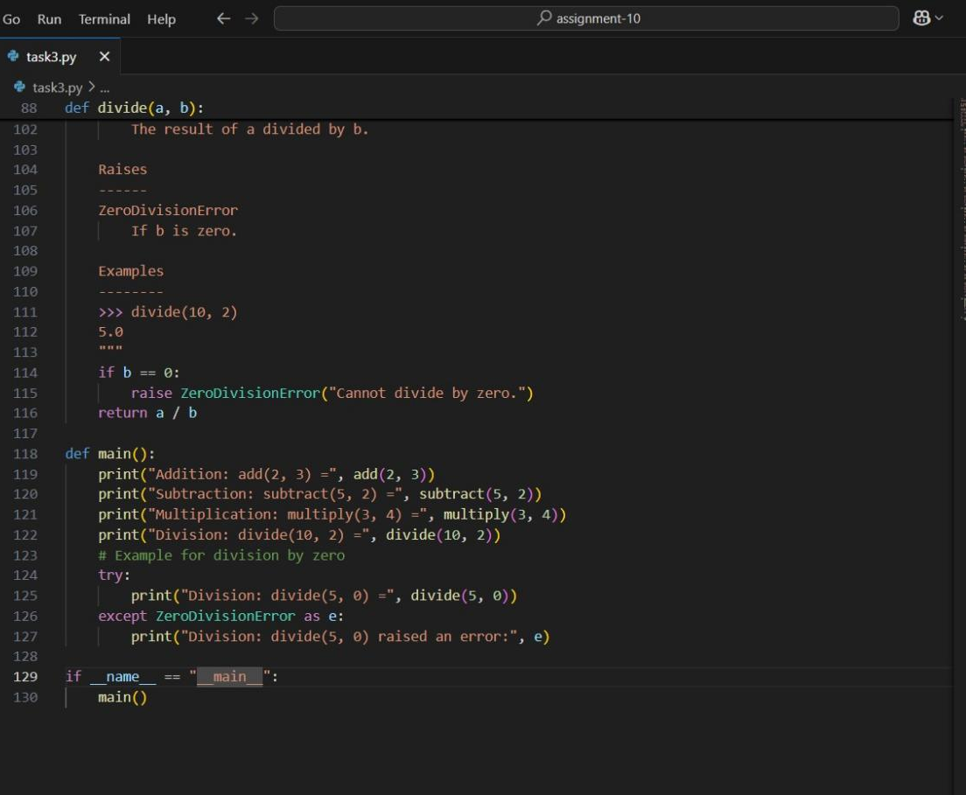
OUTPUT:

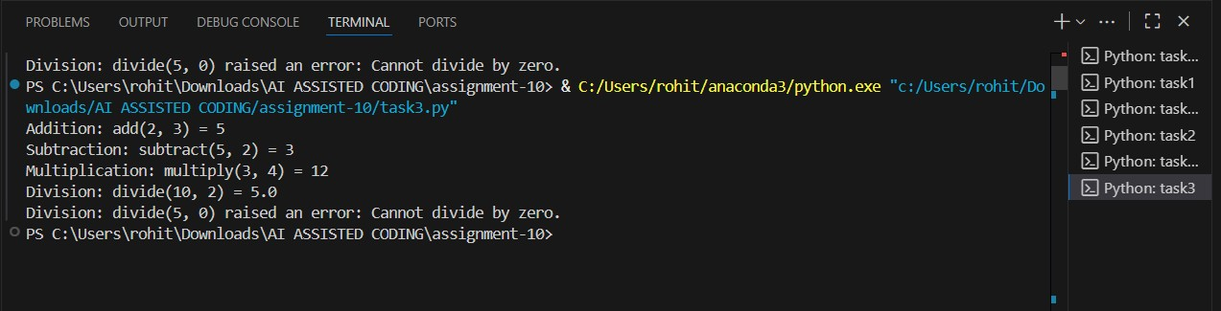
OBSERVATION:
This assignment combines Python function design with good documentation practices. It reinforces core concepts like functions and parameters while promoting clear, professional NumPy-style docstrings. Comparing manual and AI-generated docstrings improved understanding of clarity and formatting.

