AI ASSISTED CODING LAB
ASSIGNMENT-11.4
Name: Guangsinlung Phaomei
Enroll no: 2503A51L20
BATCH NO: 19

TASK DESCRIPTION 1:
Use AI to help implement a Stack class in Python with the following operations: push (), pop (), peek (), and is empty ().
Instructions:
  - Ask AI to generate code skeleton with docstrings.
  - Test stack operations using sample data.
  - Request AI to suggest optimizations or alternative implementations (e.g., using collections. Deque).

PROMPT 1:
Write a Python program that defines a Stack class with push, pop, peek, and is_empty methods. Include clear comments or docstrings, test it with sample data, and have the AI suggest improvements using collections.deque for efficiency and readability.

CODE GENERATED:

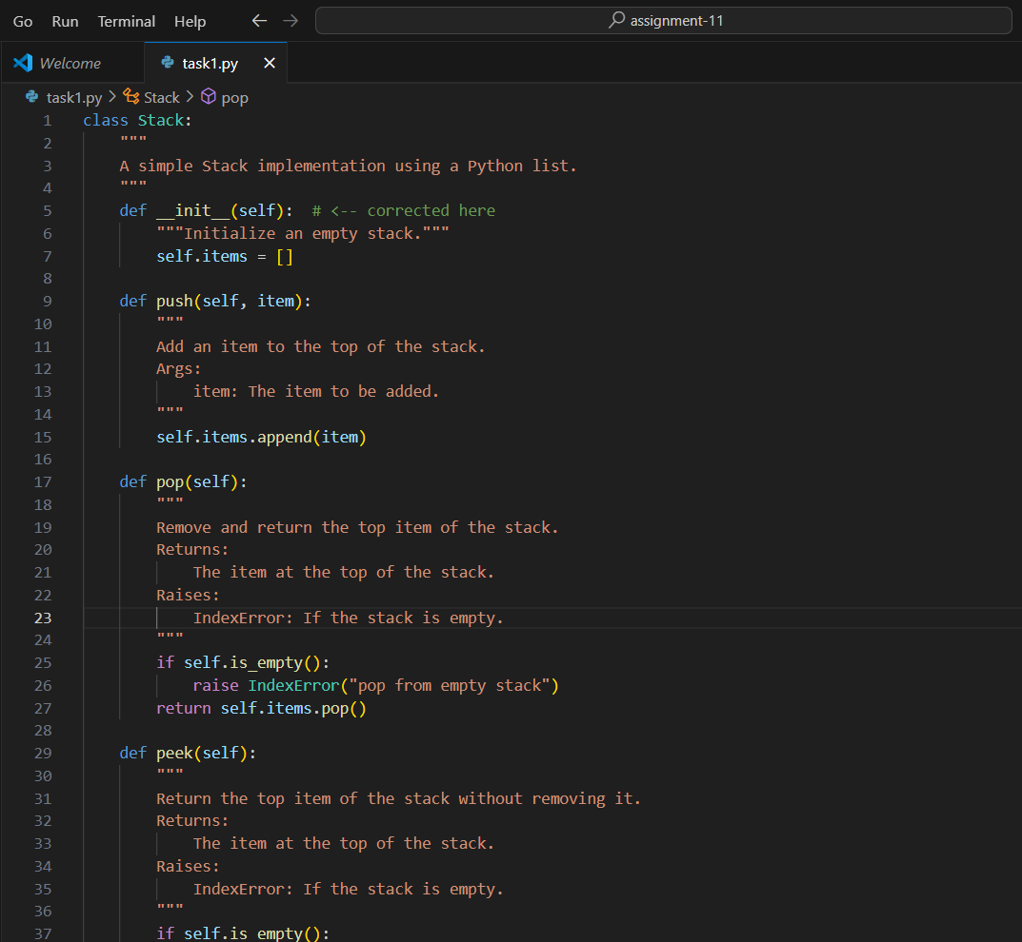

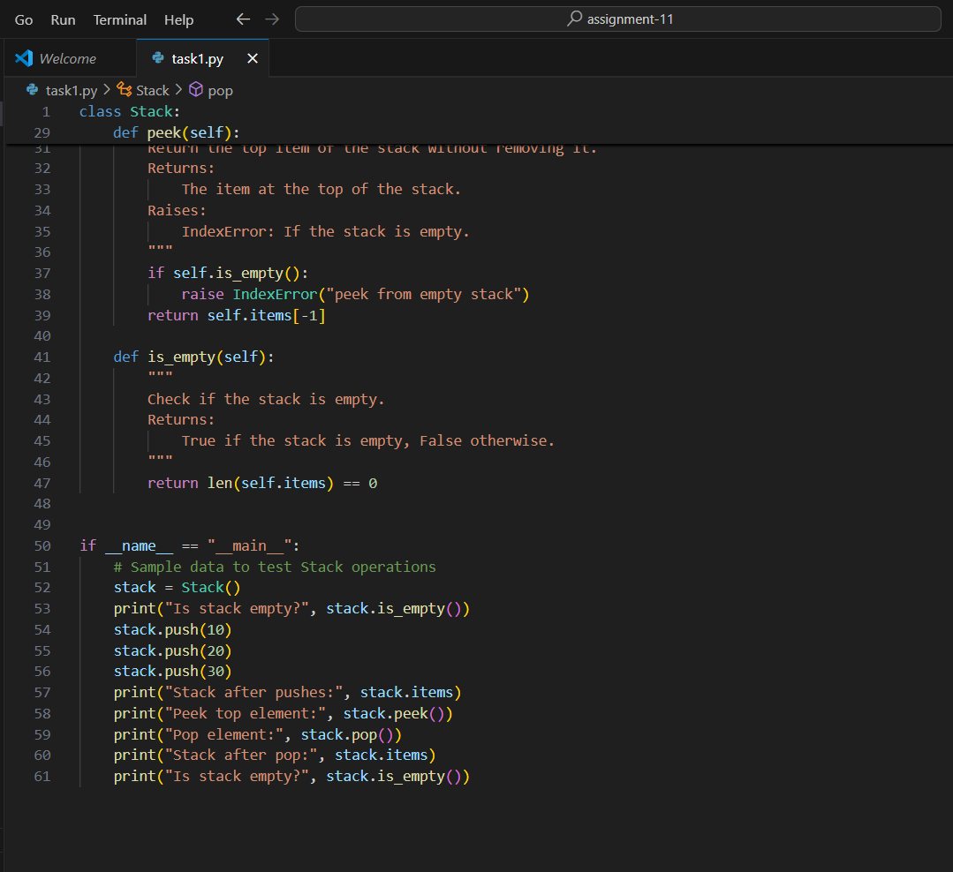

OUTPUT:

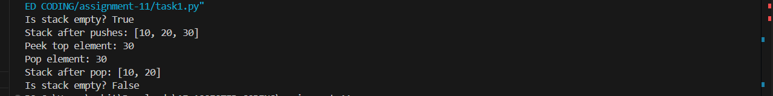

OBSERVATION:
This assignment demonstrates strong understanding of data structures by implementing a Stack class with key operations. It emphasizes clean code, documentation, and testing, while AI suggestions using collections.deque improved efficiency and Pythonic design.

TASK DESCRIPTION 2:
Implement a Queue with enqueue (), dequeue (), and is empty () methods.
- Instructions:
  - First, implement using Python lists.
  - Then, ask AI to review performance and suggest a more efficient implementation (using collections. Deque).

PROMPT 1:
Write a Python program that defines a Queue class with enqueue, dequeue, and is_empty methods using a list. Test it, then have the AI suggest improvements using collections.deque for better performance and efficiency.

CODE GENERATED:

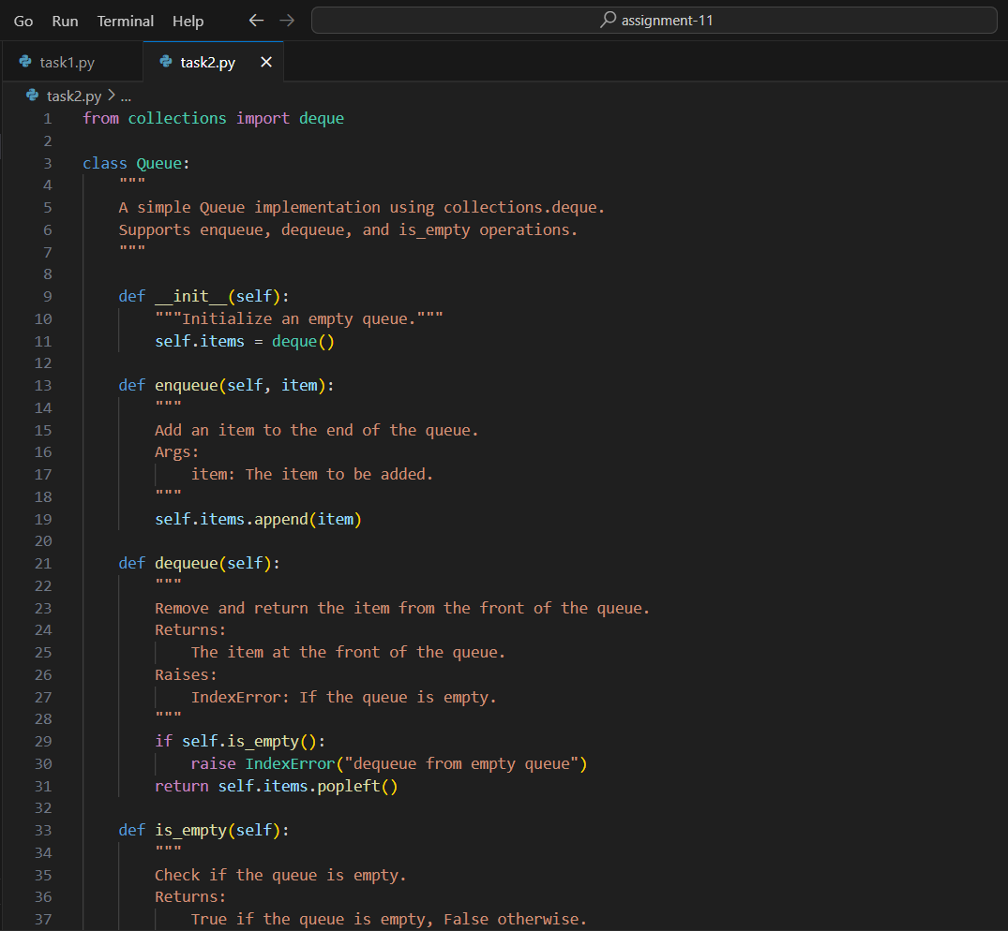

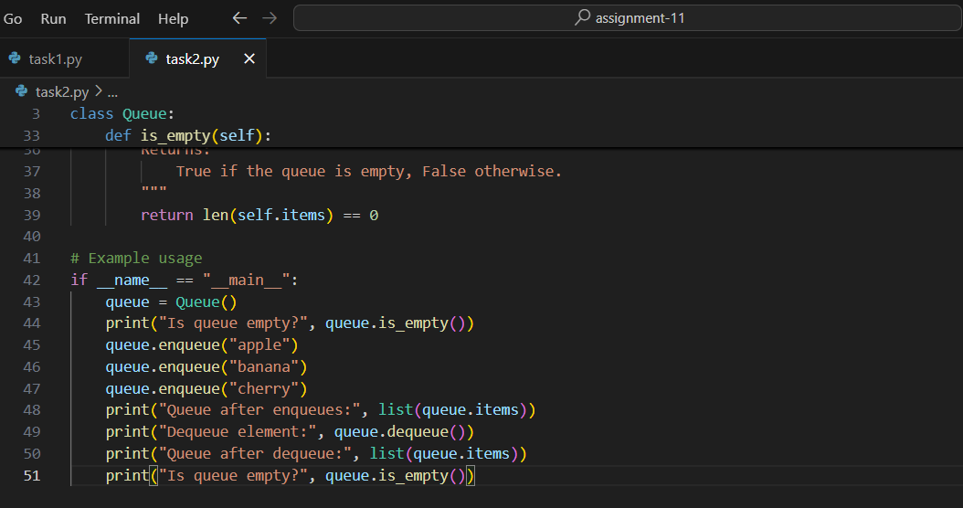
OUTPUT:

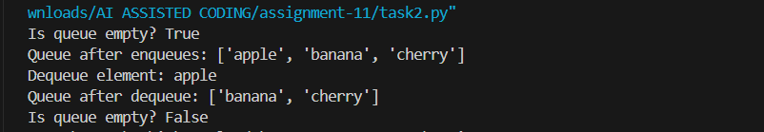

OBSERVATION:
This assignment provides a solid introduction to queue data structures and the importance of writing efficient code. By first implementing a Queue class with Python lists, it reinforces core concepts like enqueueing and dequeuing. The AI’s review highlights performance issues with list-based queues and suggests using collections.deque, which offers faster, more memory-efficient operations. Overall, the task effectively combines coding practice with performance analysis and Pythonic improvement.

TASK DESCRIPTION 3:
Implement a Singly Linked List with operations: instated (), delete value (), and traverse ().
- Instructions:
  - Start with a simple class-based implementation (Node, LinkedList).
  - Use AI to generate inline comments explaining pointer updates (which are non-trivial).
  - Ask AI to suggest test cases to validate all operations.
PROMPT 1:
Create a Python program for a Singly Linked List with insert(), delete_value(), and traverse() methods using Node and LinkedList classes. Include inline comments explaining pointer updates, and have the AI suggest test cases for all operations, including edge cases

CODE GENERATED:

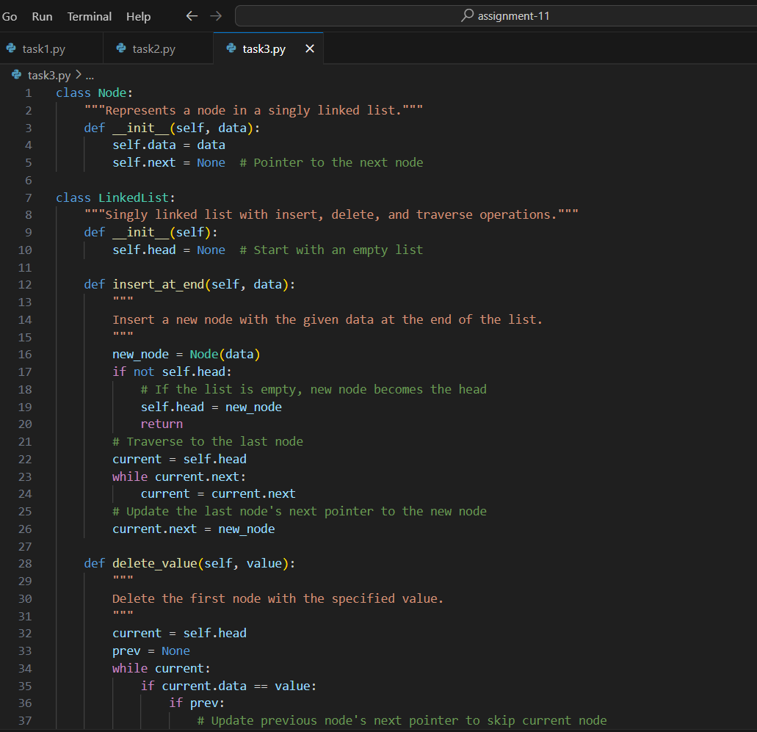

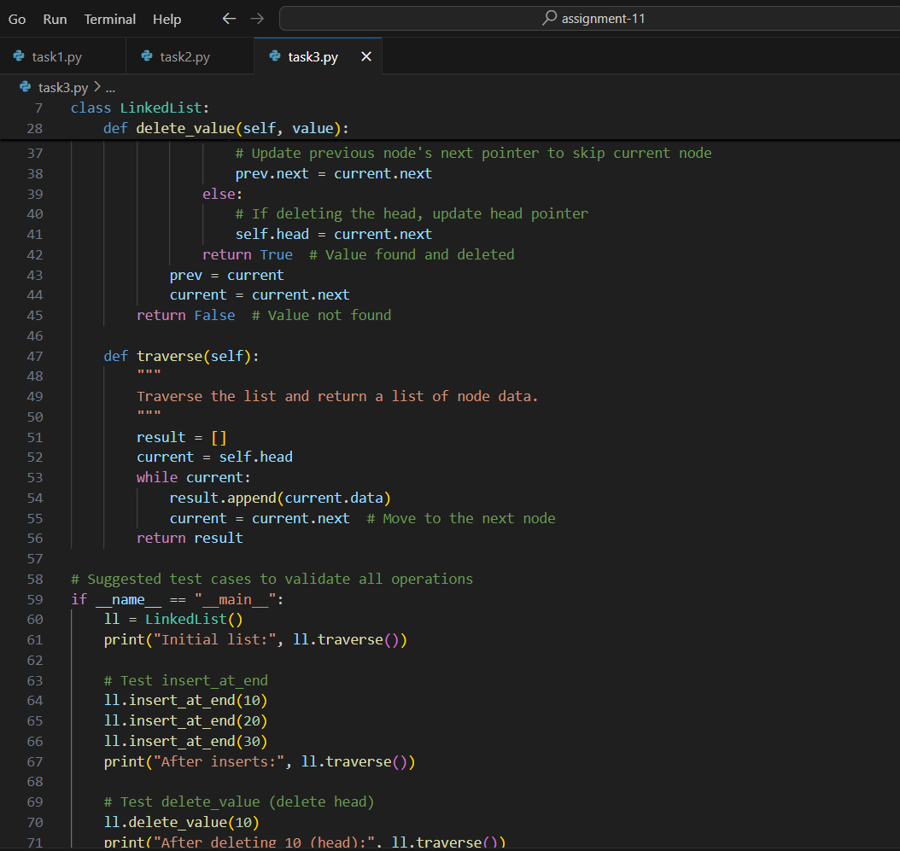

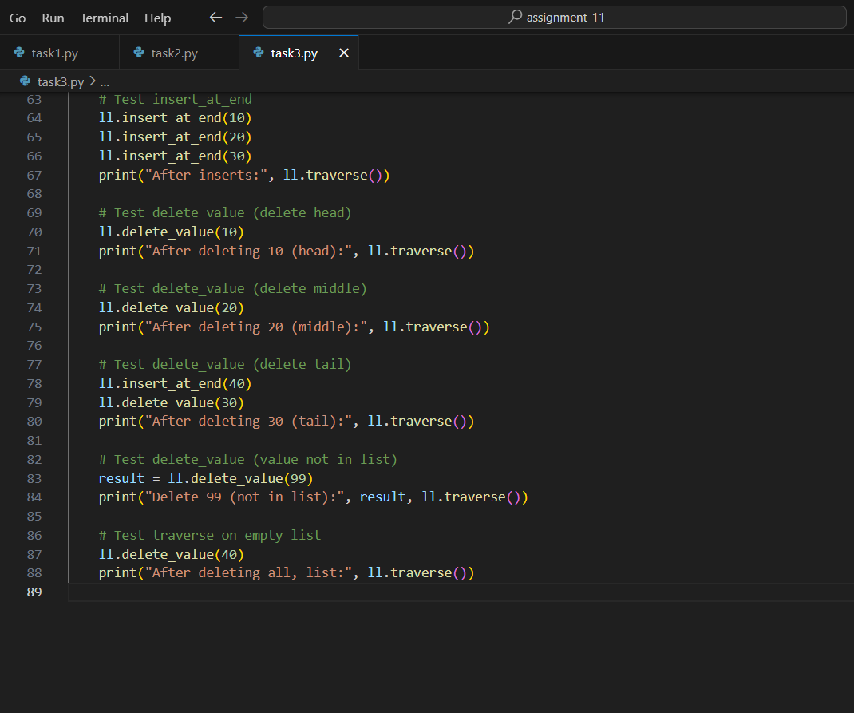

OUTPUT:

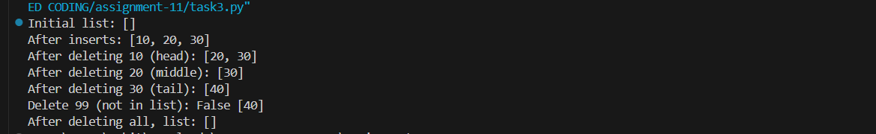

OBSERVATION:
This assignment provides practical experience with singly linked lists and pointer manipulation. Implementing insert(), delete_value(), and traverse() reinforces node handling and object-oriented design. AI-generated comments clarify pointer updates, while test cases for edge conditions ensure thorough validation and deeper understanding.

TASK DESCRIPTION 4:
- Implement a Binary Search Tree with methods for insert (), search (), and inorder_traversal ().
- Instructions:
  - Provide AI with a partially written Node and BST class.
  - Ask AI to complete missing methods and add docstrings.
Test with a list of integers and compare outputs of search () for present vs absent elements.

PROMPT 1:
Create a Python program for a Binary Search Tree with insert(), search(), and inorder_traversal() methods in Node and BST classes. Add docstrings for each method, then test the tree using a list of integers to compare search results for existing and missing values

CODE GENERATED:

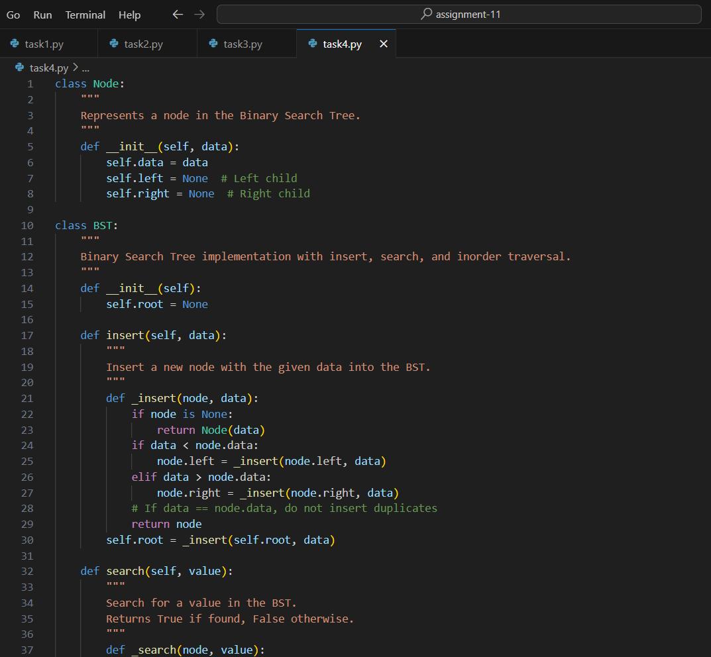

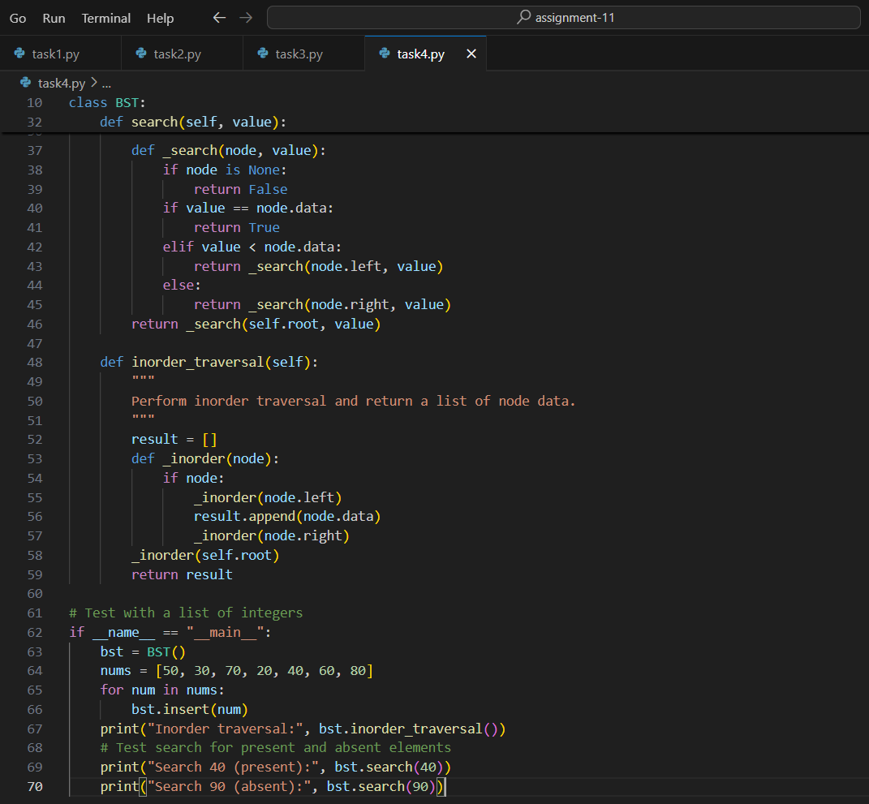
OUTPUT:

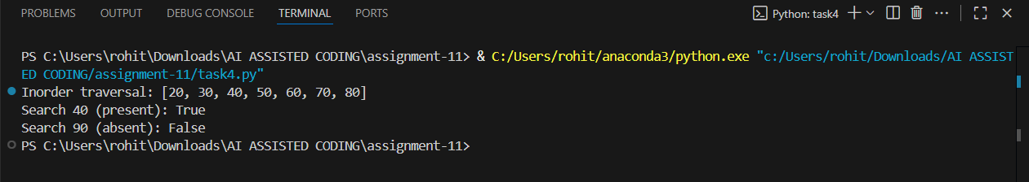

OBSERVATION:
This assignment provides a clear introduction to recursive data structures through a Binary Search Tree. Completing the insert(), search(), and inorder_traversal() methods builds understanding of tree logic, while AI-generated docstrings and testing with sample data reinforce clarity, validation, and good coding practices.

TASK DESCRIPTION 5:
Implement a Graph using an adjacency list, with traversal methods BFS () and DFS ().
- Instructions:
  - Start with an adjacency list dictionary.
  - Ask AI to generate BFS and DFS implementations with inline comments.
  - Compare recursive vs iterative DFS if suggested by AI.

PROMPT 1:
Create a Python program for a Graph using an adjacency list (dictionary). Implement BFS() and DFS() traversal methods with clear inline comments explaining node visits and tracking. Include both recursive and iterative DFS versions, and compare their readability and performance.

CODE GENERATED:

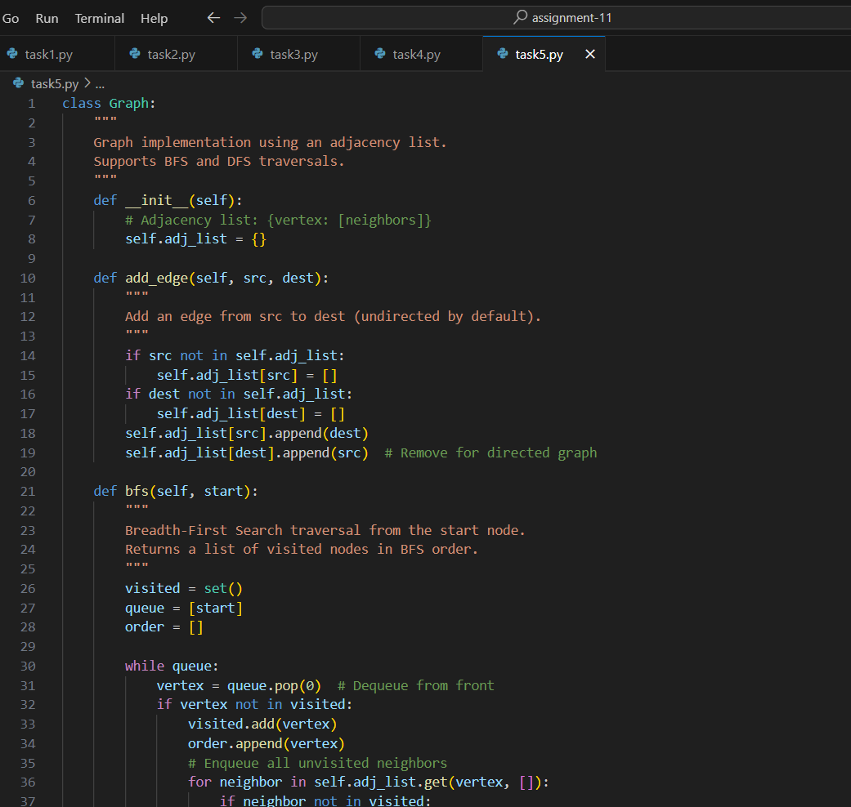

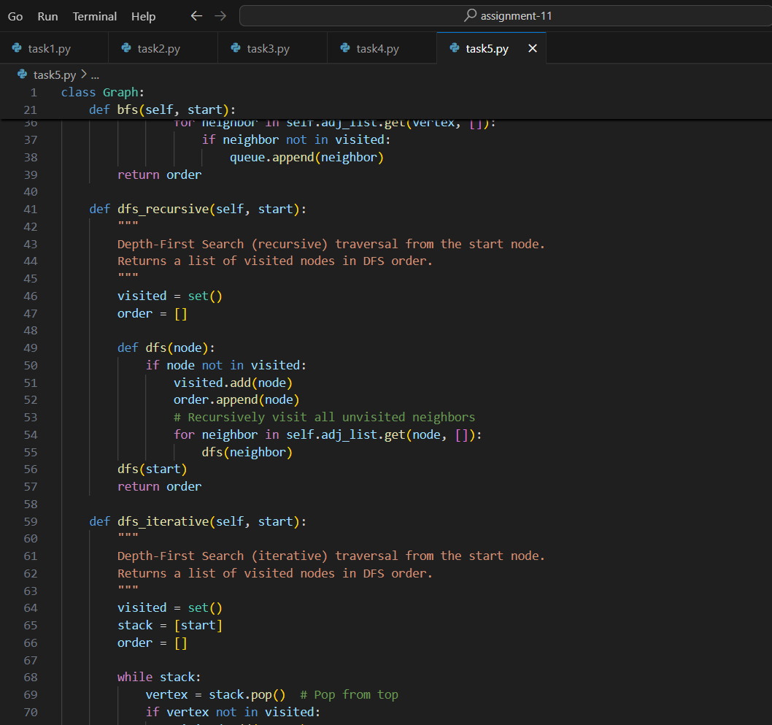

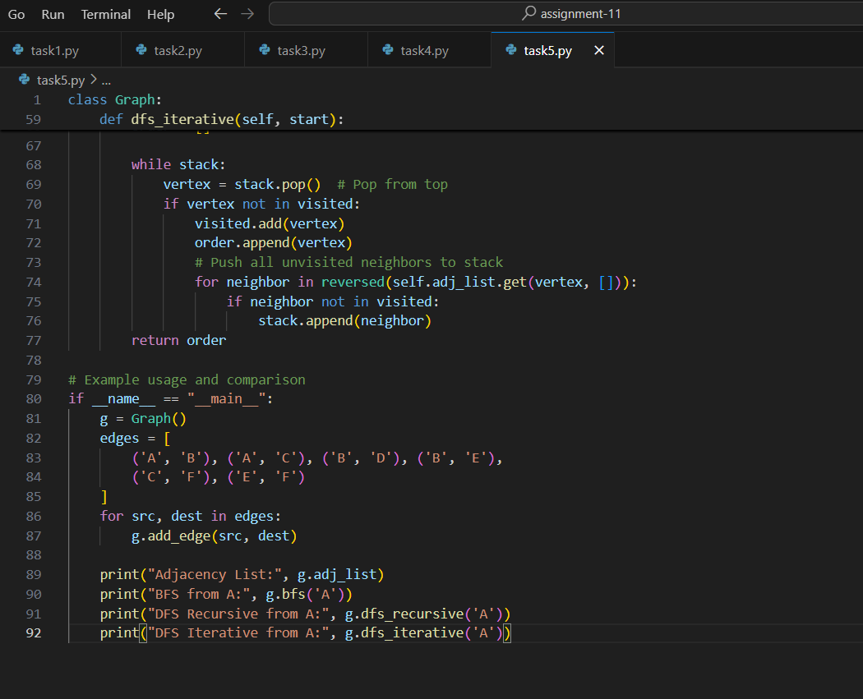
OUTPUT:

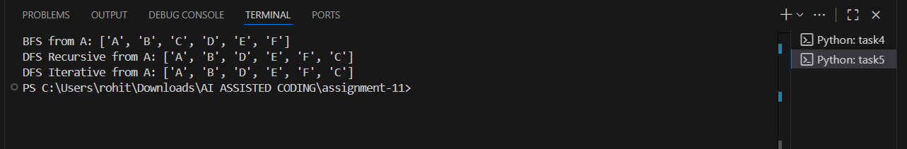

OBSERVATION:
This assignment builds a solid understanding of graph traversal using an adjacency list in Python. Implementing BFS and DFS helps explore different traversal strategies, while inline comments clarify node visits and tracking. Comparing recursive and iterative DFS adds insight into performance and readability, combining practical coding with analytical learning.

