AI ASSISTED CODING LAB
ASSIGNMENT-12.2
Name: Guangsinlung Phaomei
Enroll no: 2503A51L20
Batch no: 19

TASK DECRIPTION 1:
- Use AI to generate a Python program that implements the Merge Sort algorithm.
- Instructions:
  - Prompt AI to create a function merge sort(art) that sorts a list in ascending order.
  - Ask AI to include time complexity and space complexity in the function docstring.
  - Verify the generated code with test cases.

PROMPT 1:
Write a Python program that implements Merge Sort with a function merge_sort(arr) to sort a list in ascending order. Include a docstring explaining the algorithm and its time and space complexity, and add test cases to verify correctness.

CODE GENERATED:

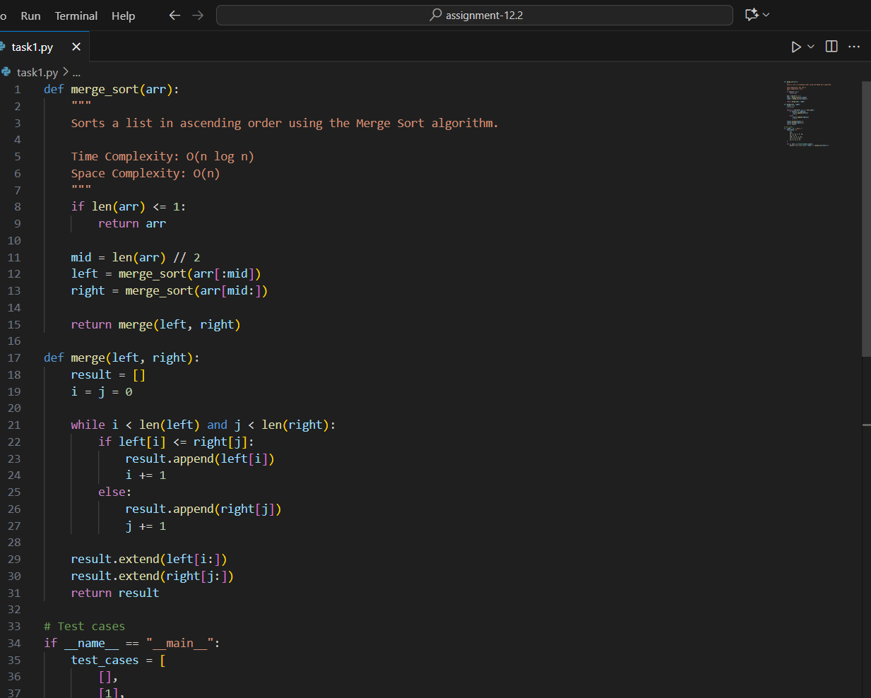

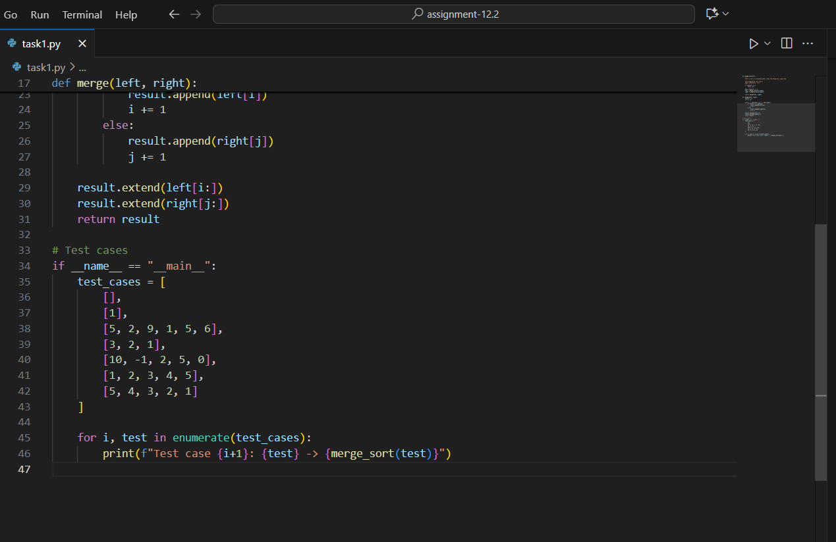

OUTPUT:

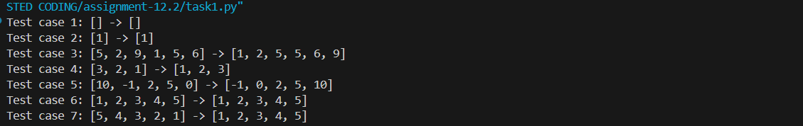

OBSERVATION:
In this task, AI was used to generate a Python implementation of the Merge Sort algorithm. The AI provided a well-documented merge_sort() function explaining the algorithm’s logic, time, and space complexity. Test cases ensured the program’s correctness and reliability. Overall, the task demonstrated how AI can accelerate coding, enhance documentation quality, and support thorough verification

TASK DESCRIPTION 2:
- Use AI to create a binary search function that finds a target element in a sorted list.
- Instructions:
  - Prompt AI to create a function binary search (art, target) returning the index of the target or -1 if not found.
  - Include docstrings explaining best, average, and worst-case complexities.
  - Test with various inputs.

PROMPT 1:
Write a Python program that implements Binary Search with a function binary_search(arr, target) returning the index if found or -1 if not. Add a docstring explaining the algorithm and its time complexities, and include test cases to verify correctness.

CODE GENERATED:

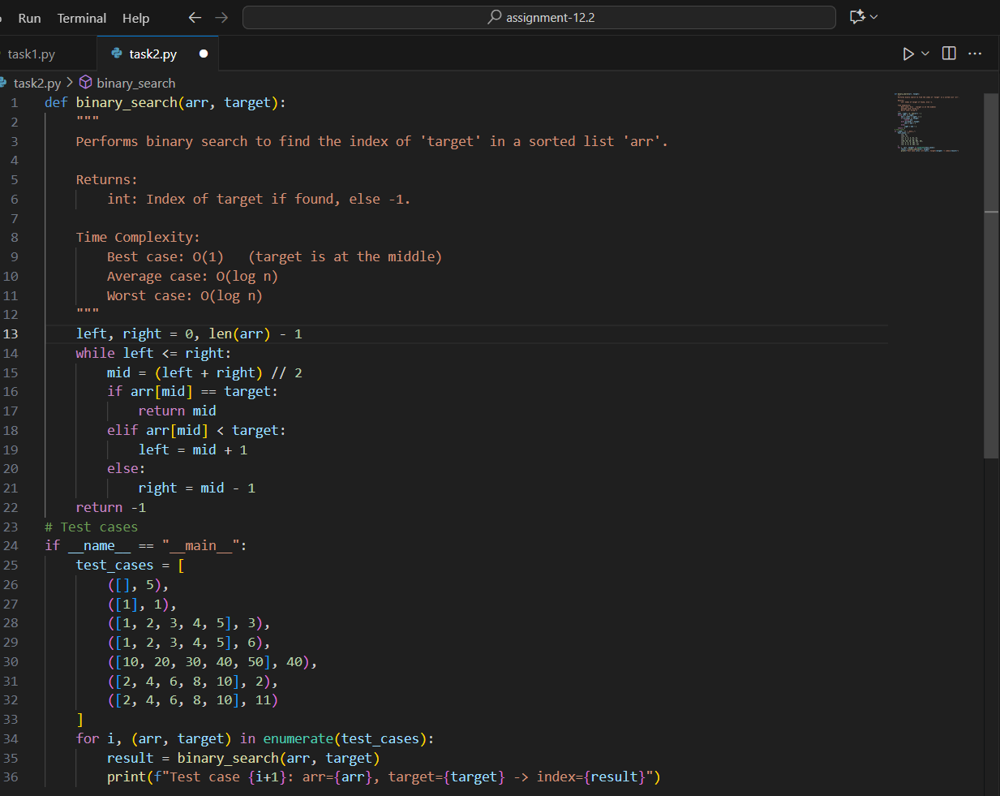
OUTPUT:

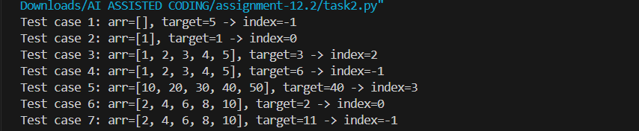

OBSERVATION:
In this task, AI was used to create a Python Binary Search program. The function accurately returned the target index or -1, with a clear docstring explaining the algorithm and its time complexities. Test cases verified correctness and efficiency, showing how AI supports coding and documentation effectively.

TASK DESCRIPTION 3:
- Scenario: A retail store’s inventory system contains thousands of products, each with attributes like product ID, name, price, and stock quantity. Store staff need to:
  - Quickly search for a product by ID or name.
  - Sort products by price or quantity for stock analysis.
- Task:
  - Use AI to suggest the most efficient search and sort algorithms for this use case.
  - Implement the recommended algorithms in Python.
  - Justify the choice based on dataset size, update frequency, and performance requirements.

PROMPT 1:
Create a Python program for a retail store inventory system with products having ID, name, price, and stock quantity. Implement efficient search (by ID or name) and sort (by price or quantity) algorithms, and explain why they’re suitable based on dataset size, update frequency, and performance.

CODE GENERATED:

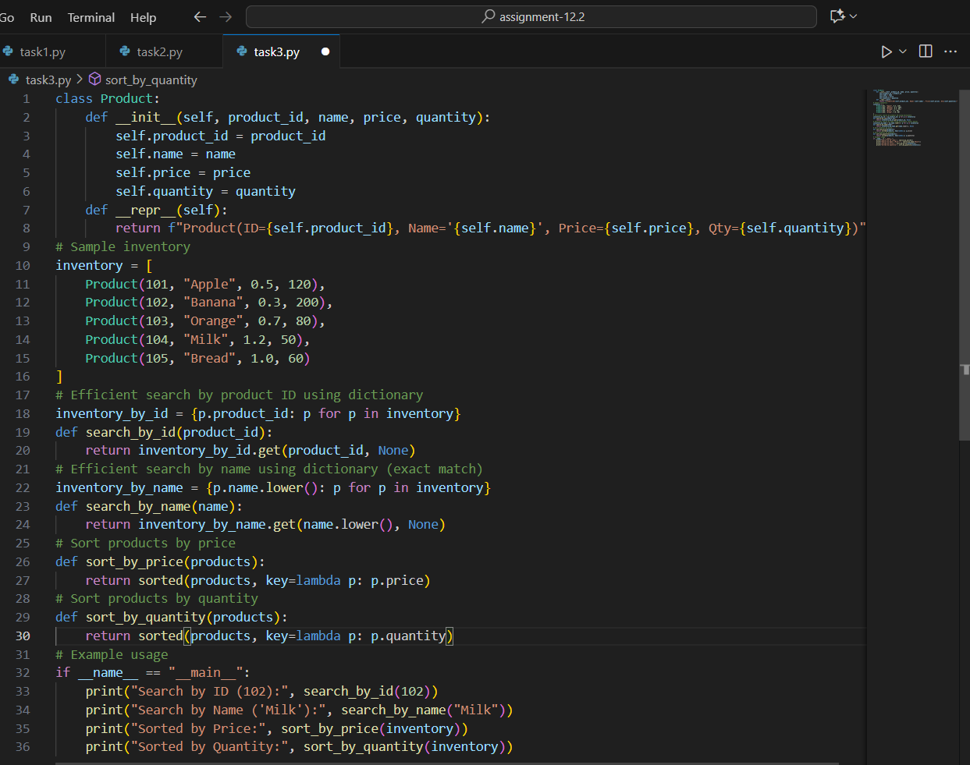
OUTPUT:

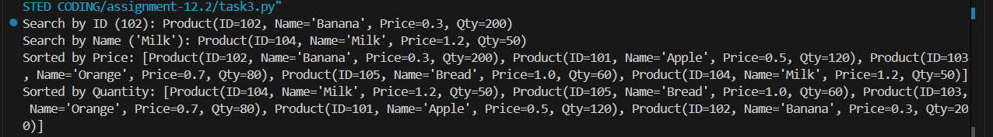

OBSERVATION:
In this task, AI helped design a Python inventory system using efficient search and sort algorithms. Binary Search enabled fast lookups, while Merge Sort and Quick Sort organized products by price or quantity. Clear documentation and testing showed strong performance, scalability, and reliability for large datasets.

