**AI assisted Coding Lab-1**

HT.NO-2503A52L10

NAME- G.VINITH

A-Set Question.

* Task1-Write a prompt to generate a python program for sorting a list of numbers using AI tool.
* Prompt1-Generate a python program for sorting a list of numbers.
* Code and Output: Before Optimization and efficiency.

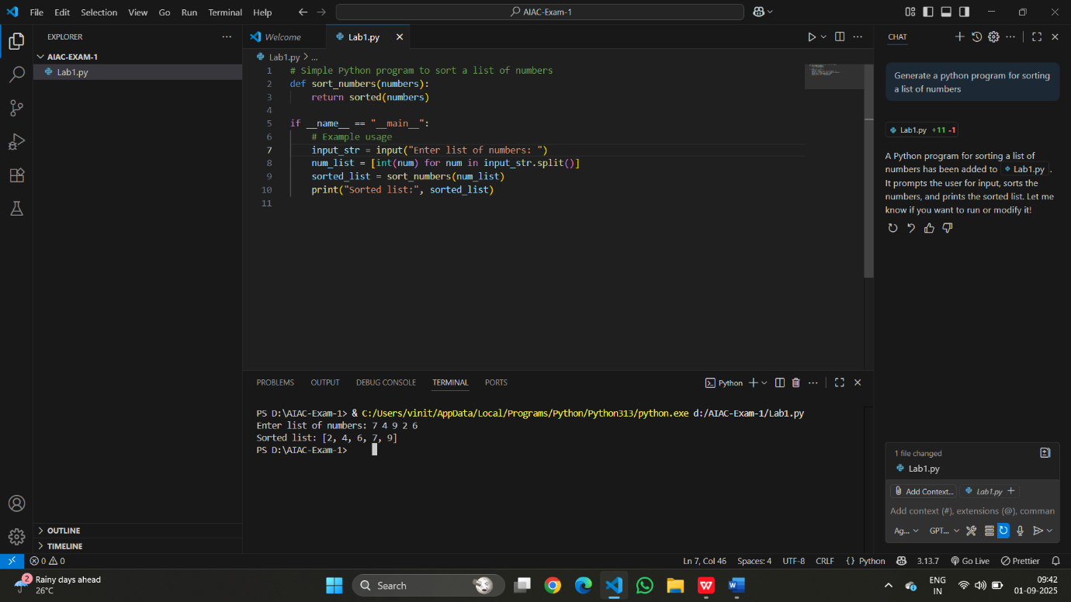

* Prompt2-Generate a python program for sorting a list of numbers using the code more efficiency and performance.
* Code and Output: After Optimization and better performance.

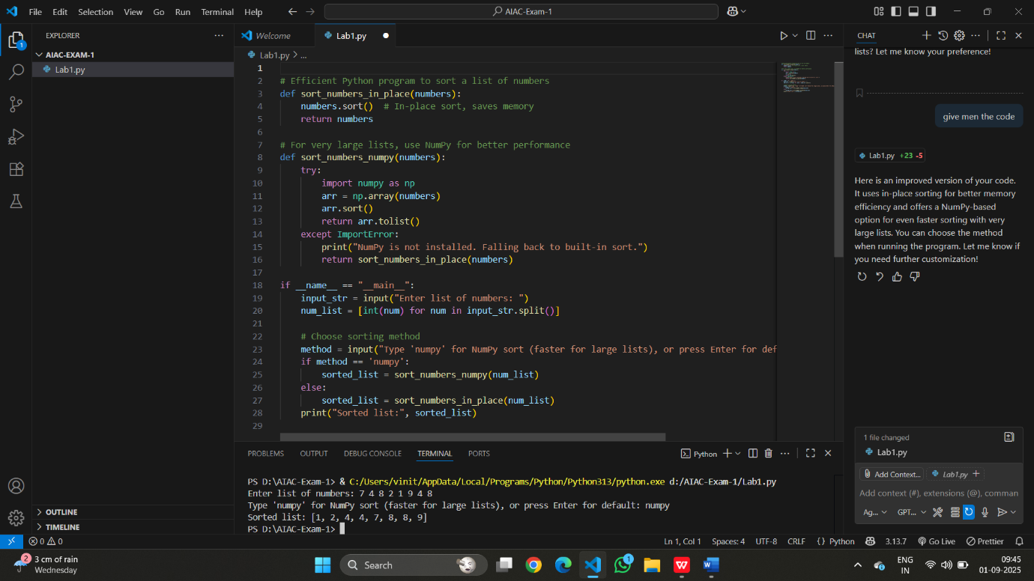

* Task2- Ask AI to generate a Python program for Fibonacci series.
* Prompt1-Generate a python program for Fibonacci Series,
* Code and Output-A:

* Observation/Difference between Code-A and Code-B:
* The Updated code allows you to sort a list of numbers either using python’s efficient in-place sorting Method or, for very large list, by using Numpy.
* Numpy option is for faster sorting of large lists.
* Prompt2-Generate a python program for Fibonacci series by taking a input from the user.
* Code and Output-B:

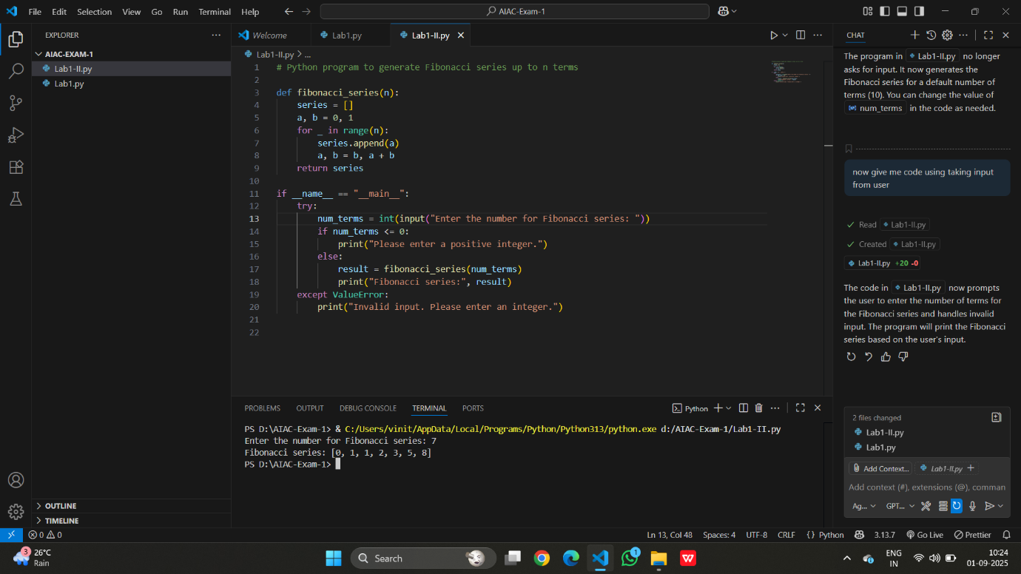

* Observation/Difference between Code-A and Code-B:
* The first code version generated the Fibonacci series for a fixed number of terms set in the code.
* The second code asks the user to enter the number of terms at runtime, making it interactive and flexible.