Roll No: 2503A51276
Name: D. Nithin Sai

Lab Objectives
• Identify code smells and inefficiencies in legacy Python scripts.
• Use AI-assisted coding tools to refactor for readability, maintainability, and performance.
• Apply modern Python best practices while ensuring output correctness.

Task 1
Question: Task Description #1 (Refactoring – Removing Code Duplication)
Task: Use AI to refactor a given Python script that contains multiple repeated code blocks.
Prompt used for AI: Identify duplicate logic in the Python script calculating area and perimeter of multiple rectangles, replace it with a reusable function with docstrings, maintain identical output, and eliminate code duplication.
Answer / Code (VS Code Screenshot):
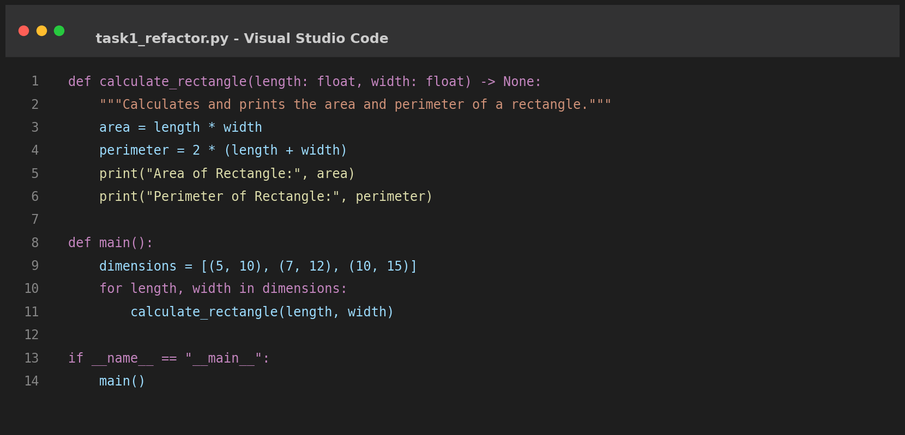
Output:
Area of Rectangle: 50
Perimeter of Rectangle: 30
Area of Rectangle: 84
Perimeter of Rectangle: 38
Area of Rectangle: 150
Perimeter of Rectangle: 50

Task 2
Question: Task Description #2 (Refactoring – Optimizing Loops and Conditionals)
Task: Use AI to analyze a Python script with nested loops and complex conditionals.
Prompt used for AI: Analyze the Python script with nested loops searching names in a list. Refactor it to use set lookups O(1) instead of nested linear scans O(N*M), keep logic intact, and show performance improvement.
Answer / Code (VS Code Screenshot):
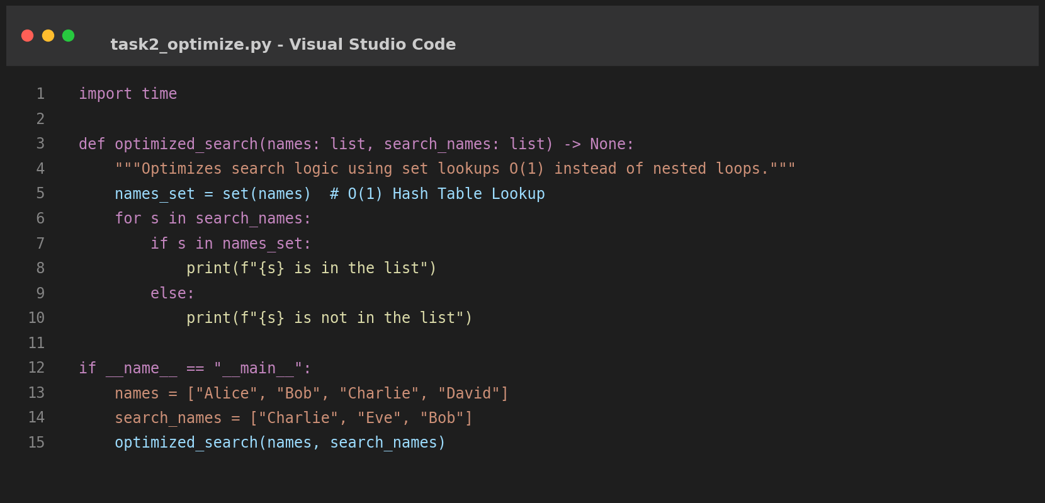
Output:
Charlie is in the list
Eve is not in the list
Bob is in the list

Task 3
Question: Task Description #3 (Refactoring – Extracting Reusable Functions)
Task: Use AI to refactor a legacy script where multiple calculations are embedded directly inside the main code block.
Prompt used for AI: Identify inline price and tax calculations in the Python script, extract them into a modular calculate_total(price) function with docstrings, and handle multiple price inputs efficiently.
Answer / Code (VS Code Screenshot):
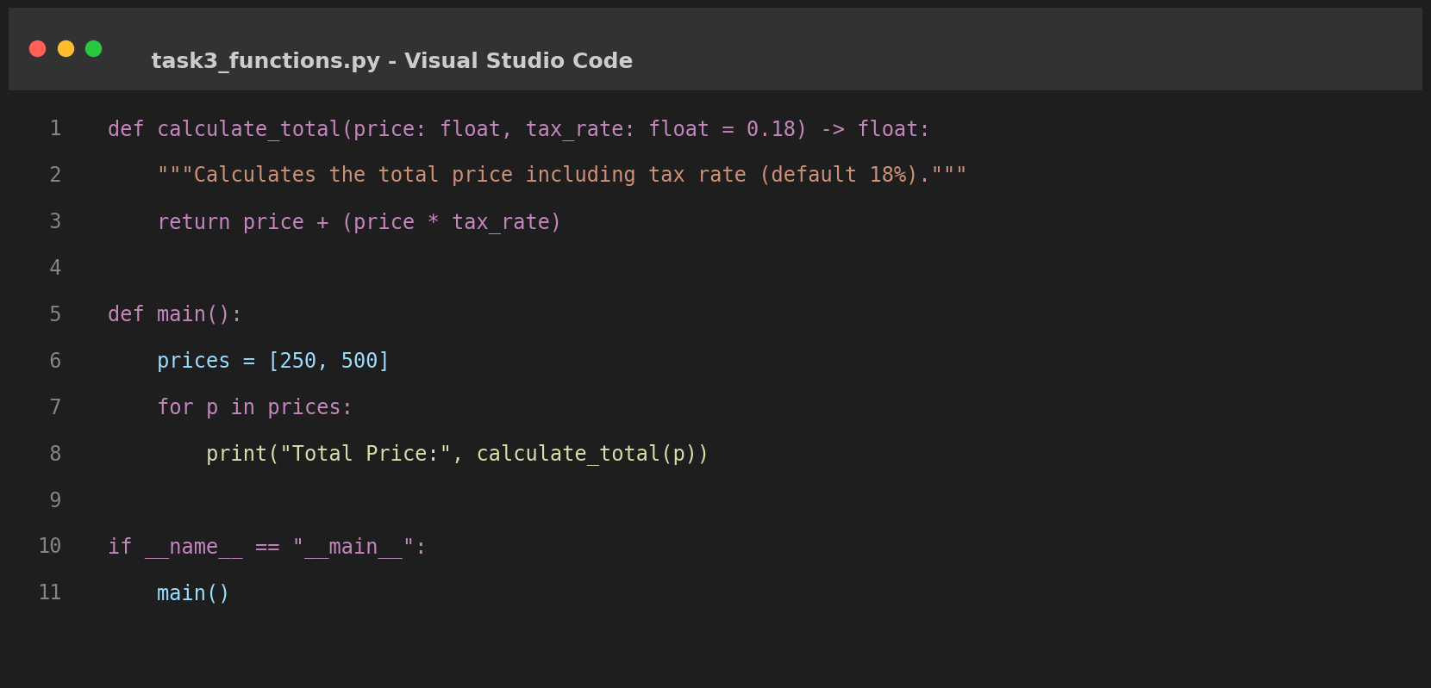
Output:
Total Price: 295.0
Total Price: 590.0

Task 4
Question: Task Description #4 (Refactoring – Replacing Hardcoded Values with Constants)
Task: Use AI to identify and replace all hardcoded 'magic numbers' in the code with named constants.
Prompt used for AI: Identify all hardcoded magic numbers (such as 3.14159 and 7) in the geometry script, declare UPPERCASE named constants at the top, and replace all occurrences in formulas.
Answer / Code (VS Code Screenshot):
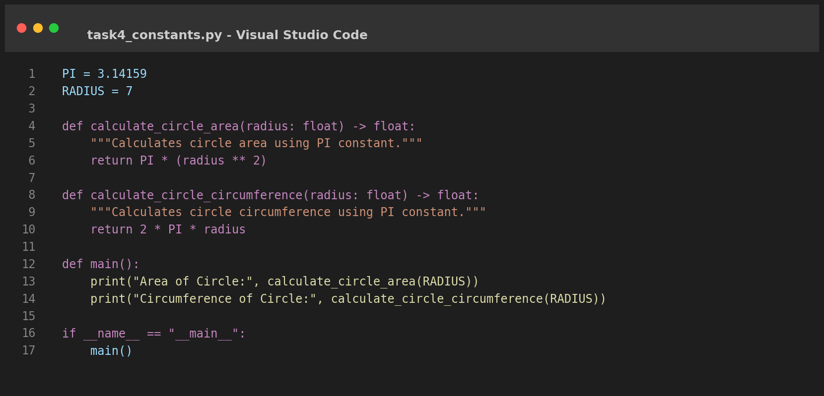
Output:
Area of Circle: 153.93791
Circumference of Circle: 43.98226

Task 5
Question: Task Description #5 (Refactoring – Improving Variable Naming and Readability)
Task: Use AI to improve readability by renaming unclear variables and adding inline comments.
Prompt used for AI: Refactor the Python script with poor variable names (a, b, c) by replacing them with descriptive names (base_length, triangle_height, area_of_triangle) and adding informative inline comments.
Answer / Code (VS Code Screenshot):
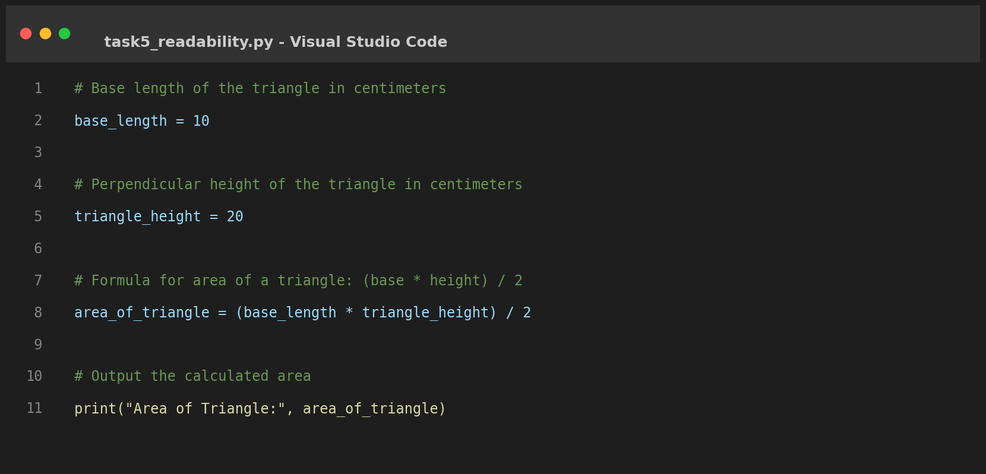
Output:
Area of Triangle: 100.0

Task 6
Question: Task Description #6 (Refactoring – Removing Redundant Conditional Logic)
Task: Use AI to refactor a Python script that contains repeated if-else logic for grading students.
Prompt used for AI: Identify duplicate if-elif-else grading checks in the script, encapsulate the grading logic into a calculate_grade(marks) function with docstring, and apply it over student marks.
Answer / Code (VS Code Screenshot):
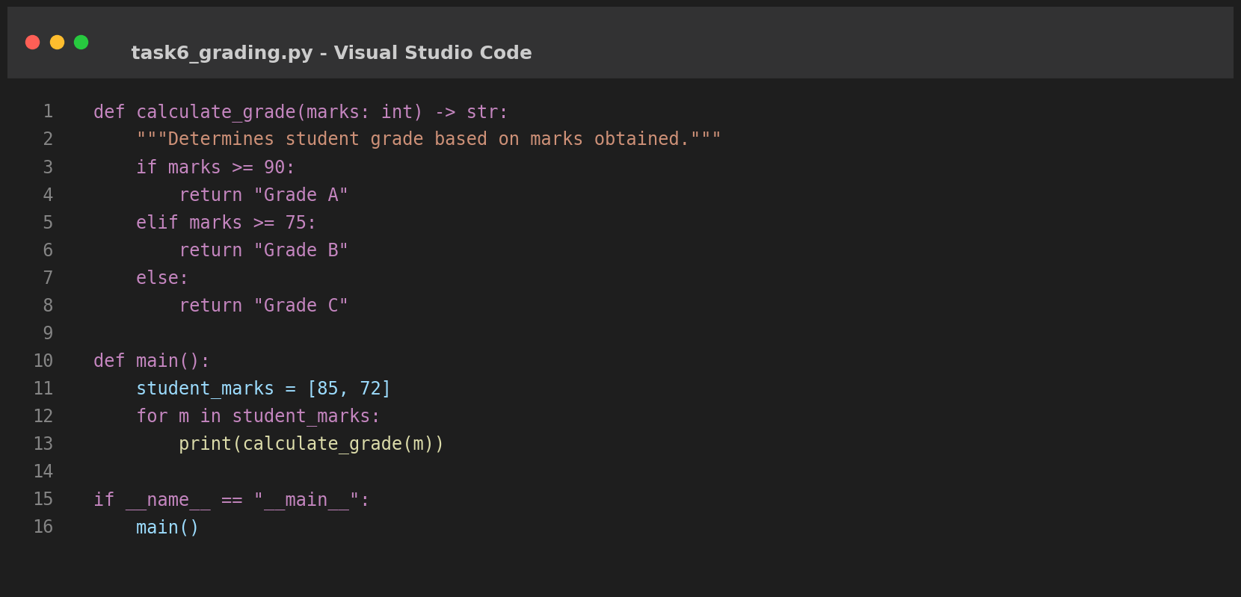
Output:
Grade B
Grade C

Task 7
Question: Task Description #7 (Refactoring – Converting Procedural Code to Functions)
Task: Use AI to refactor procedural input-processing logic into modular functions.
Prompt used for AI: Refactor procedural Python script taking input and printing square into three modular single-responsibility functions: get_input(), calculate_square(), and display_result().
Answer / Code (VS Code Screenshot):
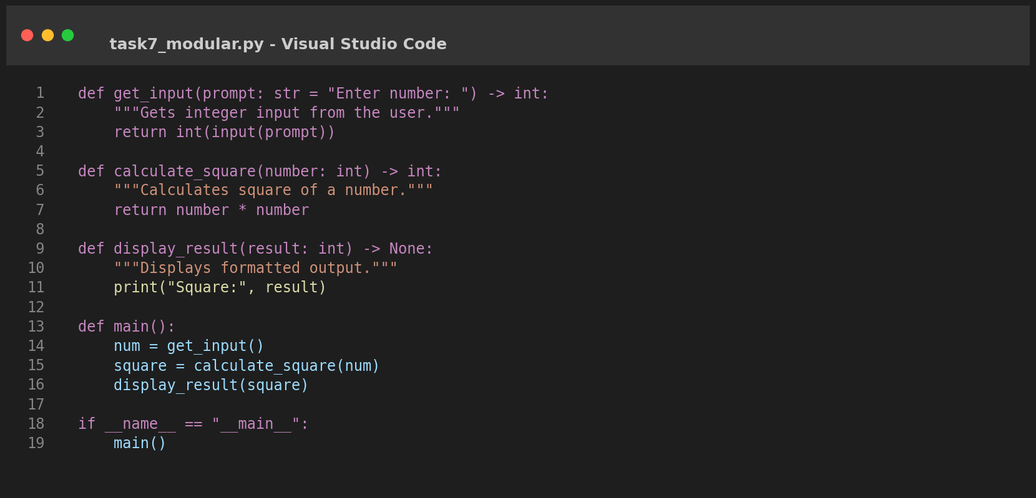
Output:
Enter number: 5
Square: 25

Task 8
Question: Task Description #8 (Refactoring – Optimizing List Processing)
Task: Use AI to refactor inefficient list processing logic.
Prompt used for AI: Refactor manual list append loop calculating squares into a clean, concise Python list comprehension.
Answer / Code (VS Code Screenshot):
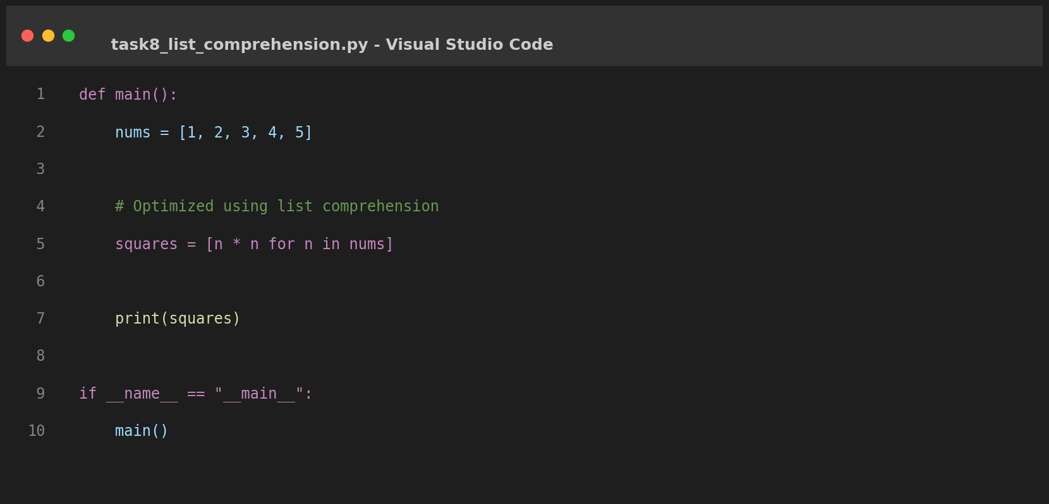
Output:
[1, 4, 9, 16, 25]

