AI ASSISTED CODING LAB
ASSIGNMENT-14.4
ENROLLMENT NO:2503A51L05
BATCH NO: 19
NAME: NARADALA SATYA SRI CHARAN
TASK DESCRIPTION 1:
AI-Assisted Portfolio Website
Scenario:
A student wants to showcase their projects, skills, and contact details in a portfolio website. Instead of writing all code manually, they want to speed up the process using GitHub Copilot.

- Use Copilot to generate an HTML structure for a personal portfolio page (sections: Home, About, Projects, Contact).
- Ask Copilot to suggest responsive CSS styling for the layout (e.g., grid/flexbox).
- Customize Copilot’s suggestions to add a hover effect on project cards.
PROMPT :
Create a responsive student portfolio website using HTML and CSS. The website should have sections: Home, About, Projects, and Contact.
CODE GENERATED :

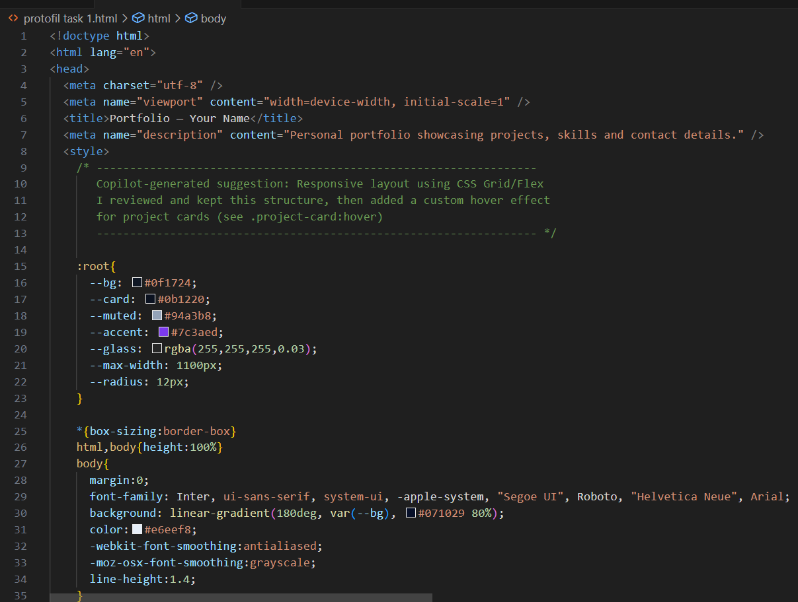
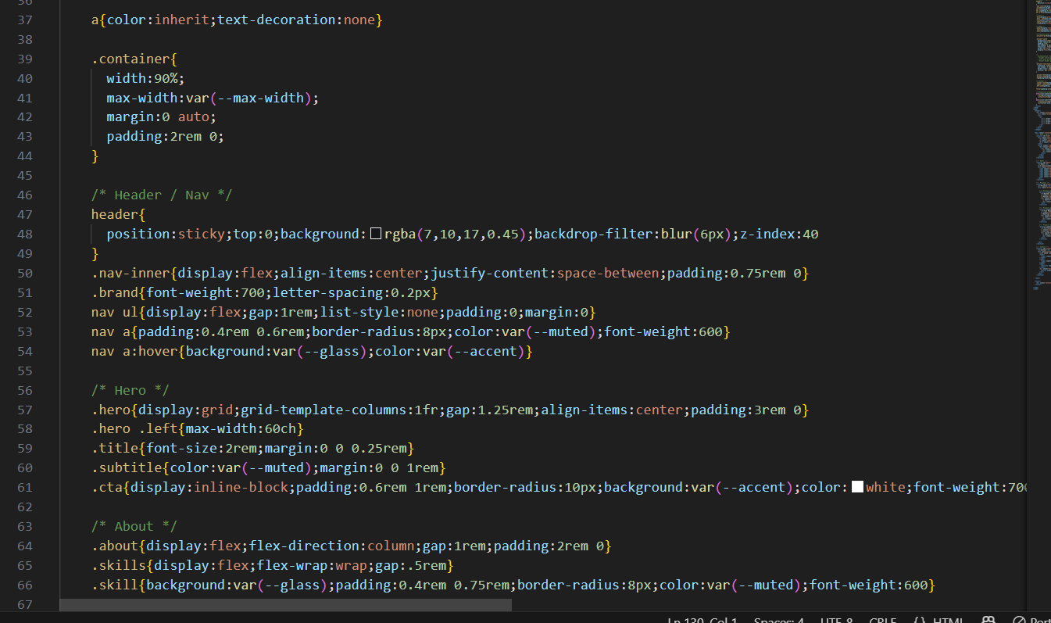
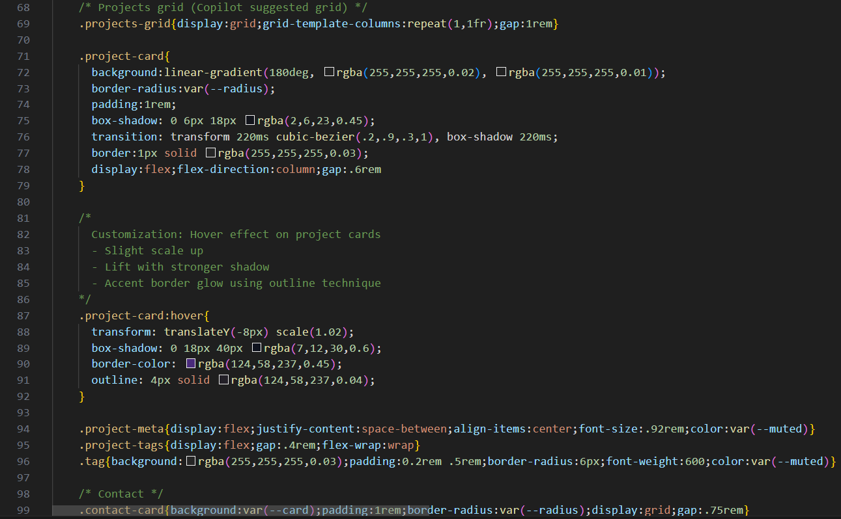
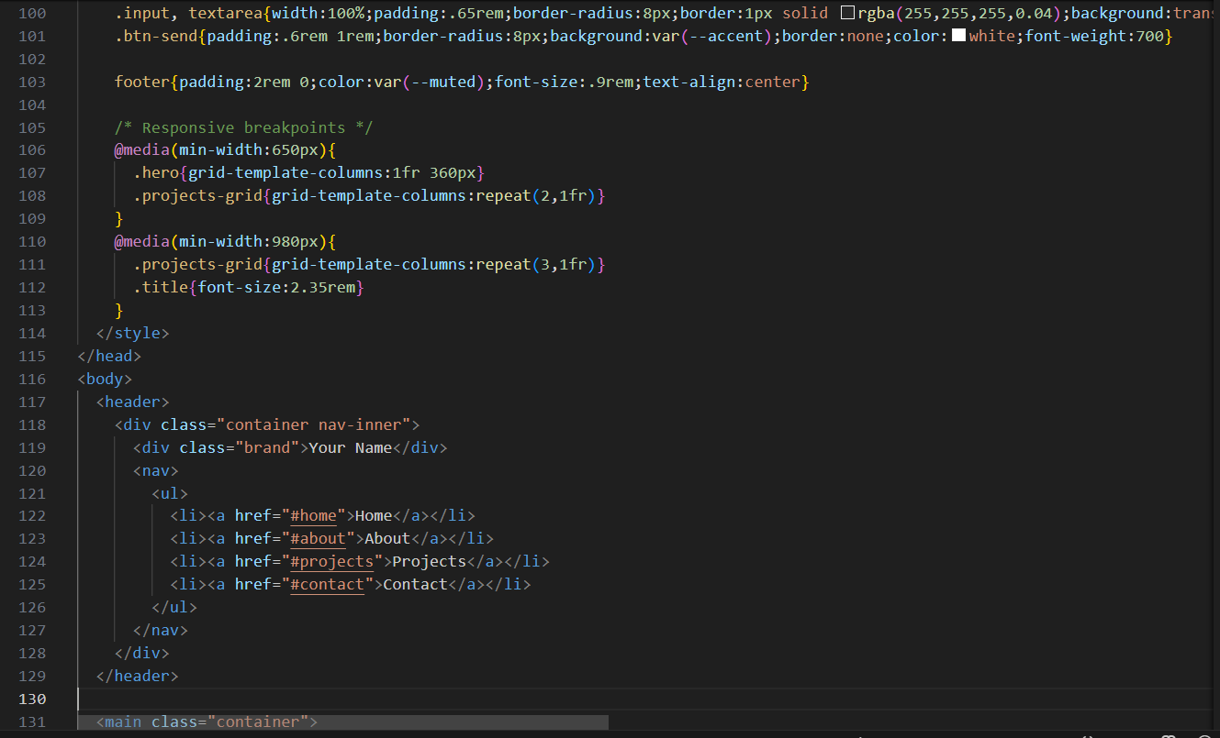
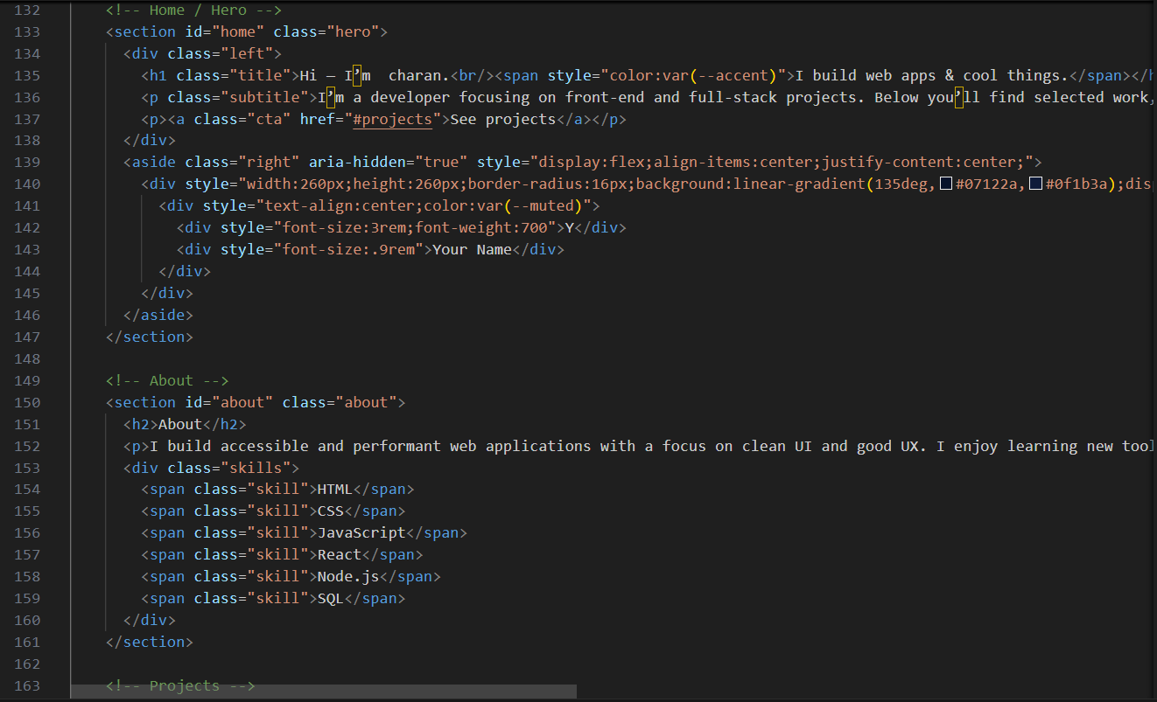
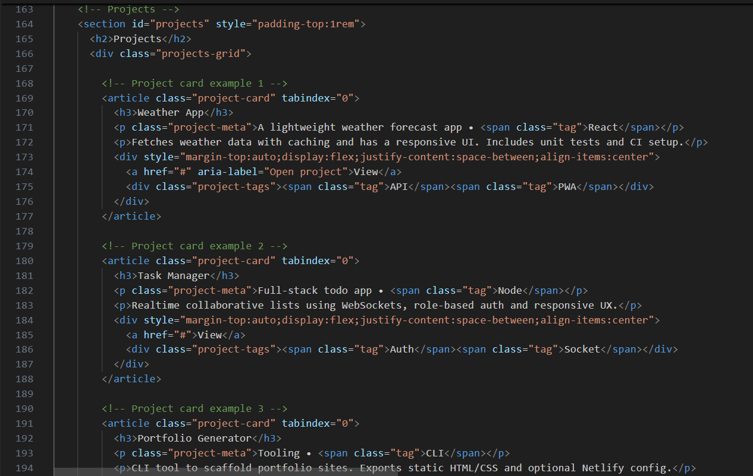
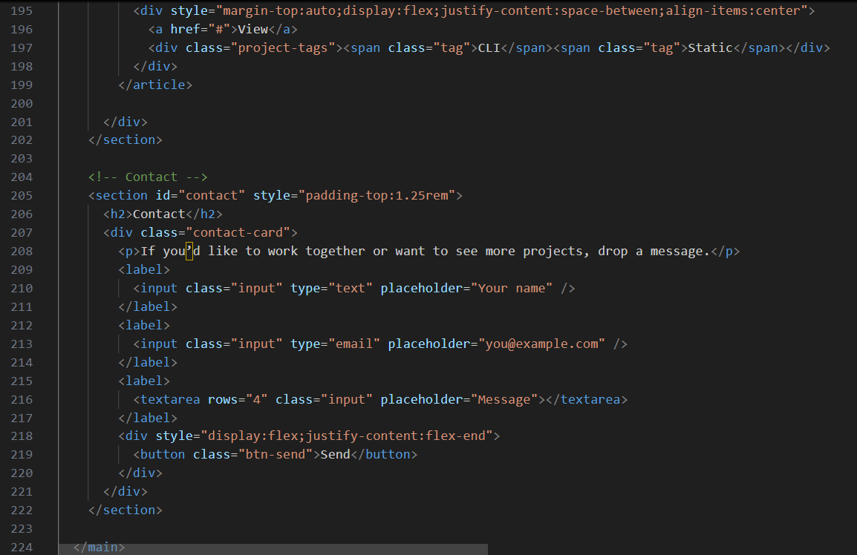

OUTPUT:

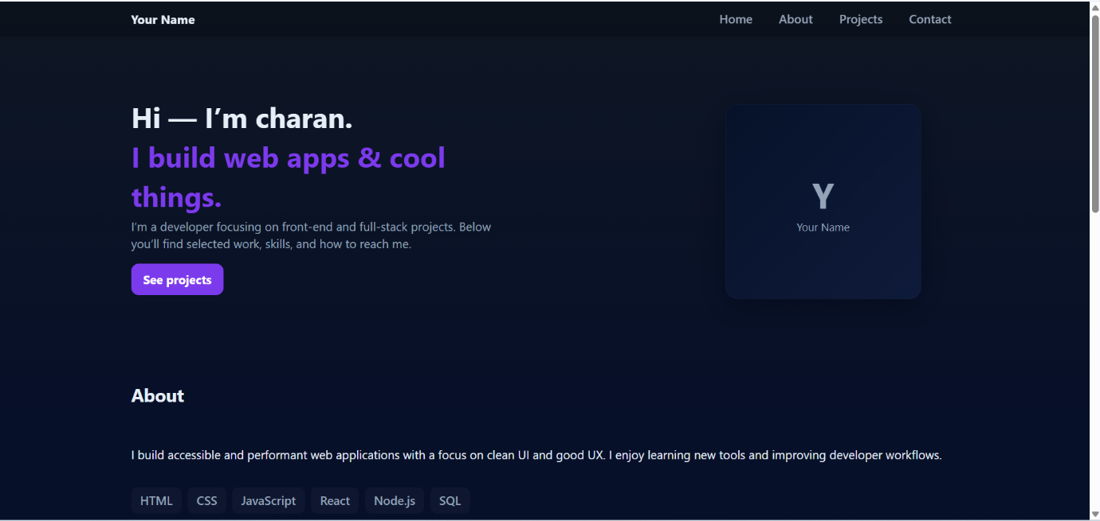
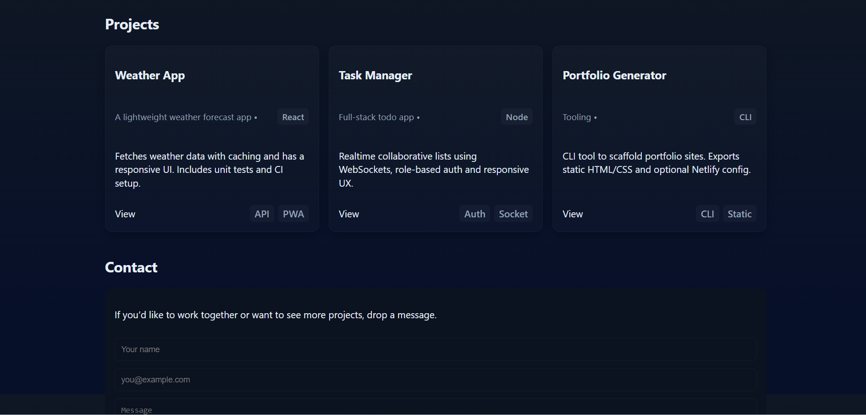
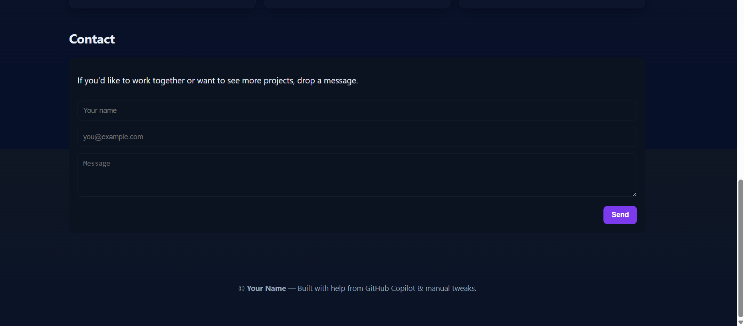

OBSERVATION :
The portfolio website was developed using HTML and CSS to create a clean, responsive, and user-friendly design. The structure includes a header with navigation links and four main sections: Home, About, Projects, and Contact. The Projects section showcases work using styled cards with hover effects, while the Contact section provides a functional form for user interaction. Media queries are applied to ensure the site adapts well to different screen sizes, including mobile devices. Overall, the assignment demonstrates the application of web development concepts such as semantic HTML, CSS styling, responsiveness, and interactivity.
TASK DESCRIPTION 2 :
AI-Generated Restaurant Landing Page
Scenario:
A local restaurant needs a simple landing page with a navigation bar, menu highlights, and an image gallery. The developer wants to quickly generate it using AI assistance.

- Use Copilot to create a navigation bar with links (Home, Menu, Gallery, Contact).
- Generate a menu section styled with CSS cards.
- Add a JavaScript-based image slider for the gallery, with Copilot suggesting the base code.

PROMPT :
Create a responsive and visually appealing single-page website for a local restaurant called "Delicious Bites."
CODE GENERATED :
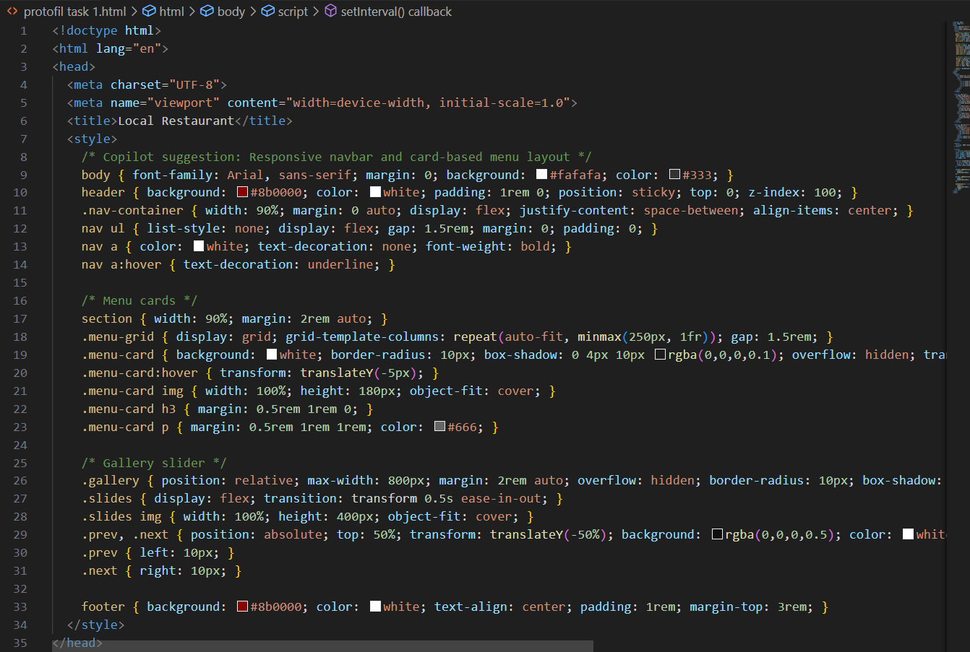
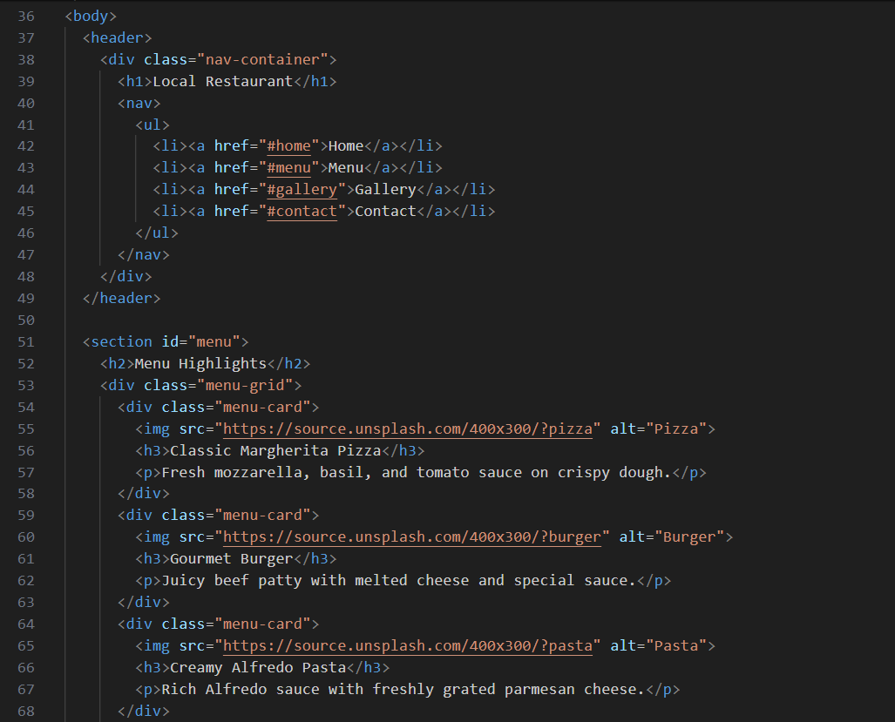
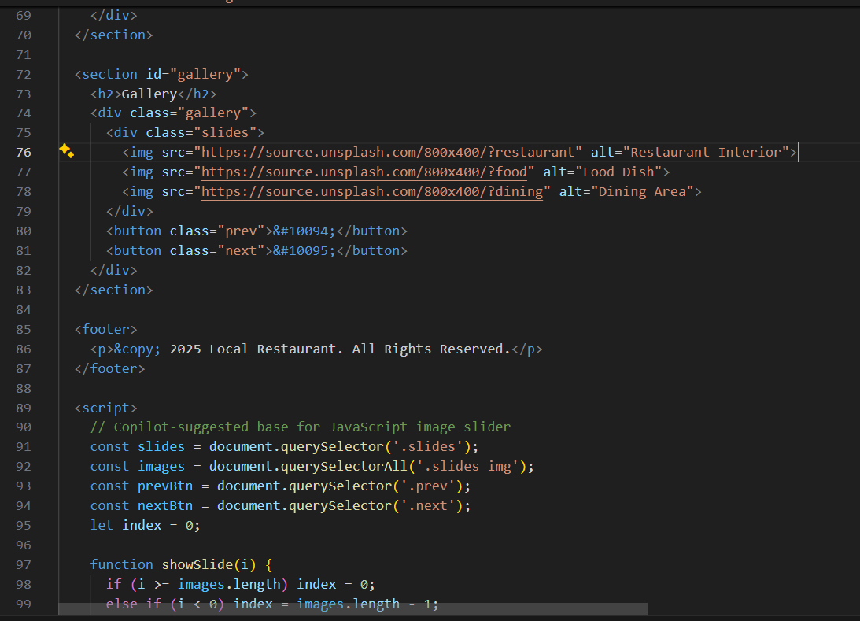
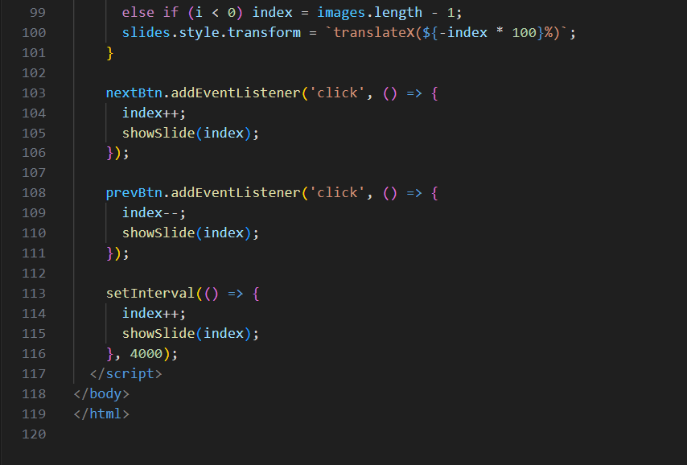

OUTPUT :
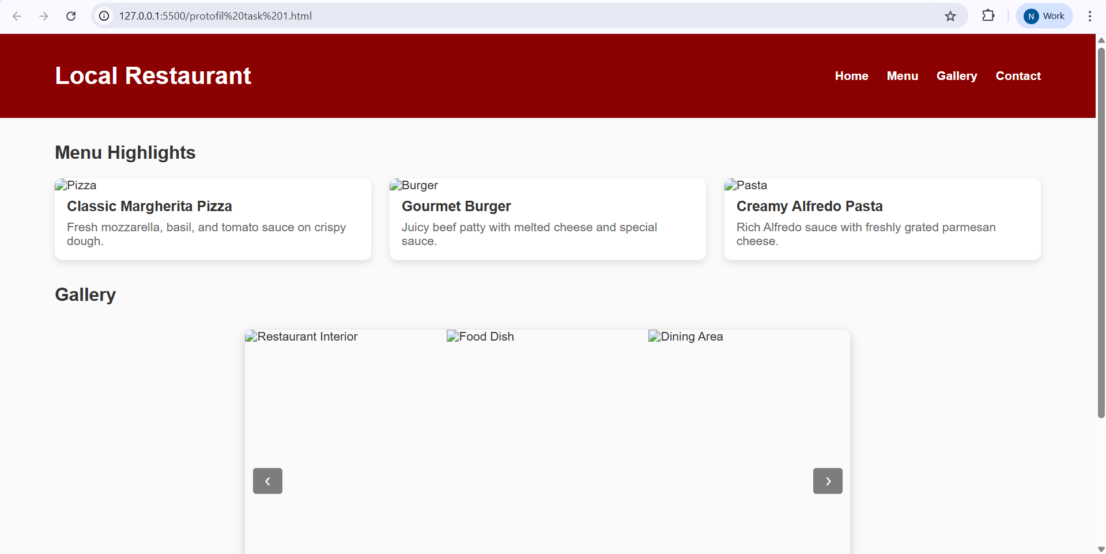

OBSERVATION :
This restaurant website code creates a clean, responsive single-page layout for “Delicious Bites,” featuring a warm color scheme and smooth user experience. It includes a header with navigation links, a welcome section, a menu display with interactive cards for three dishes, a gallery slider showcasing food images with left/right buttons, and a contact section listing phone, email, and address. The design adapts well to mobile screens using media queries, and the image slider is powered by simple JavaScript. Overall, the code is well-structured, visually appealing, and easy to maintain—ideal for showcasing a local restaurant online.
TASK DESCRIPTION 3 :
AI-Powered Event Registration Form
Scenario:
SR University is hosting a tech fest. They need a web-based registration form for students. The form must validate user input in real-time.

- Ask Copilot to generate an HTML form (fields: Name, Email, Phone, Department, Event Selection).
- Use Copilot to assist in adding CSS styling for an attractive form layout.
- Implement JavaScript validation (e.g., email format check, phone number length check) using Copilot’s suggestions.

PROMPT :
Create a tech fest registration form titled "SRU Tech Fest Registration" with fields for name, email, phone, department, and event.
CODE GENERATED :

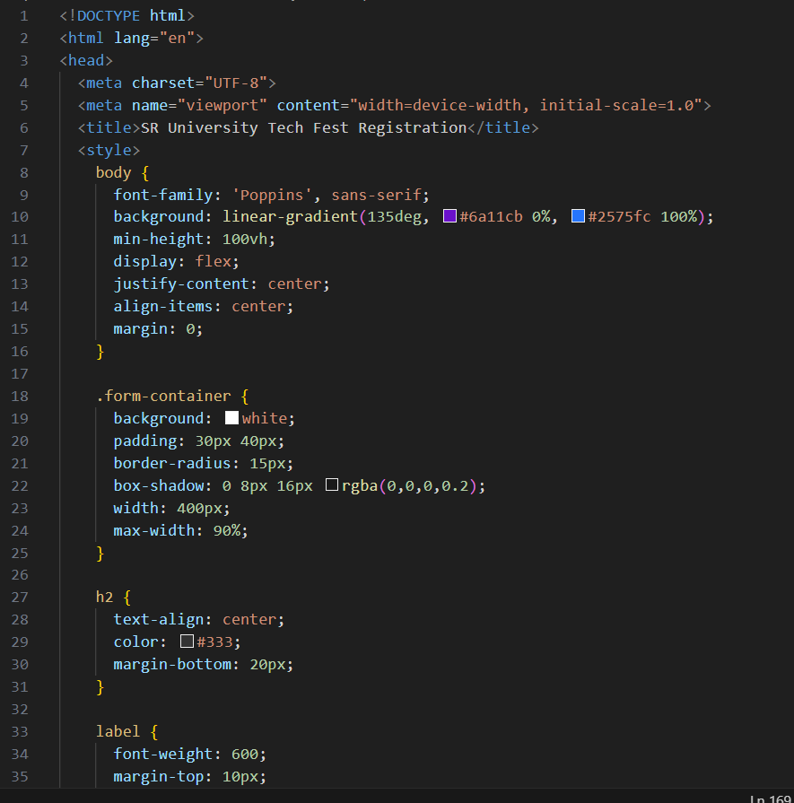
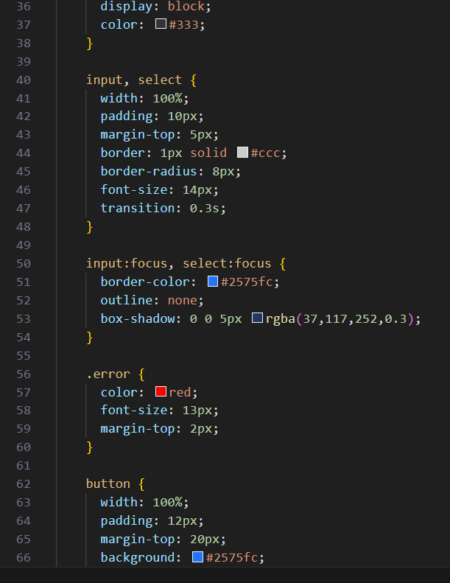
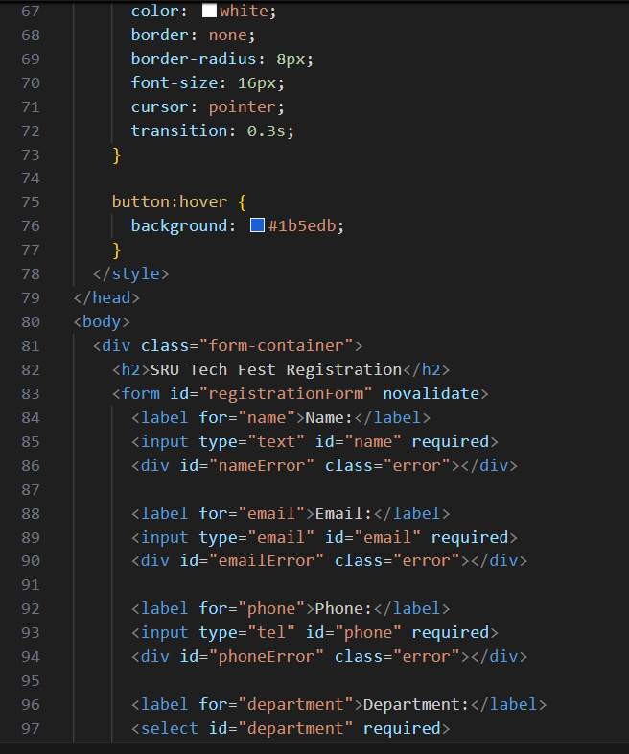
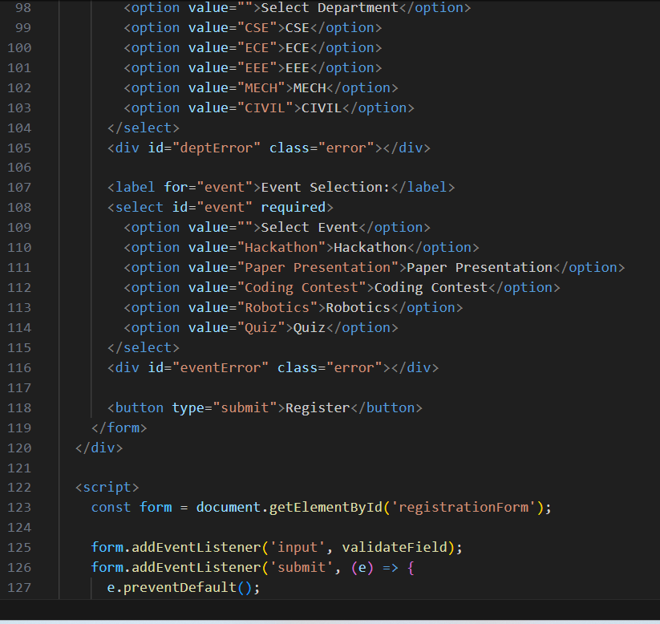
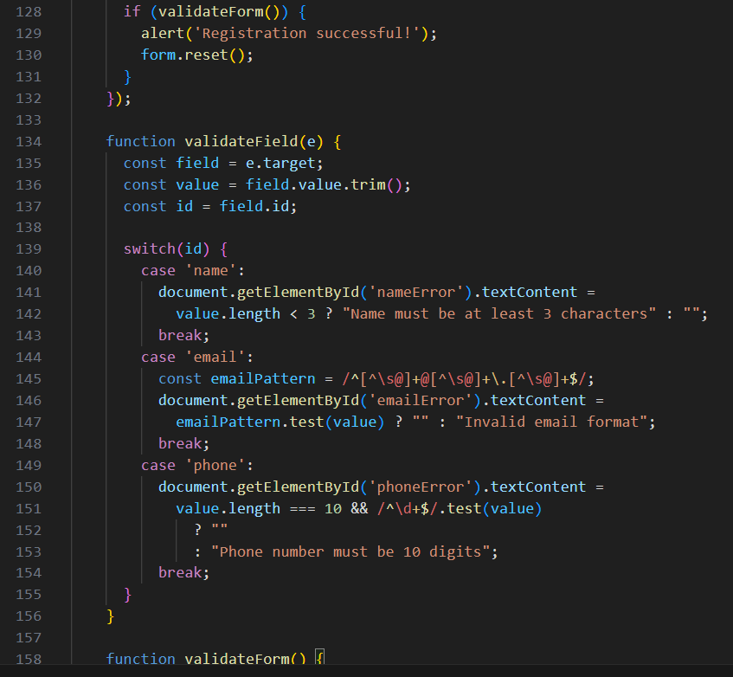
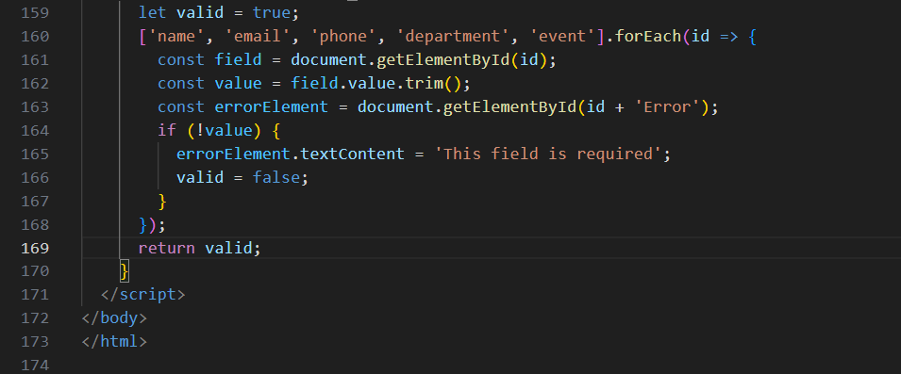

OUTPUT :
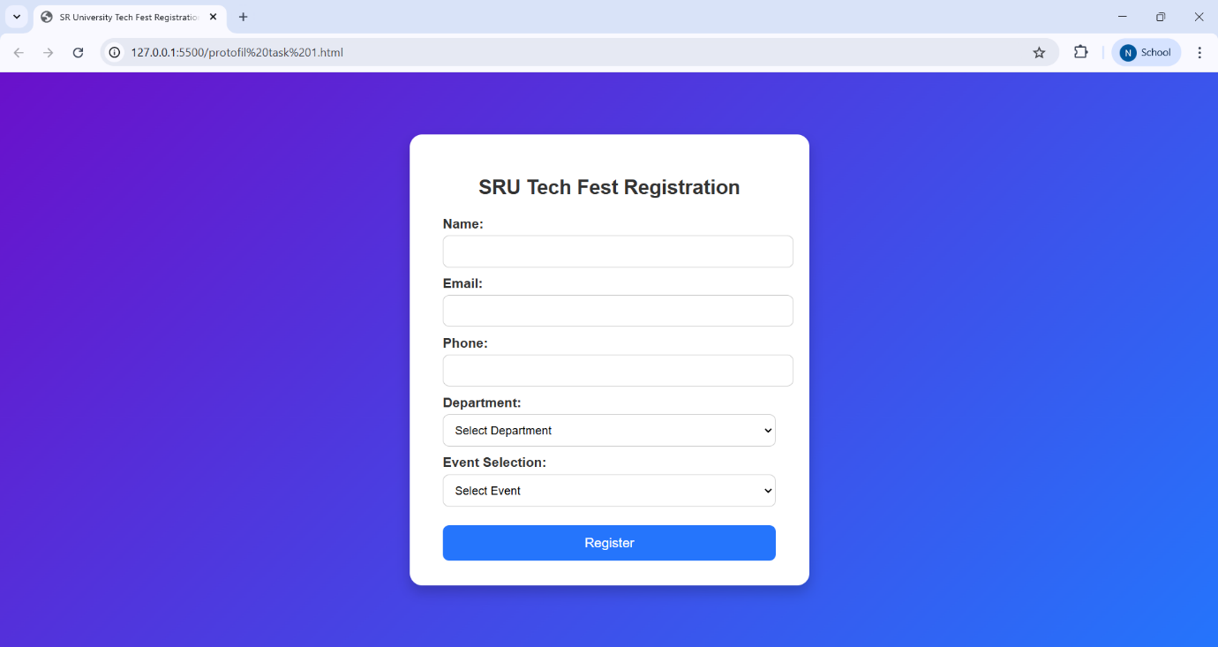

OBSERVATION :
The form is well-structured and user-friendly, with clearly labeled fields for name, email, phone number, department, and event selection. The design uses a clean layout with a centered container, soft background, and rounded corners, making it visually appealing. Real-time validation is handled smoothly with JavaScript, showing helpful error messages when inputs are missing or incorrect. Overall, the code is neat, responsive, and provides a smooth registration experience for users.
TASK DESCRIPTION 4 :
AI-Assisted E-Commerce Product Page
Scenario:
A startup wants a basic e-commerce product page to display products with prices and an “Add to Cart” button.

- Use Copilot to generate a grid-based product catalog in HTML/CSS.
- Implement a JavaScript “Add to Cart” functionality with Copilot’s guidance.
- Modify Copilot’s suggestions to include a cart counter at the top-right corner of the page.

PROMPT :
This code builds a clean and responsive product page for "Startup Shop," displaying four tech items in a grid layout with images, descriptions, prices, and “Add to Cart” buttons.
CODE GENERATED :
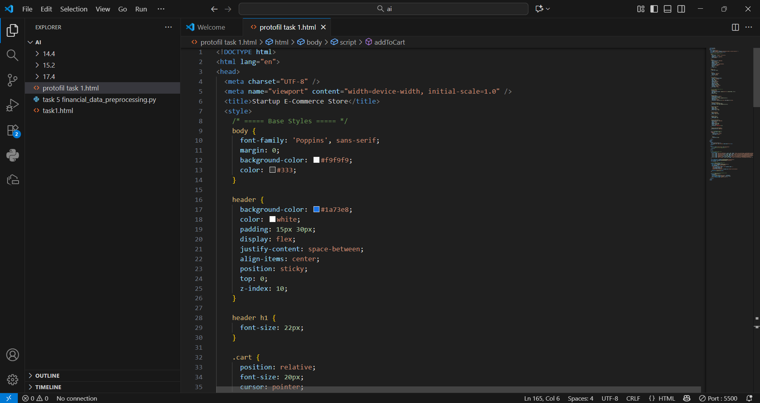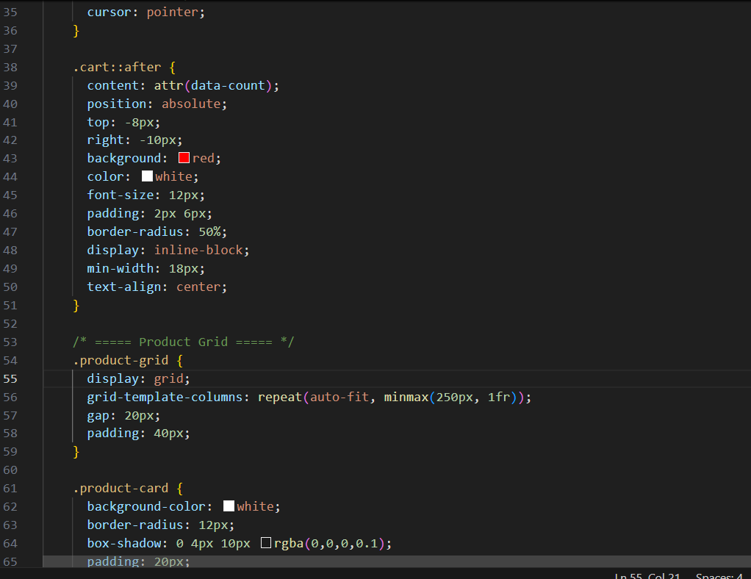
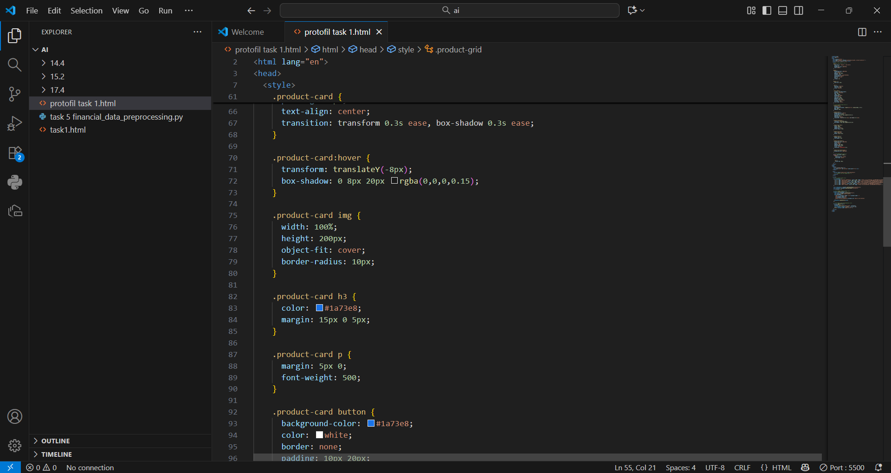
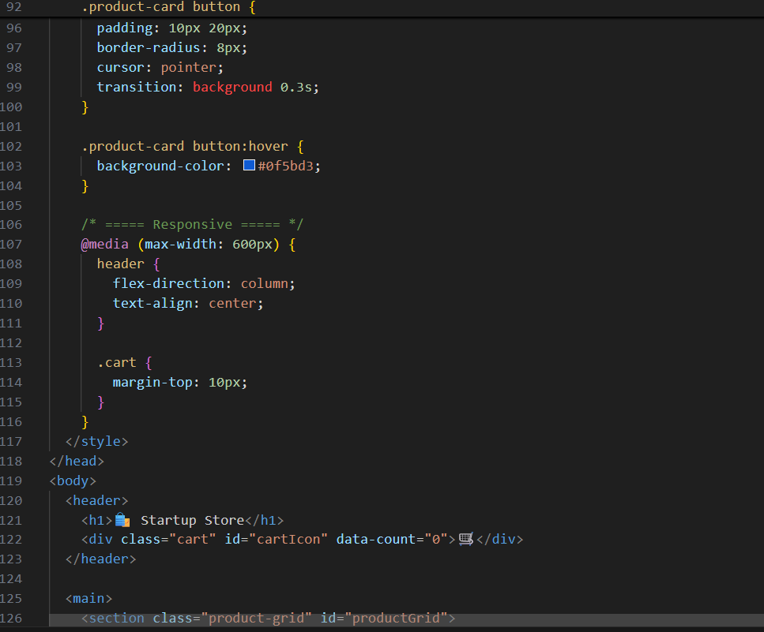
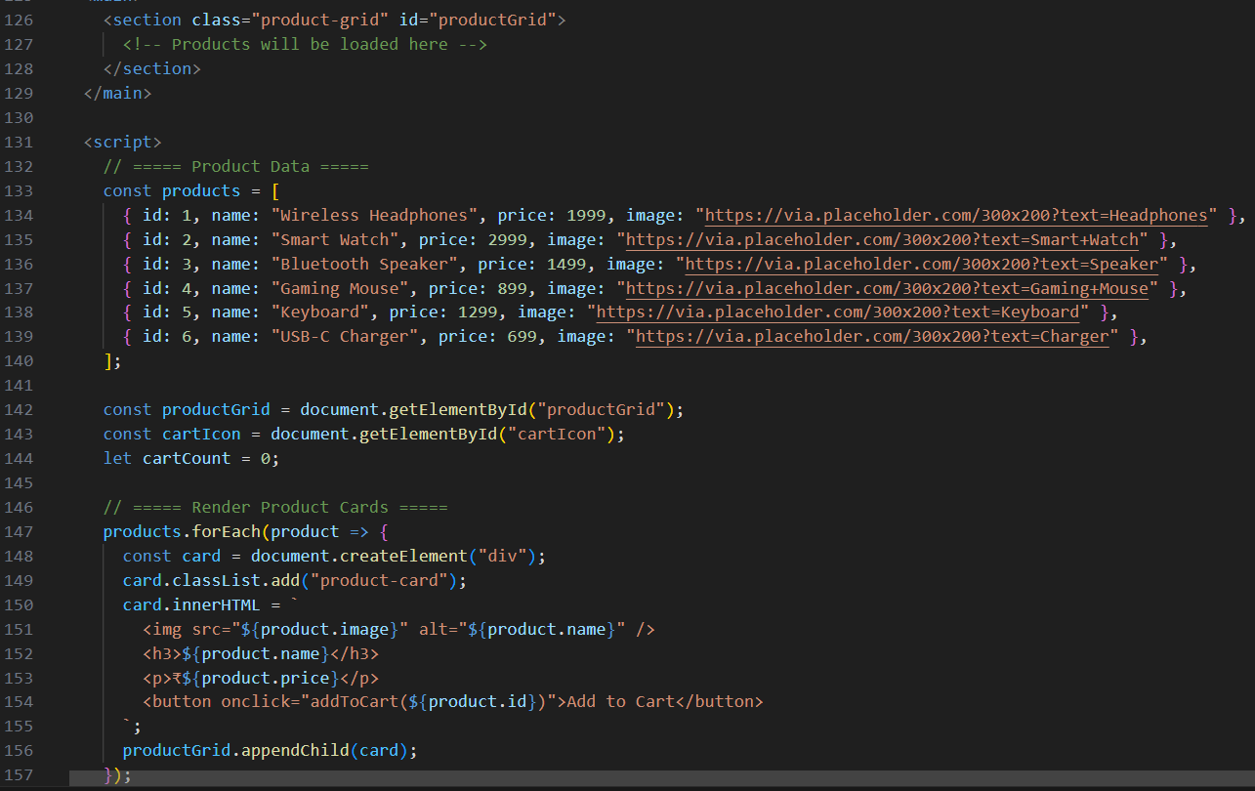
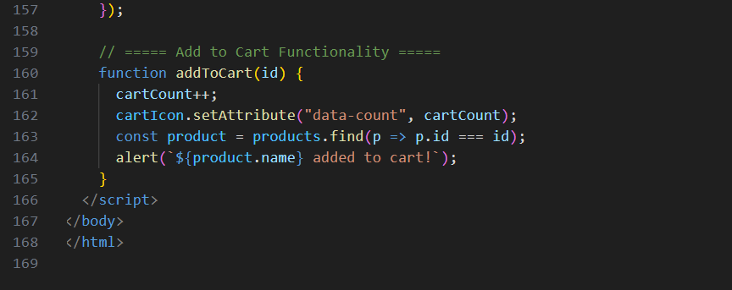
OUTPUT :
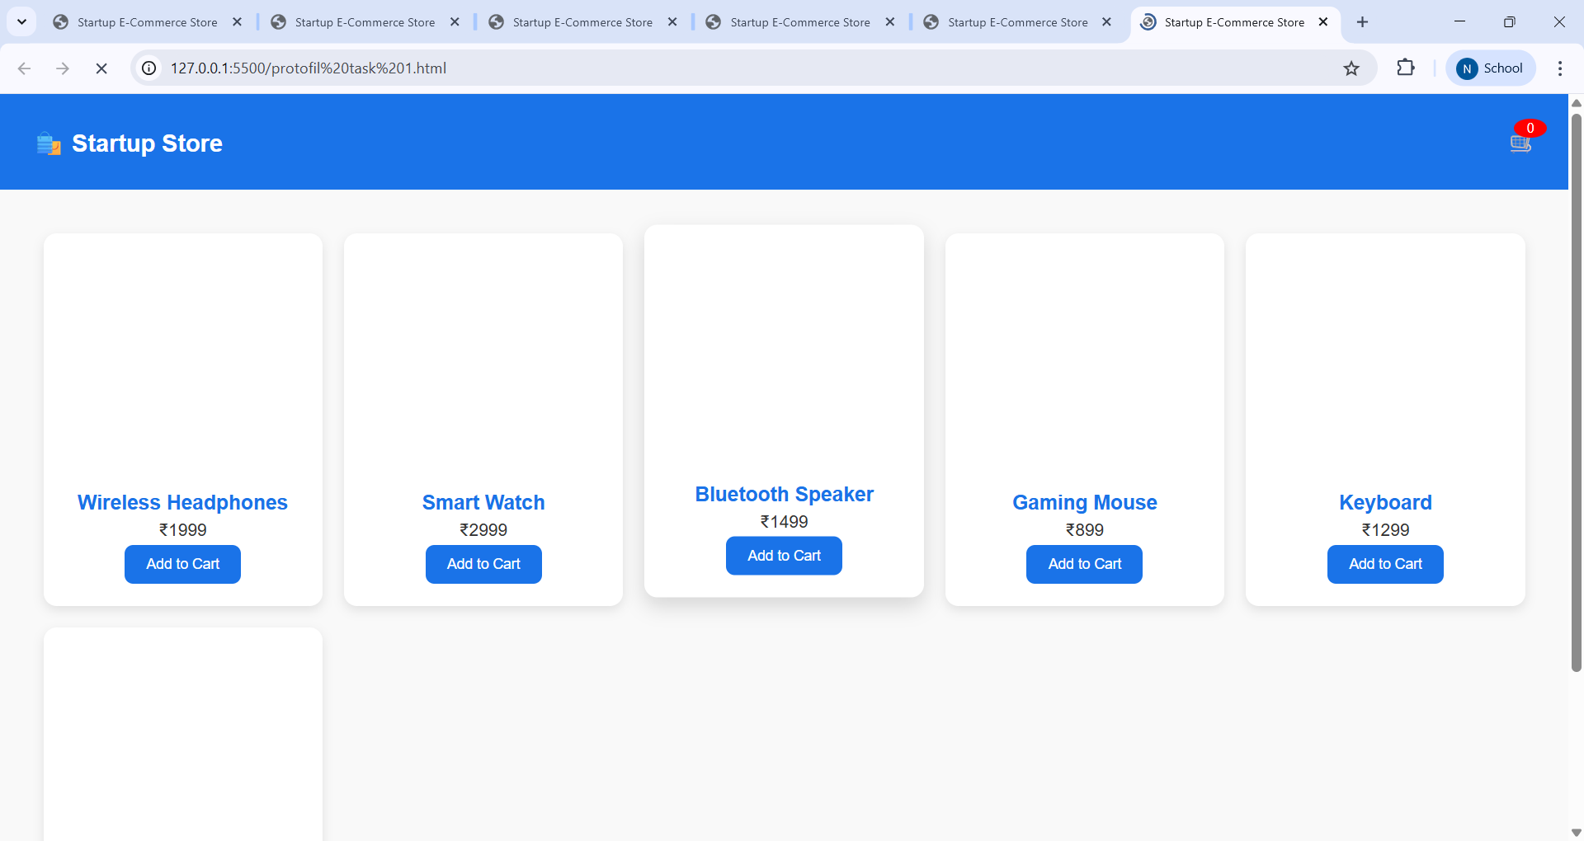
OBSERVATION :
The layout is clean and responsive, showcasing four tech products in a grid format with images, descriptions, prices, and “Add to Cart” buttons. The cart counter in the header updates dynamically using JavaScript, providing instant feedback when items are added. Styling is modern and consistent, with hover effects and soft shadows that enhance user interaction. The use of media queries ensures the design adjusts well on smaller screens, making it mobile-friendly and user-centric.

