SR UNIVERSITY
AI ASSISTED CODING
ELIGATI RAVALI
2503A51L18

Lab 9.5 – Documentation Generation: Automatic Documentation and Code Comments
Lab Objectives:
- Inline Comments.
- Docstrings.
- Auto-Documentation Tools.
- AI assisted Summarization.

TASK DESCRIPTION #1 (Automatic Code Commenting)

Scenario: You have been given a Python Function without comments .

def calculate_discount(price ,discount_rate):
Return price –(price*discount_rate/100)

- Use an AI tool (or manually simulate it) to generate line-by-line comments for the function.
- Modify the function so that it includes a docstring in Google-style or NumPy-style format.
- Compare the auto-generated comments with your manually written version.

CODE:
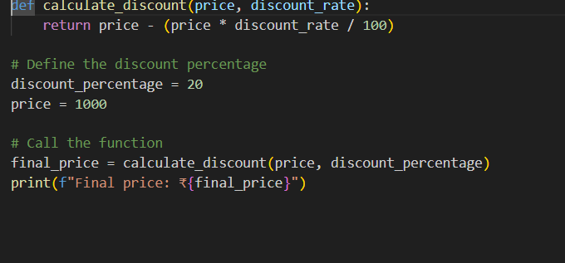
OUTPUT:
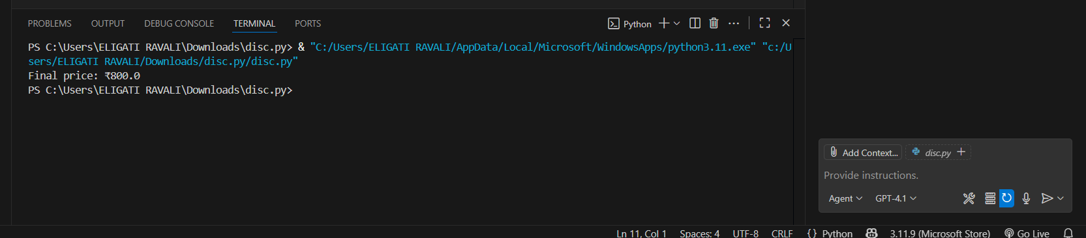

TASK DESCRIPTION #2(API Documentation Generator)
Scenario: A Team is building a Libaray Management System with multiple functions.
def add_book(title, author, year):
# code to add book
pass
def issue_book(book_id, user_id)
# code to issue book
Pass
- Write a Python script that uses docstrings for each function (with input, output, and description).
- Use a documentation generator tool (like pdoc, sphinx, or MkDocs) to automatically create HTML documentation.
- Submit both the code and the generated documentation as output.

CODE :
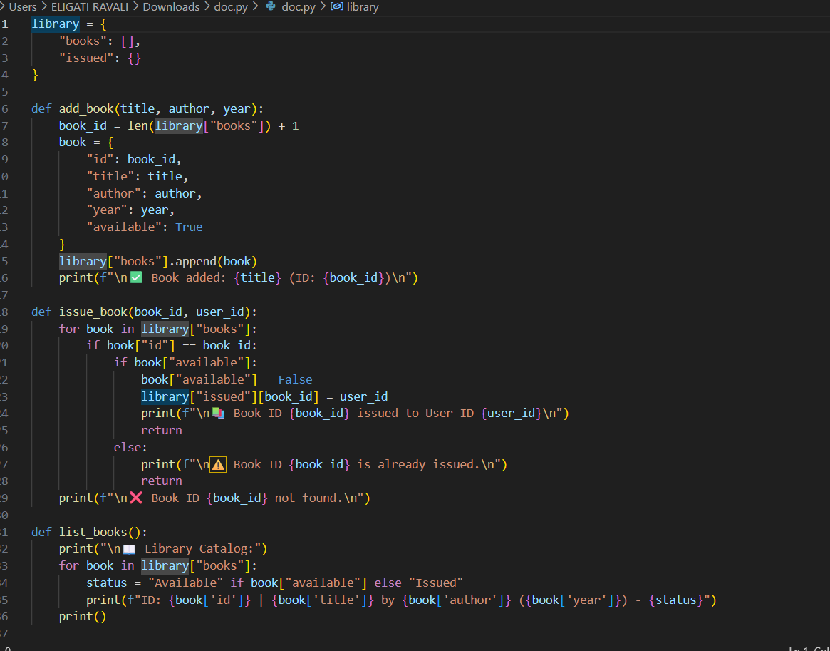
OUTPUT :
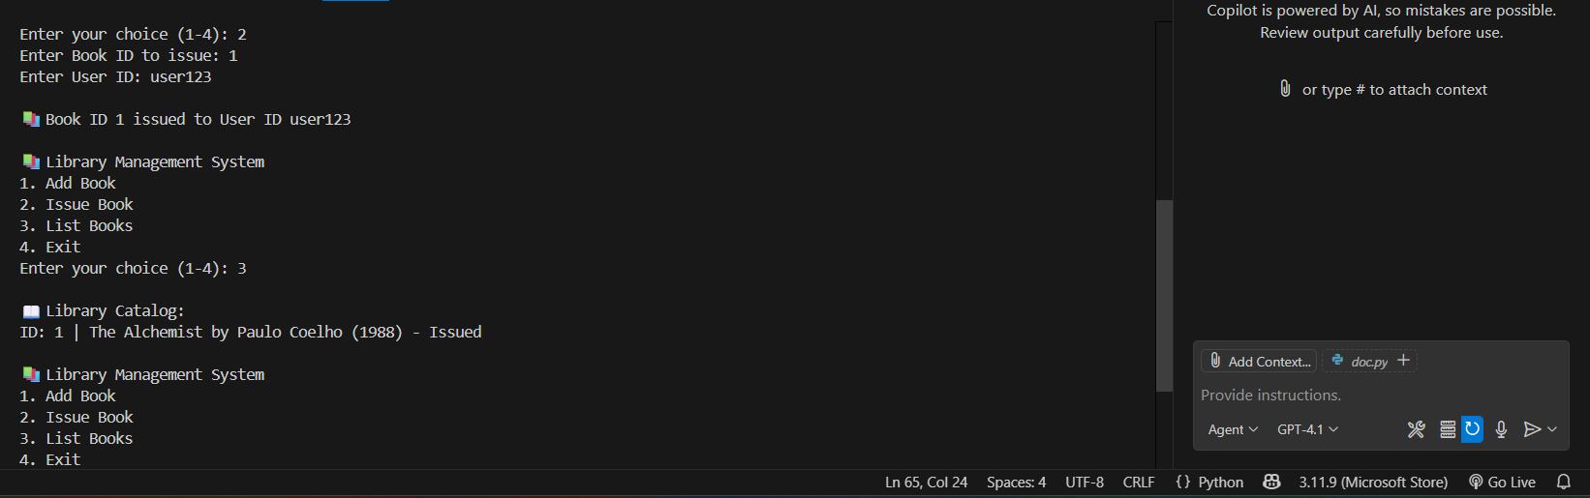
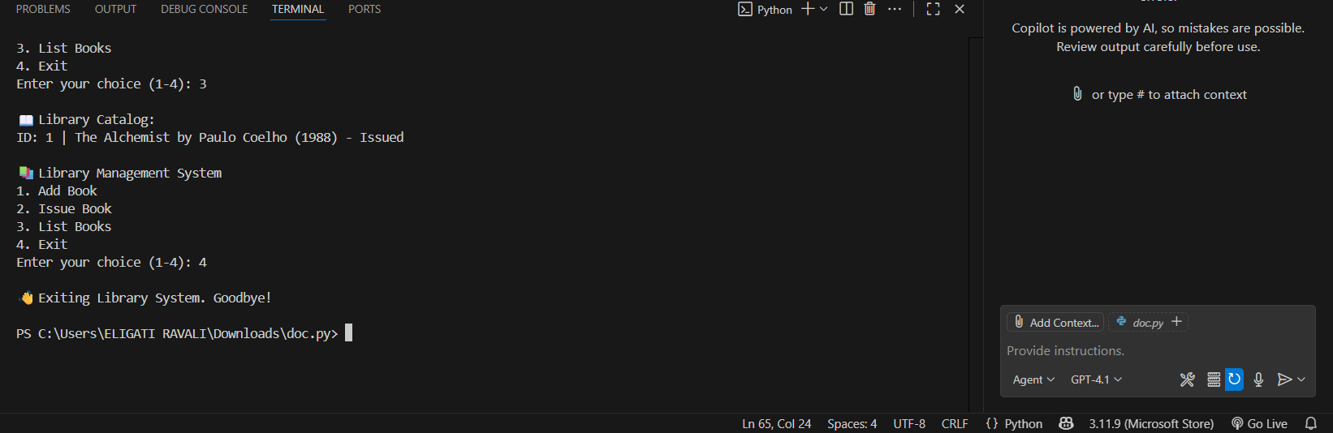

TASK DESCRIPTION #3 (AI_Assisted Code Summarization)
SCENARIO: You are reviewing a colleagues codebase containing long functions.
def process_sensor_data(data):
Cleansed = [x for x in data if x is not None]
avg = sum (cleaned)/len(cleaned)
anomalies = [x for x in cleaned if abs(x- avg) > 10]
return {“average”: avg, “anomalies”:anomalies}
- Generate a summary comment explaining the purpose of the function in 2-3 lines.
- Create a flow-style comment (step-by-step explanation).
- Write a short paragraph of documentation describing possible use cases of this function in real-world scenarios.

CODE :
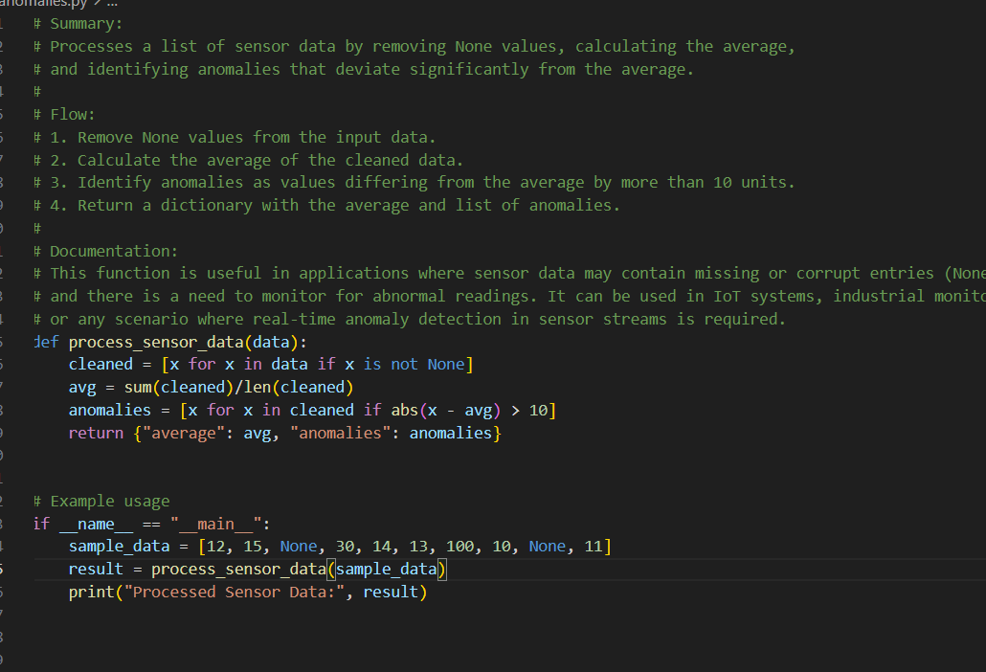
OUTPUT:
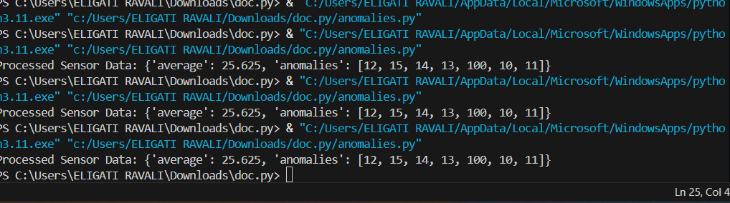

TASK DESCRIPTION #4 (Real-Time Project Documentation)
Scenario: You are part of a project team that develops a Chatbot
Application. The team needs documentation for maintainability.
- Write a README.md file for the chatbot project (include project
description, installation steps, usage, and example).
- Add inline comments in the chatbot’s main Python script (focus
on explaining logic, not trivial code).
- Use an AI-assisted tool (or simulate it) to generate a usage guide
in plain English from your code comments
- Reflect: How does automated documentation help in real-time
projects compared to manual documentation?

CODE:
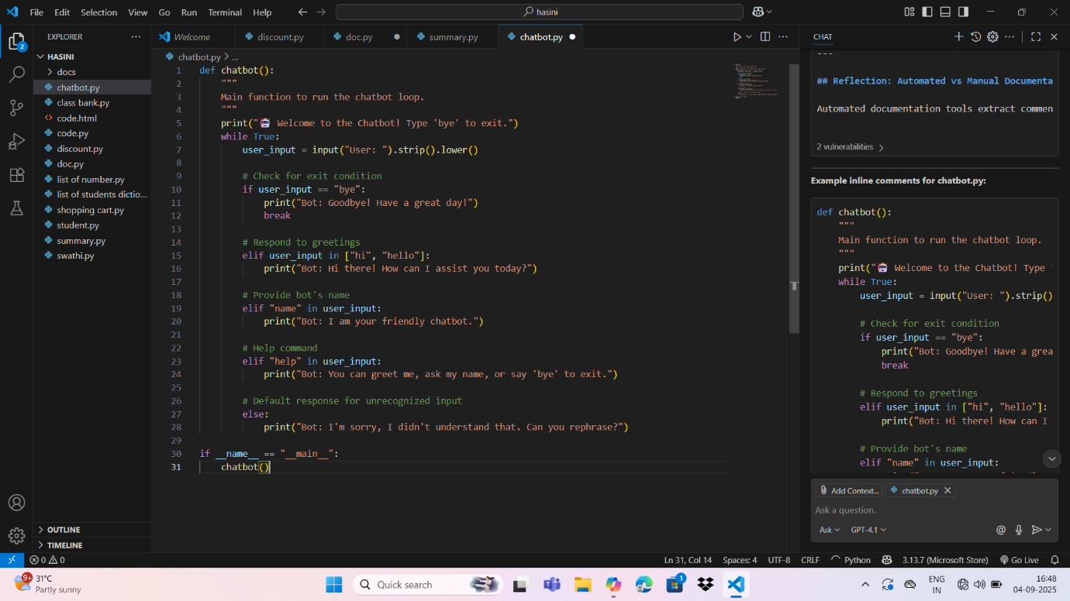

OUTPUT:
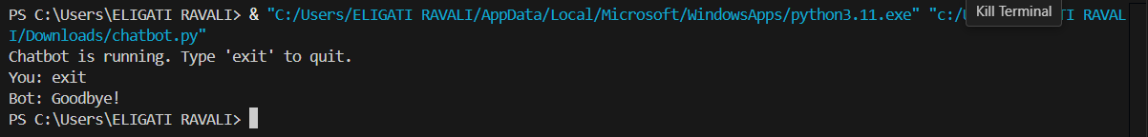

OBSERVATIONS :
By completing this Assignment ,I am able to:
- Compare the auto-generated comments with manually written version using AI Tools.
- Generates the API Documentation Generator using the python scripts .
- Generated the AI_Assisted Code Summarization.
- Implements the Real-Time Project Documentation.

