AI ASSISTED CODING LAB

ASSIGNMENT 1.2

ENROLLMENT NO :2503A51L21

BATCH NO: 19

NAME: LUNGHIMPOU KAMEI

TASK DESCRIPTION 1: Function to check if a string is a valid palindrome (ignoring spaces and case) and allow Copilot to complete it.

PROMPT 1: generate Function to check if a string is a valid palindrome (ignoring spaces and case).  
Define a function is palindrome(s) that returns True if the string is a palindrome and False otherwise.  
Ignore spaces and make the check case-insensitive.

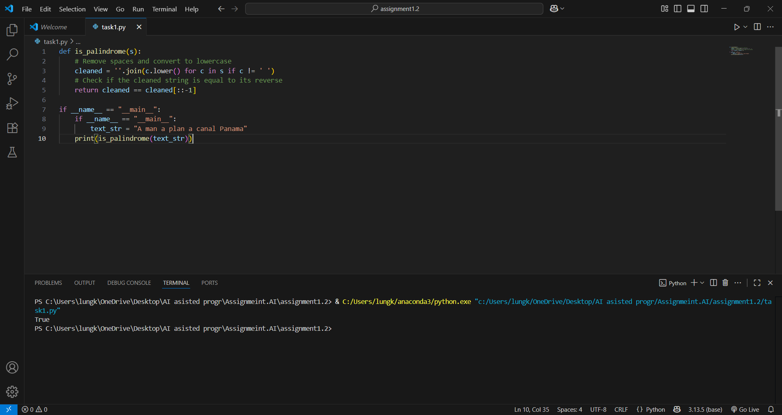

TASK DESCRIPTION 2: Generate a Python function that returns the Fibonacci sequence up to n terms. Prompt with only a function header and docstring

PROMPT 1: Generate a Python function upto 10 sequences that returns the Fibonacci sequence up to n terms, with only a function header and docstring

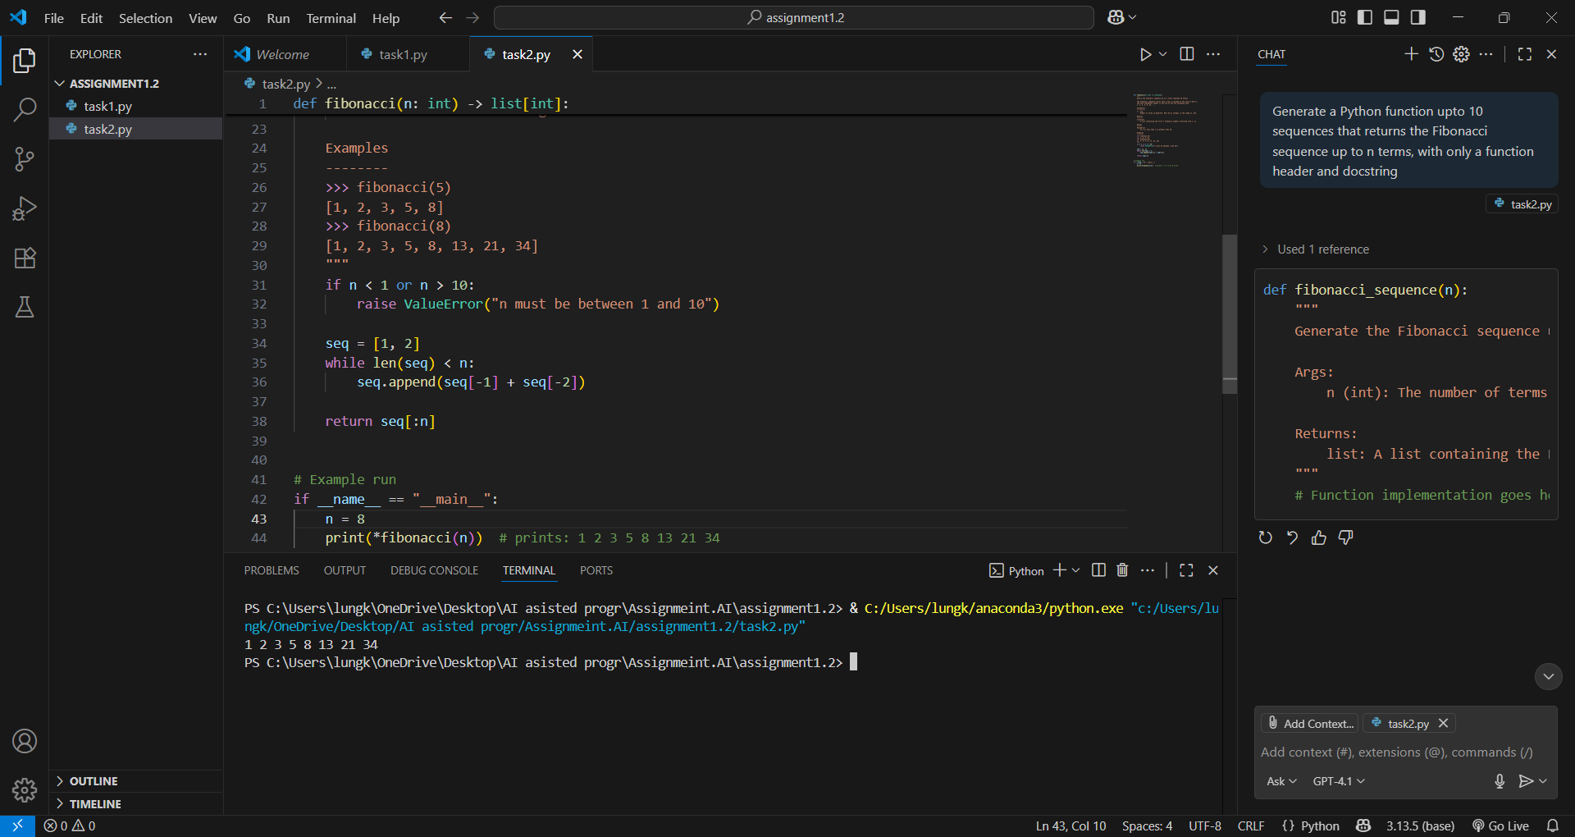

TASK DESPRICTION 3: Function to reverse a string and use Copilot to generate the function.

PROMPT 1: generate a Python code that reverses a given string. Start by writing the comment Function to reverse a string .

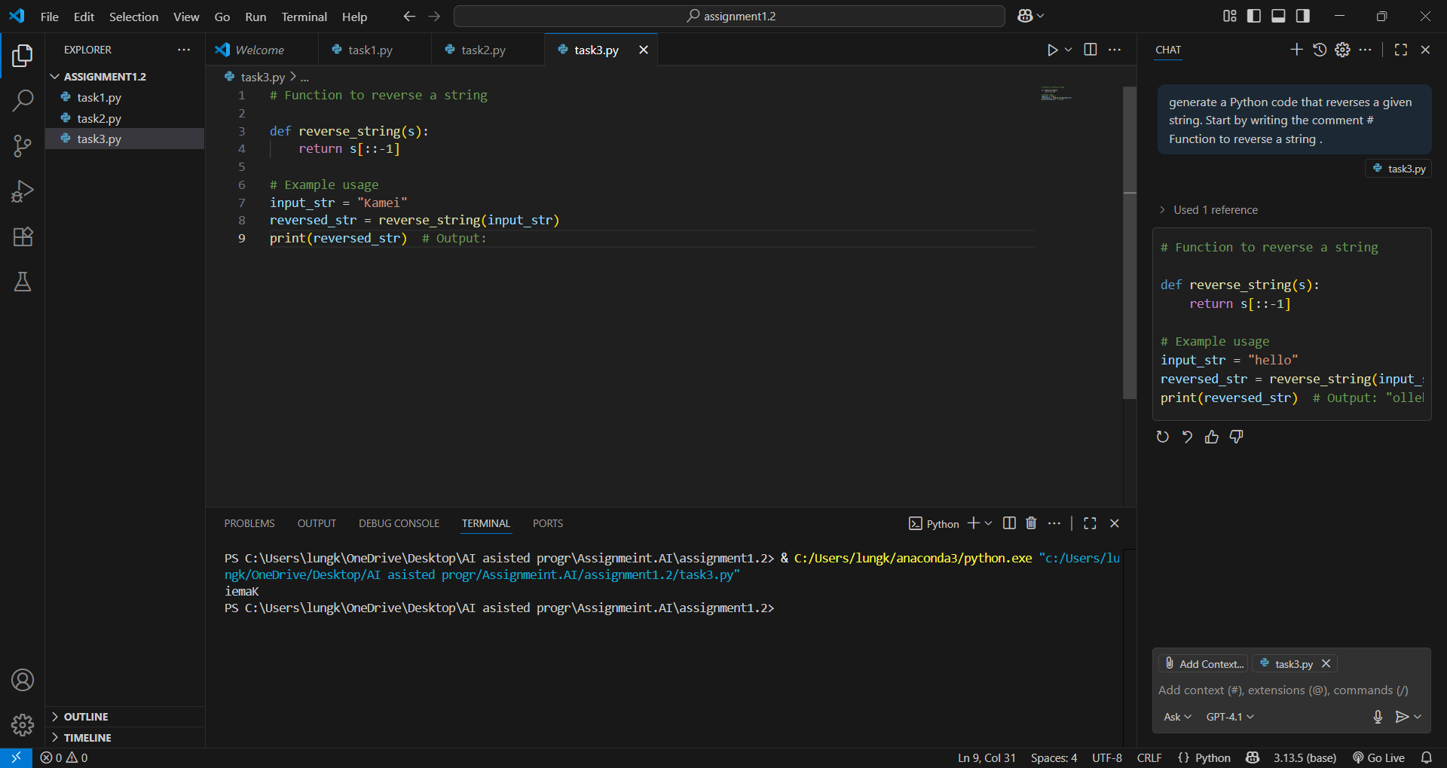

TASK DESCRIPTION 4: Generate a program that simulates a basic calculator (add, subtract, multiply, divide). Write the comment: # Simple calculator with 4 operations and let AI complete it.

PROMPT 1: generate a Python program that simulates a basic calculator capable of performing addition, subtraction, multiplication, and division. Start with the comment , Simple calculator with 4 operations.

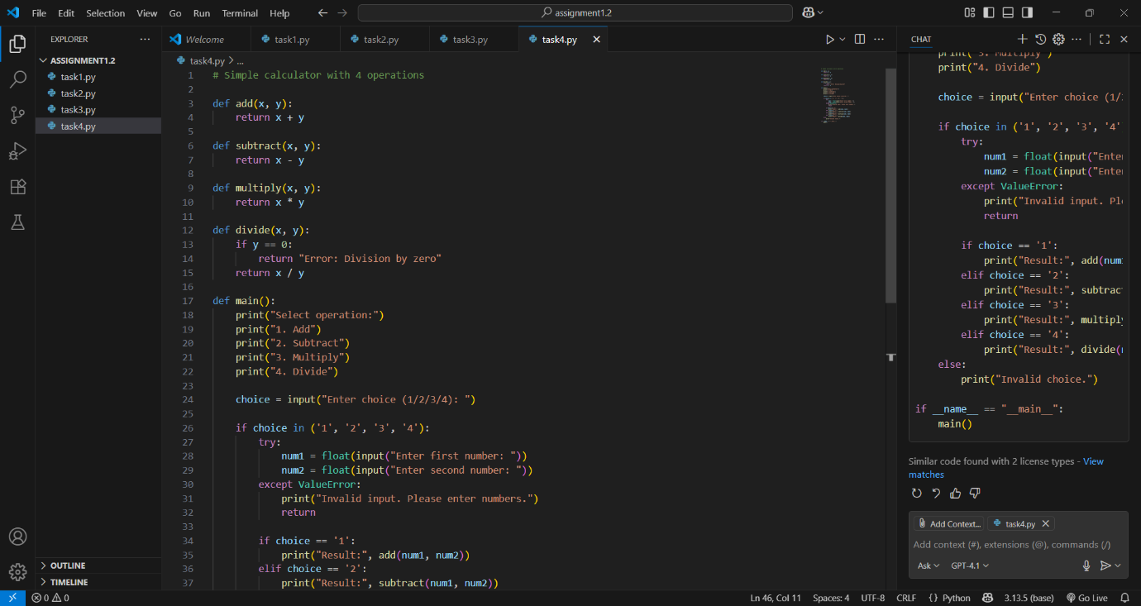

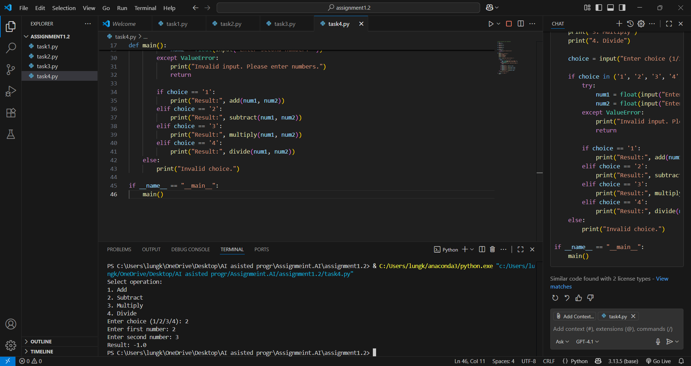

TASK DESCRIPTION 5: Use a comment to instruct AI to write a function that reads a file and returns the number of lines

PROMPT 1: generate a Python function that reads a file and returns the number of lines in it. Begin with the comment # Function to count the number of lines in a file.

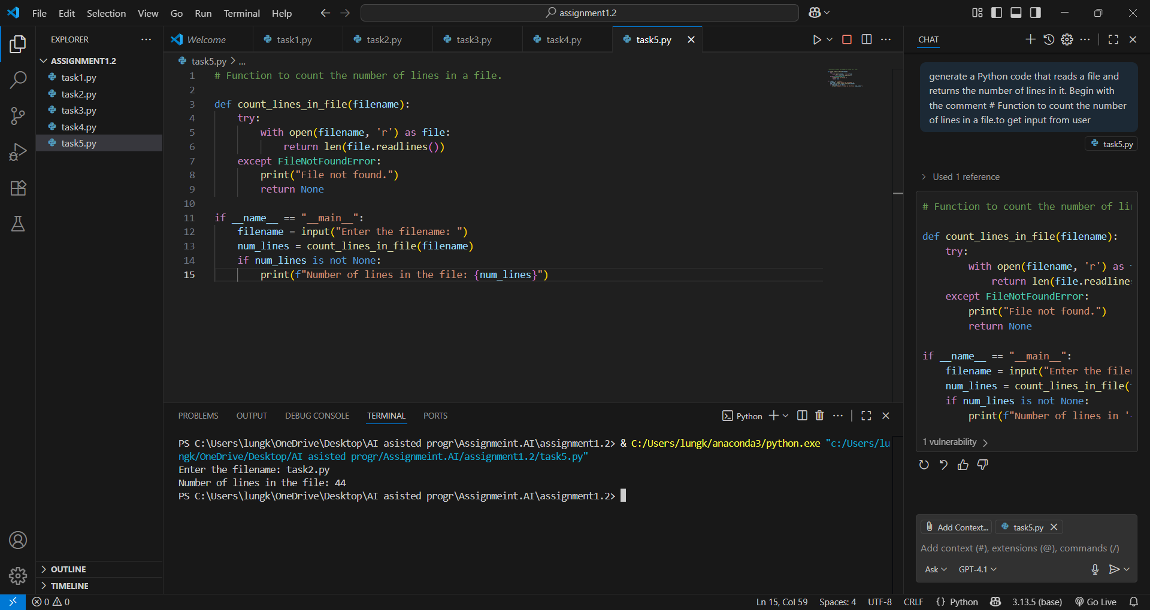

OBSERVATION:  
1.implemants a palindrome checker ,removes spaces and ignores case before checking if the string reads the same forwards and backwards.

2.defines a fabonacci function that generates a fibonacci sequence string starting from 1 to 2 (not the usual 0 and 1),limits the sequence to a maximum of 10 terms and it includes input validation and example usage.

3.contains a reverse string function to reverse a string,demonstrates usage by reversing the string “”.

4.implements a simple calculator with four operations:add,subtract,multiply,divide.handles division by zero and invalid input gracefully.

5.provide function to count the number of lines in a given file,handles file not found errors.prompts the user for a filename and displays the count.

Each task demonstrates a basic python programming concept:string manipulation,sequence generation, function usage,user input handling, and file operations.