AI ASSISTED CODING LAB

ASSIGNMENT 2.4

ENROLLMENT NO :2503A51L21

BATCH NO: 19

NAME: LUNGHIMPOU KAMEI

TASK DESCRIPTION 1: Open Google Colab and use Google Gemini to generate Python code that performs sorting of a list using both the bubble sort algorithm and Python’s built-in sort () function. Compare the two implementations.

PROMPT 1: Generate Python code that demonstrates sorting a list using two methods: (1) implementing the bubble sort algorithm manually, and (2) using Python’s built-in sort () function. The code should generate a random list of integers, apply both sorting methods, and print the sorted results for comparison.

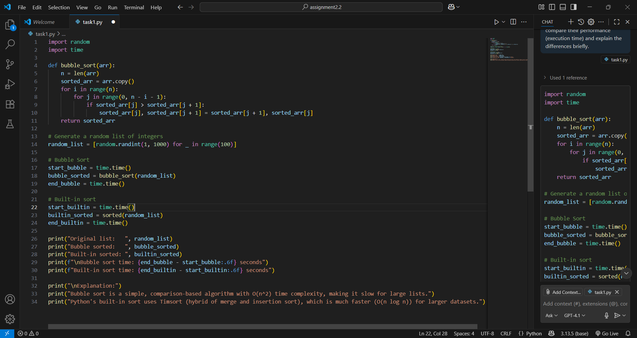

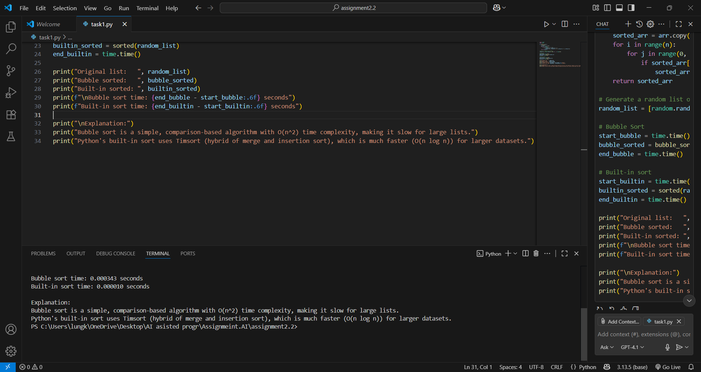

TASK DESCRIPTION 2: In Colab, use Google Gemini to generate a Python function that takes a string and returns:

The number of vowels, The number of consonants, The number of digits in the string

PROMPT 1: Generate a Python function that takes a string as input and returns three values: (1) the number of vowels in the string, (2) the number of consonants, and (3) the number of digits. The function should handle both uppercase and lowercase letters. Demonstrate the function with a few example strings.

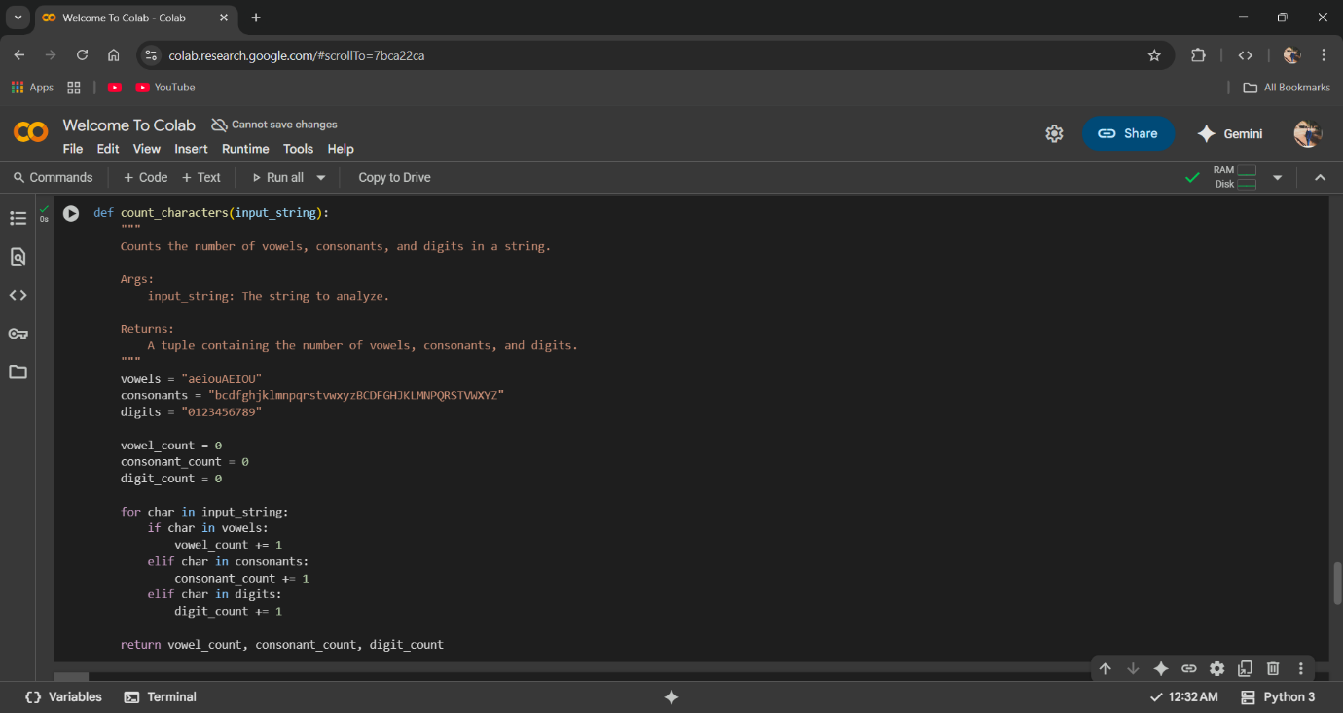

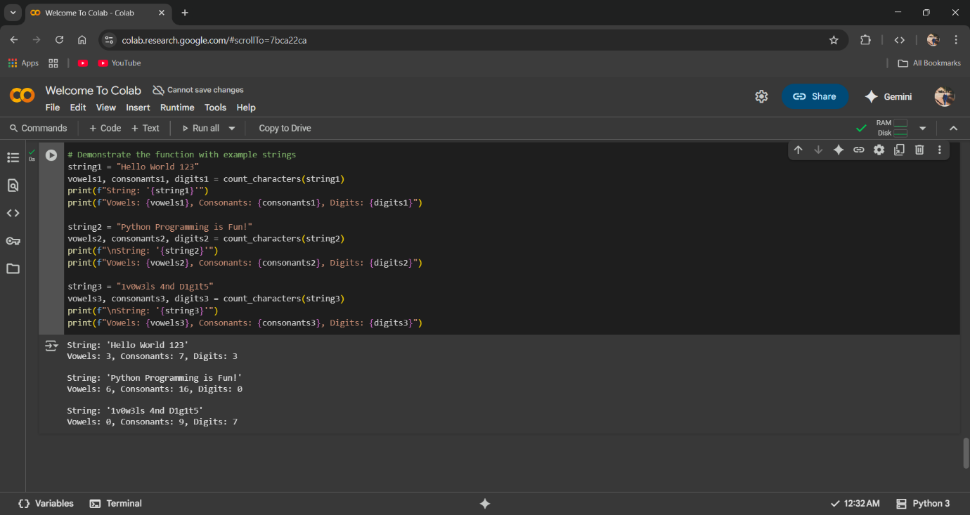

TASK DESCRIPTION 4: Ask Google Gemini to generate a Python program that implements a simple calculator using functions (add, subtract, multiply, divide). Then, ask Gemini to explain how the code works.

PROMPT 1: Generate a Python program that implements a simple calculator using functions for addition, subtraction, multiplication, and division. The program should allow the user to enter two numbers and select an operation.

