AI ASSISTED CODING LAB

ASSIGNMENT 3.2

ENROLLMENT NO :2503A51L21

BATCH NO : 19

NAME : LUNGHIMPOU KAMEI

* TASK DISPRICTION 1: Ask AI to write a function to calculate compound interest, starting with only the function name. Then add a docstring, then input-output example

PROMPT 1:Generate a python code to calculate compound interest,starting with only the function name,then input-output example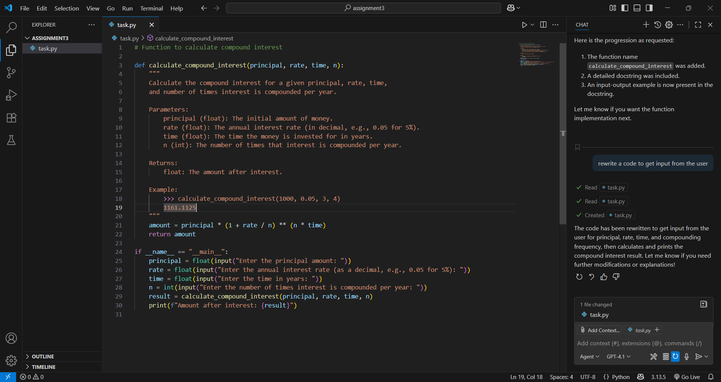

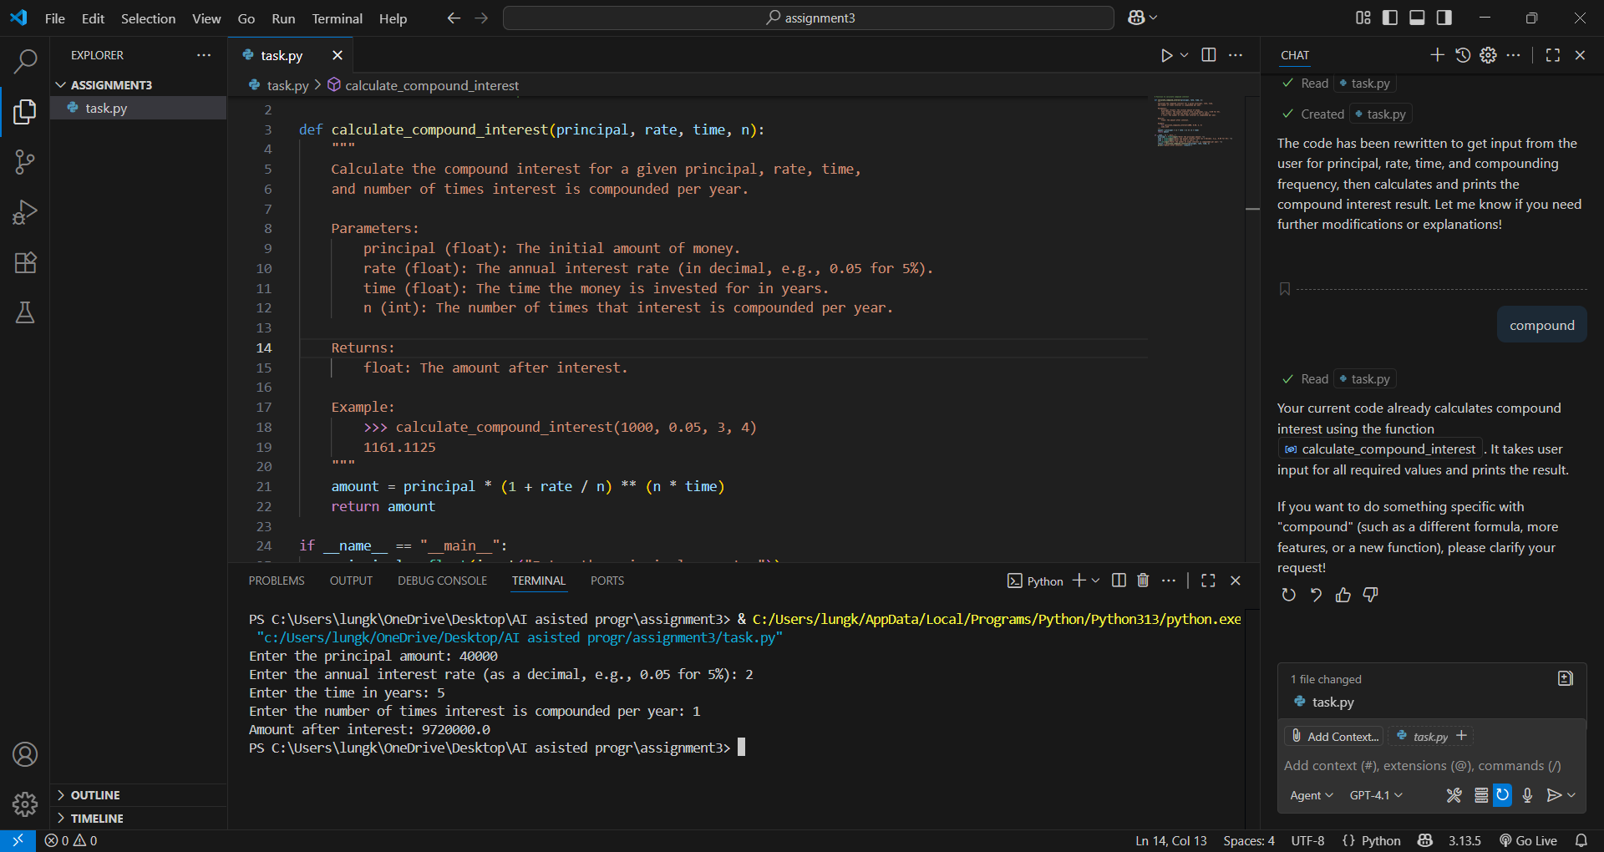

TASK DISCRIPTION 2: Do math stuff, then refine it to: Write a function to calculate average, median, and mode of a list of numbers.

PROMPT 1:Generate a python code to do math, to calculate average, median, and mode of a list of numbers.

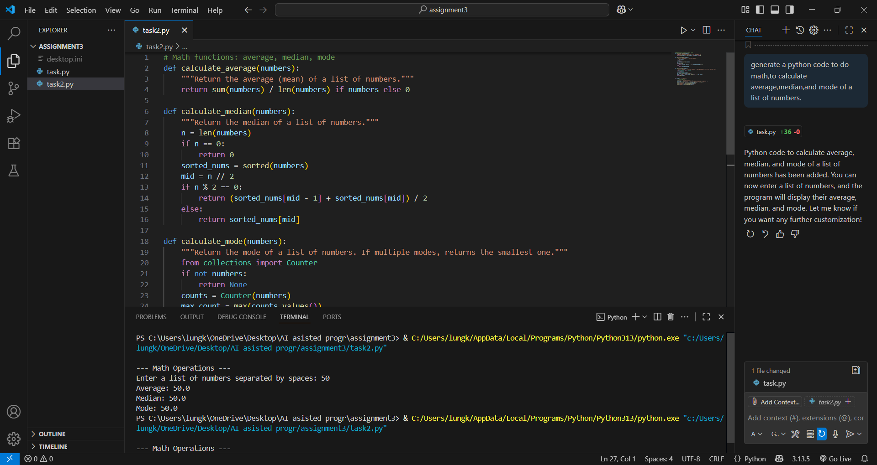

TASK DISCRIPTION 3: Provide multiple examples of input-output to the AI for convert to binary (num) function. Observe how AI uses few-shot prompting to generalize

PROMPT 1: Generate a python code for convert to binary (num) function.

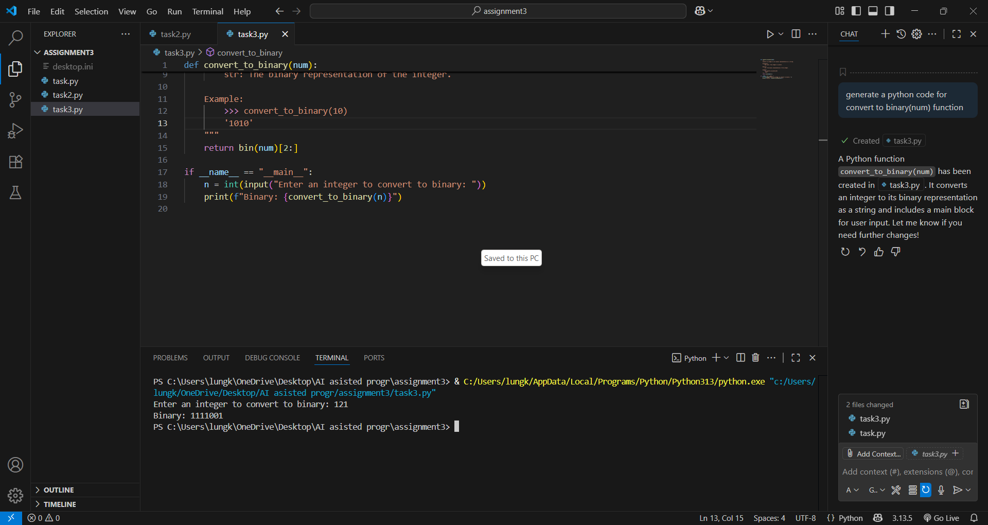

TASK DISCRIPTION 4: Create an user interface for an hotel to generate bill based on customer requirements

PROMPT 1:Write a python code to create an user interface for an hotel bill based on customer requirements.

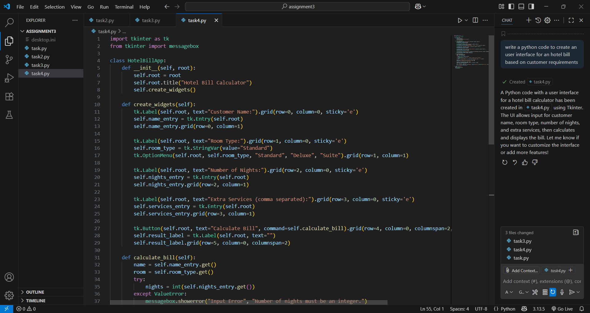

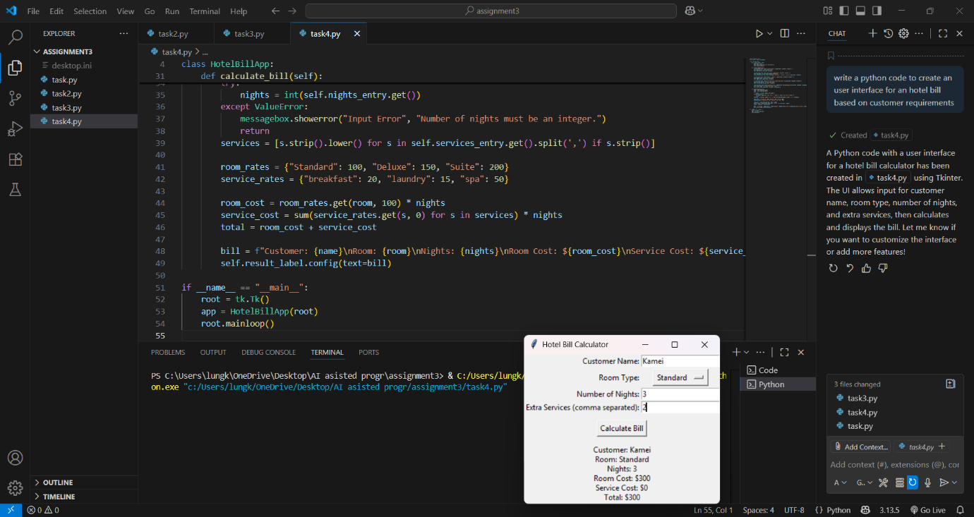

* TASK DISCRIPTION 5:Analyzing Prompt Specificity: Improving Temperature Conversion Function with Clear Instructions

PROMPT 1: Generate a python code for improving temperature conversion with clear instructions.

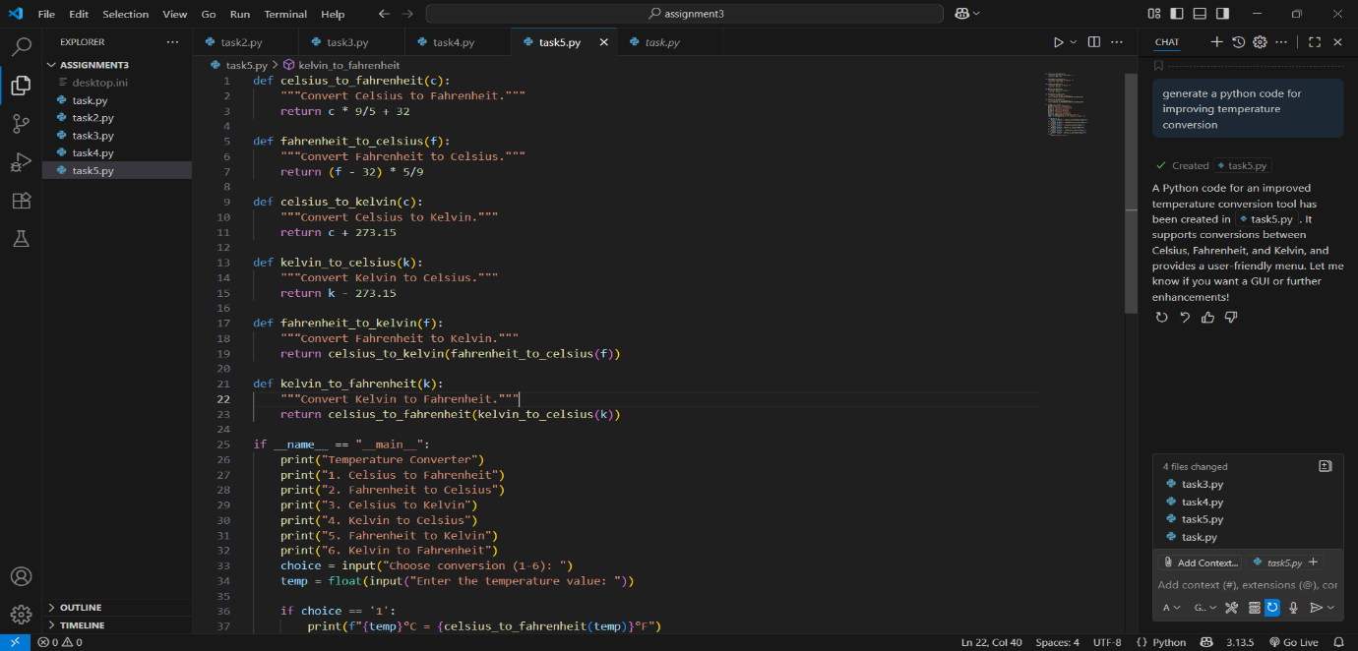

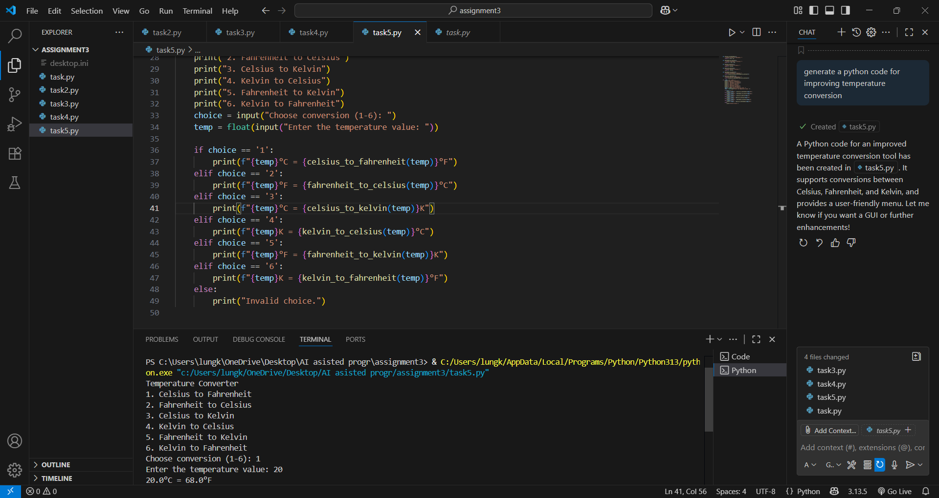

OBSERVATION: In this assignment, GitHub Copilot was effectively utilized to auto-completely different Python coding tasks. Each task was structured with a clear description and a starting prompt, allowing Copilot to generate the remaining logic. The tasks covered fundamental programming concepts such as mathematical calculation, user input handling function documentation, binary conversion.

1.Compound interest – that calculates compound interest based on user input for principal, rate, time, and

Compound frequency. The code is clear, interactive, and demonstrates good use of function documentation.

2.Math operation(Average, Median, Mode) – provide with function to compute average, median, mode for a list of numbers. The code is modular and user-friendly, allowing easy extension for statistics.

3.Binary Conversion – converts an integer to its binary string representation. Code is concise and include a user prompt for input.

4.Hotel Bill User Interface – allows user to enter customer details, room type, nights, and extra services, then calculates the total bill. The interface is simple, practical, and demonstrates basic programming.

5.Temperature Conversion – provides a menu driven interface for converting temperatures between Celsius, Fahrenheit, and Kelvin. It cover all common conversions and is easy to use.