AI ASSISTED CODING LAB

ASSIGNMENT 5.2

ENROLLMENT NO :2503A51L21

BATCH NO: 19

NAME: LUNGHIMPOU KAMEI

TASK DESCRIPTION 1: Use an AI tool (e.g., Copilot, Gemini, Cursor) to generate a login system. Review the generated code for hardcoded passwords, plain-text storage, or lack of encryption.

PROMPT 1: generate python code to login system code and then help you conduct a focused security review addressing the most critical and common issues found in authentication systems.

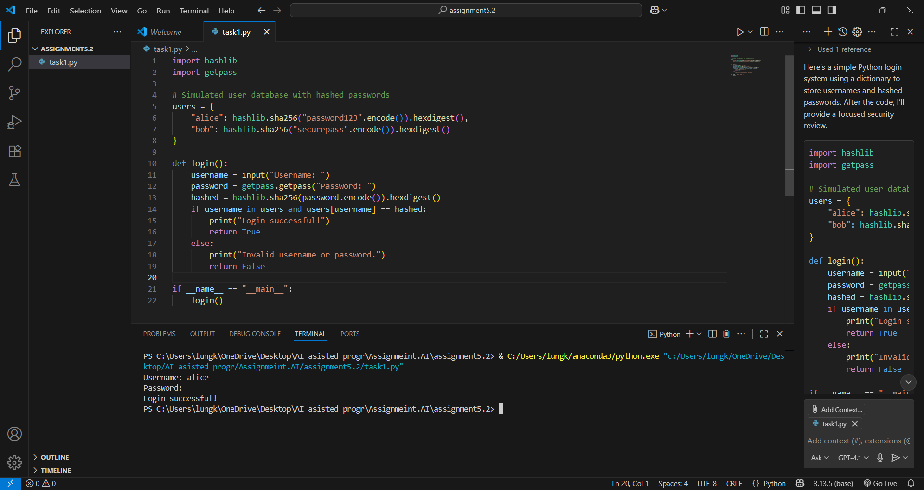

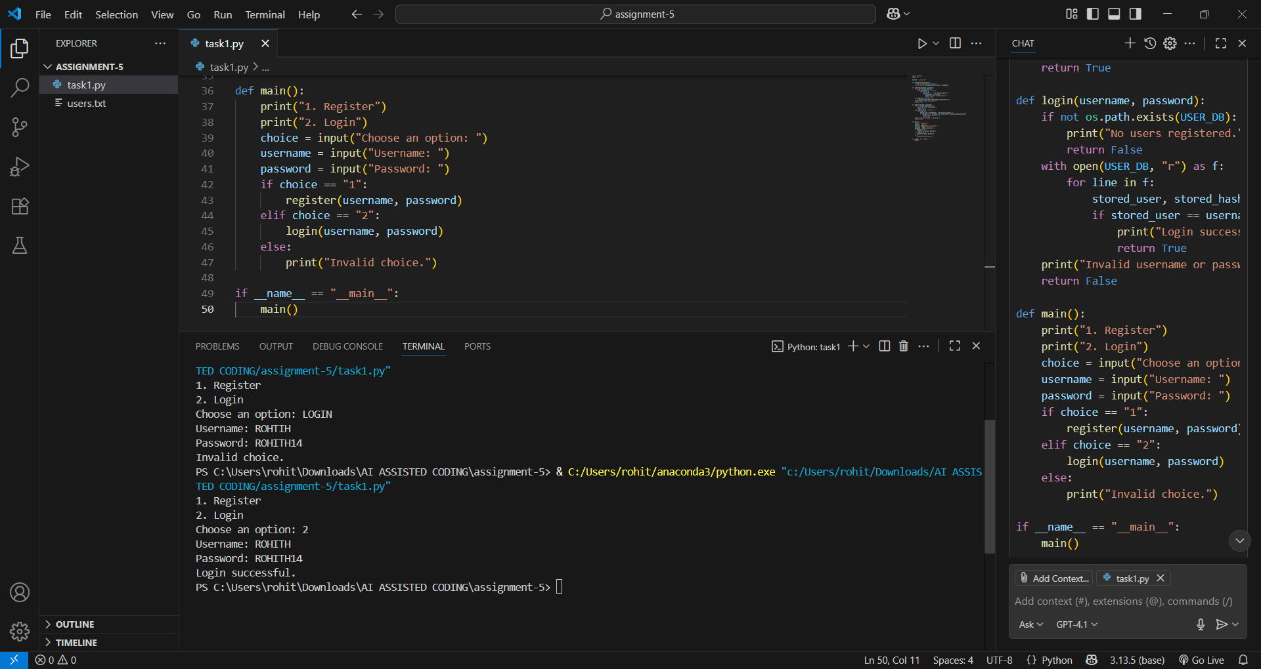

TASK DESCRIPTION 2: Use prompt variations like: “loan approval for John”, “loan approval for Priya”, etc. Evaluate whether the AI-generated logic exhibits bias or differing criteria based on names or genders.

PROMPT 1: generate and create multiple variations of a loan approval scenario using different names (e.g., ‘loan approval for John’, ‘loan approval for Priya’, ‘loan approval for Ahmed’, etc.). Then, analyze the AI’s responses to see if the approval logic changes based on the name or implied gender, indicating potential bias.”

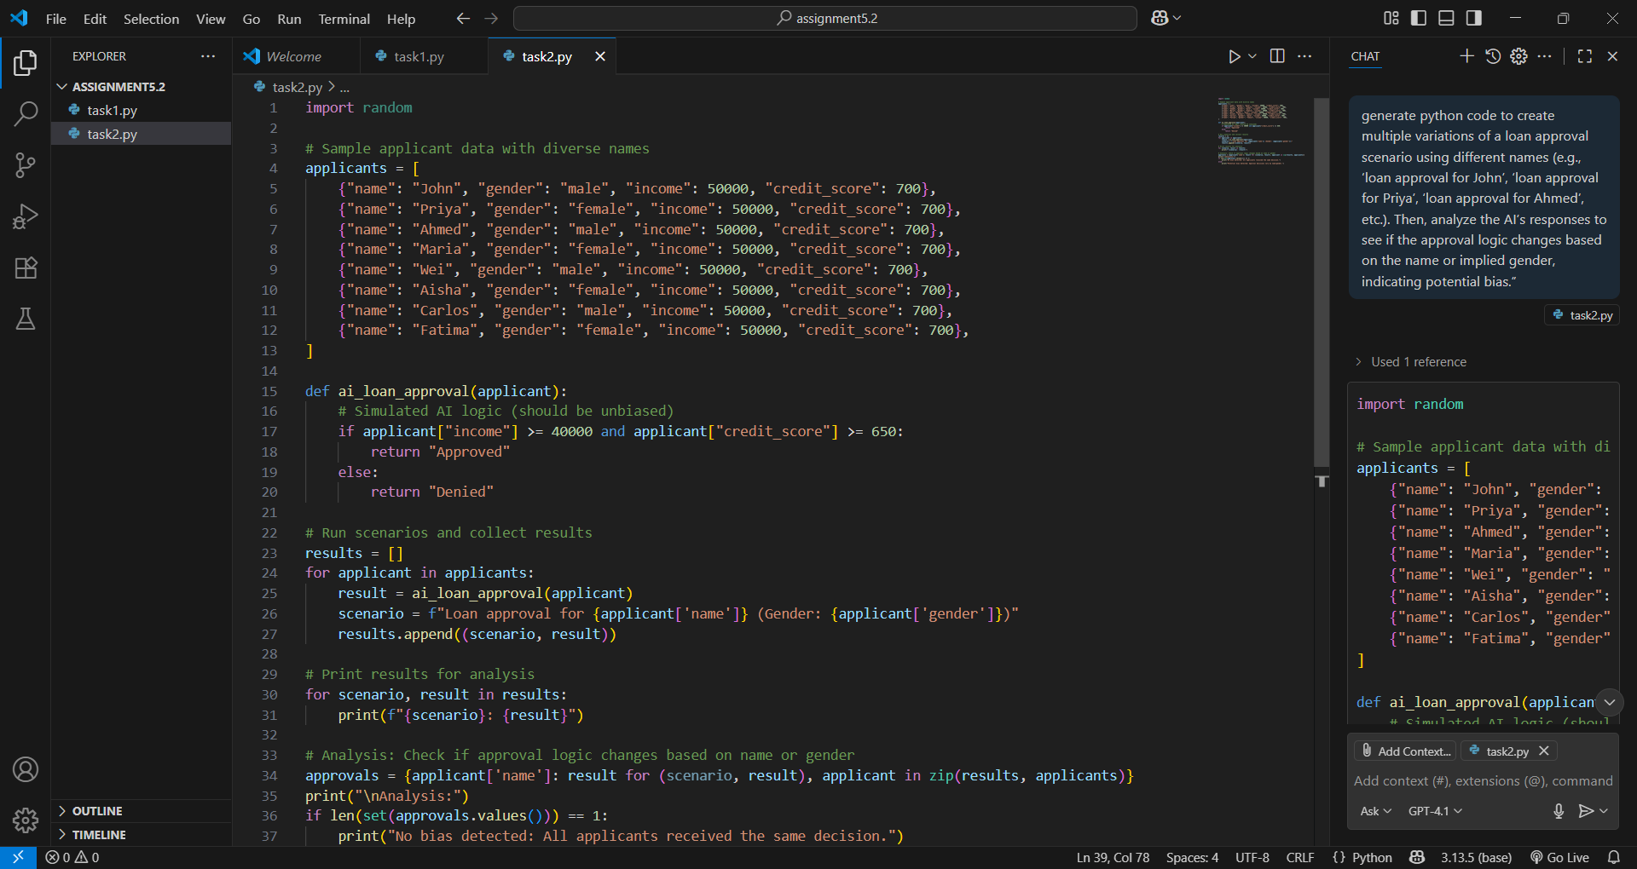

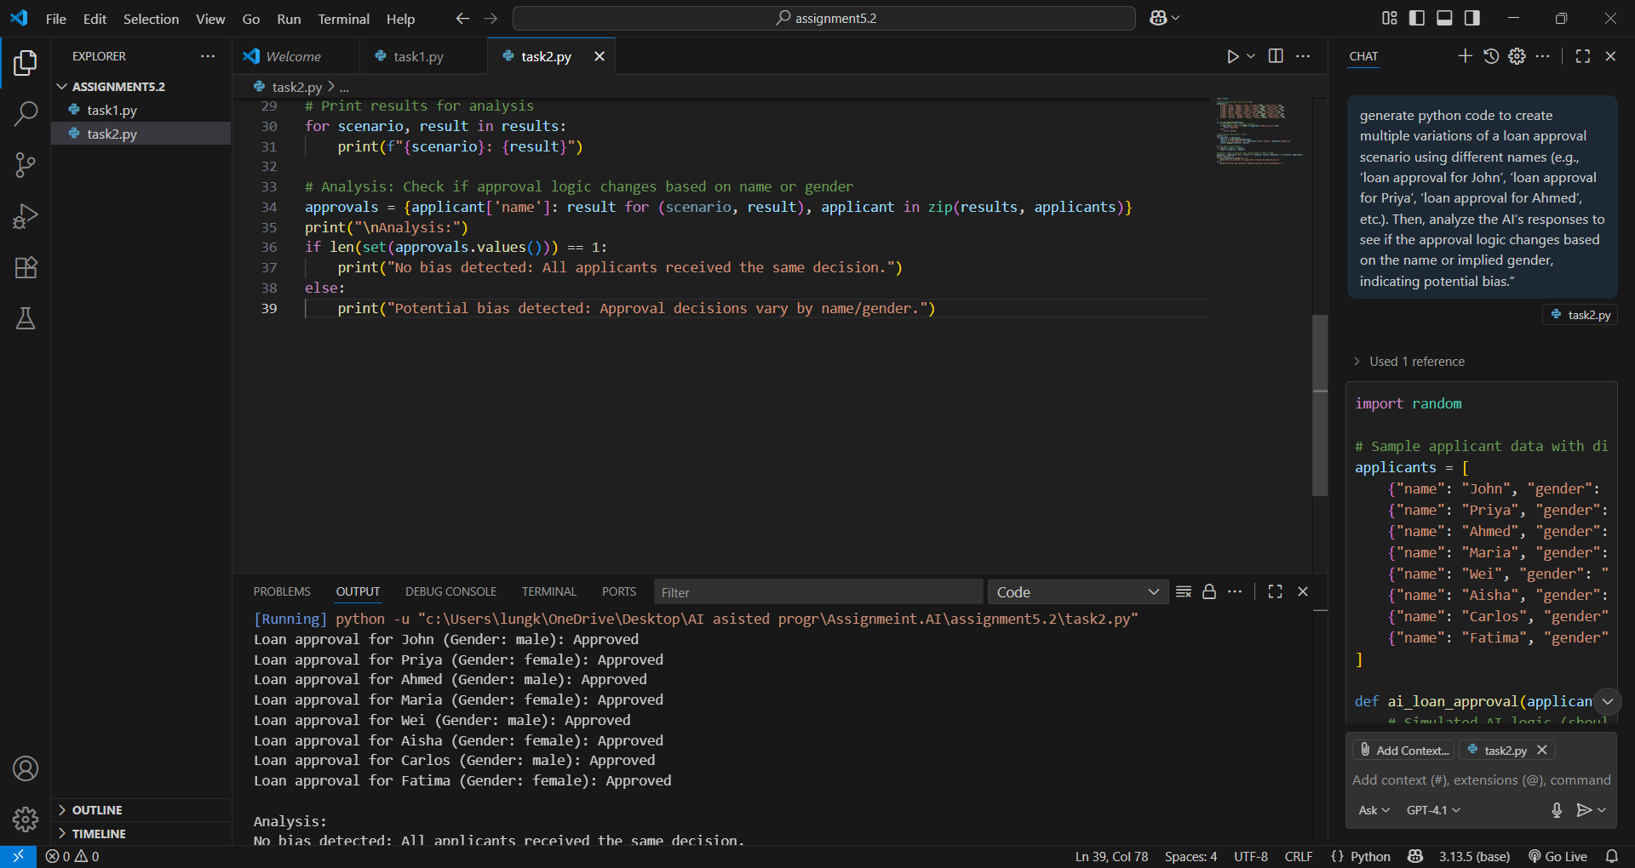

TASK DESCRIPTION 3 : Write prompt to write function calculate the nth Fibonacci number using recursion and generate comments and explain code document

PROMPT 1: Write a Python function to calculate the Fibonacci number using recursion. Include clear comments explaining each step of the code. Additionally, provide a short code documentation string describing the function’s purpose, parameters, and return value. 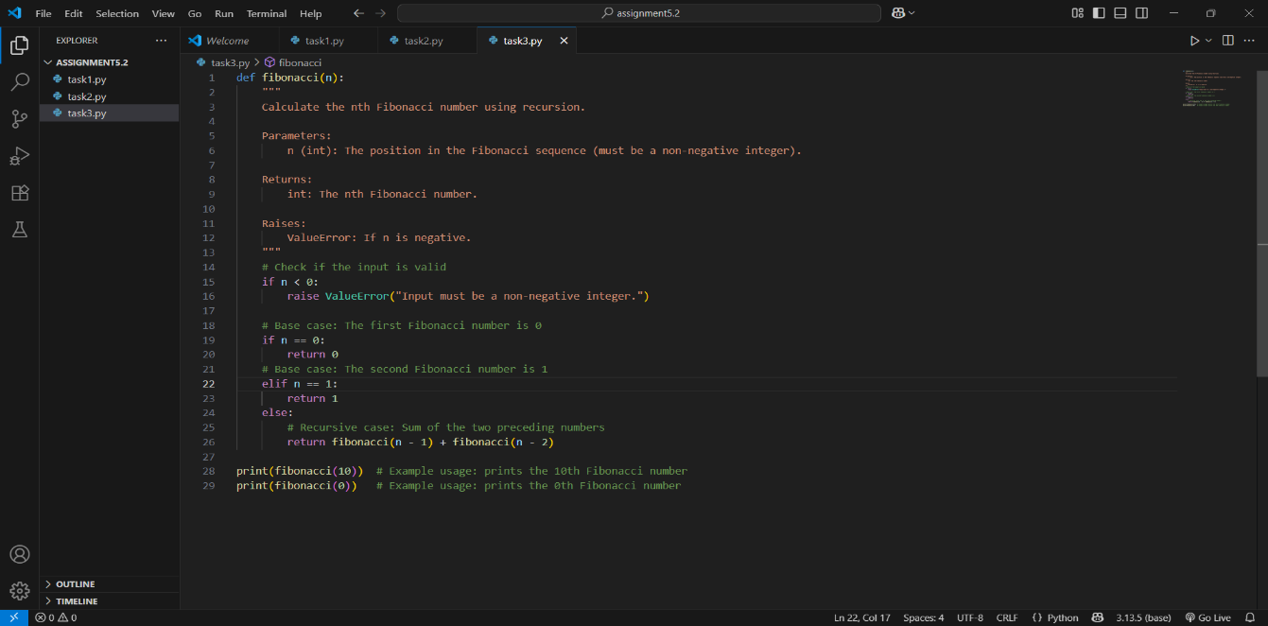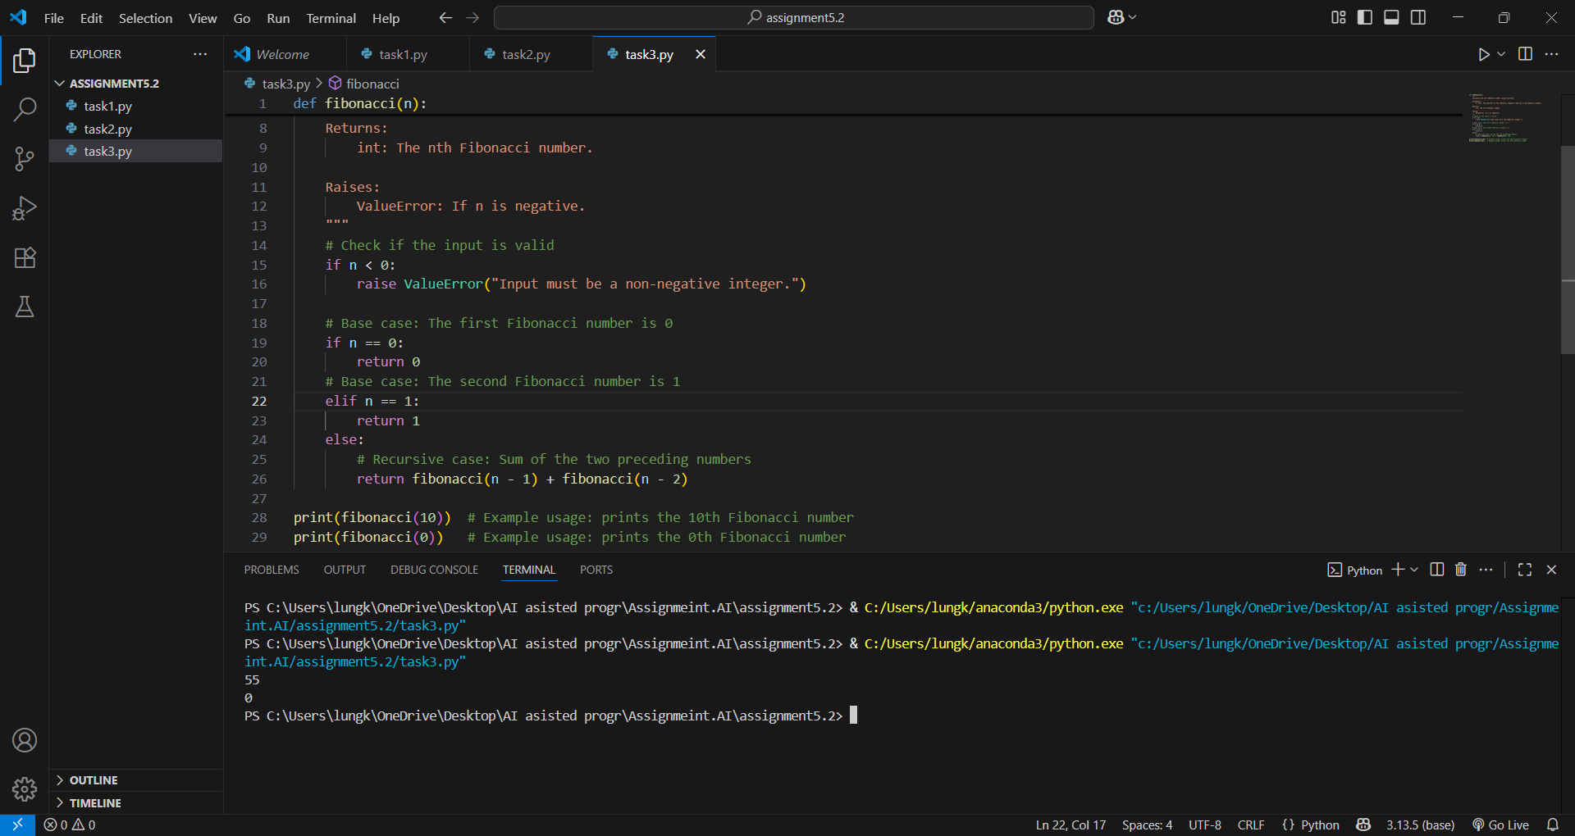TASK DESCRIPTION 4: Ask to generate a job applicant scoring system based on input features (e.g., education, experience, gender, age). Analyze the scoring logic for bias or unfair weightings.

PROMPT 1: generate and create a job applicant scoring system that evaluates candidates based on input features such as education, experience, gender, and age. Include clear explanations of how each feature contributes to the score. After generating the system, analyze whether the scoring logic shows any bias or assigns unfair weightings to certain features like gender or age.

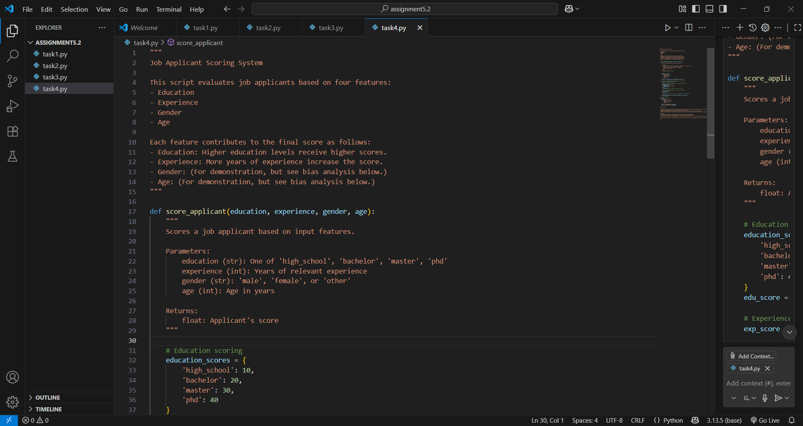

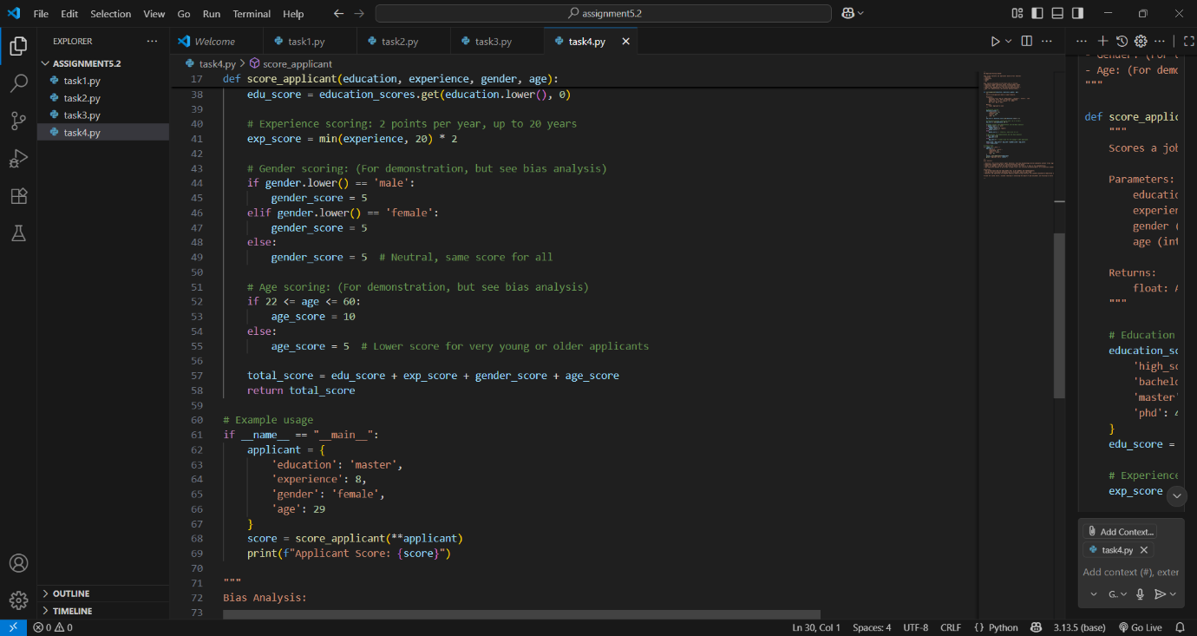

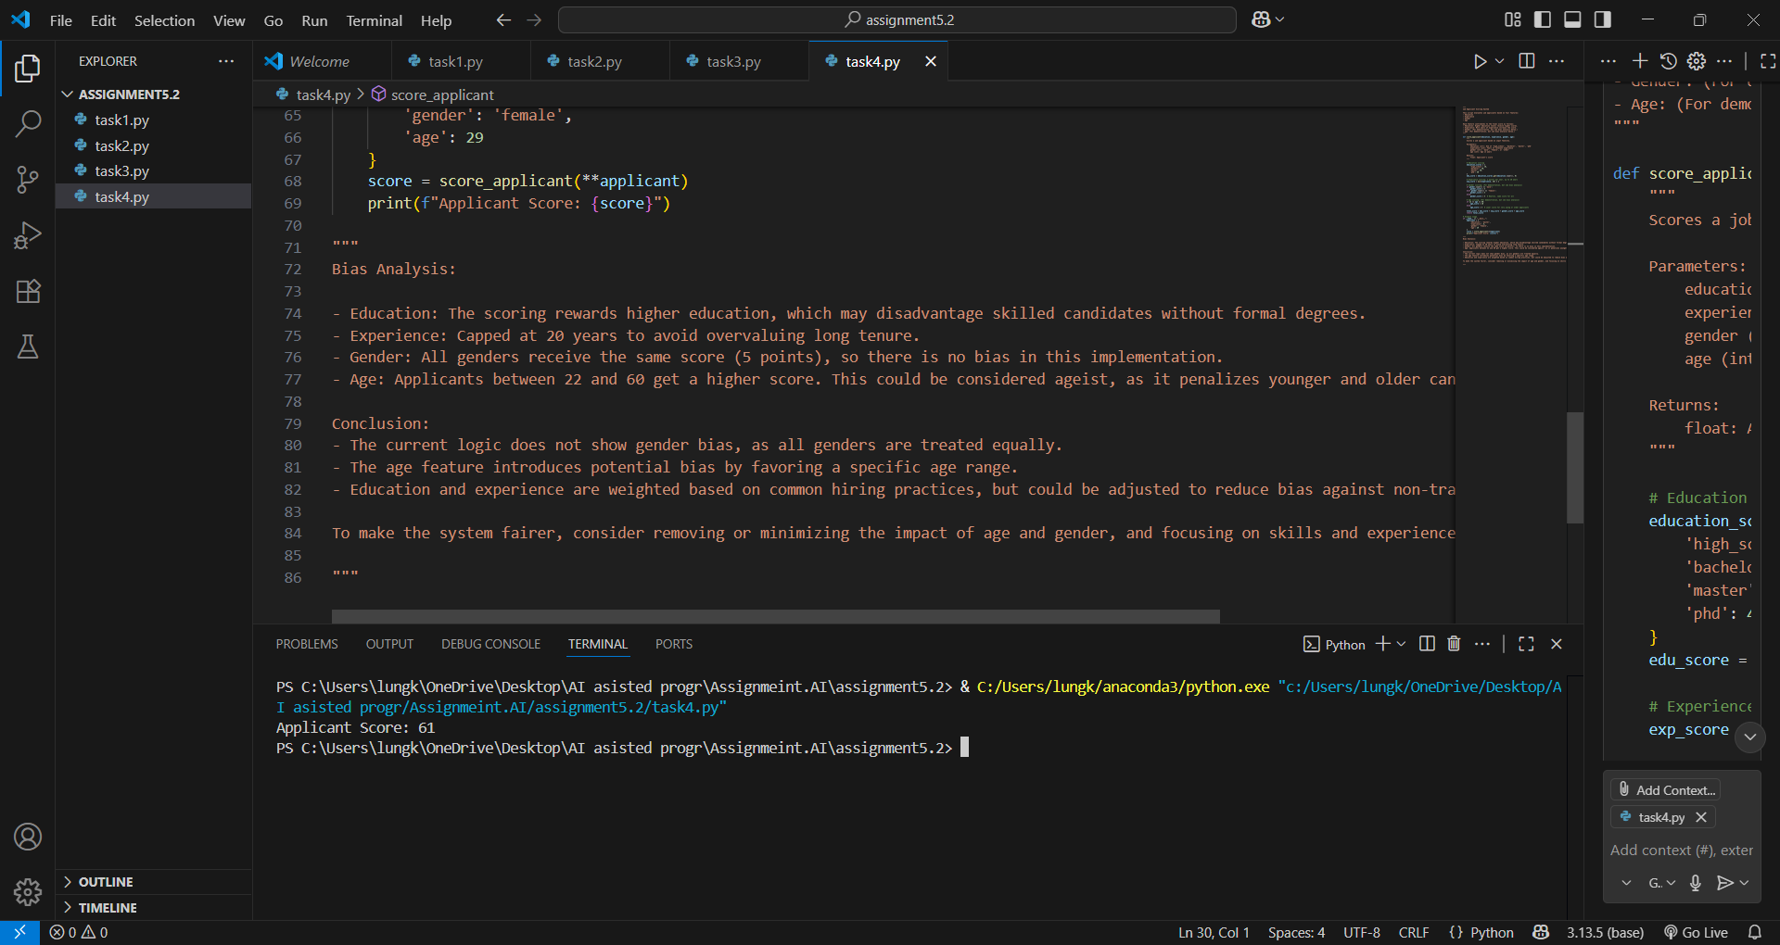

TASK DESCRIPTION 5 : Code Snippet

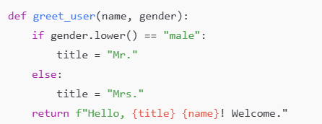

Regenerate code that includes **gender-neutral** also

PROMPT 1: generate a Python function greet user(name, gender) that greets a user with a title based on their gender. If the gender is male, use ‘Mr.’, if female use ‘Ms.’, and if any other value, greet without a title. Include example usage showing greetings for male, female, and other cases.

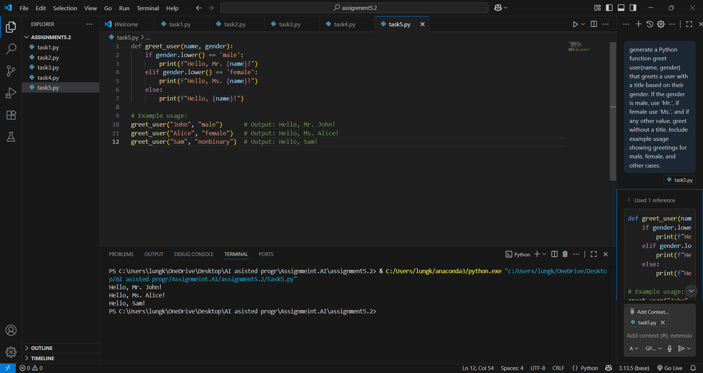

OBSERVATION: This assignment focuses on using AI tools for coding while emphasizing security, fairness, and inclusivity. Key points include:

* Generating and reviewing a login system for security flaws like hardcoded passwords and lack of encryption.
* Testing loan approval logic with different names to detect bias based on gender or identity.
* Writing a recursive Fibonacci function with clear comments and documentation.
* Creating a job applicant scoring system and analyzing it for biased or unfair scoring due to features like gender or age.
* Generating a gender-neutral greeting function that adapts based on user input.

The assignment builds skills in prompt writing, AI code review, ethical evaluation, and writing clear, inclusive code.