AI ASSISTED CODING LAB ASSIGNMENT 11.1

ENROLLMENT NO :2503A51L21
BATCH NO: 19
NAME: LUNGHIMPOU KAMEI

Lab 11- Data Structures with AI: Implementing Fundamental Structures.

TASK1: Implementing a Stack (LIFO)
- Task: Use AI to help implement a Stack class in Python with the following operations: push(), pop(), peek(), and is_empty().
- Instructions:
  - Ask AI to generate code skeleton with docstrings.
  - Test stack operations using sample data.
  - Request AI to suggest optimizations or alternative implementations (e.g., using collections.deque).

PROMPT: Generate a code to implement a Stack(LIFO) class in python supporting push(), pop(), peek(), and is_empty().
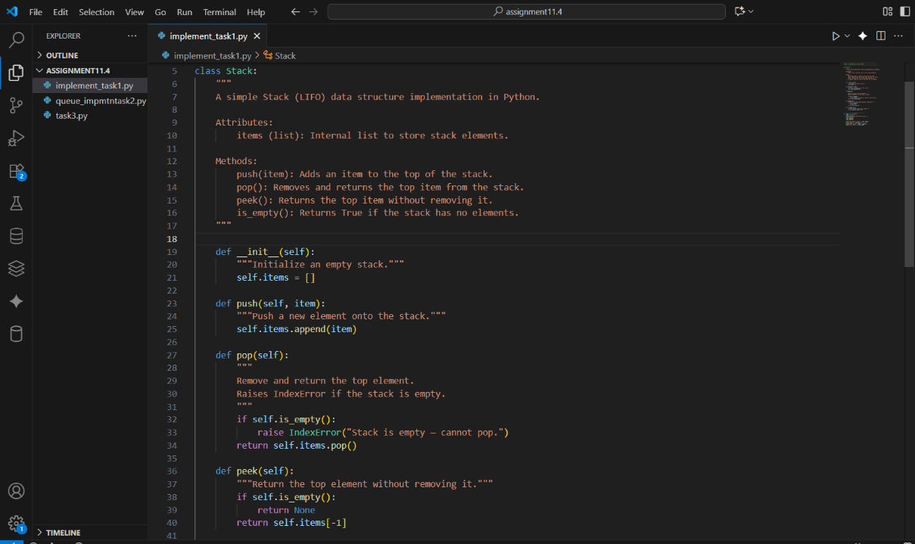
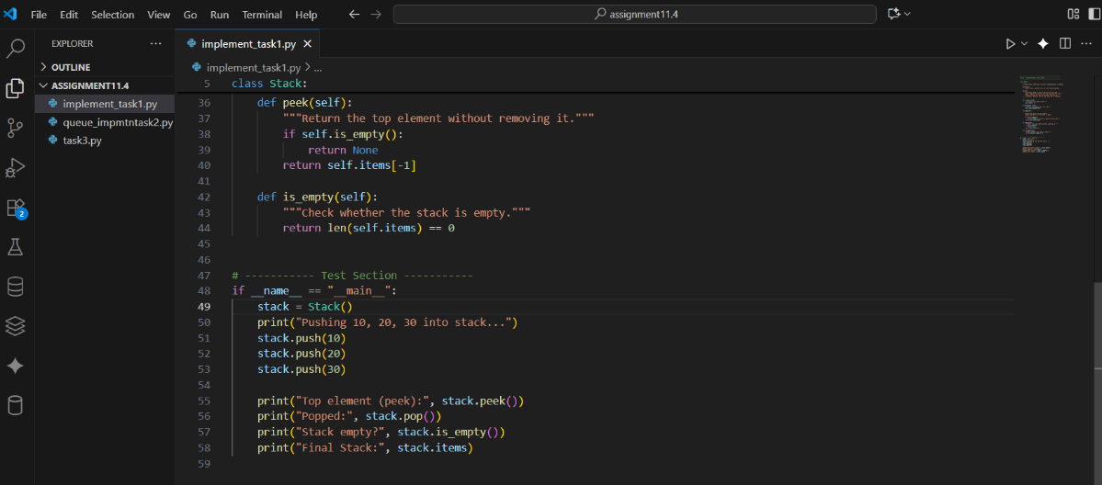
OUTPUT:
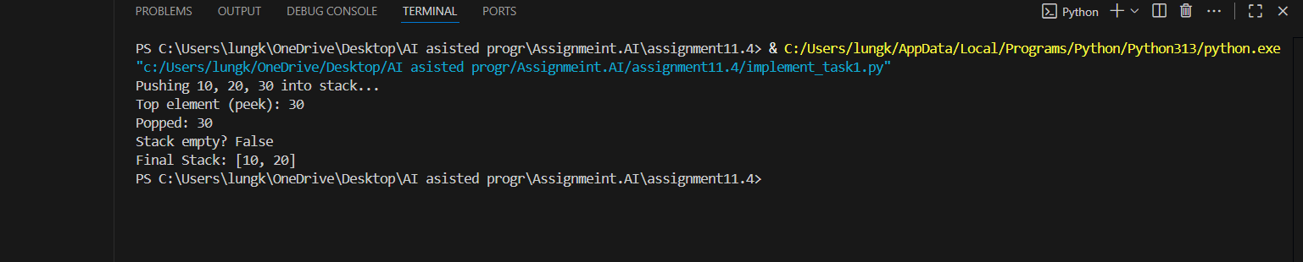

OBSERVATION:
The Stack program works correctly in LIFO order.
Elements are added and removed properly using push() and pop().
The output shows the top element using peek(), and is_empty() checks the stack status correctly.

TASK2: Queue Implementation with Performance Review
- Task: Implement a Queue with enqueue(), dequeue(), and is_empty() methods.
- Instructions:
  - First, implement using Python lists.
  - Then, ask AI to review performance and suggest a more efficient implementation (using collections.deque).

PROMPT: Generate Python code for a Queue implementation with enqueue(), dequeue(), and is_empty() methods — first using a list, then using collections.deque, and include a short performance comparison
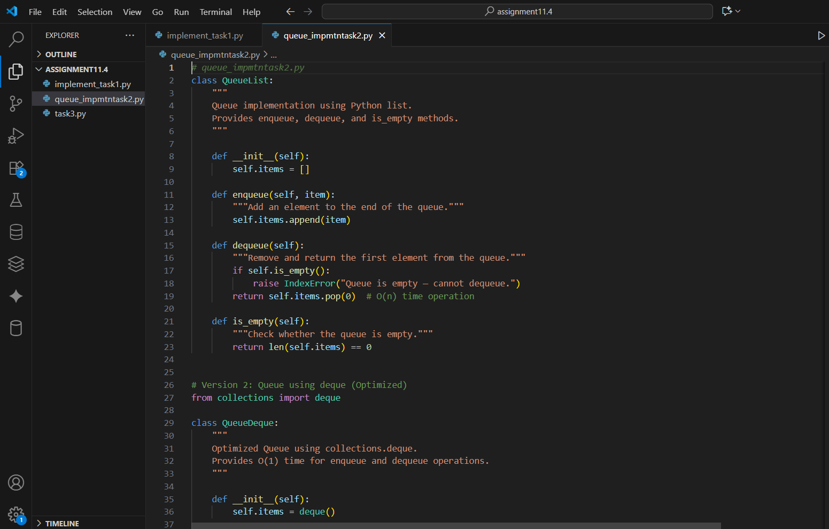
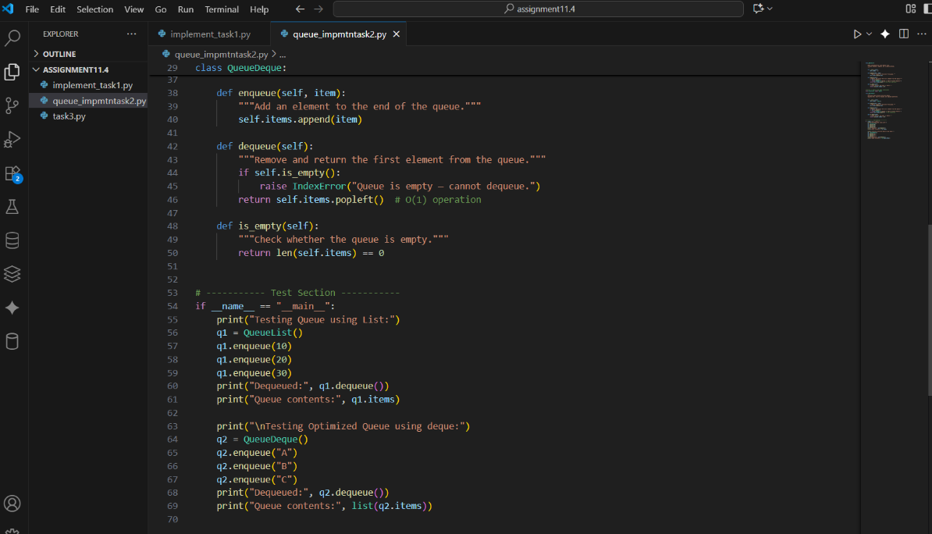

OUTPUT:
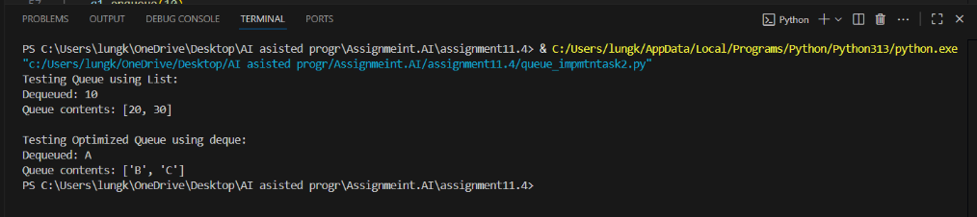

OBSERVATION:
In the QueueList, elements are enqueued and dequeued correctly — after removing the first element, the remaining queue updates as expected.
In the QueueDeque, operations produce the same result but execute more efficiently.
Both implementations maintain the First-In-First-Out (FIFO) order: the first element inserted is the first one removed.

TASK3: Singly Linked List with Traversal
- Task: Implement a Singly Linked List with operations: insert_at_end(), delete_value(), and traverse().
- Instructions:
  - Start with a simple class-based implementation (Node, LinkedList).
  - Use AI to generate inline comments explaining pointer updates (which are non-trivial).
  - Ask AI to suggest test cases to validate all operations.

- PROMPT: Write a Python program that implements a Singly Linked List using classes. Include the following methods: insert_at_end(), delete_value(), and traverse().
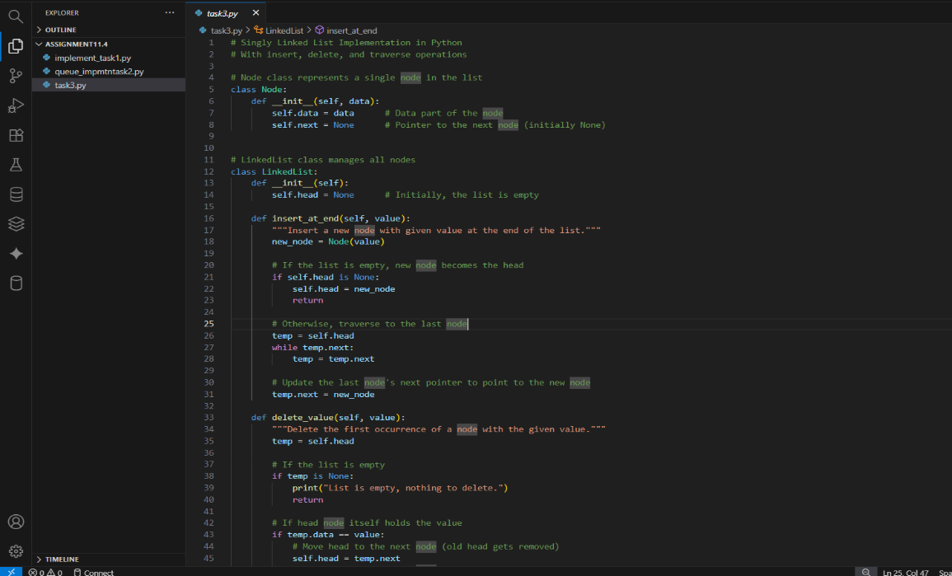
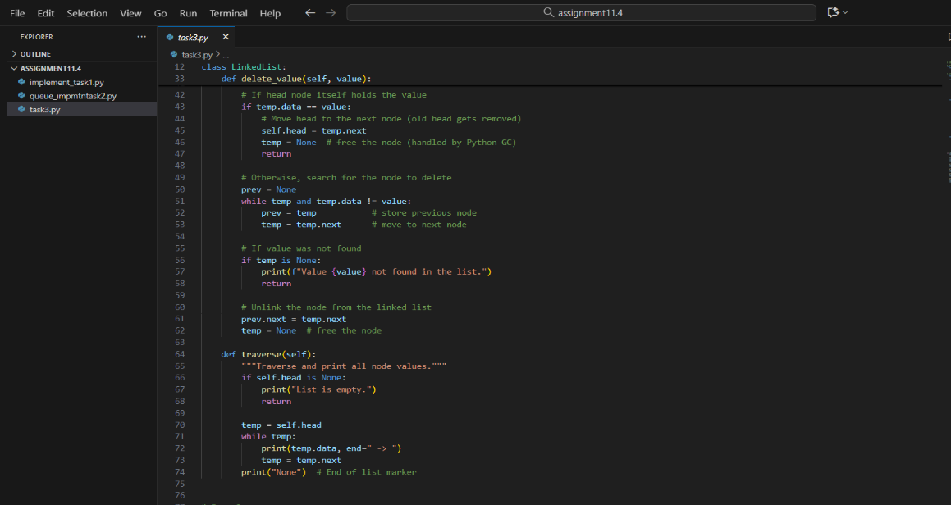
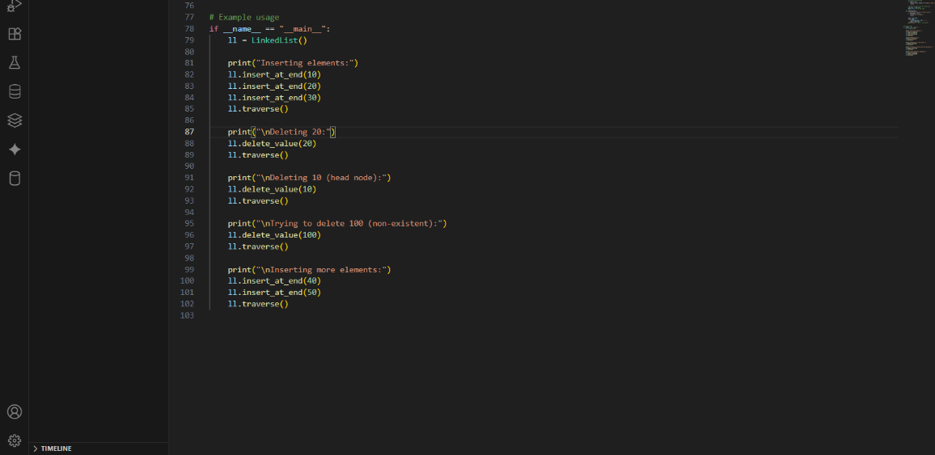

OUTPUT:
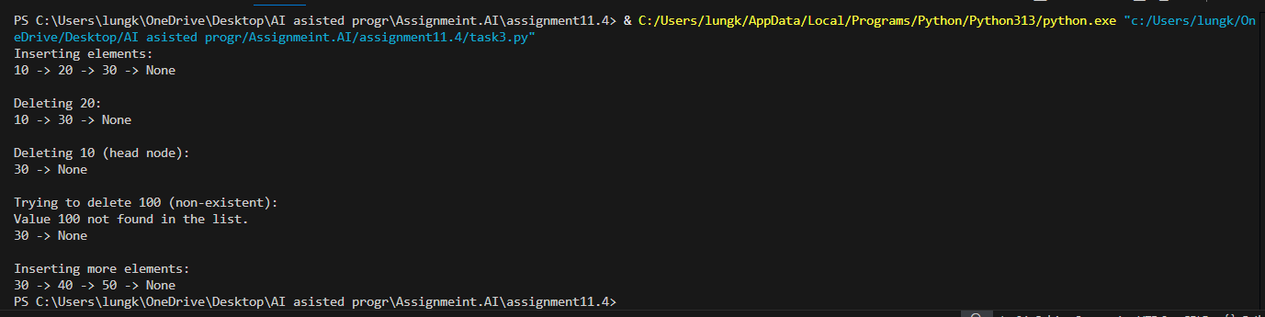
OBSERVATION:
• Insertion adds a new node at the end by updating the last node’s next pointer.
• Deletion removes a node by adjusting the previous node’s next pointer.
• Deleting the head moves the head pointer to the next node.
• If the value isn’t found, the list stays unchanged.
• Empty list operations are handled safely without errors.

TASK4: Binary Search Tree (BST)
- Task: Implement a Binary Search Tree with methods for insert(), search(), and inorder_traversal().
- Instructions:
  - Provide AI with a partially written Node and BST class.
  - Ask AI to complete missing methods and add docstrings.
  - Test with a list of integers and compare outputs of search() for present vs absent elements.

PROMPT: Write a Python program to implement a Binary Search Tree (BST) with methods: insert(value), search(value), inorder_traversal()
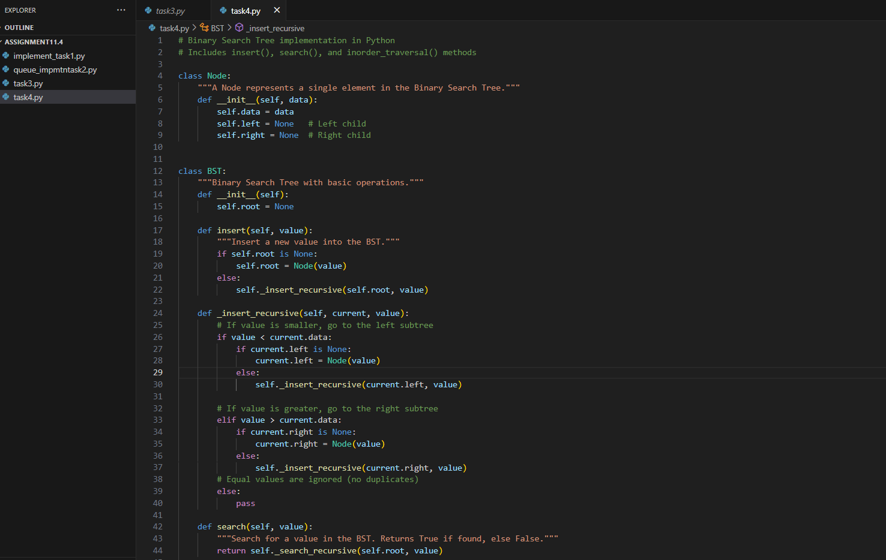
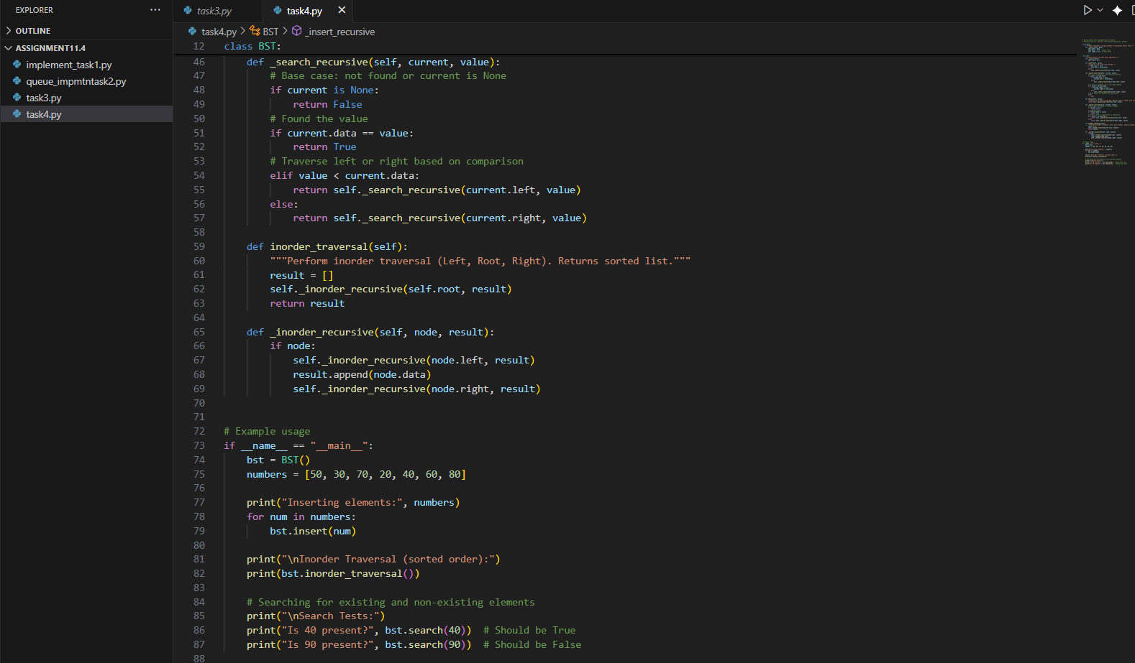

OUTPUT:
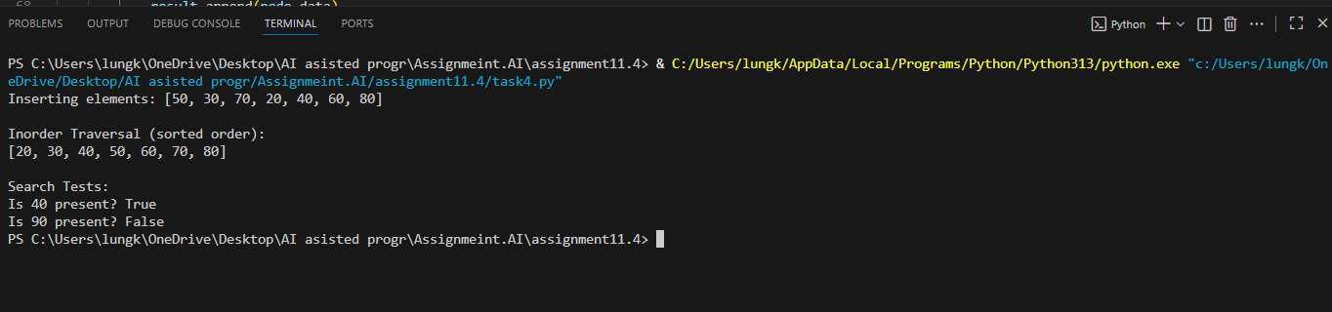

OBSERVATION:
1.Insertion places smaller values to the left and larger to the right.
2️. In order traversal visits nodes in sorted order.
3️. Search compares values recursively until it finds or reaches a dead end.
4️. Absent elements return False without errors.

Task 5: Graph Representation and BFS/DFS Traversal
- Task: Implement a Graph using an adjacency list, with traversal methods BFS() and DFS().
- Instructions:
  - Start with an adjacency list dictionary.
  - Ask AI to generate BFS and DFS implementations with inline comments.
  - Compare recursive vs iterative DFS if suggested by AI.

PROMPT: Write a Python program to implement a Graph using an adjacency list (dictionary).
Add methods for: add_edge(u, v), BFS(start), DFS(start)
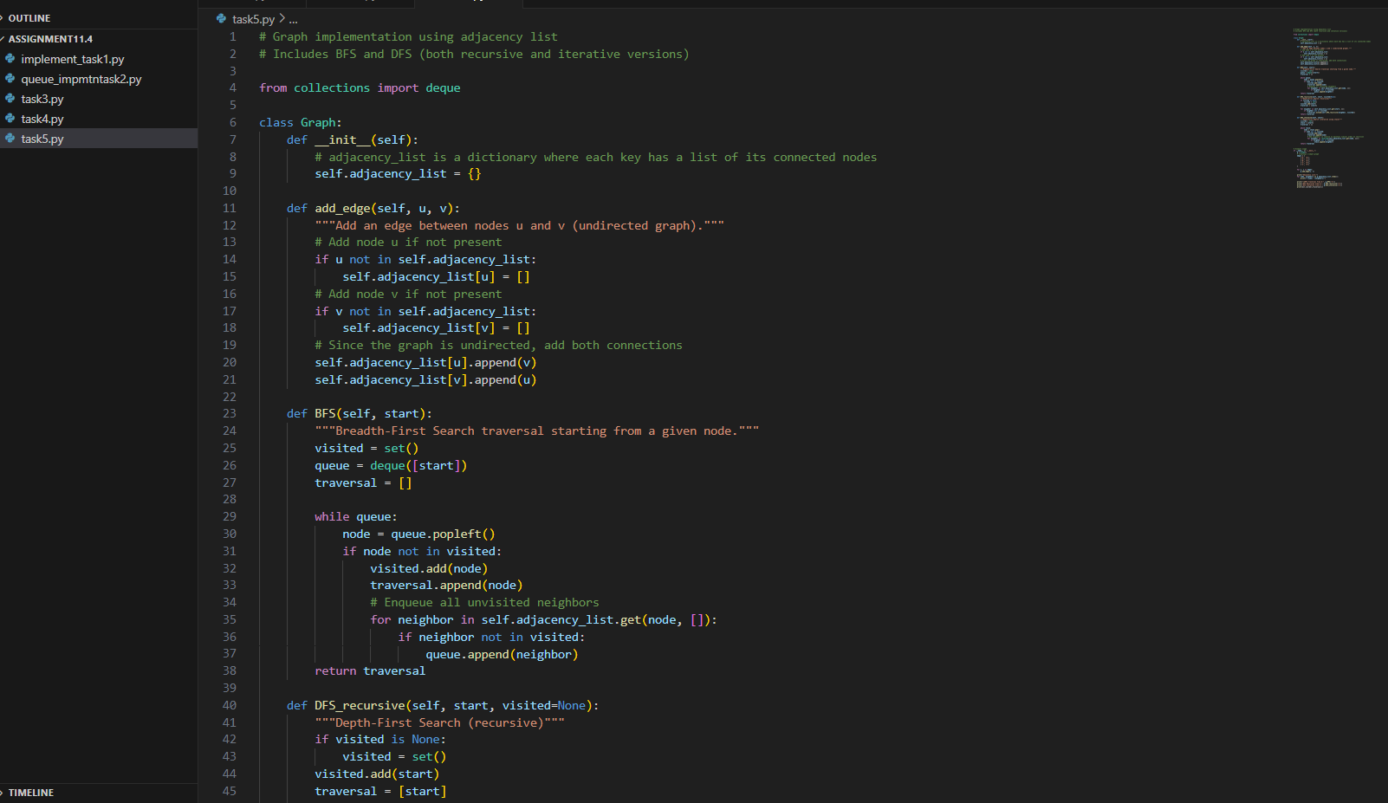
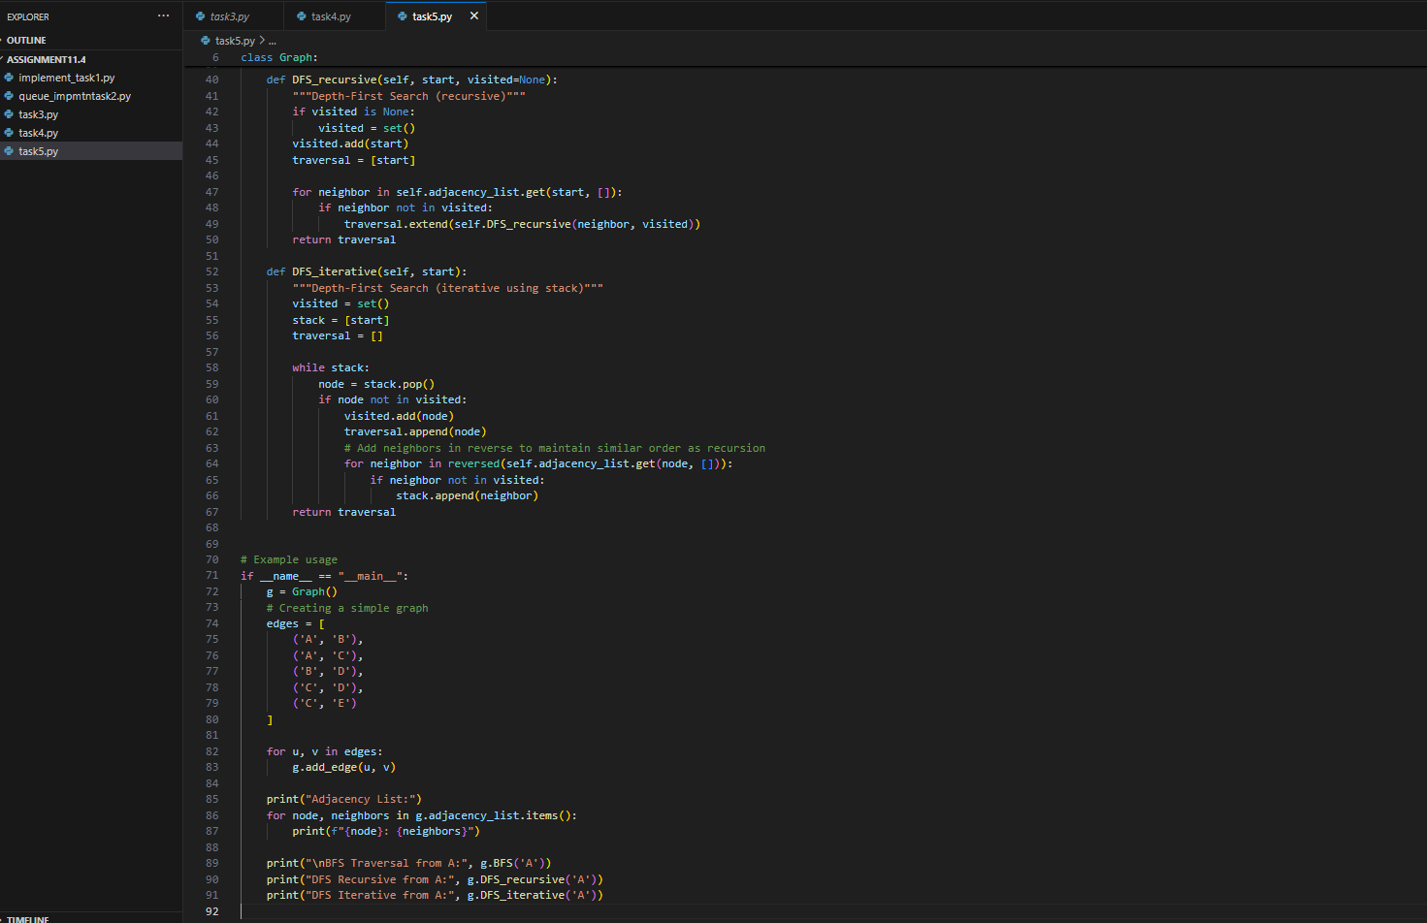
OUTPUT:
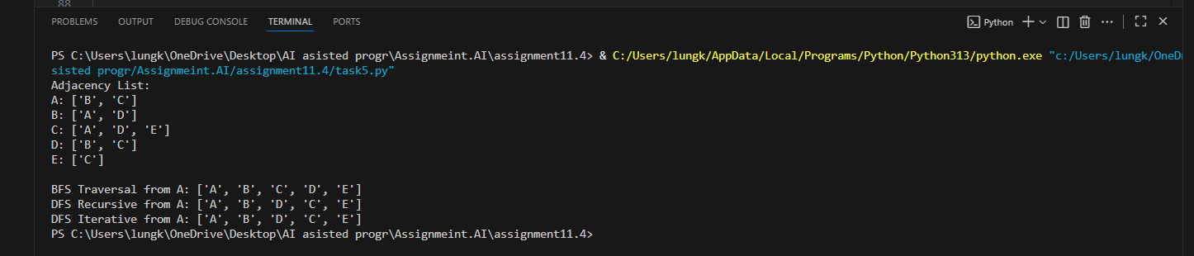

OBSERVATION:
1️ BFS explores level by level using a queue.
2️ DFS (recursive) explores deep paths using recursion (stack in memory).
3️ DFS (iterative) uses an explicit stack to mimic recursion.
4️ Both DFS versions visit the same nodes, but order may slightly differ.

