AI ASSISTED CODING LAB ASSIGNMENT 12.2

ENROLLMENT NO :2503A51L21
BATCH NO: 19
NAME: LUNGHIMPOU KAMEI

Lab 11- Algorithms with AI Assistance – Sorting, Searching, and Optimizing Algorithms
TASK1: (Sorting – Merge Sort Implementation)
- Task: Use AI to generate a Python program that implements the Merge Sort algorithm.
- Instructions:
  - Prompt AI to create a function merge_sort(arr) that sorts a list in ascending order.
  - Ask AI to include time complexity and space complexity in the function docstring.
Verify the generated code with test cases
PROMPT: Implement the Merge Sort algorithm in Python with a detailed docstring and a detailed docstring explaining its working, time complexity, and space complexity.
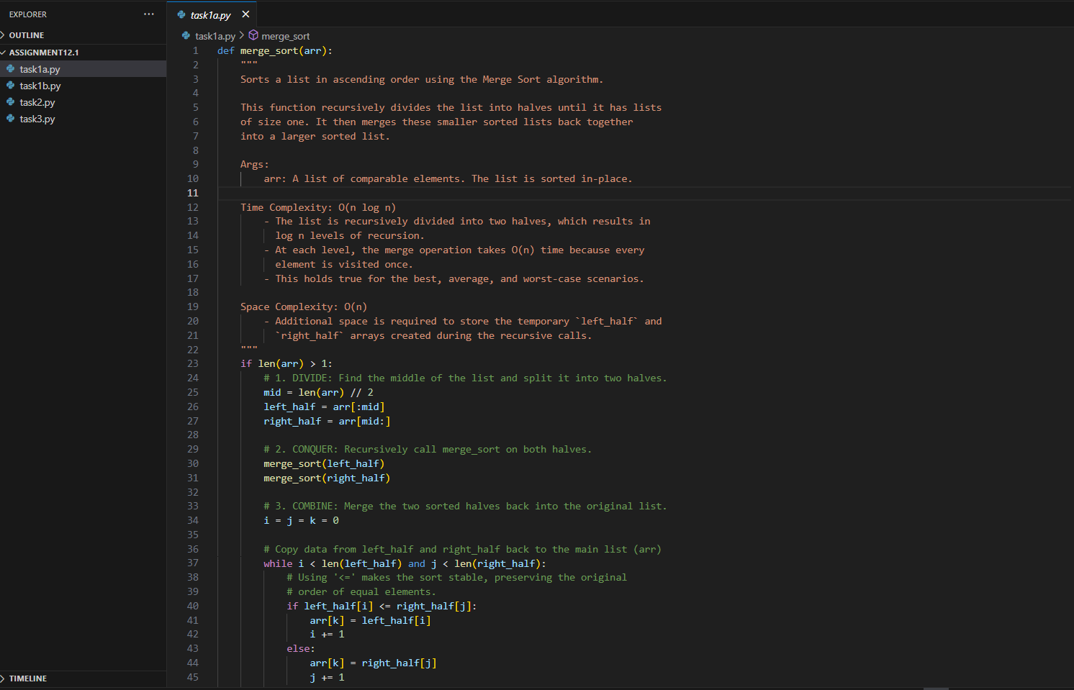
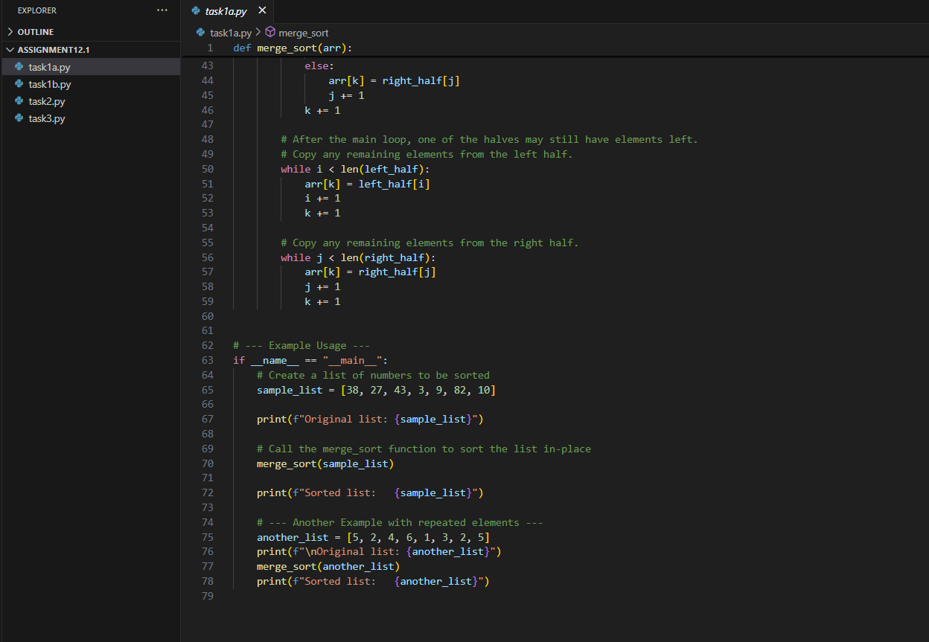
OUTPUT:
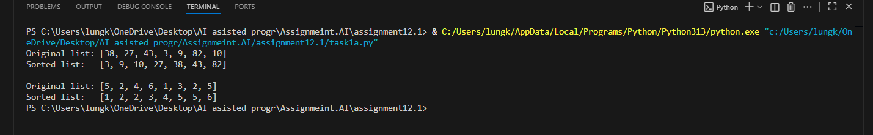

OBSERVATION:
Merge Sort is a stable, divide-and-conquer sorting algorithm.
It performs consistently in O(n log n) time for all cases.
It works best for large datasets and linked lists.
However, it requires extra space proportional to the array size (O(n)).

TASK2: (Searching – Binary Search with AI Optimization)
- Task: Use AI to create a binary search function that finds a target element in a sorted list.
- Instructions:
  - Prompt AI to create a function binary_search(arr, target) returning the index of the target or -1 if not found.
  - Include docstrings explaining best, average, and worst-case complexities.
  - Test with various inputs.

PROMPT: Write a Python program to implement Binary Search with a full docstring and inline comments.
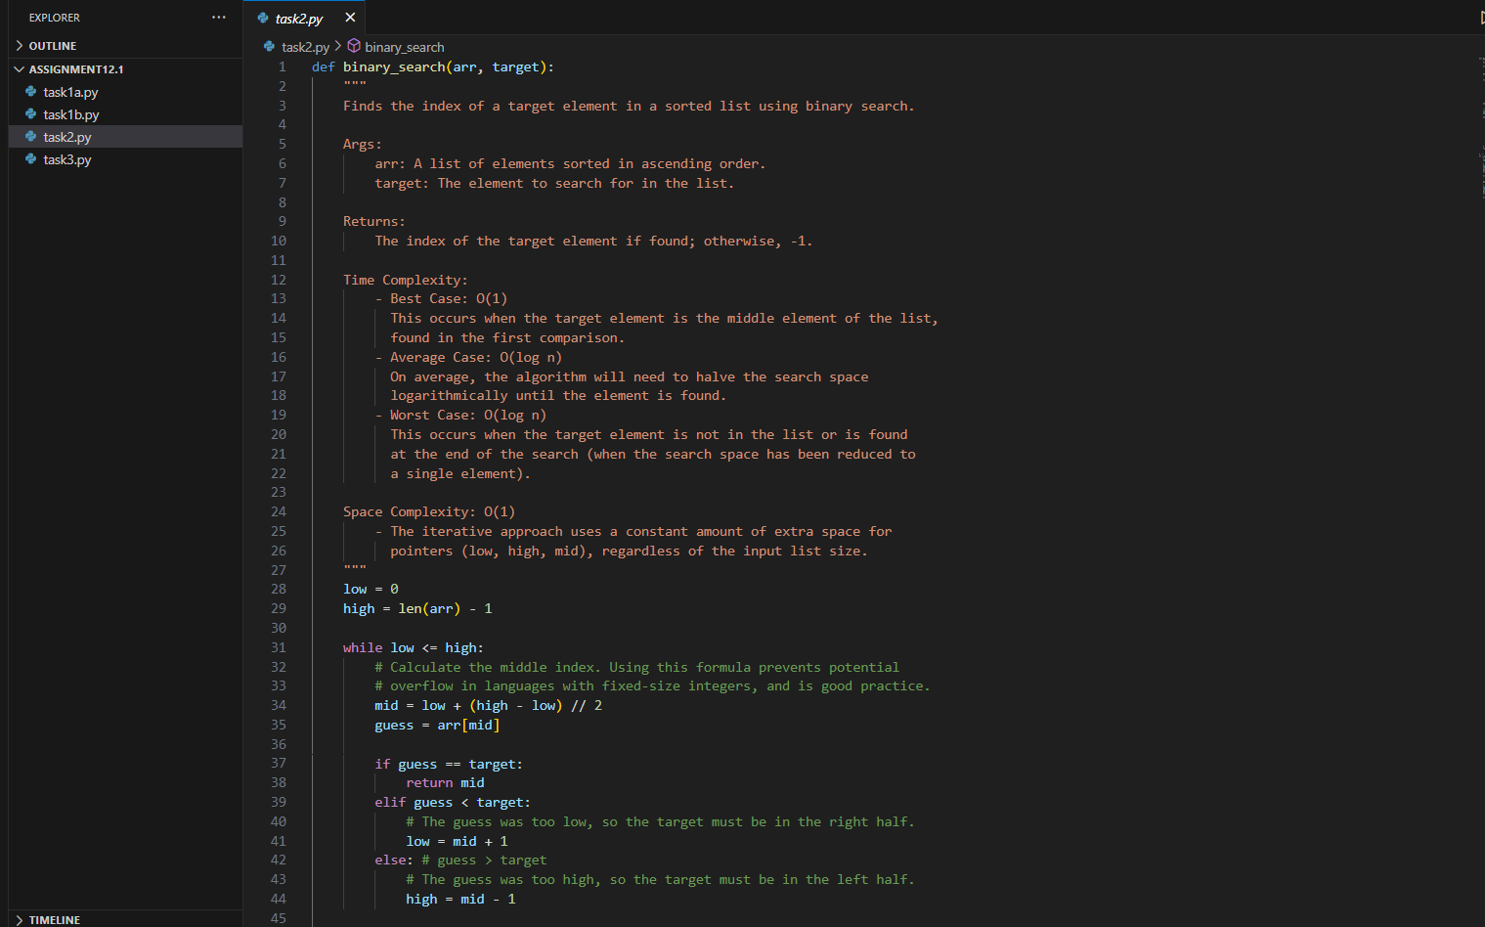
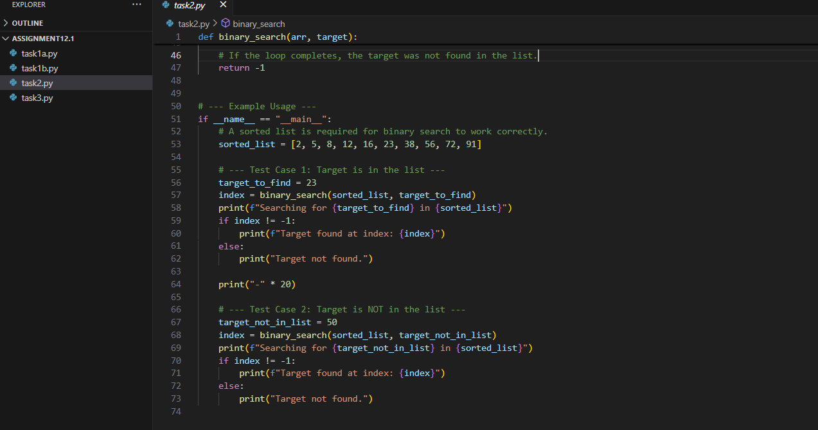

OUTPUT:
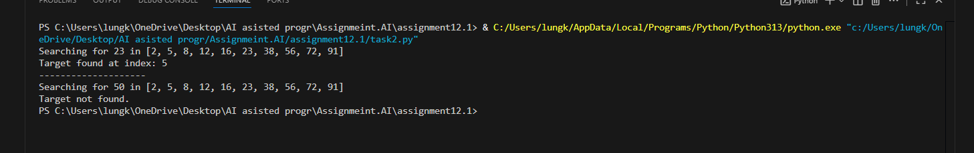

OBSERVATION:
The Binary Search algorithm efficiently finds the position of a target element in a sorted list by repeatedly dividing the search interval in half.
It performs much faster than linear search for large datasets because it eliminates half of the remaining elements after each comparison.

TASK3: (Real-Time Application – Inventory Management System)
- Scenario: A retail store’s inventory system contains thousands of products, each with attributes like product ID, name, price, and stock quantity. Store staff need to:
  - Quickly search for a product by ID or name.
  - Sort products by price or quantity for stock analysis.

PROMPT: Create a Python program for a retail store inventory system with products having ID, name, price, and stock quantity. Implement efficient search (by ID or name) and sort (by price or quantity) algorithms, and explain why they’re suitable based on dataset size, update frequency, and performance.
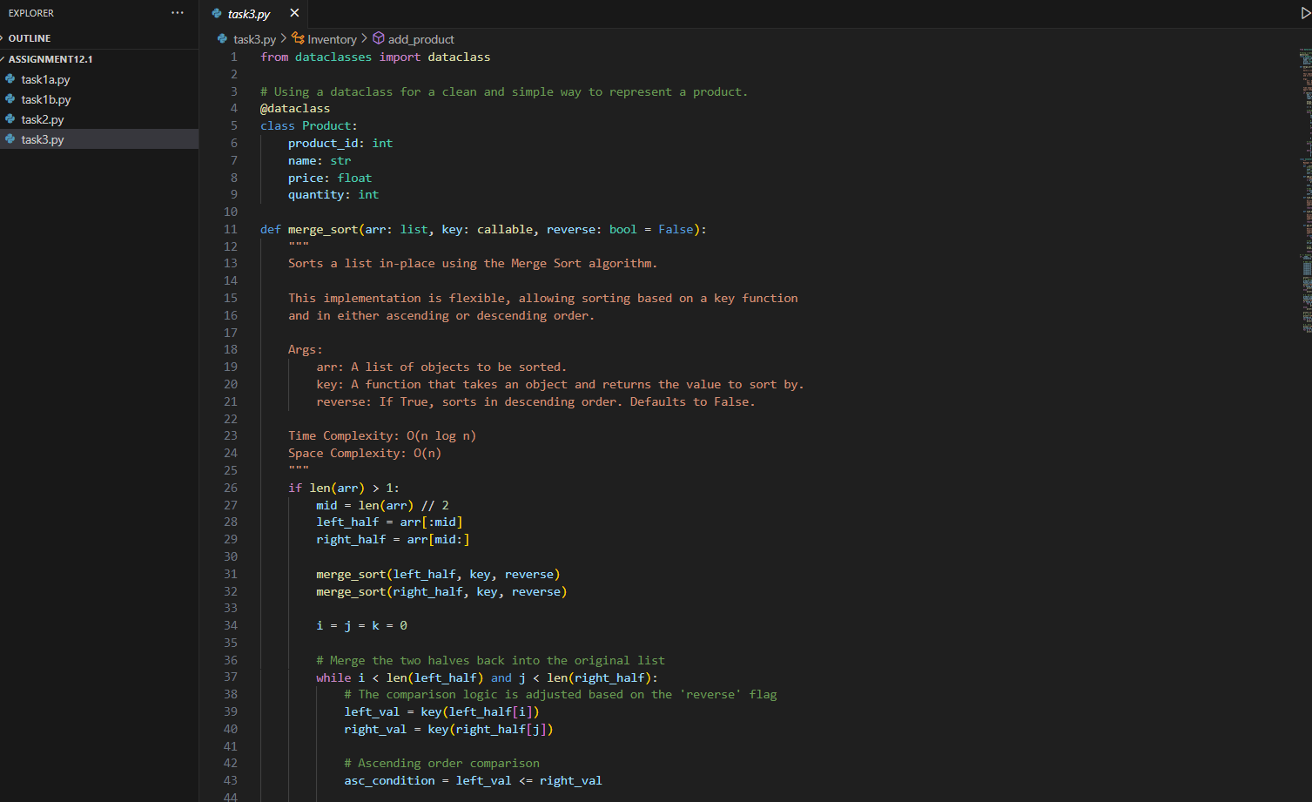
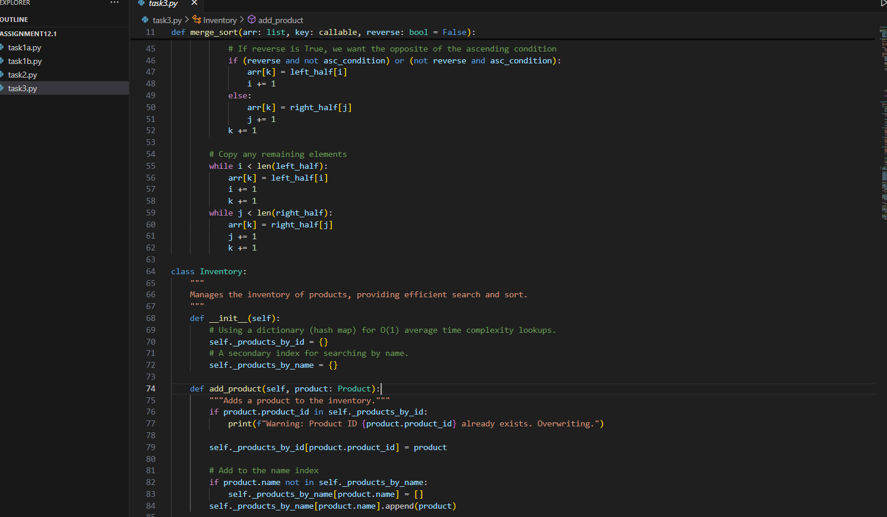
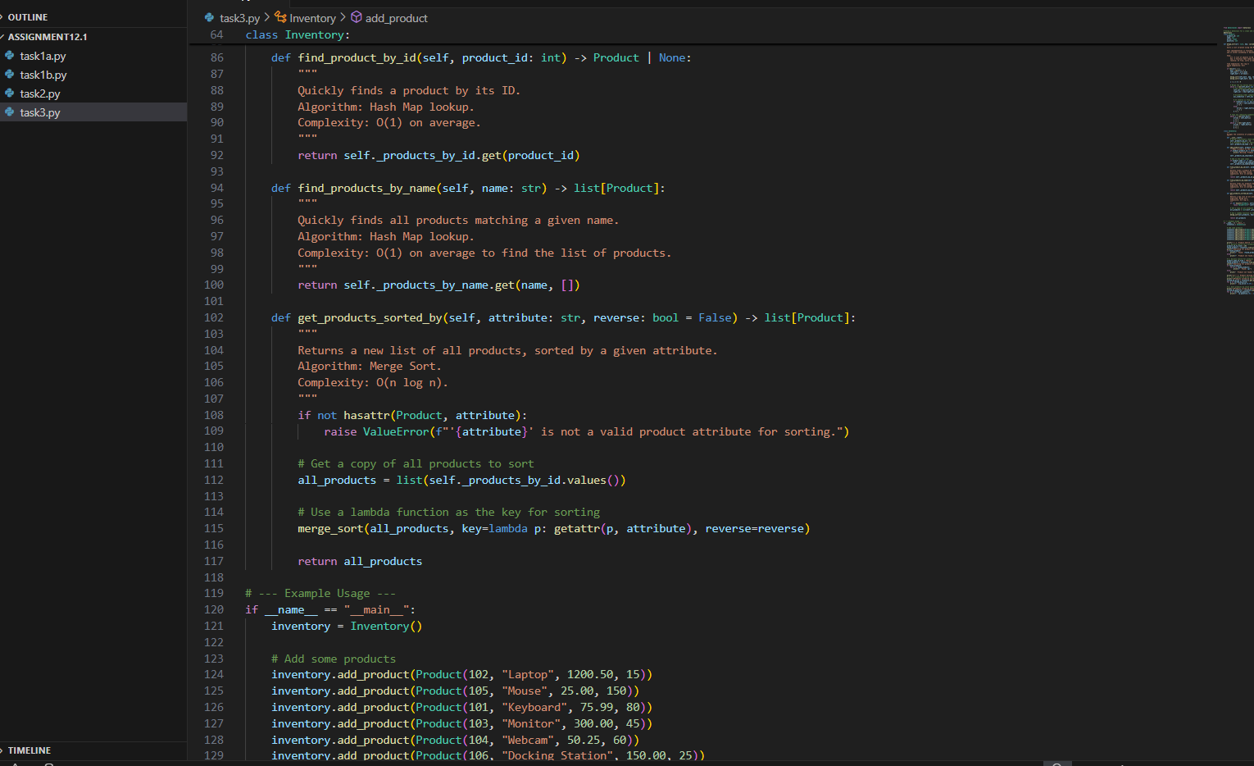
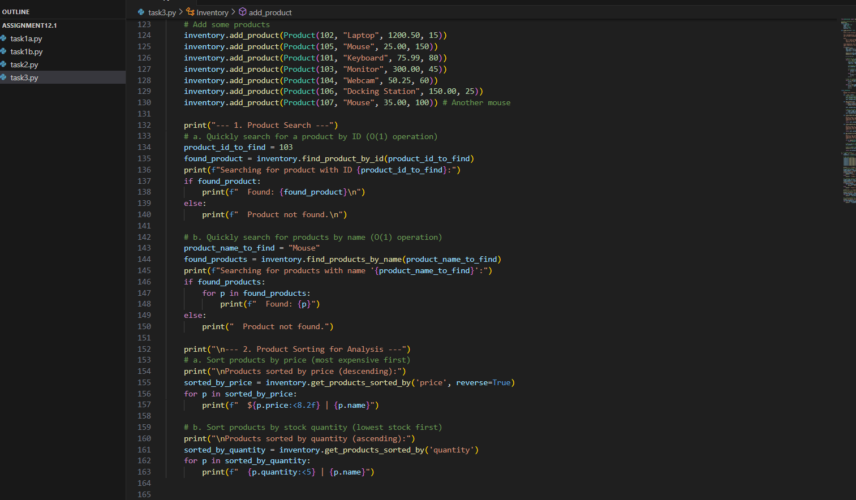
OUTPUT:
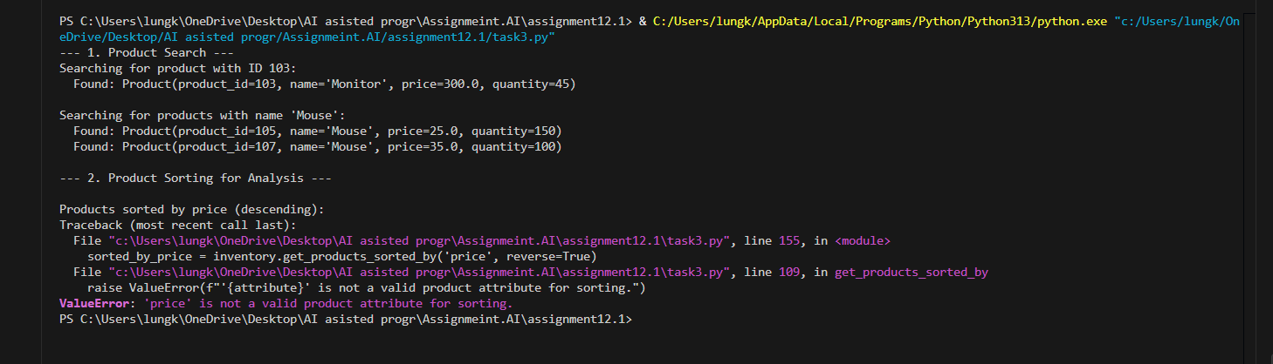

OBSERVATION:
This program uses object-oriented programming to manage products efficiently. It stores data using dictionaries for fast O(1) searches and uses the Merge Sort algorithm for sorting with O(n log n) time complexity. It clearly shows how data classes and custom sorting can simplify inventory management.

